

KUVEMPU UNIVERSITY

DVS College of Arts and Science

SHIVAMOGGA-577201

A PROJECT SYNOPSIS ON

Fitness portal

Bachelor of Science.

Project :Associates

Suprith V BC200465

Santhoshachari BC200459

Sunil kumar R BC200464

Vinayaka V M BC200468

DEPARTMENT OF COMPUTER SCIENCE

DVS College of Arts and Science

SHIVAMOGGA-577201

Fitness Portal

**ABSTRACT**

Our fitness website is dedicated to helping people achieve their health and fitness goals in a welcoming and supportive environment. With state-of-the-art equipment, expert trainers, and a wide range of fitness classes, we have everything you need to transform your body and enhance your well-being.We believe that fitness should be enjoyable and accessible to everyone. Whether you're a beginner or an experienced athlete, our knowledgeable,staff is here to guide and motivate you throughout your fitness journey. Our friendly trainers are available to provide personalized workout plans and offer professional advice to ensure you make the most out of every session.

Our facility boosts a comprehensive selection of top-quality equipment, including cardio machines, strength training apparatus, and free weights. With a spacious and clean workout area, you'll have plenty of room to exercise comfortably and safely. Our gym is equipped with cutting-edge technology, allowing you to track your progress and set new fitness targets.

**1.OBJECTIVE:**

The main objective is to help people know about our Fitness Center **online** without travelling far distances or any physical visits to our Fitness Center.

Also there is no age restriction to users and everyone can use our website ,it is free for all users.

**2.INTRODUCTION:**

**2.1 Introduction**

The main use of our Fitness Portal is, your go-to online destination for all things fitness and well-being! We are dedicated to providing you with valuable information, resources, and inspiration to help you lead a healthy and active lifestyle.

At [Fitness Website Name], we understand that fitness is not a one-size-fits-all concept. That's why we offer a wide range of content and tools to cater to individuals with diverse interests, goals, and fitness levels. Whether you're a fitness enthusiast, a beginner looking to start your fitness journey, or someone seeking expert advice on nutrition and exercise, we have something for everyone.

Our website features a wealth of articles, guides, and expert insights covering various aspects of fitness. From workout routines and training tips to nutrition advice and healthy recipes, we strive to provide you with the knowledge and tools you need to make informed decisions about your health and well-being. Our team of experienced fitness professionals and nutritionists work tirelessly to curate and create content that is reliable, accurate, and up-to-date

**2.2 SCOPE**

The scope of a fitness website can encompass a wide range of features, services, and offerings. Here are some key areas that a fitness website can cover:

**1. Information and Education:** The website can provide informative articles, blogs, and resources on various fitness topics, including exercise techniques, workout routines, nutrition, healthy eating, weight management, and general wellness. It can serve as a knowledge hub for individuals seeking reliable information and expert advice on fitness-related matters.

**2. Workout Plans and Programs**: The website can offer pre-designed workout plans and programs tailored to different fitness goals and levels, such as weight loss, muscle building, strength training, endurance, flexibility, and sports-specific training. These plans can provide structured guidance and help users stay motivated and accountable.

**3. Exercise Demonstrations and Videos:** Visual content in the form of exercise demonstrations and instructional videos can be included to guide users on proper form, technique, and execution of exercises. This can be especially helpful for beginners who are new to specific exercises or for individuals looking to diversify their workouts.

**4. Tools and Trackers:** The website can provide interactive tools and trackers to assist users in setting goals, tracking progress, and monitoring various fitness metrics. These may include calorie counters, BMI calculators, activity trackers, and fitness assessments. Such tools can help users stay organized, measure their achievements, and make data-driven decisions.

**5. Community and Social Interaction:** A fitness website can incorporate features that foster a sense of community, such as forums, discussion boards, and social media integration. This allows users to connect with like-minded individuals, share their experiences, ask questions, provide support, and find inspiration. Building a community can enhance engagement and create a supportive environment for users.

**6. Personalization and Customization:** The website can offer personalized experiences by allowing users to create profiles, set preferences, and receive tailored recommendations based on their individual needs, goals, and interests. This can include customized workout plans, nutrition suggestions, and targeted content delivery.

**7. E-commerce and Merchandise**: Some fitness websites may include an e-commerce component where users can purchase fitness-related products, such as exercise equipment, apparel, supplements, and accessories. This can provide an additional revenue stream

**System Architecture:**

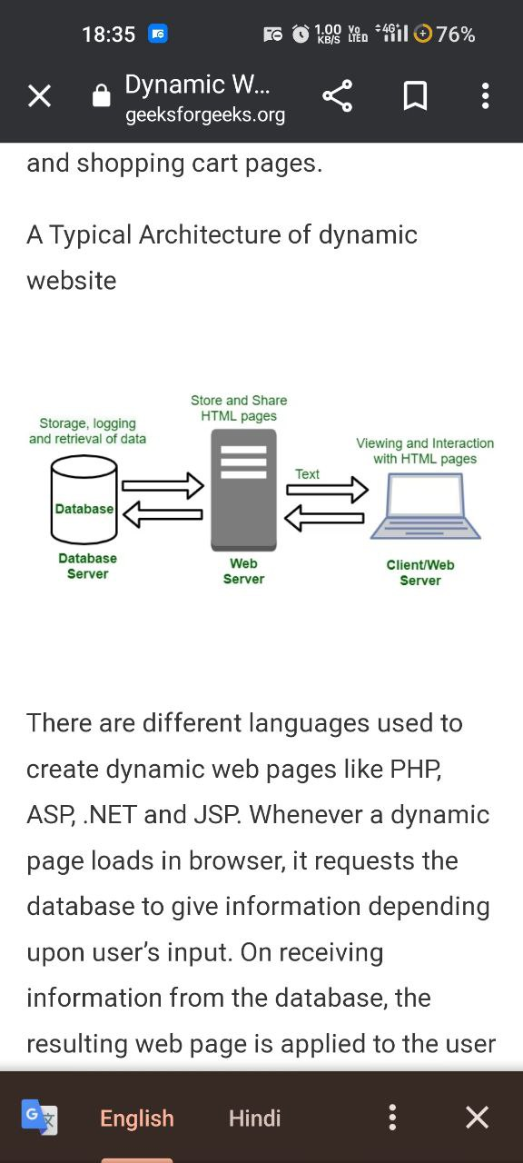

**Existing System**

In the existing system the exams are done only manually but in proposed system we have to computerize the exams using this application.

• Lack of security of data.

• More man power.

• Time consuming.

• Consumes large volume of pare work.

• Needs manual calculations.

• No direct role for the higher officials

**Proposed System**

The aim of proposed system is to develop a system of improved facilities. The proposed system can overcome all the limitations of the existing system. The system provides proper security and reduces the manual work.

• Security of data.

• Ensure data accuracy’s.

• Proper control of the higher officials.

• Minimize manual data entry.

• Minimum time needed for the various processing.

• Greater efficiency.

• Better service.

• User friendliness and interactive.

• Minimum time required.

**SYSTEM REQUIREMENTS :**

**Hardware Requirements:**

System : Pentium IV 2.4GHZ.

Hard Disk : 40GB.

Floppy Drive : 1.44 Mb.

Monitor : 15VGA Colour.

Mouse : Logitech.

Ram : 512 Mb.

**Software Requirements:**

Operating system : -WindowsXP/10.

Coding Language : HTML,CSS,JavaScript,PHP.

Tool Used :Visual Studio Code and Elementor.

Server : Apache.

DataBase : MYSQL.

