LOGISTICS DATA ANALYST INTERNSHIP

Week 4: Predictive Modeling
and Optimization in Logistics Systems
Predicting Shipment Transit Time Using Machine Learning

Prepared by: Supriya Babasaheb Adhav
Role: Logistics Data Analyst Intern
Internship Period: 30 July 2026 – 27 August 2026
Analysis Environment: Python / Jupyter Notebook
Dataset: Cleaned logistics shipment dataset (2,000 records)

Submitted to YuvaIntern

Executive Summary
This Week 4 project applies predictive analytics to a logistics shipment dataset containing 2,000 records and 12 variables. The primary business objective is to predict shipment transit time, represented by the target variable Transit_Days, so that logistics teams can anticipate delivery duration and support proactive operational planning.
Three regression algorithms were developed and evaluated: Linear Regression, Decision Tree Regressor, and Random Forest Regressor. The models were trained using an 80:20 train-test split with 1,600 training records and 400 testing records. Categorical variables were converted using one-hot encoding through a scikit-learn preprocessing pipeline. Delivery_Date was deliberately excluded to avoid data leakage because it is known only after delivery.
On the held-out test set, Linear Regression produced the strongest performance, with an MAE of 0.8136 days, RMSE of 0.9914 days, and R² of 0.6714. Five-fold cross-validation also favored Linear Regression, with a mean CV RMSE of 0.9645, compared with 1.0014 for Random Forest and 1.1458 for Decision Tree. The results indicate that the selected features contain useful predictive information about transit time, while also showing that substantial variation remains unexplained.
A supplementary Random Forest feature-importance analysis identified Distance_miles as the dominant transformed predictor, with an importance of 0.8116, followed by Cost (0.0504) and Weight_kg (0.0455). These findings support practical recommendations centered on route efficiency, carrier allocation, proactive monitoring of long-distance shipments, and better shipment scheduling. The optimization component is presented as a data-driven operational strategy rather than a live vehicle-routing solver.

1. Introduction
Logistics operations depend on timely movement of shipments, efficient routing, appropriate carrier selection, and controlled transportation costs. Predictive modeling can help transform historical shipment information into estimates that managers can use before or during operational planning.
This project extends the data preparation and exploratory analysis completed in earlier internship weeks. The cleaned shipment data is used to build a regression-based forecasting workflow and then translate model findings into actionable logistics optimization recommendations.

2. Problem Definition

2.1 Business Question
Can shipment characteristics such as origin warehouse, destination, carrier, shipment weight, transportation cost, and distance be used to predict the number of days required to complete a shipment?

2.2 Prediction Target
Item | Definition
Target variable | Transit_Days
Prediction type | Regression
Unit | Days
Business purpose | Estimate shipment duration for operational planning

2.3 Objectives
- Prepare the cleaned shipment dataset for machine learning.
- Develop multiple regression models for transit-time prediction.
- Compare models using MAE, RMSE, and R².
- Validate model consistency using five-fold cross-validation.
- Identify influential predictors using Random Forest feature importance.
- Translate predictive findings into practical logistics optimization strategies.

3. Dataset Description
The Week 4 notebook loads the cleaned logistics shipment dataset and reports 2,000 records and 12 columns. The variables represent shipment identity, origin, destination, carrier, shipment and delivery dates, shipment weight, cost, status, distance, transit time, and a date-validity flag.
Variable | Type | Role in Week 4
Shipment_ID | Categorical / ID | Excluded; identifier only
Origin_Warehouse | Categorical | Predictor
Destination | Categorical | Predictor
Carrier | Categorical | Predictor
Shipment_Date | Date/text | Not used as predictor
Delivery_Date | Date/text | Excluded to prevent leakage
Weight_kg | Numeric | Predictor
Cost | Numeric | Predictor
Status | Categorical | Not used in selected predictor set
Distance_miles | Numeric | Predictor
Transit_Days | Numeric | Target
Invalid_Date | Boolean | Excluded from predictor set

The dataset contains no missing values and no duplicate rows at the modeling stage. Descriptive statistics show an average shipment weight of 23.1709 kg, average transportation cost of 807.1946, average distance of 1,280.7725 miles, and average transit time of 4.2330 days.

4. Data Preparation

4.1 Data Quality Validation
The notebook checks missing values and duplicate rows before model training. All 12 columns contain 2,000 non-null records, and the duplicate-row count is zero. This provides a consistent base for the modeling workflow.

4.2 Target Distribution
Transit_Days ranges from 1 to 9 days. Its mean is 4.233 days, median is 4 days, standard deviation is 1.6939 days, and the 25th and 75th percentiles are 3 and 6 days respectively.
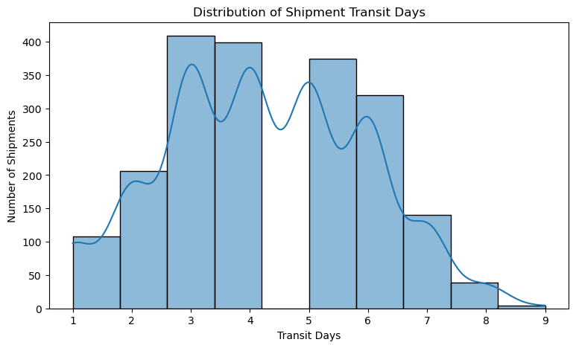
Figure 1. Distribution of shipment transit days from the Week 4 notebook.

4.3 Feature Selection and Leakage Prevention
Shipment_ID is excluded because it is an identifier rather than an operational predictor. Delivery_Date is excluded because using a completed delivery date to predict transit duration would leak information from the outcome into the predictors. Invalid_Date is also excluded because it is a data-quality indicator rather than a meaningful operational input.

4.4 Encoding and Train-Test Split
Origin_Warehouse, Destination, and Carrier are categorical variables and are one-hot encoded using OneHotEncoder(handle_unknown='ignore'). Weight_kg, Cost, and Distance_miles are treated as numerical predictors. The data is split into 80% training and 20% testing data using random_state=42.
Subset | Records | Share
Training | 1,600 | 80%
Testing | 400 | 20%

5. Model Selection and Implementation

5.1 Linear Regression
Linear Regression was selected as the baseline because it is interpretable and provides a useful benchmark for a continuous target such as transit time.
linear_model = Pipeline(
steps=[
("preprocessor", preprocessor),
("model", LinearRegression())
]
)
linear_model.fit(X_train, y_train)
linear_predictions = linear_model.predict(X_test)

5.2 Decision Tree Regressor
A Decision Tree Regressor was included to capture non-linear relationships and threshold effects that may not be represented well by a linear model. The notebook uses max_depth=8 and random_state=42.
decision_tree_model = Pipeline(
steps=[
("preprocessor", preprocessor),
("model", DecisionTreeRegressor(
random_state=42,
max_depth=8
))
]
)

5.3 Random Forest Regressor
Random Forest was selected as an ensemble alternative that combines multiple decision trees and can capture more complex interactions. The notebook uses 200 trees, max_depth=10, random_state=42, and n_jobs=-1.
random_forest_model = Pipeline(
steps=[
("preprocessor", preprocessor),
("model", RandomForestRegressor(
n_estimators=200,
max_depth=10,
random_state=42,
n_jobs=-1
))
]
)

6. Model Evaluation and Validation

6.1 Evaluation Metrics
Metric | Interpretation
MAE | Average absolute prediction error in days; lower is better.
RMSE | Penalizes larger errors more strongly; lower is better.
R² | Proportion of target variation explained by the model; higher is better.

6.2 Test-Set Results
Model | MAE | RMSE | R²
Linear Regression | 0.8136 | 0.9914 | 0.6714
Random Forest | 0.8379 | 1.0311 | 0.6445
Decision Tree | 0.9275 | 1.1557 | 0.5534

Linear Regression achieved the lowest MAE and RMSE and the highest R² among the three models. Its MAE of 0.8136 days means that the average absolute prediction error on the test set was about 0.81 days. The RMSE of 0.9914 days indicates that larger errors were also kept below one day on the selected test evaluation scale.
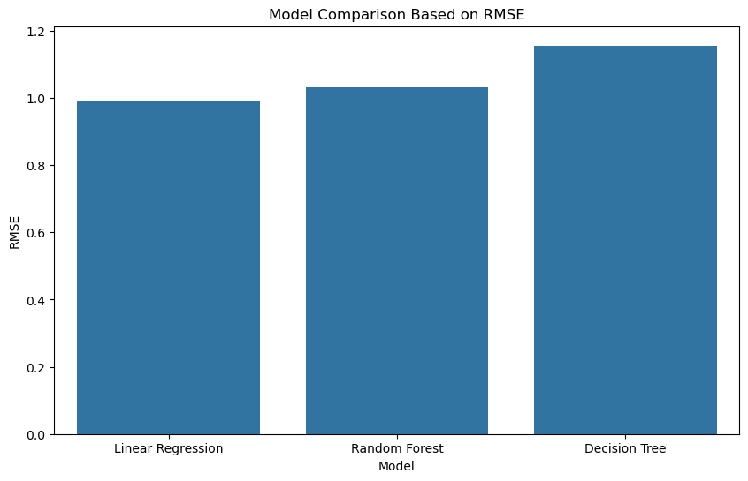
Figure 2. Model comparison based on RMSE.

6.3 Five-Fold Cross-Validation
Model | Mean CV RMSE
Linear Regression | 0.9645
Random Forest | 1.0014
Decision Tree | 1.1458

The cross-validation results reinforce the test-set comparison. Linear Regression has the lowest mean five-fold CV RMSE of 0.9645. This consistency supports selecting Linear Regression as the final model for this project.

6.4 Final Model Selection
The final selected model is Linear Regression. It is preferred because it performs best on the held-out test set and also has the strongest five-fold cross-validation result. The result also provides a clear, interpretable baseline for future improvements.

7. Feature Importance and Prediction Error Analysis
Although Linear Regression is the selected final model, the notebook also uses the fitted Random Forest to inspect feature importance. This supplementary analysis helps identify which transformed predictors are most influential for operational interpretation.
Transformed Feature | Importance
Distance_miles | 0.8116
Cost | 0.0504
Weight_kg | 0.0455
Destination_Mumbai | 0.0054
Carrier_Delhivery | 0.0052
Destination_Kolkata | 0.0049
Carrier_XpressBees | 0.0044
Origin_Warehouse_Pune_Warehouse | 0.0043
Origin_Warehouse_Ahmedabad_Warehouse | 0.0043
Destination_Nashik | 0.0042

Distance_miles has a substantially larger importance than the other listed predictors, accounting for 0.8116 of the Random Forest importance score. Cost and Weight_kg follow at 0.0504 and 0.0455. This suggests that route length is the most influential factor among the transformed predictors in this supplementary model interpretation. The result should be interpreted as predictive importance rather than proof that distance alone causes transit delays.
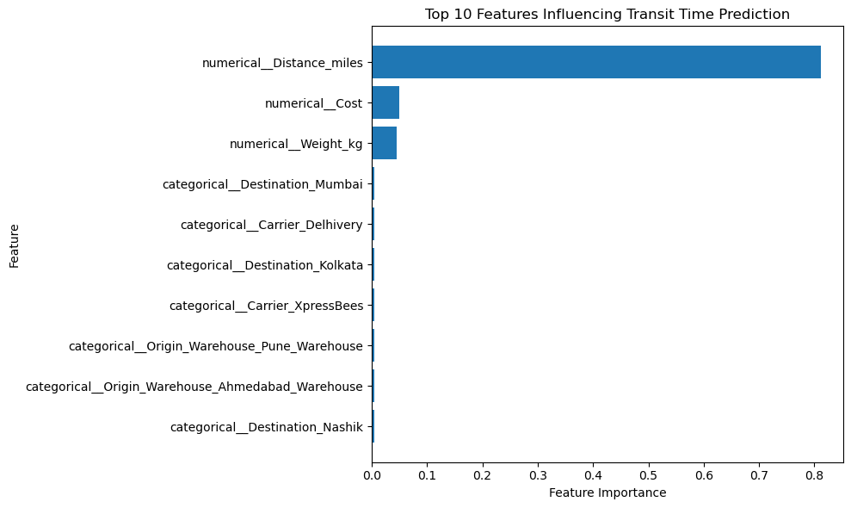
Figure 3. Top transformed features influencing transit-time prediction.

7.1 Prediction Error Examples
Actual Days | Predicted Days | Error | Absolute Error
3 | 4.53 | -1.53 | 1.53
3 | 3.88 | -0.88 | 0.88
8 | 6.02 | 1.98 | 1.98
4 | 6.11 | -2.11 | 2.11
3 | 2.34 | 0.66 | 0.66

The notebook's supplementary Random Forest error analysis shows examples where predicted transit time differs from the actual value. For example, an 8-day shipment was predicted at 6.02 days, while another 4-day shipment was predicted at 6.11 days. Such deviations illustrate why prediction should be used as decision support rather than as an exact guarantee.
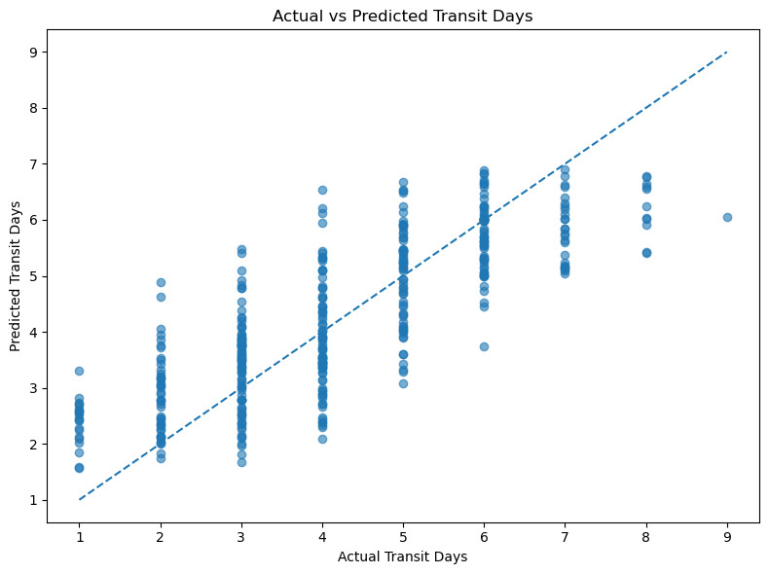
Figure 4. Actual versus predicted transit days using the notebook's Random Forest prediction analysis.

8. Logistics Optimization Strategies
The notebook proposes operational strategies based on predictive findings. The project does not claim to have implemented a live route-optimization solver; instead, it translates the observed model and feature-importance results into practical actions that could be implemented in a logistics environment.
Optimization Area | Data-Driven Strategy | Expected Operational Benefit
Route Planning | Prioritize efficient routes for shipments with high predicted transit times. | Lower expected transit time and improved service reliability.
Carrier Allocation | Use predicted transit time together with historical carrier performance when assigning shipments. | Better matching of shipments with suitable carriers.
Proactive Delay Monitoring | Flag shipments with unusually high predicted transit times for early intervention. | Earlier corrective action and fewer avoidable delays.
Warehouse Planning | Use predicted delivery requirements to support shipment scheduling and resource allocation. | Improved workload planning and resource utilization.
Transportation Cost | Review long-distance shipments carefully because distance is the dominant predictive feature in the supplementary Random Forest analysis. | Better cost and route-efficiency monitoring.

8.1 Proposed Optimization Workflow
- Generate a predicted transit time for each new shipment using the selected Linear Regression model.
- Flag shipments whose predicted duration exceeds an operational threshold defined by the logistics team.
- For flagged shipments, review route alternatives, carrier availability, and shipment scheduling options.
- Prioritize route and carrier combinations that balance delivery time, cost, and operational constraints.
- Monitor actual outcomes against predictions and use the accumulated results for future model retraining.

9. Key Findings
- The modeling dataset contains 2,000 shipment records with no missing values or duplicate rows at the modeling stage.
- Transit_Days ranges from 1 to 9 days, with an average of 4.233 days.
- Linear Regression is the best-performing model in the notebook, with MAE 0.8136, RMSE 0.9914, and R² 0.6714.
- Five-fold cross-validation also ranks Linear Regression first, with a mean CV RMSE of 0.9645.
- Random Forest feature importance identifies Distance_miles as the dominant transformed predictor at 0.8116.
- Cost and Weight_kg are the next two most important numerical predictors in the supplementary Random Forest analysis.
- Prediction errors demonstrate that model estimates are useful for planning but should not be treated as exact delivery guarantees.

10. Actionable Recommendations
- Integrate transit-time prediction into shipment planning so that potentially slow shipments can be identified before dispatch.
- Give additional operational attention to long-distance shipments because Distance_miles dominates the supplementary feature-importance analysis.
- Develop carrier-level performance dashboards that combine predicted transit time with historical delivery performance.
- Use threshold-based alerts for shipments with unusually high predicted transit time so operations teams can intervene earlier.
- For future implementation, connect the prediction layer to a formal route-optimization method that considers vehicle capacity, route distance, delivery windows, and cost.
- Continuously retrain and validate the model as new shipment records become available to reduce performance drift.

11. Limitations and Future Work
- The dataset is a simulated/logistics-analysis dataset rather than a live operational feed, so results should be interpreted within the project context.
- The selected target is transit duration, not a direct probability of late delivery.
- The current optimization component proposes strategies; it does not execute a mathematical vehicle-routing optimization.
- The Random Forest feature-importance analysis is supplementary because Linear Regression was selected as the final predictive model.
- Additional operational variables such as traffic conditions, service-level commitments, vehicle capacity, weather, route restrictions, and real-time tracking could improve future models.
- Future work could compare additional algorithms and perform systematic hyperparameter tuning.

12. Conclusion
This Week 4 project demonstrates an end-to-end predictive modeling workflow for logistics transit-time forecasting. Starting with the cleaned shipment dataset, the project validates data quality, selects appropriate predictors, prevents target leakage, encodes categorical variables, trains multiple regression models, evaluates them with quantitative metrics, and validates their performance using five-fold cross-validation.
The analysis provides concrete evidence that Linear Regression is the strongest of the three tested models for this dataset. Its test-set MAE of 0.8136 days, RMSE of 0.9914 days, and R² of 0.6714 are supported by the lowest cross-validation RMSE of 0.9645. The supplementary Random Forest analysis further highlights Distance_miles as the dominant predictive factor, providing a clear operational direction for route and shipment planning.
The project therefore moves beyond descriptive analytics toward predictive decision support. In practice, predicted transit times can be used to prioritize high-risk shipments, support carrier allocation, improve route planning, and guide proactive interventions. A future production implementation should connect these predictions to a formal optimization engine and continuously evaluate performance against newly observed shipments.

13. Submission Description (200+ Words)
This Week 4 report presents a practical predictive modeling and optimization study for logistics shipment operations using a cleaned dataset of 2,000 shipment records. The project focuses on forecasting shipment transit time through the Transit_Days target variable and demonstrates how machine learning can support data-driven operational decisions. The workflow begins with data validation and descriptive analysis, followed by feature selection and leakage prevention. Shipment identifiers and post-delivery information were excluded from the predictor set, while categorical variables such as warehouse, destination, and carrier were converted using one-hot encoding. An 80:20 train-test split was used, resulting in 1,600 training records and 400 testing records.
Three regression models were implemented and compared: Linear Regression, Decision Tree Regressor, and Random Forest Regressor. Model performance was measured using Mean Absolute Error, Root Mean Squared Error, and R². Linear Regression achieved the strongest test performance with MAE 0.8136, RMSE 0.9914, and R² 0.6714. Five-fold cross-validation produced a mean RMSE of 0.9645 for Linear Regression, confirming its selection as the final model among the tested alternatives. A supplementary Random Forest feature-importance analysis identified Distance_miles as the dominant transformed predictor with an importance of 0.8116, followed by Cost and Weight_kg.
The report translates these analytical results into practical optimization recommendations covering route planning, carrier allocation, proactive delay monitoring, warehouse scheduling, and transportation-cost control. It also identifies limitations and proposes future integration with formal route optimization and additional real-time operational variables. Overall, the project demonstrates how predictive analytics can complement logistics management by providing measurable forecasts, model validation evidence, and actionable operational strategies.

14. References
- Scikit-learn documentation — Linear Regression, Decision Tree Regression, Random Forest Regression, preprocessing pipelines, and model evaluation metrics.
- Pandas documentation — data loading, inspection, descriptive statistics, and data manipulation.
- Matplotlib and Seaborn documentation — statistical visualization and model-result visualization.
- Week 4 Jupyter Notebook: logistics_week4_predictive_modeling.ipynb — source of the reported dataset checks, model results, validation results, feature importance, and figures.

End of Report

