WEEK 3 LOGISTICS ANALYSIS
Advanced Data Analysis and Visualization

Internship Project Report
Dataset: Cleaned Logistics Shipment Dataset (2,000 records)
Tools: Python, Pandas, NumPy, Matplotlib, Seaborn, Jupyter Notebook

1. Executive Summary
This report presents an exploratory data analysis (EDA) and visualization study of a cleaned logistics shipment dataset containing 2,000 shipment records and 12 variables. The analysis focuses on shipment characteristics, transportation cost, distance, transit time, carrier patterns, warehouse activity, destination volumes, and relationships among numerical logistics metrics. Python libraries including Pandas, NumPy, Matplotlib, and Seaborn were used to perform statistical analysis and generate visualizations.
The dataset contains complete records with no missing values and no duplicate rows at the time of analysis. The average shipment weighs 23.17 kg, has an average transportation cost of 807.19, travels approximately 1,280.77 miles, and requires 4.23 transit days. The analysis also shows that distance is strongly associated with both transportation cost and transit time. The strongest observed numerical relationship is between distance and transit days (correlation 0.824), followed by cost and distance (0.797). These results indicate that route length is an important operational factor affecting both cost and delivery duration.

2. Objective
The objective of Week 3 is to deepen logistics analytics skills through exploratory data analysis, descriptive statistics, visualization, correlation analysis, and interpretation of operational patterns. The analysis is intended to support data-driven decision-making by identifying cost drivers, shipment patterns, and potential operational considerations.

3. Dataset Overview
The analysis uses the cleaned dataset produced during Week 2. The dataset contains 2,000 shipment records and the following 12 variables:
Variable | Type | Purpose
Shipment_ID | Categorical | Unique shipment identifier
Origin_Warehouse | Categorical | Shipment origin warehouse
Destination | Categorical | Shipment destination
Carrier | Categorical | Transportation provider
Shipment_Date | Date/Text | Shipment dispatch date
Delivery_Date | Date/Text | Delivery date
Weight_kg | Numeric | Shipment weight
Cost | Numeric | Transportation cost
Status | Categorical | Shipment delivery status
Distance_miles | Numeric | Shipment distance
Transit_Days | Numeric | Transit duration
Invalid_Date | Boolean | Date-quality flag

4. Data Quality Verification
Before performing the analysis, the cleaned dataset was inspected for structural and quality issues. The notebook confirms 2,000 records and 12 columns. Every column contains 2,000 non-null values, indicating no missing values remain in the analysis dataset. The duplicate check returned zero duplicate rows. The Invalid_Date flag is False for all 2,000 records, so no records are flagged as having invalid dates in the cleaned dataset.

5. Descriptive Statistics
Metric | Mean | Median | Standard Deviation
Weight (kg) | 23.17 | 18.50 | 43.13
Cost | 807.19 | 794.26 | 371.80
Distance (miles) | 1,280.77 | 1,262.50 | 704.47
Transit Days | 4.23 | 4.00 | 1.69
The mean is higher than the median for shipment weight and cost, suggesting that some relatively large observations influence the averages. Weight has a particularly large standard deviation relative to its mean, and the maximum recorded weight is 1,200 kg compared with a median of 18.5 kg. This indicates a highly variable shipment-weight distribution and highlights the importance of considering both central tendency and dispersion when evaluating logistics operations.

6. Shipment Status Analysis
Shipment status analysis shows 1,551 shipments marked Delivered, 292 marked Delayed, and 157 marked In Transit. Delivered shipments therefore form the clear majority of the dataset, while delayed shipments represent a meaningful operational segment that can be monitored for service-level improvement.
Status | Shipments
Delivered | 1551
Delayed | 292
In Transit | 157

7. Distribution Analysis
Histograms were created for shipment weight, transportation cost, shipment distance, and transit time. These visualizations help identify the concentration, spread, and potential extreme observations in key logistics variables. Transit time ranges from 1 to 9 days, while distance ranges from 51 to 2,499 miles. Cost ranges from 63.81 to 6,500, indicating substantial variation in transportation expenditure.
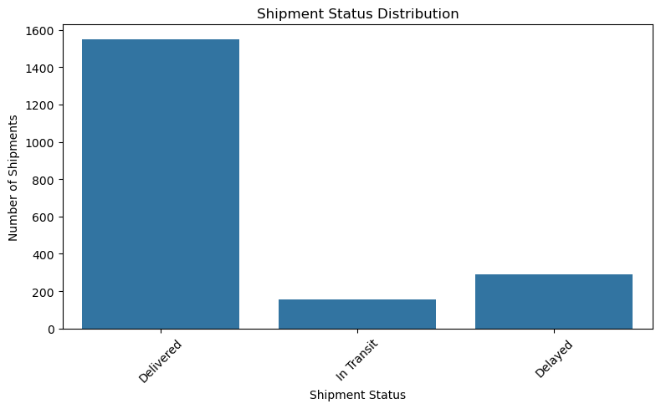
Figure 1. Shipment status distribution.
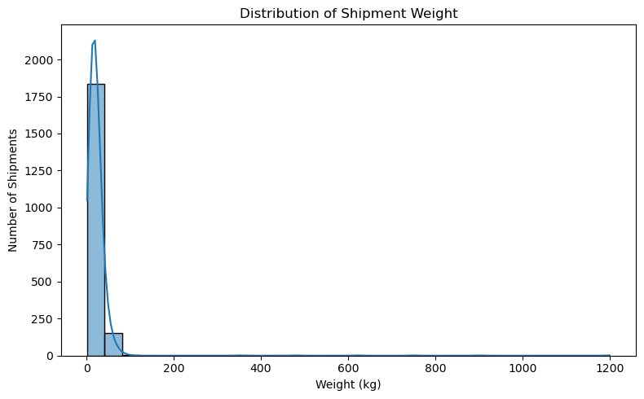
Figure 2. Distribution of shipment weight.
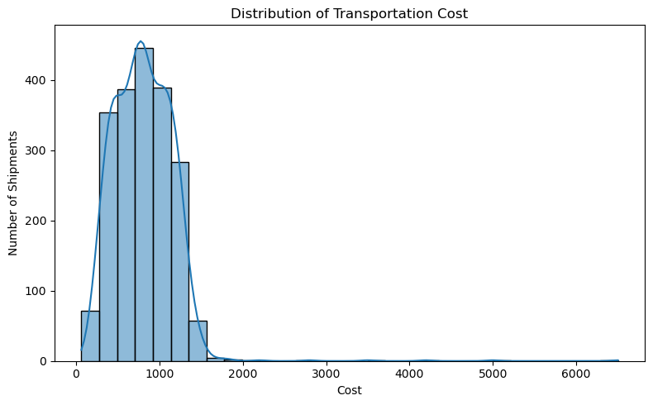
Figure 3. Distribution of transportation cost.
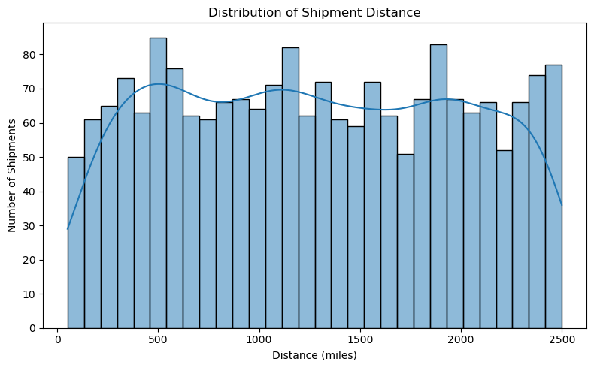
Figure 4. Distribution of shipment distance.
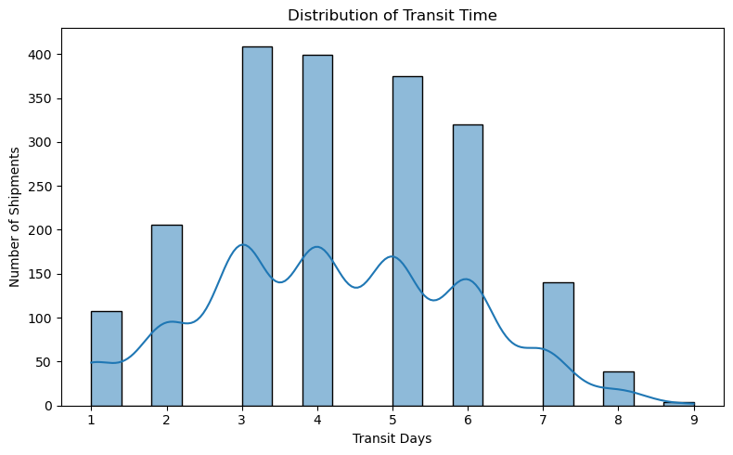
Figure 5. Distribution of transit time.

8. Correlation Analysis
A correlation matrix was used to examine linear relationships among weight, cost, distance, and transit time. Correlation values range from -1 to +1, where values closer to +1 indicate stronger positive linear association.
Variable Pair | Correlation | Interpretation
Distance vs Transit Days | 0.824 | Strong positive relationship
Cost vs Distance | 0.797 | Strong positive relationship
Cost vs Transit Days | 0.650 | Moderate-to-strong positive relationship
Weight vs Cost | 0.091 | Very weak positive relationship
Weight vs Distance | -0.019 | Negligible relationship
Weight vs Transit Days | -0.027 | Negligible relationship
The strongest relationship is between distance and transit days (0.824), indicating that longer routes are generally associated with longer transit times. Cost and distance also show a strong positive relationship (0.797), suggesting that route length is a major cost driver in this dataset. Cost and transit days have a positive correlation of 0.650, while shipment weight has only weak relationships with the other numeric measures. Correlation indicates association rather than causation, so these results should be used as analytical evidence rather than proof of a causal relationship.
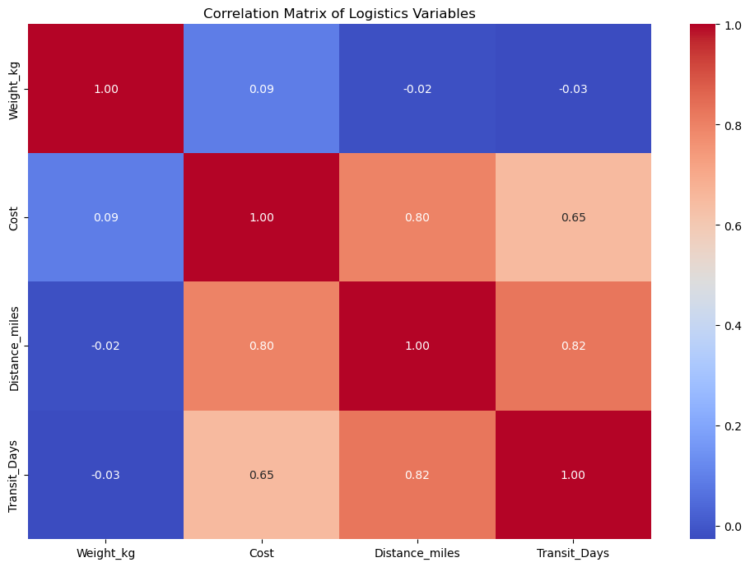
Figure 6. Correlation heatmap of logistics variables.
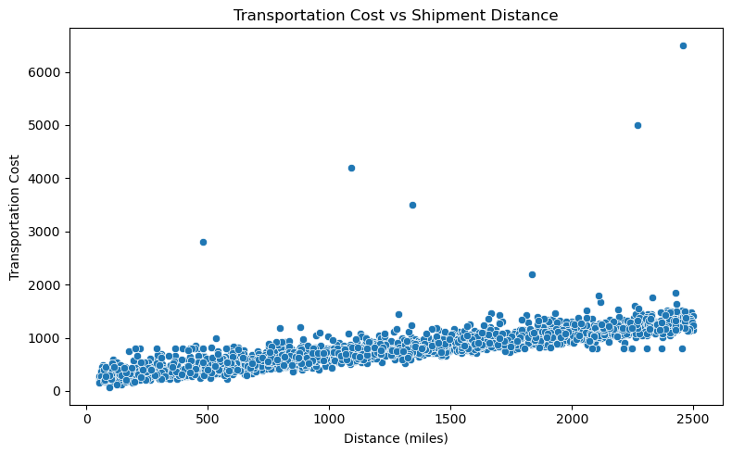
Figure 7. Transportation cost vs shipment distance.
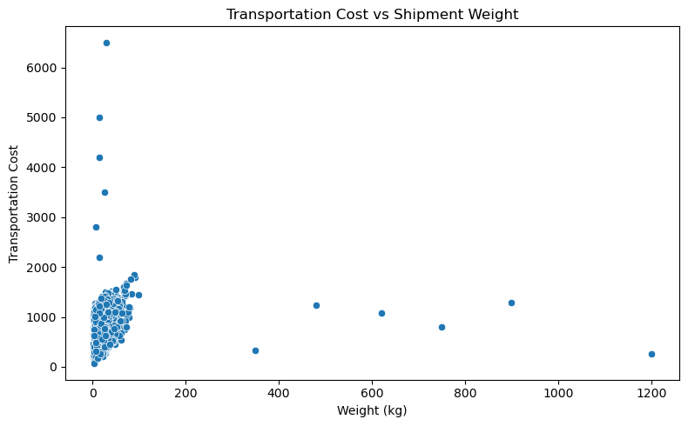
Figure 8. Transportation cost vs shipment weight.
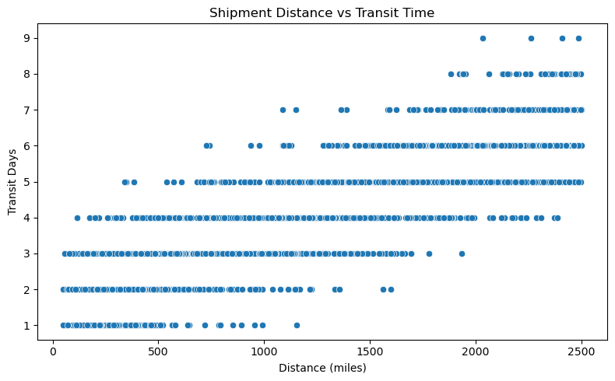
Figure 9. Shipment distance vs transit time.
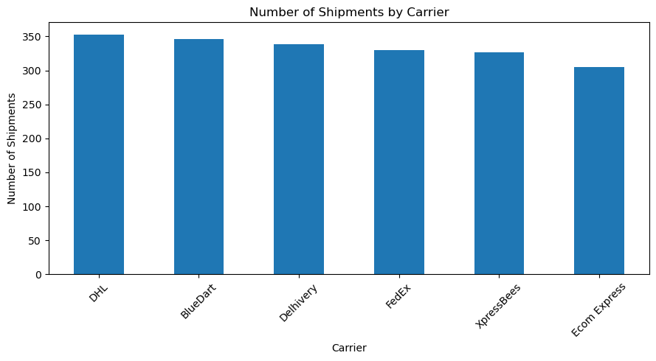
Figure 10. Shipment volume by carrier.

9. Carrier Analysis
Carrier-level analysis was performed to compare shipment volume and average transportation cost. DHL is the most frequent carrier in the dataset, and the overall analysis identifies meaningful differences in average cost between carriers.
Carrier | Average Cost
BlueDart | 828.61
FedEx | 816.15
Delhivery | 812.76
Ecom Express | 802.36
XpressBees | 792.81
DHL | 789.98
BlueDart has the highest average transportation cost among the listed carriers at 828.61, while DHL has the lowest at 789.98. The difference does not by itself establish that one carrier is universally better or worse, because route mix, distance, shipment characteristics, and service requirements can influence cost.

10. Origin Warehouse and Destination Analysis
The origin-warehouse analysis shows Ahmedabad_Warehouse as the most frequently used origin warehouse, with 353 shipments. Destination analysis identifies Kolkata and Jaipur as the two most frequent destinations, with 192 shipments each. The top ten destinations are shown below.
Destination | Shipments
Kolkata | 192
Jaipur | 192
Chennai | 181
Nashik | 175
Surat | 174
Hyderabad | 169
Nagpur | 164
Pune | 160
Delhi | 152
Mumbai | 149

11. Operational Insights
- Route distance is a key operational factor. Its strong relationship with transit time (0.824) indicates that route planning and distance management can materially affect delivery duration.
- Distance is also strongly associated with transportation cost (0.797), making route length an important cost-management consideration.
- The dataset contains 292 delayed shipments. This represents a substantial group for operational monitoring even though delivered shipments are the majority.
- Shipment weight shows much weaker linear relationships with cost, distance, and transit time than distance does. This suggests that route characteristics may be more influential than weight alone in this dataset.
- Ahmedabad_Warehouse has the highest shipment volume, which may warrant attention to capacity planning and workload balancing.
- Kolkata and Jaipur have the highest destination volumes at 192 shipments each, making them important destinations for route and service monitoring.
- The very high maximum shipment weight of 1,200 kg compared with the median of 18.5 kg indicates extreme variability. Such observations should be reviewed before building predictive models.

12. Recommendations
- Prioritize route optimization for long-distance shipments because distance is strongly associated with both cost and transit duration.
- Monitor delayed shipments by carrier, route, and destination in future analysis to identify specific bottlenecks rather than relying only on overall delay counts.
- Use carrier-level cost comparisons together with route distance and shipment characteristics before making carrier allocation decisions.
- Review high-weight shipments separately because extreme weights can distort averages and may require different handling or transportation arrangements.
- Monitor Ahmedabad_Warehouse capacity and workload because it has the highest shipment volume in the analyzed dataset.
- Develop route-level KPIs such as cost per mile, average transit time, and delay rate in future iterations to support more detailed operational decision-making.

13. Python Methodology and Tools
The analysis was implemented in Jupyter Notebook using Python. Pandas was used for data loading, aggregation, descriptive statistics, grouping, and validation. NumPy supported numerical operations. Matplotlib and Seaborn were used to generate histograms, bar charts, scatter plots, and the correlation heatmap. The notebook follows a reproducible workflow: load the cleaned dataset, inspect structure and quality, calculate statistics, visualize distributions and relationships, and summarize logistics KPIs.
df = pd.read_csv("logistics_shipment_data_cleaned.csv")
df.describe()
df.isnull().sum()
df.duplicated().sum()
correlation_matrix = df[numeric_columns].corr()
df.groupby("Carrier")["Cost"].mean().sort_values(ascending=False)

14. Conclusion
The Week 3 analysis demonstrates how exploratory data analysis and visualization can convert shipment records into actionable logistics information. The cleaned dataset contains complete and non-duplicated records, providing a reliable basis for analysis. The main analytical finding is that distance has strong positive relationships with both transit time and transportation cost, making route characteristics a key focus for operational planning. Carrier, warehouse, destination, and shipment-status analyses add further context for understanding logistics performance.
Overall, the analysis supports a data-driven approach to logistics decision-making. Future work can extend this project by introducing route-level delay analysis, cost-efficiency metrics, time-series trends, and predictive modeling for delivery delays and transportation costs.

15. Project Deliverables
- Week 3 Jupyter Notebook: logistics_week3_advanced_analysis.ipynb
- Week 3 Word Report: Week_3_Advanced_Data_Analysis_Report.docx
- Input dataset: logistics_shipment_data_cleaned.csv from Week 2

