INFOSYS SPRINGBOARD INTERNSHIP 7.0
SUPPLY CHAIN VISIBILITY & OPTIMIZATION
MILESTONE 2 – PROJECT REPORT
Exploratory Data Analysis • KPI Questions • DAX Measures • Power BI Dashboards
INTERNSHIP DOMAIN: DATA VISUALIZATION
Milestone 2 documents the transformation of supply-chain data into measurable KPIs, interactive Power BI dashboards, business insights and optimization recommendations.

Milestone 2 at a Glance
Stage | Focus | Outcome
01 | EDA | Understand patterns, relationships and analytical opportunities.
02 | KPI Questions | Convert observations into measurable business questions.
03 | DAX | Implement reusable KPI calculations in Power BI.
04 | Dashboards | Present supply-chain, product and supplier performance.
05 | Insights | Interpret results and recommend improvement actions.
Prepared for Infosys Springboard Internship 7.0 | August 2026

1. Exploratory Data Analysis (EDA)
Complete EDA process used as the analytical foundation for Milestone 2
Exploratory Data Analysis is the process of examining, summarizing, cleaning, visualizing and analyzing data to understand its structure, patterns, anomalies and relationships. In this project, EDA connects the supply-chain dataset with the KPI questions used later in Power BI.
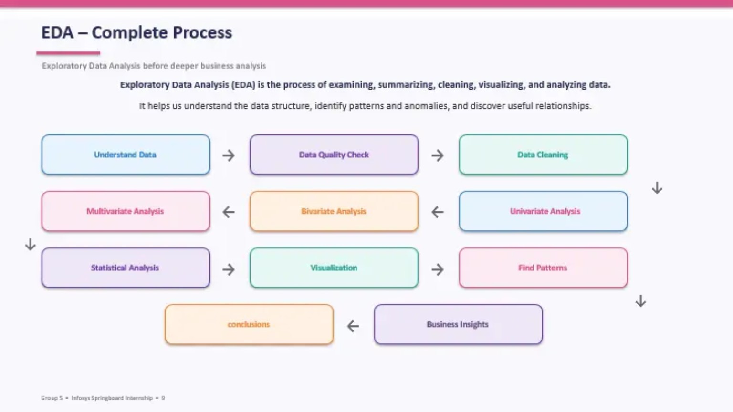
Figure 1. EDA – Complete Process from data understanding to business insights.

How the EDA supports this project
• Data understanding and quality checks establish confidence in the variables used for analysis.
• Univariate, bivariate and multivariate analysis helps compare individual measures and relationships.
• Visualization and pattern identification reveal useful supply-chain performance signals.
• Business insights and conclusions from EDA guide the selection of relevant KPI questions.

2. KPI Questions & DAX Measures
Turning analytical observations into measurable supply-chain performance indicators

2.1 KPI Questions
The Milestone 2 analysis focuses on questions that help management monitor inventory, revenue, fulfillment, delivery, products and suppliers.
Business Area | KPI Question | Decision Use
Inventory | What is the total inventory and inventory value? | Monitor stock position and capital tied in inventory.
Fulfillment | How effectively are ordered quantities being shipped? | Measure fulfillment performance.
Delivery | How do shipping and delivery times perform? | Identify logistics delays and service gaps.
Product | Which product types show stronger performance? | Support product-level decisions.
Supplier | Which suppliers contribute more inventory/value? | Support supplier comparison and review.
Revenue | How does generated revenue vary by product type? | Understand financial contribution.

2.2 DAX Measures
Measure | DAX Logic | Purpose
Total Orders | COUNTROWS(Sheet1) | Overall order volume
Fulfillment Rate | DIVIDE(SUM(Quantity Shipped), SUM(Quantity), 0) × 100 | Shipment effectiveness
Inventory Value | SUMX(Sheet1, (Quantity − Quantity Shipped) × Unit Price) | Value of remaining stock
Inventory Turnover | COGS ÷ Average Inventory | Inventory efficiency
Average Delivery Time | Total Delivery Time ÷ Number of Deliveries | Delivery performance
On-Time Delivery Rate | On-Time Deliveries ÷ Total Deliveries × 100 | Service reliability

Why DAX is important
DAX measures provide consistent, reusable calculations that respond to filters and visual context in Power BI. This allows the same KPI definition to support different dashboard views.

3. Power BI Dashboard 1 – Supply Chain KPIs
Actual project dashboard used for Milestone 2 analysis
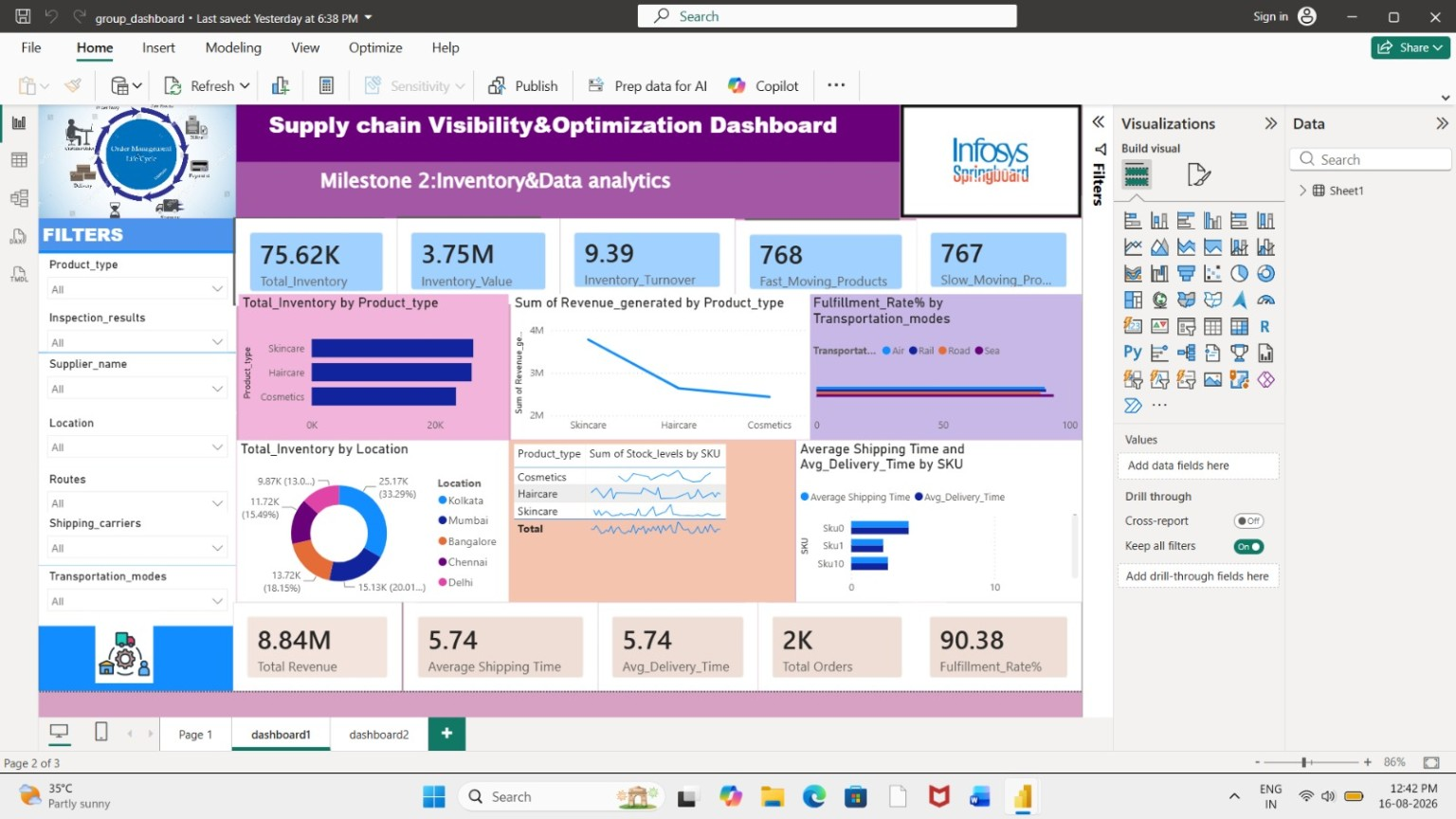
Figure 2. Supply Chain Visibility & Optimization Dashboard – Milestone 2 Inventory & Data Analytics.

Dashboard 1 – What it communicates
• The top KPI cards summarize Total Inventory, Inventory Value, Inventory Turnover, Fast-Moving Products and Slow-Moving Products.
• Revenue is compared across product types, while fulfillment rate is analyzed across transportation modes.
• Inventory is examined by location and product/SKU, giving a geographical and product-level view.
• Shipping and delivery time visuals help identify logistics performance differences.
• Interactive filters allow analysis by product type, inspection result, supplier, location, route, shipping carrier and transportation mode.

4. Power BI Dashboard 2 – Product & Supplier Analysis
Detailed product, supplier, quality and logistics analysis
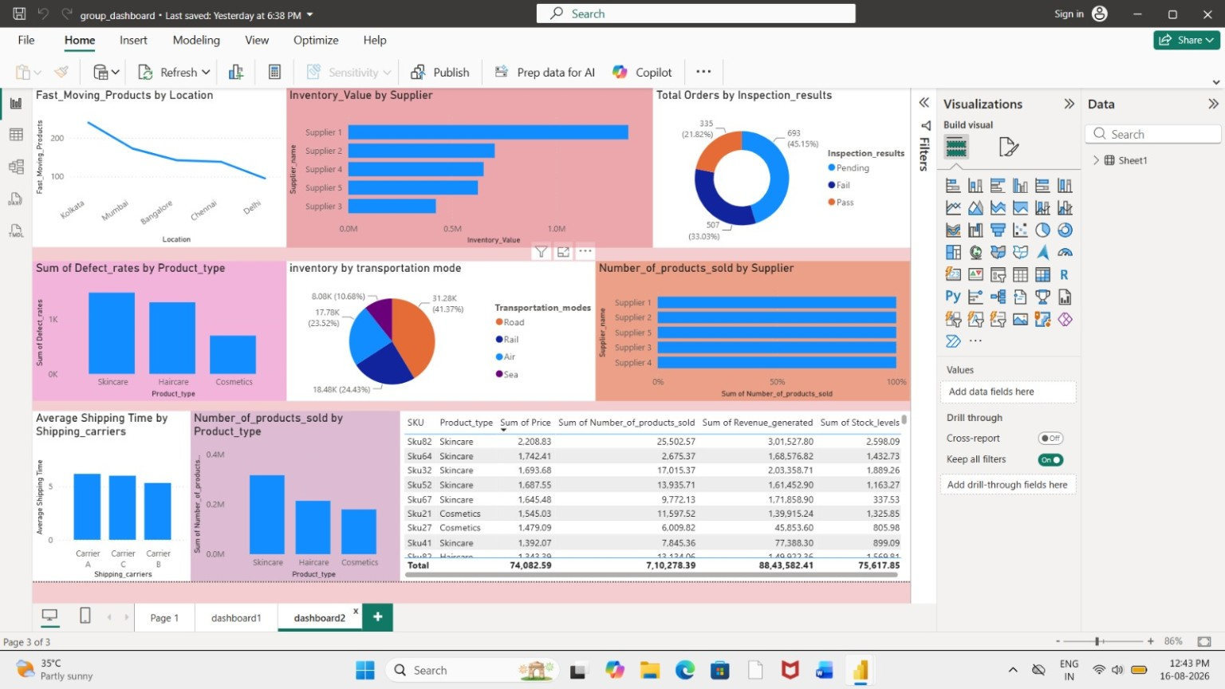
Figure 3. Product & Supplier Analysis Dashboard – Milestone 2.

Dashboard 2 – What it communicates
• Fast-moving products are compared across locations to understand geographical demand patterns.
• Inventory value is compared by supplier to identify suppliers associated with higher inventory contribution.
• Inspection results show the distribution of Pending, Fail and Pass outcomes.
• Defect rates are compared across product types to identify quality-related differences.
• Inventory by transportation mode supports logistics analysis.
• Product and supplier tables provide detailed SKU-level values for price, products sold, revenue and stock levels.

5. Key Insights, Recommendations & Conclusion
Final interpretation of Milestone 2

5.1 Key Insights
• Inventory and inventory value are central indicators for supply-chain visibility and should be monitored together.
• Fast-moving and slow-moving product measures can support better inventory planning.
• Fulfillment rate and shipping/delivery time provide direct visibility into logistics effectiveness.
• Supplier-level inventory value comparison can reveal concentration and improvement opportunities.
• Inspection results and defect-rate comparisons provide a quality perspective alongside operational KPIs.
• Combining KPI cards, charts, filters and SKU-level detail supports both summary monitoring and deeper analysis.

5.2 Recommendations
• Monitor inventory levels and inventory value regularly to reduce both shortage and excess-stock risk.
• Use fast/slow-moving product analysis to improve stock allocation and replenishment decisions.
• Investigate transportation modes, carriers and locations with weaker delivery performance.
• Review suppliers with high inventory contribution together with quality and operational indicators.
• Use inspection and defect-rate results to prioritize quality improvement actions.
• Add automated KPI thresholds and trend alerts in future dashboard versions.

5.3 Conclusion
Milestone 2 successfully connects exploratory analysis with decision-oriented visualization. EDA establishes the analytical understanding, KPI questions define what needs to be measured, DAX converts those requirements into reusable measures, and Power BI dashboards communicate the resulting performance. The completed dashboards provide a practical foundation for improving inventory, fulfillment, logistics, product, supplier and quality decisions.
INFOSYS SPRINGBOARD INTERNSHIP 7.0 • MILESTONE 2 COMPLETE

