INFOSYS SPRINGBOARD VIRTUAL INTERNSHIP 7.0
SUPPLY CHAIN
VISIBILITY & OPTIMIZATION
MILESTONE 4 DOCUMENTATION
Developing • Optimizing • Testing • Deployment

Submitted By | Supriya
Group | 5
Milestone | 4

Professional project documentation for GitHub

1. Introduction
Milestone 4 represents the final stage of the Supply Chain Visibility & Optimization project. The focus is to transform the developed analytical dashboards into a refined, validated, reliable, and deployment-ready business intelligence solution.
The milestone covers warehouse efficiency reporting, an executive-level supply chain overview, dashboard performance optimization, and final testing, documentation, and deployment readiness. These activities strengthen the usability of the solution and support data-driven supply chain decision-making.
2. Milestone 4 Overview
The milestone is structured around four core activities: validation, documentation, refinement, and deployment.
01 | Validate | Verify KPIs and visuals so that the final dashboard is accurate, consistent, and reliable.
02 | Document | Capture the methods, metrics, dashboards, and insights as clear project evidence.
03 | Refine | Improve clarity, usability, navigation, and visual impact to create a simpler decision-making experience.
04 | Deploy | Move the solution from project work toward practical delivery and ready-to-use supply chain monitoring.
3. Warehouse Efficiency Reports
3.1 Warehouse Efficiency — Overview
The Warehouse Efficiency Overview provides a centralized view of inventory, fulfillment, orders, delivery, revenue, and defect performance across locations.
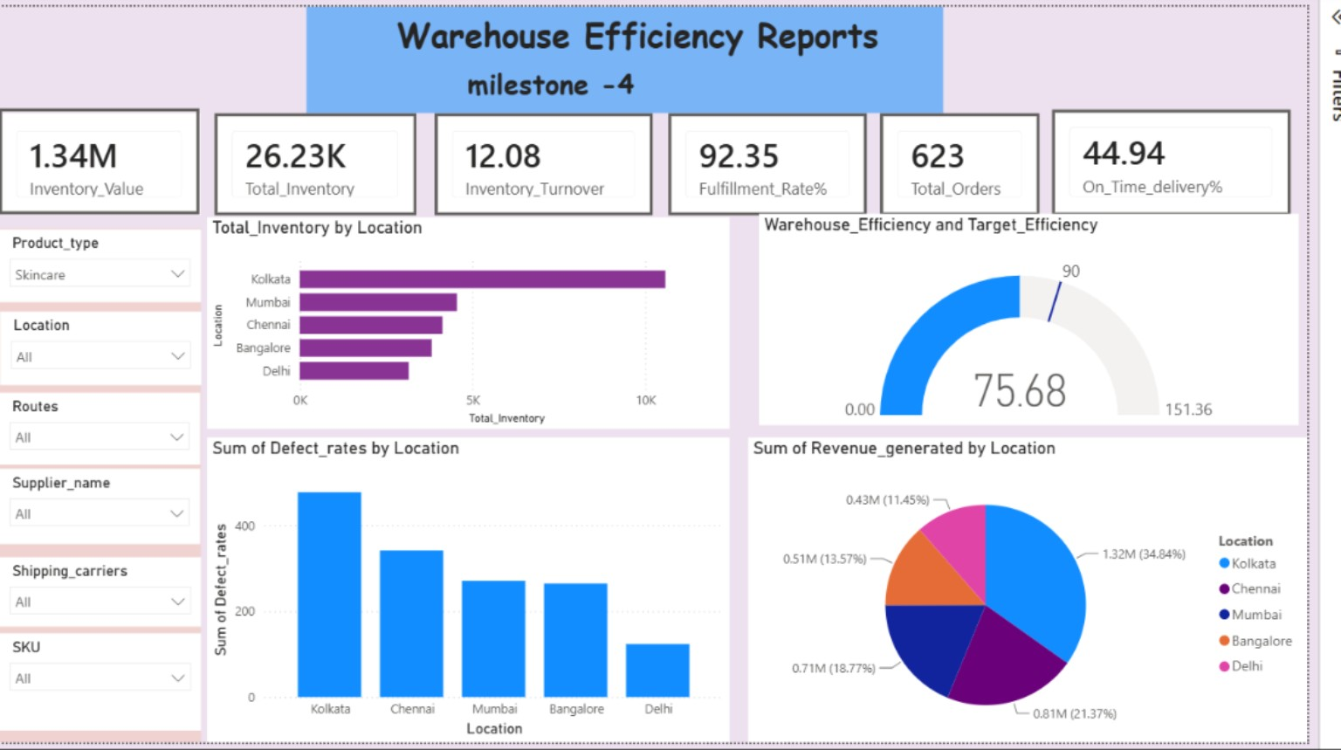
The dashboard supports comparison of inventory efficiency, revenue, defect rates, and fulfillment performance by location and other key supply chain dimensions.
Purpose
Identify efficiency gaps and provide a centralized view that supports data-driven supply chain decisions.

3.2 Warehouse Efficiency — Detailed Analysis
The detailed warehouse efficiency view provides deeper analysis of warehouse performance, shipping costs, product availability, and location-level performance.
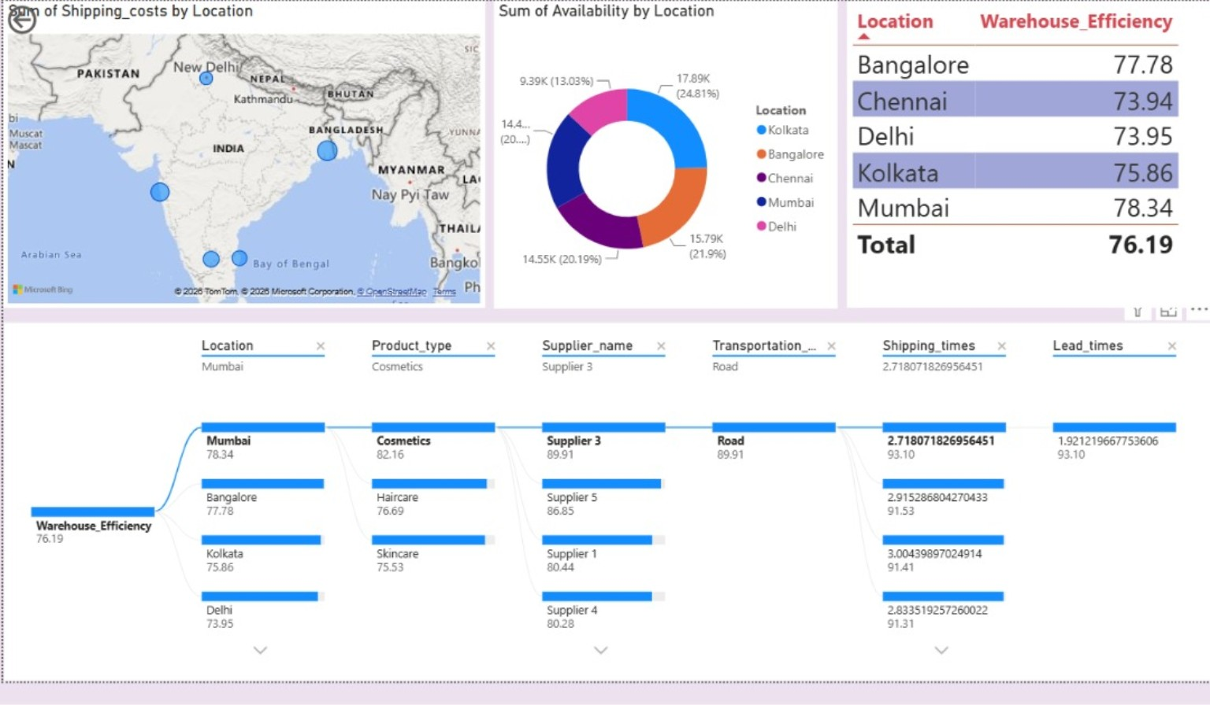
Users can drill down by product type, supplier, transportation mode, and shipping time to identify location-level and supply-chain factors affecting warehouse efficiency.
Purpose
Support better operational decisions by identifying the factors influencing warehouse efficiency.

4. Supply Chain Executive Overview
The Supply Chain Executive Overview brings major supply chain performance indicators together into a single analytical view covering sales, revenue, production, manufacturing, shipping, quality, and location.
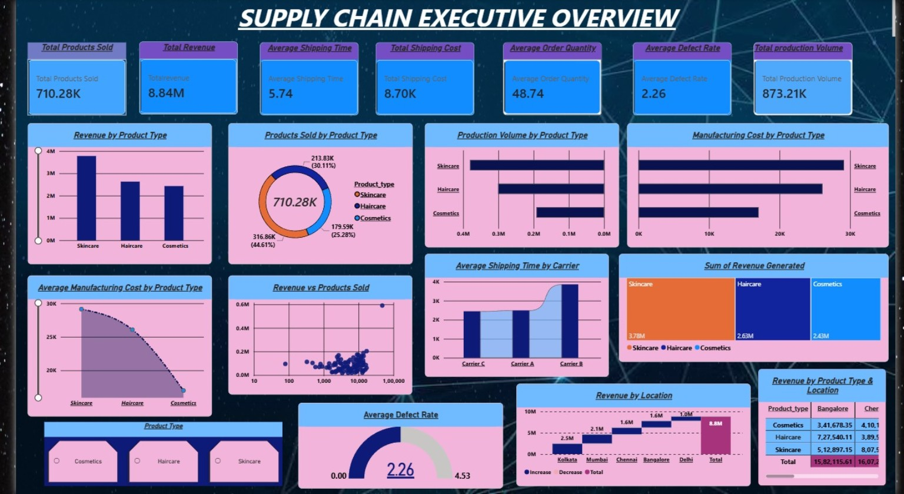
The dashboard enables comparison of product types, carriers, locations, shipping time, revenue, production volume, manufacturing cost, and defect rate.
Purpose
Provide an executive-level view of key supply chain KPIs to identify performance gaps and support data-driven decisions.

5. Dashboard Performance Optimization
Dashboard performance optimization focuses on improving clarity, usability, navigation, and the overall analytical experience of the Power BI solution.
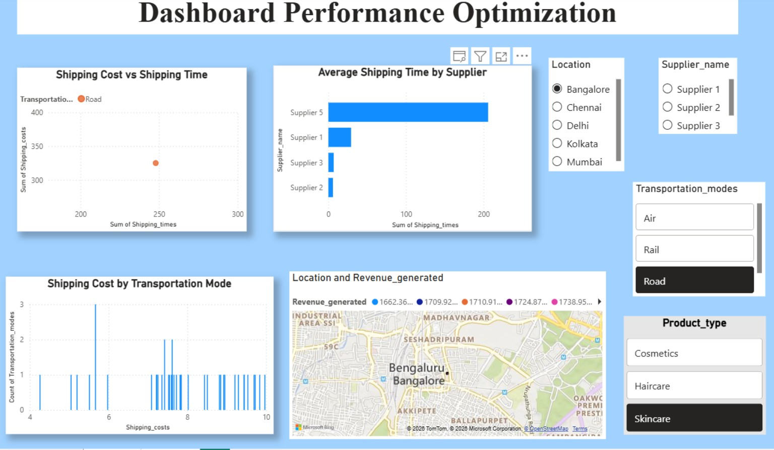
The optimized dashboard supports analysis of shipping cost, shipping time, supplier performance, transportation modes, revenue, location-level performance, and product types. Interactive filters help users examine cost–time relationships and compare supply chain dimensions efficiently.
Optimization Focus
Identify cost patterns, detect efficiency gaps, compare performance, and support faster supply chain decision-making.

6. Final Testing, Documentation & Deployment
The final stage ensures that the completed dashboard solution is accurate, consistent, reliable, and ready for practical use.
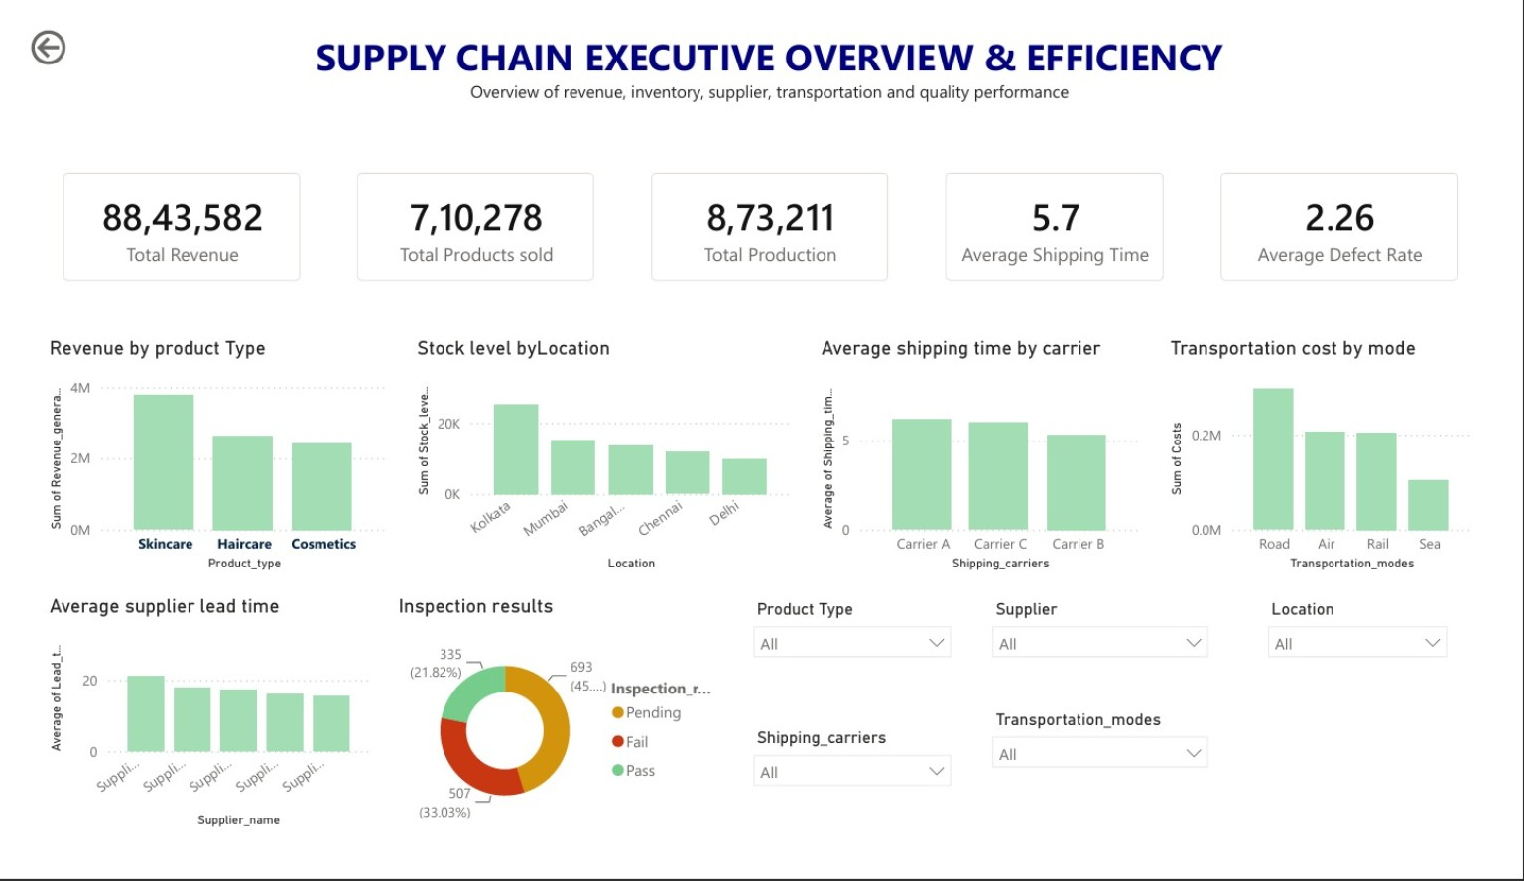
6.1 Final Testing
- KPI accuracy
- Visual consistency
- Data reliability
- Filter functionality
- Dashboard usability
- Overall analytical consistency
6.2 Documentation
The completed work is organized as clear project evidence covering the dashboards, analytical metrics, insights, findings, and recommendations.
6.3 Deployment Readiness
The final dashboard provides a centralized view of supply chain performance across revenue, products, production, inventory, shipping, suppliers, transportation, and quality. It is structured to support continued monitoring and data-driven decision-making.
7. Key Findings
- Supplier performance varies across sales contribution, stock levels, product contribution, and logistics indicators.
- Transportation costs differ across modes, locations, and carriers, highlighting major cost drivers.
- Shipping speed and transportation cost together reveal important route and carrier trade-offs.
- Integrated KPIs provide a consolidated view of operational performance and supply-chain bottlenecks.
8. Recommendations
- Continuously monitor supplier performance using multiple performance indicators.
- Review high-cost transportation routes and modes to identify optimization opportunities.
- Select routes and carriers by balancing shipping cost with delivery speed.
- Use interactive KPI dashboards for ongoing supply-chain performance monitoring.
Optimization Approach
Improve Visibility → Identify Bottlenecks → Optimize Decisions → Monitor Performance

9. Overall Key Insights & Impact
The combined dashboard analysis provides integrated insights into supplier performance, transportation costs, route and carrier performance, and overall KPI performance.
- Multi-metric supplier evaluation helps identify supplier strengths and improvement areas.
- Mode-, location-, and carrier-level transportation analysis helps identify major cost drivers.
- Combining shipping time and cost supports balanced route and carrier selection.
- Integrated KPIs provide a consolidated view of operational performance and supply-chain bottlenecks.
10. Future Scope
- Real-time supply chain data streaming and automated alerts.
- Predictive demand forecasting.
- Machine-learning-based supplier risk assessment.
11. Conclusion
Milestone 4 completes the final stage of the Supply Chain Visibility & Optimization project by bringing together warehouse efficiency reporting, executive-level analysis, dashboard optimization, testing, documentation, and deployment readiness.
The final Power BI solution provides a structured and interactive approach to understanding supply chain performance, identifying inefficiencies, and supporting reliable, data-driven decision-making.

