**Cloud Formation Bits:**

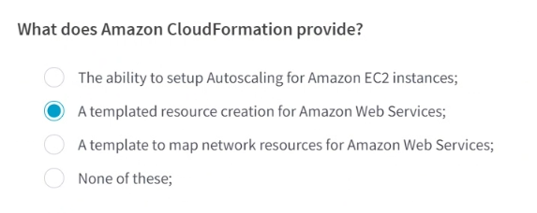

**CI-CD:**

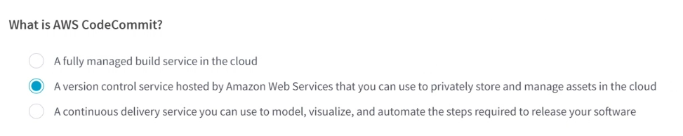

**Distributed Tracing and Monitoring**

**Serverless:**

