**MODULE-10**

**Sub-Task 1:**

**Step 1:**

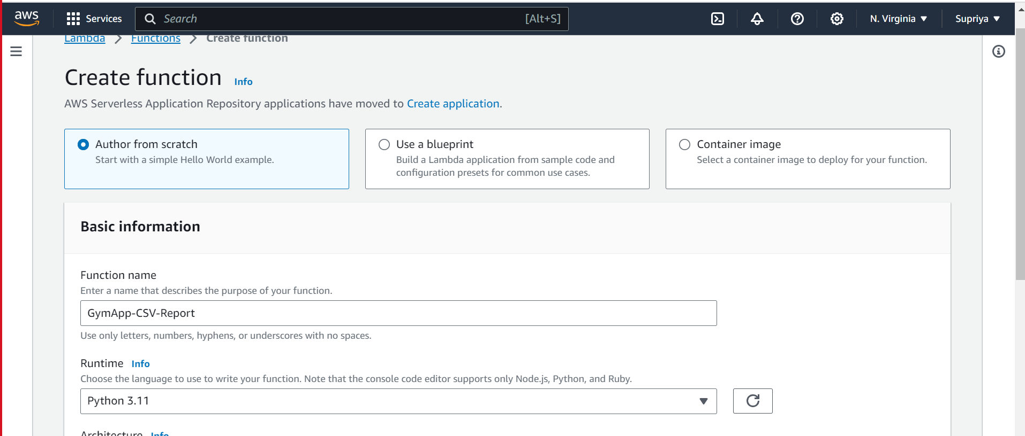

**Step 2 and 3:**

**Step 4:**

**Step 5:**

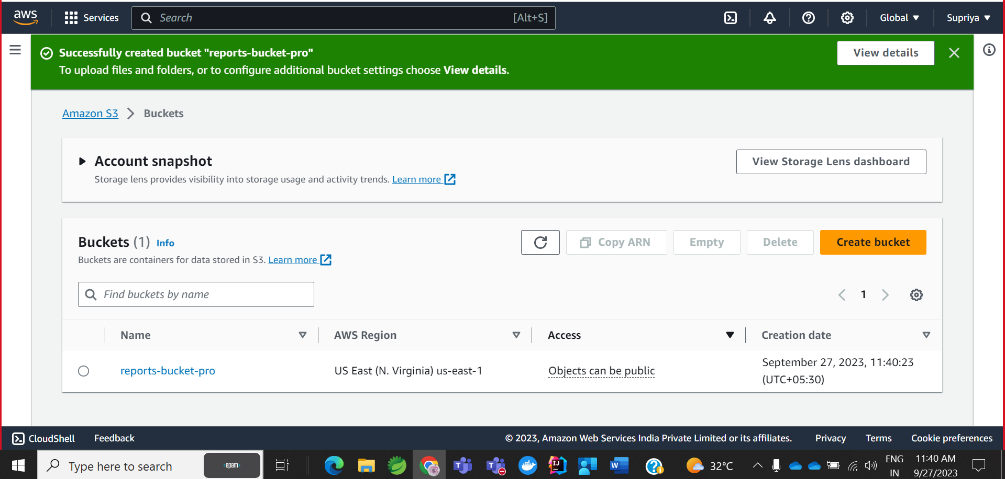

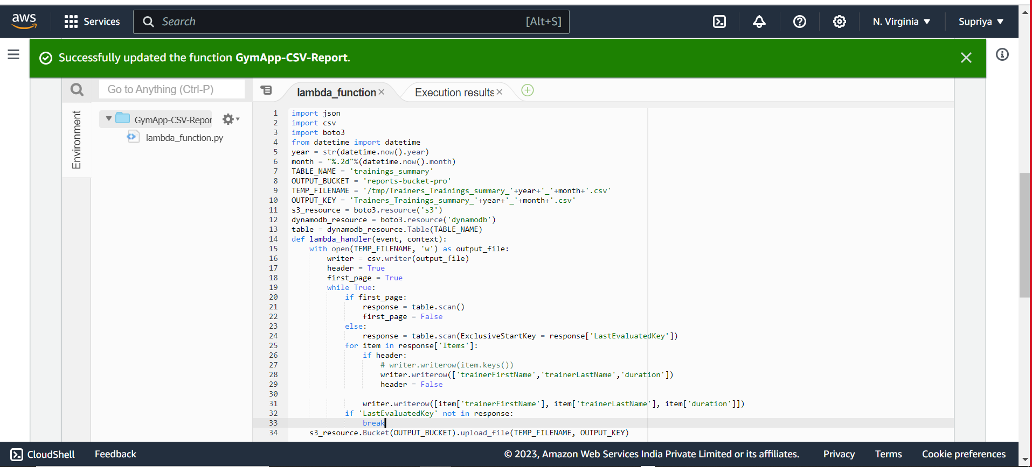

**Logs related to lambda:**



