**MODULE-11**

**Sub-Task 1:**

**Step 1:**

**Step 2:**

**Step 3:**

**Step 4:**

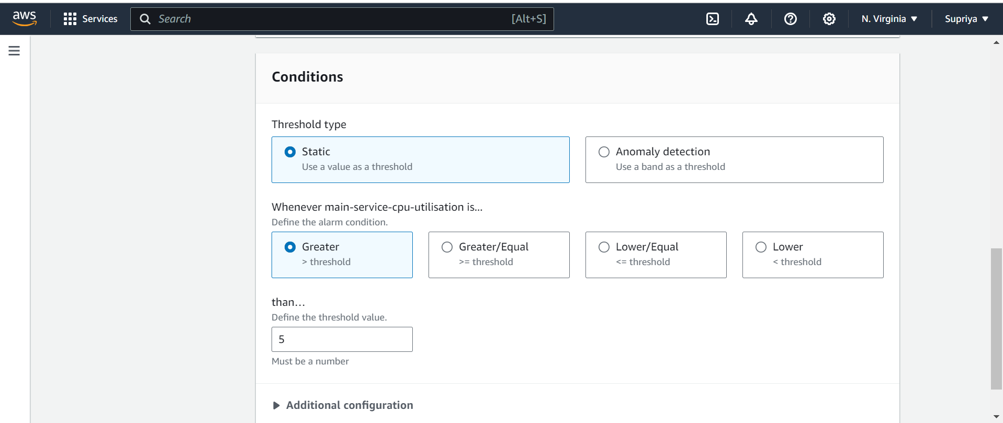

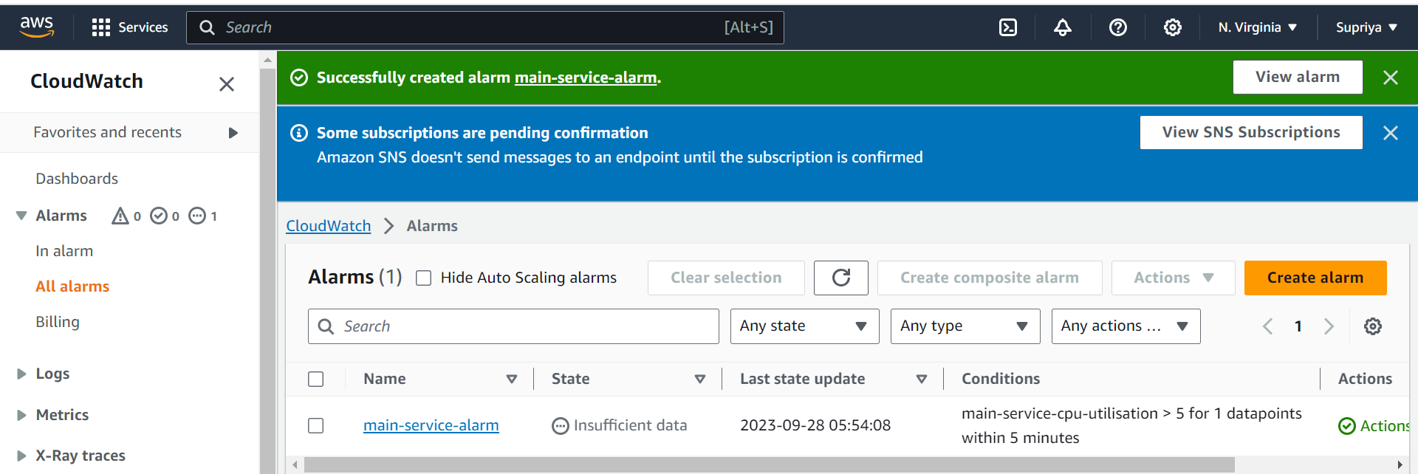

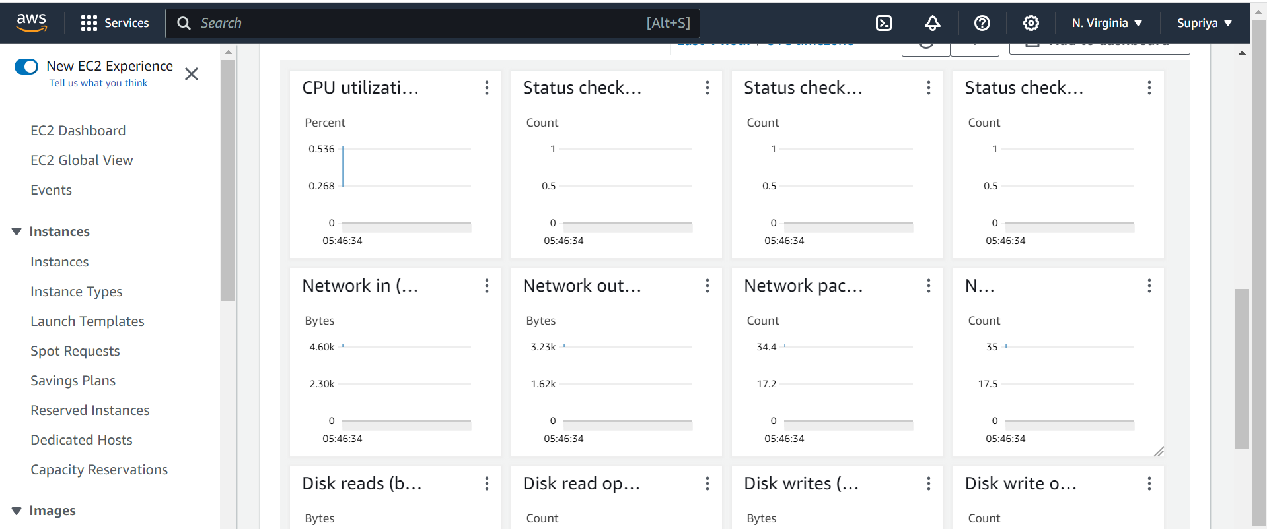

**Sub-Task 2:**

**Step 1:**

**Step 2:**

**Sub-Task 3:**

**Step 1:**

Integrating AWS CloudWatch with your system can provide valuable insights into the performance, availability, and health of your resources and applications. Here are some ways to integrate CloudWatch with your system:

1. **AWS SDKs and Command Line Tools**:

- Utilize AWS SDKs (Software Development Kits) available for various programming languages to programmatically interact with CloudWatch. This allows you to retrieve metrics, set up alarms, and perform various operations.

- Use AWS Command Line Interface (CLI) to interact with CloudWatch from the command line, allowing you to perform tasks like retrieving metrics and setting up alarms.

2. **Custom Metrics**:

- Publish custom metrics to CloudWatch using the AWS SDKs. This allows you to monitor specific application-level metrics that aren't available by default in AWS services.

3. **EC2 and On-Premises Instances**:

- Install and configure the CloudWatch agent on your EC2 instances or on-premises servers. This agent allows you to collect custom metrics, logs, and system-level metrics.

4. **AWS Lambda**:

- Add CloudWatch Logs integration to your AWS Lambda functions. This allows you to capture and analyze logs generated by your functions.

5. **Elastic Load Balancers (ELB)**:

- Integrate ELB with CloudWatch to monitor metrics related to request counts, latency, error rates, and more. You can set up alarms based on these metrics.

6. **RDS and DynamoDB**:

- Enable CloudWatch integration for Amazon RDS (Relational Database Service) instances and Amazon DynamoDB tables. This provides you with performance metrics for your databases.

7. **S3 Bucket Metrics**:

- Enable CloudWatch metrics for S3 buckets to monitor request counts, data transfer, and other relevant metrics.

8. **Auto Scaling Groups**:

- Monitor Auto Scaling groups by integrating them with CloudWatch. This allows you to track metrics related to instances, scaling activities, and overall group health.

9. **Amazon ECS and EKS**:

- Integrate Amazon Elastic Container Service (ECS) or Elastic Kubernetes Service (EKS) with CloudWatch to monitor container-level metrics, service health, and more.

10. **Elastic Beanstalk**:

- Elastic Beanstalk provides built-in integration with CloudWatch, allowing you to monitor application and environment metrics for your AWS Elastic Beanstalk applications.

11. **API Gateway**:

- Integrate Amazon API Gateway with CloudWatch to monitor API usage, error rates, and other relevant metrics.

12. **AWS CloudTrail**:

- Utilize AWS CloudTrail to monitor and log API calls made on your AWS account. CloudTrail logs can be used to generate CloudWatch alarms for specific events or patterns.

13. **Third-Party Integrations**:

- Leverage third-party tools and services that offer CloudWatch integration to enhance monitoring capabilities. Some monitoring and observability platforms have built-in CloudWatch support.

**Step 2:**

Integrating AWS CloudTrail with your system allows you to monitor and log AWS account activity. This can be crucial for security, compliance, and auditing purposes. Here are some ways to integrate CloudTrail with your system:

1. **S3 Bucket for CloudTrail Logs**:

- Choose an S3 bucket to store CloudTrail logs. Make sure the bucket is properly configured to receive and manage CloudTrail log files.

2. **Amazon CloudWatch Alarms**:

- Set up CloudWatch Alarms based on specific CloudTrail events. For example, you can create an alarm to trigger when a certain API call is made or when unauthorized access is detected.

3. **Amazon SNS Notifications**:

- Integrate CloudTrail with Amazon Simple Notification Service (SNS) to receive notifications about specific events. This can be useful for immediate alerts on critical activities.

4. **Amazon S3 Event Notifications**:

- Configure event notifications on the CloudTrail S3 bucket to automatically trigger actions (e.g., Lambda functions, notifications) when new log files are delivered.

5. **AWS Config Rules**:

- Use AWS Config to set up rules that evaluate the configuration of your AWS resources. These rules can be based on CloudTrail events, providing additional governance and compliance checks.

6. **AWS Lambda Functions**:

- Create AWS Lambda functions to process CloudTrail events. This can be used for custom processing, alerting, or for taking automated actions based on specific events.

7. **Third-Party Security Information and Event Management (SIEM) Systems**:

- Many SIEM solutions have the capability to ingest CloudTrail logs directly. Integrate CloudTrail with your SIEM to perform advanced security analysis, threat detection, and compliance reporting.

8. **AWS Glue for Data Transformation**:

- Use AWS Glue to process and transform CloudTrail log data. This can be helpful for data warehousing, data analytics, or for generating custom reports.

9. **Amazon Athena for Querying Logs**:

- Use Amazon Athena to run SQL-like queries on CloudTrail log data stored in your S3 bucket. This can be useful for ad-hoc analysis and investigations.

10. **Custom Log Processing Pipelines**:

- Build custom log processing pipelines using services like AWS Kinesis, AWS Lambda, and Amazon Elasticsearch to aggregate, analyze, and visualize CloudTrail log data.

11. **Automated Remediation**:

- Leverage CloudTrail events to trigger automated remediation actions using services like AWS Systems Manager Automation, AWS Step Functions, or AWS Lambda.

12. **Compliance and Governance Dashboards**:

- Utilize tools like AWS Config and AWS Security Hub to create compliance and governance dashboards that incorporate CloudTrail data.

13. **Security Information and Event Management (SIEM) Tools**:

- Integrate CloudTrail with SIEM tools like Splunk, Sumo Logic, or others that offer support for AWS services.

Remember to configure appropriate IAM roles and permissions for your systems to interact with CloudTrail logs securely. This ensures that your systems have the necessary permissions to access and process the log data effectively.