Task 1:

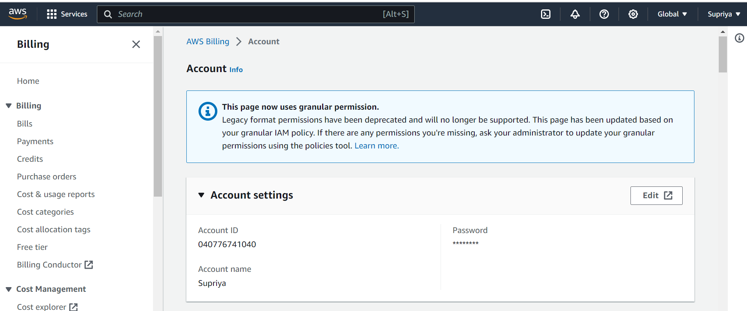

Task 2:

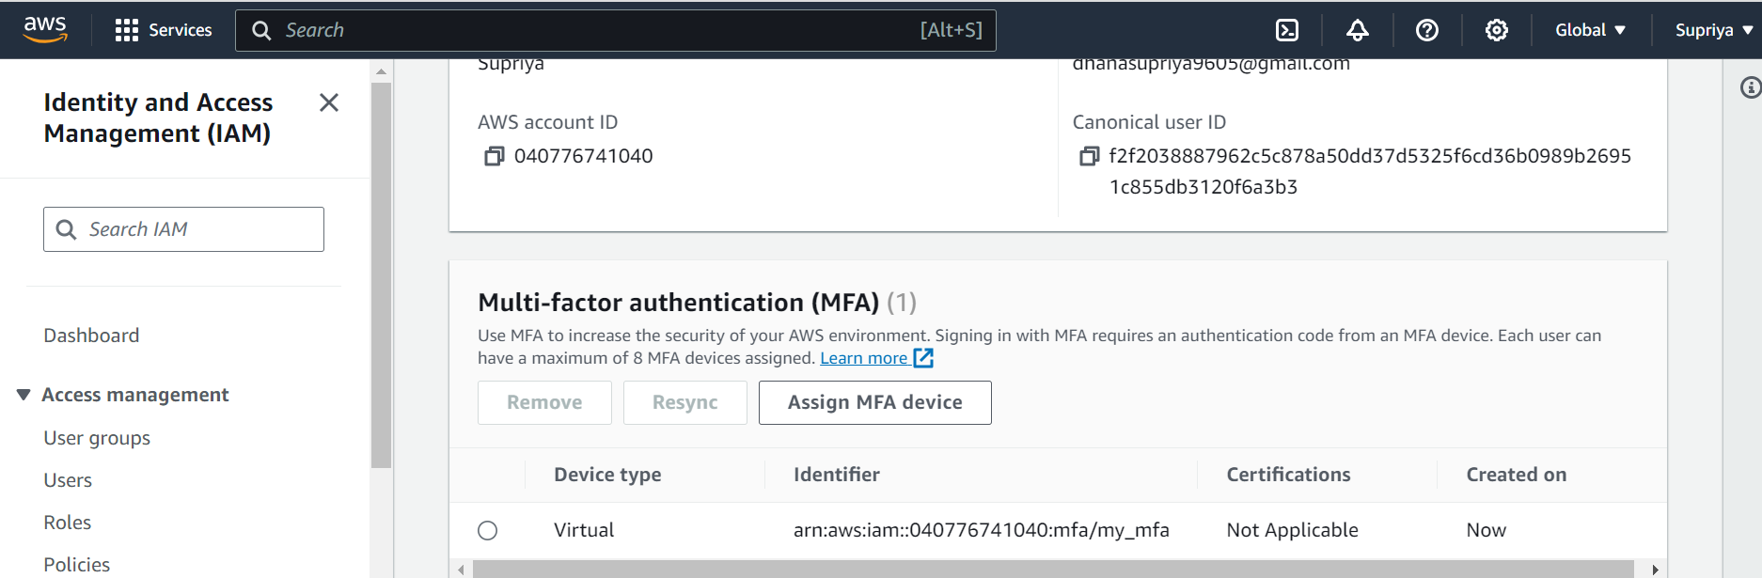

Task 3:

Task 4:

Deny Policy:

Allow Policy:

