Task 1:

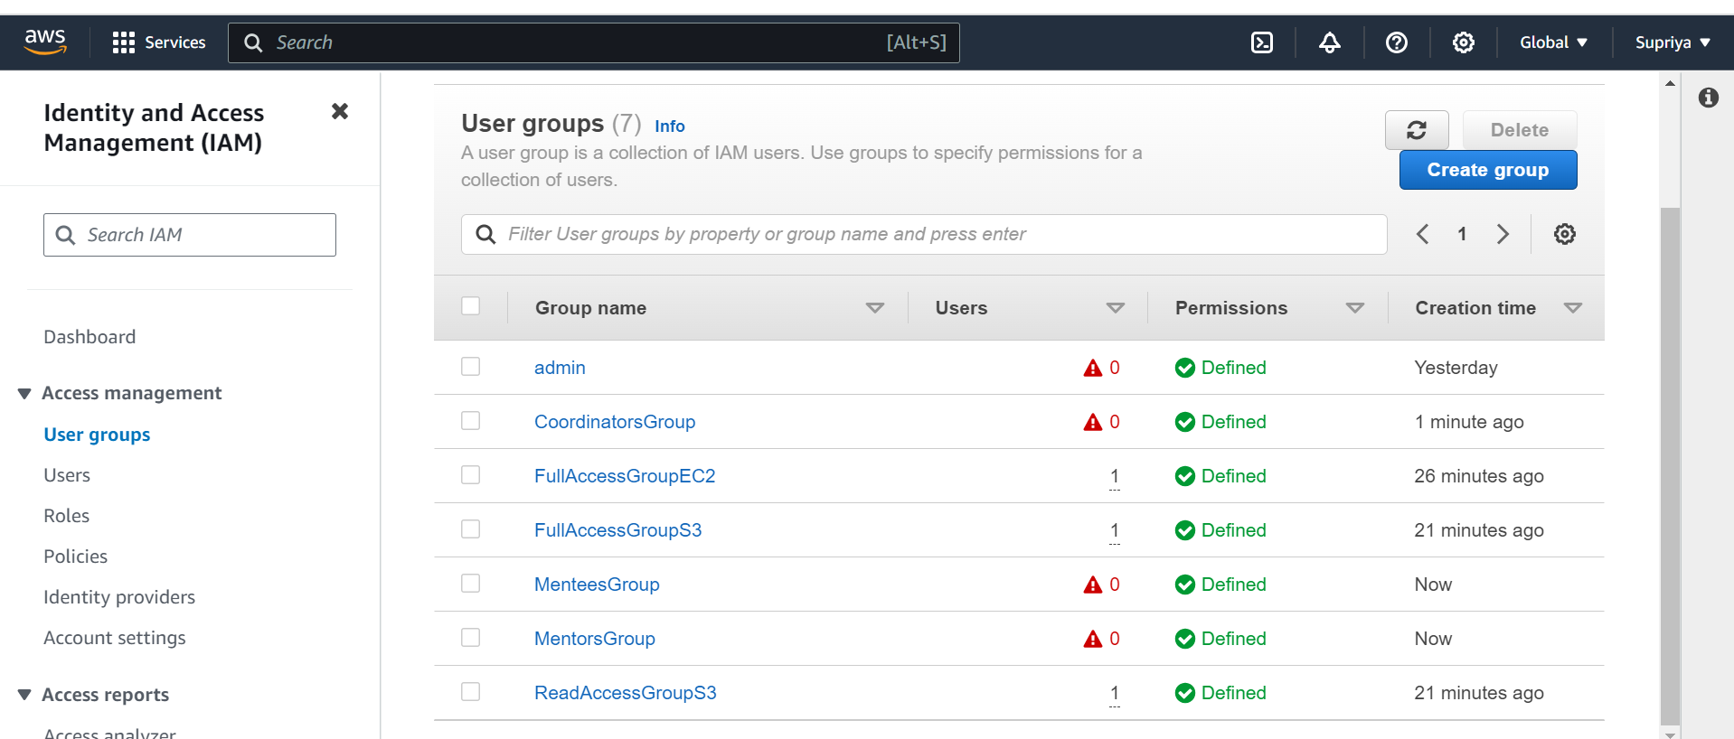

Task 2:

Custom Policies:

Roles:

Users:

User Groups:

