**MODULE-5**

**Task 1 :**

**Before Step 1:**

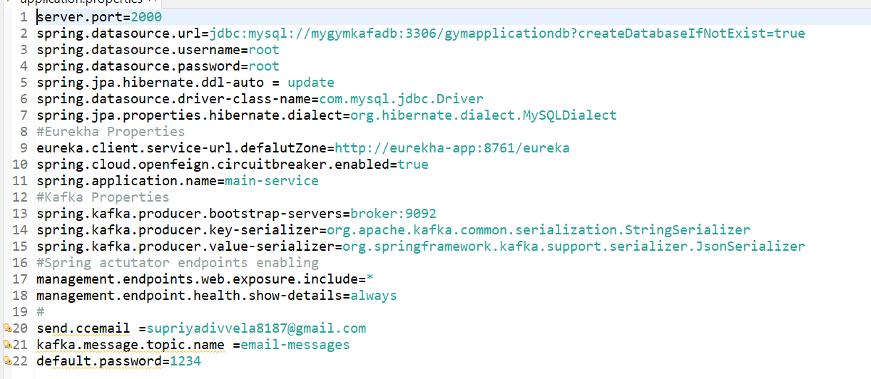

**After Step 1:**

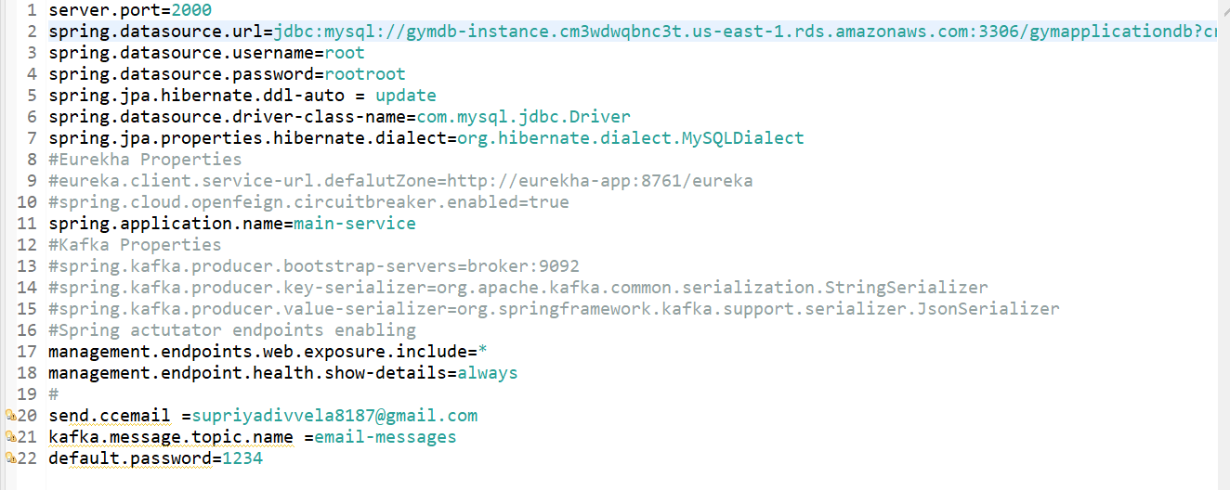

**Step 2:**

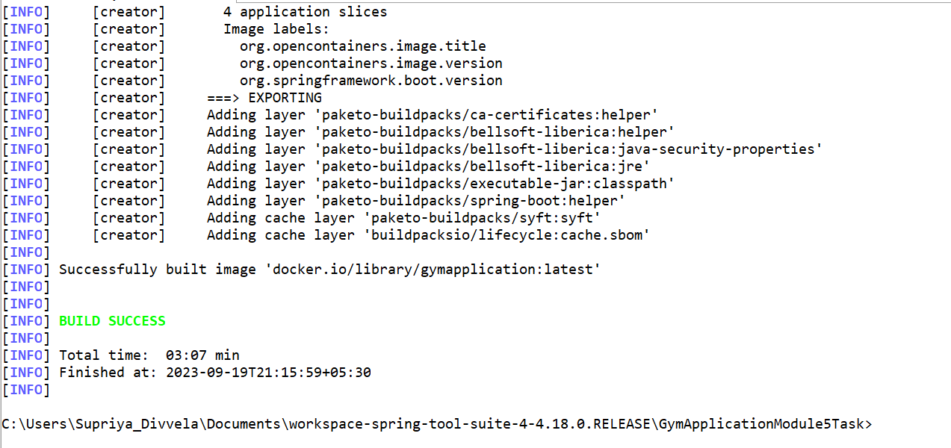

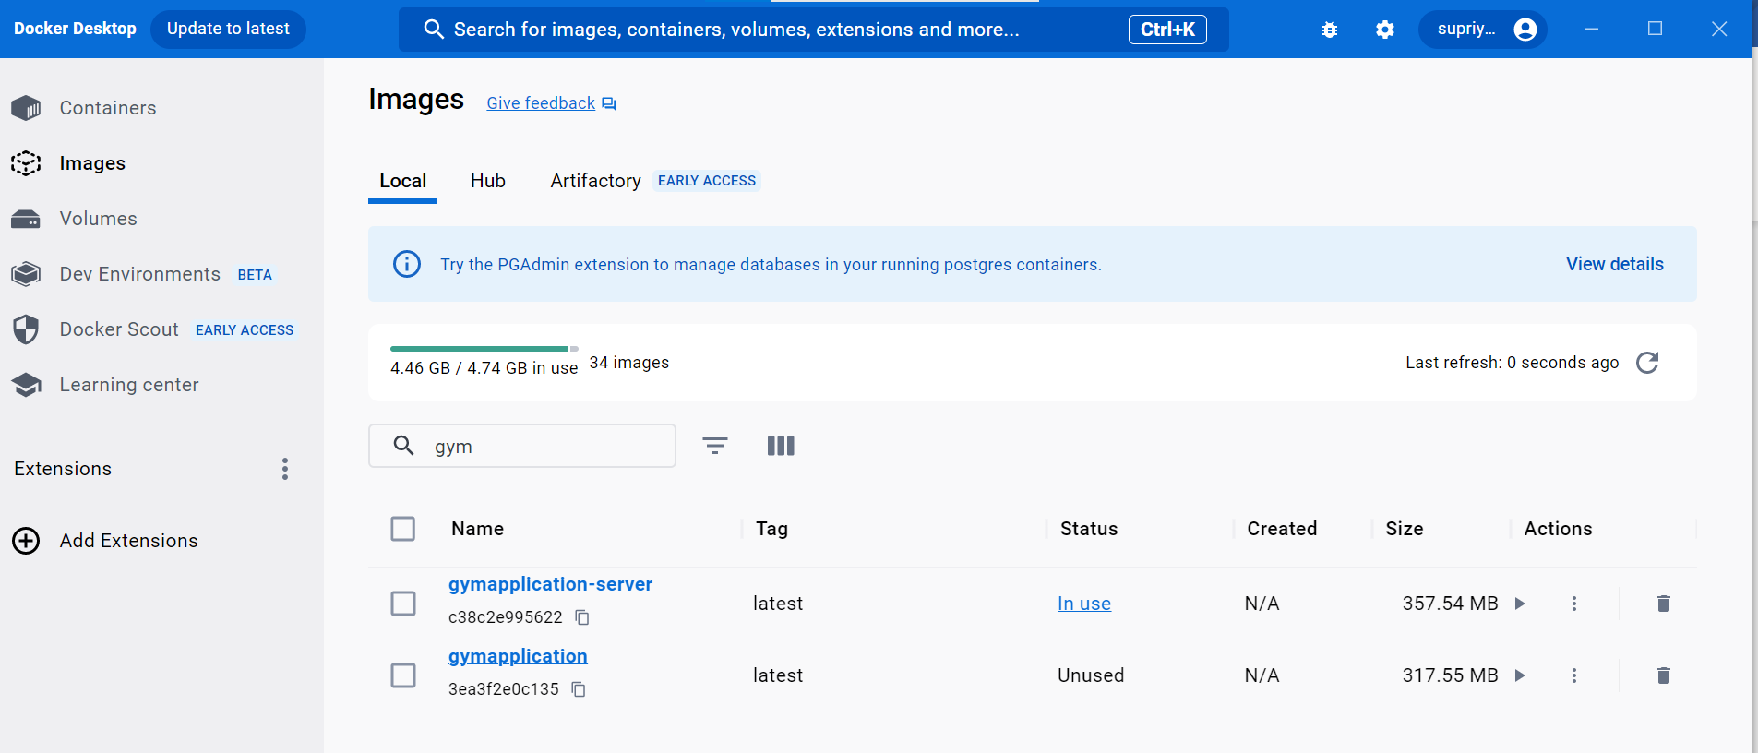

**Step 3:**



**Step 4:**

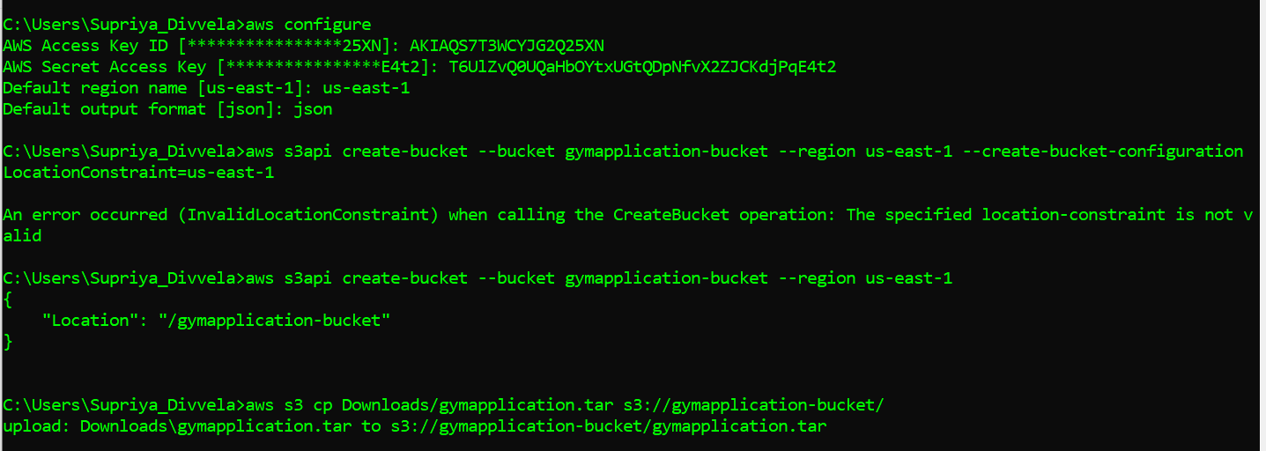

**Before Upload:**

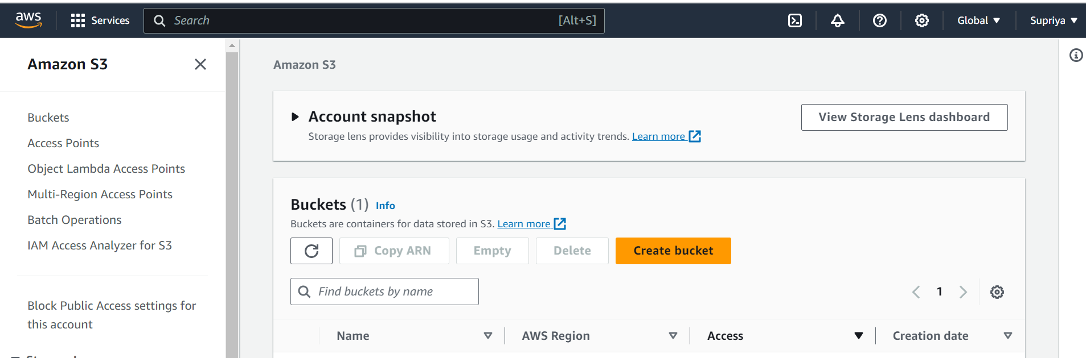

**After Upload:**

**Task 2:**

**Step 1:**

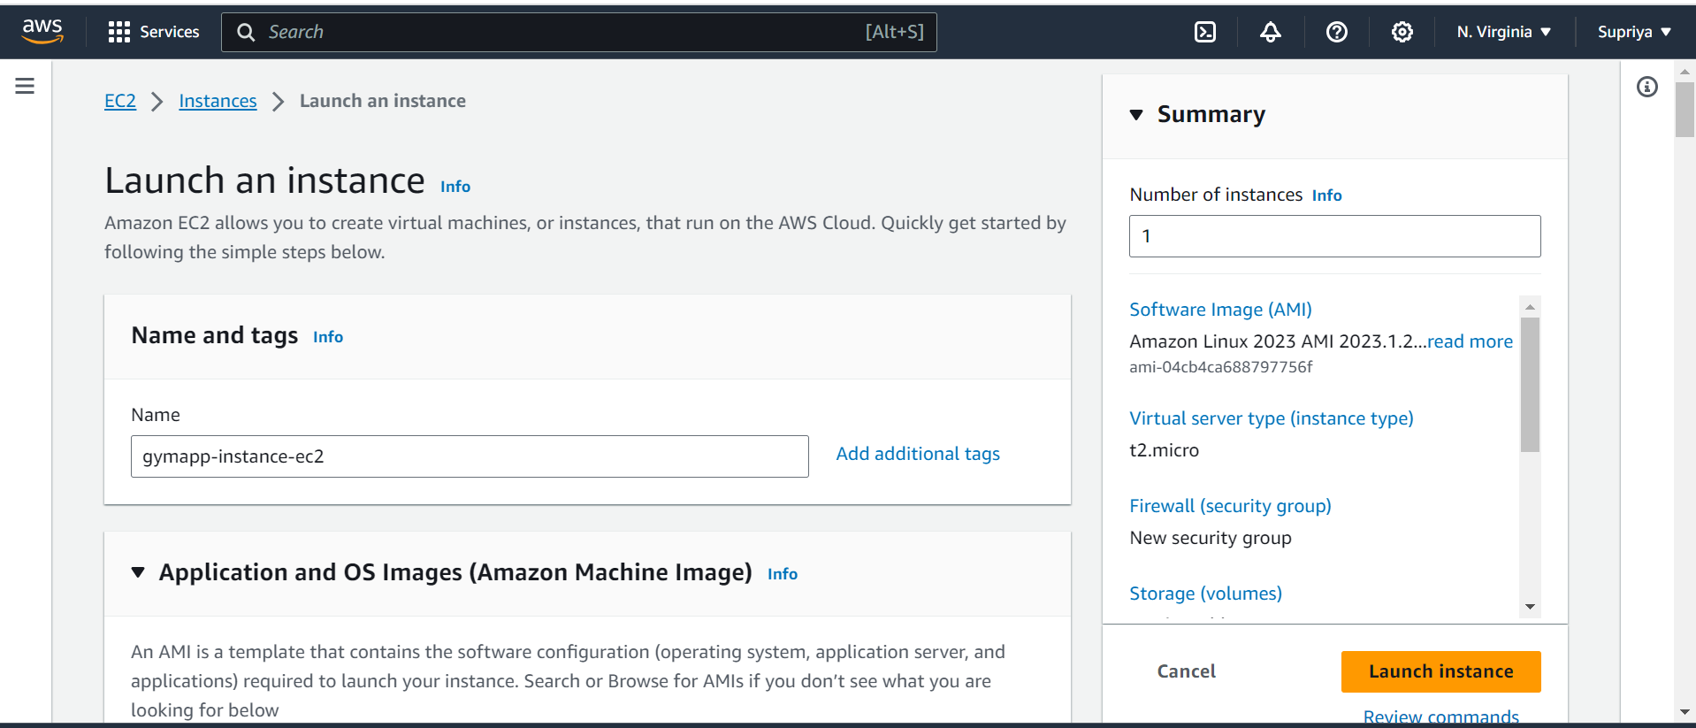

**Step 2:**

**Step 3:**

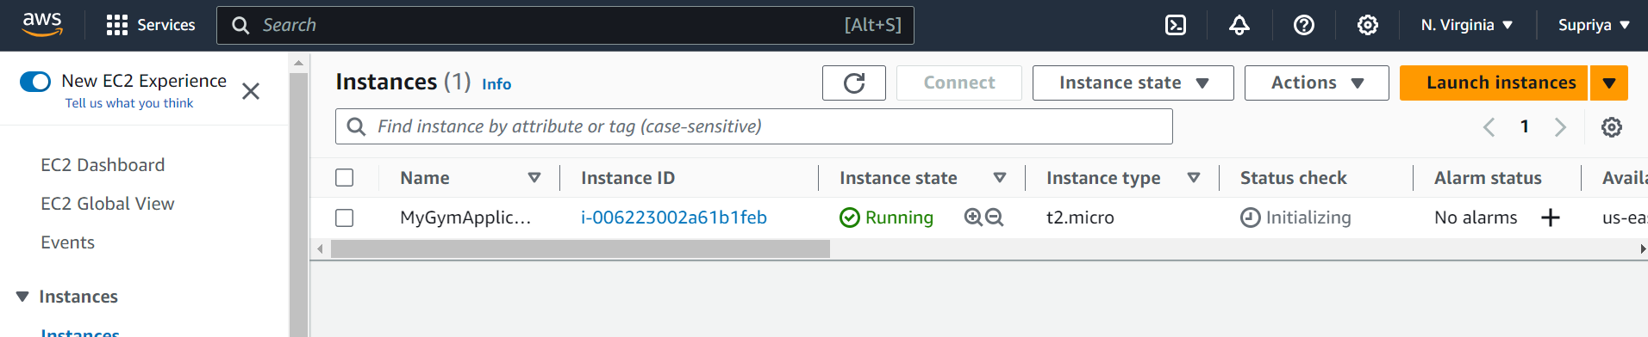

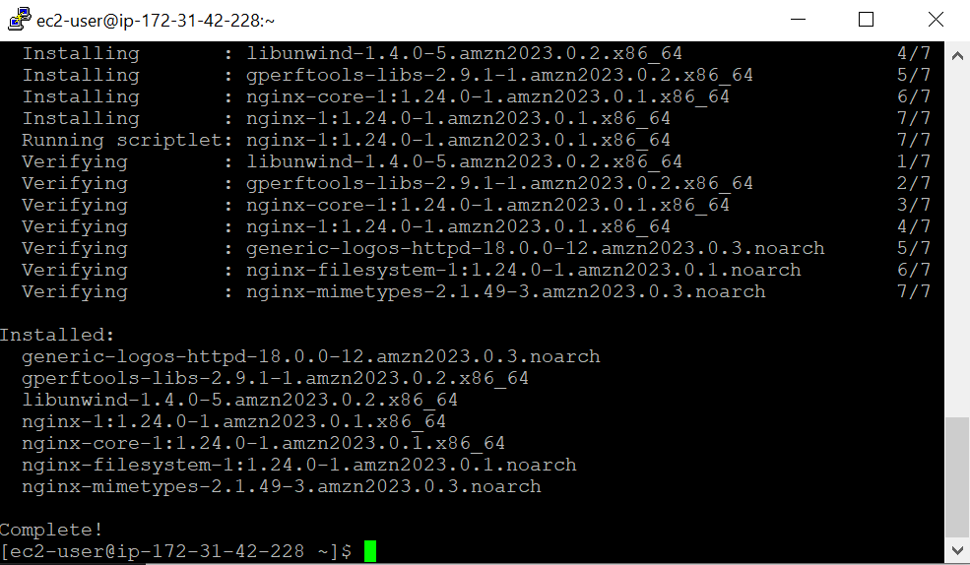

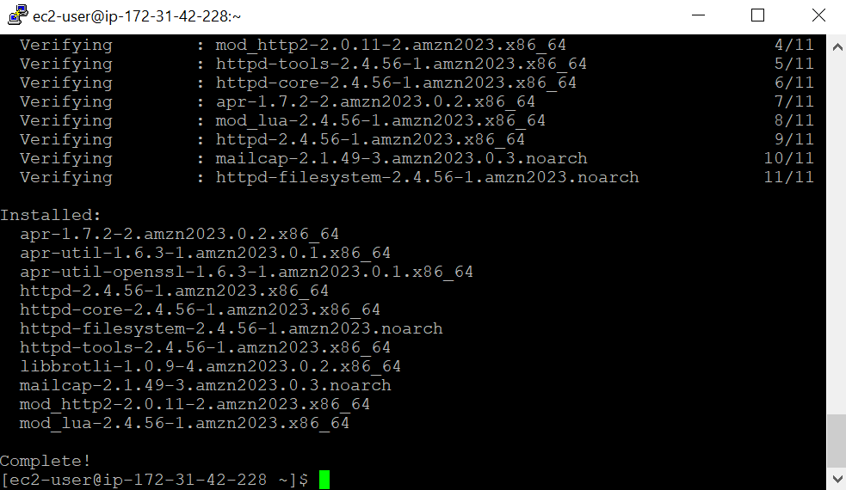

**Step 4:**

**Task 3:**

**Step 1:**

**Step 2:**

**Step 3:**



**Step 4:**

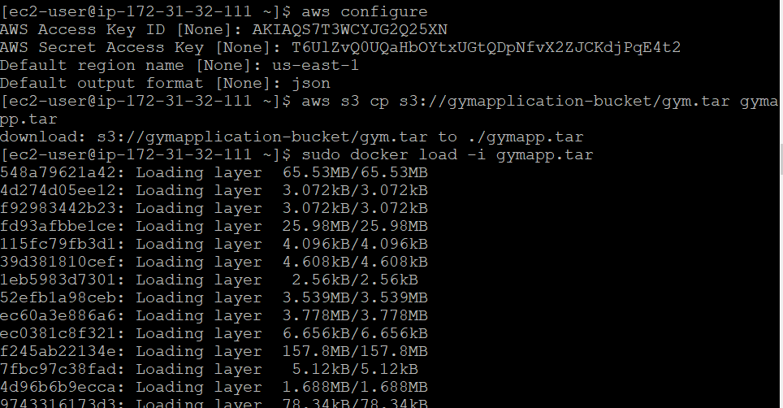

**Step 5:**

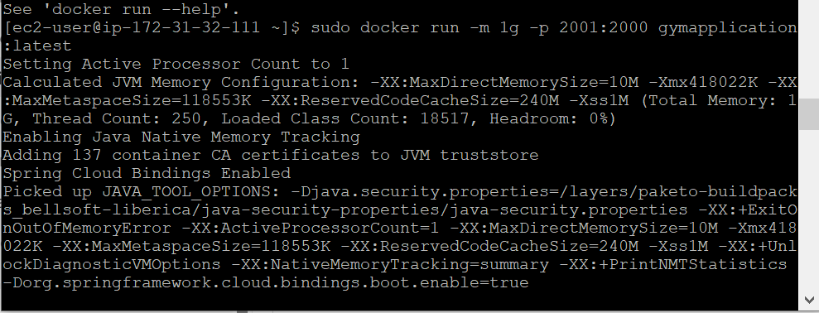

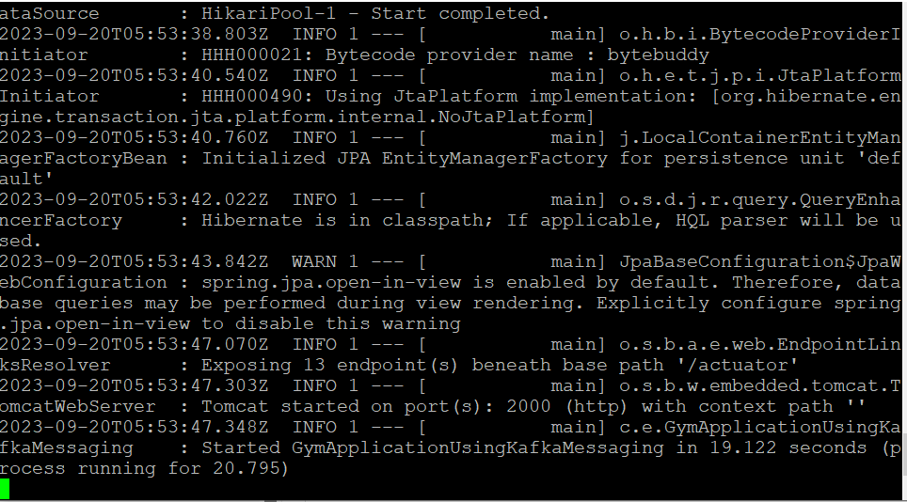

**Step 6:**

**Task 4:**

**Step 1:**

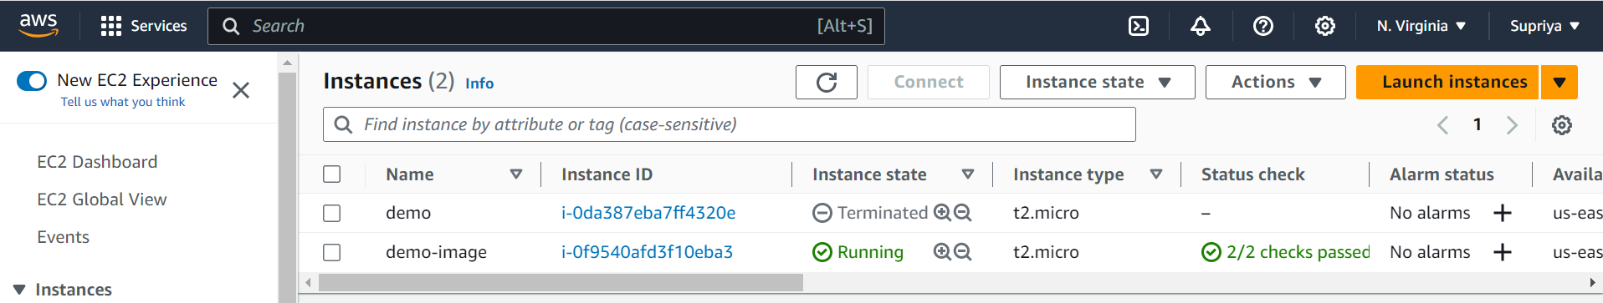

**Step 2:**

**Step 3:**

**Step 4:**

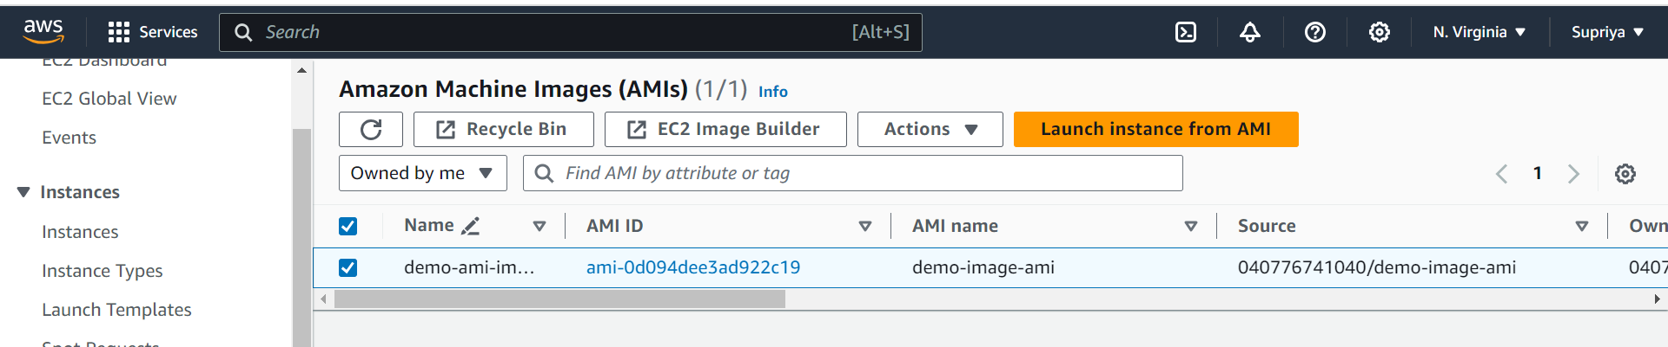

**Step 5:**

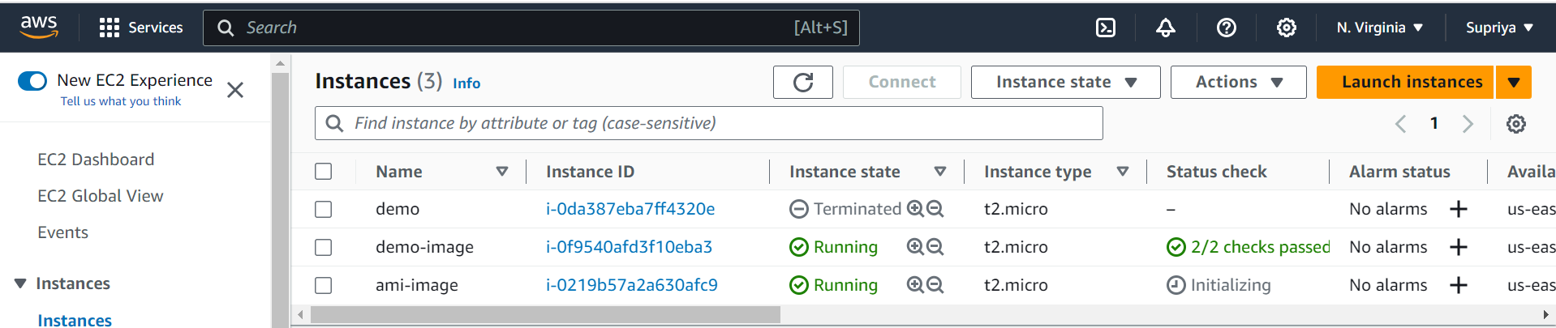

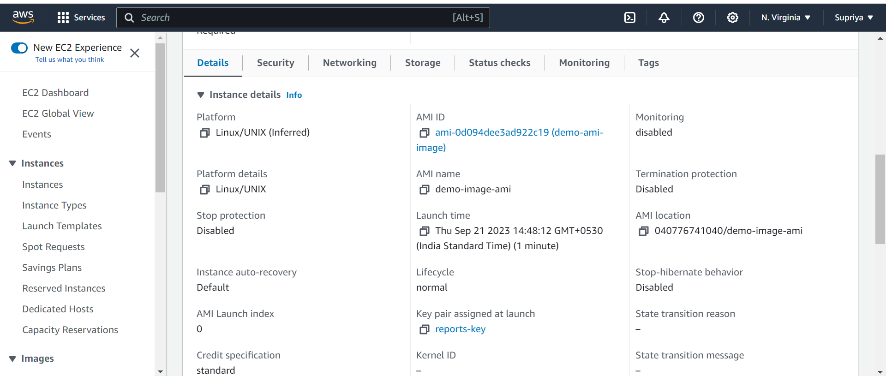

**Step 6:**



**Task 5:**

**Step 1:**

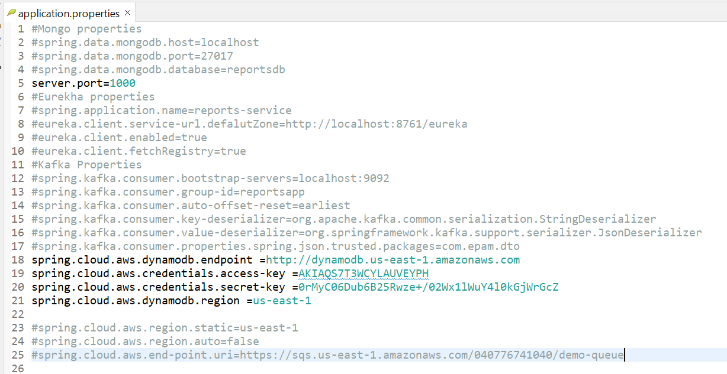

**Step 2:**

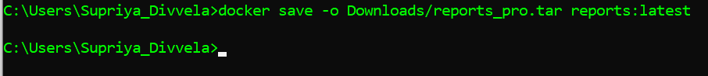

**Step 3:**

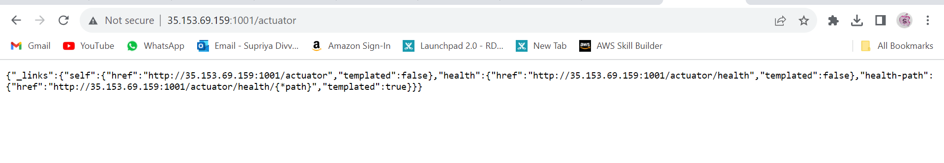

**Task 6:**

**Step 1:**

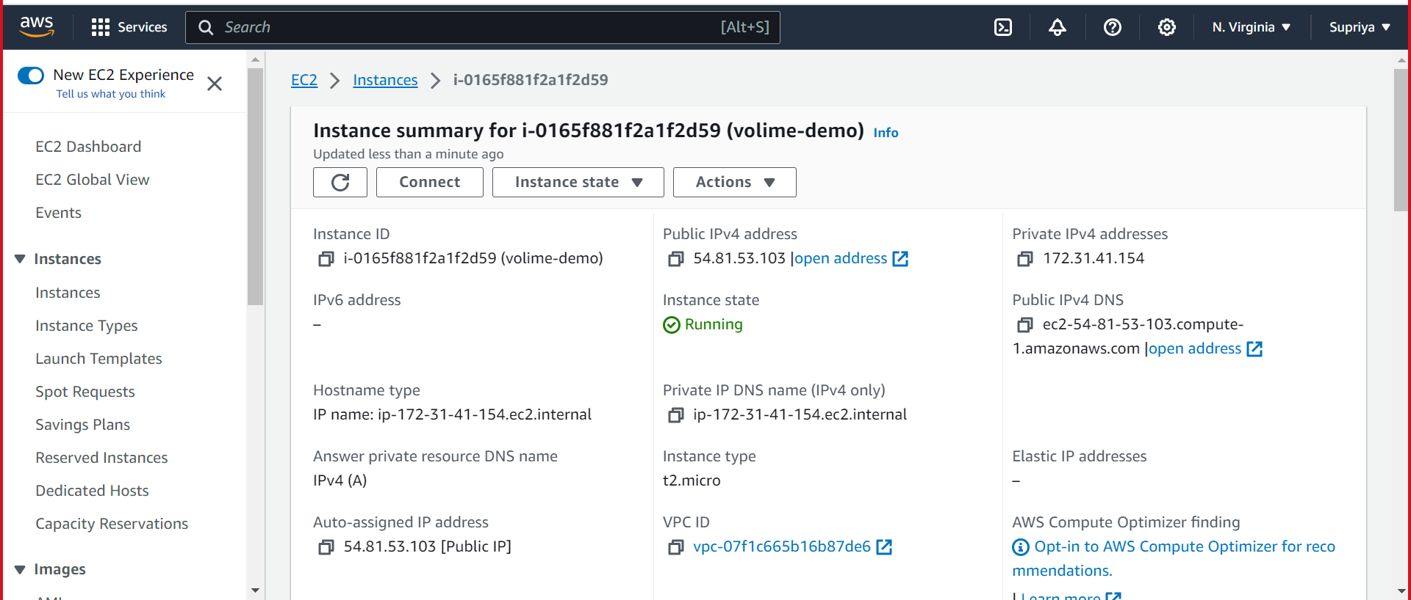

**Step 2:**

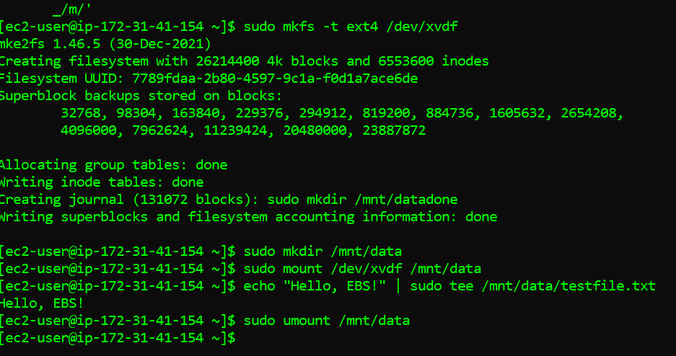

**Step 3:**

