**Module-7**

**Sub-Task 1:**

**Step 1:**

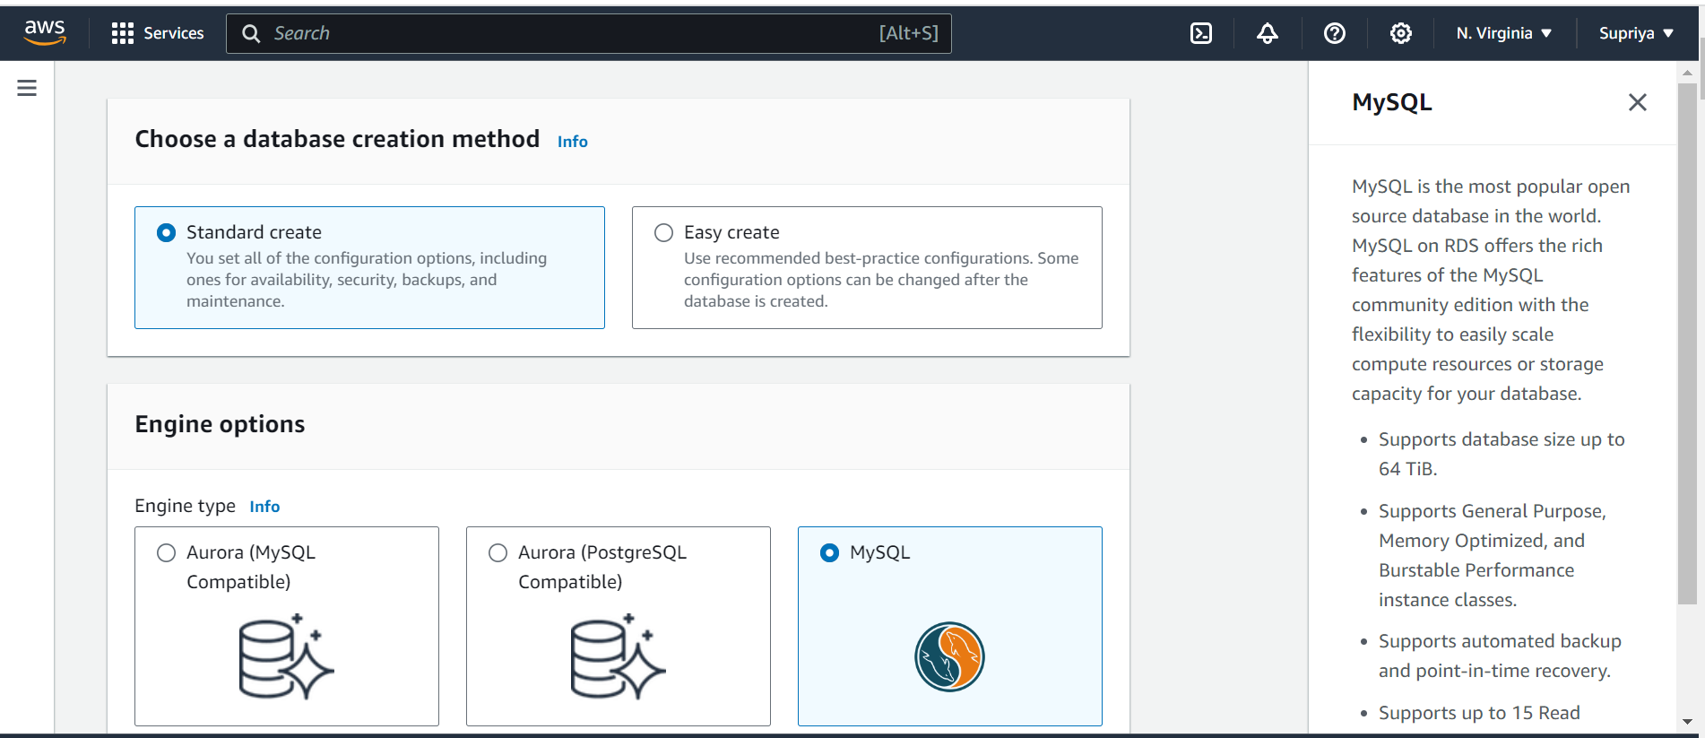

**Step 2:**

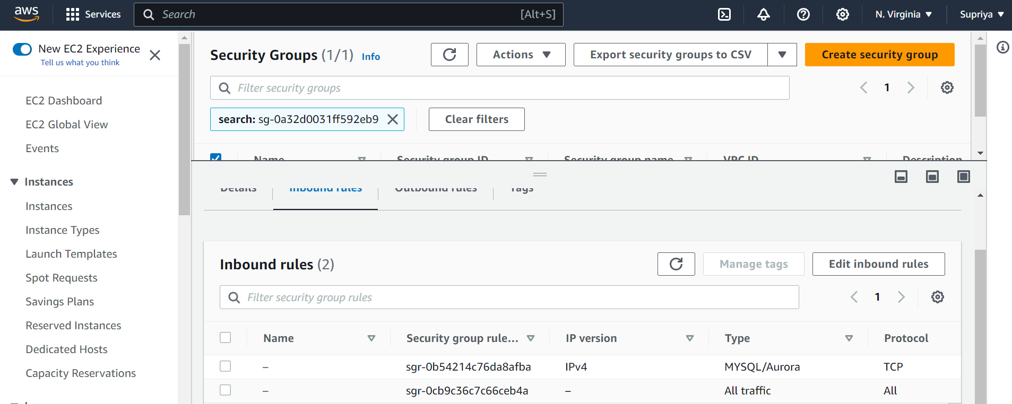

**Step 3:**

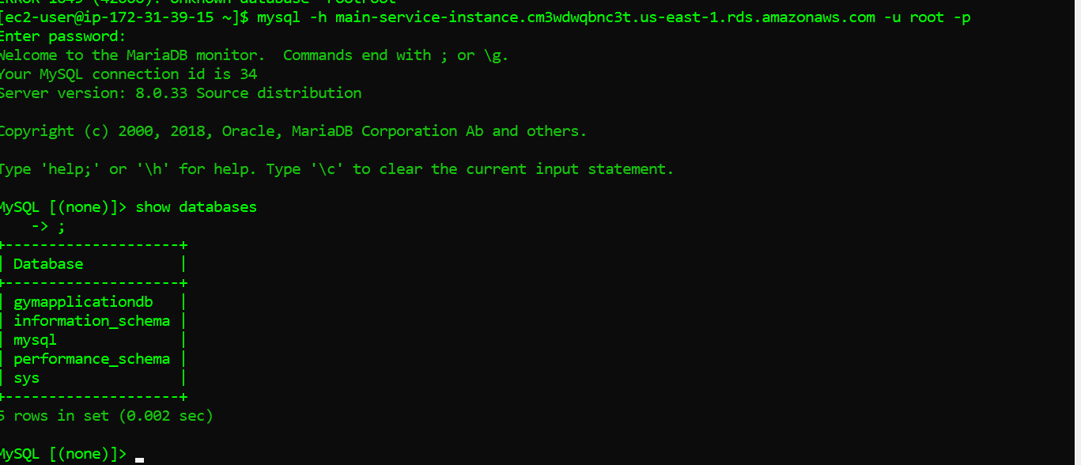

**Sub-Task 2:**

**Step 1:**

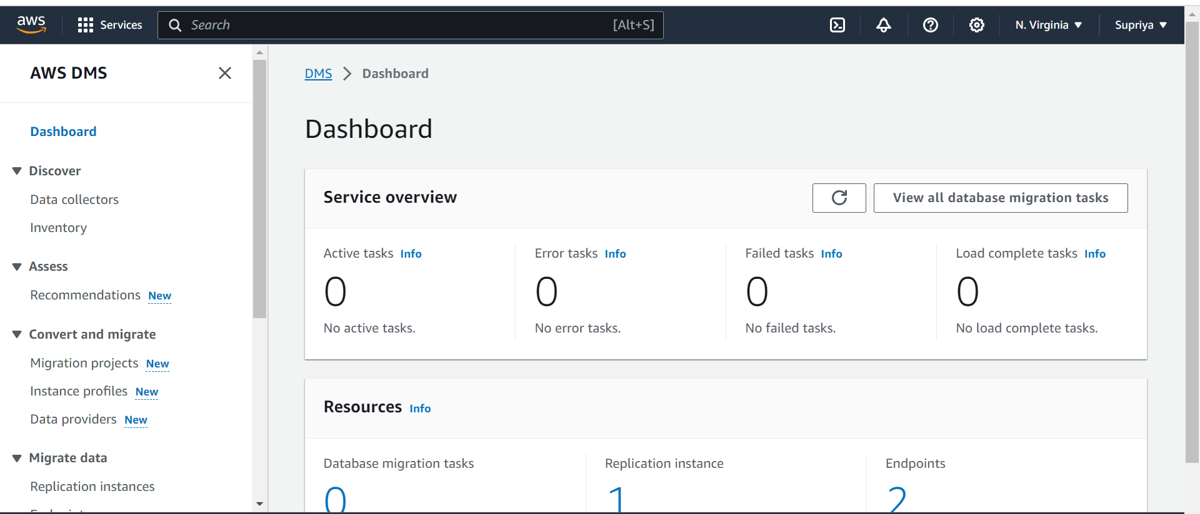

**Step 2:**

**Step 3:**

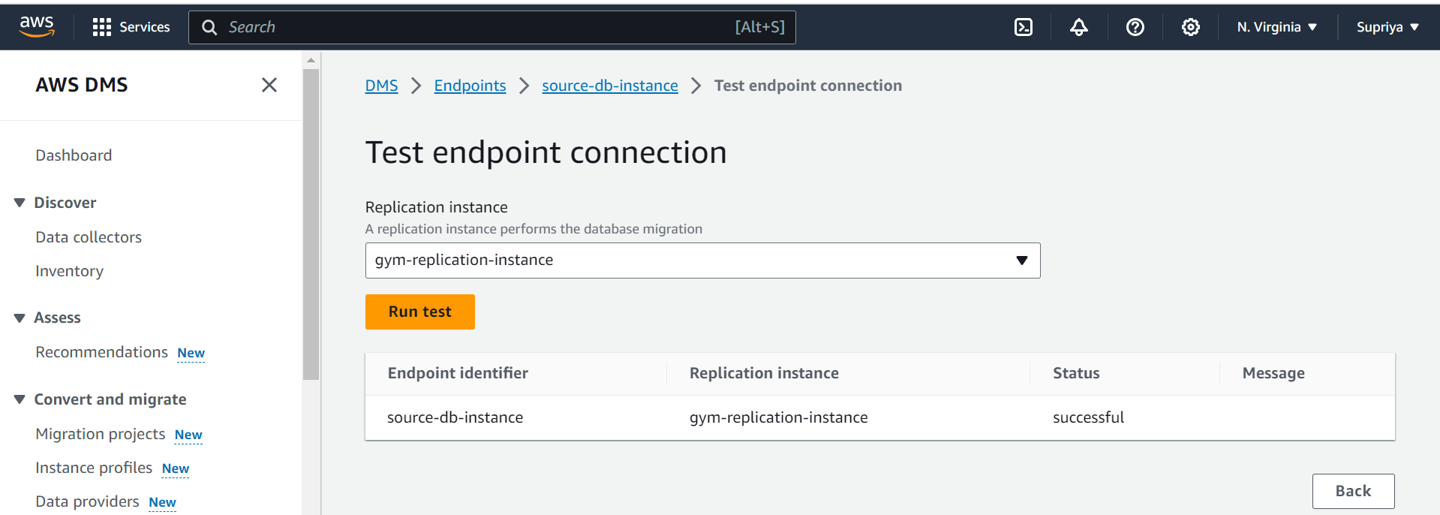

**Step 4:**

**Step 5:**

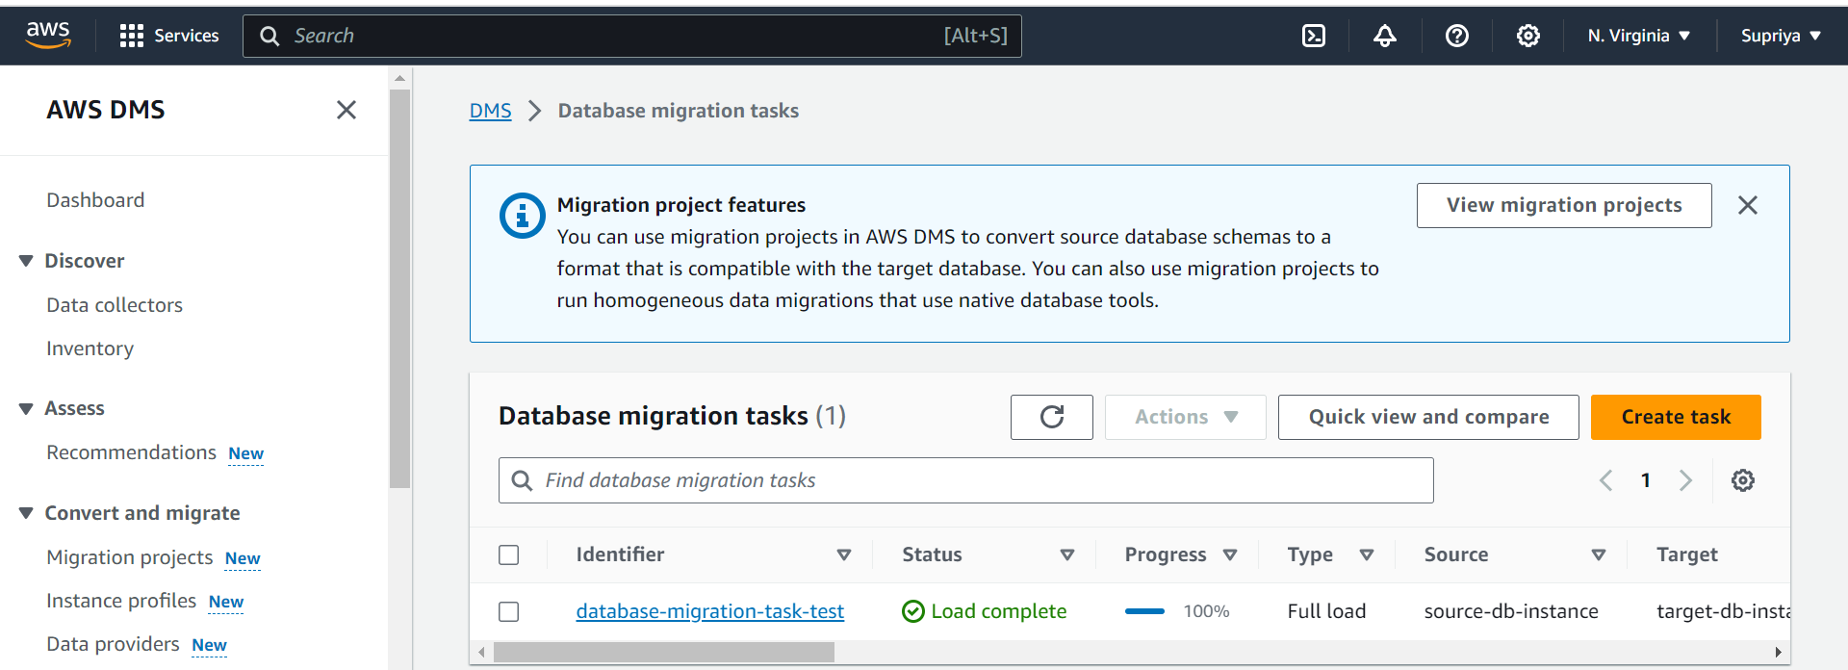

**Sub-Task 3:**

**Step 1:**

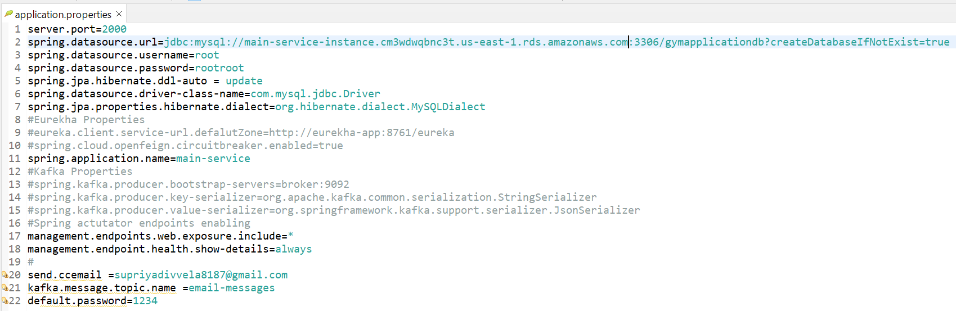

**Step 2:**

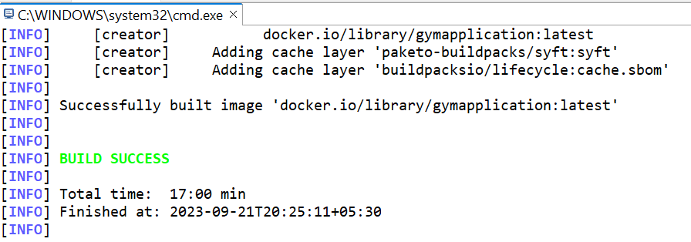



**Step 3:**

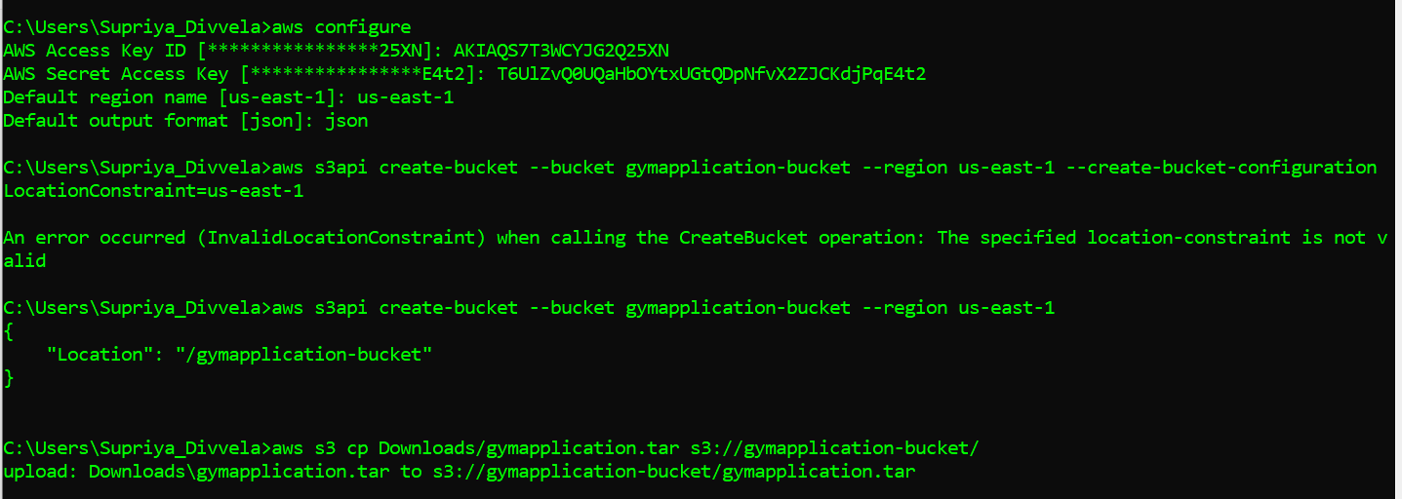

**Step 4:**

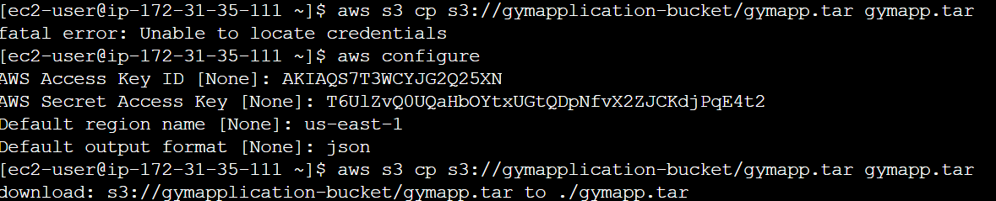

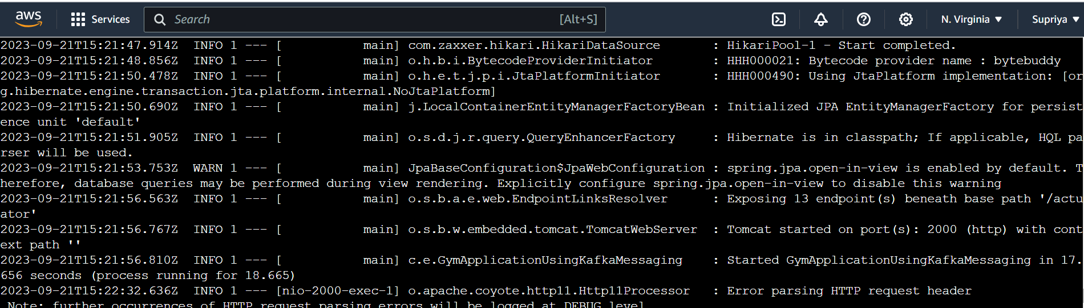

**Step 5:**

**Step 6:**

