**MODULE-8**

**Sub-Task 1:**

**Step 1:**

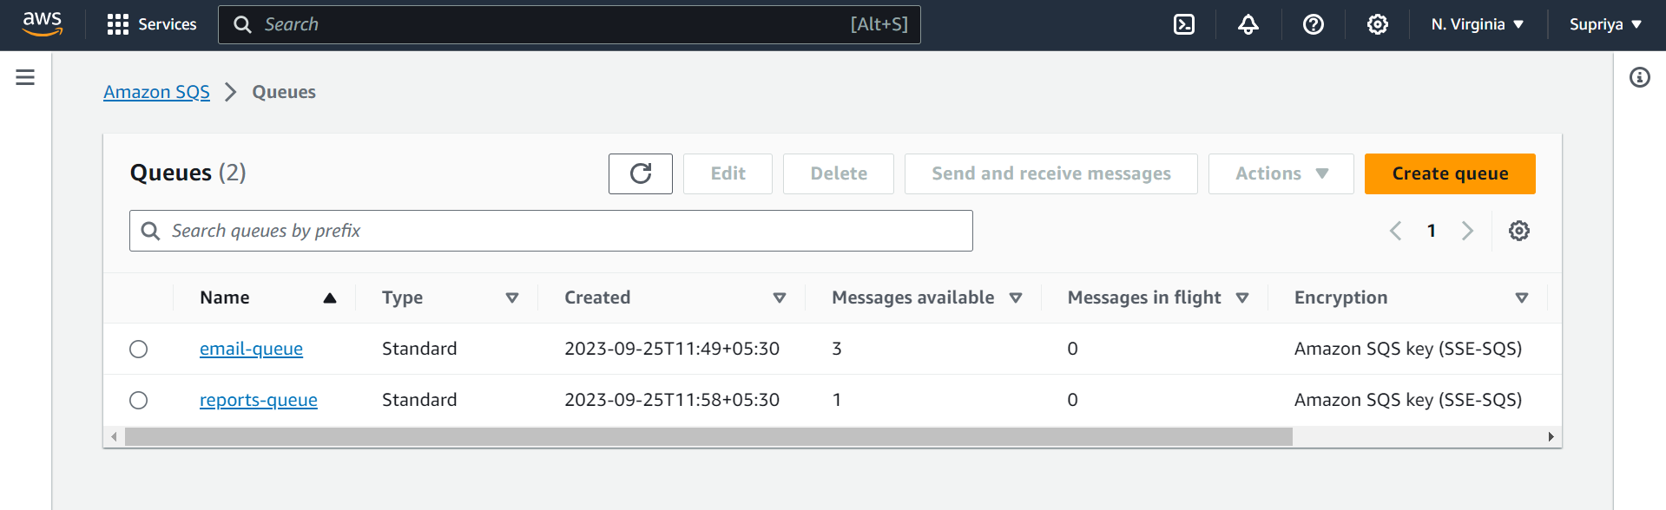

**Step 2:**

**Step 3:**

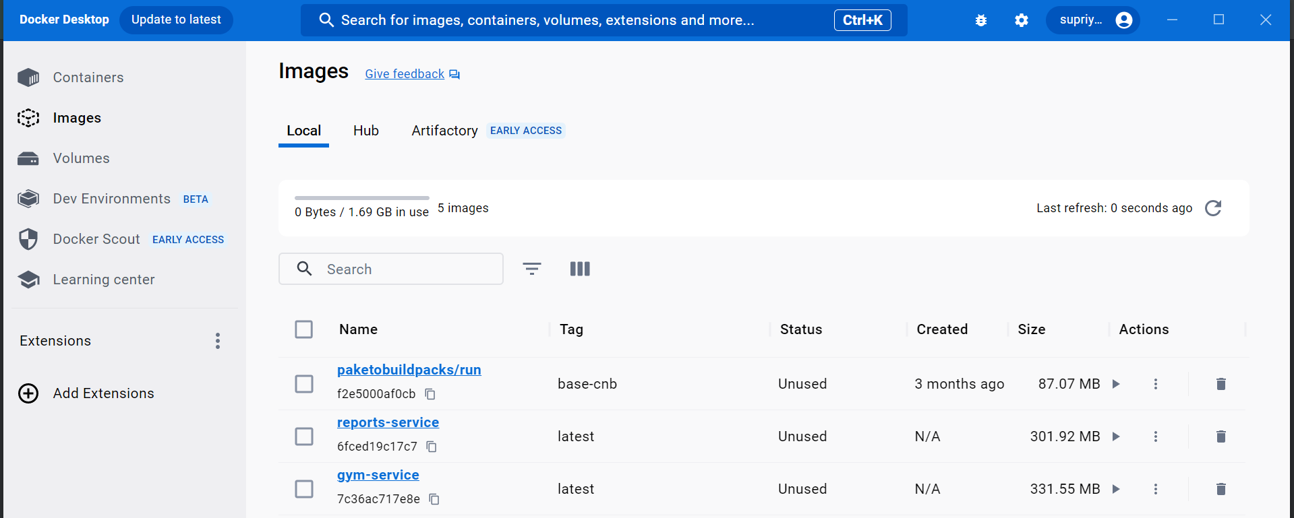

**Step 4:**

**,**

**Step 5:**

**Step 6:**

**Step 7:**

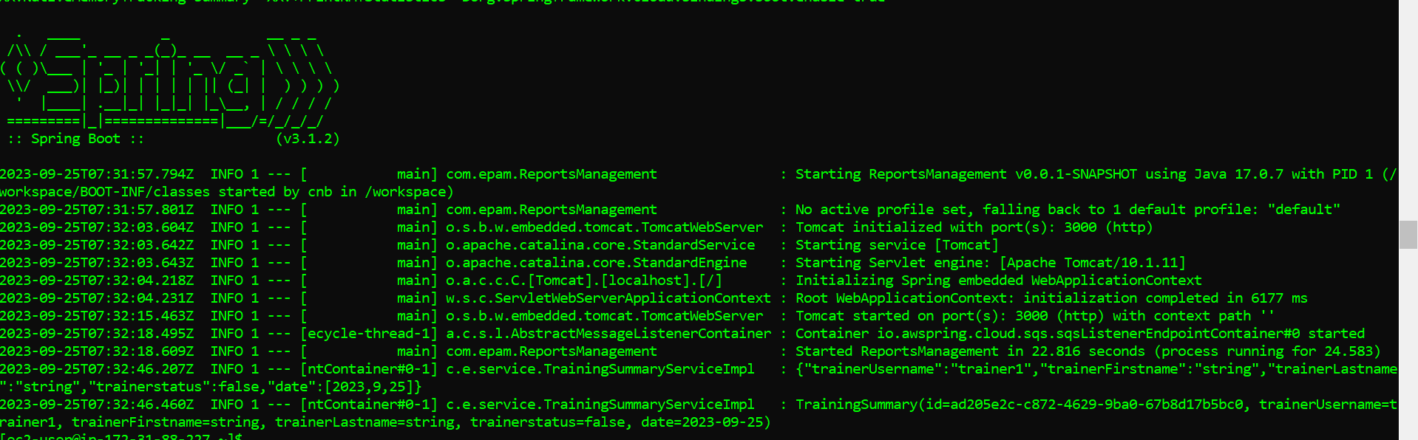

**Sub-Task 2:**

**Step 1:**

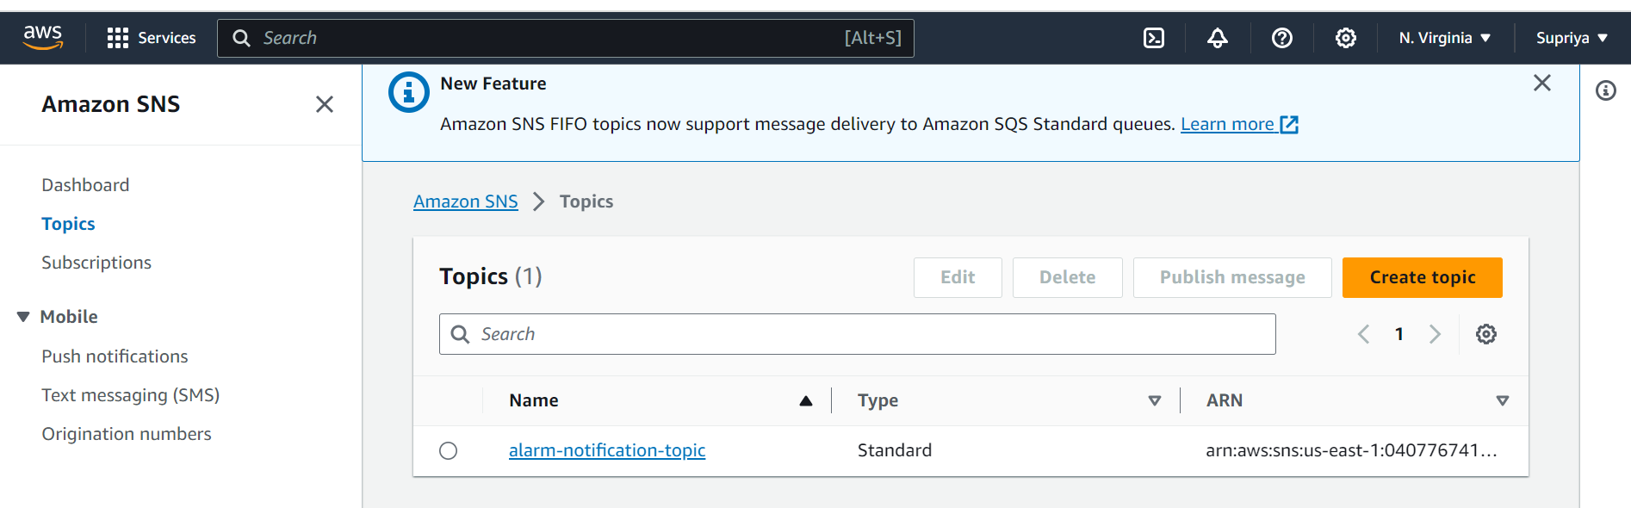

**Step 2:**

**Step 3:**

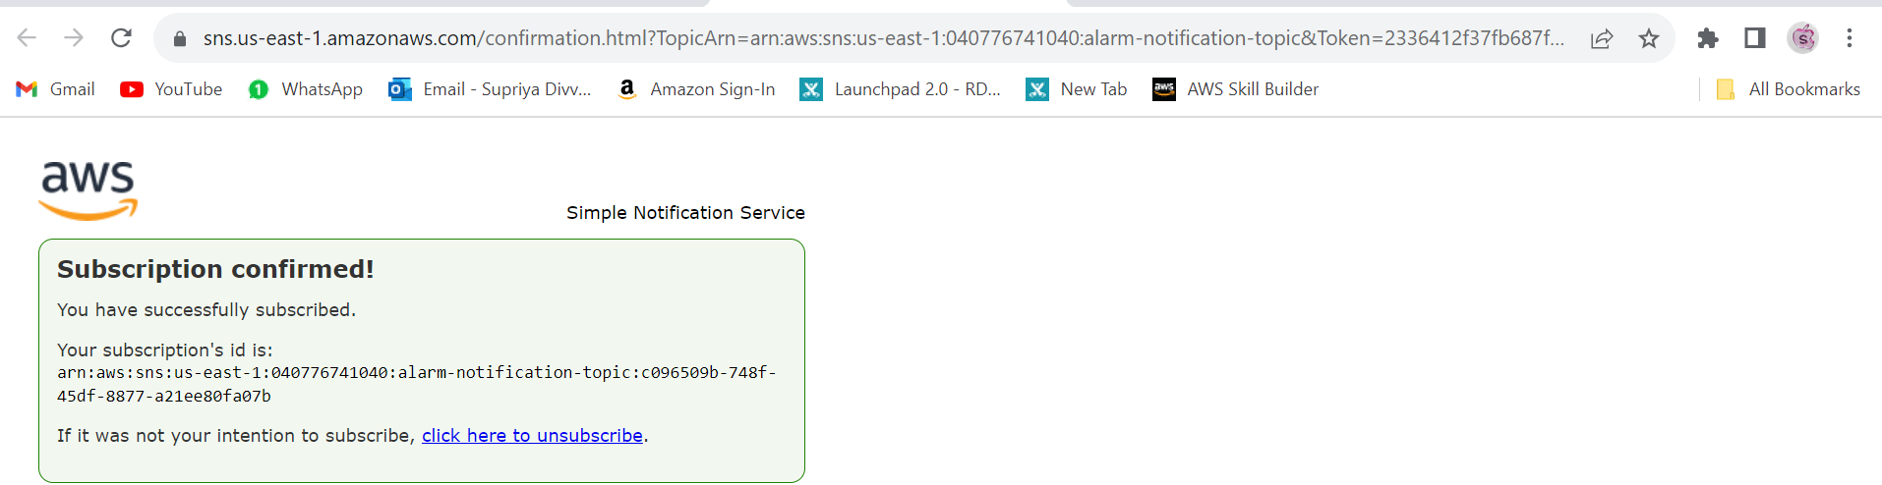

**Step 4:**

