**Module 9**

**Sub Task 1:**

**Step 1:**

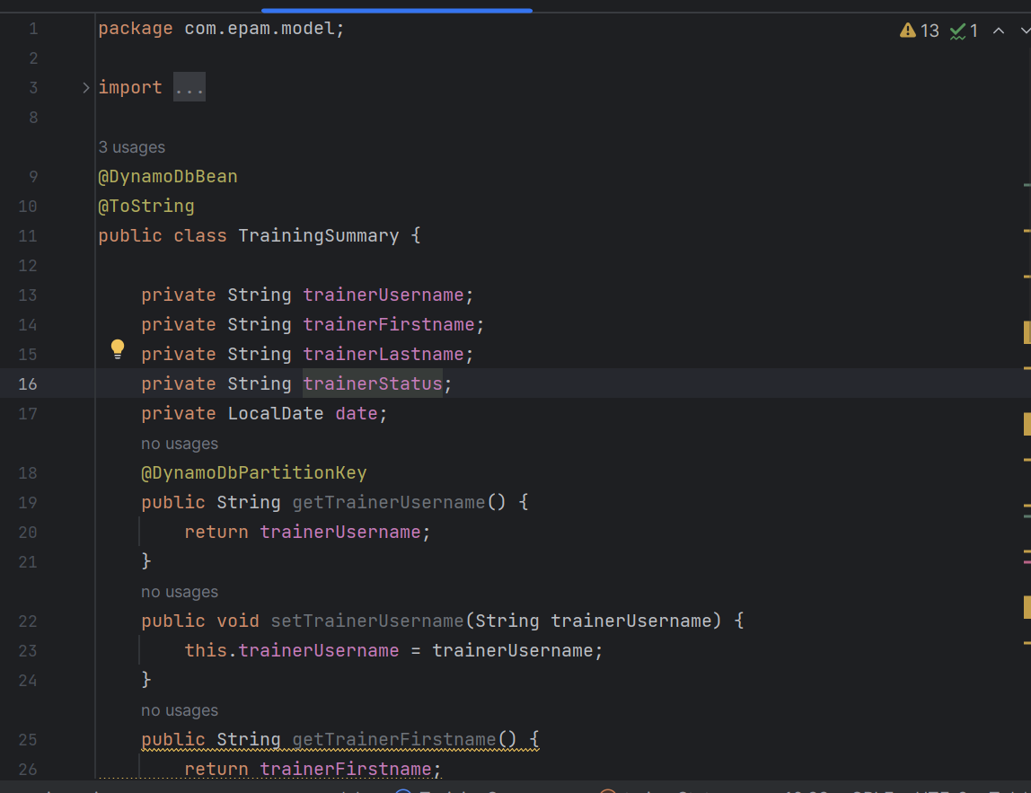

**Step 2:**

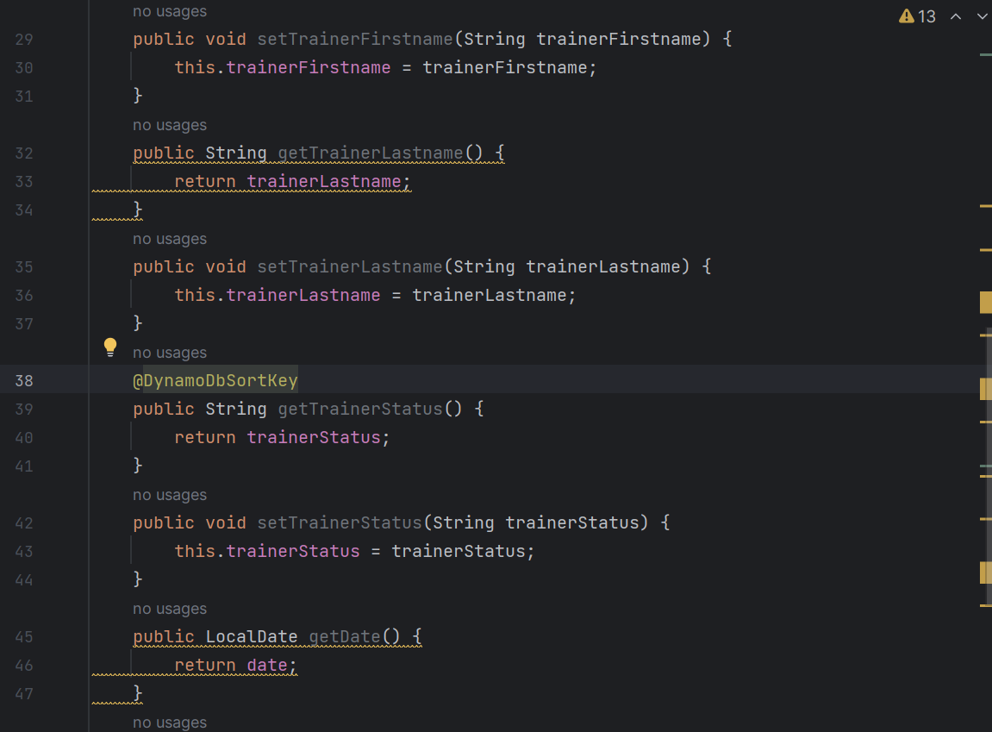

**Step 3:**

**Step 4:**

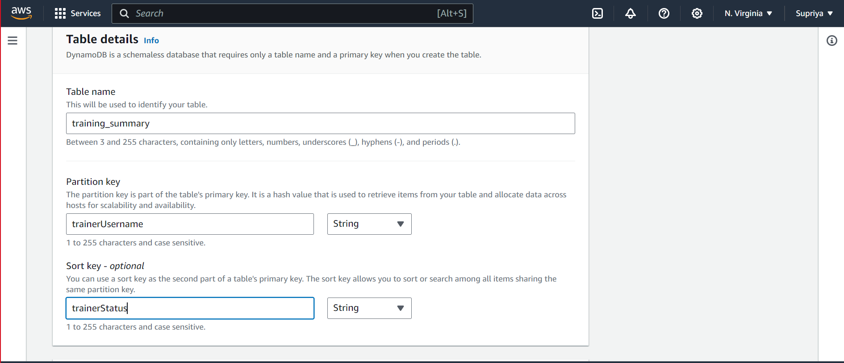

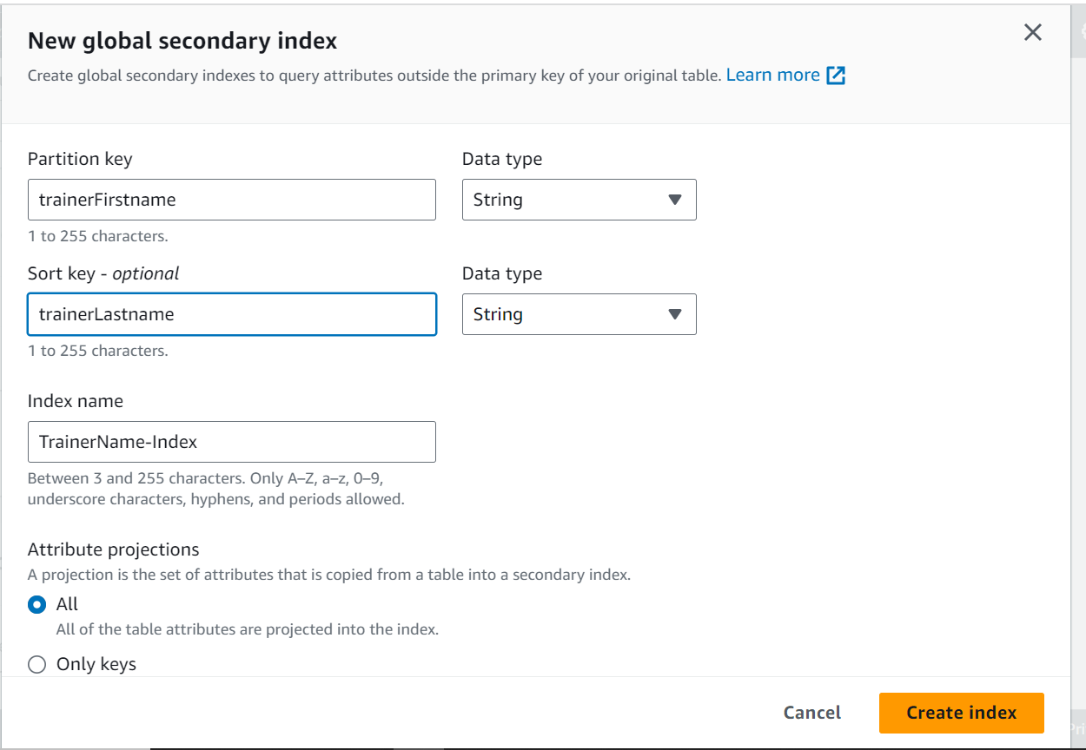

**Sub Task 2:**

**Step 1:**

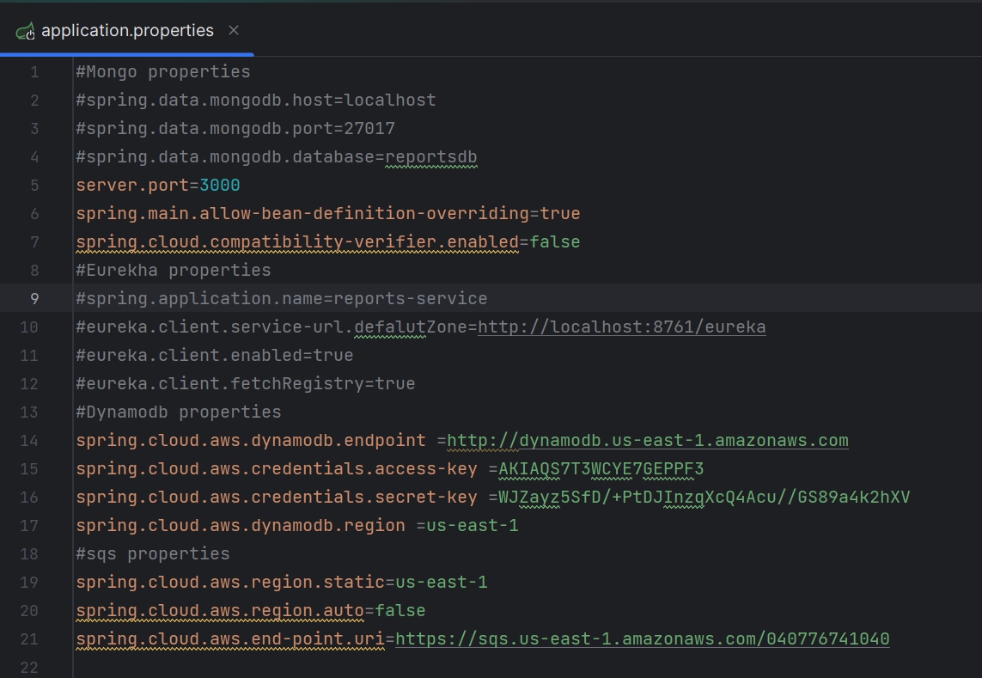

**Step 2:**

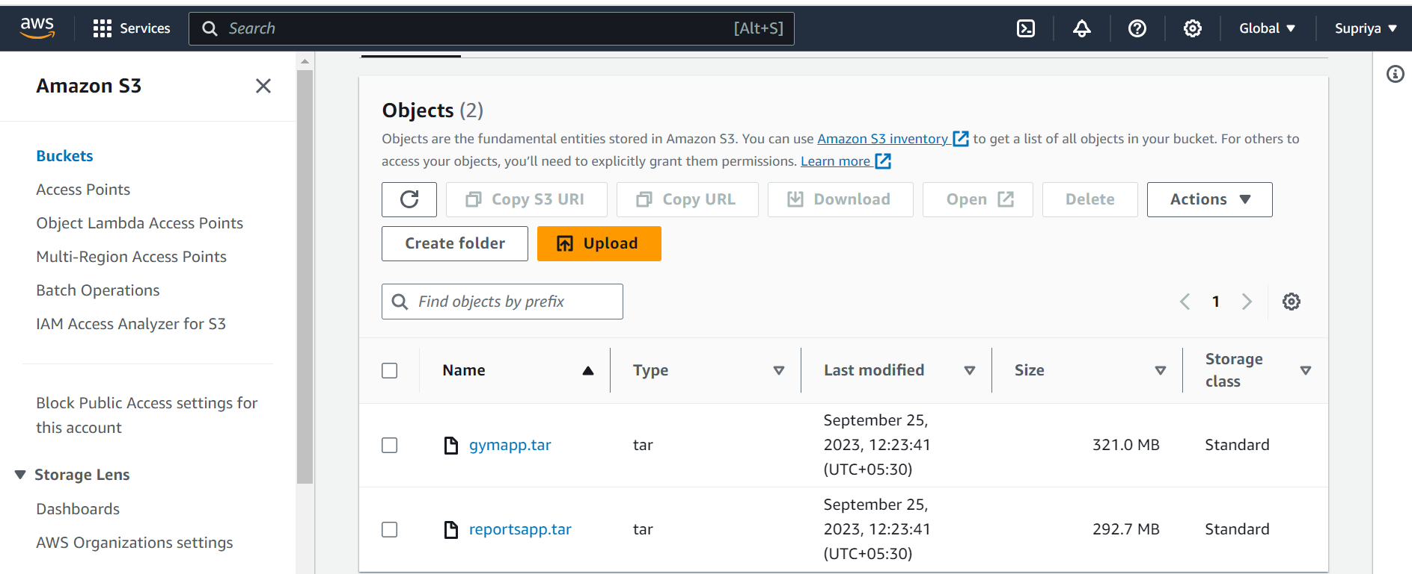

**Step 3:**

