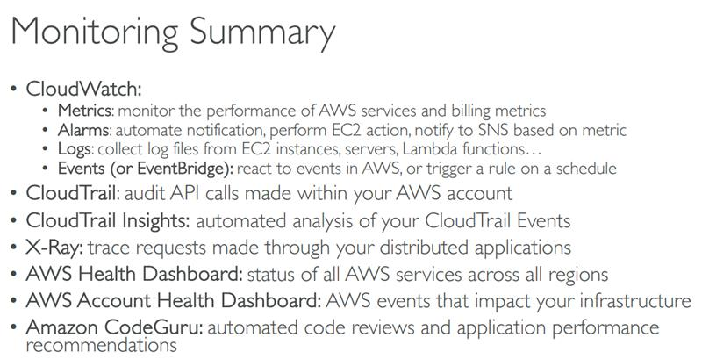

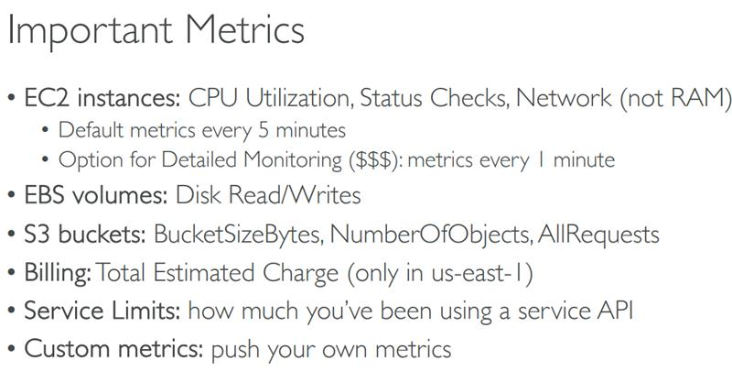

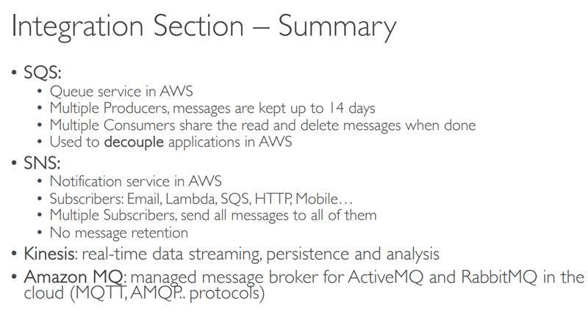

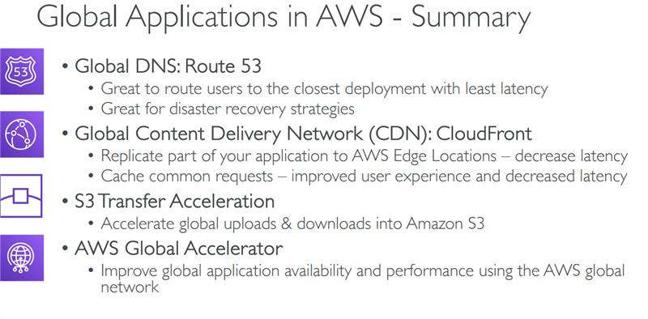

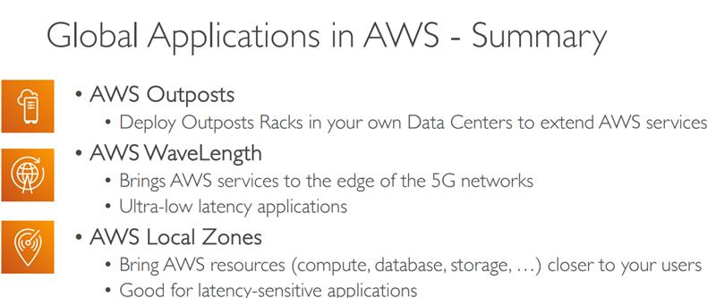

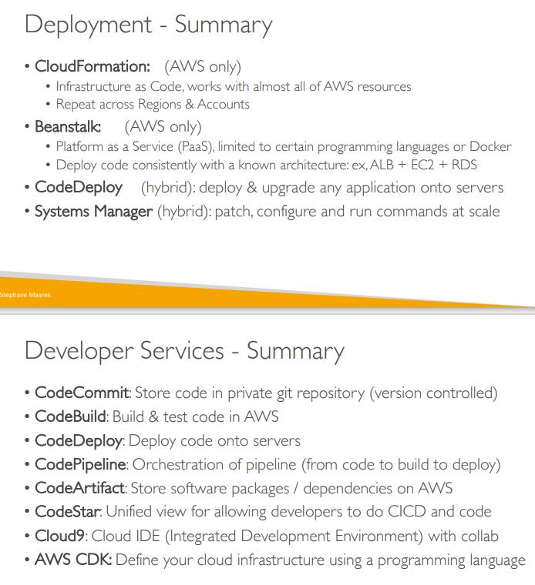

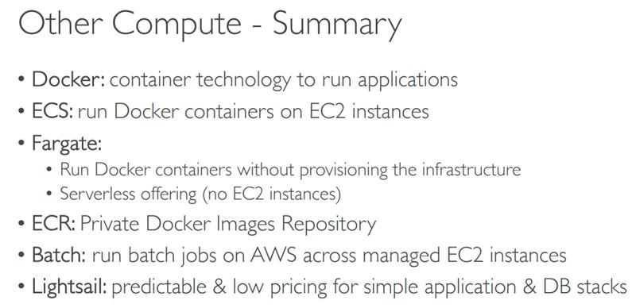

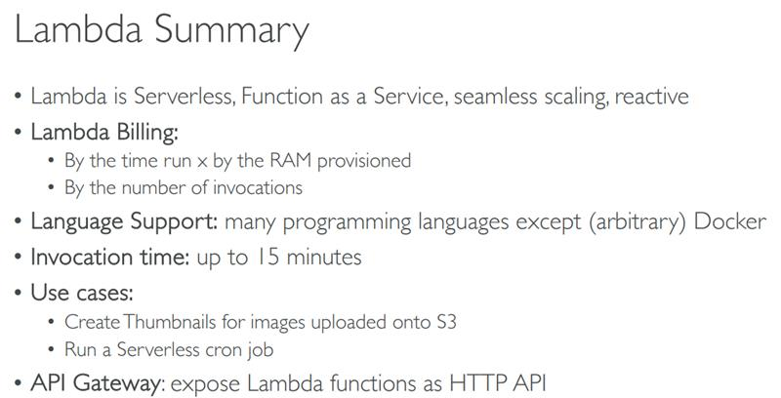

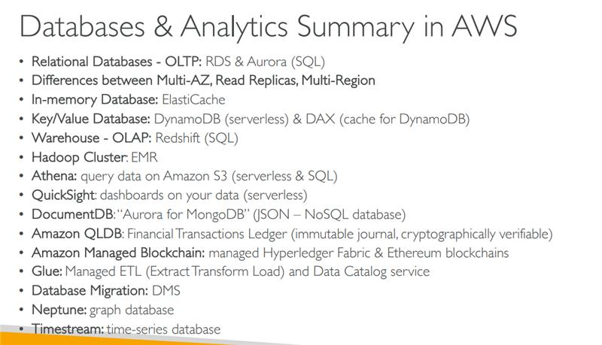

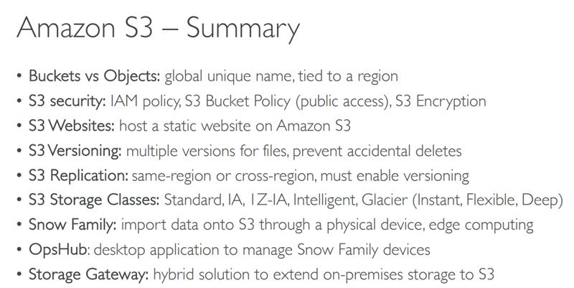

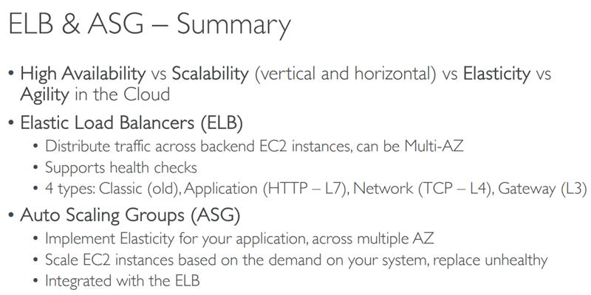

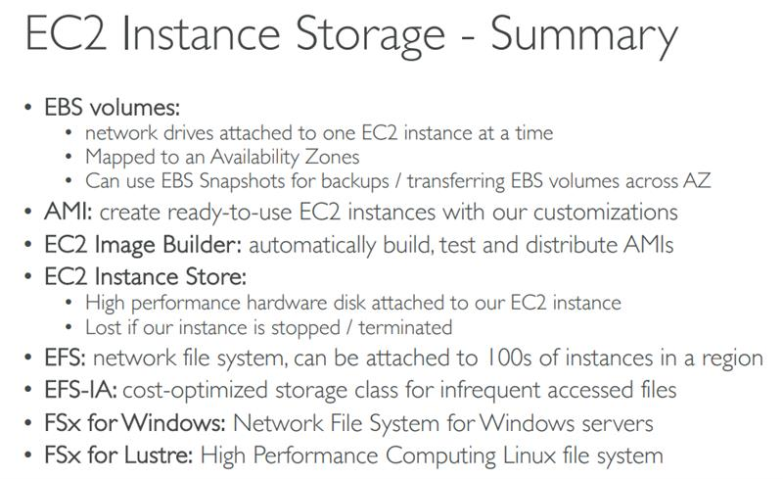

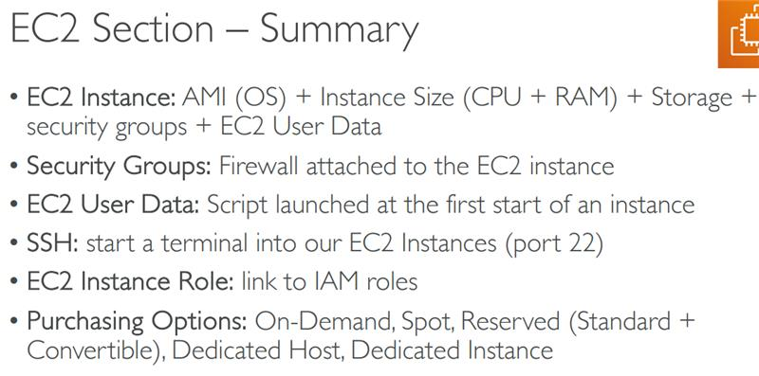

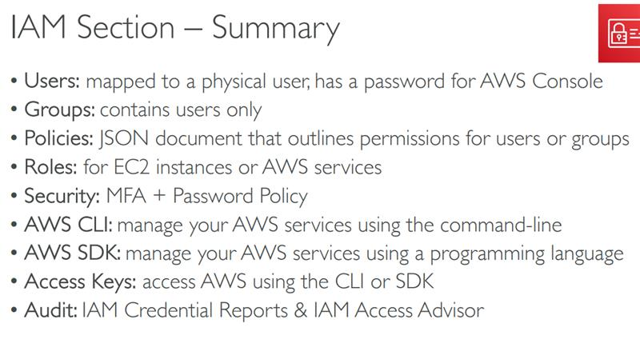

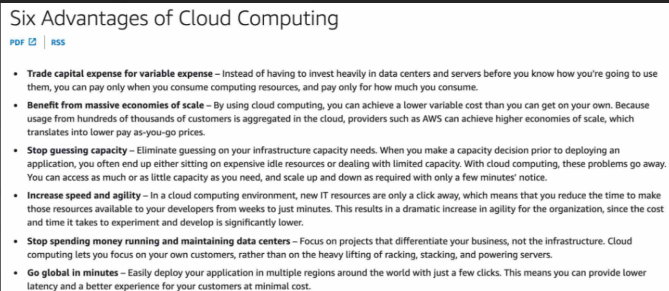

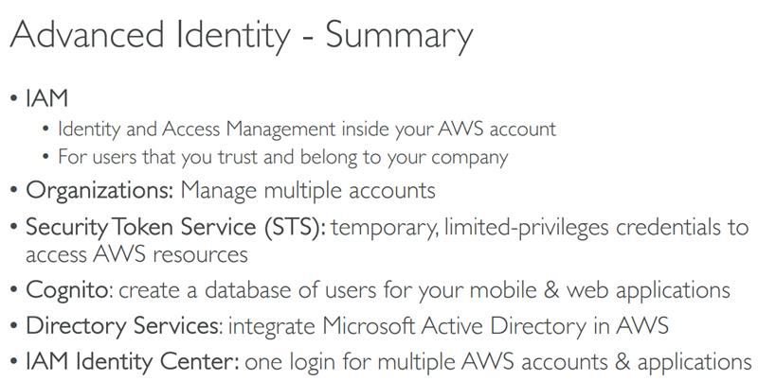

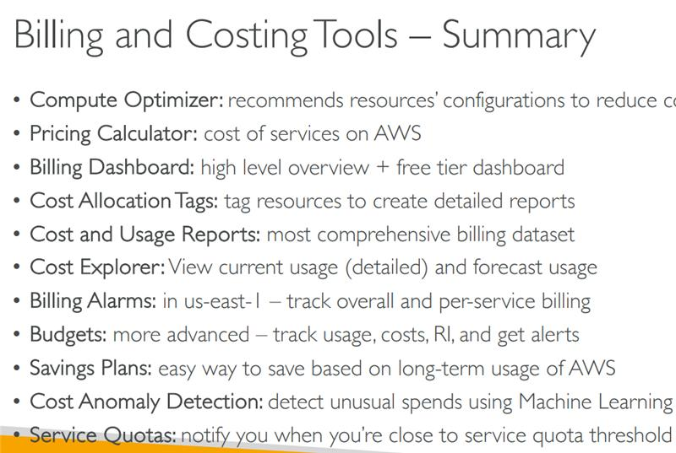

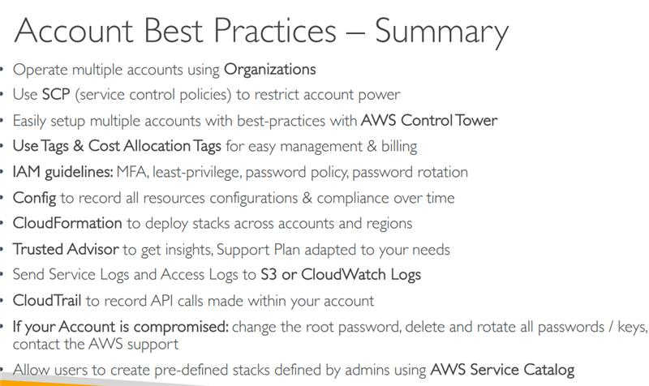

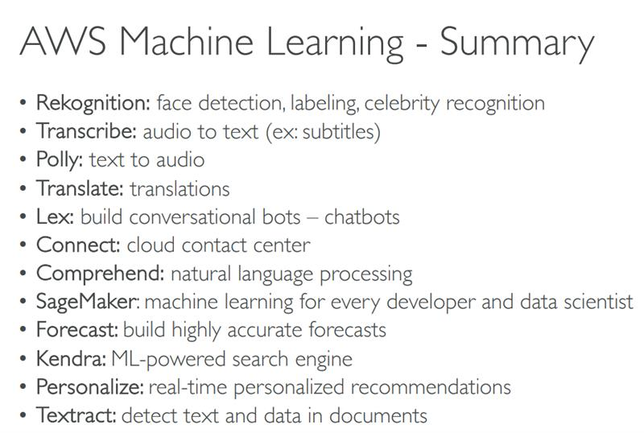



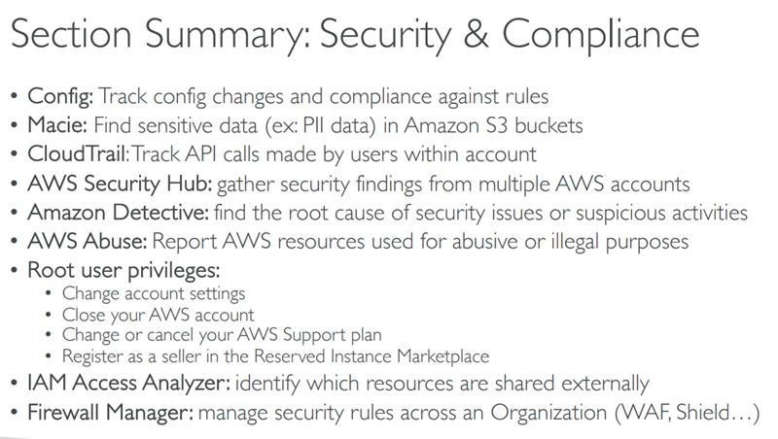



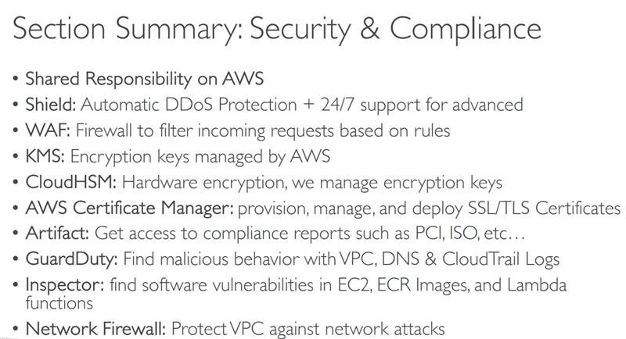



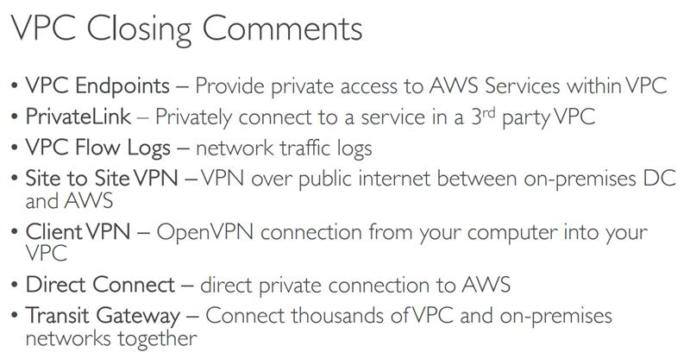

<https://www.examtopics.com/exams/amazon/aws-certified-cloud-practitioner-clf-c02/view/>

Config to record all resources configurations & compliance over time

Allow users to create pre-defined stacks defined by admins using AWS Service Catalog

Service Quotas: notify you when you’re close to service quota threshold

Disaster Recovery Strategy:

Backup and restore

pilot light

Warm Standby

Multisite/hot-site

AWS DataSync • Move large amount of data from on-premises to AWS

AWS Elastic Disaster Recovery (DRS)  • Quickly and easily recover your physical, virtual, and cloud-based servers into AW

AWS Device Farm • Fully-managed service that tests your web and mobile apps against desktop browsers, real mobile devices, and tablets

AWS Amplify • A set of tools and services that helps you develop and deploy scalable full stack web and mobile applications

AWS AppSync • Store and sync data across mobile and web apps in real-time • Makes use of GraphQL (mobile technology from Facebook)

Amazon Elastic Transcoder • Elastic Transcoder is used to convert media files stored in S3 into media files in the formats required by consumer playback devices (phones etc.)

Amazon AppStream 2.0: The application is delivered from within a web browser

AWS Fault Injection Simulator (FIS) • A fully managed service for running fault injection experiments on AWS workloads

The Acceptable Use Policy describes prohibited uses of the web services offered by Amazon

AWS CloudTrail • Provides governance, compliance and audit for your AWS Account

AWS Config • Helps with auditing and recording compliance of your AWS resources

Amazon Inspector • Automated Security Assessments

**AWS Service Health Dashboard** - AWS Service Health Dashboard publishes most up-to-the-minute information on the status and availability of all AWS services in tabular form for all Regions that AWS is present in. You can check on this page (<https://status.aws.amazon.com/)> any time to get current status information or subscribe to an RSS feed to be notified of interruptions to each service.

AWS Personal Health Dashboard provides alerts and remediation guidance when AWS is experiencing events that may impact you. With Personal Health Dashboard, alerts are triggered by changes in the health of your AWS resources, giving you event visibility, and guidance to help quickly diagnose and resolve issues.

AWS Artifact (not really a service) • Portal that provides customers with on-demand access to AWS compliance documentation and AWS agreement

Amazon Inspector is an automated security assessment service that helps improve the security and compliance of applications deployed on AWS. Amazon Inspector automatically assesses applications for exposure, vulnerabilities, and deviations from best practices.

Reservations provide you with greater discounts, up to 75%, by paying for capacity ahead of time. Some of the services you can reserve include: EC2, DynamoDB, ElastiCache, RDS, and RedShift.

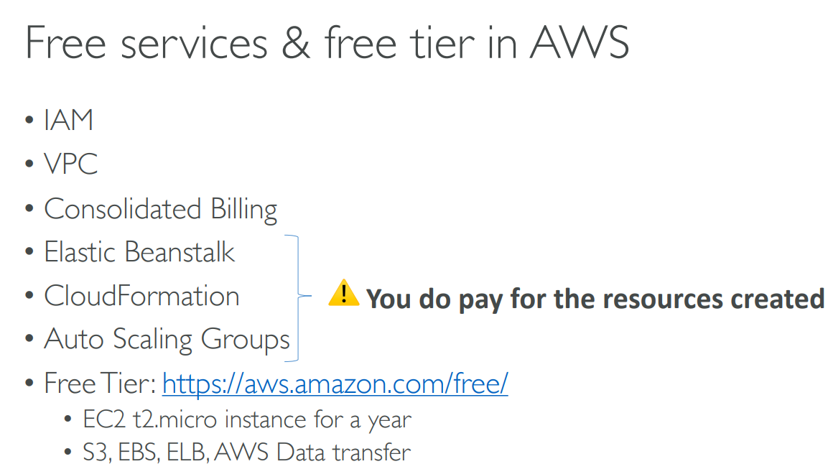

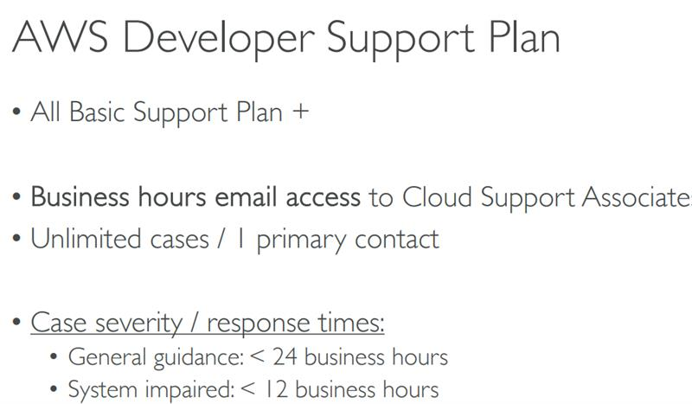

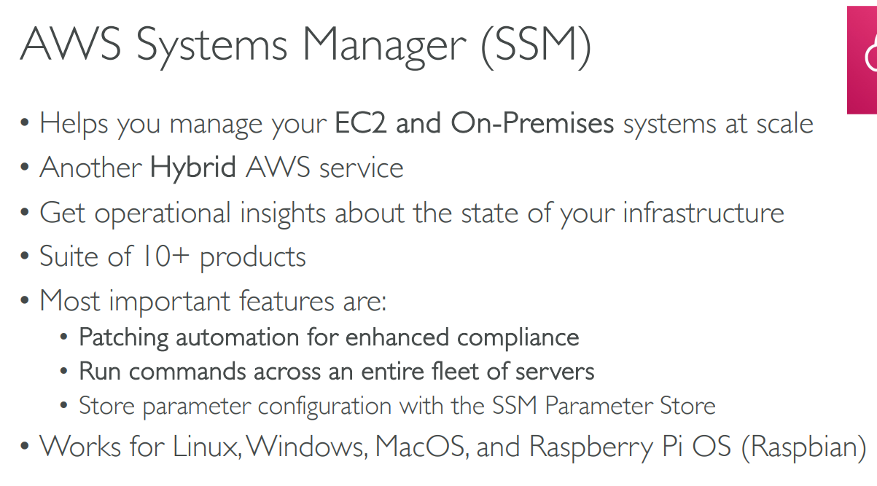

VPC Endpoint Gateway: S3 & DynamoDB

VPC Endpoint Interface: the rest

Ami built in specific region

Ebs volumes are bound to availability zone