Using Mapped By(OneToOne Mapping) or bidirectional mapping:

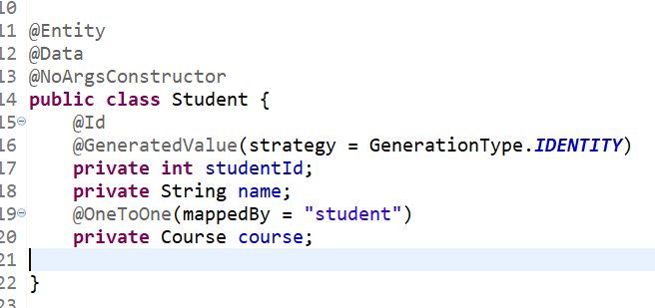

Using JoinColumn(OneToOne Mapping) or unidirectional mapping:

Output same as above

Using OneToMany and ManyToOne:

Here in the below relation only 2 tables will form with foreign key attached with student table

Here in the below relation 3 tables will form with separate table of relation between course_id and student_id if we use targetEntity instead of mappedBy:

If we use JoinColumn instead of mappedBy it forms 3 tables same as targetEntity:

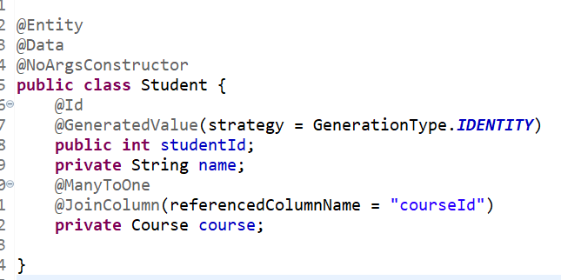

ManyToMany:

