MPI USER MASTER

Passwordless

sudo apt-get install openmpi-bin

sudo nano /etc/hosts

//add master and client ip address

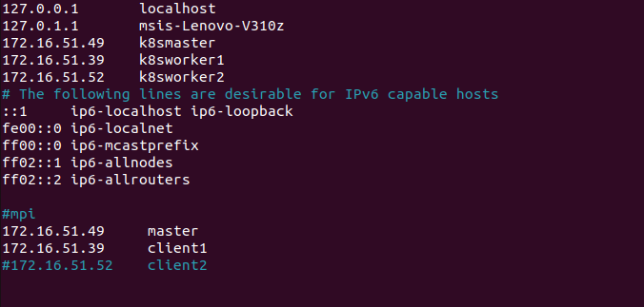
sudo adduser cam5

sudo usermod -aG sudo cam5

sudo apt-get install openssh-server

su - cam5

ssh-keygen -t rsa

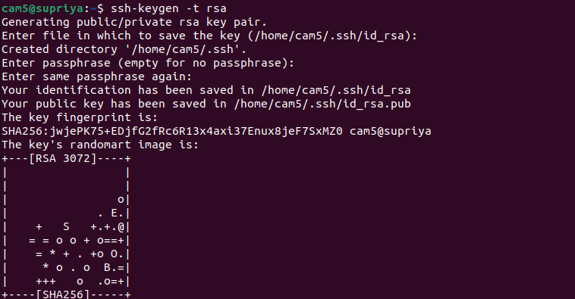
cd .ssh/

ls

cat id_rsa.pub >> authorized_keys

ssh-copy-id client1

ssh client1

exit

cd ..

Mounting

sudo apt-get install nfs-kernel-server

mkdir cloud

sudo nano /etc/exports

//add the following command

/home/cam5/cloud *(rw,sync,no_root_squash,no_subtree_check)
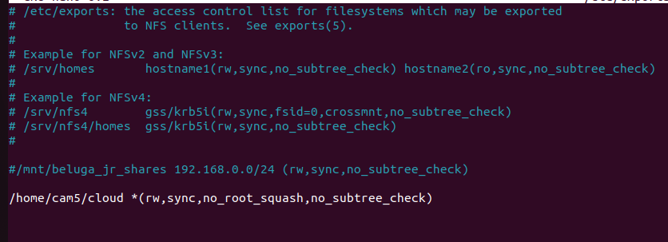
exportfs -a

cd cloud/

ls

//sudo apt-get install openmpi-bin (optinal)

