|  |  |
| --- | --- |
| Automotive Cabin Climate Control System/hvac Name : Supriya S. AmbiUnique ID:2005309 |  |
|  |  |

Contents

[Name and Unique ID : 1](file:///C:\Users\shweta\Desktop\HVAC_REPORT.docx#_Toc59201059)

[Introduction](#_Toc59201061) 2

[Market Analysis 3](#_Toc59201062)

[Fig 1.Automotive HVAC Market........................................3](#_Toc59201062)

[Fig 2.Global HVAC Market...........................................3](#_Toc59201062)

[Design: 5](#_Toc59201070)

Fig 3.automotive climate Control Model..............................5

Fig 4.Engine State Subsystem Model..................................5

Fig 5.Temperature Subsystem Model...................................6

Fig 6.Humidity Subsystem Model......................................6

Fig 7.CAR Climate Control System Model..............................7

Fig 8.Automotive Climate Control Model when Engine Is Off...........7

Fig 9.Automotive Climate Control Model when Engine Is ON............8

Fig 10.Automotive Climate Control Model when Engine Is ON...........9

[Results:.............................................................9](#_Toc59201071)

Fig 11.Automotive Climate Control Model when Engine Is OFF..........9

Fig 12.Automotive Climate Control Model when Engine Is OFF.........10

[References: 11](#_Toc59201072)

## Introduction

…

Car passengers' comfort plays an increasing role not only from the feel good or travel comfort point of view but also from the transportation safety perspective where the driver's thermal comfort is of crucial importance. The main components that affect optimal comfort are HVAC vents.

Heating Ventilation and Air Conditioning (HVAC)is the technology for indoor and automotive ambient comfort. HVAC facilitates in managing the pleasant climate inside the cabin by controlling the degree of hotness/coolness.

There were times when having an air conditioner in the car was considered one of the big features ,but today HVAC installation in the car become standard equipment even in entry-level automobiles. The primary purpose of automatic climate control is to manage the temperature of a given area for the comfort of onboard passengers.

## Market Analysis

## A company in New York City in the united state first offered installation of air conditioning for cars in 1993.

## On October 7,1935, Ralph Peo of Houde Engineering, Buffalo, NY, applied for a patent for and AIR Cooling Unit for Automobiles”.

## In 1993,Packard became the first automobile manufacture to offer an air conditioning unit in its cars.

## D:\1KPIT\automotive-HVAC-market-pressrelease.png

Fig 1.Automotive HVAC Market

## D:\1KPIT\Automotive_HVAC.webp

Fig 2.Global HVAC Market

## Global Automotive HVAC Market Research Information by

## technology (Manual and Automatic)

## component (Evaporator,Compressor,Condenser,Receiver/Drier)

## Vehicle Type (Passenger Cars,LCV,HCV)

## 

## Design:

## 

Fig 3.automotive climate Control Model

To design automotive climate control model using MATLAB SIMULINK using

Humidity and temperature sensor data controlling the climate the climate of the car. here engine state is used as one of the input and temperature and humidity data is also inputs connected to the CLIMATE

CONTROL MODEL and the final outputs are AC control and Heater control connected to the 2 LEDs which indicates AC control and Heater control on and off states.

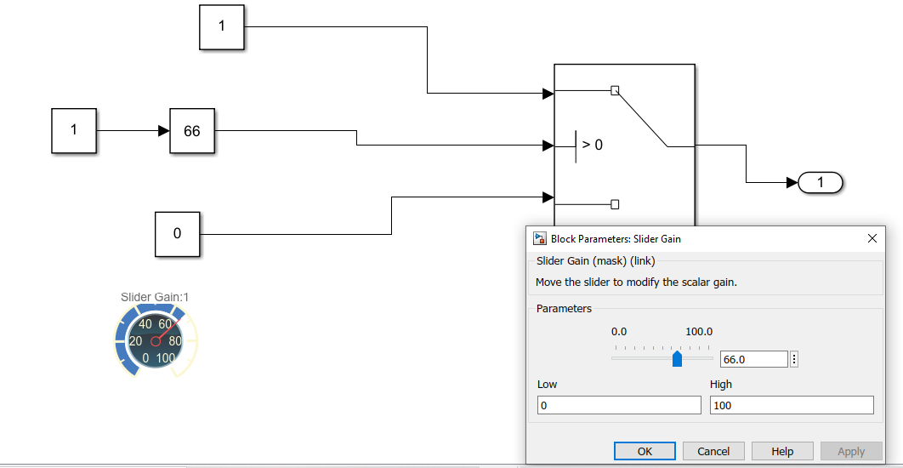

Fig 4.Engine State Subsystem Model

The AC control and Heater control model start working when the vehicle engine is ON so if ENGINE STATE is 1 then automotive climate control model control the vehicle climate. If engine is OFF then no climate controlling is happens.

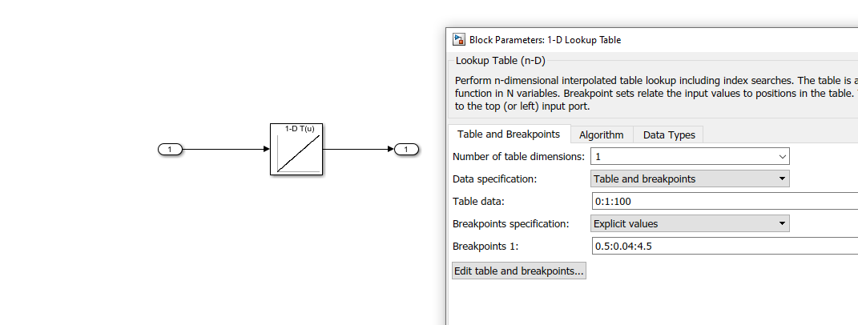

Fig 5.Temperature Subsystem Model

The automotive climate control model control works based on one of the input i.e Temperature sensor value which is analog in nature. We can achieve this using 1D lookup table which contain sensor VOLTAGE value range 0.5 to 4.5 and converted temperature range is 0 to 100 degree Celsius.

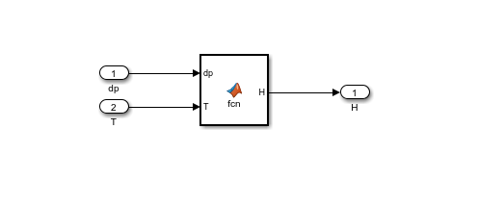

Fig 6.Humidity Subsystem Model

The automotive climate control model control works based on one of the input i.e Humidity sensor value which is analog in nature. If we know the dew point and temperature values we can calculate HUMIDITY

Es=6.11\*10\*(7.5\*T)

(237.3+T)

E=6.11\*10\*(7.5\*Td)

(237.3+Td)

HUMIDITY=(E/ES)\*100

Es-standard vapor pressure

T-air temperature

E-actual vapor pressure

Td-dew point

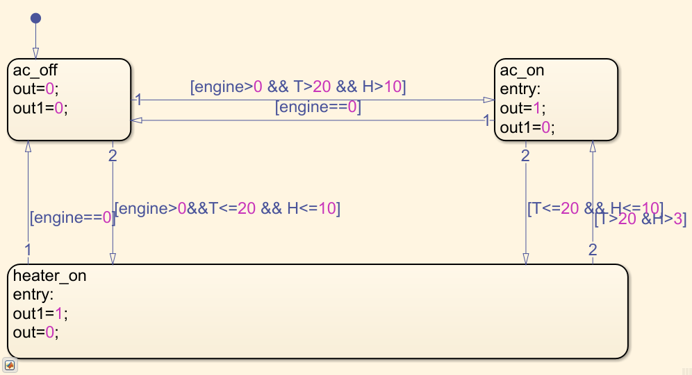

Fig 7.CAR Climate Control System Model

The main model is CAR cabinet climate model its engine and T(temperature) and H(humidity)are the inputs and out(ac control output) and out1(humidity control output) set the T and H THRESHOLD values.

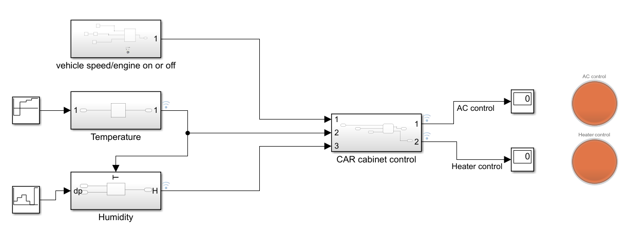

Fig 8.Automotive Climate Control Model when Engine Is Off

When the engine is OFF the AC control and Heater control are OFF

Irrespective of sensor values.

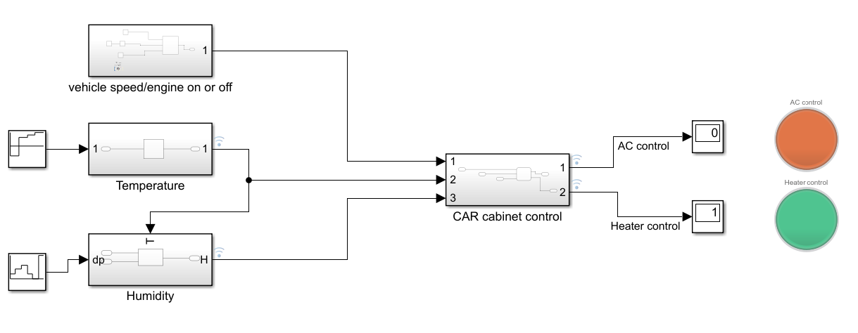

Fig 9.Automotive Climate Control Model when Engine Is ON

When the engine is ON the AC control and Heater control are ON with respective of temperature and humidity sensor values. In the above fig The climate is cold i.e Temperature and Humidity values are lower than the threshold values so controller should turn on the HEATER.

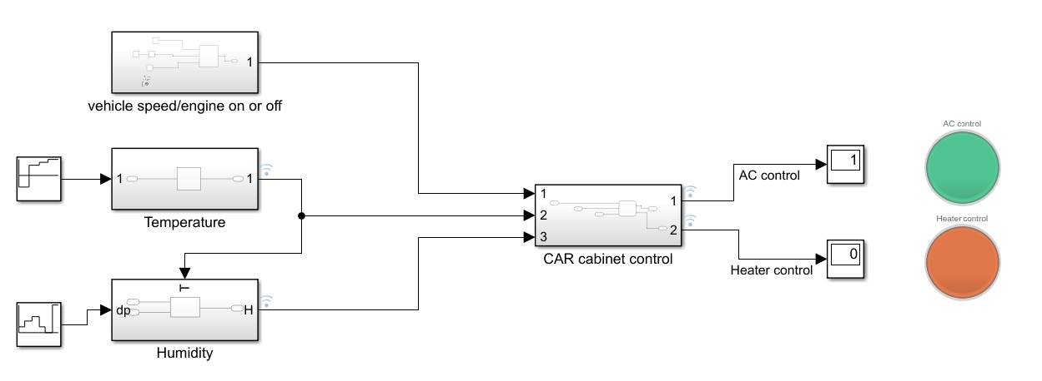

Fig 10.Automotive Climate Control Model when Engine Is ON

When the engine is ON the AC control and Heater control are ON with respective of temperature and humidity sensor values. In the above fig The climate is hot i.e Temperature and Humidity values are higher than the threshold values so controller should turn on the AC.

## Results:

## D:\1KPIT\MATLAB\controller_ENGINE _off.PNG

Fig 11.Automotive Climate Control Model when Engine Is OFF

When the engine is OFF the AC control and Heater control are OFF

Irrespective of sensor values.

## C:\Users\shweta\MATLAB\Projects\Problem17\HVAC_control.png

Fig 12.Automotive Climate Control Model when Engine Is ON

When the engine is ON the AC control and Heater control are ON with respective of temperature and humidity sensor values. If The climate is cold i.e Temperature and Humidity values are lower than the threshold values so controller should turn on the HEATER.

If The climate is hot i.e Temperature and Humidity values are higher than the threshold values so controller should turn on the AC.

## References:

## Toftum J. 2004. Air movement--good or bad? Indoor Air, 14(Suppl 7): 40-5.

Norin F., Wyon D.P. 1992. Driver vigilance—the effects of compartment temperature. SAE Technical

## Paper, 920168.

Galatsis K., Wlodarski W. 2006. Car Cabin Air Quality Sensors and Systems. in C. Grimes, E. Dickey,

## M Pishko (ed.) Encyclopedia of Sensors, 2 Ca-D: 1-11.

https:/www.edn.com/fundamentals-of-the-automotive-cabin-climate-control-system/

https:/www.wikihow.com/calculate-Humidity?amp=1

<https://in.mathworks.com>

<https://arketresearchfuture.com>