Minor Project-2 Mid Evaluation


For the partial fulfillment for the award of Degree of Bachelor of Technology (C.S.)
(Session: 2014 to 2018)

Project Title: Automated Fire Extinguishing System

Batch | Enrolment | Name | E-mail ID | Mb. No. | Supervisor
B10 | 14103057 | Supriya | Supriya.sahu650@gmail.com | 7042913845 | Mrs. Hema N.

Introduction:
Make a Fire Extinguishing System that would be installed in the building or in forests or in busy streets which would automatically select the extinguisher placed at one of the nodes and take it to the affected state.
The task planning in robotics/automated extinguisher should be informed efficiently due to the real time requirements of robot environments interactions.
To save the building from fire where human involvement becomes difficult, this method will securely send appropriate extinguishers[oil fire,normal fire etc] to the affected area in the shortest time using shortest distance.
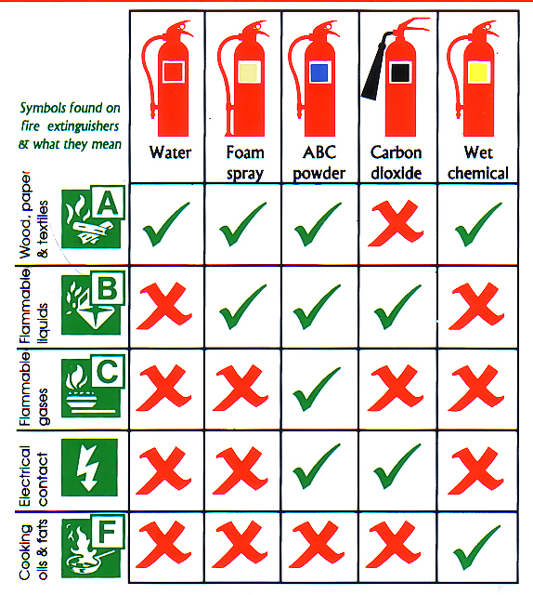
Whole system will be installed under ground, hence saving space.
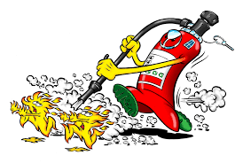

Literature Survey
Today our small world is evolving and developing automated machines at a very faster pace. One day I was sitting in my room and thinking on how to make this world a better place. That is when the Idea of making Automated fire EXtinguishing System popped up.
- I read mainly 2 research papers,the reference to which is given at the end of the file.
i. Cormen, Thomas H.; Leiserson, Charles E.; Rivest, Ronald L.; Stein, Clifford (2001). "Section 24.3: Dijkstra's algorithm". Introduction to Algorithms (Second ed.). MIT Press and McGraw–Hill. pp. 595–601. ISBN 0-262-03293-7.
ii. T. LozanoPerez and P. O’Donnell, “Parallel robot motion planning,” in Proc. IEEE Int. Conf. on Robotics and Automation, 1991, 1000-1007.
- Wikipedia.com and Geeksforgeeks were my sources to learn about the shortest path algorithms.
- www.arduino.cc Documentation.
- Master-Slave Technology, Motor Driver Board and its need.
- Wire and wireless Technology.

Development/Principle of Operation
I used the principle that fire emits Infrared Radiation.
- Robots loaded with fire extinguishers will be placed at various node of the map.
- Arduino Mega is used as the server and arduino unos will be used as slaves.
- Thermal Sensors will be installed at all the nodes. And these are connected with a single Arduino Mega which acts as a server.
- Server Uses Dijkastra Algorithm to find out shortest path and decide which Slave would be the best to serve in terms of distance from the affected area.
- Slave is made on a chasis which is equipped with a motor driver board, an arduino uno, wheels for movement. These are directly attached to the Mega which supplies them power.
- Slave will move to the affected place along with the cylinder.
- As it will reach the destination, the sensing will be done using IR-Sensor. The robot will turn in that direction and press the nozzel of Extinguisher. The knob will open automatically and it will extiguish the fire. As soon as the fire extinguishes it tuns off the nozzle.
- If the fire is more,server will sense it and decide the intensity of fire using temperature difference. In this case it will send more number of slaves and hence minimizing the loss.
- Slave will inform the server that the fire is extinguished.

PROBLEMS FACED AND WORK DONE
I am a newbie, how should I proceed? How will I implement Dijkastra algorithm on arduino IDE or how will my robot run with the hardware involved? Till now I had only seen working algorithm on the software.
Moreover, Dijkastra algorithm only takes a graph and fing the shortest distance from root to node. How will my robot find its path.
All these answers were solved once I started to work.
Problem 1 – Arduino IDE works on older version of C. This means I could not use Map, Stacks, Queues or any other STL Library on which all the programs noawadays are based.
Solution1 - It took me 7-8 days to fully understand the algorithm and write it from scratch using Structures and functions.
Problem 2 – Understanding Master and slave technology and implementing those.
Solution 2 – 2 Days. Internet was a good source. Moreover, Arduino documentation on web is phenomenal. Everything seems easy withh the Wire Library.
Problem 3 – Thermal Sensor attachment
Solution 3 – Hardware part was easy but implementing it with the shortest path algorithm was making it a bit complex.
Problem 4 – Implementation of Wire library.
Problem 5 – Receiving it on the other end using eventReceive() function. Storing the path in the array finding the directions of the movement of the robot was an exhausting and difficult task.
Solution 5 -It was solved by using various if...else statements and determining previous state.
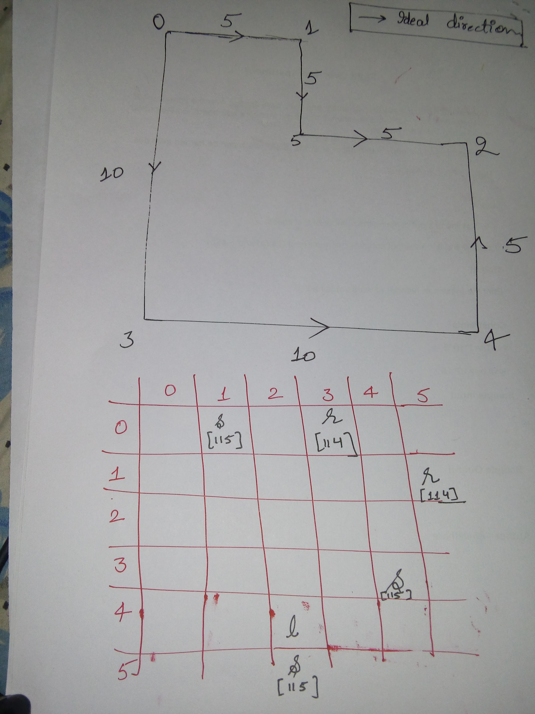
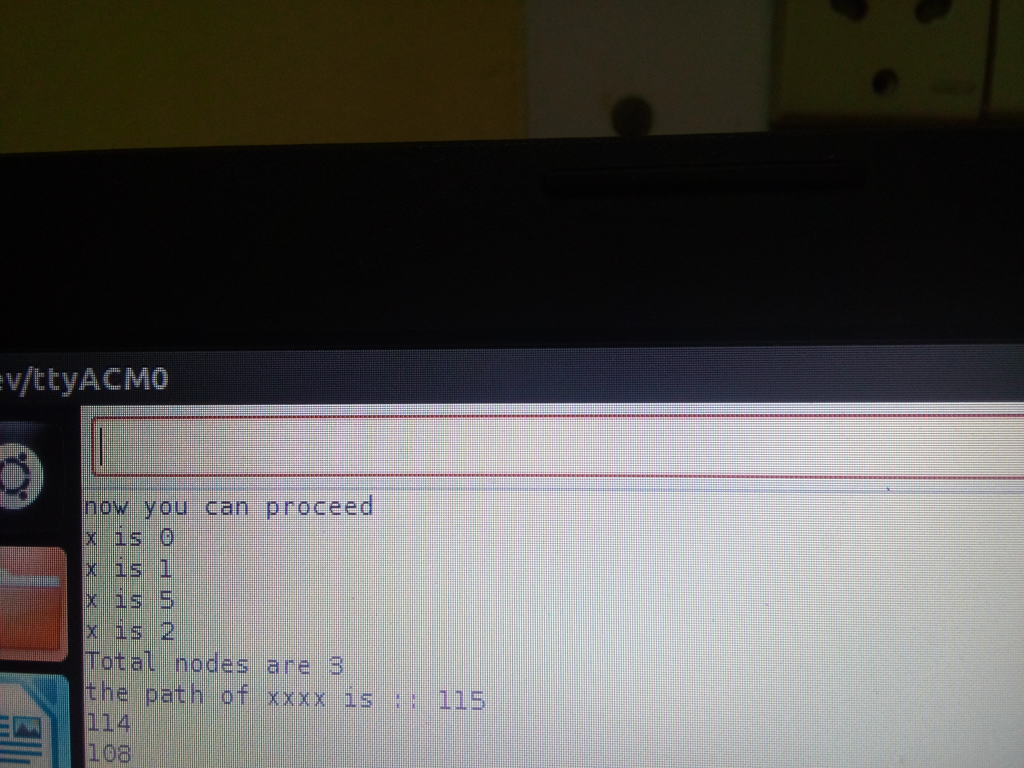
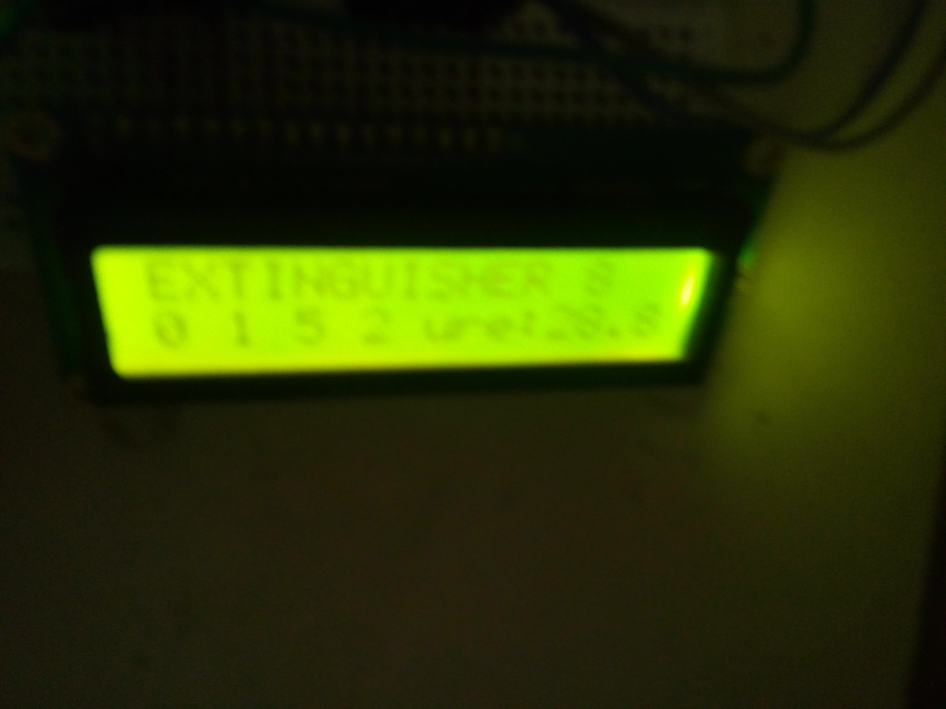
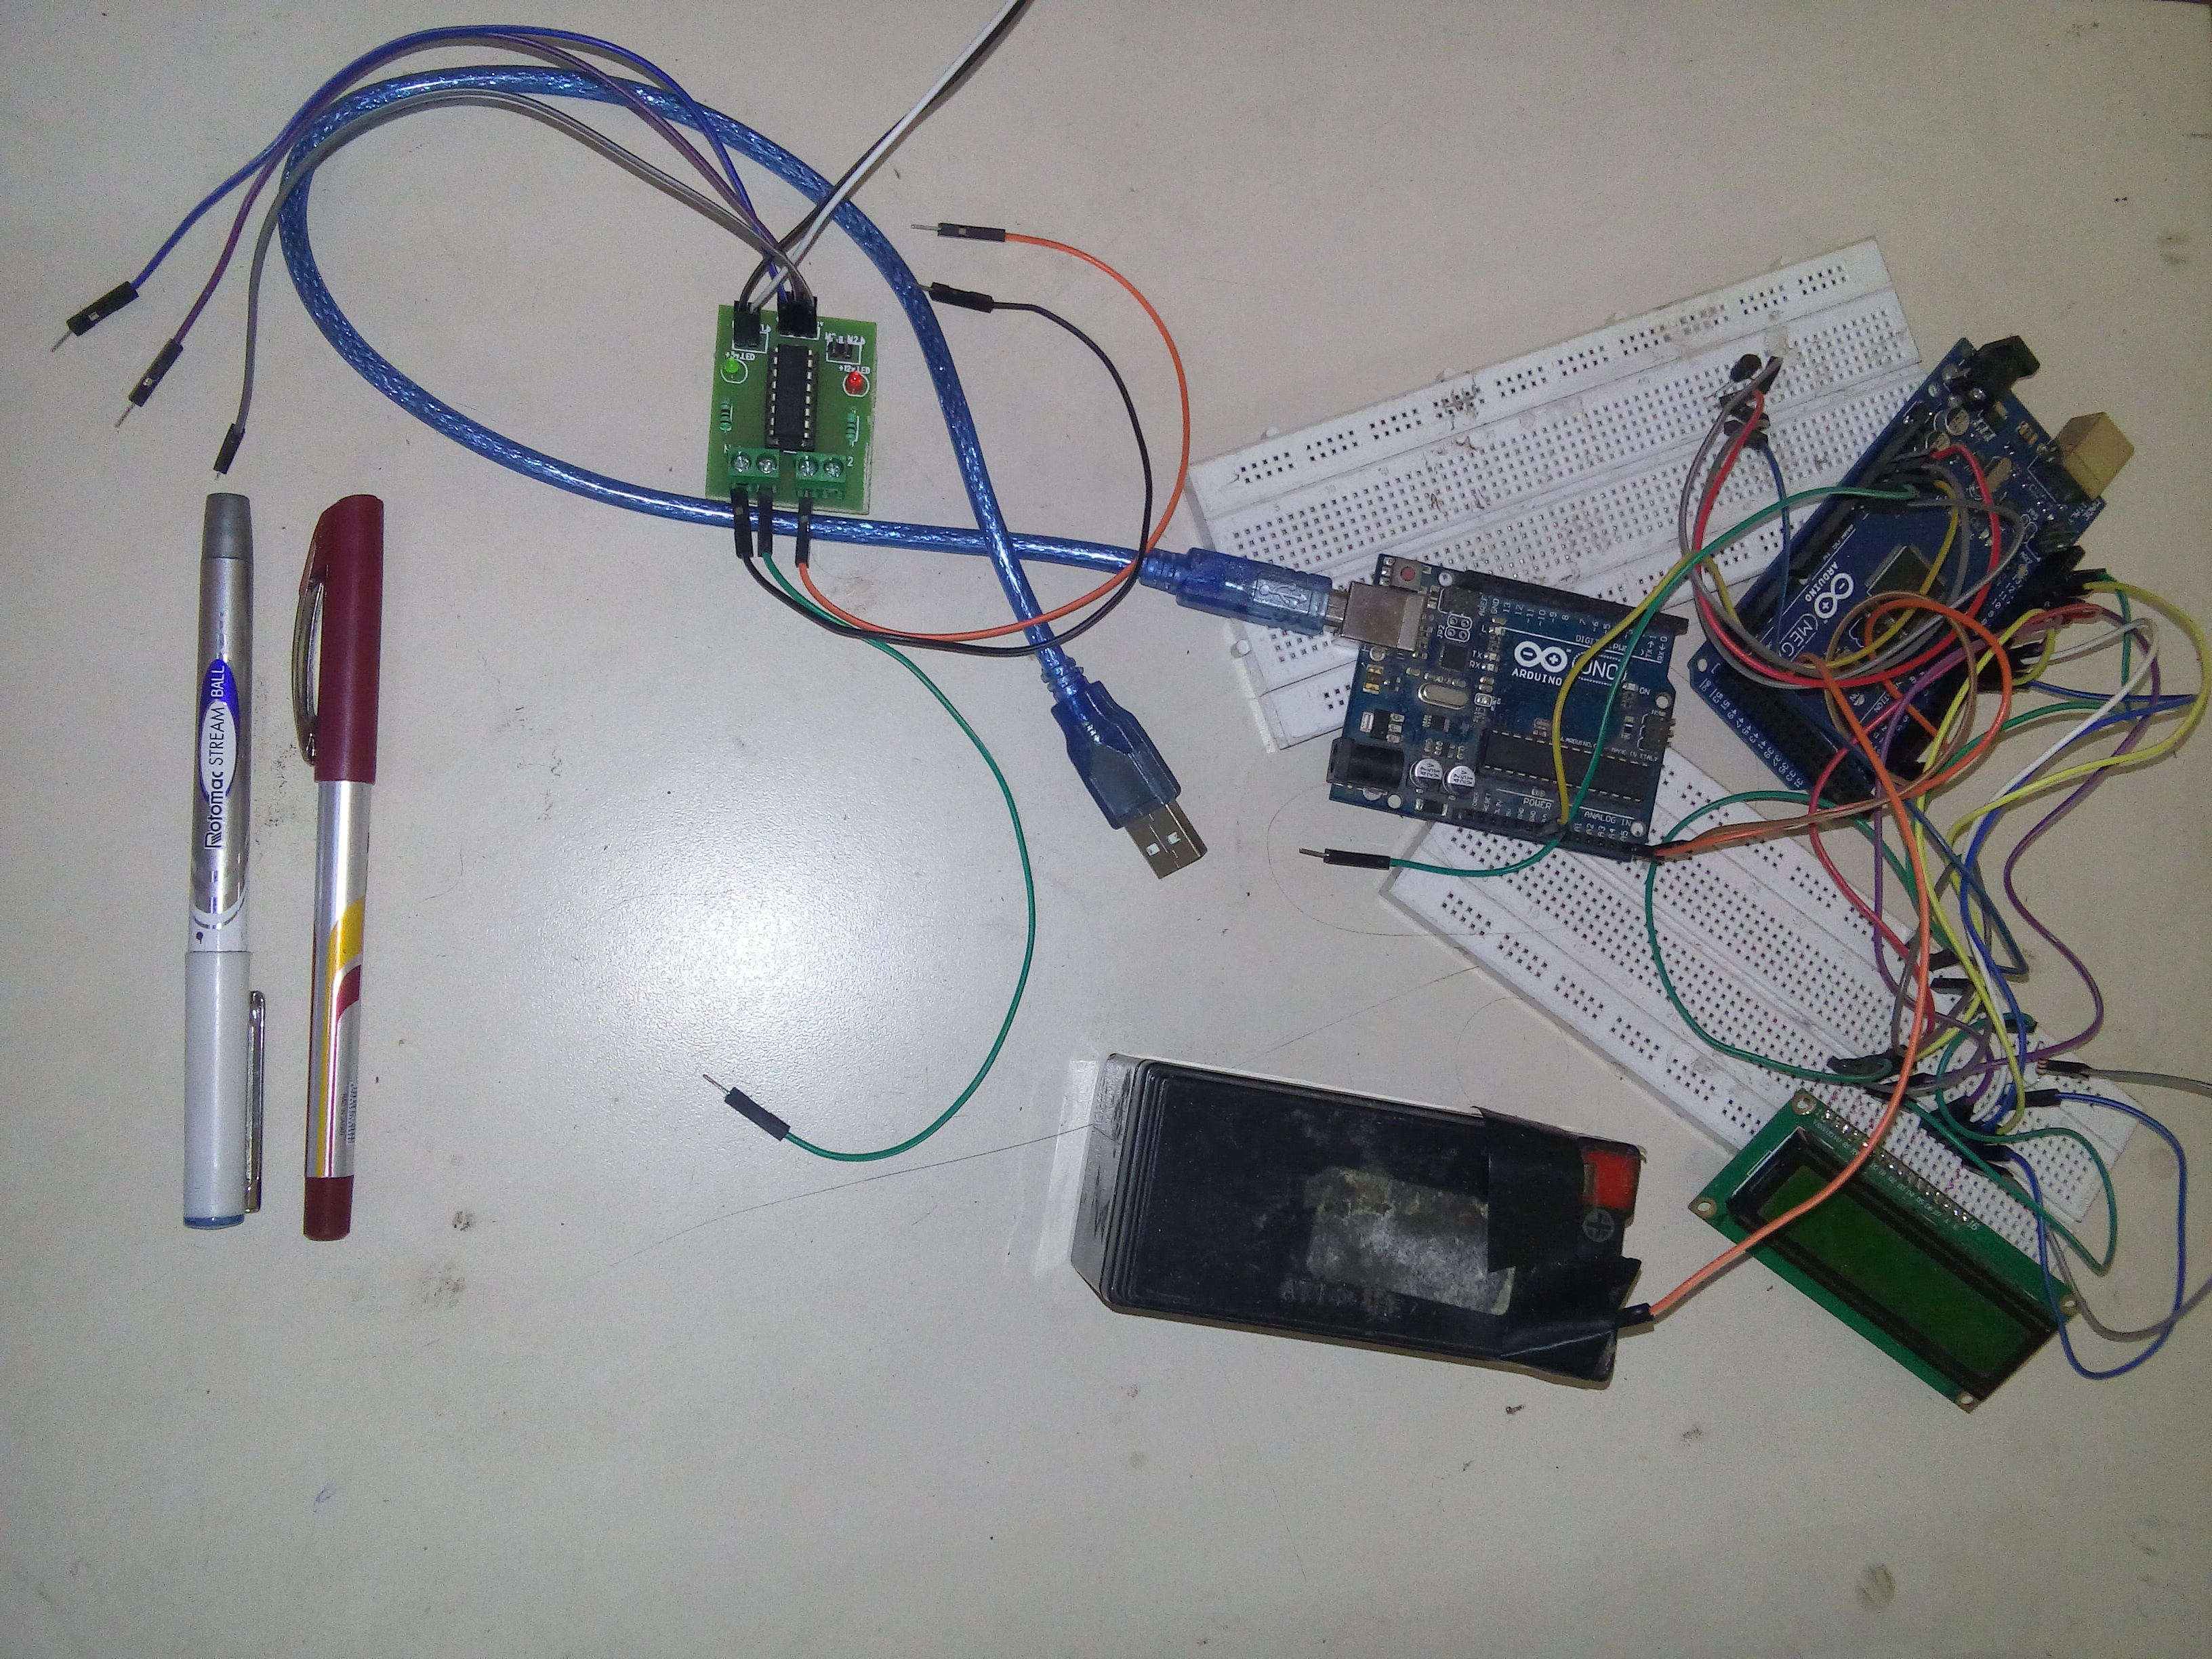
Computation part
Mathematical calculation was based on:
- Input of thermal Sensors.
- Map of the building and adjency matrix along with path matrix.

Hardware/Software Components used
- Thermal Sensor- used to keep an eye on temperature.
- IR- sensors – Used to find the direction of fire.
- Arduino Boards – This is equipped with microcontroller and is the heart of whole system.
- LCD – Used to display which slave is chosen and the path sent.
- Arduino IDE – To write the code.
- Battery – To supply current to the whole circuit.

Application
- Detect fire and extinguish it.
- Transport things at a lesser cost.
Industrial Relevance
The development of automated fire extinguisher signifies to control and prevent the fire in wild forest as well as commercial and residential complexes in the entire human community. This type of emerging robotic technology would help to save the life of human beings and also help to conserver the wild community without any severe economic losses. The robotic system to extinguish the fire in a residential area including the commercial places is better than the present smoke detectors along with the water sprinklers and chemical process.
Achievements
My paper based on this topic was selected in DTU Technical Fest to be presented.
Future work
- Server has to be connected with wireless technology to slaves.
- More slaves have to be connected.
- Map has to be more complex and better.

This is a very new idea and has not been implemented till date. Maybe If time and will permits, I will have my startup based on this project.
References
1. C. Chang, M. J. Chung, and B.H. Lee, “Collision avoidance of two robots
manipulators by minimum delay time.” IEEE Trans. Syst., Man Cybern., vol. 24 (3), 1994, 517-522.
2. T. LozanoPerez, “Spatial planning: A configuration space approach,” IEEE
Trans. Comput., vol. C-32, 1983, 108- 120.
3. T. LozanoPerez and P. O’Donnell, “Parallel robot motion planning,” in Proc.
IEEE Int. Conf. on Robotics and Automation, 1991, 1000-1007.
4. W. Newman and M. Branicky, “Real time configuration space transforms for
obstacle avoidance,” Int. J. Robot. Res., vol. 6 (10), 1991, 650-667.

