**RAD (Rapid Application Development) Model**

**RAD:** RAD means Rapid Application Development

**Diff B/w All other models and RAD model?**

* It is based on Prototype Model and Iterative model.
* It is Developed with no specific planning involved.
* It focuses on Gathering customer Requirements through Workshops or Focus groups.
* By using RAD model we can complete the project within Days fastly.
* The most important aspect for this model to be successful is to make sure that the prototypes developed are reusable.
* All stages are common in RAD model like other models. Here Modeling is divided into five stages .

Five Stages of RAD Model:

1. Communication

2. Planning

3. Modeling

a. Business Modeling

b. Data Modeling

c. Process Modeling

d. Application generation

e. Testing & Turn over.

4. Construction

5. Deployment

**Diagram Of RAD model:**

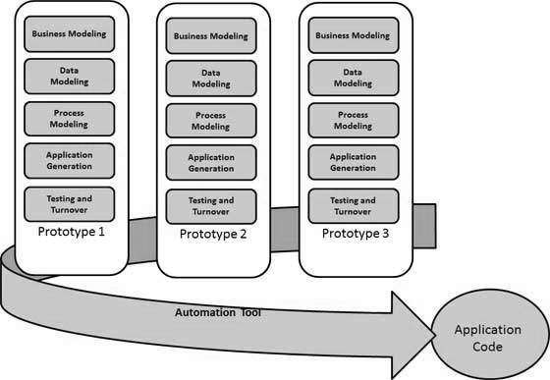

Following are the various phases of the RAD Model −

**Business Modelling**

The business model for the product under development is designed in terms of flow of information and the distribution of information between various business channels.

**Data Modelling**

The information gathered in the Business Modelling phase is reviewed and analyzed to form sets of data objects vital for the business. The attributes of all data sets is identified and defined. The relation between these data objects are established and defined in detail in relevance to the business model.

**Process Modelling**

The process model for any changes or enhancements to the data object sets is defined in this phase. Process descriptions for adding, deleting, retrieving or modifying a data object are given.

**Application Generation**

The actual system is built and coding is done by using automation tools to convert process and data models into actual prototypes.

**Testing and Turnover**

The overall testing time is reduced in the RAD model as the prototypes are independently tested during every iteration.

**where RAD can be used ?**

* RAD should be used only when a system can be modularized to be delivered in an incremental manner.
* It should be used if there is a high availability of designers for Modelling.
* It should be used only if the budget permits use of automated code generating tools.
* RAD SDLC model should be chosen only if domain experts are available with relevant business knowledge.
* Should be used where the requirements change during the project and working prototypes are to be presented to customer in small iterations of 2-3 months.

**ADVANTAGES OF THE RAD MODEL :**

1. Changing requirements can be accommodated.
2. Progress can be measured.
3. Iteration time can be short with use of powerful RAD tools.
4. Productivity with fewer people in a short time.
5. Reduced development time.
6. Increases reusability of components.
7. Encourages customer feedback.

**DISADVANTAGES OF THE RAD MODEL :**

1. Only system that can be modularized can be built using RAD.
2. Requires highly skilled developers/designers.
3. High dependency on Modelling skills.
4. Inapplicable to cheaper projects as cost of Modelling and automated code generation is very high.
5. Management complexity is more.
6. Requires user involvement throughout the life cycle.
7. Suitable for project requiring shorter development times.