**Lab-2: Empathy Map**

**Date :**   
**Aim:** To create an Empathy Map for university professors.  
**Tools:** UXPressia Tool

**Procedure:**

1. Open the UXPressia tool.
2. Click on **Find** and go to the **Persona** tab.
3. Find the **Empathy Map** template.
4. Click **Add** to fill and edit it in your workspace.
5. Fill in the respective fields with appropriate answers.

**Objective:**

* To articulate what we know about a particular type of user — a university professor.
* To provide a glance into who a user is as a whole.

**Conclusion:**  
Using UXPressia, we created an empathy map on university professors to understand their needs and behaviors.

**ii) Persona**

**Aim:** To create a persona based on your interests.

**Tools:** UXPressia Tool

**Procedure:**

1. Open the UXPressia tool.
2. Click on **Add new** and go to the **Persona** tab.
3. Find the persona template and click on **Add to Workspace**.
4. An empty grid will open — this is your persona template.
5. Add a name to your persona. This should be a clear and concise name that accurately identifies the user.
6. Add a photo that reflects the persona, along with other information related to your persona.
7. Review and finalize your persona.

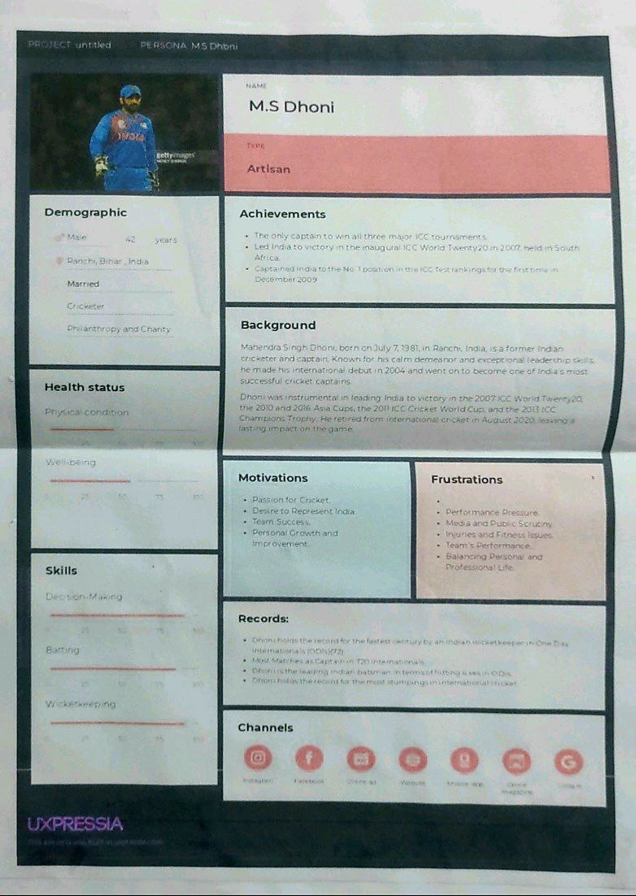

**Conclusion:**

Using UXPressia, we created a persona.