Comparison of implementations of Kruskal's Algorithm using van Emde Boas tree, Binomial Heap and Fibonacci heap

Rajat Kumar Verma & Supriya Priyadarshani
International Institute of Information Technology, Hyderabad

Deliverables

1. Studied the recursive data structure of Van Emde Boas Tree.

2. Implemented the insert() function of VEB tree.

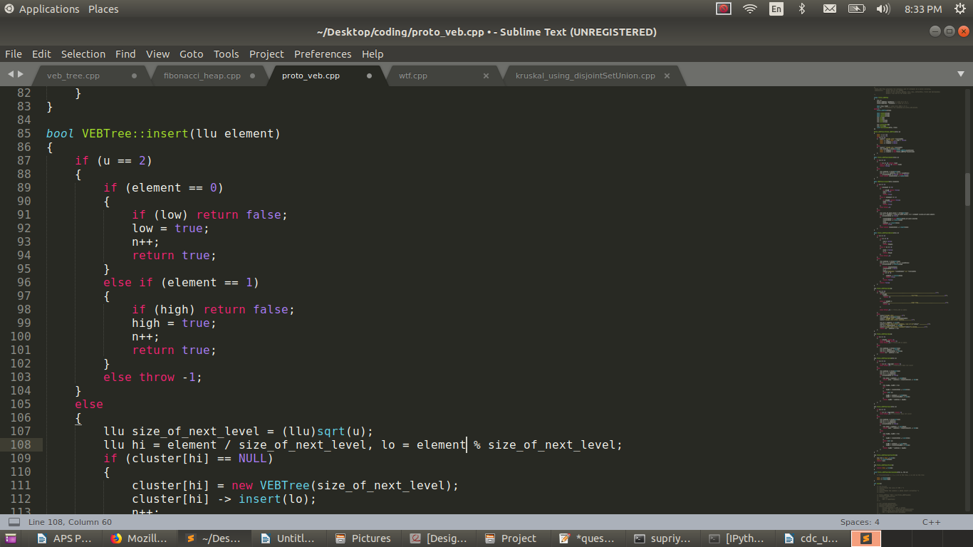

Time Complexity for insert is O(log log u).
‘u’ is the universe, that is the total number of elements currently present in the array.
The size of array is always taken of the order (2²)^{k} because at every upper level during
recusrsive call, the clusters are divided into u^{1/2} clusters.

3. Implemented Kruskal using Fibonacci Heap.

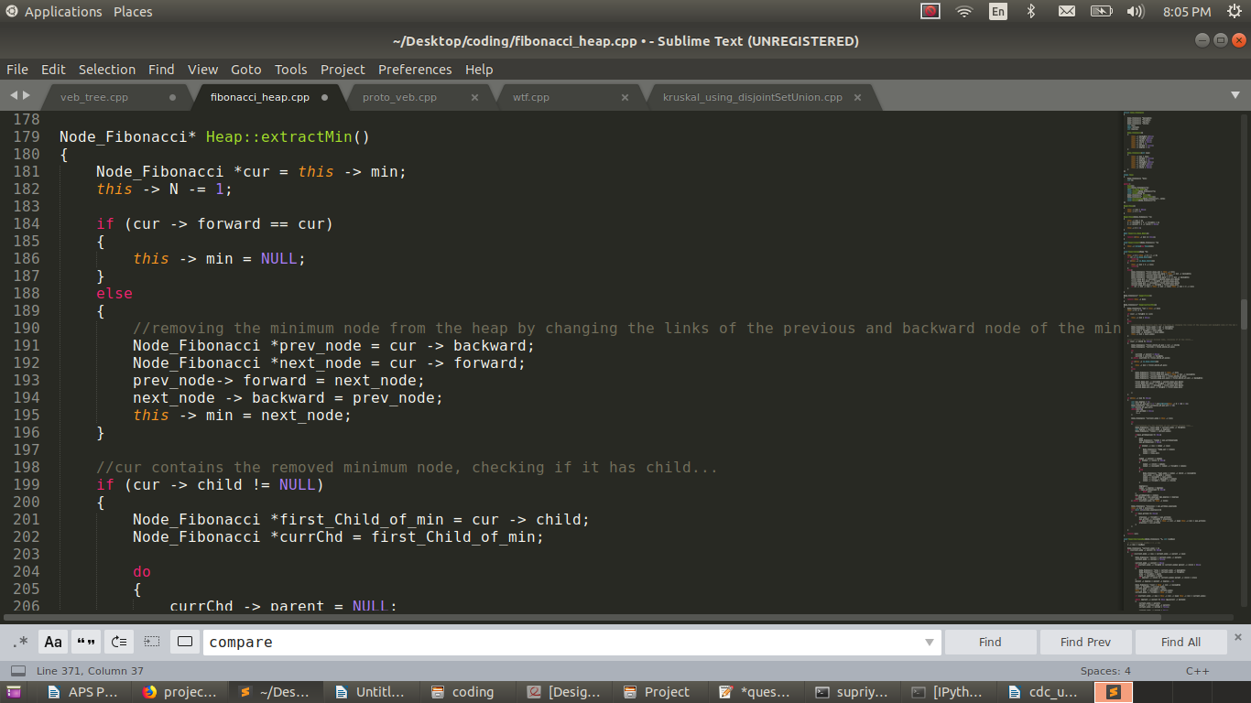
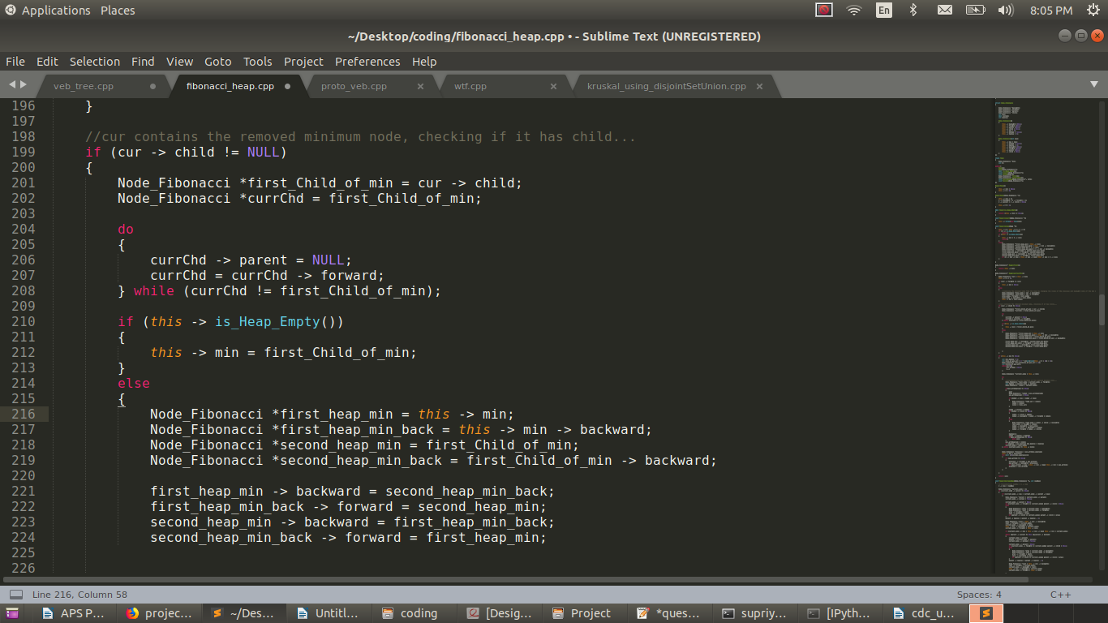
Above is the snapshot of a part of extractMin() function of Fibonacci Heap which takes O(log n) time to extract the current minimum from the heap. Repeating the process for ‘n’ number of times, returns us the sorted form of the input array which will take O(n log n) time. Other functions of Fibonacci Heap, like, insert, first and merge take O(1) time and, decreasKey() function O(1) time (ammortized cost) .

Ammortized cost = actual cost + change in potential cost.

Project Delivery Plan

1. Implementation of Fibonacci Heap and using the insert() and extract_min() operations implement Kruskal.

2. Implementation of Ven Emde Boas Tree and using the insert(), delete() and extract_min() operations implement Kruskal.

3. Implementation of Binomial Heap and using the insert() and extract_min() operations implement Kruskal.

4. Study and compare the time complexities of all the implementations.

Technology Used

Plotly API

Git Repository

Comparison_Of_Algorithms

Testing Plan

Testing with the integer array of size greater than the size of RAM.

End User Documentation

There will be a menu provided to the user displaying options for comparison amongst the three algorihtms on different parameters .

October 23, 2018

