WEEK 3: ADVANCED DATA ANALYSIS AND VISUALIZATION IN LOGISTICS
Exploratory Analysis of a Hypothetical Shipment Dataset

1. Executive Summary
This report analyzes 500 simulated shipments to demonstrate how exploratory data analysis (EDA) supports logistics decisions. The variables include distance, shipment volume, delivery duration, planned duration, transport cost, transport mode, and region. After median imputation and IQR-based capping of extreme delivery-time and cost values, the on-time delivery rate is 45.8%, mean delivery time is 4.66 days, and mean transport cost is $40.33. These are simulated results for academic practice, not actual carrier performance.

2. Scenario and Objectives
A regional e-commerce distributor dispatches orders to North, South, East, and West using road, rail, and air transport. Managers want to understand delivery variability, cost drivers, and regional performance so they can make better routing and service-level decisions.
- Calculate central tendencies, distributions, and correlations.
- Compare average transport cost and delivery time across transport modes.
- Compare on-time performance by region.
- Identify data quality issues and explain cleaning decisions.
- Translate the findings into measurable logistics recommendations.

3. Dataset Structure
The hypothetical dataset contains 500 shipment records. Each row represents one shipment. Missing values and several extreme values were deliberately introduced to simulate practical data-quality challenges.
Variable | Type | Meaning
Shipment_ID | Identifier | Unique shipment reference
Region | Category | Operating region
Transport_Mode | Category | Road, Rail, or Air
Distance_km | Numeric | Route distance
Shipment_Volume_m3 | Numeric | Shipment volume
Delivery_Days | Numeric | Actual duration
Planned_Days | Numeric | Planned duration
Transport_Cost_USD | Numeric | Simulated transportation cost

4. Data Cleaning and Methodology
Duplicate shipment IDs were checked and removed. Missing numeric values in delivery time, transport cost, and volume were filled using each column's median. The median was chosen because it is less sensitive to extreme values than the mean. The IQR rule was then used to flag extreme delivery-time and cost observations; values outside the bounds were capped rather than deleting entire shipments. In real operations, such observations should be investigated because they may be data errors or genuine disruptions.
import pandas as pd
df = pd.read_csv("Week_3_Hypothetical_Logistics_Dataset.csv")
df = df.drop_duplicates(subset=["Shipment_ID"])
for col in ["Delivery_Days", "Transport_Cost_USD",
"Shipment_Volume_m3"]:
df[col] = df[col].fillna(df[col].median())
for col in ["Delivery_Days", "Transport_Cost_USD"]:
q1, q3 = df[col].quantile([0.25, 0.75])
iqr = q3 - q1
lower = max(0, q1 - 1.5 * iqr)
upper = q3 + 1.5 * iqr
df[col] = df[col].clip(lower, upper)
df["Delay_Days"] = (
df["Delivery_Days"] - df["Planned_Days"]
).clip(lower=0)
df["On_Time"] = (
df["Delivery_Days"] <= df["Planned_Days"]
).astype(int)

5. Descriptive Statistics
Mean describes the arithmetic average, while the median is the middle value and is more robust to skew. Both statistics are reported to avoid describing logistics performance with a single number.
Metric | Mean | Median
Distance (km) | 414.26 | 365.20
Volume (m³) | 8.97 | 8.22
Delivery time (days) | 4.66 | 4.68
Cost (USD) | 40.33 | 35.21
Delay (days) | 0.53 | 0.12
Overall on-time delivery rate: 45.8%. It is calculated as shipments delivered on or before planned duration divided by all shipments, multiplied by 100.

6. Visualizations and Interpretation
Figure 1. Delivery-time distribution. A histogram shows the typical delivery range, spread, skew, and potential long-duration shipments.
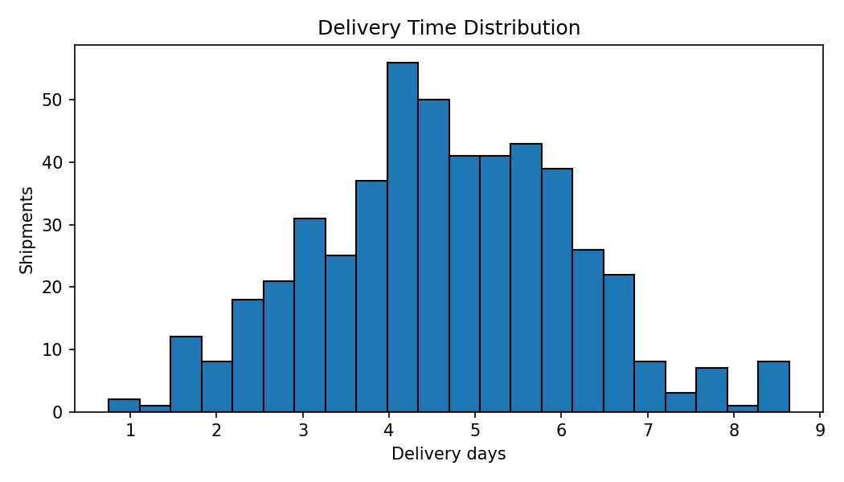
Interpretation: Mean delivery time is 4.66 days and median is 4.68 days. If the mean exceeds the median, relatively slow shipments pull the average upward. The distribution supports reporting percentiles and mode/region breakdowns rather than relying on one average.
Figure 2. Average transport cost by mode. A bar chart compares categories clearly.
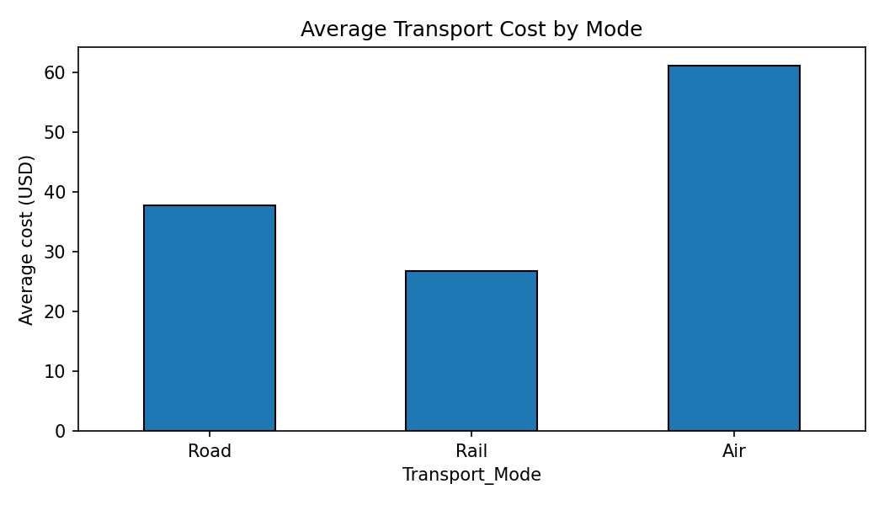
Average cost and mean delivery time by mode:
Mode | Count | Mean cost (USD) | Mean days
Road | 325 | $37.76 | 4.72
Rail | 82 | $26.85 | 5.76
Air | 93 | $61.18 | 3.48
Interpretation: Air is expected to cost more per shipment in this simulated scenario, while it is generally faster. Mode selection should balance urgency, service requirements, volume, and total cost rather than choosing the cheapest option for every shipment.
Figure 3. Distance versus transport cost. A scatter plot displays the relationship between two numerical variables and reveals clusters or unusual observations.
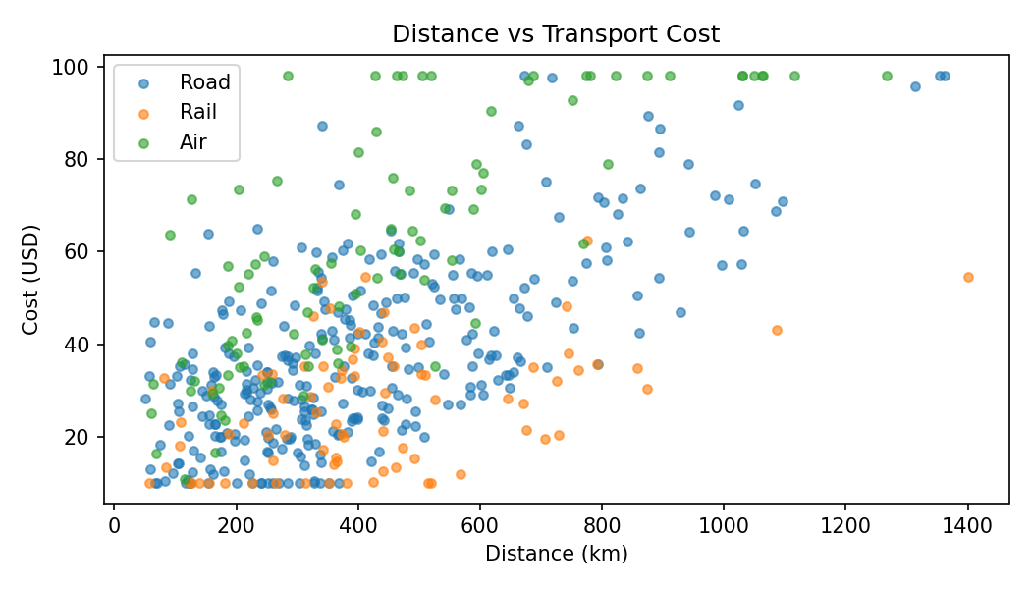
Interpretation: Pearson correlation between distance and cost is 0.60. A positive relationship indicates that longer routes tend to cost more in this simulated data. Different transport modes create different cost patterns.
Figure 4. On-time delivery by region. This chart compares the same KPI across operating regions.
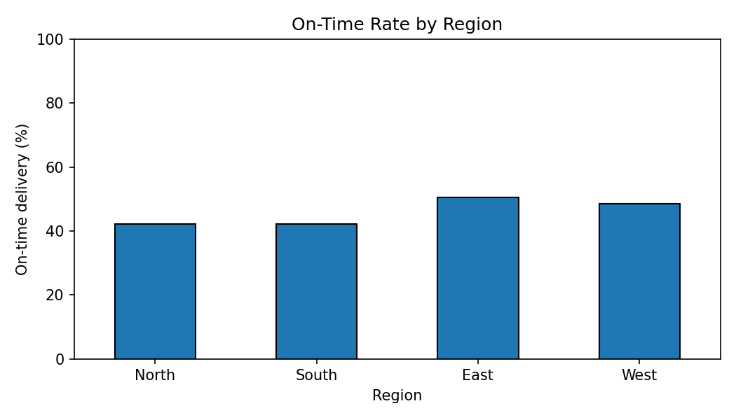
Regional on-time rates: North: 42.1%; South: 42.1%; East: 50.4%; West: 48.5%. A lower rate is a signal to investigate carrier, route, dispatch timing, or distance; it does not by itself prove the cause.
Figure 5. Correlation matrix. A heatmap summarizes pairwise linear relationships. Values near +1 are positive, near −1 are negative, and near 0 indicate weak linear relationships.
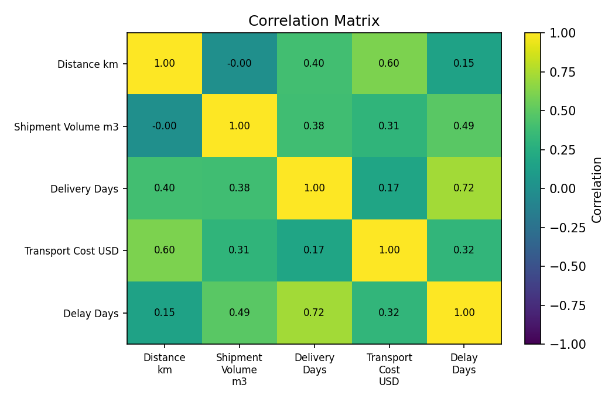
Selected correlations: distance vs cost = 0.60; distance vs delivery time = 0.40; delivery time vs delay = 0.72. Correlation does not establish causation.

7. Python EDA Code
import pandas as pd
import matplotlib.pyplot as plt
df = pd.read_csv("Week_3_Hypothetical_Logistics_Dataset.csv")
print(df[["Distance_km", "Shipment_Volume_m3",
"Delivery_Days", "Transport_Cost_USD"]].describe())
print(df.isnull().sum())
print(df.groupby("Transport_Mode")[
["Delivery_Days", "Transport_Cost_USD"]].mean())
plt.hist(df["Delivery_Days"].dropna(), bins=20)
plt.xlabel("Delivery days")
plt.ylabel("Shipment count")
plt.title("Delivery Time Distribution")
plt.show()
plt.scatter(df["Distance_km"], df["Transport_Cost_USD"])
plt.xlabel("Distance (km)")
plt.ylabel("Cost (USD)")
plt.show()
print(df[["Distance_km", "Delivery_Days",
"Transport_Cost_USD"]].corr())

8. Clustering and Optimization Extension
Clustering can group shipments by distance, volume, delivery time, and cost. For a first experiment, standardize these variables and apply K-Means with k=3. Inspect the cluster means before naming the groups; possible interpretations could be local/light, medium-distance/standard, and long-distance/high-cost shipments, but the labels must be supported by actual cluster centers.
from sklearn.preprocessing import StandardScaler
from sklearn.cluster import KMeans
features = ["Distance_km", "Shipment_Volume_m3",
"Delivery_Days", "Transport_Cost_USD"]
X = clean[features]
X_scaled = StandardScaler().fit_transform(X)
model = KMeans(n_clusters=3, random_state=42, n_init=10)
clean["Cluster"] = model.fit_predict(X_scaled)
print(clean.groupby("Cluster")[features].mean().round(2))
Optimization can be framed as minimizing total transport cost while meeting delivery deadlines and mode-capacity limits. Each shipment should receive exactly one mode; urgent shipments must meet their deadline; and the total volume assigned to each mode must not exceed capacity. Before claiming savings, compare the optimized allocation with the current baseline using both total cost and on-time rate.

9. Key Findings and Recommendations
- On-time delivery rate is 45.8% in the simulated dataset; use it as the baseline KPI.
- Mean delivery time is 4.66 days and median is 4.68 days; the gap helps reveal skew.
- Distance-cost correlation is 0.60, so distance is useful for preliminary cost planning.
- Compare transport modes on both cost and delivery speed; a low-cost option may be unsuitable for urgent consignments.
- Investigate regional differences before changing carrier or route policies.
- Preserve raw data and document imputation and outlier decisions.
- Collect carrier, dispatch time, traffic/weather, promised timestamps, fuel cost, and capacity utilization to explain performance more accurately.

10. Limitations
The dataset is simulated and does not represent an actual carrier. IQR capping can reduce the influence of genuine extreme shipments. Correlation does not prove causation. The data does not include carrier identity, traffic, weather, shipment priority, or true capacity constraints, so it cannot establish the cause of delays or prove cost savings.

11. Conclusion
This analysis demonstrates how descriptive statistics, histograms, bar charts, scatter plots, and correlation matrices can turn shipment data into actionable operational questions. The numerical results provide a baseline for delivery performance, identify cost patterns, and highlight regions for further investigation. Clustering and optimization are proposed as next steps, with clear validation requirements. Applying this workflow to real, validated logistics data would help managers test improvements using measurable KPIs instead of assumptions.

References
McKinney, W. (2022). Python for Data Analysis (3rd ed.). O'Reilly Media.
Hunter, J. D. (2007). Matplotlib: A 2D graphics environment. Computing in Science & Engineering, 9(3), 90–95.
Pedregosa, F., et al. (2011). Scikit-learn: Machine Learning in Python. Journal of Machine Learning Research, 12, 2825–2830.
Dataset note: all 500 records and resulting metrics are simulated for academic practice.

