WEEK 4: PREDICTIVE MODELING AND OPTIMIZATION IN LOGISTICS SYSTEMS
Forecasting Shipment Delivery Time and Supporting Operational Decisions

1. Executive Summary
This report builds and evaluates models to estimate shipment delivery time from logistics characteristics. The dataset contains 788 simulated shipments with distance, volume, transport mode, region, priority, traffic, weather, planned delivery duration, and transport cost. Linear Regression is compared with Random Forest using an 80/20 train-test split and five-fold cross-validation on the training data. The selected model is Linear Regression, with test MAE 0.57 days, RMSE 0.77 days, and R² 0.662. These are simulated results and do not represent real carrier performance.

2. Problem Definition
Logistics teams need to estimate delivery duration early enough to plan dispatches, inform customers, and intervene on shipments likely to miss a planned delivery window. This project predicts Delivery_Days, a continuous target, from shipment and operating features. The output is a predicted duration and a rule-based late-risk flag when the prediction exceeds Planned_Days.
- Forecast delivery time from known operational features.
- Compare a simple baseline model with a non-linear ensemble model.
- Evaluate predictions with MAE, RMSE, and R².
- Translate model outputs into risk-based operational review and cost/service optimization.

3. Dataset and Features
The hypothetical dataset originally contains 800 rows. Missing values were deliberately introduced in traffic level, shipment volume, and delivery time, and several extreme delivery times were added. Rows with missing target values are excluded from supervised model fitting because the true outcome is unknown; missing predictor values are handled inside the model pipeline.
Feature | Type | Role
Distance_km | Numeric | Route length
Shipment_Volume_m3 | Numeric | Shipment size
Transport_Mode | Category | Road, Rail, Air
Region | Category | Operating region
Priority | Category | Standard, Express, Urgent
Traffic_Level | Category | Traffic conditions
Weather | Category | Weather conditions
Planned_Days | Numeric | Planned duration / threshold
Transport_Cost_USD | Numeric | Estimated cost
Delivery_Days | Numeric | Prediction target
Shipment_ID is excluded because it is only an identifier. All data is simulated for academic demonstration.

4. Data Preparation
Numeric predictors are imputed with their median and standardized. Categorical predictors are imputed with their most frequent category and one-hot encoded. These transformations are inside a Scikit-learn Pipeline fitted only on training data, preventing preprocessing information from leaking from the test set. Rows without Delivery_Days are omitted from training and evaluation because the target cannot be reliably guessed.
X = df.drop(columns=["Shipment_ID", "Delivery_Days"])
y = df["Delivery_Days"]
X_train, X_test, y_train, y_test = train_test_split(
X, y, test_size=0.20, random_state=42
)
numeric_features = [
"Distance_km", "Shipment_Volume_m3",
"Planned_Days", "Transport_Cost_USD"
]
categorical_features = [
"Region", "Transport_Mode", "Priority",
"Traffic_Level", "Weather"
]
numeric_pipe = Pipeline([
("imputer", SimpleImputer(strategy="median")),
("scaler", StandardScaler())
])
categorical_pipe = Pipeline([
("imputer", SimpleImputer(strategy="most_frequent")),
("onehot", OneHotEncoder(handle_unknown="ignore"))
])
preprocess = ColumnTransformer([
("num", numeric_pipe, numeric_features),
("cat", categorical_pipe, categorical_features)
])

5. Model Selection
Linear Regression is an interpretable baseline. Random Forest is an ensemble of decision trees that can capture non-linear relationships and interactions, such as traffic affecting long road shipments differently from air shipments. Comparing a baseline and an ensemble provides evidence for model choice.
linear_model = Pipeline([
("prep", preprocess),
("model", LinearRegression())
])
forest_model = Pipeline([
("prep", preprocess),
("model", RandomForestRegressor(
n_estimators=200, min_samples_leaf=2,
random_state=42, n_jobs=-1
))
])
linear_model.fit(X_train, y_train)
forest_model.fit(X_train, y_train)

6. Evaluation and Validation
MAE is the average absolute error in days. RMSE also measures error in days but penalizes larger mistakes more heavily. R² compares model performance with a simple mean-prediction baseline; higher is generally better, but a negative test R² means the model performs worse than that baseline on the test sample.
Model | Test MAE (days) | Test RMSE (days) | Test R²
Linear Regression | 0.566 | 0.767 | 0.662
Random Forest | 0.686 | 0.881 | 0.554
Linear Regression had the lower test RMSE in this run. Five-fold cross-validation MAE on the training set averaged 0.613 days (standard deviation 0.047). The held-out test set was not used to fit model parameters.
for name, model in [
("Linear Regression", linear_model),
("Random Forest", forest_model)
]:
pred = model.predict(X_test)
print(name,
"MAE:", mean_absolute_error(y_test, pred),
"RMSE:", mean_squared_error(y_test, pred) ** 0.5,
"R2:", r2_score(y_test, pred))
cv = KFold(n_splits=5, shuffle=True, random_state=42)
scores = cross_val_score(
best, X_train, y_train,
cv=cv, scoring="neg_mean_absolute_error"
)
print("Cross-validation MAE:", -scores.mean())

7. Model Performance Visualizations
Figure 1 compares test RMSE. Lower bars indicate smaller errors, with greater penalty for large misses.
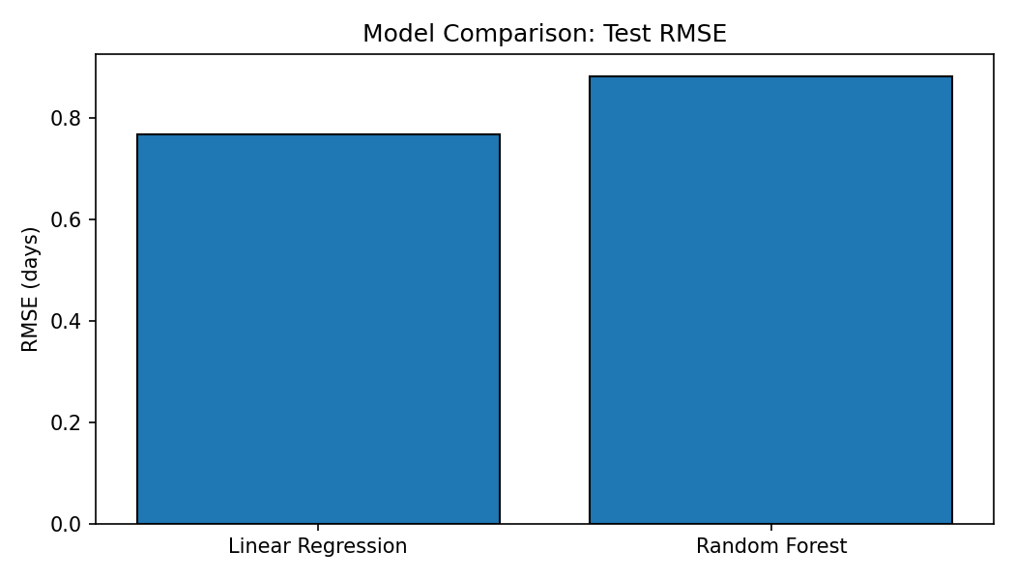
Figure 2 plots actual versus predicted delivery times. Points close to the diagonal indicate more accurate predictions; systematic differences suggest bias.
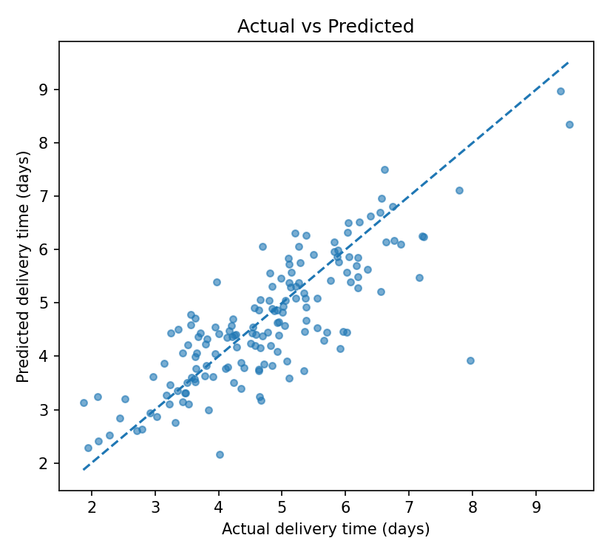
Figure 3 shows residuals (actual minus predicted). Residuals centered near zero suggest limited average bias; long tails can reveal shipment cases the model struggles to predict.
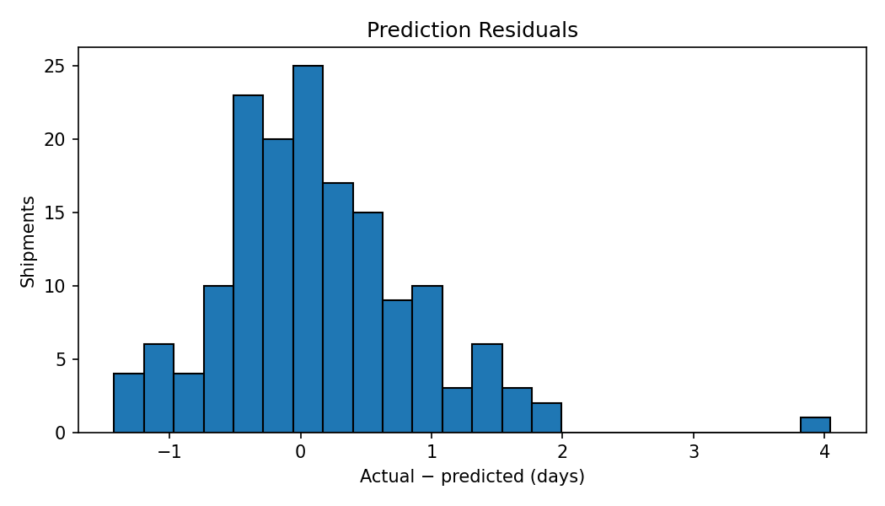

8. Using Predictions to Identify Late Risk
In the held-out test sample, 44.9% of shipments were flagged as potentially late because predicted delivery duration exceeded the planned duration. The actual share exceeding planned duration was 48.7%. This is a rule-based screening flag, not a calibrated probability of lateness. A production system should measure alert precision/recall or train a dedicated late/not-late classifier if that is the main business objective.
predicted = best.predict(X_test)
risk = X_test.copy()
risk["Predicted_Delivery_Days"] = predicted
risk["Predicted_Late_Risk"] = (
risk["Predicted_Delivery_Days"] > risk["Planned_Days"]
)
print(risk["Predicted_Late_Risk"].mean() * 100)

9. Optimization Strategies
Predictive modeling estimates likely outcomes; optimization chooses actions under constraints. The recommendations below should be piloted and evaluated, not treated as guaranteed savings.
- Risk-based exception management: prioritize urgent shipments predicted to exceed the planned duration, then review alternatives with dispatch staff.
- Transport-mode selection: compare predicted delivery duration and cost for road, rail, and air. Reserve expensive express modes for cases where meeting the deadline justifies the premium.
- Route and dispatch planning: use traffic and weather features to consider alternate routes or departure windows when route-level alternatives are available.
- Capacity allocation: reserve limited express/air capacity for high-priority or high-delay-risk shipments.
- Cost-service trade-off: minimize total transportation cost subject to a target on-time rate, delivery deadlines, and mode capacity limits.
- Monitor weekly: track MAE, RMSE, on-time rate, and cost per shipment; retrain only after checking data quality and drift.

10. Conceptual Optimization Formulation
Let x(i,m) equal 1 if shipment i is assigned to transport mode m and 0 otherwise. Minimize total assigned cost: sum(cost(i,m) × x(i,m)). Constraints require each shipment to receive one mode, urgent shipments to meet their deadline, and total assigned volume for each mode to remain within capacity. Implementation requires reliable cost and duration estimates for each feasible shipment-mode option.
# Conceptual optimization constraints
# Minimize sum(cost[i, mode] * x[i, mode])
# Each shipment receives exactly one mode:
# sum_mode x[i, mode] == 1
# Urgent shipment duration <= its deadline
# Assigned volume per mode <= mode capacity
# x[i, mode] is binary (0 or 1)

11. Implementation Roadmap
- Collect real historical shipment, route, carrier, cost, traffic, weather, and delivery records.
- Validate units, timestamps, missingness, and extreme observations.
- Use a pipeline and split data before fitting preprocessing steps.
- Compare a simple baseline with stronger models using MAE, RMSE, R², and cross-validation.
- Inspect errors by region and transport mode before deployment.
- Pilot risk alerts and mode recommendations with human review.
- Compare cost and service KPIs against a baseline before scaling the optimization.

12. Limitations and Risk Controls
- All records and reported metrics are simulated; performance must be verified on real data.
- Transport cost is included as a predictor; it should only be used if known at prediction time. Otherwise replace it with a dispatch-time estimate or remove it.
- A random split is used for this independent simulated-shipment exercise; real deployment should use a time-based test split.
- Median imputation can hide data-quality problems and should be monitored.
- Prediction quality may vary by region and mode; subgroup evaluation is necessary.
- Predicted duration above a deadline is a simple risk flag, not a calibrated probability.
- Optimization requires real alternatives, prices, deadlines, and capacity constraints.

13. Conclusion
This report demonstrates a predictive modeling workflow for delivery-time estimation. Linear Regression provides an interpretable baseline, while Random Forest can capture more complex patterns. The selected model achieved test MAE 0.57 days, RMSE 0.77 days, and R² 0.662 on simulated data. Cross-validation and a held-out test set provide a stronger evaluation than training scores alone. Predictions are translated into risk-based exception management and a constrained cost-minimization framework. The next step is to validate the model on real logistics records and evaluate proposed changes against measurable cost and service KPIs.

References
McKinney, W. (2022). Python for Data Analysis (3rd ed.). O'Reilly Media.
Pedregosa, F., et al. (2011). Scikit-learn: Machine Learning in Python. Journal of Machine Learning Research, 12, 2825–2830.
Breiman, L. (2001). Random Forests. Machine Learning, 45, 5–32.
Dataset note: records and reported performance metrics are simulated for academic demonstration.

