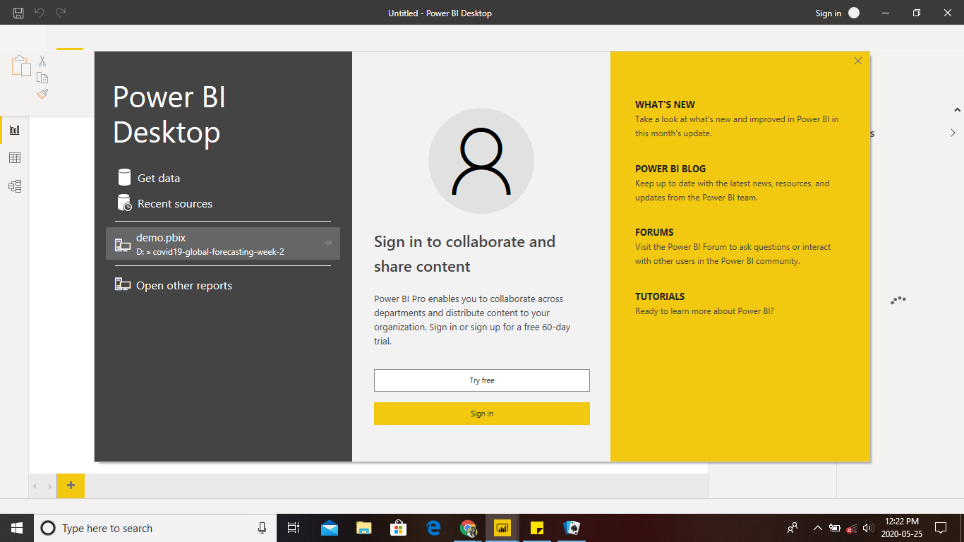Start page:

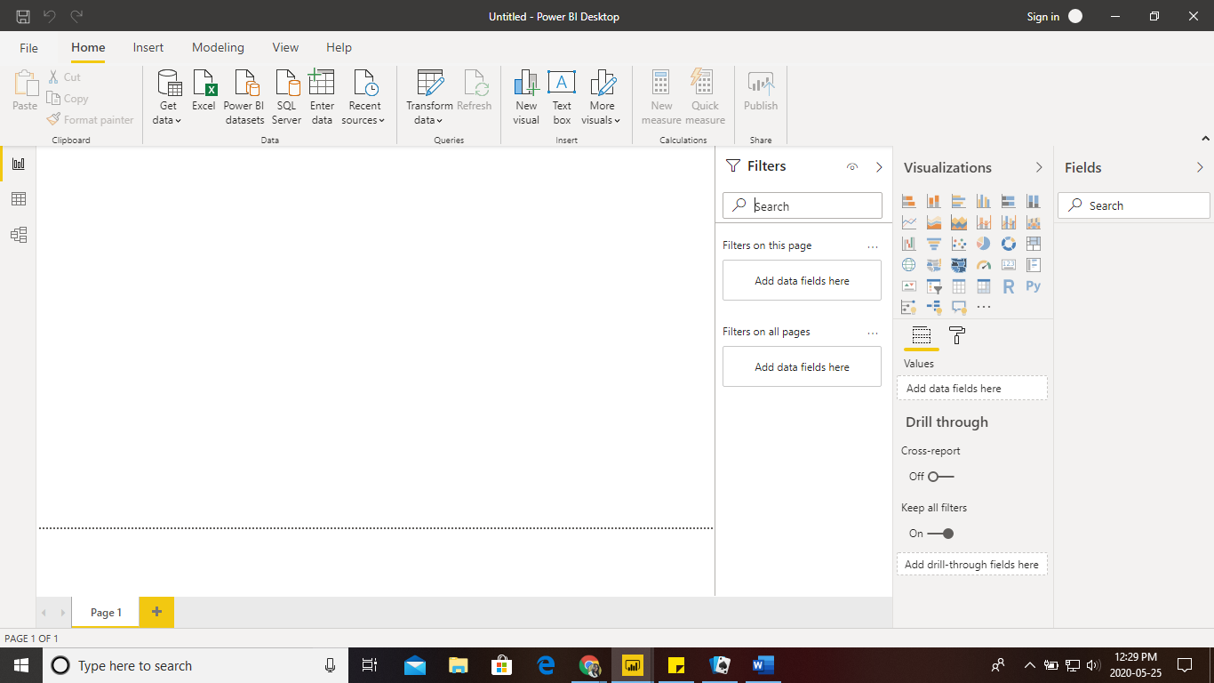Report View:

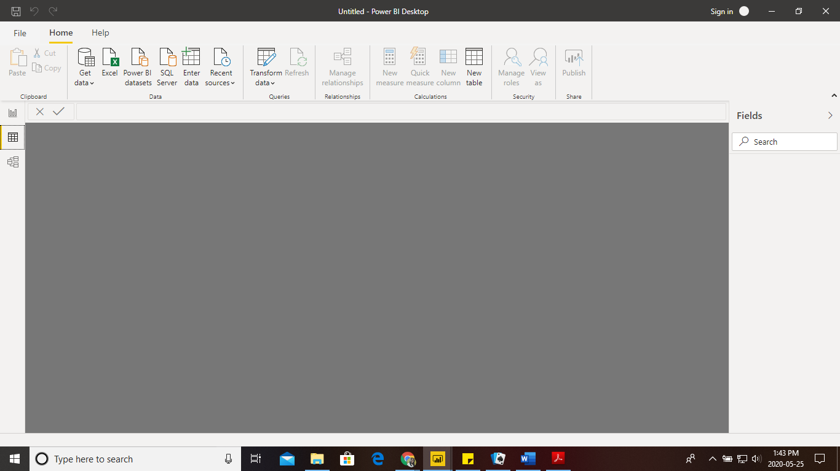Data View:

Model View:

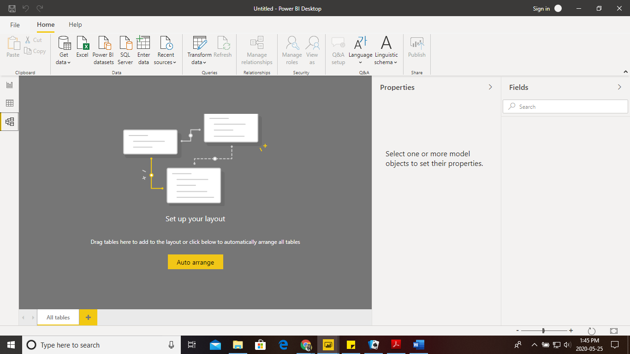

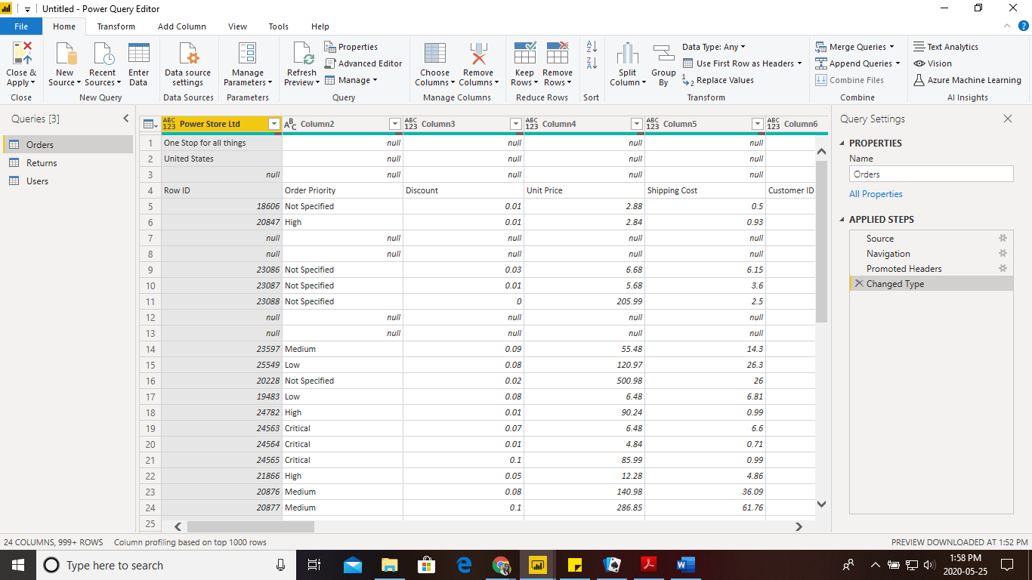Power query editor:

Advance editor:

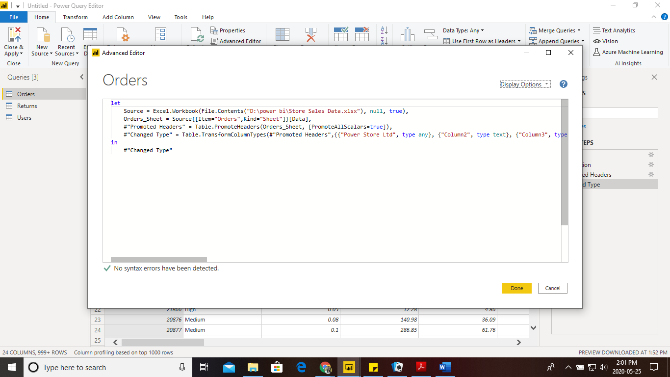

− Power BI Desktop:

Cost :free

**Microsoft Power BI Desktop** is built for the analyst. It combines state-of-the-art interactive visualizations, with industry-leading data **query** and modeling built-in. ... After you connect to a data source, you can shape the data to match your analysis and reporting needs:

− Power BI Pro:

Cost: **$9.99** Monthly price per user

When we need self-service BI then we can Choose Power BI Pro

* Self-service and modern BI in the cloud
* Collaboration, publishing, sharing, and ad-hoc analysis
* Fully managed by Microsoft

− Power BI Premium:

Cost:**$4,995** Monthly price per dedicated cloud compute and storage resource with annual subscription

We need advanced analytics, big data support, and on-premises and cloud reporting?

**Then we can add Power BI Premium**

* Enterprise BI, big data analytics, cloud and on-premises reporting
* Advanced administration and deployment controls
* Dedicated cloud compute and storage resources
* Allows any user to consume Power BI content