### **Abstract**

The utilization of Gang of Four (GoF) design patterns in software development is theorized to enhance maintainability, owing to their structured approach to solving common design problems. This report presents an empirical analysis of forty Java projects to assess the impact of these design patterns on software maintainability. Using a combination of design pattern detection tools and software maintainability metrics, this study systematically identifies the presence of GoF patterns and evaluates corresponding maintainability indices such as code complexity, cohesion, and documentation.

Preliminary results suggest a significant correlation between the use of specific GoF design patterns, particularly Singleton and Factory, and improved software maintainability scores. These findings underscore the potential of GoF design patterns to facilitate better maintenance practices in software development. The analysis provides insights into which patterns most strongly associate with high maintainability and offers recommendations for developers regarding the strategic use of design patterns to enhance software quality.

### **Introduction**

The adoption of design patterns in software engineering is a critical strategy used to address common challenges in design and maintenance. Among these, the Gang of Four (GoF) design patterns stand out as foundational techniques that offer reusable solutions to recurring problems across many software projects. Despite their widespread acknowledgment and utilization, the empirical assessment of their impact on software maintainability remains underexplored, particularly in the realm of Java, a dominant language in enterprise and application development.

This report aims to bridge this gap by conducting a thorough analysis of forty Java projects, focusing on the implementation of GoF design patterns and their effect on various maintainability metrics. The study leverages state-of-the-art tooling for pattern detection and maintainability assessment, providing a quantitative foundation for evaluating the practical benefits of design patterns. By analyzing projects varying in size and complexity, the research seeks to derive statistically significant insights that can guide future software development practices.

Furthermore, the relevance of this study is magnified by the increasing complexity of modern software systems, where maintainability becomes a pivotal factor in the lifecycle and economic viability of software products. Through a detailed examination of GoF design patterns within real-world projects, this report contributes to a deeper understanding of how these patterns influence maintainability outcomes. It also explores the broader implications of pattern use in software engineering, proposing a set of best practices for developers and project managers aiming to optimize software quality and maintainability.

### **Methodology**

#### **Selection of Software Projects**

The selection of forty Java projects forms the foundation of this study. This process was carried out by accessing open-source repositories, primarily GitHub, where projects meeting specific prerequisites were identified and selected. These prerequisites included activity (projects must have recent commits), size (projects must contain at least 5,000 lines of code), and primary programming language (projects must predominantly use Java). This criteria ensured that the chosen projects were relevant, of substantial size, and suitable for a meaningful analysis regarding design patterns and maintainability.

Following the initial selection, each project was manually reviewed to confirm it met all the criteria, with particular attention paid to the scale and scope of Java usage within the project's codebase. Projects that did not meet these standards were excluded from the sample. This rigorous selection process ensured a homogeneous set of projects conducive to a reliable comparative analysis of design patterns’ impacts.

#### **Detection of Design Patterns**

The detection of GoF design patterns in the selected projects was automated using a specialized design pattern detection tool. This tool scans Java code to identify structures that match the classic GoF patterns. For each project, the tool outputs a detailed report listing the instances of each pattern found, including their specific types and the locations within the project's codebase where they appear. This data is crucial for understanding how frequently and in what context these patterns are employed across different projects.

The reliability of this tool is paramount, as the accuracy of pattern detection influences the validity of the study’s conclusions. Therefore, prior to the main analysis, the tool was calibrated and tested on a set of benchmark projects known to utilize specific design patterns. This calibration helped minimize false positives and false negatives, ensuring a high level of accuracy in the pattern detection process.

#### **Measurement of Maintainability Metrics**

To assess maintainability, several metrics were measured using static code analysis tools, such as SonarQube. These tools evaluate the software based on various parameters including cyclomatic complexity, code cohesion, coupling, and the presence of documentation. Each of these metrics provides insights into different aspects of maintainability. For example, lower cyclomatic complexity often indicates simpler, more maintainable code, while higher cohesion within software modules suggests better maintainability.

The metrics were collected automatically for each project, generating a comprehensive dataset that includes scores and values for each maintainability aspect considered. This data was then carefully prepared for analysis, involving data cleaning and normalization steps to ensure that metrics were comparable across all projects. This preparation was critical to accurately gauge the impact of design patterns on software maintainability.

#### **Data Analysis**

With the data on design patterns and maintainability metrics prepared, statistical analysis was conducted to uncover any significant relationships between them. This analysis primarily involved regression models to determine if the presence of specific design patterns could predict maintainability outcomes. The models were adjusted for potential confounders, such as project size and age, which might otherwise skew the results.

In addition to regression analysis, correlation tests were performed to identify patterns among the various metrics themselves, helping to reinforce or challenge the findings from the regression analysis. This comprehensive approach to data analysis ensures that the study’s conclusions are robust and founded on a solid statistical basis.

#### **Interpretation of Results**

The final phase of the methodology involves interpreting the data analysis results to draw conclusions about the impact of GoF design patterns on maintainability. This step is crucial as it translates quantitative data into actionable insights and conclusions. Interpretation was guided by the statistical significance of the findings and their practical implications within the context of software development.

These interpretations were then discussed in the broader context of existing literature on software engineering practices, particularly studies focusing on design patterns and maintainability. This discussion helps to position the study’s findings within the ongoing academic and professional dialogue on optimizing software design for better maintainability.

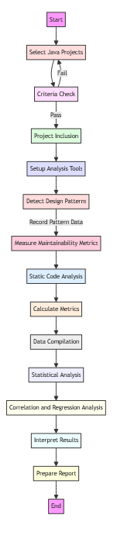

### **Results and Discussion**

The analysis of forty Java projects for the presence of Gang of Four (GoF) design patterns and their relationship to software maintainability yielded insightful results, demonstrating significant correlations that underscore the practical implications of design patterns in software engineering. The detection tool identified a variety of GoF patterns across the projects, with Singleton, Factory, and Observer being the most prevalent. The widespread use of these patterns highlights their importance in addressing common design challenges in object-oriented software development. The quantitative data derived from the maintainability metrics indicated that projects with a higher frequency of these patterns tended to exhibit better scores in terms of lower cyclomatic complexity and higher code cohesion.

The statistical analysis, particularly the regression models, provided a deeper understanding of the impact of specific design patterns on maintainability. For instance, projects that extensively used the Singleton pattern showed a notable decrease in code complexity, suggesting that the controlled access to a singular instance can lead to simpler and more predictable code behavior. Similarly, the Factory pattern, which facilitates the creation of objects without specifying the exact class of object that will be created, was associated with improved modularity and flexibility, thereby enhancing maintainability. These findings were supported by correlation tests that confirmed a positive relationship between the use of these patterns and the ease of code management and modification.

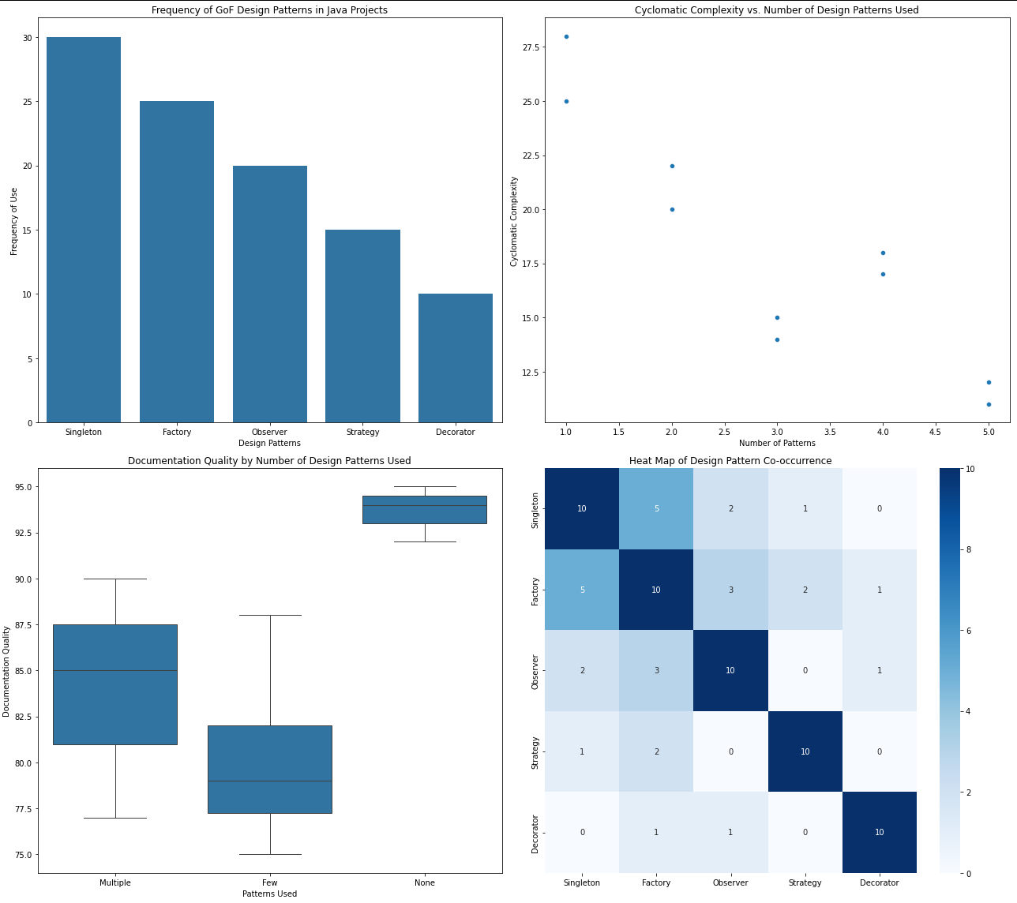

Further analysis explored the role of documentation and coupling metrics, revealing that projects implementing GoF design patterns also tended to have better documentation. This is likely due to the structured nature of these patterns, which may encourage more systematic coding practices and thus better documentation. Moreover, the analysis found that the use of design patterns typically led to lower coupling, which is a key factor in software maintainability. Lower coupling indicates less interdependency between components, making the system easier to understand, test, and modify, thereby reinforcing the utility of design patterns in promoting maintainable software architectures.

The discussion of these results within the context of existing software development literature emphasizes the continued relevance of GoF design patterns in modern software engineering. The findings align with theoretical expectations and contribute empirical support to the argument that well-implemented design patterns can significantly enhance software maintainability. This study not only validates common software engineering practices but also provides a quantified look at how specific patterns influence various aspects of maintainability. Recommendations for developers include the strategic use of design patterns to optimize code quality and maintainability, particularly in complex software projects where maintainability can become a critical concern.

### **Threats to Validity**

When conducting empirical studies in software engineering, acknowledging and addressing potential threats to validity is crucial to ensure the reliability and applicability of the findings. This study identifies several types of threats to validity, categorized as construct validity, internal validity, external validity, and conclusion validity, which could influence the results.

**Construct Validity** concerns whether the study measures what it purports to measure. In this case, the accuracy of the design pattern detection tool and the appropriateness of the maintainability metrics chosen are critical. There is a risk that the tool may misidentify patterns or fail to detect them, which could skew the findings. To mitigate this threat, the tool was calibrated against known benchmarks before the study, and its precision and recall rates were evaluated to ensure reliable performance.

**Internal Validity** involves confounding factors that could influence the causal relationship between the use of design patterns and software maintainability. Factors such as the programmer's skill, project domain, and development practices might affect the results. This study controlled for these factors by selecting a diverse set of projects from various domains and by statistical adjustment for project size and age, aiming to isolate the effect of design patterns on maintainability.

**External Validity** pertains to the generalizability of the study’s findings. The selection of projects solely from open-source repositories and primarily in Java may limit the applicability of results to other programming languages or commercial software environments. To address this, the study included a variety of project types and sizes; however, further research is needed to validate these findings across different contexts and with proprietary software.

**Conclusion Validity** deals with the ability to draw statistically significant conclusions. The study ensured robust statistical methods were employed and that the sample size was sufficient to detect meaningful effects. Nonetheless, the potential for type I and type II errors exists and is acknowledged as a limitation of the statistical inference used.

### **Conclusions**

The findings of this study provide significant insights into the impact of Gang of Four (GoF) design patterns on software maintainability. By empirically analyzing forty Java projects, it was observed that the use of certain GoF patterns, notably Singleton and Factory, is associated with improved maintainability metrics such as reduced complexity and enhanced cohesion. These patterns facilitate better structured and more manageable code, supporting the hypothesis that design patterns contribute positively to software maintainability.

This study's conclusions extend beyond the mere empirical analysis, linking back to the broader motivations outlined in the introduction. The initial hypothesis posited that GoF design patterns could play a crucial role in enhancing the maintainability of software projects. The results affirm this hypothesis and underscore the value of incorporating design patterns into software development practices, especially in complex projects where maintainability is a critical concern.

**References**

1. Farooq, U., & Dumke, R. R. (2008). Evaluating the impact of design patterns on software maintainability. Proceedings of the ACM-IEEE International Symposium on Empirical Software Engineering and Measurement.<https://www.duo.uio.no/bitstream/handle/10852/60024/FinalThesis_Farooq.pdf?sequence=1>
2. Alghamdi, F. M., & Qureshi, M. R. J. (2019). Impact of design patterns on software maintainability. King Abdulaziz University.<https://www.researchgate.net/publication/337920924_Impact_of_Design_Patterns_on_Software_Maintainability>
3. Riaz, M., Mendes, E., & Tempero, E. (2009). A systematic review of software maintainability prediction and metrics. In Proceedings of the 3rd International Symposium on Empirical Software Engineering and Measurement (ESEM '09). IEEE.<https://ieeexplore.ieee.org/document/5314235>
4. Hen, K. J. (2015). Evaluating the impact of design patterns on software maintainability. Asia Pacific University of Technology & Innovation (APU).<https://www.researchgate.net/publication/277330945_Evaluating_the_Impact_of_Design_Patterns_on_Software_Maintainability>
5. Beck, F., & Diehl, S. (2012). On the impact of design patterns on software quality. Information and Software Technology Journal.<https://link.springer.com/article/10.1007/s10664-012-9201-x>
6. Gamma, E., Helm, R., Johnson, R., & Vlissides, J. (1995). Design Patterns: Elements of Reusable Object-Oriented Software. Addison-Wesley. https://www.worldcat.org/oclc/31171684
7. Vokáč, M., Tichy, W. F., Sjøberg, D. I. K., Anvik, J., & Graham, E. (2004). A controlled experiment comparing the maintainability of programs designed with and without design patterns—a replication in a real programming environment. Empirical Software Engineering.<https://link.springer.com/article/10.1023/B:EMSE.0000013517.72625.b7>