The Coding Capsule

Supriya rani Dhal
Regd. No.: 2101219111



Department of Computer Science & Engineering College of Engineering Bhubaneswar
(Affiliated to Biju Patnaik University of Technology)
Bhubaneswar, Odisha - 751024, India

MAY 2025

The Coding Capsule
Seminar report submitted in partial fulfillment of the requirements for the degree
of

Bachelor of Technology
By

Supriya rani Dhal,
Regd. No.: 2101219111

under the guidance of

Prof. Dr. Sonali Pradhan
Department of Computer Science & Engineering
College of Engineering Bhubaneswar


Department of Computer Science & Engineering
College of Engineering Bhubaneswar
(Affiliated to Biju Patnaik University of Technology)
Bhubaneswar, Odisha - 751024, India

MAY 2025

Declaration

I certify that

- I have followed the guidelines provided by the university in preparing the report.

- Whenever, I have used materials (data, theoretical analysis, figures, and text) from other sources, I have given due credit to them by citation in the text of the project report and giving their details in the references.

- Neither this project report nor any part of it has been submitted for any degree or academic award elsewhere.

Supriya rani Dhal
Regd. No.: 2101219111


DEPARTMENT OF COMPUTER SCIENCE AND ENGINEERING
COLLEGE OF ENGINEERING BHUBANESWAR
(An Affiliated College of Biju Patnaik University of Technology, Odisha)
PLOT NO-1, SECTOR-B CHANDAKA NEUCLEUS COMPLEX
PATIA, BHUBANESWAR-751024

CERTIFICATE

This is to certify that the project entitled The Coding Capsule, submitted by Supriya rani Dhal, bearing 2101219111 to the Department of Computer Science & Engineering, College of Engineering Bhubaneswar, Odisha, India, as a Minor Project for the partial fulfilment of the degree of Bachelor of Technology, is a record of the original work carried out by them. This project work fulfils all the requirements as per the regulations of the university and has reached the standard needed for submission.

Dr. Sonali Pradhan Prof. Tanmaya Kumar Das
Guide Head, Dept. of CSE

Acknowledgement

First and foremost, We would like to express deepest gratitude to our guide Dr. Sonali Pradhan, Department of Computer Science & Engineering, College of Engineering Bhubaneswar, for giving me the guidance, support, encouragement and counseling throughout our minor project work.

We take this opportunity to express our sincere thanks to Prof. Tanmaya Kumar Das, HOD, CSE for providing valuable feedback and insightful comments.

We are thankful to all the faculty members of the department of CSE for their helpful comments, constant encouragement, assistance and invaluable advice without which it would not have been possible for us to complete this project work in time.

Last but not the least, We would like to thank our friends for their encouragement and help in several forms.

- Supriya rani Dhal, 2101219111
- Parbeen Mirza, 2101219043
- Nidhi Roy, 2101219040
- Rajkishor Satapathy, 2101219053

Abstract

Coding Capsule is a lightweight, browser-based collaborative coding platform designed to enable real-time code sharing and editing among multiple users. With a focus on simplicity and accessibility, this Progressive Web App (PWA) eliminates the need for user authentication or database integration, making it instantly usable for anyone, anywhere.
Built using modern technologies like React with Vite, Chakra UI, and Node.js, Coding Capsule uses Socket.io for real-time communication and CodeMirror as its core editor. It supports multiple programming languages, dynamically loads default code snippets based on the selected language, and allows users to execute code using the Judge0 API via RapidAPI integration.
Each collaborative session is identified by a unique room ID generated using UUID, enabling seamless sharing and connection. Users can also download their code files directly to their local system, with the platform intelligently determining the correct file extension based on the selected language.
As a fully functional PWA, Coding Capsule offers enhanced performance and cross-device compatibility. The project demonstrates the practical implementation of real-time systems and collaborative tools without relying on complex infrastructure or authentication systems, making it an ideal tool for learning, pair programming, and quick code sharing.

Contents

TITLE PAGE NO

- Introduction 8-11
  - 1.1 Background and Context 8
  - 1.2 Purpose and Objectives 8-9
  - 1.3 Motivation 9-10
  - 1.4 Project Significance 10
  - 1.5 Features at a Glance 10-11
  - 1.6 Scope of the Project 11
- Literature Survey 12-13
  - Introduction 12
  - Existing Platforms 12
  - Relevant Technologies 13
  - Research Gap Identified 13
- System Design
- Methodology &
Project Interface Outline
- Limitations
- Conclusion
- Reference

Introduction

1.1 Background and Context
In today’s rapidly evolving technological landscape, collaborative software development has become an essential practice. With the increasing adoption of remote work, online learning, and globally distributed teams, the demand for platforms that support real-time collaboration, especially in coding, has seen exponential growth.
Traditional Integrated Development Environments (IDEs) are powerful, but they often lack real-time collaboration features unless extended with third-party tools or plugins. Moreover, most online collaborative coding platforms require user registration, come with storage or usage limitations, and often rely on heavyweight infrastructure, making them inaccessible or inconvenient for quick collaborative tasks.
Coding Capsule was envisioned to bridge this gap—a web-based platform that empowers users to collaborate on code in real time without any need for sign-up, installation, or learning curve. The goal is to create a solution that is lightweight, intuitive, and free-to-use, while still offering core functionalities such as multi-language support, live code execution, and file export.

1.2 Purpose and Objectives
The primary objective of this project is to design and implement a real-time collaborative coding platform that is both practical and user-friendly. The specific goals include:

- Developing a collaborative environment where multiple users can simultaneously write and edit code.
- Enabling language switching with the automatic generation of language-specific default code templates.
- Integrating an online code execution engine using Judge0 API to compile and run code instantly.
- Allowing users to download their code locally with automatically determined file extensions.
- Ensuring the platform is simple, accessible, and installation-free, with PWA support for offline usability.
- Avoiding the complexity of user management by removing authentication and database dependencies.
Through these objectives, the platform aims to serve learners, educators, developers, and interviewers looking for a fast and effective coding collaboration tool.

1.3 Motivation
The motivation behind developing Coding Capsule stemmed from common frustrations faced by students and developers during online collaborative sessions. Some of the key pain points identified include:
- Cumbersome onboarding processes in existing tools, such as requiring account creation or workspace setup.
- Lack of flexibility in language support and switching.
- Unreliable or sluggish performance in real-time synchronization.
- Overwhelming interfaces that deter quick usage for short-term collaborations.

- The absence of a lightweight, no-login solution that functions seamlessly across devices and platforms.
- By addressing these challenges, Coding Capsule offers a refreshing alternative—an instantly accessible and minimalistic coding tool that encourages collaboration without barriers.

1.4 Project Significance
Coding Capsule holds significance in both academic and professional contexts:
- For students and educators, it serves as a perfect tool for pair programming, live demos, and collaborative problem-solving.
- For developers, it becomes a quick environment to brainstorm ideas, test code, and work jointly on small tasks.
- For interviewers, it offers a hassle-free way to conduct live coding interviews without needing any setup.
Its PWA capability also adds value by enabling offline use and mobile installation, thus enhancing reach and accessibility.

1.5 Features at a Glance
Some of the key features that distinguish Coding Capsule include:
- Real-Time Coding: Users see each others changes as they happen, synchronized via WebSockets using Socket.io.
- Multi-Language Support: Choose from various programming languages like C++, Python, JavaScript, and more.
- Default Snippet Loading: On changing the language, a starter template is auto-loaded to ease the coding experience.

- Live Code Execution: Judge0 API integration lets users run and test their code instantly within the platform.
- Smart Code Download: Users can enter a filename and the system detects the correct extension based on the language.
- No Authentication: No logins, no passwords----just a simple and fast way to code collaboratively.
- Zero Database Usage: All state is managed in real time without persistent storage----ensuring speed and simplicity.
- PWA Functionality: Installable as a native app on mobile and desktop.

1.6 Scope of the Project
The project is designed with a clear and focused scope. While it doesn’t aim to replicate the full functionality of a traditional IDE, it prioritizes:
- Real-time collaboration on code for teams or individuals.
- Temporary workspaces identified by unique room IDs, ideal for short-lived sessions or quick sharing.
- Code testing and execution without the need for manual compilation tools.
- User convenience by eliminating complex configurations and dependencies.
Future enhancements can potentially include optional authentication, GitHub integration, collaborative debugging tool, Database integration for File/Folder management . However, for its current version, the project emphasizes core functionality with minimal friction.

Literature Survey
2.1 Introduction
The literature survey reviews existing tools and platforms related to collaborative coding, real-time synchronization, and online code execution. It helps identify gaps and design choices that led to the development of Coding Capsule.

2.2 Existing Platforms
- Replit
A feature-rich collaborative IDE supporting multiple languages and code execution. However, it requires sign-in and can be heavy for simple use cases.
- CodePen / JSFiddle
Primarily for front-end development with live previews. Lacks real-time collaboration and multi-language support.
- Visual Studio Live Share
Great for pair programming with deep VS Code integration, but needs installations and user authentication.
- Collabedit
A minimal collaborative editor with basic syntax support. No code execution, language switching, or modern features.
- Google Colab
Powerful for Python and data science with real-time collaboration, but not ideal for general coding and requires login.

2.3 Relevant Technologies
- Socket.io: Enables real-time communication between users.
- CodeMirror: Lightweight browser-based editor with syntax highlighting and multi-language support.
- Judge0 API: Executes code in various languages via REST API.
- UUID: Generates unique room IDs for each session.
- PWA: Adds a native-app experience.

2.5 Research Gap Identified
From the study of the existing systems, several key limitations and areas for improvement were identified:
- Lack of a fully browser-based collaborative coding tool that is both lightweight and functional.
- Most platforms require sign-up or installation, which becomes a barrier for quick usage.
- Many tools don’t support code execution across multiple languages.
- Native-like behavior through PWA is largely missing.
- Lack of platforms that offer on-the-fly downloadable files with language-specific extensions.
- These gaps directly influenced the design choices made in Coding Capsule.

System Design

3.1 System Overview
Coding Capsule is a browser-based collaborative code editor built with a focus on real-time communication, multi-language support, simplicity, and platform independence. It is designed to work without any backend database or user authentication, allowing users to join coding sessions instantly and collaborate effectively.

3.2 System Architecture
The architecture of Coding Capsule is based on a client-server model where:
- The frontend (client) handles the user interface, code editor, language selection, and displaying outputs.
- The backend (server) handles real-time communication (via WebSockets), processes code execution requests, and relays output to all connected users in a room.

3.2.1 Components Overview
- Frontend (React + Vite + Chakra UI)
- Code Editor (CodeMirror)
- Language Selector
- Output Terminal
- Download Functionality
- PWA Support
- Room Join/Create (UUID)
- Backend (Node.js + Express + Socket.io)
- Manages WebSocket connections
- Broadcasts code changes
- Handles execution requests via Judge0 API
- Maintains active rooms
- External APIs
- Judge0 API (via RapidAPI) for compiling and executing code.
- UUID for generating unique room IDs.
- Axios for handling API requests from frontend to backend.

3.3 Key Modules
Module | Description
Code Editor | Built using CodeMirror, supports syntax highlighting for various languages.
WebSocket Connector | Handles real-time communication using Socket.io.
Language Selector | Allows users to switch programming languages and updates editor content.
Code Executor | Sends code to Judge0 API and fetches the output.
File Downloader | Enables code to be downloaded locally with appropriate file extensions.
PWA Service Worker | Ensures offline access and fast loading.

3.4 Advantages of the Design
- No login/registration: Faster and more accessible.
- Room-based collaboration: Simple session sharing using UUIDs.
- Multi-language support: Covers most popular coding languages.
- Lightweight and fast: Built with Vite, optimized for speed.
- No data persistence: Enhances privacy and keeps it simple.

3.5 Data Flow Diagram (Level 0)
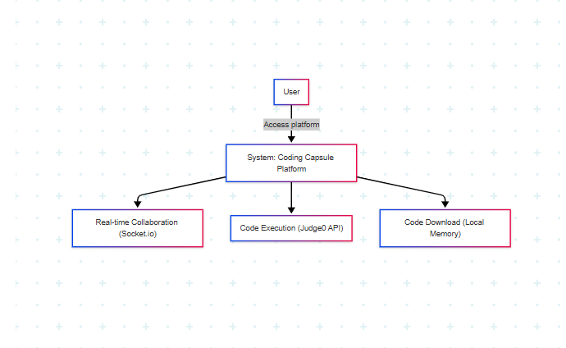

Data Flow Diagram (Level 1)
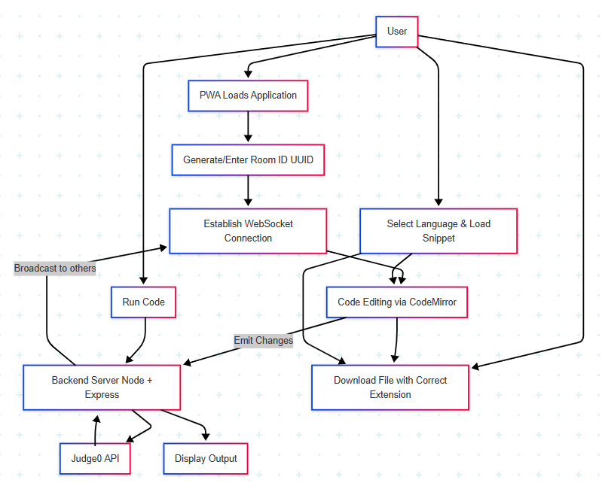

Methodology & Project Interface Outline

4.1 Development Methodology
The project follows an Agile development methodology, which allows for iterative design, regular testing, and continuous improvements based on feedback. The phases include:
- Requirement Gathering: Studying user needs and existing platforms.
- System Design: Structuring the application into modular components.
- Implementation: Developing frontend and backend components.
- Integration: Connecting editor, language execution, and socket communication.
- Testing: Verifying code synchronization, execution, and download features.
- Deployment: Deploying frontend (Netlify) and backend (Render).

4.2 System Architecture
The architecture is divided into three logical layers:
1. Presentation Layer (Frontend)
Technologies: React, Chakra UI, CodeMirror, Vite
Role: Handles user interaction, UI rendering, and socket communication.

2. Application Layer (Backend)
Technologies: Node.js, Express.js, Socket.io
Role: Manages socket connections, code sync, and API requests.
3. External Service Layer
Technologies: Judge0 API (via RapidAPI)
Role: Executes submitted code and returns output or errors.

4.3 Architecture Diagram
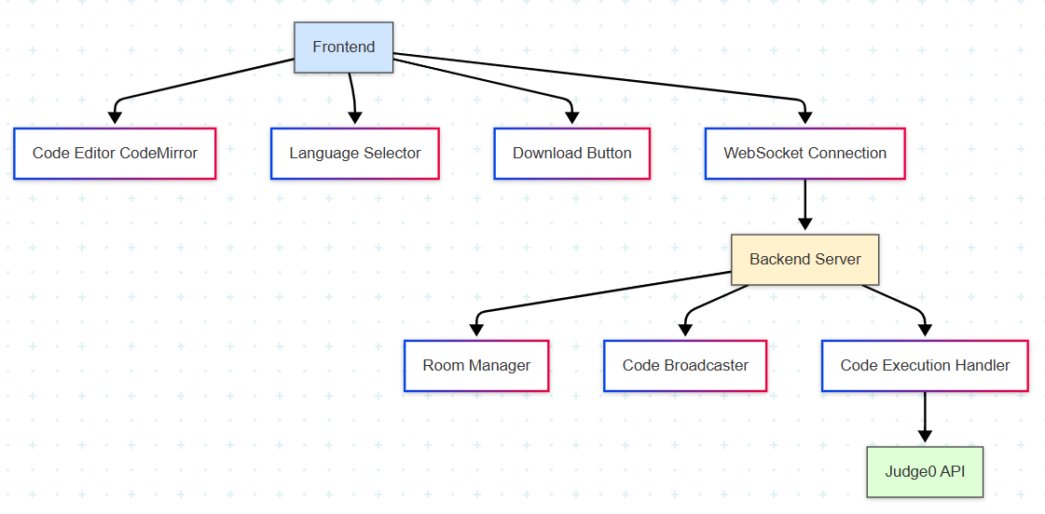
4.4 Tools and Libraries Used
Tool / Library | Purpose
React + Vite | Frontend development
Chakra UI | Styling and component library
CodeMirror | Embeddable code editor
Socket.io | Real-time communication
Node.js + Express | Backend server
UUID | Generating unique room IDs
Axios | API communication with Judge0
Judge0 API | Code compilation and execution
Netlify | Hosting frontend
Render | Hosting backend
PWA | installability

4.5 Sample Screenshots

4.5.1 Home Page
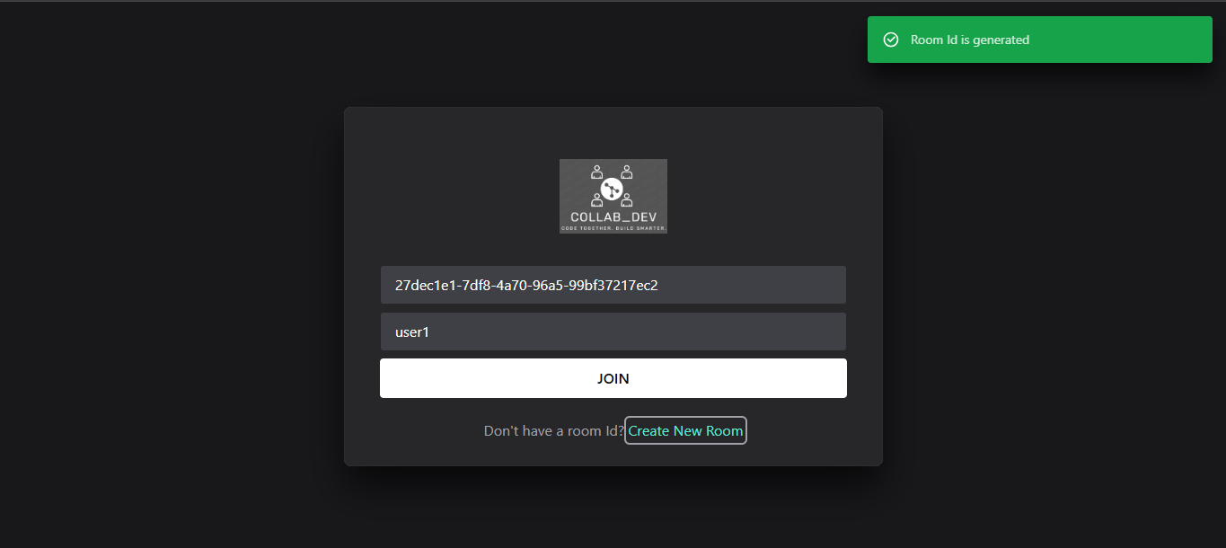

Coding:
/App.jsx

import Home from "./components/Home";
import { Route, Routes } from "react-router-dom";
import EditorPage from "./components/EditorPage";
import { Toaster } from "./components/ui/toaster";
import ErrorBoundary from "./components/ErrorBoundary";

function App() {
return (
<>
<Toaster />
<Routes>
<Route path="/" element={<Home />}></Route>
<Route
path="/editor/:roomId"
element={
<ErrorBoundary>
<EditorPage />
</ErrorBoundary>
}
></Route>
</Routes>
</>
);
}

export default App;

/App.css
#root {
max-width: 1280px;
margin: 0 auto;
padding: 2rem;
text-align: center;
}

.logo {
height: 6em;
padding: 1.5em;
will-change: filter;
transition: filter 300ms;
}
.logo:hover {
filter: drop-shadow(0 0 2em #646cffaa);
}
.logo.react:hover {
filter: drop-shadow(0 0 2em #61dafbaa);
}

@keyframes logo-spin {
from {
transform: rotate(0deg);
}
to {
transform: rotate(360deg);
}
}

@media (prefers-reduced-motion: no-preference) {
a:nth-of-type(2) .logo {
animation: logo-spin infinite 20s linear;
}
}

.card {
padding: 2em;
}

.read-the-docs {
color: #888;
}

/Home.jsx
import {
Box,
Button,
Input,
Text,
VStack,
Link,
Image,
} from "@chakra-ui/react";
import logo from "../assets/logo.png";
import { v4 as uuidv4 } from "uuid";
import { useState } from "react";
import { useNavigate } from "react-router-dom";
import { toaster } from "./ui/toaster";

const Home = () => {
const [roomId, setRoomId] = useState("");
const [username, setUsername] = useState("");

const navigate = useNavigate();

const generateRoomID = (e) => {
e.preventDefault();
const Id = uuidv4();
setRoomId(Id);
toaster.create({
description: "Room Id is generated",
type: "success",
});
};

const joinRoom = () => {
if (!roomId || !username) {
toaster.create({
description: "Both the field is requried",
type: "error",
});
return;
}

// redirect
navigate(`/editor/${roomId}`, {
state: {
username,
},
});
toaster.create({
description: "room is created",
type: "success",
});
};

// when enter then also join
const handleInputEnter = (e) => {
if (e.code === "Enter") {
joinRoom();
}
};

return (
<Box
minH="100vh"
bg="gray.900"
display="flex"
alignItems="center"
justifyContent="center"
overflow={"hidden" }
>
<Box
bg="gray.800"
p={10}
rounded="lg"
boxShadow="2xl"
width="100%"
height={"400px"}
maxW="600px" // <-- Increased the width
>
{/* Logo or description */}
<Box display="flex" justifyContent="center" mb={4}>
<Image
src={logo}
alt="Collab Dev Logo"
boxSize="120px"
objectFit="contain"
/>
</Box>

{/* Form */}
<VStack spacing={10}>
<Input
placeholder="Room Id"
value={roomId}
bg="gray.700"
color="white"
_placeholder={{ color: "gray.400" }}
_focus={{ borderColor: "teal.400", bg: "gray.600" }}
size={"lg"}
onChange={(e) => setRoomId(e.target.value)}
onKeyUp={handleInputEnter}
/>
<Input
placeholder="Username"
value={username}
bg="gray.700"
color="white"
_placeholder={{ color: "gray.400" }}
_focus={{ borderColor: "teal.400", bg: "gray.600" }}
size="lg"
onChange={(e) => setUsername(e.target.value)}
onKeyUp={handleInputEnter}
/>
<Button
colorScheme="teal"
width="100%"
size={"lg"}
onClick={joinRoom}
>
JOIN
</Button>
</VStack>

{/* Link */}
<Text mt={6} textAlign="center" color="gray.400" fontSize="md">
Don't have a room Id?{" "}
<Link color="teal.300" href="#" onClick={generateRoomID}>
Create New Room
</Link>
</Text>
</Box>
</Box>
);
};

export default Home;

4.5.2 Editor Page
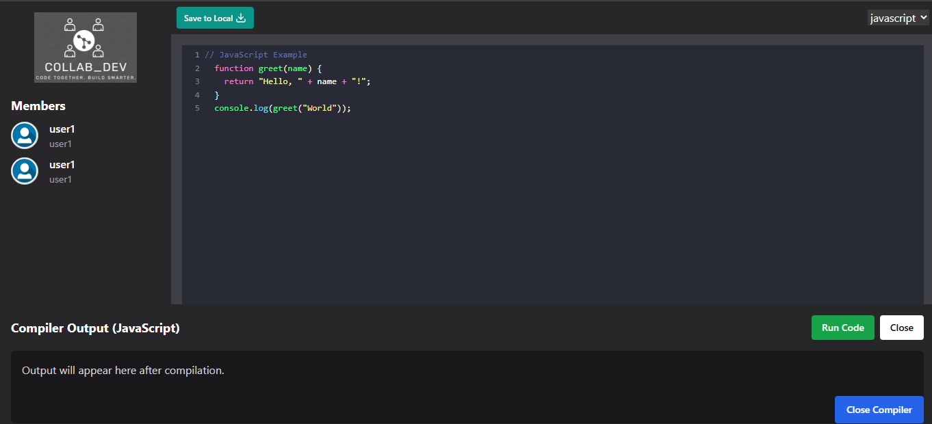

Coding:
/EditorPage.jsx
import React, { useEffect, useRef, useState } from "react";
import Client from "./Client";
import Editor from "./Editor";
import { initSocket } from "@/utils/Socket";
import { ACTIONS } from "@/utils/Actions";
import {
useNavigate,
useLocation,
Navigate,
useParams,
} from "react-router-dom";
import { Download } from "lucide-react";
import axios from "axios";
import logo from "@/assets/logo.png";

import {
Box,
Button,
Flex,
Image,
Text,
VStack,
HStack,
Portal,
CloseButton,
Dialog,
Input,
} from "@chakra-ui/react";
import { toaster } from "./ui/toaster";
import { getFileExtension } from "@/constants/fileExtension";
import { LANGUAGES } from "@/constants/languages";
import { LANGUAGE_SNIPPETS } from "@/constants/languageSnippets";

const EditorPage = () => {
const [clients, setClients] = useState([]);
const [output, setOutput] = useState("");
const [isCompileWindowOpen, setIsCompileWindowOpen] = useState(false);
const [isCompiling, setIsCompiling] = useState(false);
const [selectedLanguage, setSelectedLanguage] = useState("javascript");
const [code, setCode] = useState(LANGUAGE_SNIPPETS["javascript"]);

const Location = useLocation();
const navigate = useNavigate();
const { roomId } = useParams();
const socketRef = useRef(null);

const codeRef = useRef(null);

const cancelRef = useRef();
const [fileNameInput, setFileNameInput] = useState("");

useEffect(() => {
const init = async () => {
socketRef.current = await initSocket();
socketRef.current.on("connect_error", (err) => handleErrors(err));
socketRef.current.on("connect_failed", (err) => handleErrors(err));

const handleErrors = (err) => {
console.log("Error", err);
toaster.create({
description: "Socket connection failed, Try again later",
type: "error",
});
navigate("/");
};

socketRef.current.emit(ACTIONS.JOIN, {
roomId,
username: Location.state?.username,
});

socketRef.current.on(
ACTIONS.JOINED,
({ clients, username, socketId }) => {
if (username !== Location.state?.username) {
toaster.create({
description: `${username} joined the room.`,
type: "success",
});
}
setClients(clients);
socketRef.current.emit(ACTIONS.SYNC_CODE, {
code: codeRef.current,
socketId,
});
}
);

socketRef.current.on(ACTIONS.DISCONNECTED, ({ socketId, username }) => {
toaster.create({
description: `${username} left the room`,
type: "success",
});
setClients((prev) => {
return prev.filter((client) => client.socketId !== socketId);
});
});
};
init();

return () => {
const socket = socketRef.current;
if (socket) {
socket.off(ACTIONS.JOINED);
socket.off(ACTIONS.DISCONNECTED);
socket.disconnect();
}
};
}, []);

useEffect(() => {
selectedLanguage === "javascript" && setSelectedLanguage("javascript");
}, []);

//load default code snippets
useEffect(() => {
const newSnippet = LANGUAGE_SNIPPETS[selectedLanguage];
setCode(newSnippet);
codeRef.current = newSnippet;
}, [selectedLanguage]);

if (!Location.state) {
return <Navigate to="/" />;
}

const copyRoomId = async () => {
try {
await navigator.clipboard.writeText(roomId);
toaster.create({
description: "Room ID copied",
type: "success",
});
} catch (error) {
console.log(error);
toaster.create({
description: "Unable to copy Room ID",
type: "error",
});
}
};

const leaveRoom = () => {
navigate("/");
};

const runCode = async () => {
setIsCompiling(true);
try {
const response = await axios.post(
"https://coding-capsule.onrender.com/compile",
{
code: codeRef.current,
language: selectedLanguage,
}
);
console.log("Backend response:", response.data);
setOutput(response.data.output || JSON.stringify(response.data));
} catch (error) {
console.error(error);
setOutput(error.response?.data?.error || "An error occurred");
} finally {
setIsCompiling(false);
}
};

const toggleCompileWindow = () => {
setIsCompileWindowOpen(!isCompileWindowOpen);
};

const handleSaveToLocal = (fileName) => {
const fileExtension = getFileExtension(selectedLanguage);

const blob = new Blob([codeRef.current], { type: "text/plain" });

const link = document.createElement("a");
link.href = URL.createObjectURL(blob);
link.download = fileName.endsWith(fileExtension)
? fileName
: `${fileName}${fileExtension}`;
document.body.appendChild(link);
link.click();
document.body.removeChild(link);
};

return (
<Flex direction="column" minH="100vh" bg="gray.900">
<Flex flex="1">
{/* Sidebar */}
<Flex
direction="column"
w={{ base: "100%", md: "250px" }}
bg="gray.800"
p={4}
overflowY="auto">
<Image src={logo} alt="Logo" mx="auto" mb="5" maxW="150px" />

<Text mb={2} color="white" fontSize="lg" fontWeight="bold">
Members
</Text>
<VStack align="stretch" spacing={2} flex="1">
{clients.map((client) => (
<Client key={client.socketId} username={client.username} />
))}
</VStack>

<Box borderTop="1px" borderColor="gray.700" my={4} />

<VStack spacing={2} mt="auto">
<Button colorPalette="teal" size="sm" w="full" onClick={copyRoomId}>
Copy Room ID
</Button>
<Button colorPalette="red" size="sm" w="full" onClick={leaveRoom}>
Leave Room
</Button>
</VStack>
</Flex>

{/* Editor Area */}
<Flex flex="1" direction="column" bg="gray.700">
{/* Top Toolbar */}
<Flex justify="space-between" align="center" bg="gray.800" p={2}>
{/* Save to Local Button */}
<Dialog.Root>
<Dialog.Trigger asChild>
<Button size="xs" colorPalette="teal">
Save to Local <Download />
</Button>
</Dialog.Trigger>
<Portal>
<Dialog.Backdrop />
<Dialog.Positioner>
<Dialog.Content>
<Dialog.Header>
<Dialog.Title>Enter the name of the file</Dialog.Title>
</Dialog.Header>
<Dialog.Body>
<Input
placeholder="Enter file name"
value={fileNameInput}
onChange={(e) => setFileNameInput(e.target.value)}
/>
</Dialog.Body>
<Dialog.Footer>
<Dialog.ActionTrigger asChild>
<Button variant="outline" ref={cancelRef}>
Cancel
</Button>
</Dialog.ActionTrigger>
<Button
colorScheme="teal"
ml={3}
onClick={() => {
handleSaveToLocal(fileNameInput);
setFileNameInput("");
}}
isDisabled={!fileNameInput.trim()}>
Save
</Button>
</Dialog.Footer>
<Dialog.CloseTrigger asChild>
<CloseButton size="sm" />
</Dialog.CloseTrigger>
</Dialog.Content>
</Dialog.Positioner>
</Portal>
</Dialog.Root>

{/* Language selector */}
<div className="bg-dark p-2 d-flex justify-content-end">
<select
placeholder={selectedLanguage}
className="form-select w-auto"
value={selectedLanguage}
onChange={(e) => setSelectedLanguage(e.target.value)}>
{LANGUAGES.map((lang) => (
<option key={lang} value={lang}>
{lang}
</option>
))}
</select>
</div>
</Flex>

{/* Editor */}
<Box flex="1" overflowY="auto" p={4}>
<Editor
socketRef={socketRef}
roomId={roomId}
language={selectedLanguage}
defaultCode={code}
onLanguageChange={(lang) => {
setSelectedLanguage(lang);
}}
onCodeChange={(updatedCode) => {
codeRef.current = updatedCode;
setCode(updatedCode);
}}
/>
</Box>
</Flex>
</Flex>

{/* Compiler Toggle Button */}
<Button
pos="fixed"
bottom="4"
right="4"
colorPalette="blue"
onClick={toggleCompileWindow}
zIndex="1050">
{isCompileWindowOpen ? "Close Compiler" : "Open Compiler"}
</Button>

{/* Compiler Section */}
<Box
pos="fixed"
bottom="0"
left="0"
right="0"
height={isCompileWindowOpen ? "30vh" : "0"}
overflowY="auto"
bg="gray.800"
transition="height 0.3s ease"
p={isCompileWindowOpen ? 4 : 0}
zIndex="1040">
{isCompileWindowOpen && (
<Flex direction="column" height="full">
<Flex justify="space-between" align="center" mb={4}>
<Text fontSize="lg" fontWeight="bold" color="white">
Compiler Output (
{selectedLanguage ? selectedLanguage : "JavaScript"})
</Text>
<HStack>
<Button
colorPalette="green"
size="sm"
onClick={runCode}
loading={isCompiling}>
{isCompiling ? "Compiling..." : "Run Code"}
</Button>
<Button
colorPalette="gray"
size="sm"
onClick={toggleCompileWindow}>
Close
</Button>
</HStack>
</Flex>
<Box bg="gray.900" flex="1" rounded="md" p={4} overflowY="auto">
<Text whiteSpace="pre-wrap" color="gray.300">
{output || "Output will appear here after compilation."}
</Text>
</Box>
</Flex>
)}
</Box>
</Flex>
);
};

export default EditorPage;

Backend:
/index.js
import express from "express";
import { Server } from "socket.io";
import { ACTIONS } from "./Actions.js";
import cors from "cors";
import { createServer } from "http";
import dotenv from "dotenv";

dotenv.config();

const app = express();

const server = createServer(app);

// Enable CORS
app.use(cors());

// Parse JSON bodies
app.use(express.json());

const io = new Server(server, {
cors: {
origin: ["http://localhost:3000", "https://coding-capsule.netlify.app/"],
methods: ["GET", "POST"],
},
});

const userSocketMap = {};
const getAllConnectedClients = (roomId) => {
return Array.from(io.sockets.adapter.rooms.get(roomId) || []).map(
(socketId) => {
return {
socketId,
username: userSocketMap[socketId],
};
}
);
};

io.on("connection", (socket) => {
// console.log('Socket connected', socket.id);
socket.on(ACTIONS.JOIN, ({ roomId, username }) => {
userSocketMap[socket.id] = username;
socket.join(roomId);
const clients = getAllConnectedClients(roomId);
// notify that new user join
clients.forEach(({ socketId }) => {
io.to(socketId).emit(ACTIONS.JOINED, {
clients,
username,
socketId: socket.id,
});
});
});

// sync the code
socket.on(ACTIONS.CODE_CHANGE, ({ roomId, code }) => {
socket.in(roomId).emit(ACTIONS.CODE_CHANGE, { code });
});
// when new user join the room all the code which are there are also shows on that persons editor
socket.on(ACTIONS.SYNC_CODE, ({ socketId, code }) => {
io.to(socketId).emit(ACTIONS.CODE_CHANGE, { code });
});

// leave room
socket.on("disconnecting", () => {
const rooms = [...socket.rooms];
// leave all the room
rooms.forEach((roomId) => {
socket.in(roomId).emit(ACTIONS.DISCONNECTED, {
socketId: socket.id,
username: userSocketMap[socket.id],
});
});

delete userSocketMap[socket.id];
socket.leave();
});
});

const JUDGE0_API =
"https://judge0-ce.p.rapidapi.com/submissions?base64_encoded=false&wait=true";

const LANGUAGE_MAP = {
javascript: 63,
python: 71,
c: 50,
cpp: 54,
java: 62,
typescript: 74,
ruby: 72,
go: 60,
php: 68,
};

app.post("/compile", async (req, res) => {
let { language } = req.body;
let { code } = req.body;

if (!language) {
language = "javascript";
}

//Judge0 always compiles Java code like javac Main.java internally, so we need to normalize
function normalizeJavaCode(code) {
//Match the class name using regex
const match = code.match(/class\s+([A-Za-z_]\w*)\s*/);
if (match) {
const originalClass = match[1];
// Replace class name with 'Main'
return code.replace(new RegExp(`\\b${originalClass}\\b`, "g"), "Main");
}
return code; // if no class found, return as-is
}
if (language === "java") {
code = normalizeJavaCode(code);
}

const languageId = LANGUAGE_MAP[language];

if (!languageId) {
return res.status(400).json({ error: "Unsupported language" });
}

try {
const submission = await fetch(JUDGE0_API, {
method: "POST",
headers: {
"Content-Type": "application/json",
"X-RapidAPI-Key": "6b0195e3d8mshdf7be554565bd24p1a0709jsn225ea4fef34e",
"X-RapidAPI-Host": "judge0-ce.p.rapidapi.com",
},
body: JSON.stringify({
source_code: code,
language_id: languageId,
}),
});

const submissionData = await submission.json();

return res.json({
output: submissionData.stdout || submissionData.stderr,
error: submissionData.compile_output || null,
status: submissionData.status.description,
});
} catch (err) {
console.error("Error compiling code:", err.message);
res.status(500).json({ error: "Internal Server Error" });
}
});

const PORT = process.env.PORT || 5000;
server.listen(PORT, () => console.log(`Server is running on port ${PORT}`));

Limitations
Despite the various strengths and benefits offered by Coding Capsule, the platform does have certain limitations due to its scope, technology choices, and the conscious decision to keep the platform simple and lightweight. Below are the key limitations observed:
5.1 Lack of User Authentication
The platform does not support login or user authentication. As a result, there is no way to track user sessions, prevent unauthorized access to rooms, or implement personalized features such as user history or preferences.

5.2 No Data Persistence
The system does not use any database for storing code or user data. All code shared or written during a session is temporary and lost once the session ends or the page is refreshed. Users must remember to download their code before leaving the session.

5. 3 Dependency on External API
Code execution is handled by an external service (Judge0 API via RapidAPI). The platform's execution feature is dependent on the availability and quota limits of the third-party API. Any downtime, rate limits, or changes in the API may directly affect platform functionality.

5.4 No Access Controls in Rooms
Rooms are open to anyone who has the unique room ID. There are no permissions, admin roles, or controls to restrict who can join or edit the code in a collaborative session.

5.5 Limited IDE Features
While CodeMirror provides syntax highlighting and basic editor features, it lacks advanced IDE capabilities such as:
- Code auto-completion
- Real-time linting
- File tree navigation
- Debugging tools

5.6 Limited Language Support
Although multiple languages are supported, the list is constrained by what Judge0 provides. Not all languages may be fully supported or may lack up-to-date compiler versions.

5.7 Not Optimized for Large Teams
The platform is best suited for small groups or pair programming. With too many users in a room, synchronization and UI responsiveness may degrade due to lack of optimization for large-scale collaboration.

5.8 Offline Functionality is Limited
While the app is a PWA and can be installed, real-time collaboration and code execution require an internet connection. The offline mode is restricted to viewing or editing cached code and does not support syncing or running code.

Conclusion
The Coding Capsule project successfully achieves its objective of providing a lightweight, real-time collaborative coding platform that is simple, fast, and accessible to users without the need for authentication or installation. Built using modern web technologies such as React with Vite, Chakra UI, Node.js, Express.js, Socket.io, and CodeMirror, the platform delivers a seamless coding experience for multiple users simultaneously.
Through the integration of WebSockets for real-time synchronization and the Judge0 API for multi-language code execution, Coding Capsule allows users to not only write and share code together but also compile and run it instantly. The feature that automatically determines the correct file extension during download enhances usability, while its PWA functionality ensures offline readiness and platform independence.
The decision to exclude databases and authentication layers aligns with the project’s core philosophy of being simple and freely accessible. While this introduces certain limitations, it also contributes to the speed and ease of use, especially for users who wish to quickly collaborate without setup hassles.
The development process provided valuable insights into real-time application design, socket communication, API integration, and PWA development. It has also laid a foundation for future enhancements such as user authentication, persistent storage, advanced code editor features, and role-based collaboration control.
In conclusion, Coding Capsule stands as a robust proof-of-concept for a minimalistic yet powerful collaborative coding environment, and showcases the potential of combining simplicity with real-time web technologies to build efficient and useful tools for the developer community.

References

- OpenAI Documentation
- Next.js Documentation
- Tailwind CSS Documentation
- Liveblocks Documentation
- WebXR API Documentation

