Wireframes/Simulation-Low Fidelity

The Easiest and quickest visual presentation of expected web page or interface design. Represents what and how information will be located on the website screen as compared to pencil sketch on paper.

Cart Screen

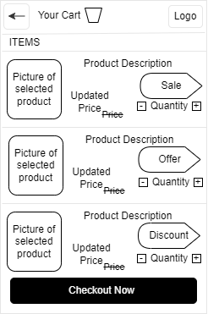

Chatbot Screen

