**Requirements Elicitation**

**• Brainstorming Sessions**

Brainstorming is an elicitation way where stakeholders discuss about business objective, with the intrest of generating many potential solutions possible, without focusing on any one single solution.

**• Document Analysis**

A non obstructive way of eliciting requirements, by looking into the support documentation of a system that is already in use. The use of this method reduces the impact to business sources as the analysis occurs behind the scenes

**• Focus Groups**

A focus group is prepared of select qualified individuals together, with the intrest to discuss their experiences in particular system, questioning stakeholder questions or help in the decision making process.

**• Interviews**

Interviews are traditional and custom technique for requirements elicitation. When these are conducted by skilled individuals prove to be most benefit form of requirements elicitation.

**• Joint Application Design**

It is commonly known as JAD, JAD is a method in which problem statement and powerful solutions are represented to have discuss with the collaborators. The advantage of this way is provided all members are available at present, decisions can be made really quick and problems resolved asap.

**• Product Evaluations**

This is a method whereby the business and technical members to analyze available products or solutions to check if production would satisfy the business goals.

**• Prototyping**

This method helps stakeholders with a mock up of the process of system to enable practical testing of possible solutions. When combined this with other techniques proves to provide an correct means of issue resolution.

**• Questionnaires**

The productive of the this, is predicated on focused questions so as to avoid collecting large quantity of useless data. It gives an productive way to gather info from many stakeholders quickly, but are limited amount of knowledge they can gather.

**• Researching the Past**

This is the technique of determine and calculate past data and experiences to elicit an productive solution. This process can include analyzing peer group systems via case studies/white papers.

**• Structured Walkthroughs**

This is a medium process whereby stakeholders check and discuss their particular requirements. The goal of the process is to ask questions, recommendations and comments, which could lead to further examination and refining process.

• **Verbal protocols**

Thia happens when a member performs a task while announcing it aloud, explaining the actions being performed. This method gives the requirements specialist the a chance to understand the activities taken before or pre-requisites and reliabilities.

**• Workshops**

This session is planned carefully, which has selected participants or company members. Participants can have pay interest in the discussion or to project execution. This is a great way to gather requirements by quickly eliciting majority of the requirements of the project

S**IPOC**

It is a BA process that identifies Suppliers, Inputs, Process, Outputs, and Customers of any process. Here we have taken Jewellery Product Customization as our process. It provides High Level project view along with analyzing and improving business.

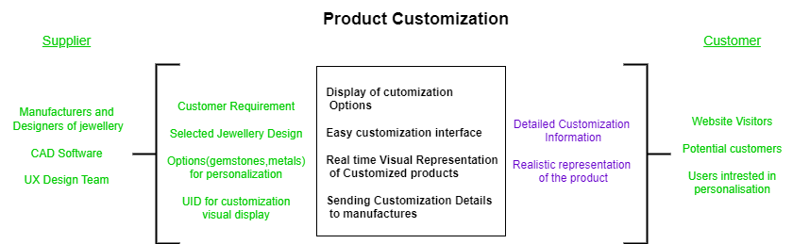

**Business Context Diagram**

It is a high level data flow diagram that showcases relation between System, Stakeholders, Process and Constraints involved in a process. It places system in the center and other entities.

**Swimlane Diagram**

It represents a particular process from start till the end including the steps and systems involved in a process with the functions and tasks of each steps mentioned clearly.

