**Project #1 - E/R: Contact Tracing**

**Student #:** *215318728*

**Sur (Family) Name:** *Ghosh*

**Given Name:** *Supriyo*

**Section:** *B*

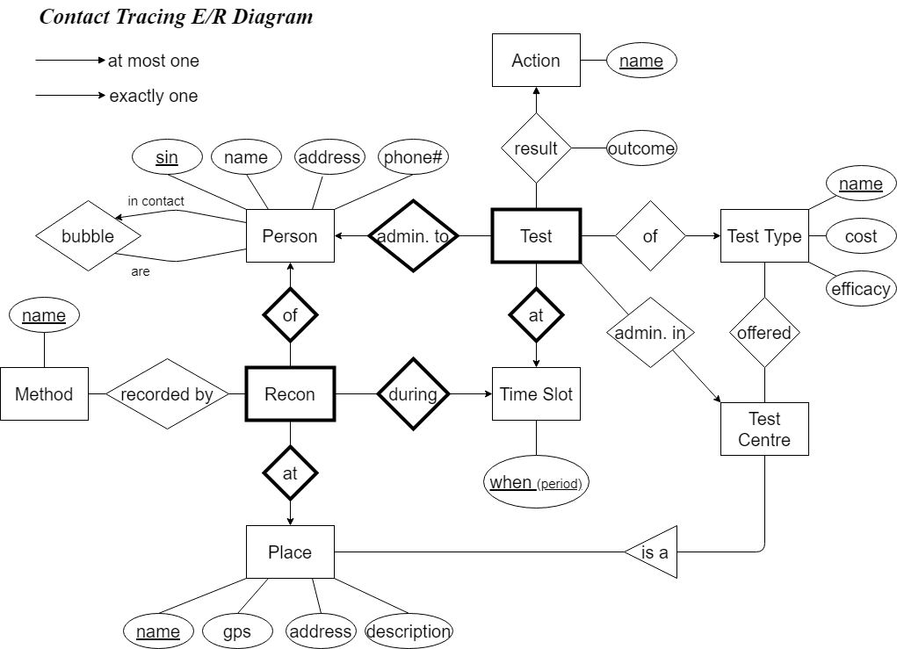

Documentation

* Recon is a weak entity because it is identified by a Person (sin), a Place (name) and a Time Slot (when). A recon can be recorded by many different methods (one to many).
* A Test is also a weak entity because it is only identified by a Person (sin) and a Time Slot (when). A Test is exactly of one Test Type and is performed (administered in) in exactly one Test Centre. Lastly, a Test will result in at most one Action after considering the type of outcome (positive or negative) from the result. If negative, there is no action.
* A Test Centre offers many different Test Types and also a Test Type is offered in many Test Centres. This defines a many to many relationship. A Test Center is a Place.
* A given Person identifies his ‘bubble’. Bubble (family and friends) is a group of other Persons. These other Persons individually can be defined by the Person entity. Here bubble acts as recursive relationship.