**Question-0 (Preprocessing) Remove all row corresponding to the labeled winery 3. After this process, you should have only 2 labels on your data.**

% LOAD DATASET %

load('wine.mat');

% LOAD VALUES INTO VARIABLES %

wine=double(A);

wine_label = wine(:, 14);

wine_data = wine(:, 1:13);

% DEFINE ATTRIBUTES AND CLASSES %

categories = {'Alcohol'; 'Malic acid'; 'Ash'; 'Alcalinity of ash'; 'Magnesium'; 'Total phenols'; 'Flavanoids'; 'Nonflavanoid phenols'; 'Proanthocyanins'; 'Color intensitys'; 'Hue'; 'OD280/OD315 of diluted wines'; 'Proline'};

classnumber = 3;

% Question-0 (Preprocessing) %

%Remove all row corresponding to the labeled winery 3. After this process,

%you should have only 2 %

idx = (wine_label > 2);

wine(idx,:) = [];

wine_label = wine(:, 14);

wine_data = wine(:, 1:13);

**Question-1 (0.25 pts) Load the data and plot (visualize) the data points of wines by their Alcohol (feature 1 in x axis) and Malic acid (feature 2 in y axis).**

%Question-1 (0.25 pts)

% Load the data and plot (visualize) the data points of wines by their Alcohol (feature 1 in x axis) and

% Malic acid (feature 2 in y axis).

alcohol=wine(:,1);

malic_acid=wine(:,2);

c = linspace(1,100,length(wine(:,14)));

figure

gscatter(alcohol,malic_acid,wine_label)

title('Question-1 :Alcohol vs Malic Acid', 'FontSize', 12);

xlabel('Alcohol','FontSize', 12)

ylabel('Malic Acid','FontSize', 12)

grid on

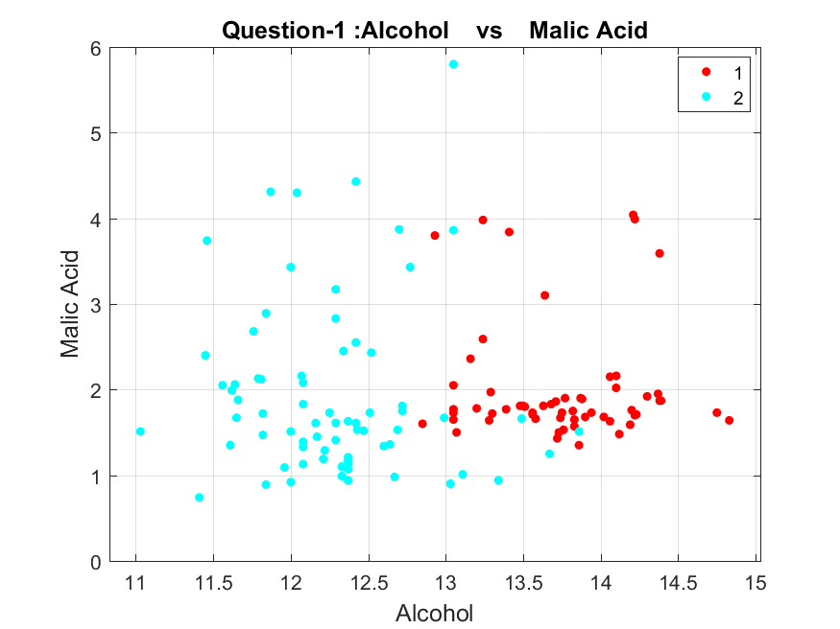

**Question-2 (1 pts) Pick Magnesium and Color intensity as your two features and for degrees n =1, …, 10 fit a polynomial of degree n to your data. Plot those fitting lines on the data. You can check the correctness of your solution with MALAB’s built-in curve fitting function**

% Question-2 (1 pts)

% Pick Magnesium and Color intensity as your two features and for degrees n =1, …, 10 fit a polynomial

% of degree n to your data. Plot those fitting lines on the data. You can check the correctness of your

% solution with MALAB’s built-in curve fitting function.

magnesium=wine(:,5);

color_intensity=wine(:,10);

figure('Renderer', 'painters', 'Position', [0 0 900 900])

xlabel('Magnesium','FontSize', 8)

ylabel('Color Intensity','FontSize', 8)

grid on

for i=1:10

p = polyfit(magnesium,color_intensity,i);

y1 = polyval(p,magnesium);

B = [magnesium, y1];

C = sortrows(B,1);

subplot(5,2,i);

hold on

gscatter(magnesium,color_intensity,wine_label)

plot(C(:,1),C(:,2),'k','LineWidth',3);

hold off

str = sprintf('Question-2 Polynomial:%d', i);

title(str, 'FontSize', 8);

end

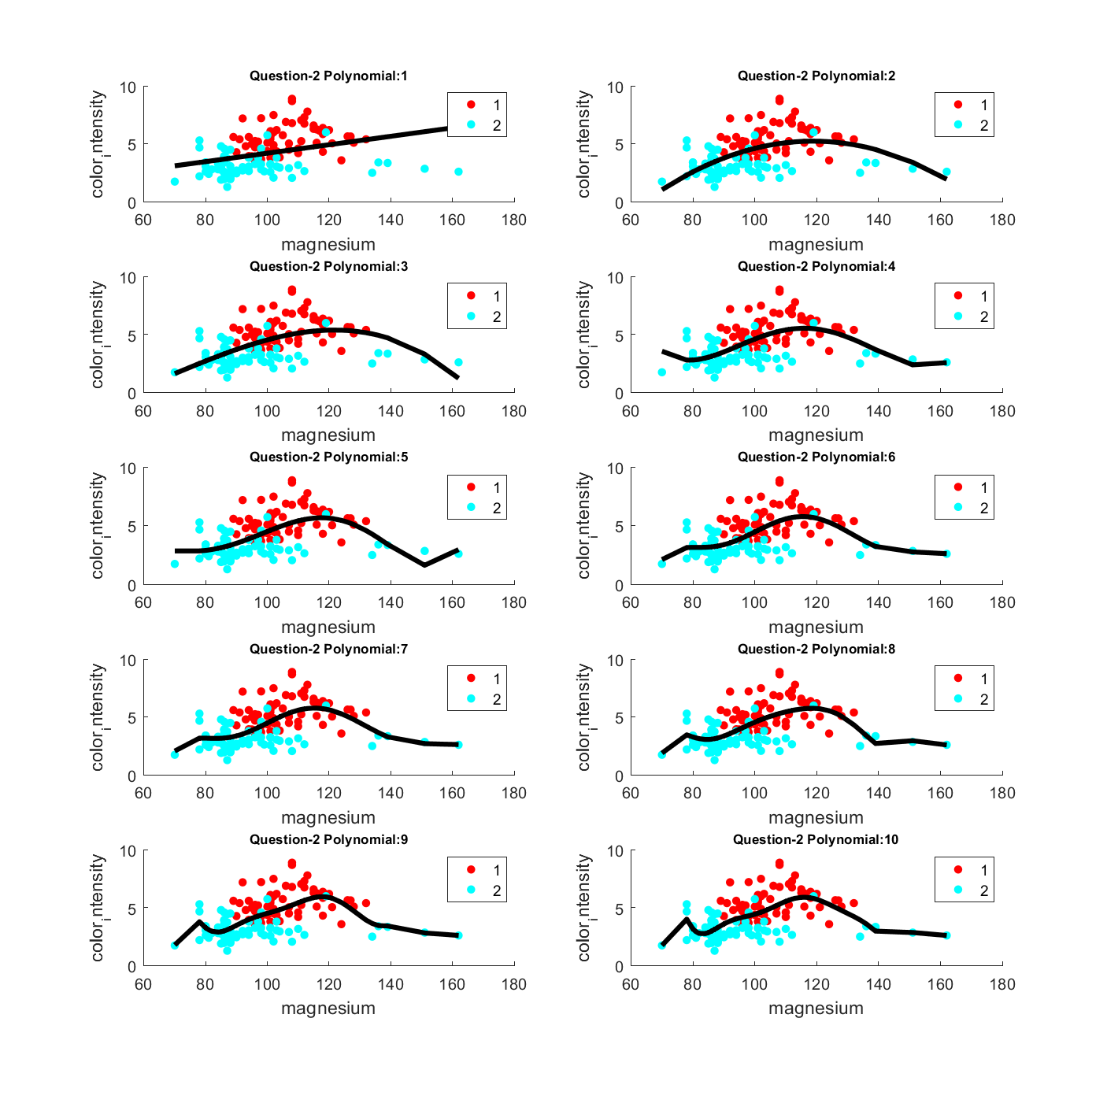

**Question-3 (1 pts) For each learned function (n=1, …, 10), compute the empirical square loss (ERM) on data and plot it as a function of n.**

% Question-3 (1 pts)

% For each learned function (n=1, …, 10), compute the empirical square loss (ERM) on data and plot

% it as a function of n.

RMSE=[10];

for i=1:10

p = polyfit(magnesium,color_intensity,i);

f = polyval(p,magnesium);

% T = table(magnesium,color_intensity,f,color_intensity-f,'VariableNames',{'X','Y','Fit','FitError'})

RMSE(i)=sqrt(mean((color_intensity-f).^2));

end

figure()

t=1:10;

bar(t,RMSE);

xlabel('Polynomial','FontSize', 12)

ylabel('ERM','FontSize', 12)

title('Question-3 ERM vs Polynomial(1:10)', 'FontSize', 15);

grid on

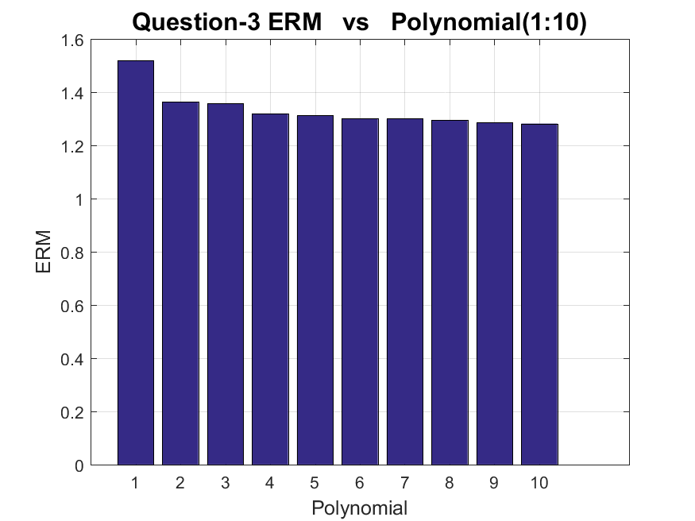

**Question-4 (1 pts) Now, fix the n=10 and add a lasso regularization for your predictor of data. Vary the regularization parameter in a loop of 20 and visualize the RLM loss. You can check the correctness of your solution with MALAB’s built-in Lasso.**

% Question-4 (1 pts)

% Now, fix the n=10 and add a lasso regularization for your predictor of data. Vary the regularization

% parameter in a loop of 20 and visualize the RLM loss. You can check the correctness of your solution

% with MALAB’s built-in Lasso.

figure()

grid on

for i=1:20

p = polyfit(magnesium,color_intensity,i);

y1 = polyval(p,magnesium);

[b,fitinfo] = lasso(magnesium,y1,'CV',10);

lam = fitinfo.Index1SE;

fitinfo.MSE(lam);

hold on

lassoPlot(b,fitinfo,'PlotType','CV');

str = sprintf('Question-4 Lasso Regularization Cross Validation fold:%d', i);

title(str, 'FontSize',10);

hold off

end

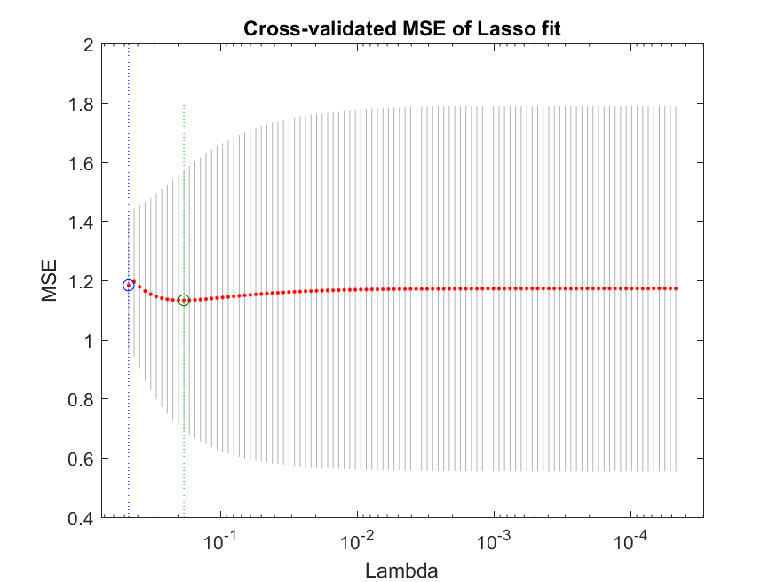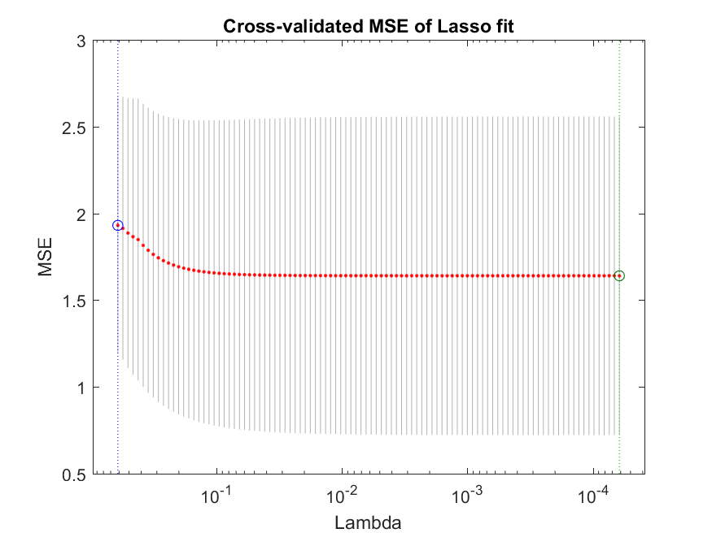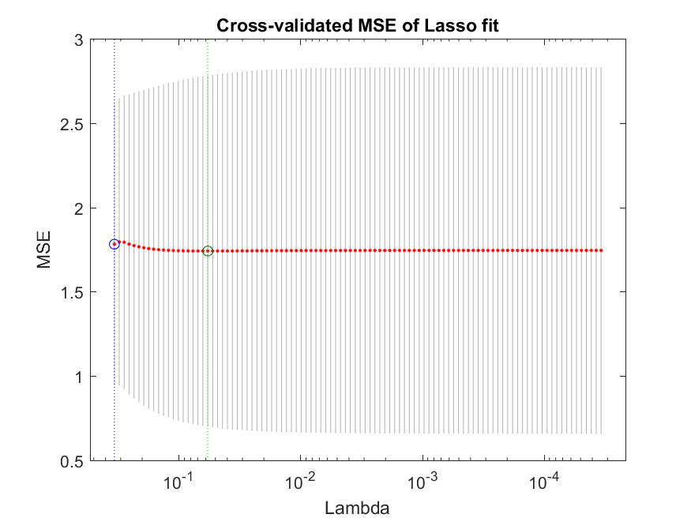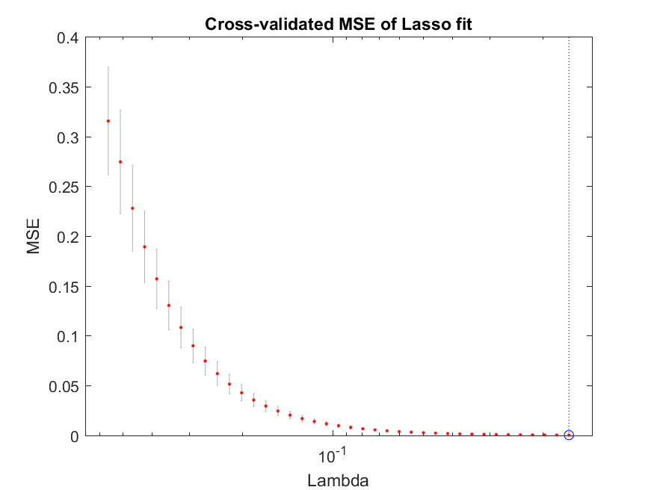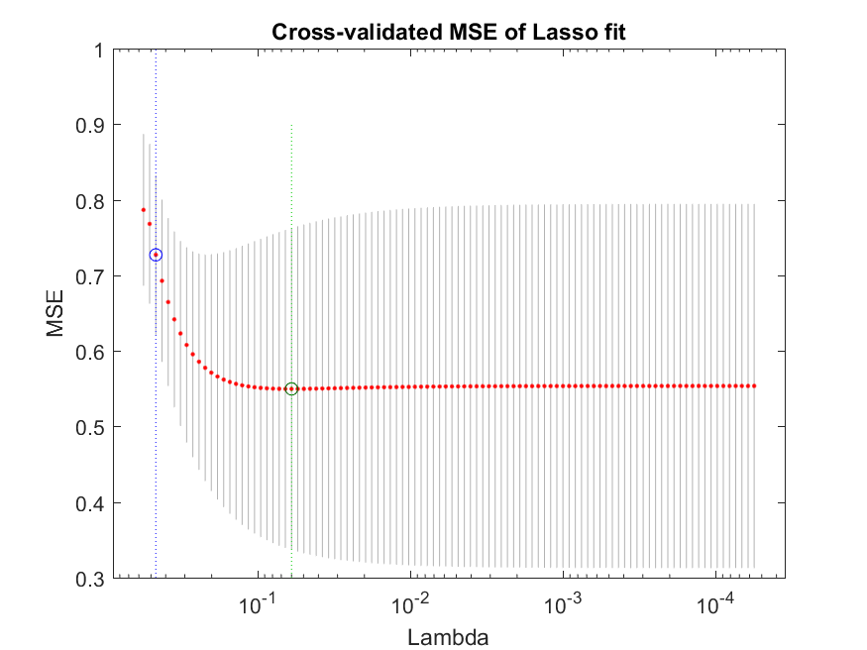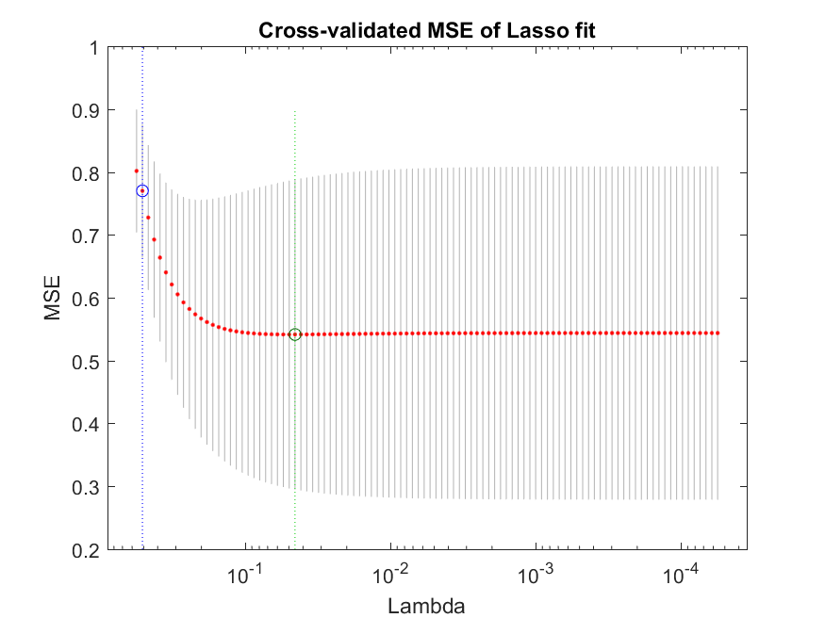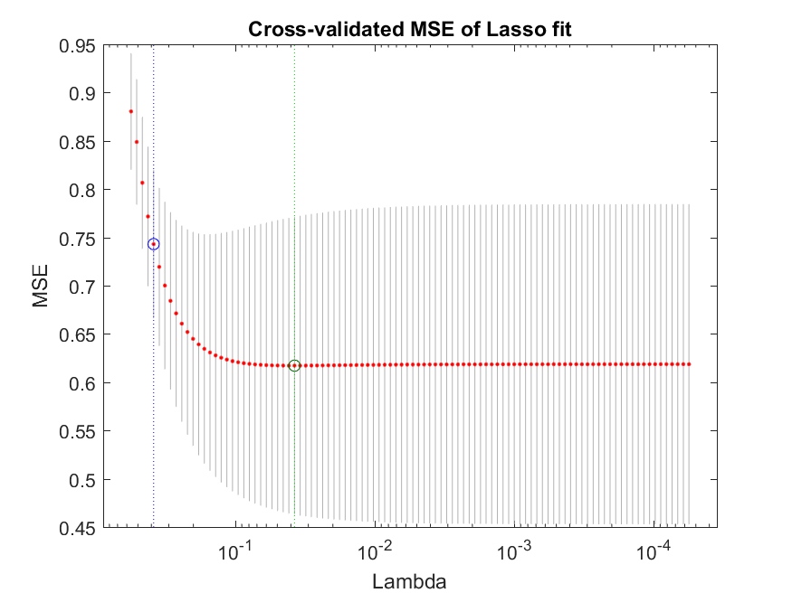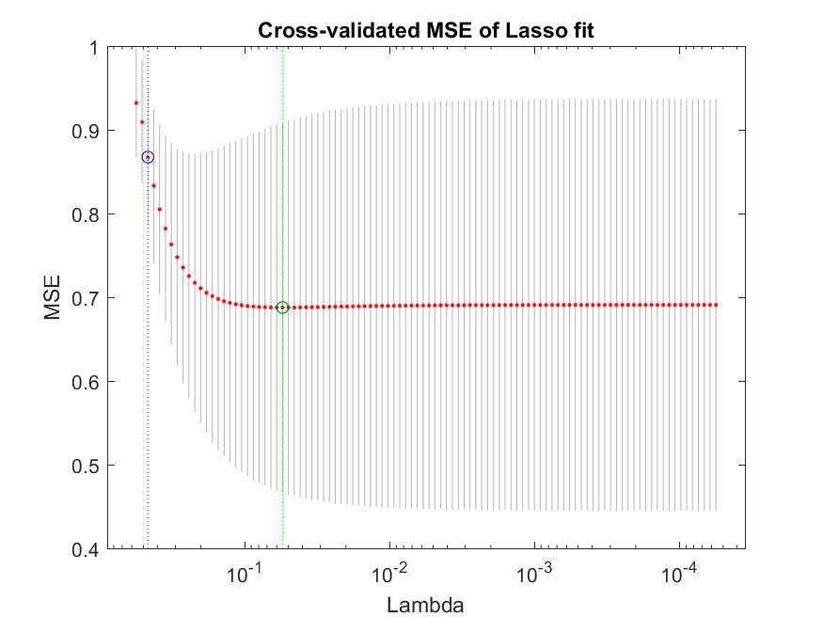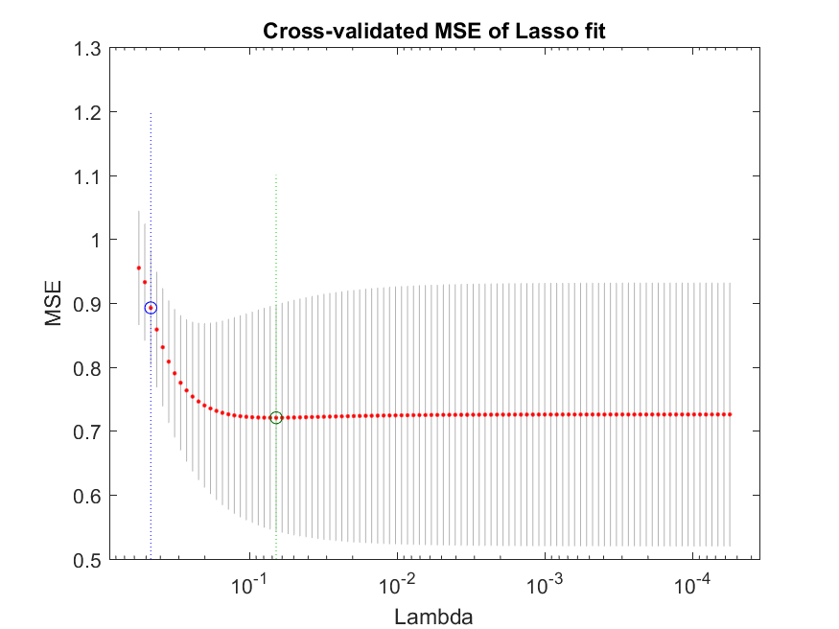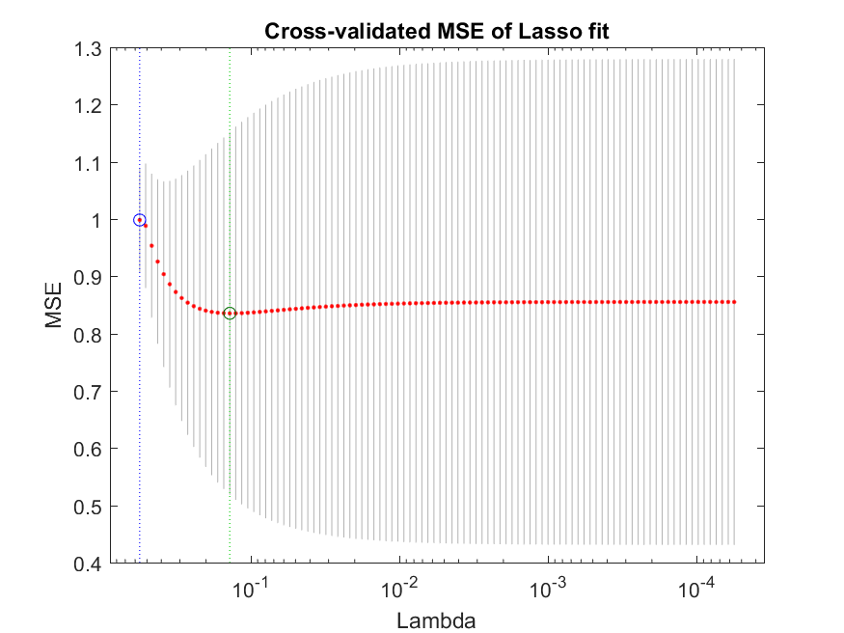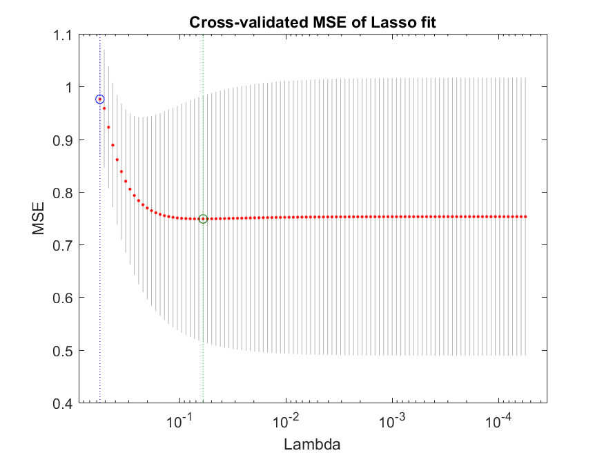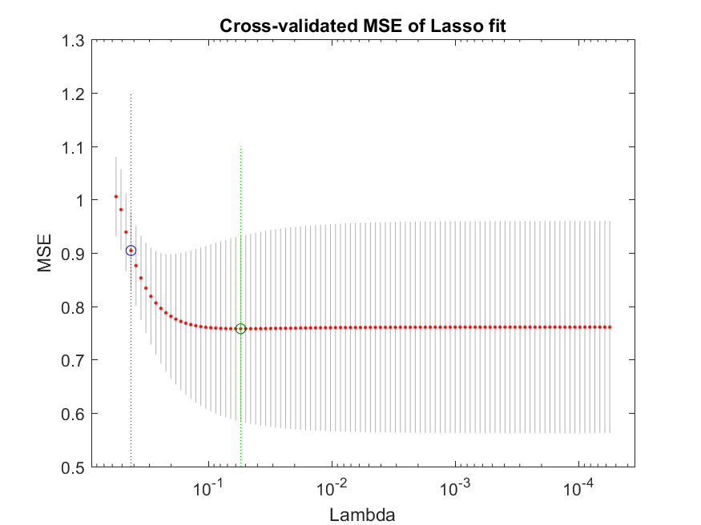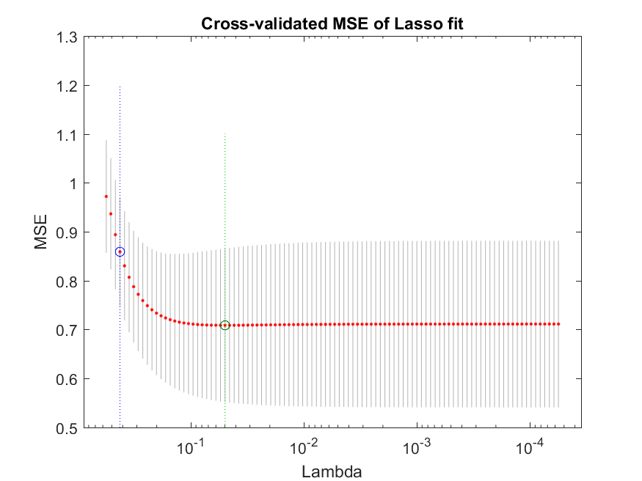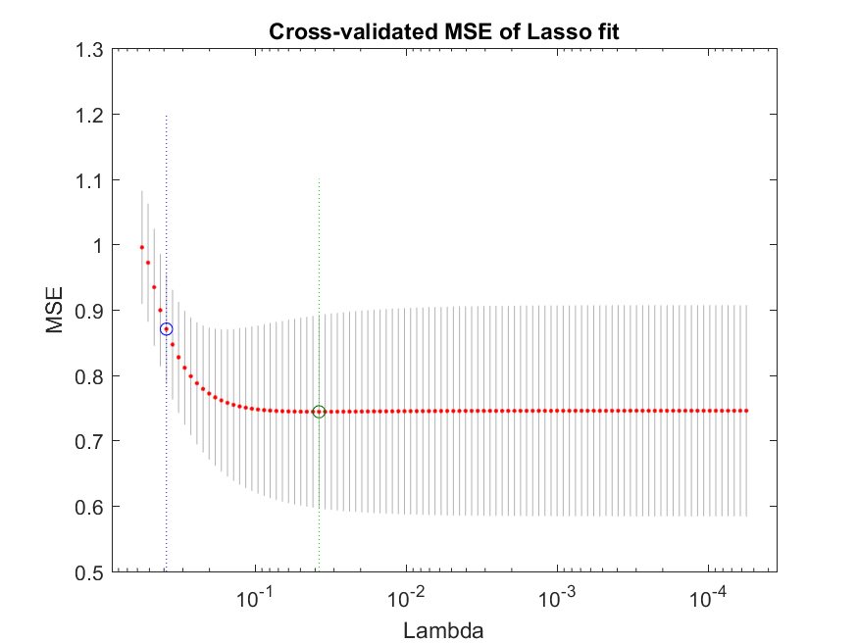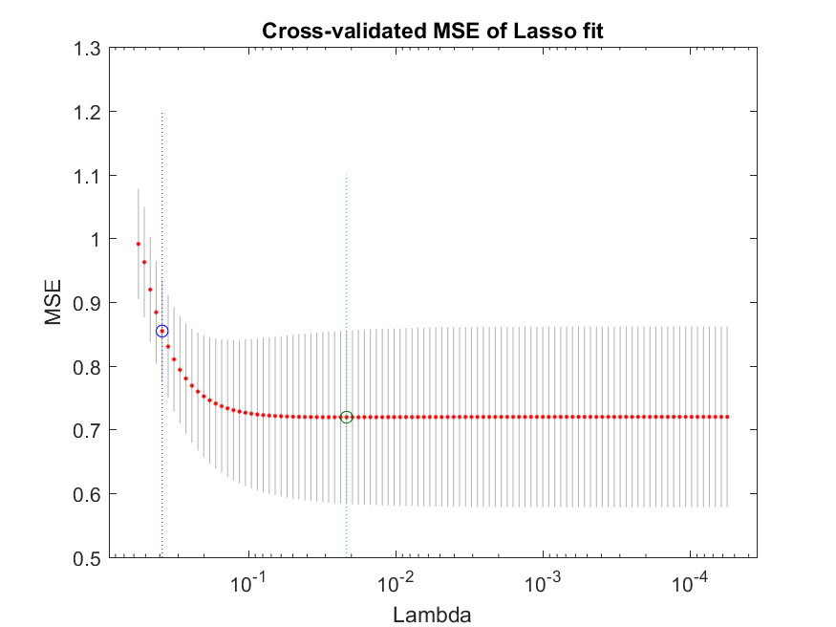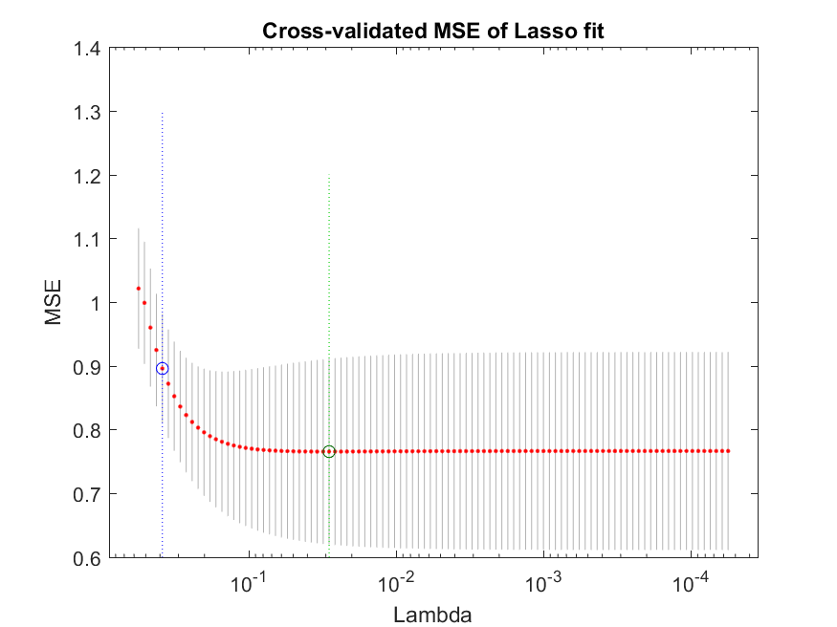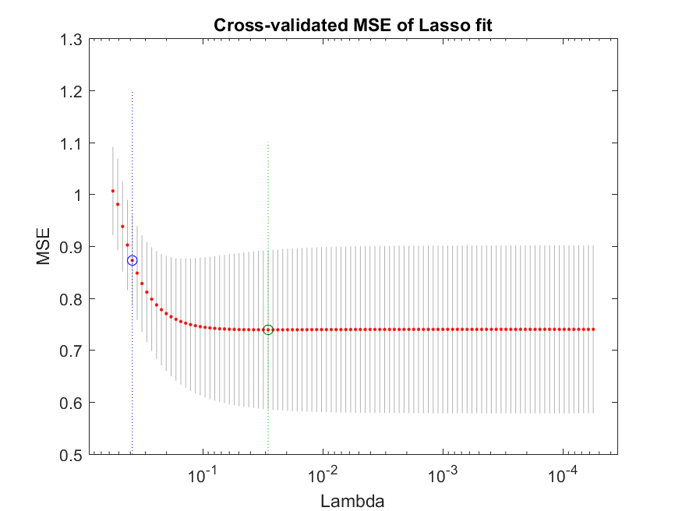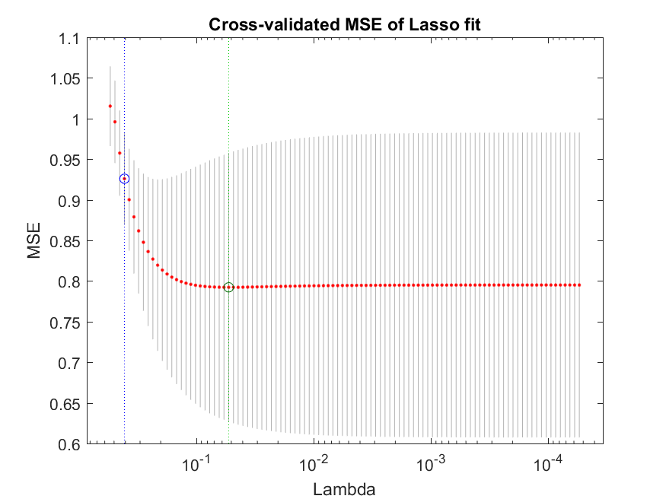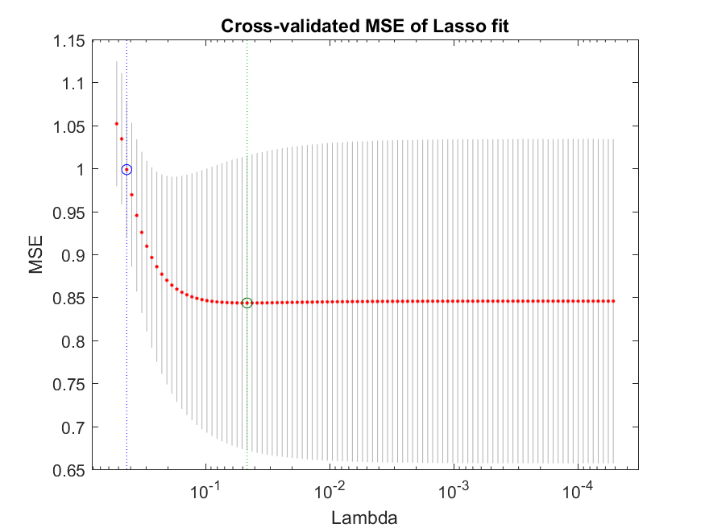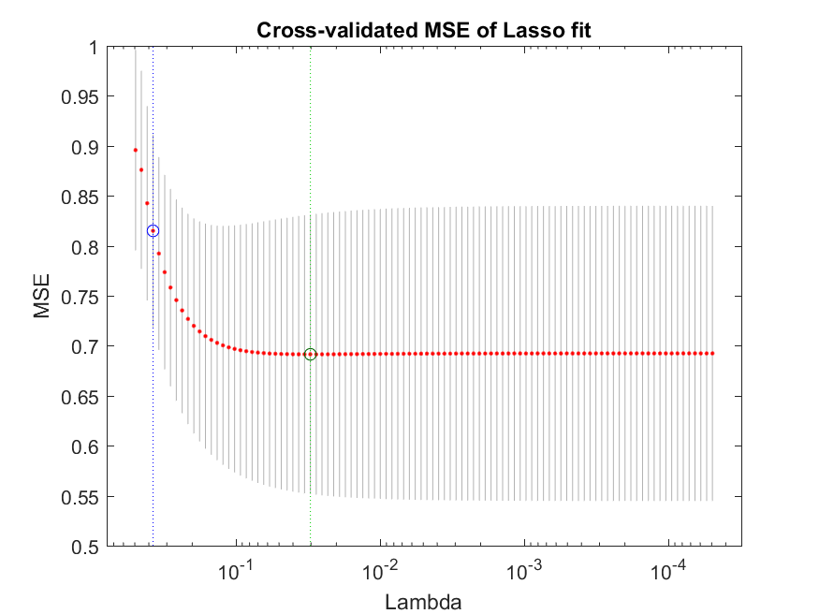

**Question-5 (0.25 pts) Now, add a third feature of Hue to your data and plot the three in a 3D plot.**

% Question-5 (0.25 pts)

% Now, add a third feature of Hue to your data and plot the three in a 3D plot.

hue=wine(:,11);

A = [magnesium,color_intensity,hue];

x = A(:,2) ; y = A(:,3) ; z = A(:,1) ;

[xq,yq] = meshgrid(0:.2:5, 0:.2:5); % change these values to suitable ones for your problem. Maybe use min and max on the x and y data etc.

zq = griddata(x,y,z,xq,yq);

figure; surf(xq,yq,zq);

xlabel('Color Intensity')

ylabel('Hue')

zlabel('Magnesium')

title('Question-5 3D Plot of Manesium/Color Intensity/Hue')

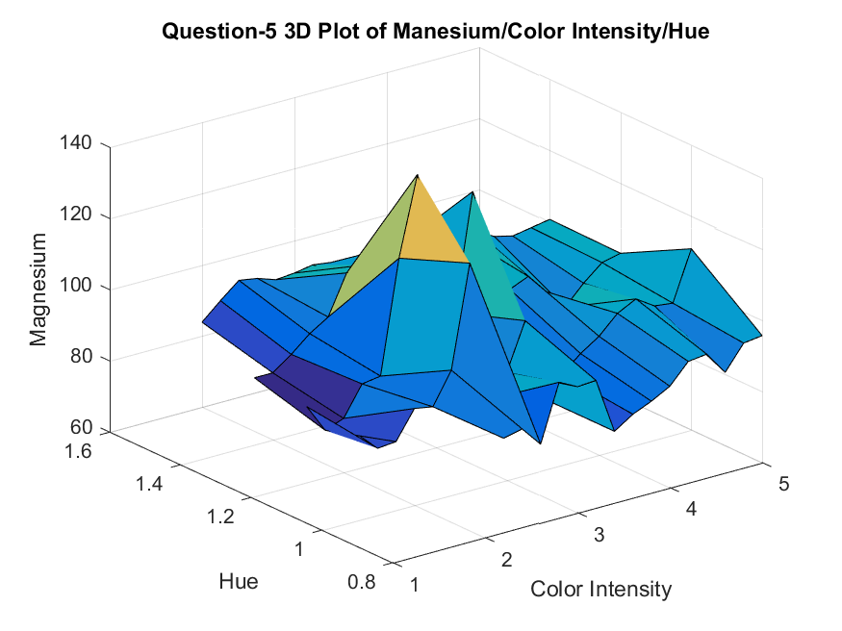

**Question-6 (1 pts) For your three selected features, fit a surface to your data of a degree 10.**

% Question-6 (1 pts)

% For your three selected features, fit a surface to your data of a degree 10.

figure()

surffit = fit( [x, y], z, 'poly10','normalize','on' );

plot(surffit, [x,y], z)

xlabel('Color Intensity')

ylabel('Hue')

zlabel('Magnesium')

title('Question-6 Surface Fit with degree 10')

xi = [5;10;7];

yi = [0.7;0.6;0.5];

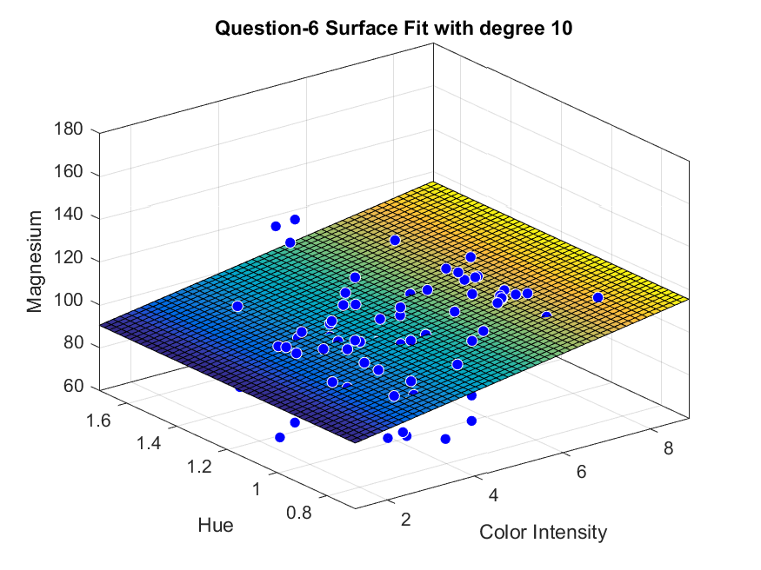

**Question-7 (0.5 pts) Compare the ERM loss of your surface (question 6) and line (question 3) predictors.**

% Question-7 (0.5 pts)

% Compare the ERM loss of your surface (question 6) and line (question 3) predictors.

se=surffit(xi,yi);

RMSE_surf=sqrt(mean(se.^2))/100;

rmse_comp=[RMSE_surf,RMSE(10)];

figure()

h=bar(rmse_comp);

xlabel('Predictors','FontSize', 12)

ylabel('ERM','FontSize', 12)

title('Question-7 ERM Surf Fit vs ERM(Poly) at degree=10', 'FontSize', 10);

l{1}='Surface'; l{2}='Polynomial';

set(gca,'xticklabel', l)

grid on

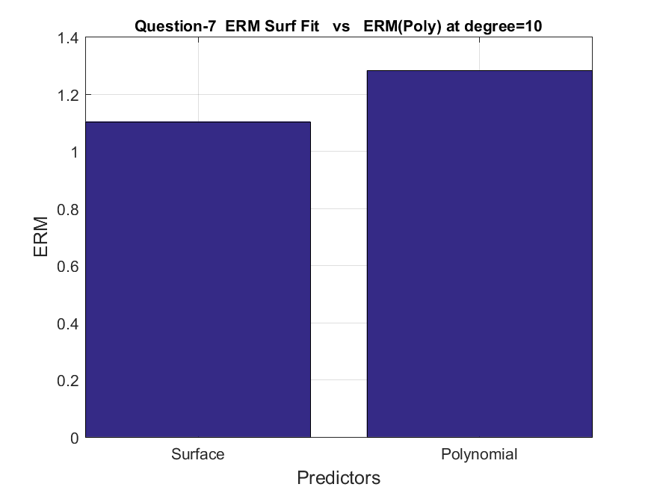

**Question-8 (1 bonus pts) Fit the data with a Perceptron classifier and compare the loss with respect to your fitted lines (question-3)**

% Question-8 (1 bonus pts)

% Fit the data with a Perceptron classifier and compare the loss with respect to your fitted lines

% (question-3)

magnesium=double(magnesium);

color_intensity=double(color_intensity);

hue=double(hue);

mag_norm=magnesium / max(magnesium);

color_intensity=color_intensity / max(color_intensity);

hue_norm=hue / max(hue);

input = [mag_norm, color_intensity, hue_norm];

numIn = 130;

desired_out = wine_label/max(wine_label);

bias = -1;

coeff = 0.01;

rand('state',sum(100*clock));

weights = -1*2.*rand(4,1);

iterations = 1000;

for i = 1:iterations

out = zeros(4,1);

for j = 1:numIn

y = bias*weights(1,1)+...

input(j,1)*weights(2,1)+input(j,2)*weights(3,1)+input(j,3)*weights(4,1);

out(j) = 1/(1+exp(-y));

delta = desired_out(j)-out(j);

weights(1,1) = weights(1,1)+coeff*bias*delta;

weights(2,1) = weights(2,1)+coeff*input(j,1)*delta;

weights(3,1) = weights(3,1)+coeff*input(j,2)*delta;

weights(4,1) = weights(4,1)+coeff*input(j,3)*delta;

end

end

rmse_comp=[RMSE(10),RMSE_surf,delta];

figure()

h=bar(rmse_comp);

xlabel('Predictors','FontSize', 12)

ylabel('ERM','FontSize', 12)

title('Question-8 ERM Surf Fit vs ERM(Poly) vs Perceptron', 'FontSize', 10);

l{2}='Surface'; l{1}='Polynomial'; l{3}='Perceptron';

set(gca,'xticklabel', l)

grid on

