Name: Supriyo Ghosh

Student ID: 215318728

Assignment: 2

**1.1 – Feedforward fully connected neural networks**

**1.1.1 – Layer-wise building block**

The *create_new_layer()*  function creates a new neural network layer from the input tensor *input_tensor* with a specified number of hidden units. The input tensor represents the raw input vector without the bias padding. The weight matrix is initialized using Xavier initialization, and the bias term is zero initialized.

**1.1.2 – Learning**

Using the above function, a simple one-layer neural network was created. To perform training, we used a minibatch size of 500 and 5000 iterations, totalling at 166 epochs. By setting the weight-decay coefficient , the following training, validation and test accuracy vs. epoch curves for different values of the learning rate were observed:

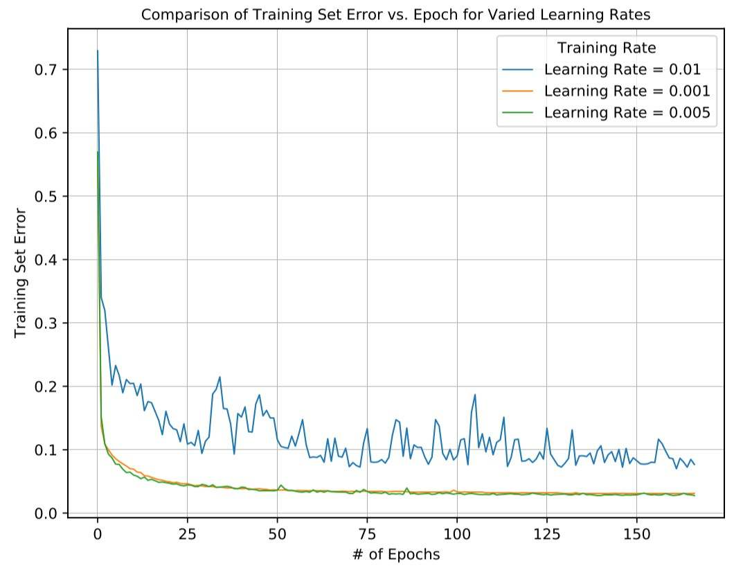

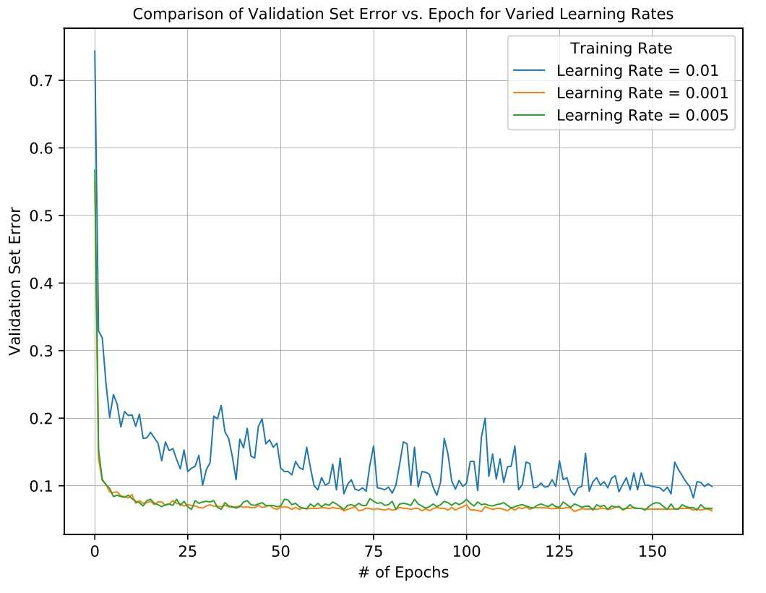

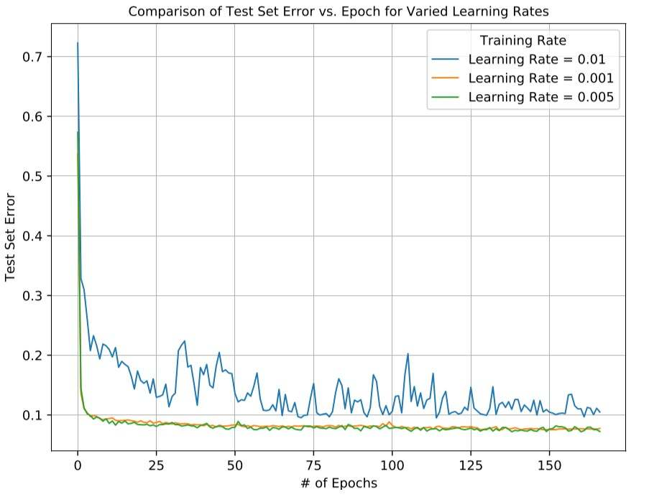

Plotting the training set loss vs. epoch, the following curve was observed:

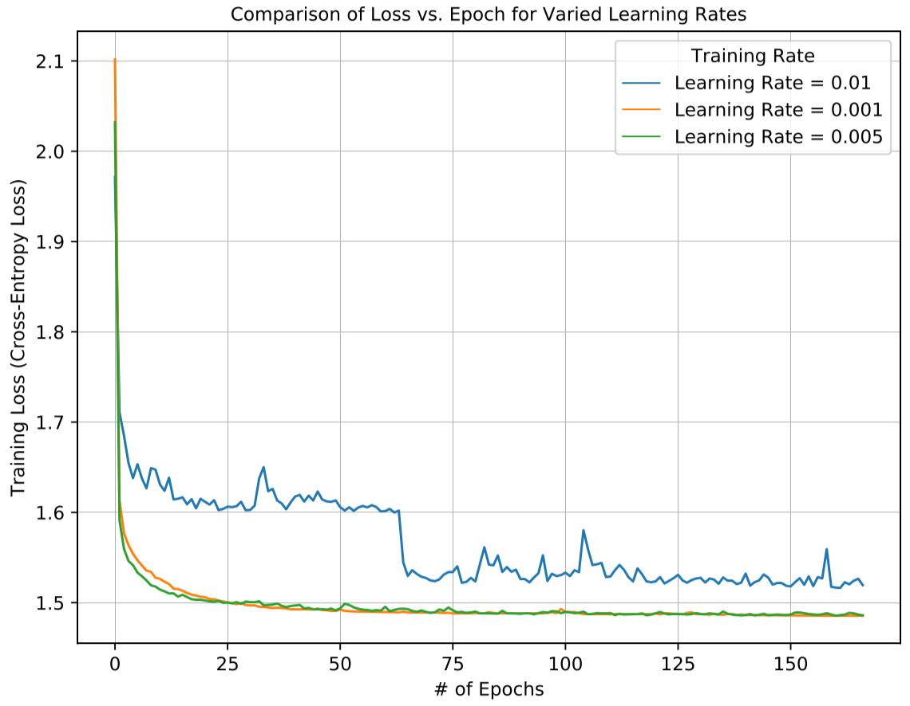

**1.1.3 – Early stopping**

Using the loss graph above and a learning rate of , we identify epoch 45 as the optimal early stopping point where loss did not appreciably change in later epochs. The test, training and validation accuracies at this point are recorded in the table below.

|  |  |  |
| --- | --- | --- |
| Training Set Error | Validation Set Classification Error | Test Set Classification Error |
| 0.0352 | 0.075 | 0.0811 |

**1.2 – Effect of hyperparameters**

**1.2.1 – Number of hidden units**

No weight decay was used in this model. The plots showing the training error and accuracies vs iterations (per epoch) can be seen in Appendix A. The following table summarizes the final values (best results bolded) for tuning the hyperparameters (where ):

|  |  |  |  |  |  |  |  |  |  |
| --- | --- | --- | --- | --- | --- | --- | --- | --- | --- |
| **# of nodes** | 100 | | | 500 | | | 1000 | | |
|  | 0.01 | 0.005 | **0.001** | 0.01 | 0.005 | **0.001** | 0.01 | 0.005 | **0.001** |
| **Val. error** | 0.0800 | 0.0790 | **0.0710** | 0.0701 | 0.0670 | **0.0670** | 0.0760 | 0.0710 | **0.0560** |
| **Test error** | 0.0932 | 0.0870 | **0.0896** | 0.0808 | 0.0775 | **0.0756** | 0.0914 | 0.0793 | **0.0727** |

In summary, increasing the number of hidden units slightly reduces the validation error (by ~1%) for a single layer neural network for this dataset, but a lower number of nodes reduces computation time significantly.

**1.2.2 – Number of layers**

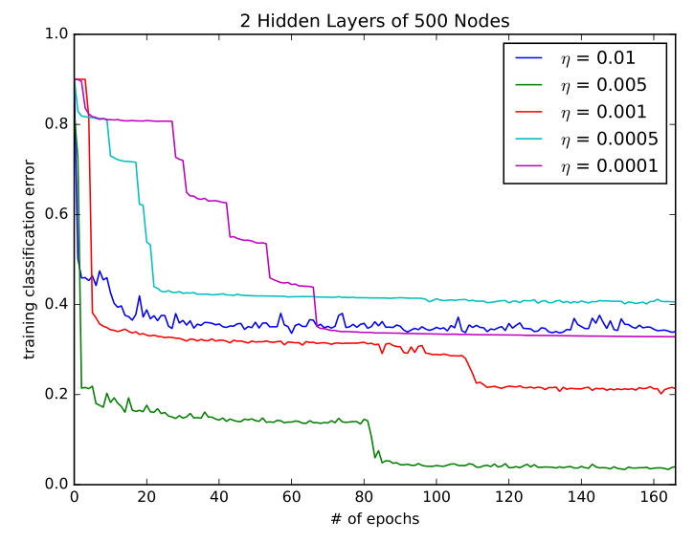

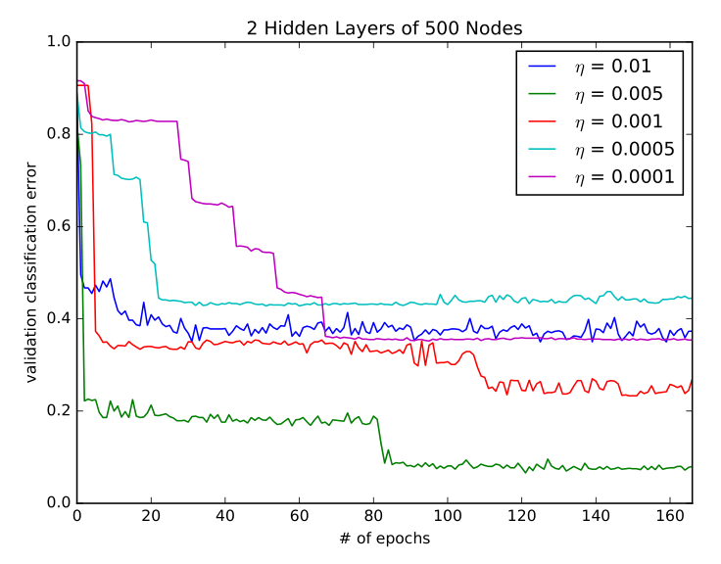

We can see in the graphs steep steps in decrease of error taking place at different epochs indicative of a multi-layer neural network. The following table summarizes the validation and test classification error final values for all learning rates. No weight decay was used in this model.

|  |  |  |  |  |  |
| --- | --- | --- | --- | --- | --- |
|  | 0.01 | **0.005** | 0.001 | 0.0005 | 0.0001 |
| **Val. error** | 0.373 | **0.0800** | 0.270 | 0.445 | 0.354 |
| **Test error** | 0.358 | **0.0830** | 0.262 | 0.452 | 0.356 |

Comparing the results of the test set for in the 2-layer neural network, we see that the error is on par, if not a bit worse than the single layer neural network.

**1.3 – Regularization and visualization**

**1.3.1 – Dropout**

The following are the resulting plots. As seen, adding dropout to the single layer neural network slightly increases test accuracy (i.e. lowers test classification error) but has a slower rate of convergence.

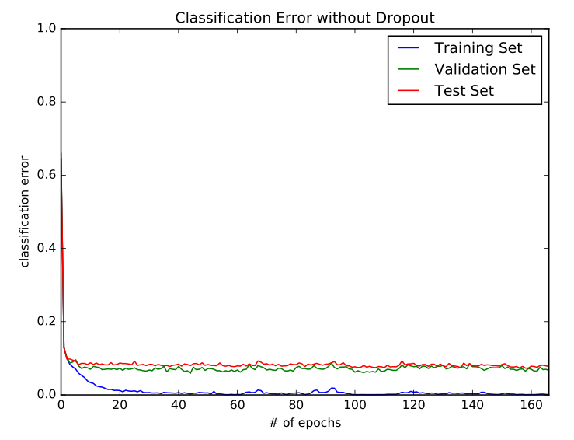

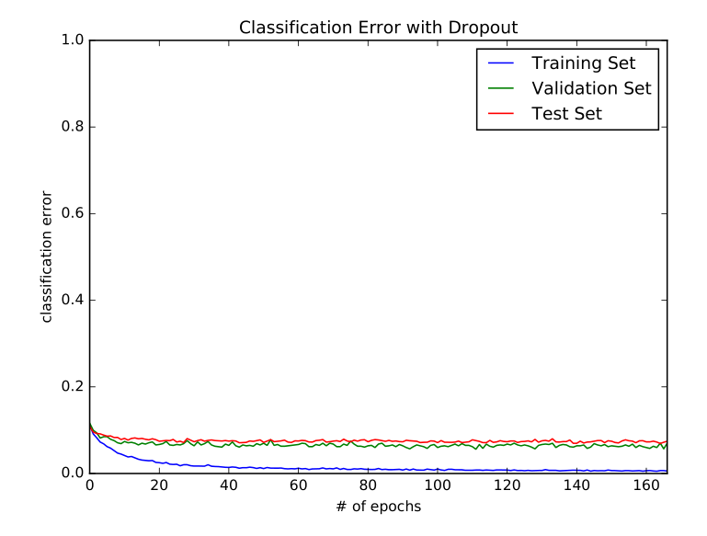

**1.3.2 – Visualization**

100 of the neurons are displayed in the images before at 25% and 100% completion of training for non-dropout and dropout cases. We can see that from 25% to 100% the images start to become clearer and you can start to make out letters for some neurons. We also see that the neurons into the dropout case are in general fuzzier than that of the non-dropout case.

25% complete without dropout

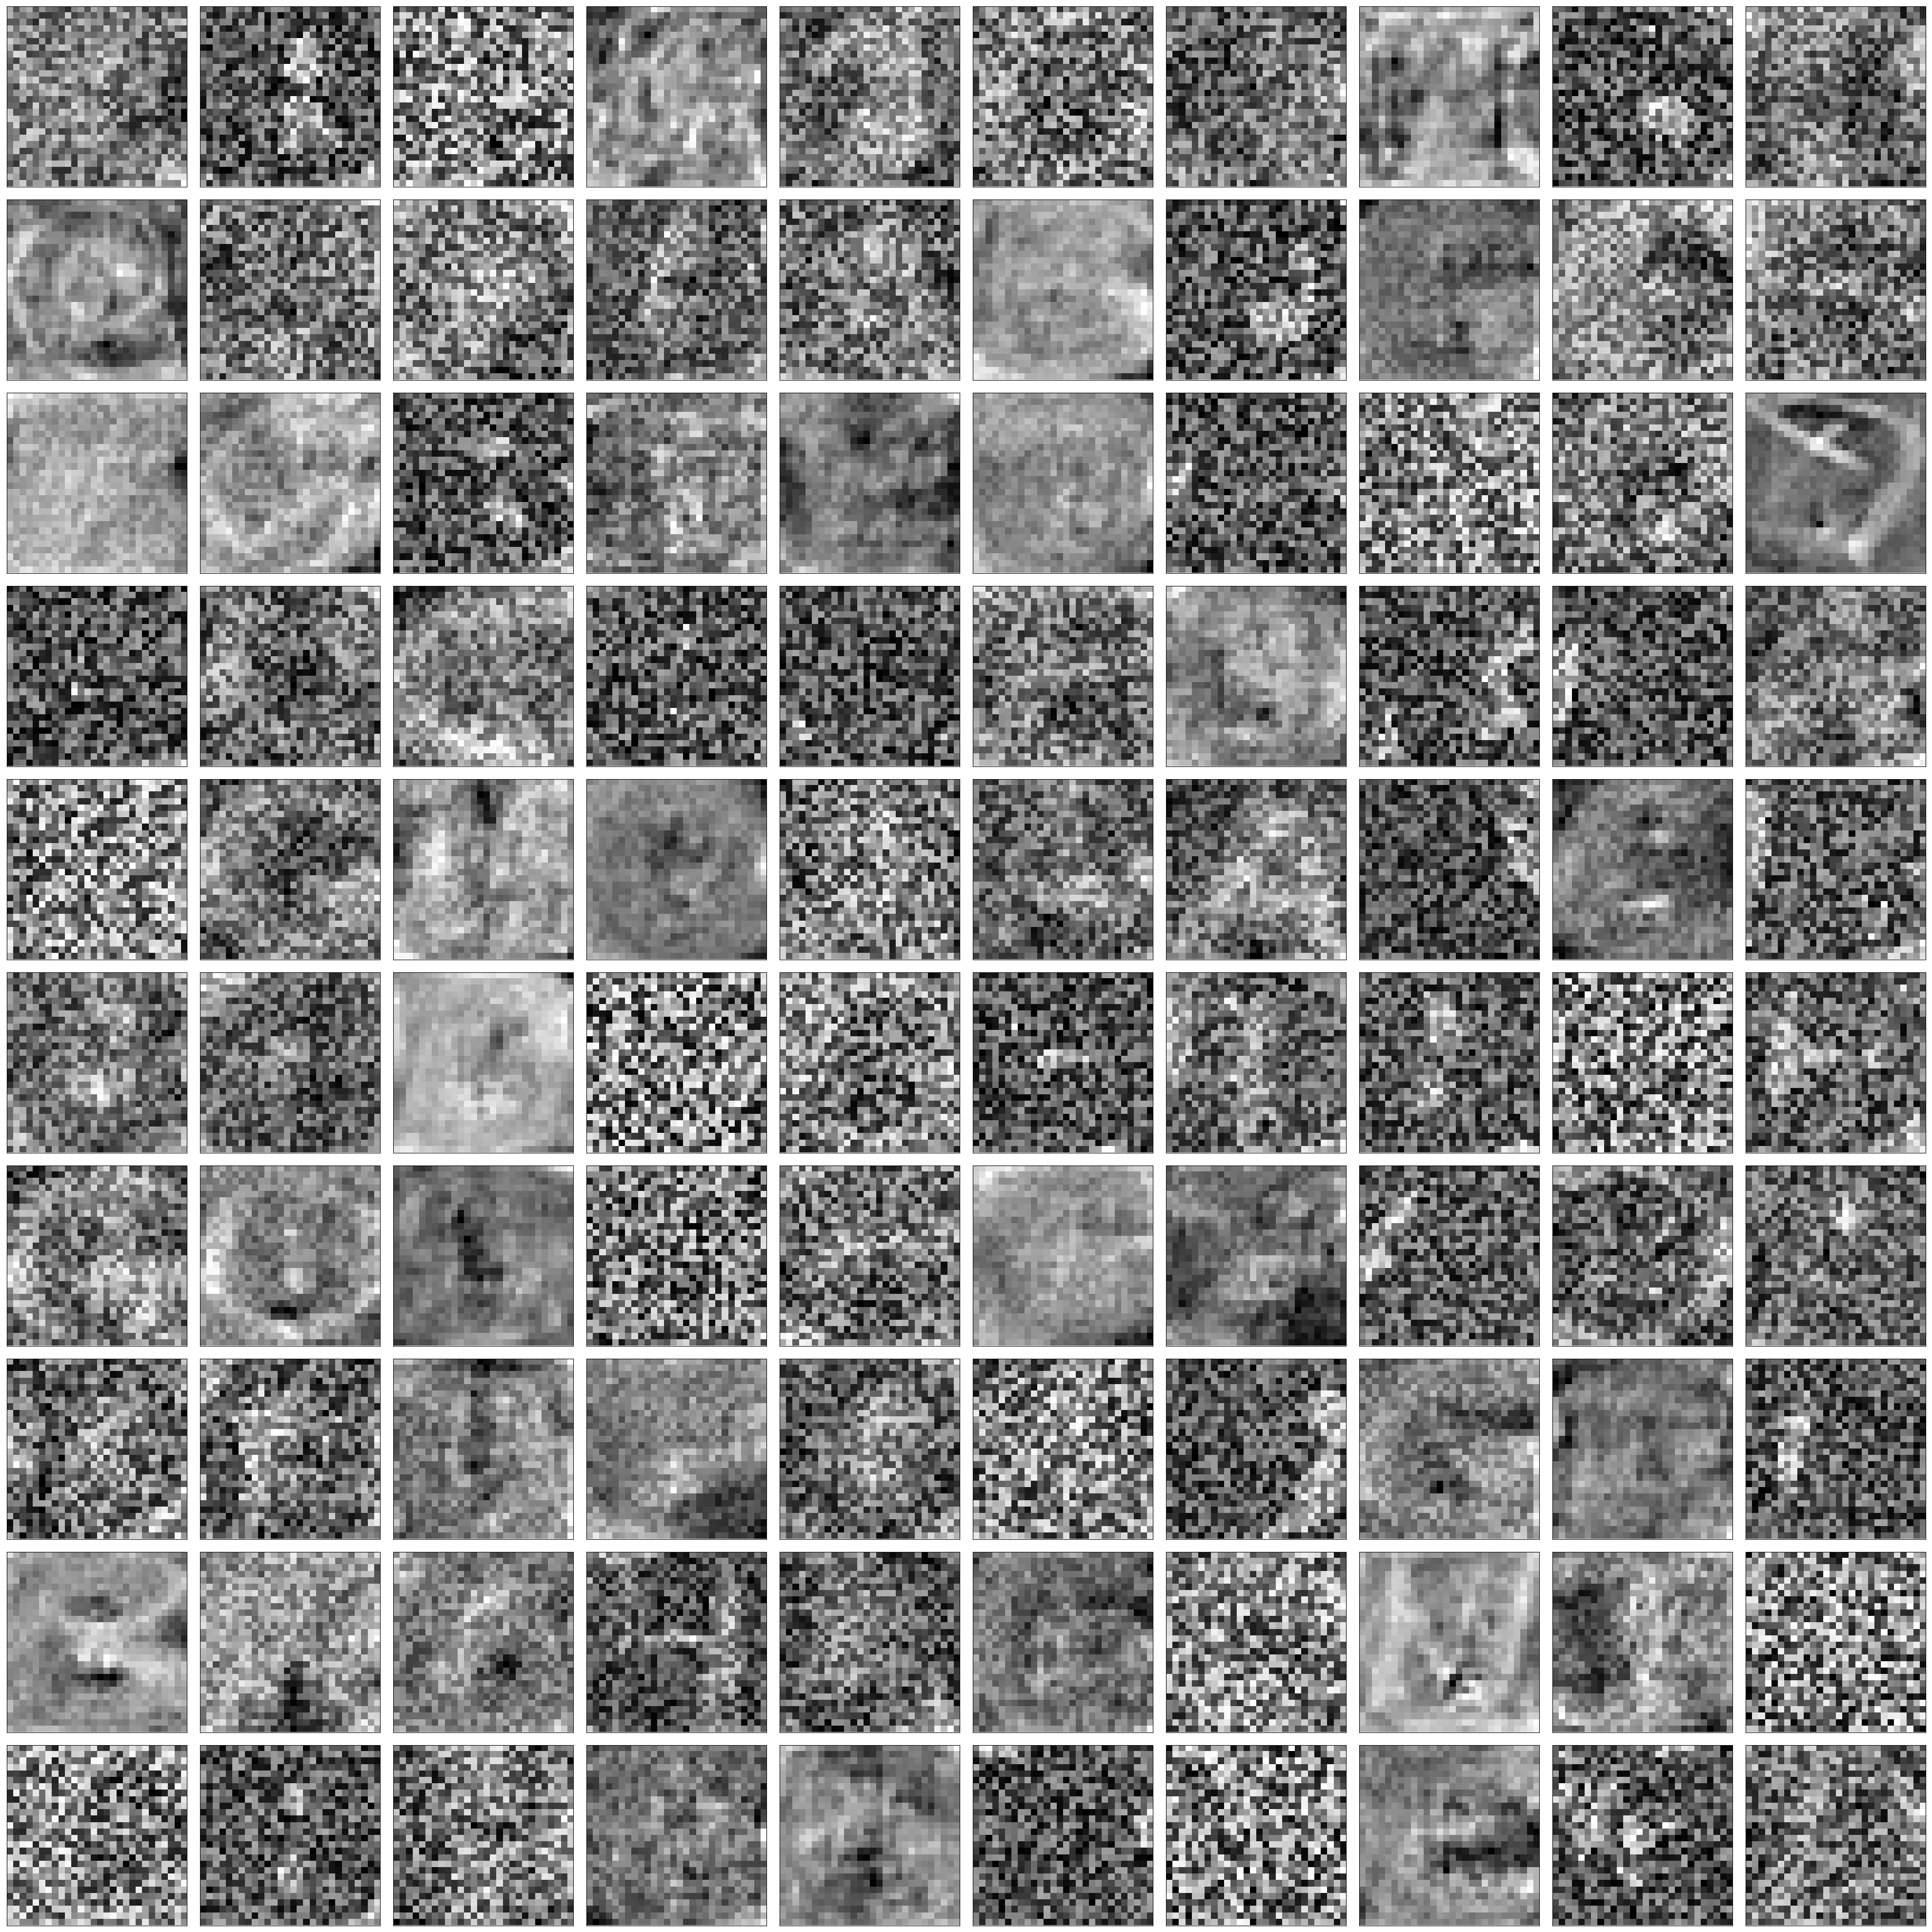

100% complete without dropout

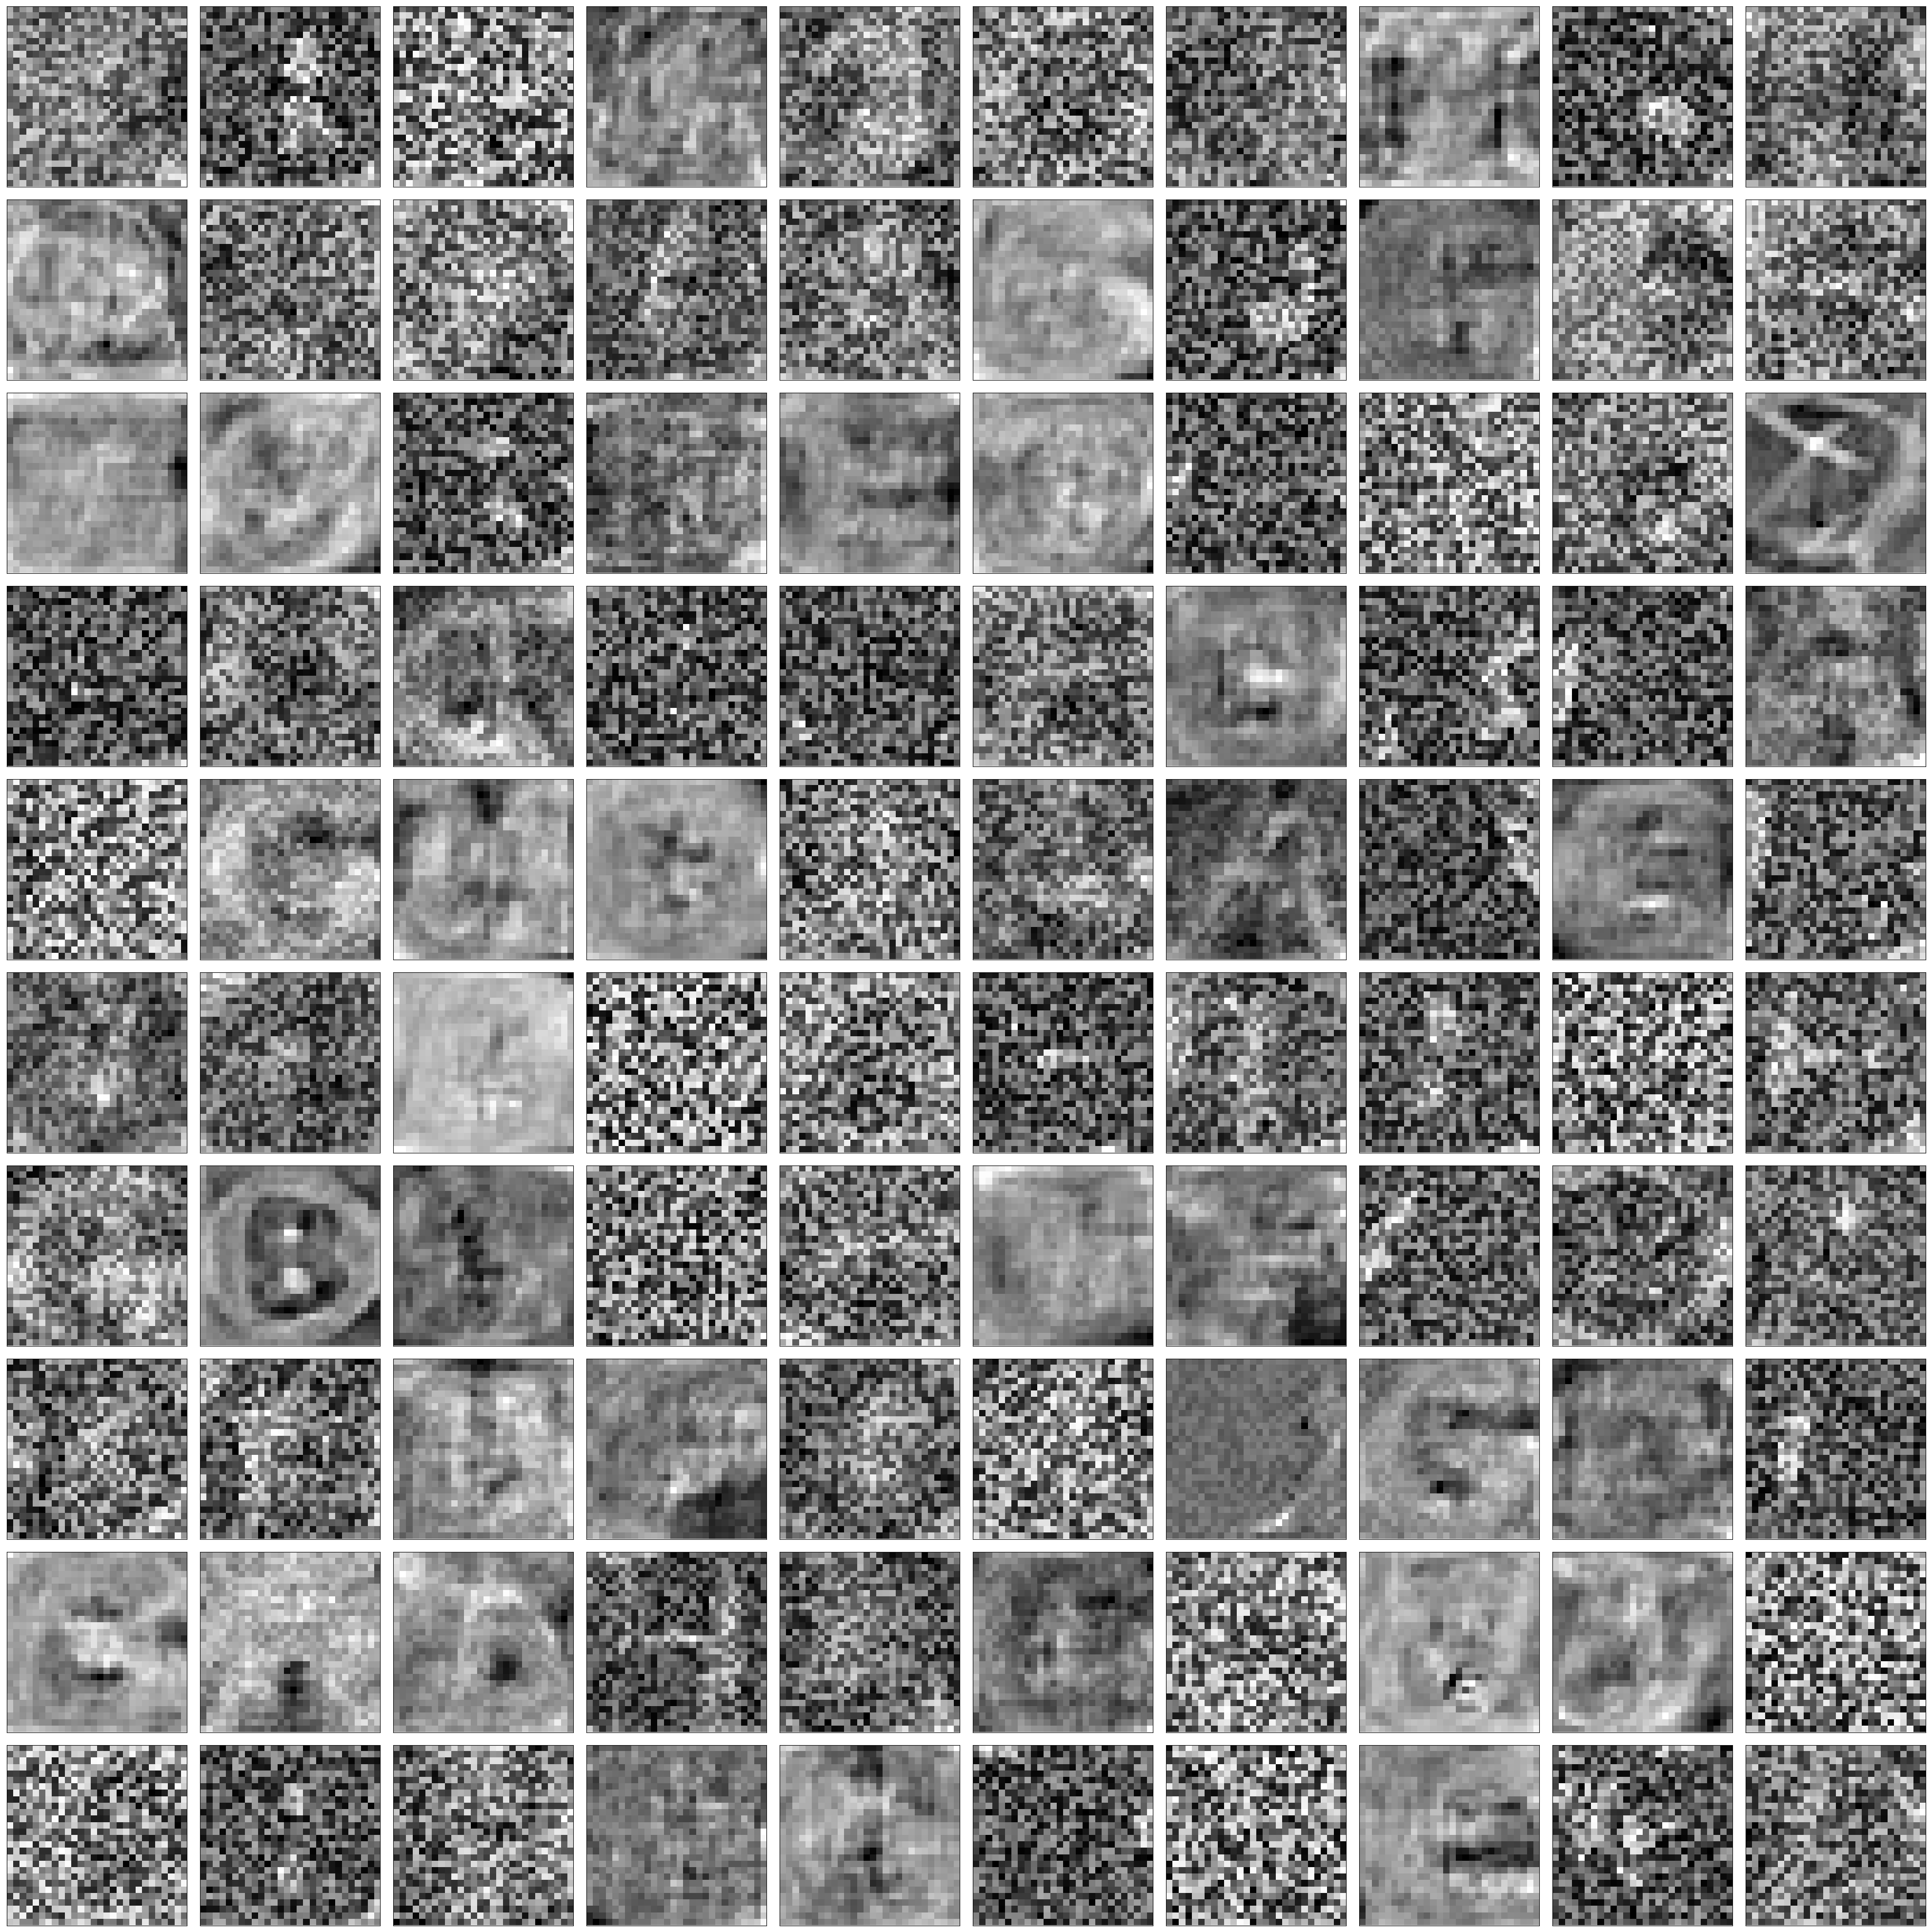

25% complete with dropout

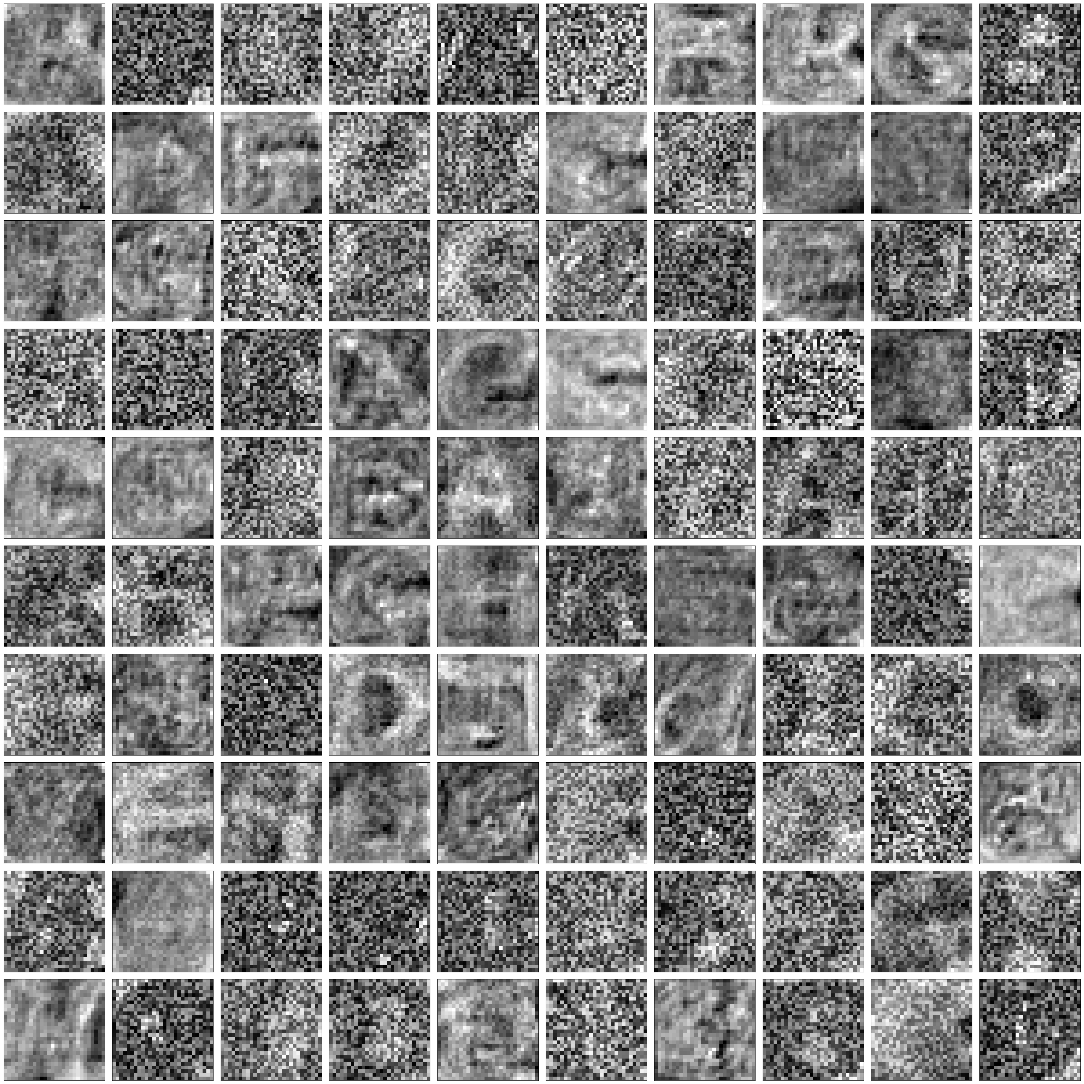

100% complete with dropout

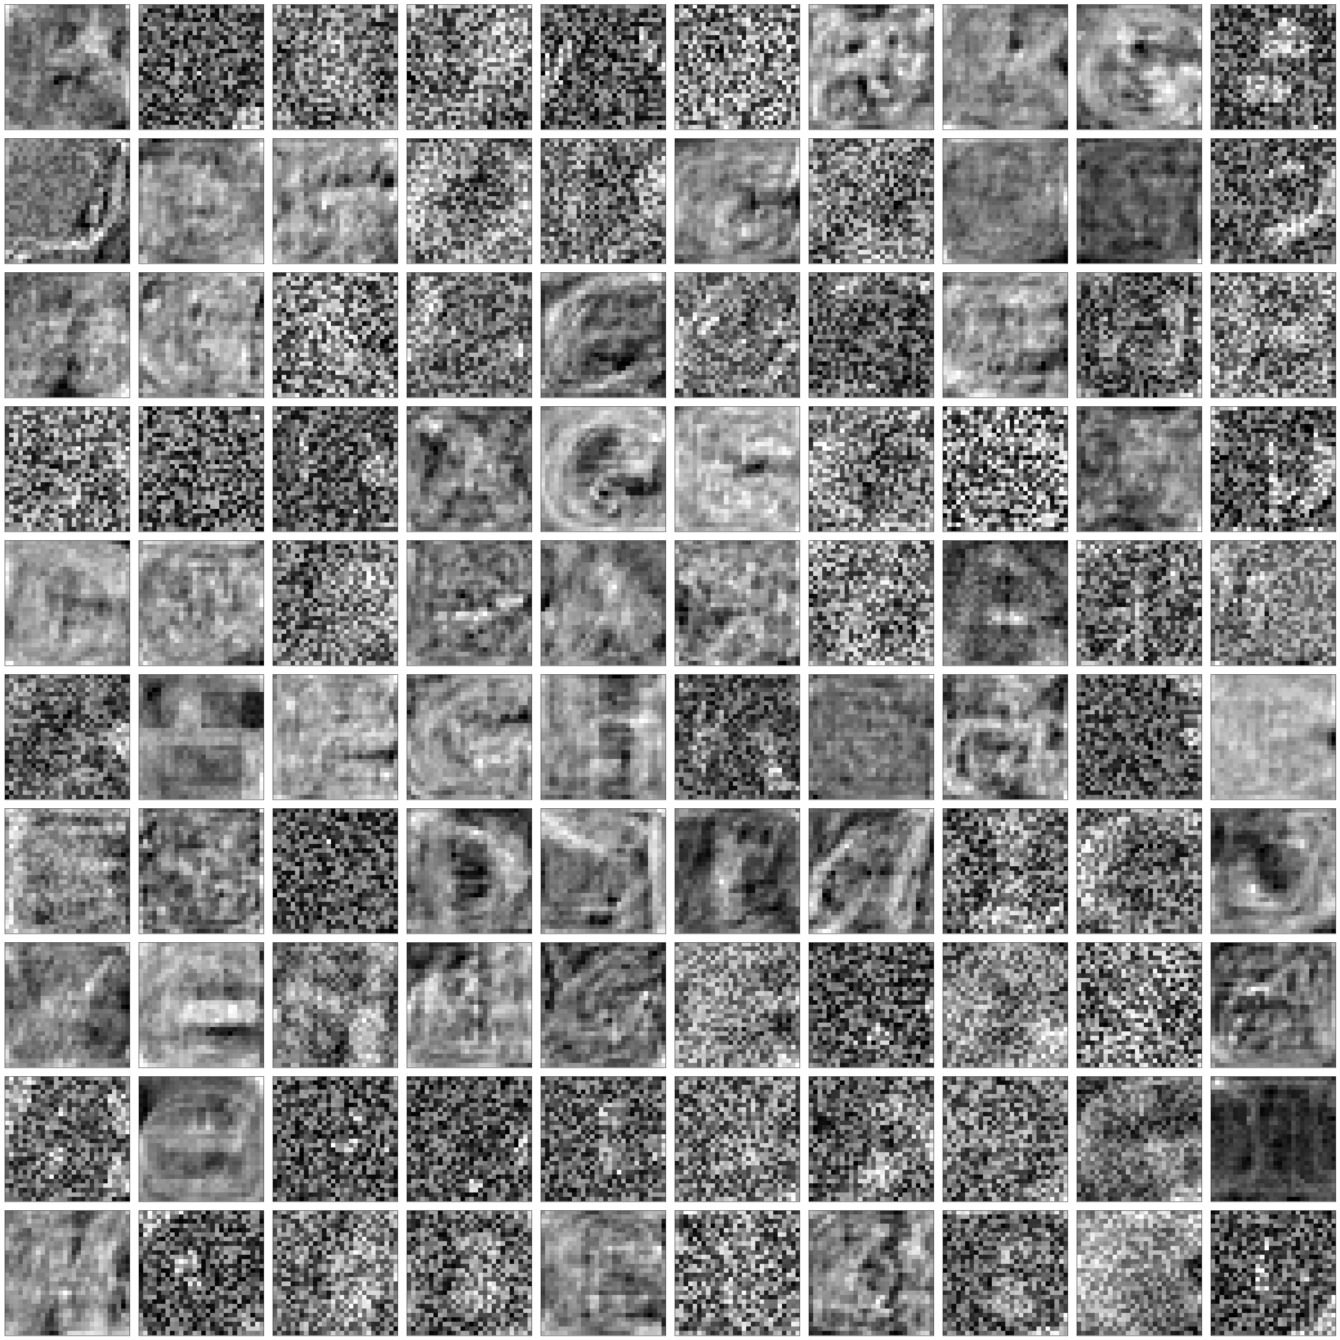

**GRAPHS for 1.2.1**

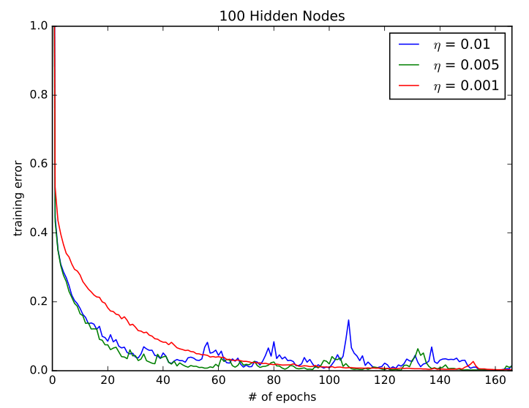

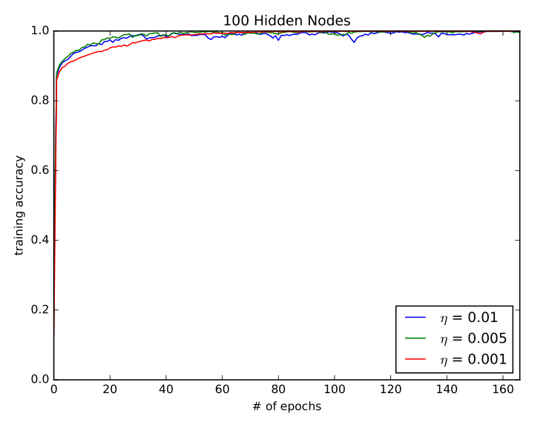

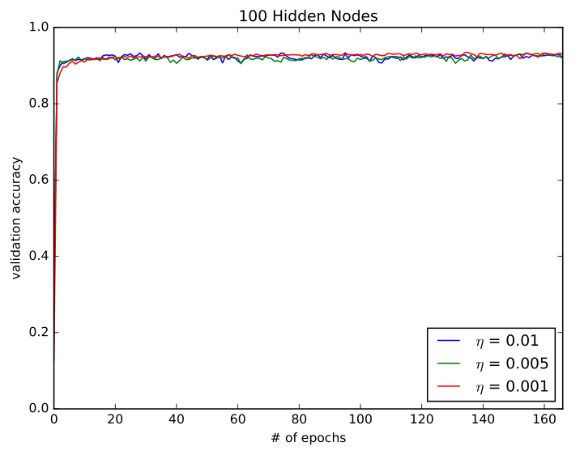

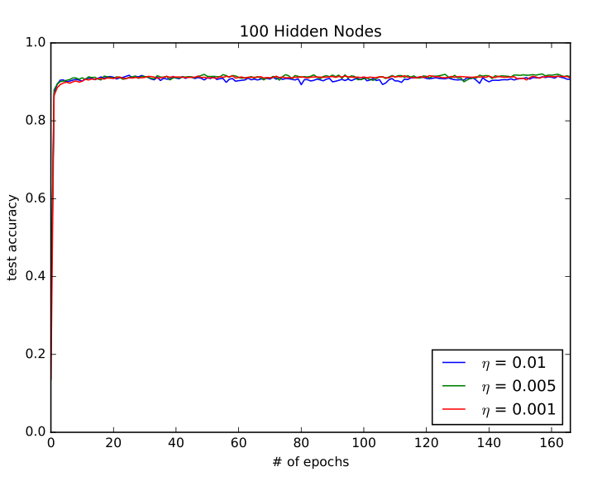

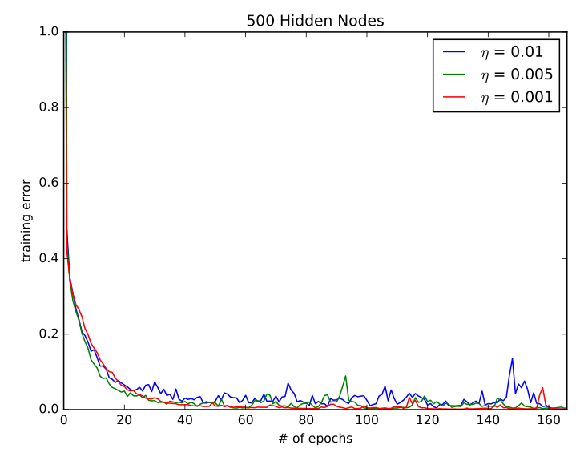

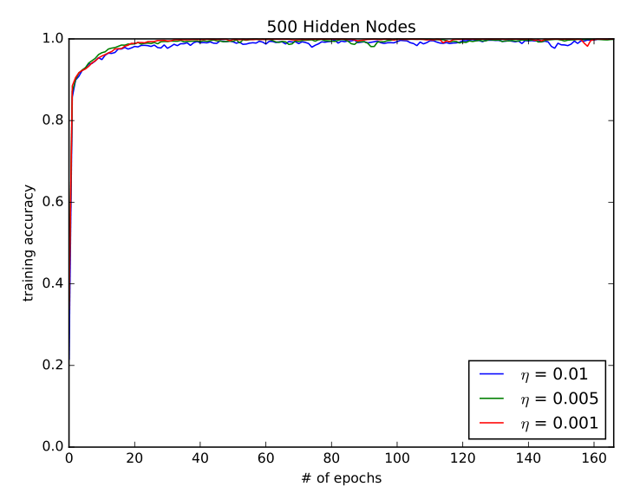

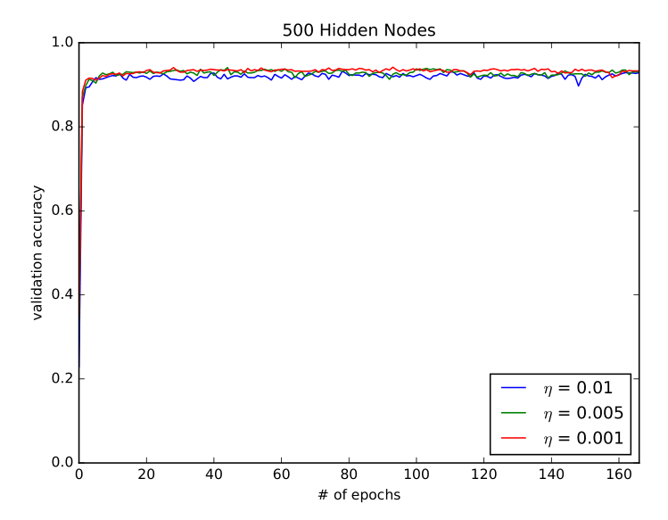

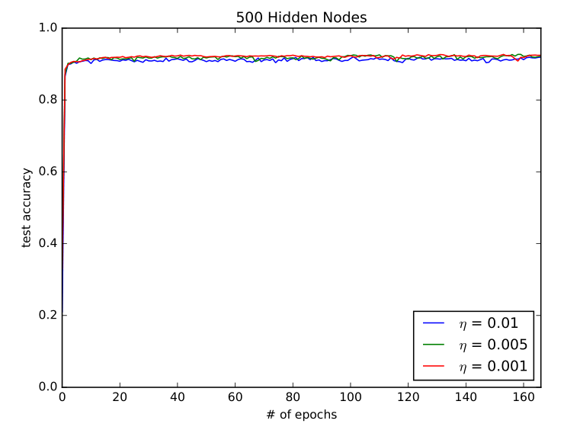

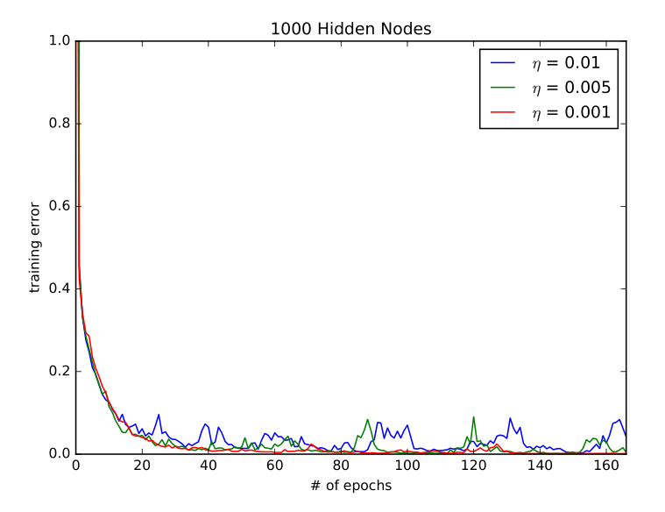

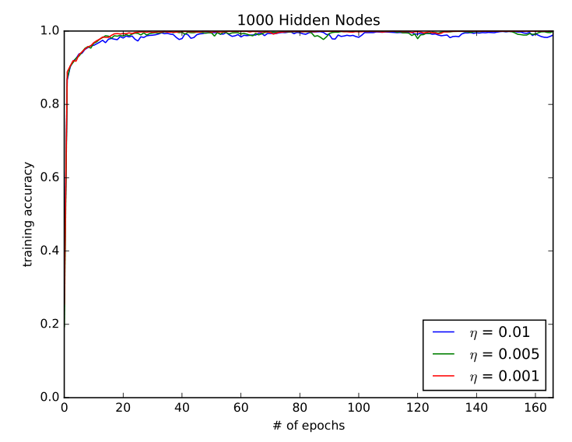

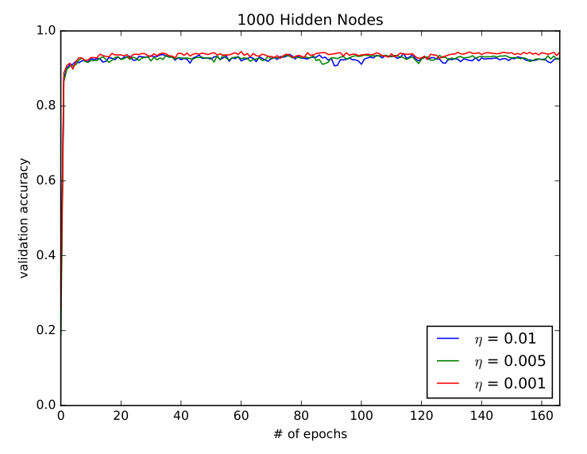

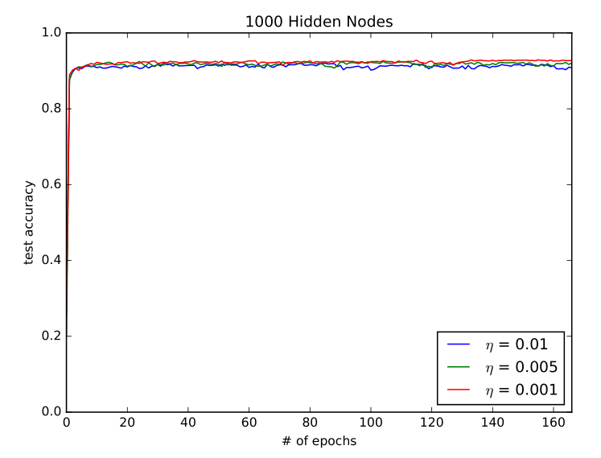

**Python Codes**

neural_networks.py

|  |
| --- |
| import tensorflow as tf  import numpy as np  # Data loader for notMNIST dataset  def load_notmnist_data():  with np.load("notMNIST.npz") as data:  Data, Target = data["images"], data["labels"]  np.random.seed(521)  randIndx = np.arange(len(Data))  np.random.shuffle(randIndx)  Data = Data[randIndx]/255  Target = Target[randIndx]  trainData, trainTarget = Data[:15000], Target[:15000]  t = np.zeros((trainTarget.shape[0], 10))  t[np.arange(trainTarget.shape[0]), trainTarget] = 1  trainTarget = t  validData, validTarget = Data[15000:16000], Target[15000:16000]  t = np.zeros((validTarget.shape[0], 10))  t[np.arange(validTarget.shape[0]), validTarget] = 1  validTarget = t  testData, testTarget = Data[16000:], Target[16000:]  t = np.zeros((testTarget.shape[0], 10))  t[np.arange(testTarget.shape[0]), testTarget] = 1  testTarget = t  return (trainData.reshape(trainData.shape[0], -1), trainTarget, validData.reshape(validData.shape[0], -1), validTarget, testData.reshape(testData.shape[0], -1), testTarget)  # Q1.1.1 layer-wise building block  def create_new_layer(input_tensor, num_hidden_units):  '''  @param input_tensor - outputs of the previous layer in the neural network, without the bias term.  @param num_hidden_units - number of hidden units to use for this new layer  '''  # Create the new layer weight matrix using Xavier initialization  input_dim = int(input_tensor.shape[-1])  initializer = tf.contrib.layers.xavier_initializer()  W_shape = [input_dim, num_hidden_units]  W = tf.get_variable("Layer1_W", initializer=initializer(W_shape), dtype=tf.float32)  # todo: zero initializer?  b = tf.get_variable("Layer1_b", shape=[1, num_hidden_units], dtype=tf.float32)  # MatMul the extended input tensor by the new weight matrix and add the biases  output_tensor = tf.matmul(input_tensor, W) + b  # Return this operation  return output_tensor  # Q1.1.2 learning  def learning():  xTrain, yTrain, xValid, yValid, xTest, yTest = load_notmnist_data()  with tf.Graph().as_default():  num_hidden_units = 1000  decay = 0  B = 500  learning_rates = [0.01, 0.005, 0.001]  iters = 5000  num_iters_per_epoch = len(xTrain)//B # number of iterations we have to do for one epoch  print("Num epochs = ",iters/num_iters_per_epoch)  # hyperparameters  learning_rate = tf.placeholder(dtype=tf.float32, name="learning-rate")  # Get Data  xTrainTensor = tf.constant(xTrain, dtype=tf.float32, name="X-Training")  yTrainTensor = tf.constant(yTrain, dtype=tf.float32, name="Y-Training")  xTestTensor = tf.constant(xTest, dtype=tf.float32, name="X-Test")  yTestTensor = tf.constant(yTest, dtype=tf.float32, name="Y-Test")  xValidTensor = tf.constant(xValid, dtype=tf.float32, name="X-Validation")  yValidTensor = tf.constant(yValid, dtype=tf.float32, name="Y-Validation")  Xslice, yslice = tf.train.slice_input_producer([xTrainTensor, yTrainTensor], num_epochs=None)  Xbatch, ybatch = tf.train.batch([Xslice, yslice], batch_size = B)  with tf.variable_scope("default") as scope:  # Create neural network layers for training  trainb_batchOutput = create_new_layer(Xbatch, num_hidden_units)  trainb_activatedOutput = tf.nn.relu(trainb_batchOutput)  scope.reuse_variables()  layer1_w = tf.get_variable("Layer1_W", shape=[784, num_hidden_units], dtype=tf.float32)  layer1_b = tf.get_variable("Layer1_b", shape=[1, num_hidden_units], dtype=tf.float32)  train_output = tf.matmul(xTrainTensor, layer1_w) + layer1_b  train_activatedOutput = tf.nn.relu(train_output)  valid_output = tf.matmul(xValidTensor, layer1_w) + layer1_b  valid_activatedOutput = tf.nn.relu(valid_output)  test_output = tf.matmul(xTestTensor, layer1_w) + layer1_b  test_activatedOutput = tf.nn.relu(test_output)  outputWeights_size = [int(trainb_activatedOutput.shape[-1]), 10] # We want a [1,10] tensor to get probabilities for each class  outputWeights = tf.Variable(tf.contrib.layers.xavier_initializer()(outputWeights_size), name="Output_W")  outputBias = tf.Variable(0, dtype=tf.float32, name="Output_Bias")  trainb_y_pred = tf.sigmoid(tf.matmul(trainb_activatedOutput, outputWeights) + outputBias)  train_y_pred = tf.sigmoid(tf.matmul(train_activatedOutput, outputWeights) + outputBias)  valid_y_pred = tf.sigmoid(tf.matmul(valid_activatedOutput, outputWeights) + outputBias)  test_y_pred = tf.sigmoid(tf.matmul(test_activatedOutput, outputWeights) + outputBias)  trainb_softmaxLoss = tf.reduce_mean(tf.nn.softmax_cross_entropy_with_logits(logits=trainb_y_pred, labels=ybatch)) + decay * tf.nn.l2_loss(layer1_w)  train_softmaxLoss = tf.reduce_mean(tf.nn.softmax_cross_entropy_with_logits(logits=train_y_pred, labels=yTrainTensor)) + decay * tf.nn.l2_loss(layer1_w)  train_accuracy = tf.count_nonzero(tf.equal(tf.argmax(train_y_pred, 1), tf.argmax(yTrainTensor, 1))) / yTrainTensor.shape[0]  valid_accuracy = tf.count_nonzero(tf.equal(tf.argmax(valid_y_pred, 1), tf.argmax(yValidTensor, 1))) / yValidTensor.shape[0]  test_accuracy = tf.count_nonzero(tf.equal(tf.argmax(test_y_pred, 1), tf.argmax(yTestTensor, 1))) / yTestTensor.shape[0]  # optimizer function  optimizer = tf.train.AdamOptimizer(learning_rate).minimize(trainb_softmaxLoss)  # TODO run a lot of iterations, plot loss vs epochs and classification error vs epochs  for r in learning_rates:  loss_amounts = []  train_accs = []  test_accs = []  valid_accs = []  with tf.Session() as sess:  coord = tf.train.Coordinator()  threads = tf.train.start_queue_runners(sess=sess, coord=coord)  sess.run(tf.global_variables_initializer())  sess.run(tf.local_variables_initializer())  for i in range(iters):  sess.run([optimizer], feed_dict={learning_rate: r})  if (i % num_iters_per_epoch == 0):  t_loss, t_acc, v_acc, test_acc = sess.run([train_softmaxLoss, train_accuracy, valid_accuracy, test_accuracy])  print("Epoch: {}, Training Loss: {}, Accuracies: [{}, {}, {}]".format(i//num_iters_per_epoch, t_loss, t_acc, v_acc, test_acc))  loss_amounts.append(t_loss)  train_accs.append(t_acc)  test_accs.append(test_acc)  valid_accs.append(v_acc)  np.save("1.1.2_r{}_loss".format(r), loss_amounts)  np.save("1.1.2_r{}_train_acc".format(r), train_accs)  np.save("1.1.2_r{}_test_acc".format(r), test_accs)  np.save("1.1.2_r{}_valid_acc".format(r), valid_accs)  learning() |

effect_of_hyperparameters.py

|  |
| --- |
| import numpy as np  import tensorflow as tf  def load_notMNIST():  with np.load("notMNIST.npz") as data:  Data, Target = data["images"], data["labels"]  np.random.seed(521)  randIndx = np.arange(len(Data))  np.random.shuffle(randIndx)  Data = Data[randIndx]/255  Target = Target[randIndx]  trainData, trainTarget = Data[:15000], Target[:15000]  t = np.zeros((trainTarget.shape[0], 10))  t[np.arange(trainTarget.shape[0]), trainTarget] = 1  trainTarget = t  validData, validTarget = Data[15000:16000], Target[15000:16000]  t = np.zeros((validTarget.shape[0], 10))  t[np.arange(validTarget.shape[0]), validTarget] = 1  validTarget = t  testData, testTarget = Data[16000:], Target[16000:]  t = np.zeros((testTarget.shape[0], 10))  t[np.arange(testTarget.shape[0]), testTarget] = 1  testTarget = t  return (trainData.reshape(trainData.shape[0], -1), trainTarget, validData.reshape(validData.shape[0], -1), validTarget, testData.reshape(testData.shape[0], -1), testTarget)  def create_new_layer(input_tensor, num_hidden_units):  '''  @param input_tensor - outputs of the previous layer in the neural network, without the bias term.  @param num_hidden_units - number of hidden units to use for this new layer  '''  # Create the new layer weight matrix using Xavier initialization  input_dim = int(input_tensor.shape[-1])  initializer = tf.contrib.layers.xavier_initializer()  W_shape = [input_dim, num_hidden_units]  W = tf.get_variable("W", initializer=initializer(W_shape), dtype=tf.float32)  # todo: zero initializer?  b = tf.get_variable("b", shape=[1, num_hidden_units], dtype=tf.float32)  # MatMul the extended input tensor by the new weight matrix and add the biases  output_tensor = tf.matmul(input_tensor, W) + b  # Return this operation  return output_tensor  def number_of_hidden_units():  # Constants  B = 500  iters = 5000  learning_rates = [0.01, 0.005, 0.001]  hidden_units = [100,500,1000]  output_data = [[],[],[]]    # Load data  (trainData, trainTarget, validData, validTarget,  testData, testTarget) = load_notMNIST()    # Precalculations  num_iters_per_epoch = len(trainData)//B # number of iterations we have to do for one epoch  print("Num epochs = ",iters/num_iters_per_epoch)  inds = np.arange(trainData.shape[0])    # Set place-holders & variables  X = tf.placeholder(tf.float32, shape=(None, trainData.shape[-1]), name='X')  Y = tf.placeholder(tf.float32, shape=(None, 10), name='Y')  learning_rate = tf.placeholder(tf.float32, name='learning-rate')    for h in range(0, len(hidden_units)):  for lr in range(len(learning_rates)):  # Build graph  with tf.variable_scope("layer1_"+str(hidden_units[h])+"_"+str(lr), reuse=tf.AUTO_REUSE):  s_1 = create_new_layer(X, hidden_units[h])  x_1 = tf.nn.relu(s_1)  with tf.variable_scope("layer2_"+str(hidden_units[h])+"_"+str(lr), reuse=tf.AUTO_REUSE):  s_2 = create_new_layer(x_1, 10)  x_2 = tf.nn.softmax(s_2)    # Calculate loss & accuracy  loss = tf.reduce_mean(tf.nn.softmax_cross_entropy_with_logits(logits=s_2, labels=Y))  accuracy = tf.reduce_mean(tf.cast(tf.equal(tf.argmax(x_2, 1), tf.argmax(Y, 1)), tf.float32))    print("Number of hidden units", hidden_units[h])    with tf.Session() as sess:  with tf.variable_scope("default", reuse=tf.AUTO_REUSE):  optimizer = tf.train.AdamOptimizer(learning_rate).minimize(loss)  coord = tf.train.Coordinator()  threads = tf.train.start_queue_runners(sess=sess, coord=coord)  sess.run(tf.global_variables_initializer())  sess.run(tf.local_variables_initializer())  print("Learning rate = ",learning_rates[lr])  temp_output = []  for i in range(iters):  if (i % num_iters_per_epoch == 0):  np.random.shuffle(inds)  sess.run([optimizer], feed_dict={learning_rate: learning_rates[lr],  X: trainData[inds[B*(i%num_iters_per_epoch):B*((i+1)%num_iters_per_epoch)]],  Y: trainTarget[inds[B*(i%num_iters_per_epoch):B*((i+1)%num_iters_per_epoch)]]})  if (i % num_iters_per_epoch == 0):  t_loss, t_acc = sess.run([loss, accuracy], feed_dict={X: trainData, Y: trainTarget})  v_loss, v_acc = sess.run([loss, accuracy], feed_dict={X: validData, Y: validTarget})  test_loss, test_acc = sess.run([loss, accuracy], feed_dict={X: testData, Y: testTarget})  print("Epoch: {}, Training Loss: {}, Accuracies: [{}, {}, {}]".format(i//num_iters_per_epoch, t_loss, t_acc, v_acc, test_acc))  temp_output.append([t_loss, t_acc, v_acc, test_acc])  output_data[h].append(temp_output)    np.save('Q1-2-1.npy', output_data)  return output_data  def number_of_layers():  # Constants  B = 250  iters = 5000  learning_rates = [0.01, 0.005, 0.001, 0.0005, 0.0001]  hidden_units = [500]  output_data = [[]]    # Load data  (trainData, trainTarget, validData, validTarget,  testData, testTarget) = load_notMNIST()    # Precalculations  num_iters_per_epoch = len(trainData)//B # number of iterations we have to do for one epoch  print("Num epochs = ",iters/num_iters_per_epoch)  inds = np.arange(trainData.shape[0])    # Set place-holders & variables  X = tf.placeholder(tf.float32, shape=(None, trainData.shape[-1]), name='X')  Y = tf.placeholder(tf.float32, shape=(None, 10), name='Y')  learning_rate = tf.placeholder(tf.float32, name='learning-rate')    for h in range(0, len(hidden_units)):  for lr in range(len(learning_rates)):  # Build graph  with tf.variable_scope("layer1_"+str(hidden_units[h])+"_"+str(lr), reuse=tf.AUTO_REUSE):  s_1 = create_new_layer(X, hidden_units[h])  x_1 = tf.nn.relu(s_1)  with tf.variable_scope("layer2_"+str(hidden_units[h])+"_"+str(lr), reuse=tf.AUTO_REUSE):  s_2 = create_new_layer(x_1, hidden_units[h])  x_2 = tf.nn.softmax(s_2)  with tf.variable_scope("layer3_"+str(hidden_units[h])+"_"+str(lr), reuse=tf.AUTO_REUSE):  s_3 = create_new_layer(x_2, 10)  x_3 = tf.nn.softmax(s_3)    # Calculate loss & accuracy  loss = tf.reduce_mean(tf.nn.softmax_cross_entropy_with_logits(logits=s_3, labels=Y))  accuracy = tf.reduce_mean(tf.cast(tf.equal(tf.argmax(x_3, 1), tf.argmax(Y, 1)), tf.float32))    print("Number of hidden layers: 2, Number of hidden units", hidden_units[h])    with tf.Session() as sess:  with tf.variable_scope("default", reuse=tf.AUTO_REUSE):  optimizer = tf.train.AdamOptimizer(learning_rate).minimize(loss)  coord = tf.train.Coordinator()  threads = tf.train.start_queue_runners(sess=sess, coord=coord)  sess.run(tf.global_variables_initializer())  sess.run(tf.local_variables_initializer())  print("Learning rate = ",learning_rates[lr])  temp_output = []  for i in range(iters):  if (i % num_iters_per_epoch == 0):  np.random.shuffle(inds)  sess.run([optimizer], feed_dict={learning_rate: learning_rates[lr],  X: trainData[inds[B*(i%num_iters_per_epoch):B*((i+1)%num_iters_per_epoch)]],  Y: trainTarget[inds[B*(i%num_iters_per_epoch):B*((i+1)%num_iters_per_epoch)]]})  if (i % num_iters_per_epoch == 0):  t_loss, t_acc = sess.run([loss, accuracy], feed_dict={X: trainData, Y: trainTarget})  v_loss, v_acc = sess.run([loss, accuracy], feed_dict={X: validData, Y: validTarget})  test_loss, test_acc = sess.run([loss, accuracy], feed_dict={X: testData, Y: testTarget})  print("Epoch: {}, Training Loss: {}, Accuracies: [{}, {}, {}]".format(i//num_iters_per_epoch, t_loss, t_acc, v_acc, test_acc))  temp_output.append([t_loss, t_acc, v_acc, test_acc])  output_data[h].append(temp_output)    np.save('Q1-2-2.npy', output_data)  return output_data    #output = number_of_hidden_units()  output = number_of_layers() |

regularization_and_visualization.py

|  |
| --- |
| import tensorflow as tf  import numpy as np  import matplotlib.pyplot as plt  def dropout(x, is_training, p):  return tf.cond(is_training, lambda: tf.nn.dropout(x, p, name='dropout'), lambda: tf.identity(x))  # Data loader for notMNIST dataset  def load_notmnist_data():  with np.load("notMNIST.npz") as data:  Data, Target = data["images"], data["labels"]  np.random.seed(521)  randIndx = np.arange(len(Data))  np.random.shuffle(randIndx)  Data = Data[randIndx]/255  Target = Target[randIndx]  trainData, trainTarget = Data[:15000], Target[:15000]  t = np.zeros((trainTarget.shape[0], 10))  t[np.arange(trainTarget.shape[0]), trainTarget] = 1  trainTarget = t  validData, validTarget = Data[15000:16000], Target[15000:16000]  t = np.zeros((validTarget.shape[0], 10))  t[np.arange(validTarget.shape[0]), validTarget] = 1  validTarget = t  testData, testTarget = Data[16000:], Target[16000:]  t = np.zeros((testTarget.shape[0], 10))  t[np.arange(testTarget.shape[0]), testTarget] = 1  testTarget = t  return (trainData.reshape(trainData.shape[0], -1), trainTarget, validData.reshape(validData.shape[0], -1), validTarget, testData.reshape(testData.shape[0], -1), testTarget)  def FCN(x, depth, name, use_dropout=False, is_training=tf.constant(False), use_relu=False):  W = tf.get_variable(name=name + "_W", shape=(x.shape[1], depth), dtype=tf.float64)  b = tf.get_variable(name=name+ "_b", shape=(depth,), dtype=tf.float64, initializer=tf.zeros_initializer)  if use_dropout:  if use_relu:  return dropout(tf.nn.relu(tf.matmul(x, W) + b), is_training, 0.5)  else:  return dropout(tf.matmul(x, W) + b, is_training, 0.5)  else:  if use_relu:  return tf.nn.relu(tf.matmul(x, W) + b)  else:  tf.matmul(x, W) + b  def build_network(input_node, is_training_t):  #can be changed for 2-layer networks  num_hidden_units = 1000  L1_out = FCN(input_node[0], num_hidden_units, name='Layer_1', use_dropout=True, is_training=is_training_t,  use_relu=True)  W = tf.get_variable(name="output_W", shape=(L1_out.shape[1], 10), dtype=tf.float64)  b = tf.get_variable(name="output_b", shape=(10,), dtype=tf.float64, initializer=tf.zeros_initializer)  #for multiple nerual networks  # L1_out = FCN(input_node[0], num_hidden_units, name='Layer_1', use_dropout=True, is_training=is_training_t, use_relu=True)  # L2_out = FCN(L1_out, num_hidden_units, name='Layer_2', use_dropout=True, is_training=is_training_t,  # use_relu=True)  # L3_out = FCN(L2_out, num_hidden_units, name='Layer_3', use_dropout=True, is_training=is_training_t,  # use_relu=True)  # L4_out = FCN(L3_out, num_hidden_units, name='Layer_4', use_dropout=True, is_training=is_training_t,  # use_relu=True)  # W = tf.get_variable(name="output_W", shape=(L1_out.shape[1], 10), dtype=tf.float64)  # b = tf.get_variable(name="output_b", shape=(10,), dtype=tf.float64, initializer=tf.zeros_initializer)  # y_pred_raw = tf.matmul(L4_out, W) + b  y_pred_raw = tf.matmul(L1_out, W) + b  return y_pred_raw  def learning():  xTrain, yTrain, xValid, yValid, xTest, yTest = load_notmnist_data()  with tf.Graph().as_default():  num_hidden_units = 1000  decay = 0  B = 500  learning_rates = [0.01, 0.005, 0.001]  iters = 5000  max_num_epochs = (B*iters)//len(xTrain)  if B*iters % len(xTrain):  max_num_epochs += 1  num_iters_per_epoch = len(xTrain) // B # number of iterations we have to do for one epoch  print("Num epochs = ", iters / num_iters_per_epoch)  # hyperparameters  learning_rate = tf.placeholder(dtype=tf.float64, name="learning-rate")  is_training_t = tf.placeholder(dtype=tf.bool, name="is_training")  base_iterator = tf.data.Iterator.from_structure((tf.float64, tf.float64), ((None, 784), (None, 10)))  input_node = base_iterator.get_next()  y_pred_raw = build_network(input_node, is_training_t)  y_pred = tf.nn.softmax(y_pred_raw)  CE_loss = tf.losses.softmax_cross_entropy(input_node[1], y_pred_raw)  vars = tf.global_variables()  l2s = []  for var in vars:  l2s.append(tf.nn.l2_loss(var))  l2_loss = tf.reduce_sum(tf.stack(l2s, axis=0))  total_loss = CE_loss + decay * l2_loss  accuracy = tf.reduce_mean(tf.cast(tf.equal(tf.argmax(y_pred, 1), tf.argmax(input_node[1], 1)), tf.float32))  # optimizer function  optimizer = tf.train.AdamOptimizer(learning_rate).minimize(total_loss)  X = tf.placeholder(dtype=tf.float64, name="X")  Y = tf.placeholder(dtype=tf.float64, name="Y")  Xdata = tf.data.Dataset.from_tensor_slices(X)  Ydata = tf.data.Dataset.from_tensor_slices(Y)  sample_dataset = tf.data.Dataset.zip((Xdata, Ydata))  batched_dataset = sample_dataset.batch(B)  # TODO run a lot of iterations, plot loss vs epochs and classification error vs epochs  accuracy_list = []  ce_list = []  check_points = [iters//4, iters//2, 3*iters//4, iters-1]  saver = tf.train.Saver(vars)  with tf.Session() as sess:  sess.run(tf.global_variables_initializer())  # initialize data input pippeline for training  dataset_init = base_iterator.make_initializer(batched_dataset)  for i in range(max_num_epochs):  sess.run(dataset_init, feed_dict={X:xTrain, Y:yTrain})  j = 0  while True:  try:  sess.run([optimizer, ], feed_dict={learning_rate: 0.005, is_training_t: True})  j += 1  if i * num_iters_per_epoch + j in check_points:  saver.save(sess, '.\my_model', global_step=i)  except tf.errors.OutOfRangeError:  break  # initialize data iterator for getting numbers to plot  # on train  sess.run(dataset_init, feed_dict={X: xTrain, Y: yTrain})  this_acc = 0.0  this_ce = 0.0  j = 0  while True:  try:  acc, ce = sess.run([accuracy, CE_loss], feed_dict={is_training_t: False})  this_acc += acc  this_ce += ce  j += 1  except tf.errors.OutOfRangeError:  break  train_acc = this_acc/j  train_ce = this_ce/j  # on val  sess.run(dataset_init, feed_dict={X: xValid, Y: yValid})  this_acc = 0.0  this_ce = 0.0  j = 0  while True:  try:  acc, ce = sess.run([accuracy, CE_loss], feed_dict={is_training_t: False})  this_acc += acc  this_ce += ce  j += 1  except tf.errors.OutOfRangeError:  break  val_acc = this_acc / j  val_ce = this_ce / j  # on test  sess.run(dataset_init, feed_dict={X: xTest, Y: yTest})  this_acc = 0.0  this_ce = 0.0  j = 0  while True:  try:  acc, ce = sess.run([accuracy, CE_loss], feed_dict={is_training_t: False})  this_acc += acc  this_ce += ce  j += 1  except tf.errors.OutOfRangeError:  break  test_acc = this_acc / j  test_ce = this_ce / j  accuracy_list.append((train_acc, val_acc, test_acc))  ce_list.append((train_ce, val_ce, test_ce))  print("Epoch: {}, Training Loss: {}, Accuracies: [{}, {}, {}]".format(i,  train_ce, train_acc, val_acc,  test_acc))  return accuracy_list, ce_list  def visualization(filepath, index=1):  base_iterator = tf.data.Iterator.from_structure((tf.float64, tf.float64), ((None, 784), (None, 10)))  input_node = base_iterator.get_next()  is_training_t = tf.placeholder(dtype=tf.bool, name="is_training")  _ = build_network(input_node, is_training_t)  saver = tf.train.Saver(tf.global_variables())  for var in tf.global_variables():  if var.name == "Layer_1_W:0":  l1_w = var  with tf.Session() as sess:  saver.restore(sess, filepath)  layer1_W = sess.run(l1_w)  target = layer1_W[:, index]  plt.imshow(np.reshape(target, (28,28)))  plt.show()  if __name__ == "__main__":  #accs, ces = learning()  #acc_array = np.array(accs)  #x = np.arange(acc_array.shape[0])  #plt.plot(x, acc_array)  #plt.show()  #ces_array = np.array(ces)  #plt.plot(x, ces_array)  #plt.show()  (ac, ce) = learning() |