Bottom Line Up Front (BLUF):

When the Proportional control was too large, we would have too large of steering movements, making the car feel unstable and all over the place, ended up off the track. Reducing the P value too small does not give the car enough of a steering angle to deal with certain curves. Adding the Derivative value reduces the oscillation and helps keep the car on a more stable path. Too small a D value, and the car still oscillates and overshoots it’s steering. Too large and the car takes too long to reach it’s zero error point. Once the P and D values were tuned, I noticed there was a bias towards 0.25 CTE. This was corrected by adding in the I value to account for our bias. You will notice these adjustments in the following graphs and their associated runs.

Tuning Method:

I started tuning by only running with the P parameter and zeroing out the other two. This helped me understand the behavior and tune the value of P. Once this was done, I moved onto the Derivative value and made adjustments until the car steered smoothly and remained on track. The last method was tuned last once I was happy.

Run 1: P = 0.2 | I = 0 | D = 0

Oscillation grows and grows, falls off track

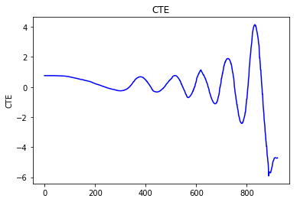

Run2: P = 0.2 | I = 0 | D = 1

Car stays on track, but oscillates the whole way. Not very comfortable for a car.

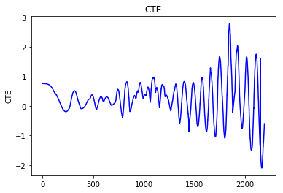

Run3: P = 1 | I = 0 | D = 1

Car oscillates and then grows until it falls off the track.

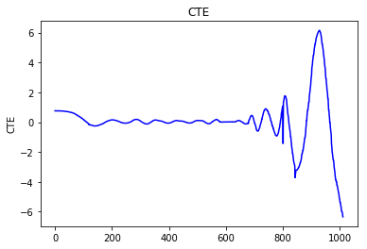

Run4: P = 0.5 | I = 0 | D = 0.25

Oscillates and then goes off track



Run6: P = 0.5 | I = 0 | D = 1

Smaller faster corrections, but got out of control.



Run7: P = 0.2 | I = 0 | D = 1

Doesn’t oscillate too much, stays on track, but gets caught in some oscillations after larger curves.



Run8: P = 0.2 | I = 0 | D = 2

Stays on track, doesn’t oscillate as large, needs some integral adjustments. Noticeable bias around 0.25



Run9: P = 0.2 | I = 0 | D = 4

Reduces the amount of oscillation and appears to be smoother. Noticeable bias around 0.25



Run10: P = 0.2 | I = 0.005 | D = 4

Starts off with a larger oscillation, but then settles. The bias is gone and we’re now oscilationg around the 0 error mark.



Run11: P = 0.2 | I = 0.003 | D = 5

Less Oscillations, but still not smooth enough



Run11: P = 0.2 | I = 0.003 | D = 6

We got a little more oscillations this time, maybe decreasing P, and put D back to 5 will give us something smoother.

