This does not represent a shift in what Amplio is.

Attend to your body’s instincts and see if this is better to understand or not.

Does this feel like a better way to explain things to the unitiated.

# Why and how to shift from frameworks of practices to frameworks of agreements

Frameworks were originally conceived as a means to a foundation for thinking. They were intended to:

* Be quick to learn
* Create a common vernacular
* Enable figuring out how to solve your problems
* Align people towards a solution

However, by not providing solid theory to explain them, they create:

* Resistance and slow learning
* Misunderstandings

They tend to ignore:

* their practices are not fit for purpose
* there is a way to explain what’s happening – here’s an irony. While it is true there is complexity and we can’t see everything that’s happening, frameworks have been created on the basis of what we do know. They are prescribing things for us to do. They leave things open in the hope that we can manage the unexpected. But in the process make a lot more unexpected.

This does not mean we should abandon a framework we’ve studied.

This does mean the agreements can change:

1. you can’t change agreements unilaterally.
2. Changes to the agreements must be consistent with the physics of flow (first principles, guidance, factors for effective value streams) – or run as an experiments.
3. And must be consistent with the overall needs of the organization.

Many managers don’t have the wherewithal to provide the alignment – without demanding solutions.

Agilists tend to not educate them and then blame for their poor results.

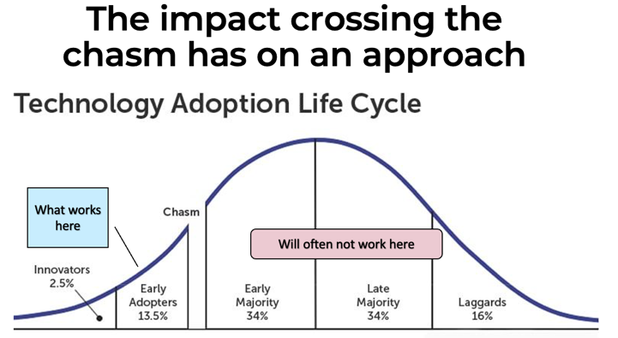



In a nutshell:

The alternative to frameworks would be the different roles making agreements with each other about how to work.

|  |  |  |
| --- | --- | --- |
|  | **Framework of predefined Practices** | **Frameworks of “physics of flow” and Agreements** |
| Composed of | Values, practices, a few concepts | First principles, factors for effective value streams, set of capabilities with patterns a la Alexander to manifest the appropriate solutions. |
| Start | Follow to understand. Little theory causes slow earning and can cause resistance. | Use a small set of agreements to start with, then add others as you go. |
| Understanding | On reads the documents and takes training. But can easily misunderstand. New users have little to verify their understanding with. Each person has their own understanding of what’s happening, and they can end up talking past each other. | Can validate whether the agreement is consistent with the goals of the organization.  People talk to each other about what they are doing together. When there is a misunderstanding, they can more easily uncover it. |
| Creating visibility | Use information radiators which show the state of the work. | Use visual controls which show the state of the work and the agreed upon way of working. |
| Adjusting how we work | Use “inspect and adapt” to adjust the practices of what’s allowed in the framework. | Use PDSA or OODA to see if an agreement is being kept and to both question whether the agreement is appropriate and to expand / challenge our understanding on which it is based |
| What is being followed | Agreeing to follow the framework. | Agreeing with each other. |
| Advantages | Can start with little thinking. | People can relate to what’s happening right up front. |
| Disadvantages | Lack of a fit for purpose solution.  Resistance.  Difficult to extend. | Requires some core training. |
| Responsibility | You can abdicate responsibility by saying you adopted the most popular framework. | Your ass is more on the line. |
| Thinking | You can agree or disagree with someone else. | You have to think more for yourself. |
| Discovering misunderstandings | When two people look at a framework, they may have different understandings of it. This may not be discovered until later. | When two people make agreements with each other their misunderstandings will happen more quickly. |

Frameworks, by their very nature, violate “people over process.”

Individuals and interactions over processes and tools  - fixed frameworks seem to violate this.

Working software over comprehensive documentation -> working agreements over the framework.

Customer collaboration over contract negotiation -> agreements over set practices

Responding to change over following a plan -> modify agreements over immutable frarmeworks

A disadvantage of frameworks

Using the framework as a basis for making decisions:

* This presumes that being consistent with the framework will result in better decisions.
* Practices are not universal. So, by definition, a framework will necessarily include practices that are not applicable.
* If the framework is immutable then can’t use practices that are applicable.

Circular and/or poor logic of frameworks:

* Frameworks are easier to start with because you are given a structure to look within.
* This means if people are using the framework they aren’t thinking outside of it – especially if they are told the framework is immutable.
* Since you’re based on empiricism. If you’re told to follow to understand implying that when you understand you can do what you see as applicable, then why not give that understanding up front? Not being able to do so presupposed as set of insights isn’t available to give to people. But it’s been empirically shown that there are and that empiricism is not enough.
* We must be purposefully incomplete in order to provide an easy start and not overwhelm people. But that does not mean what’s being provided is correct or that you can’t provide things in stages a different way.

NOTES:

Our agreements should be about adding value.

Not following a framework which only works in some circumstances which are rarely stated.

HOW AMPLIO IS STRUCTURED

Shift from frameworks to agreements between people allows people to make agreements in whichever way they believe is best for them.

The transition of frameworks to agreements

1. Frameworks are collections of practices with a few values and principles.
2. People need to implement the practice as stated because there are no rules about doing something else.
3. Inherent simplicity provides a way to decide what practice to do for your situation.
4. We need a way to align across the organization. This is accomplished by identifying critical stakeholders and their values, success criteria and constraints.
5. Shift from a practice with inherent simplicity to patterns a la Alexander. This has the pattern include the purpose of the practice which can be stated as the capability that needs to be manifested.
6. We can consider these capabilities as defining the relationships between the different players in the same way systems are defined by the relationships between the components of the system.
7. **Create alignment around value first (critical stakeholders values, constraints, success criteria).**
8. **Identify the capabilities required to achieve these effectively**
9. **We can consider these capabilities as defining the agreements between the different players in the same way systems are defined by the relationships between the components of the system.**
10. **Inherent simplicity (first principles, guidance, factors for effective value streams) provides a way to decide what practice to do for your situation.**
11. **Use inherent simplicity and patterns a la Alexander. To pick the particular practice of implementation - --- THE IMPLEMENTAION OF HOW TO MEET THE CAPABILITY IS WITHIN THE CONTEXT OF THE AGREEMENT. The person / team doing this has full authority to decide**
12. Frameworks are collections of practices with a few values and principles.

If someone does veto the agreements – there must be a valid reason – reality or authority

Frameworks

* Values
* A few principles
* Practices

Amplio

* Align about creating value
* Provide a set of capabilities
* Each capability has one or more patterns
* Use first principles and factors for effective value streams to decide on practices.

It’s a shift from preset practices to practices that are applicable to your situation.

Instead of agreeing to follow a framework we make agreements with ourselves.

*We do this shift by*

* *Adding first principles and systems thinking, and factors for effective value streams*
* *For each practice in the framework, understand the capability it is designed for*
* *Consider the practice given to be a particular solution of the amplio pattern*
* *Now look for better solutions*
* *As you do this have people engage with each other on how they are working together*

If starting from scratch then come up with a minimal set of agreements to be made.

MOVING FROM A FRAMEWORK TO AMPLIO

Creating the overall view.

Managers see different things so they care about different things.