Hidden Markov model of four activity states
Shima Serein · African Leadership University · 27 October 2026

Background and motivation
A phone at the waist, or left on a desk, streams acceleration and rotation. The question a campus break coach has to answer from that stream is which of four states the person is in: still, standing, walking, or jumping. Still, with the phone on the desk, is the sedentary time the coach should count. Standing in a corridor is not a walk across campus, and jumping belongs to sport. The state itself is hidden: the phone only sees noisy motion. A phone held flat while standing and a phone lying flat on a table both read about one gravity, so a threshold on the raw magnitude cannot tell them apart. This project treats the four activities as the hidden states of a Gaussian hidden Markov model and windowed sensor features as its observations.

Data collection and pre-processing
All 200 recordings were made on 27 October 2026, in one session of about an hour, with Sensor Logger 1.68 on one iPhone 16 Pro. The accelerometer and the gyroscope were both sampled every 10 ms (100 Hz). Each activity was recorded as a block of 50 files: standing with the phone held steady at waist level, screen up; walking at a steady pace, holding the phone the same way; continuous jumps; and still, with the phone lying on a flat surface. Every file is between 5.6 and 9.9 seconds long, and every activity has between 393 and 439 seconds in total, well above the 90-second minimum (Table 1).
Activity | Files | Total (s) | Length of one file (s) | Train / test files
Standing | 50 | 438.5 | 5.58–9.87 | 40 / 10
Walking | 50 | 393.0 | 7.21–8.68 | 40 / 10
Jumping | 50 | 399.0 | 6.71–9.46 | 40 / 10
Still | 50 | 438.0 | 7.65–9.93 | 40 / 10
Table 1. Recordings per activity. One file is one Sensor Logger export.
Collection videos, one per activity, with full body and face visible: Standing https://github.com/supserrr/hidden-markov-models/blob/main/videos/standing.mp4, Walking https://github.com/supserrr/hidden-markov-models/blob/main/videos/walking.mp4, Jumping https://github.com/supserrr/hidden-markov-models/blob/main/videos/jumping.mp4, Still https://github.com/supserrr/hidden-markov-models/blob/main/videos/still.mp4.
Sensor Logger exports each recording as a zip. On iOS its accelerometer stream is user acceleration: gravity has already been removed, and the unit is m/s². Its standard deviation is about 9.8 times that of the uncalibrated stream in the same zip, which is in g, and that confirms the unit. The gyroscope is in rad/s. A converter, src/convert.py, reads both streams by axis name, keeps the span both sensors cover, puts the gyroscope on the accelerometer timestamps, starts the clock at 0 s, and writes one labelled CSV per recording plus a manifest row. No file has a gap longer than 10 ms or a repeated timestamp.
There is one phone, so there is one rate to report: 100 Hz. The brief asks for rates to be harmonised across phones, so every file is linearly interpolated onto a 50 Hz grid before any window is cut. A second phone at 50 or 60 Hz would then give the same window length with no other change; for this phone the step is a downsample by two. The window is 1.0 second (50 samples) and the hop is 0.5 second. A walking step takes about half a second and the measured jump rate is about 1.5 per second, so every window holds at least one step or one jump, the native FFT bin is 1 Hz, and the chain gets a new observation twice a second.
The unseen test set is the last 10 recordings of each activity, by start time. They were made after every training file of the same activity, so no test window sits between two training windows in time. The scaler and the model are fitted on the other 40 files of each activity, which give 2,467 training windows.
Each window gives nine features (Table 2). First the mean acceleration of the window is subtracted, so the features describe motion rather than the tilt of the phone. Six features are time-domain and three come from an FFT of the window, zero-padded to eight times its length. Six of them are sizes, and on this data they span about seven orders of magnitude: the training mean of spectral energy is 0.0008 for still and 13,454 for jumping. A z-score over that range is set by jumping alone, and it leaves standing and still closer together than the variance floor of one Gaussian. Those six features therefore go through log10 first. Every feature is then z-scored with the mean and standard deviation of the training windows only, and test windows reuse those values. Without the log, Baum-Welch merges standing and still, and held-out accuracy falls from 1.000 to 0.862.
Feature | Domain | Why it is in the model (training means)
log acc_mag_mean | Time | Mean size of motion after gravity is removed: 0.009 m/s² still, 0.10 standing, 1.06 walking, 13.3 jumping.
log acc_mag_var | Time | Spread of that magnitude. A landing is a spike; sway is not.
log acc_mag_rms | Time | Energy of the magnitude. Separates a hard landing from a step.
log sma | Time | Signal magnitude area: motion on any axis counts, not only the largest.
acc_xy_corr | Time | Correlation of the two horizontal axes: near 0 at rest, 0.35 walking, 0.41 jumping.
acc_dom_freq | Frequency | FFT peak on the busiest axis, or 0 Hz below the noise floor. Weak here: it fires in 27% of walking windows.
log acc_spectral_energy | Frequency | FFT power from 0.15 to 8 Hz of the magnitude. The widest gap between the classes.
log gyro_mag_mean | Time | How much the phone rotates: 0.001 rad/s on the desk, 3.3 rad/s jumping.
gyro_dom_freq | Frequency | FFT peak of the busiest gyroscope axis. Fires in 86% of jumping windows near 1.5 Hz.
Table 2. The nine features. “log” marks the six that go through log10 before the z-score.

HMM setup and implementation
The hidden states Z are standing, walking, jumping, and still. An observation X is the nine-dimensional feature vector of one window. The transition matrix A gives the probability of moving from one state to another between consecutive windows, and the initial vector π gives the probability of the first state. The emission model B is a diagonal Gaussian per state over the scaled features. A diagonal covariance is enough after scaling, and it needs 18 parameters per state instead of 54.
Everything is written in NumPy (src/hmm.py). Baum-Welch learns π, A, and the Gaussian means and variances. Forward and backward messages stay in log space so a long file cannot underflow. Variances have a floor of 10⁻³, and every transition is floored at 10⁻⁸ before its row is normalised, so no log-probability becomes infinite. Learning stops when the relative change in training log-likelihood falls below 10⁻⁶. On this data that took 4 iterations, from 9,189.7 to 9,471.1, and the likelihood never fell. A self-test on a two-state chain with known parameters recovers its path with accuracy 1.00 and checks that the posteriors sum to one.
Parameters start from the labelled training windows: each state's Gaussian is fitted to its own windows, and transition counts get a Dirichlet count of one so an unseen change stays possible. After EM, states are renamed by the majority training label of their Viterbi path, using training files only. The renaming was the identity: EM kept every activity in its own state.
Baum-Welch is the learning algorithm because a deployed phone will not have labels, and EM can keep adapting π, A, and B from unlabelled windows. Viterbi is the decoder because sensitivity, specificity, and accuracy count one hard label per window, and the Viterbi path is the single most likely sequence of those labels: the one a live display would show. Forward-backward posteriors drive the E-step and would be the right output if a window were allowed to stay uncertain, but they are not what the table counts. Every Viterbi error is one off-diagonal cell of the confusion matrix.

Results and interpretation
The unseen set is 40 files and 581 windows. The Viterbi path is correct on all 581 windows, and the majority label is correct on all 40 files. Table 3 is the table the brief asks for; a sample is one held-out window. The labelled starting point already scores 1.000 before Baum-Welch, and EM changes no held-out label.
State (activity) | Number of samples | Sensitivity | Specificity | Overall accuracy
Standing | 138 | 1.000 | 1.000 | 1.000
Walking | 134 | 1.000 | 1.000 | 1.000
Jumping | 149 | 1.000 | 1.000 | 1.000
Still | 160 | 1.000 | 1.000 | 1.000
Table 3. One-versus-rest sensitivity and specificity on the 40 unseen files. Overall accuracy is the same quantity on every row.
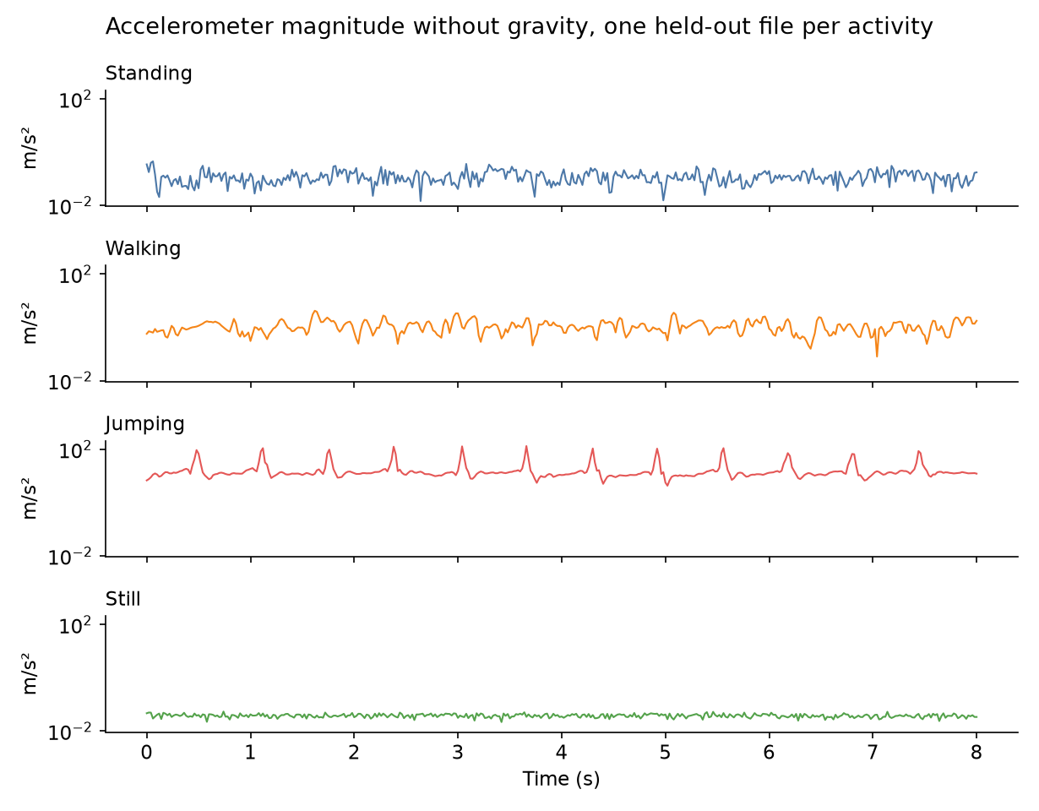
Figure 1. Accelerometer magnitude without gravity for one unseen file per activity, resampled to 50 Hz, on one logarithmic scale. Still sits at the sensor noise floor near 0.01 m/s², standing sways around 0.1, walking moves around 1, and every jump lands as a spike near 100 m/s².
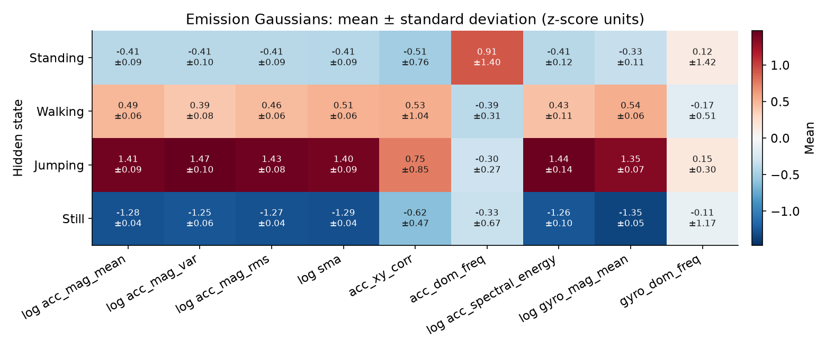
Figure 2. Emission model B: mean and standard deviation of each state's Gaussian on every scaled feature.
On every size feature in Figure 2 the four means are ordered still, standing, walking, jumping, about 0.9 pooled standard deviations apart, while each state's own spread is at most 0.14. That gap is what makes the decoding exact. The frequency features carry less: their spreads are wide, and the acceleration peak fires in only 27% of walking windows, because a one-second window holds about two strides.
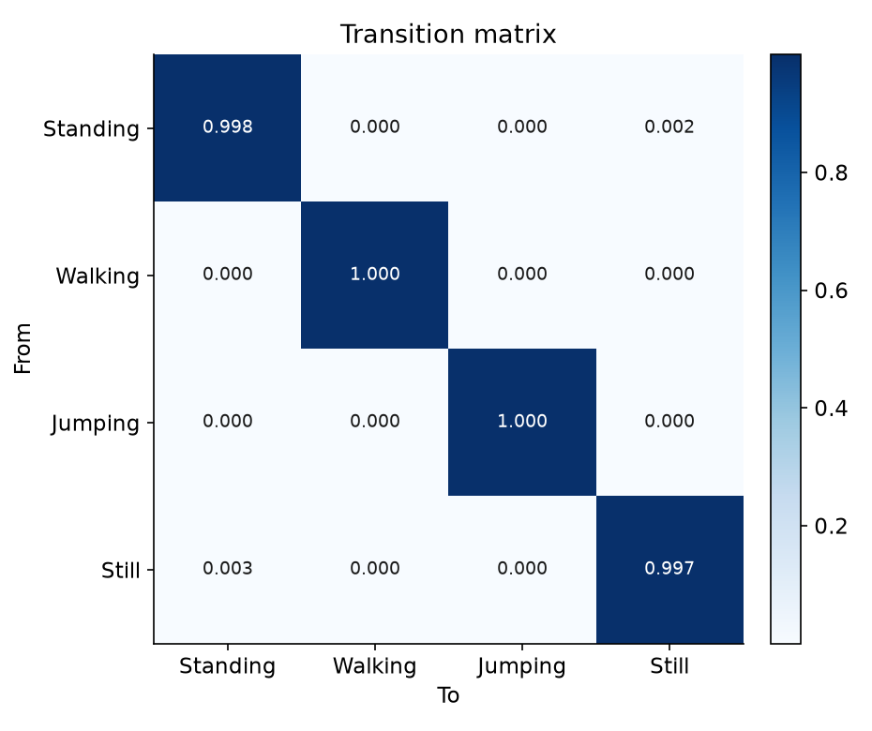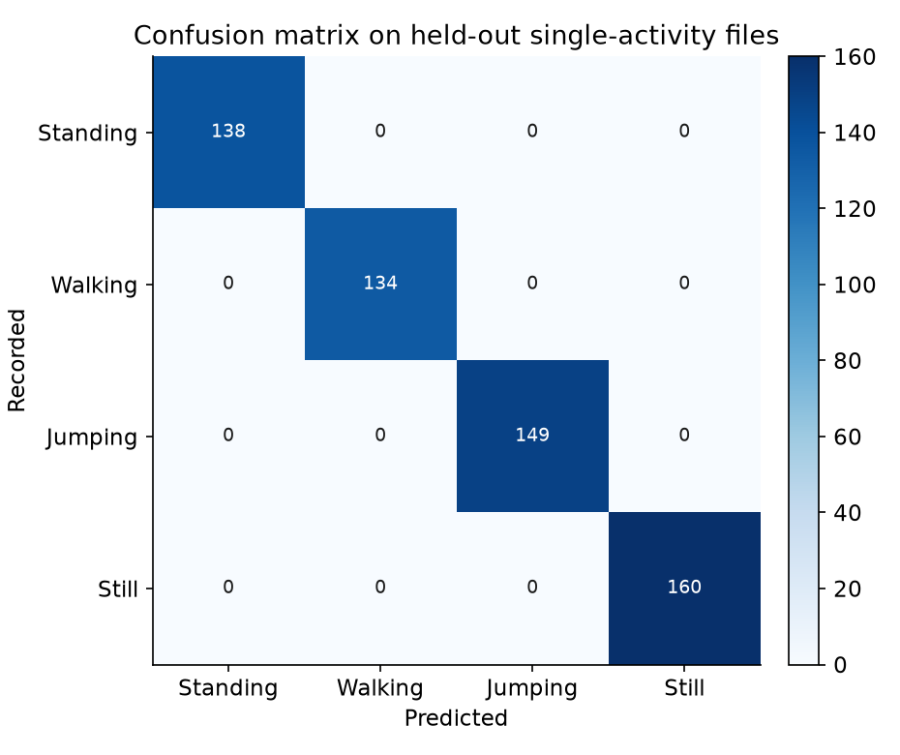
Figure 3. Left: learned transition matrix A; each row sums to 1. Right: confusion matrix on the 581 unseen windows.
The transition matrix is close to the identity. Self-transitions are 0.998 for standing, 0.997 for still, and 1.000 for walking and jumping. With a half-second hop, a self-transition a means an expected stay of 0.5 / (1 − a) seconds: about 5 minutes standing and 2.5 minutes still, which is a plausible length for those states, but an endless walk or jump is not. The cause is the protocol. Every file holds one activity, so every pair of consecutive training windows is a self-transition. The small standing-to-still and still-to-standing mass (0.002 and 0.003) is what EM assigns when a quiet standing window looks partly like still.
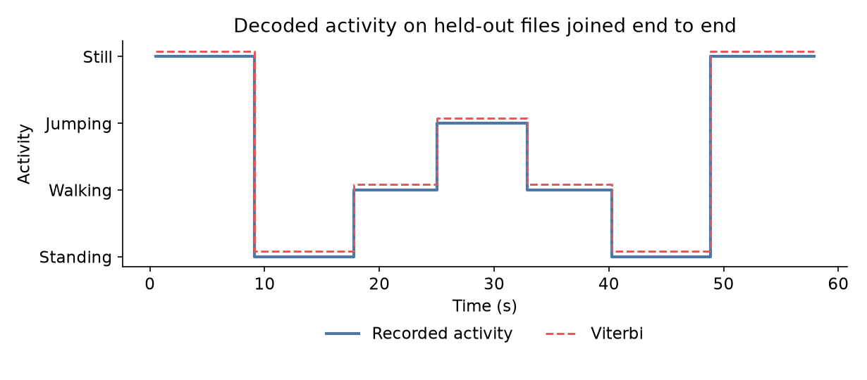
Figure 4. Viterbi on seven unseen files joined end to end: still, standing, walking, jumping, walking, standing, still. The changes are file boundaries, not recorded transitions.
No recording yet changes activity mid-file, so Figure 4 joins seven unseen files into one 58-second sequence. Viterbi follows every change, in both directions, without a wrong window. It switches even though A gives each change a probability near 10⁻⁸, because the emissions of neighbouring states differ by far more than that penalty.

Discussion and conclusion
Jumping was the easiest state: its spectral energy is about 700 times walking's, and its gyroscope peak fires in 86% of its windows. Walking came next. Standing and still were the hard pair. The phone was flat and screen-up in both, so orientation does not separate them; only the size of the motion does, about 0.1 m/s² of sway against 0.01 m/s² of sensor noise. On a plain z-score that difference is smaller than the variance floor, and Baum-Welch merged the two states: standing sensitivity fell to 0.587, and the model learned a standing-to-still probability of 0.52 that no recording supports. The log transform is what keeps them apart.
On unseen files from the same session, the model generalises without a single error. That result is narrower than it looks. Training and test files share one person, one phone, one way of holding it, and one hour, so the test asks whether later repetitions look like earlier ones. It does not show how the model handles a pocket, another surface, or another person's gait.
Sensor noise sets the still state at about 0.01 m/s², ten times below standing sway, so noise caused no errors here. The 100 Hz stream was clean. Downsampling to 50 Hz did not limit the model, but it is done without a low-pass filter, so the sharp landings can fold energy from above 25 Hz into the band below; a filter before resampling would remove that. The window length matters more than the rate. One second is too short for a reliable cadence peak, and a two-second window roughly doubles the share of walking windows with a peak, from 27% to 55%, at the cost of a slower response to a change.
The most useful next data are recordings that change activity, such as still to standing to walking, labelled at each change, so that A learns real behaviour instead of the protocol. After that come a second participant and a second phone, which would also exercise the resampling; recordings with the phone in a pocket; the gravity direction from the uncalibrated accelerometer as an extra feature, so posture can count; and a Dirichlet prior kept in every M-step, so a rare change cannot fall to the 10⁻⁸ floor. Resampling, the log and z-score scaling, Baum-Welch, and Viterbi can stay as they are.

