ML Assignment2 Report

By Supriya Subramanian (sxs180366)

1. Code submitted as Deicision_tree_Supriya.py
2. Learning Curves:

MONK1:

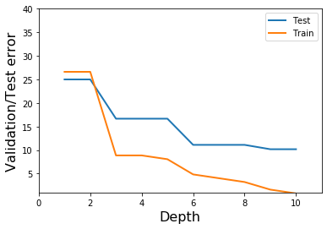

MONK2:

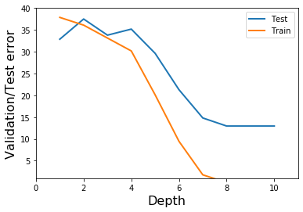

MONK3:

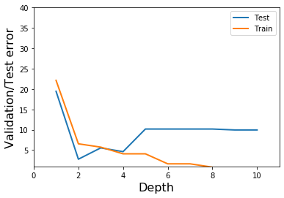

1. Weak Learners:

Depth=1

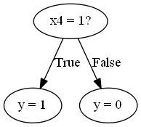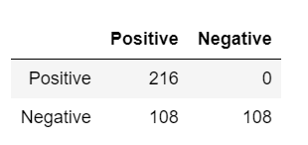

Depth=3

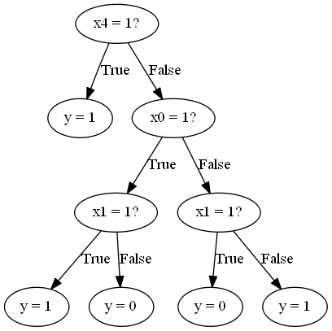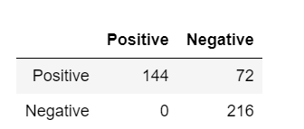

Depth=5

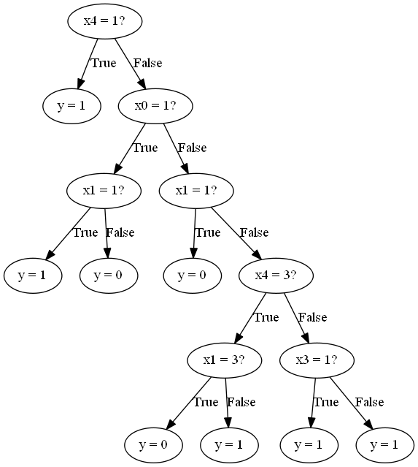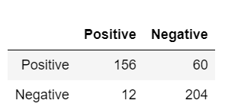

1. ScikitLearn:

Depth=1

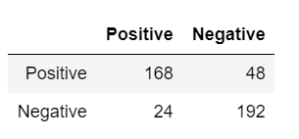

Depth=3

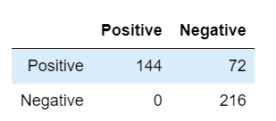

Depth=5

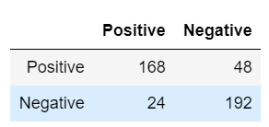

1. CEASERIAN dataset

Depth=1

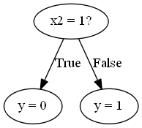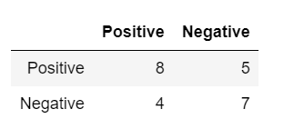

Depth=3

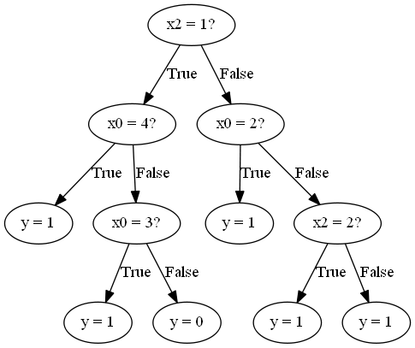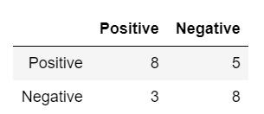

Depth=5

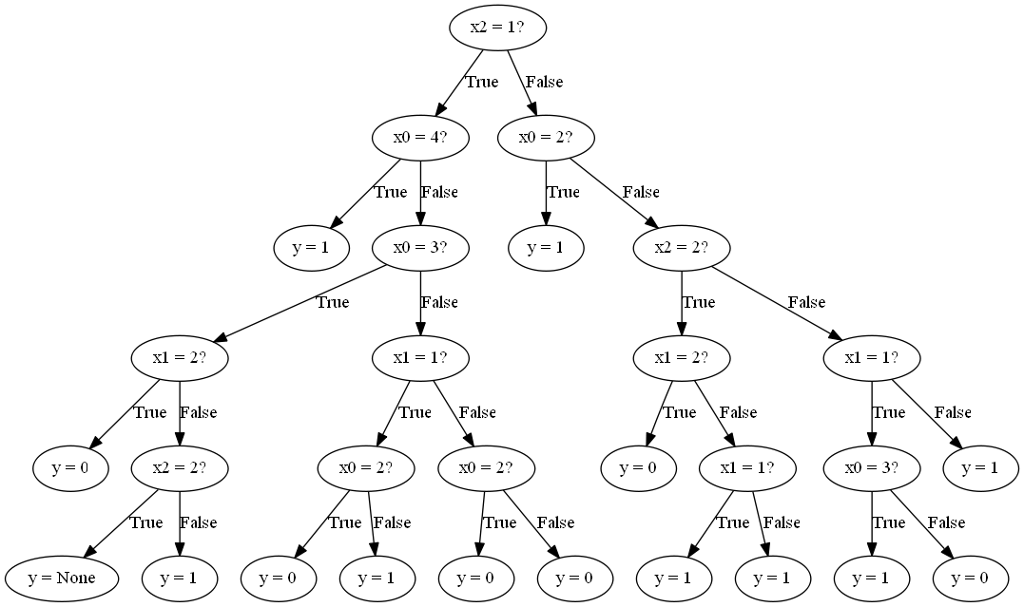

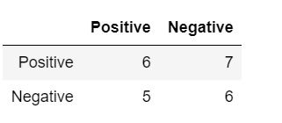

Using ScikitLearn function

Depth=1

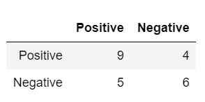

Depth=3

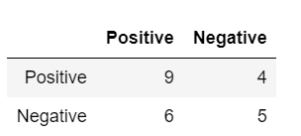

Depth=5

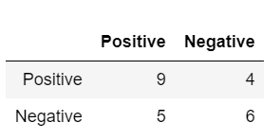

For the Monks data set, it is seen that the Scikit Learner performs better than the function we wrote. However, interestingly enough, for my own data set they perform relatively similar. A possible reason for this could be the small amount of data in my dataset, resulting in a lack of accuracy regardless of the model. However, we should expect that the Scikit Learn function perform better because it follows a more sophisticated, refined algorithm.