

**Department of Electronic and Telecommunication Engineering**

**University of Moratuwa**

**B. Sc. Eng. Semester 2**

**EN1070 Electronic Product Design and Manufacture**

**Project Report**

**RAIN SENSING AUTOMATIC CAR WIPER**

Group No : 16

Group members:

K. A. G. D. Maheekumara 180379R

B. M. D. S. Karunarathna 180308C

T. M. S. Nayanajith 180417J

P. S. C. Jayapala 180265N

K. L. G. J. Chandula 180092F

H. V. Darsha Randitha 180241M

Content

1. Product Goals
2. Specifications
3. Conceptual Designs
4. Preliminary Designs

* Orcad Schematics
* PCB layout
* Enclosure Designs

**Product Goals**

Main function of the product is to automate the wiper system of a car. It sensors when rain falls and automatically switches ON and processes the wiper and stops when rain stops.

Volume:

At initial stage we planned to manufacture 500 units per month. If the response to the product in the market increases we will increase batch size to 1500 per month.

Approximated Cost:

Demand for this rain sensing automatic car wiper is high among vehicle owners. They would like to buy this product around the price Rs. 2800

Allowable cost per unit: Rs.1800

Profit: Rs.250

Labor charge: Rs. 300

Value Added Tax (VAT): Rs. 150

Selling Price: Rs.2500

**Specifications**

Requirements

* Can detect rain and rotate the viper of the vehicle.
* Indicate whether the viper is working or not by a led.
* Wiper should always stop at one corner of the windscreen.
* Circuit system should be waterproof.

Wishes

* Sensor should withstand to any climate and whether.
* It should weigh light.
* Sensor can be easily replaced
* Should have heat control variation system

Production

* Initial Production about 500 wipers.
* General wipers are acquired from the market and will be developed.
* Electronic components are bought from outside.
* In house manufacturing of PCB and assembling.
* Enclosure made outside.

Distribution

* Introduced to existing shops.

Quality

* User Friendly
* Expected life time should be greater than 2 years.

Performance

* Function with the car battery.

Usage

* Attachable to the windscreen
* Even untrained person can install the device

**Conceptual Designs**

**Circuit designs**

*Design 1*

Motor

Power Supply

Sensor

Transistor switching system

*Design 2*

Sensor

Indicator

Amplifier

Wiper Motor

Motor Controller

Power Supply

Microcontroller

*Design 3*

Filter

Relay Switching System

Amplifier

Power Supply

Wiper motor

Rain Sensor

*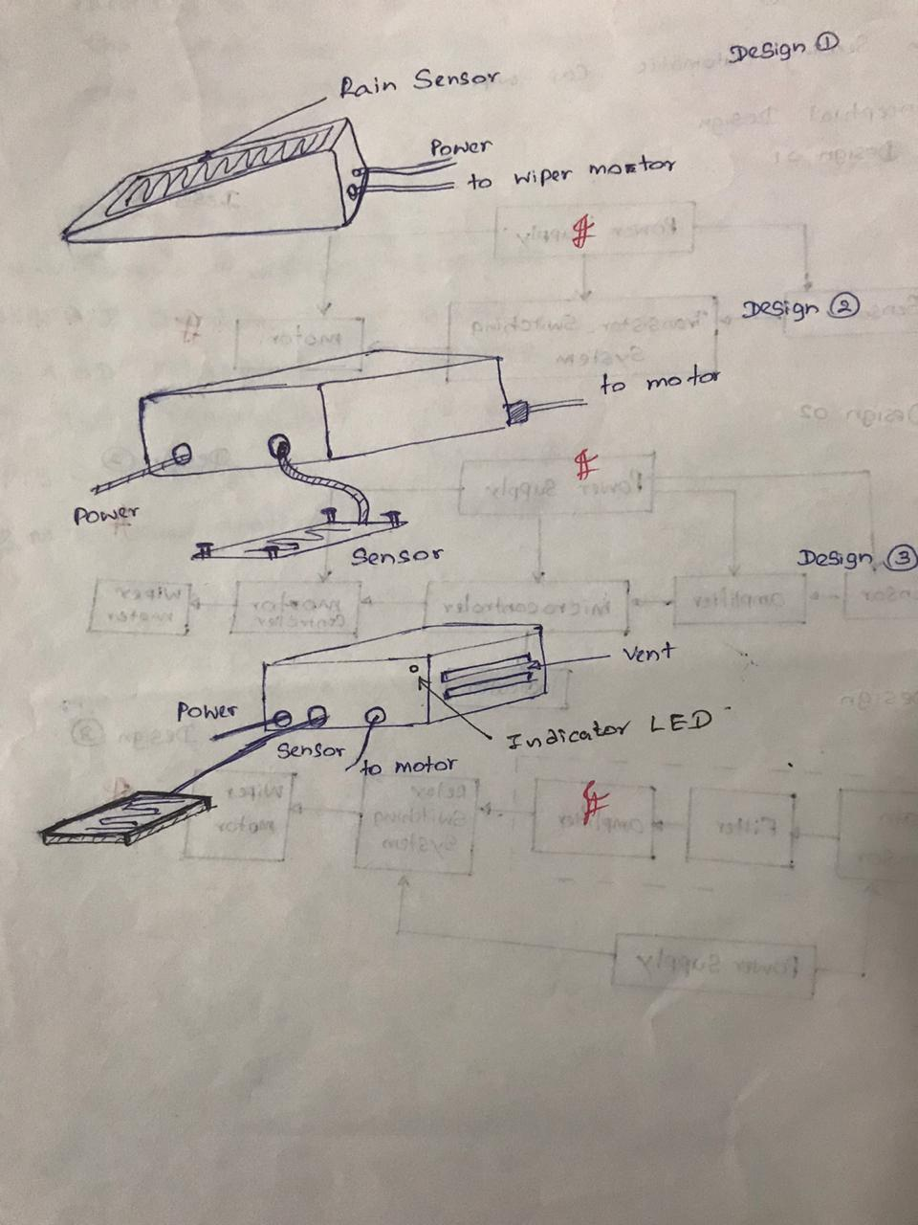***Enclosure design hand sketches**

**Criteria for conceptual designs**

*Circuit*

|  |  |  |  |  |
| --- | --- | --- | --- | --- |
|  | **Criteria** | **Design 01** | **Design 02** | **Design 03** |
| 01 | Can detect rain and rotate the viper | 05 | 10 | 10 |
| 02 | Indicate whether the wiper is working or not by a LED | Not Relevant | 10 | Not Relevant |
| 03 | Wiper should always stop at the corner of the windscreen | 03 | 10 | 07 |
| 04 | Sensor should withstand to any climate and whether | 05 | 05 | 08 |
| 05 | Even untrained person can install the device | 08 | 08 | 08 |
|  | Total | 21 | 43 | 33 |

*Enclosure*

|  |  |  |  |  |
| --- | --- | --- | --- | --- |
|  | **Criteria** | **Design 01** | **Design 02** | **Design 03** |
| 01 | Should be waterproof | 08 | 05 | 02 |
| 02 | Attachable to the windscreen | 05 | 02 | 10 |
| 03 | Suitable shape to attach the dashboard | Not relevant | 08 | 07 |
| 04 | Heat control ventilation system | Not relevant | 03 | 10 |
| 05 | Sensor can be easily replaced | Not Relevant | 05 | 08 |
|  | Total | 13 | 23 | 37 |

**Suitable Circuit and Enclosure Designs according to the Criteria Evaluation**

|  |  |  |  |
| --- | --- | --- | --- |
| ***Circuit***  ***Enclosure*** | ***Design 01*** | ***Design 02*** | ***Design 03*** |
| ***Design 01*** | 34 | 56 | 46 |
| ***Design 02*** | 44 | 66 | 56 |
| ***Design 03*** | 58 | 80 | 70 |

* According to the above evaluation ,
* Circuit – Design 02
* Enclosure – Design 03

are implemented.

**Preliminary Designs**

* ***Orcad Schematics***
* ***PCB layout***
* ***Solidwork Enclosure Design***
* *Sensor Panel Holder*

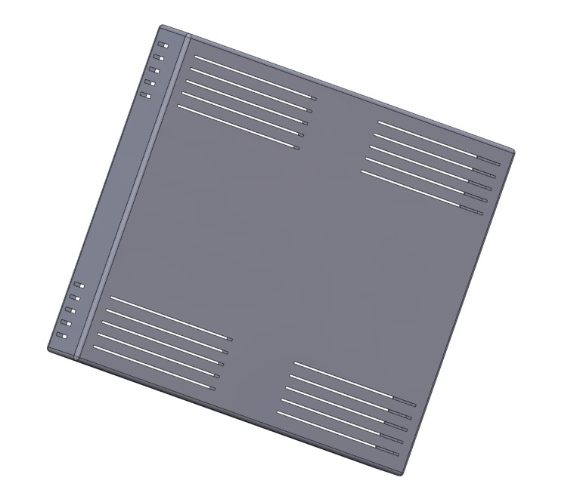

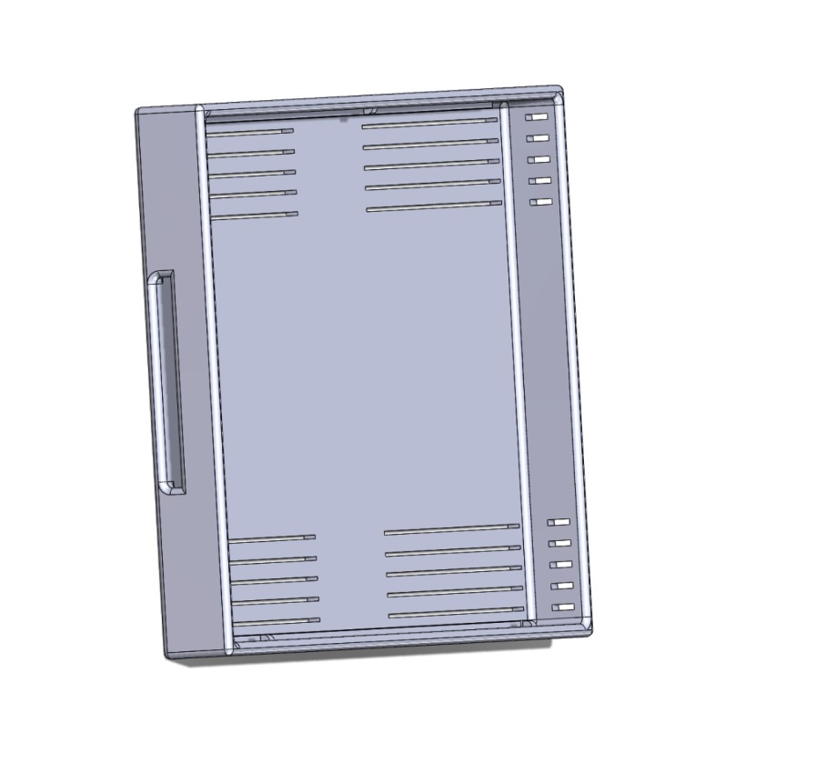

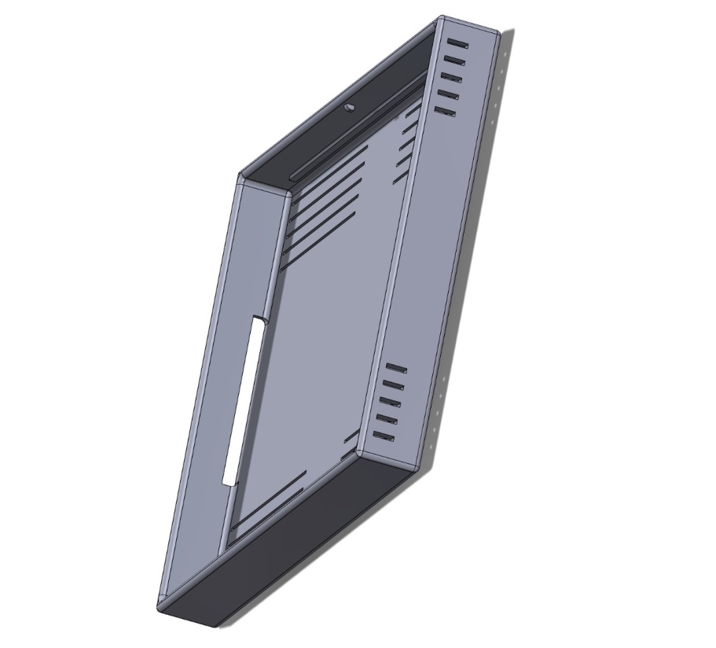

* *Circuit Board Enclosure*
* ***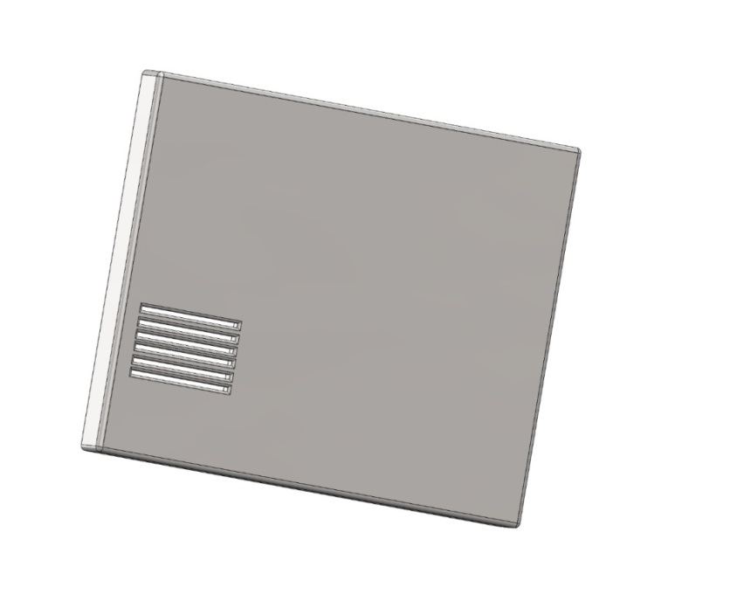****Top part*

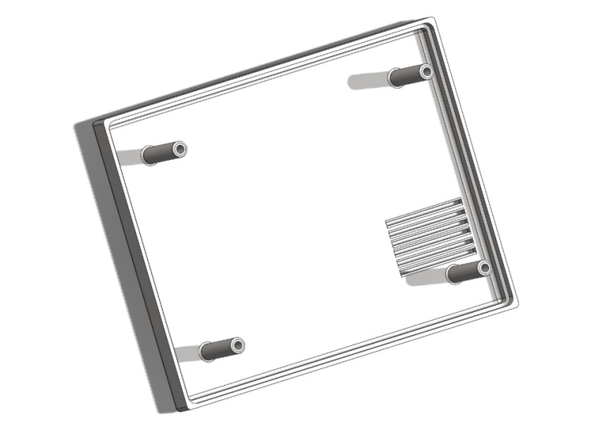

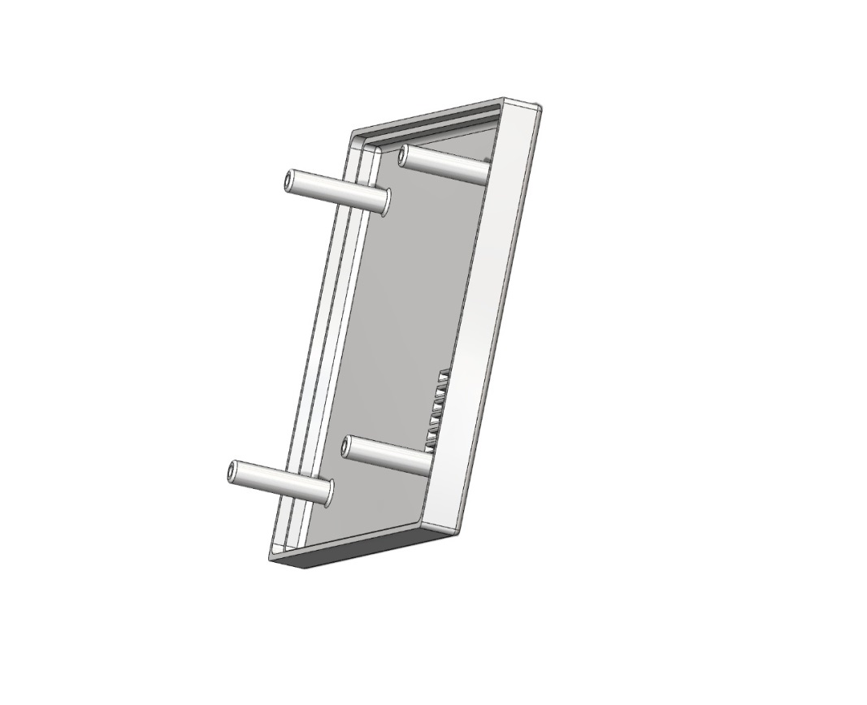

* *Bottom Part*

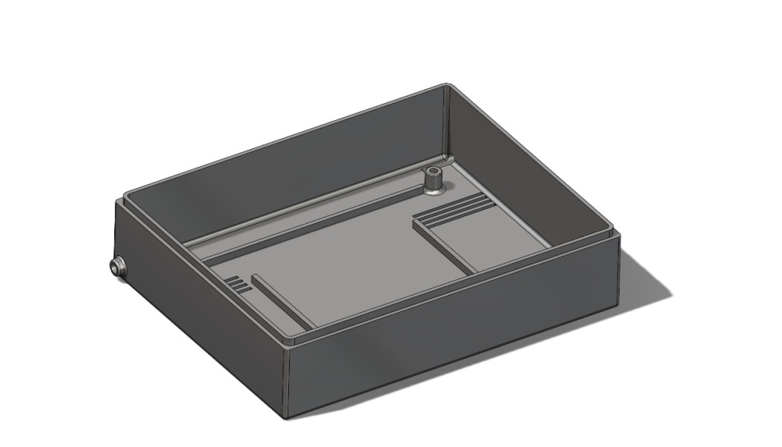

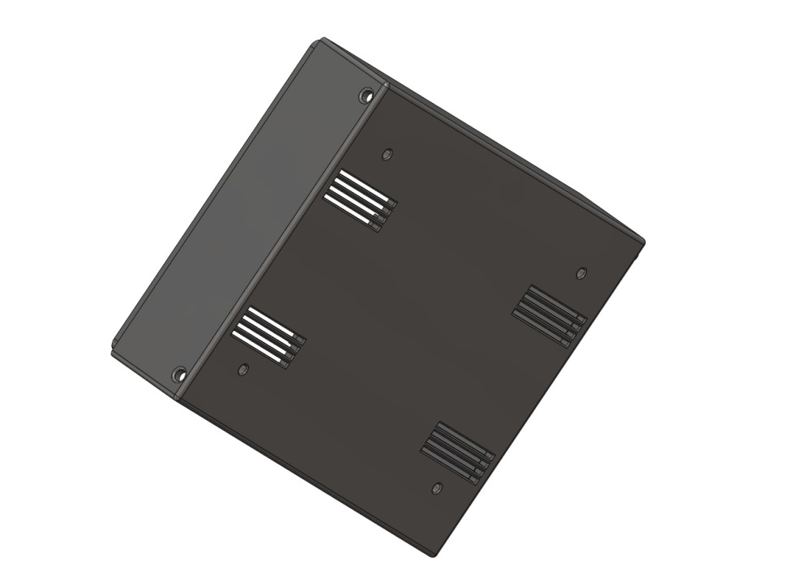

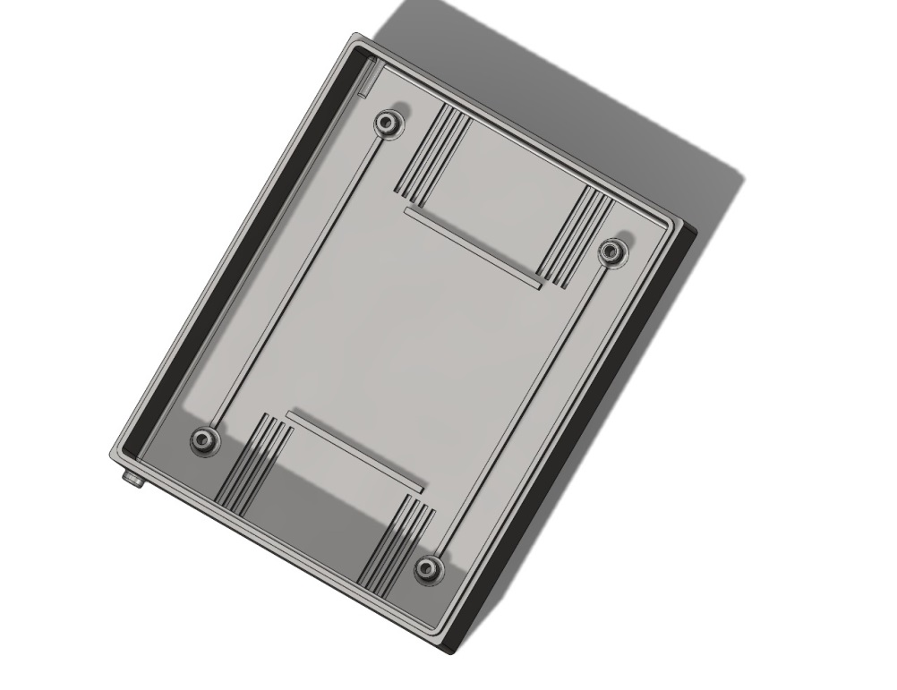

* *Assembly*

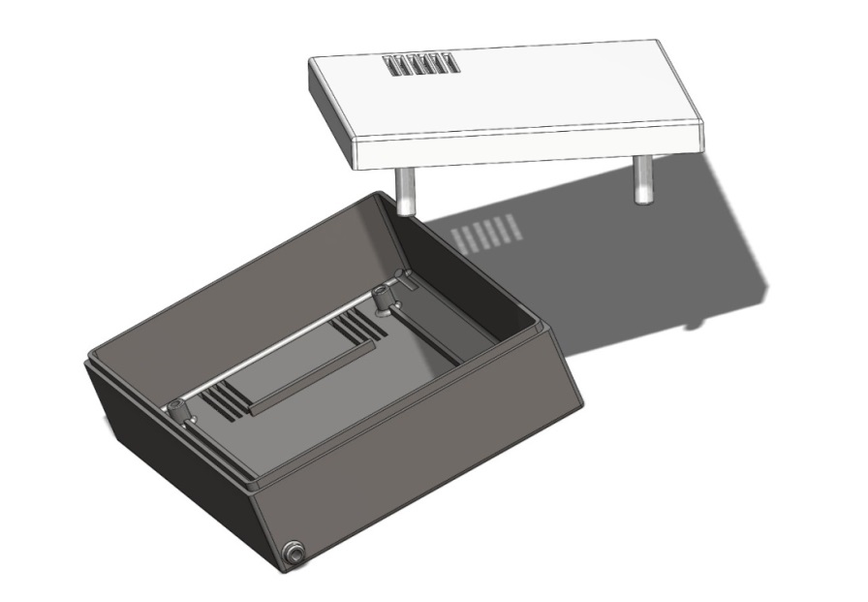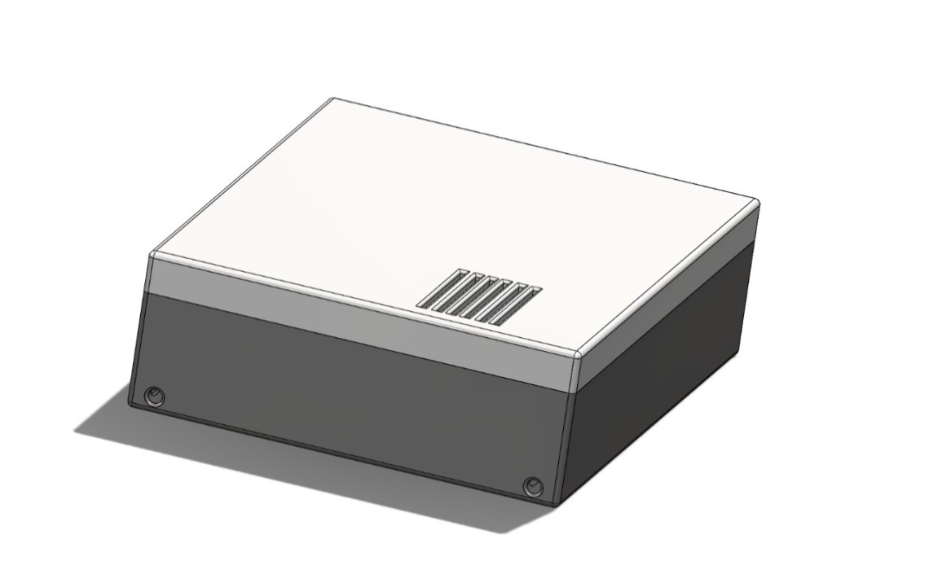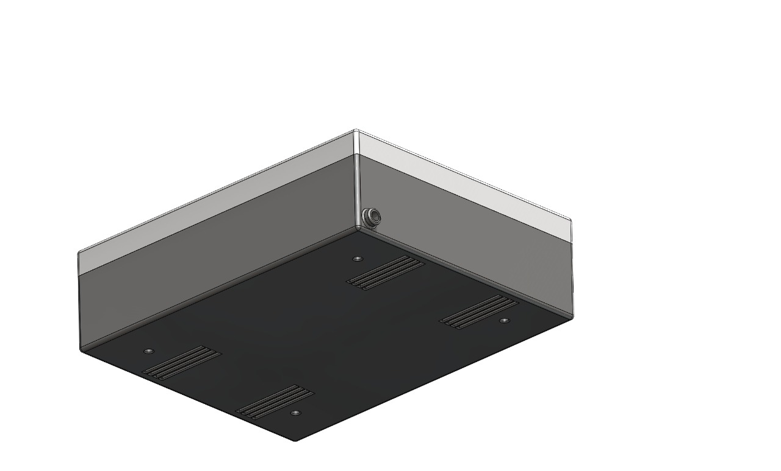

Cross Section View

