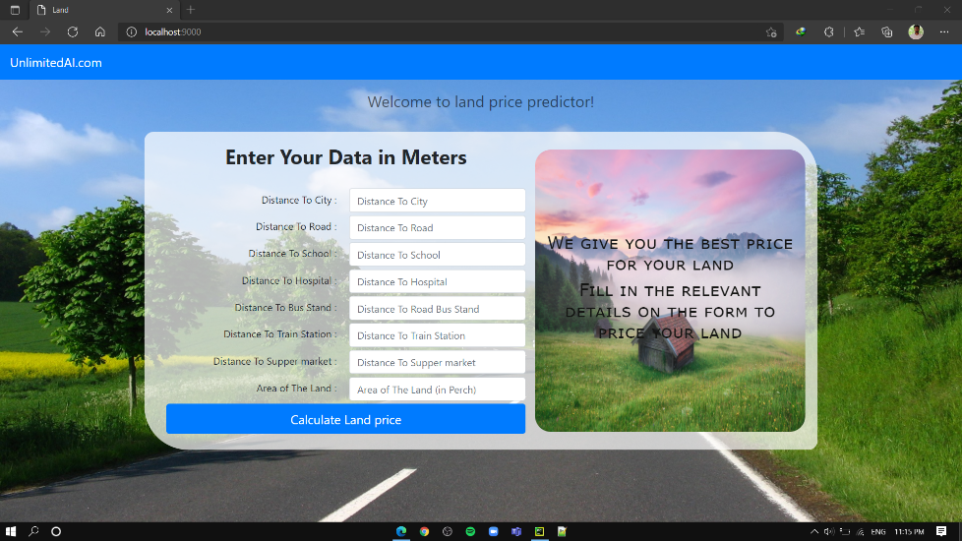This web application is about predicting the land price of the user. Simple interface allows users to provide details.

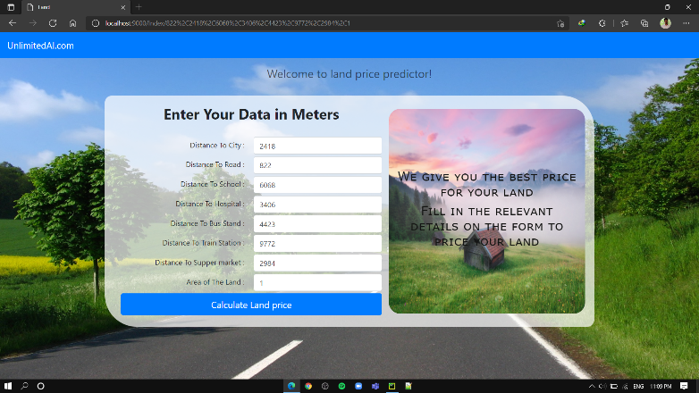The user can view the calculated land price by clicking the Calculate Land Price button.

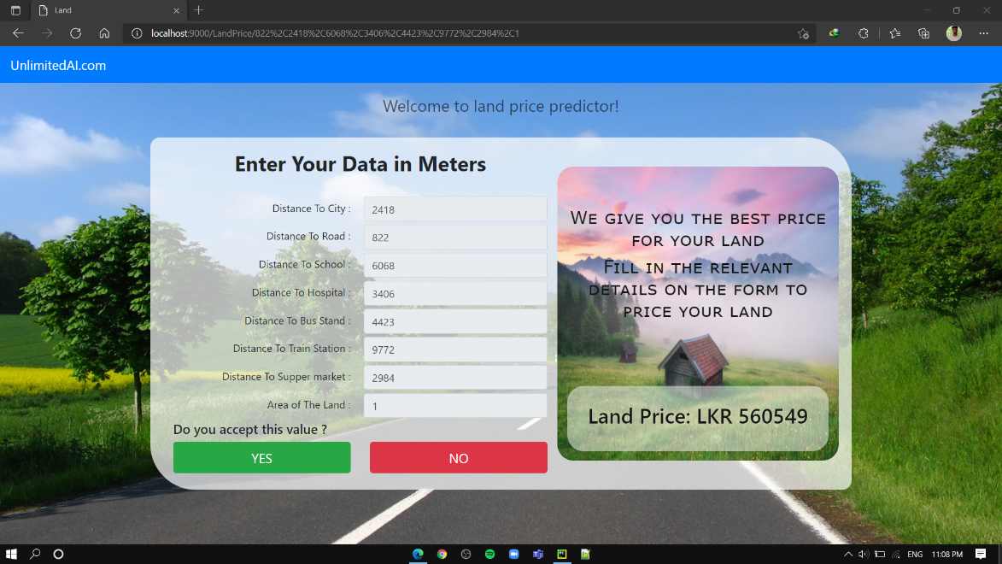"Do you accept this value?" If the user responds yes to the question, all data is stored in a database. Next, the existing data and the newly added data will be merged and the server will train a new model using the existing data.