# **Markdown Overview**

*Markdown is a lightweight markup language that allows people to write documents using a plain text format that is easy to read and write, and then convert them into richly formatted HTML pages. —* [Wikipedia](https://en.wikipedia.org/wiki/Markdown)

## **Main Features**

### **1. Code Blocks**

@requires_authorization  
def somefunc(param1='', param2=0):  
 '''A docstring'''  
 if param1 > param2: # interesting  
 print 'Greater'  
 return (param2 - param1 + 1) or None  
  
class SomeClass:  
 pass  
  
  
if __name__ == '__main__':  
 print 'hello world'

Inline code: pip install md2html-python

### **2. LaTeX Formulas**

You can create inline formulas, for example:$\Gamma(n) = (n-1)!\quad\forall n\in\mathbb N$.

Or block-level formulas:

$$

x = \dfrac{-b \pm \sqrt{b^2 - 4ac}}{2a}

$$

### **3. Tables**

|  |  |  |
| --- | --- | --- |
| **Item** | **Value** | **Qty** |
| Computer | 1600 USD | 5 |
| Phone | 12 USD | 12 |
| Pipe | 1 USD | 234 |

### **4. Flowcharts**

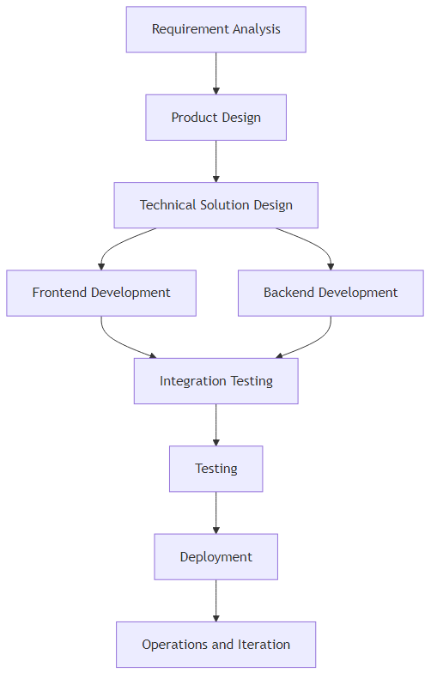

### **5. Checkboxes**

Use - [ ] and - [x] syntax to create checkboxes, useful for todo-lists. For example:

☑ Completed item

☐ Todo item 1

☐ Todo item 2

### **6. Images**

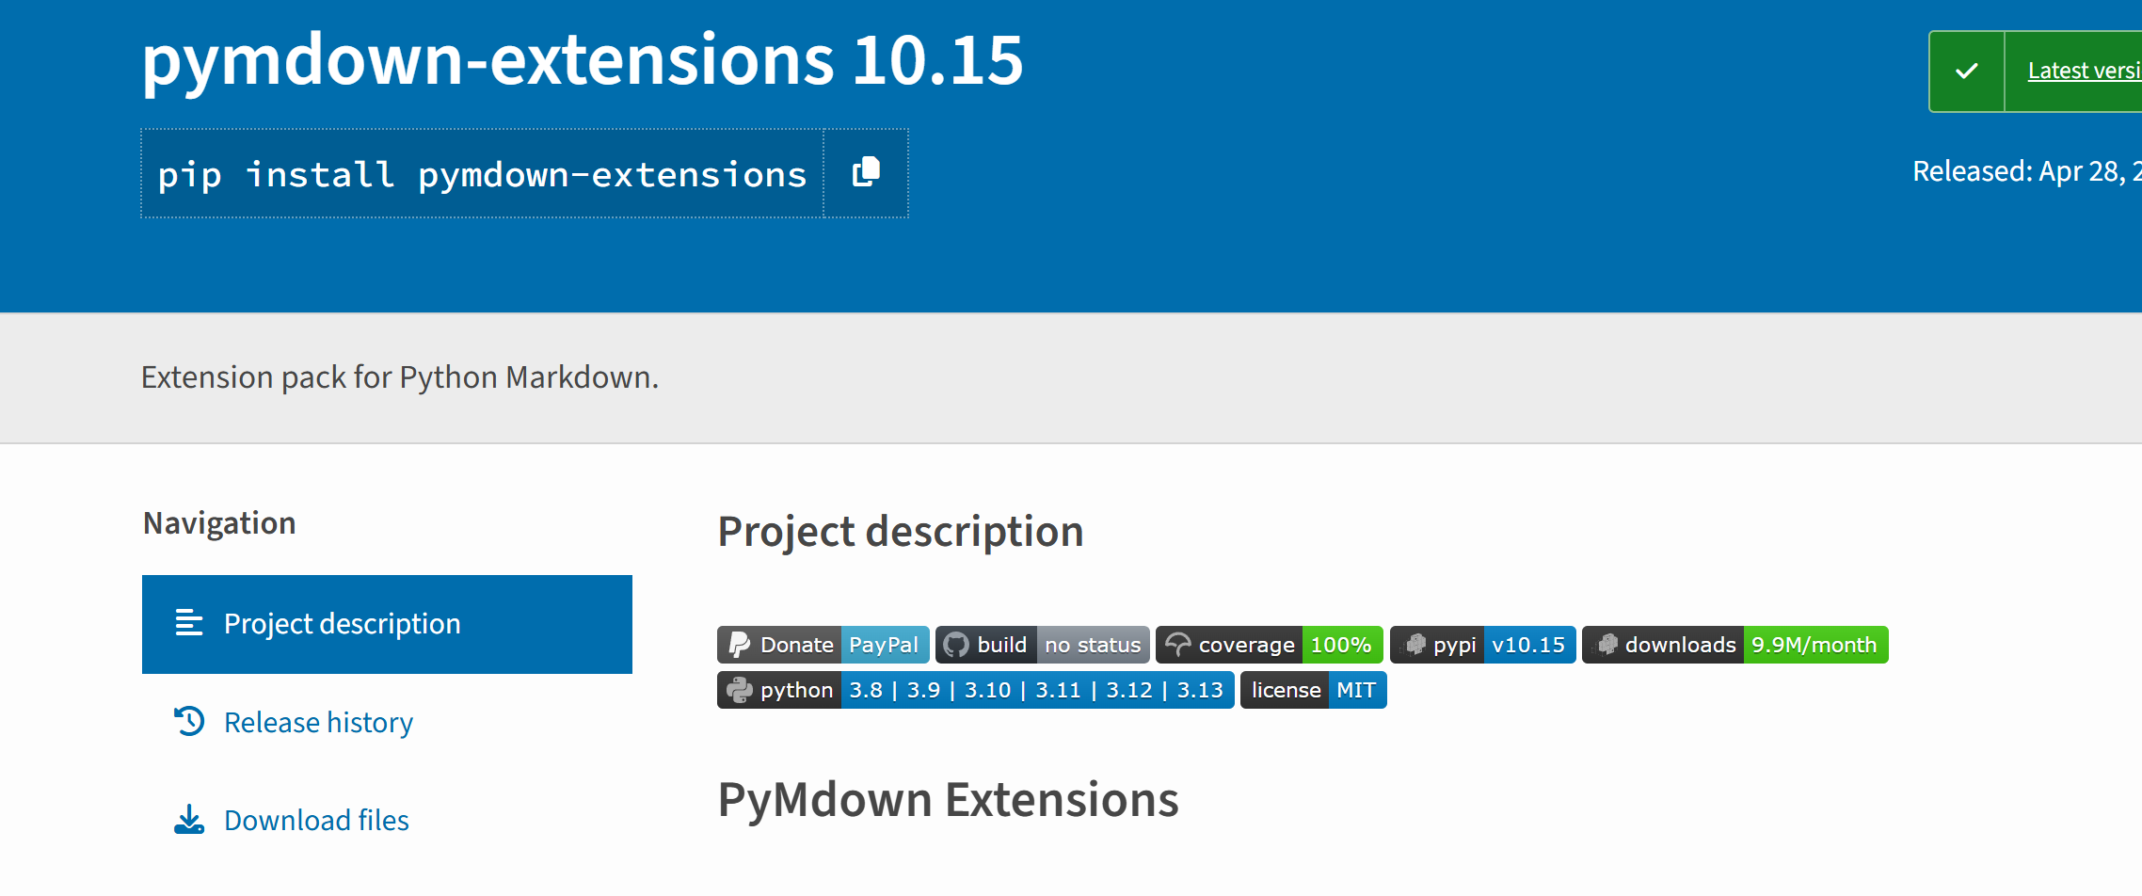

### **7. Blocks**

### **Definition**

/// define

Apple

* Pomaceous fruit of plants of the genus *Malus* in

the family *Rosaceae*.

///

### **Details**

/// details | Some summary

Some content

///

### **Emoji**

:smile: :heart: :thumbsup:

### **Tabbed**

/// tab | Tab A title

Tab A content

///

/// tab | Tab B title

Tab B content

///

This is a text with link: [Wikipedia](https://en.wikipedia.org/wiki/Markdown)