|  |  |
| --- | --- |
|  |  |

|  |  |  |  |  |  |  |
| --- | --- | --- | --- | --- | --- | --- |
| **Hoodies (Pull-over sweatshirt):**  *(Similar in color to the shooting shirt with the logo on the front.)* | Youth Sizes: | s | M | L | XL | $35 |
|  | Adult Sizes: | s | M | L | XL | $35 |
| **Shooting Shirts:** | Youth Sizes: | s | M | L | XL | $24 |
| **Basketball Crew Socks:**  *On the form below, indicate sock color (*white on blue or blue on white).* | Youth Sizes: | S | M | L | XL | $10 |

# Eden Basketball Gear Order Form

Shooting Shirt Crew Sock – white/blue Crew Sock – blue/white

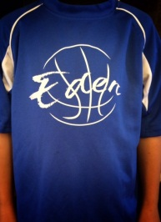 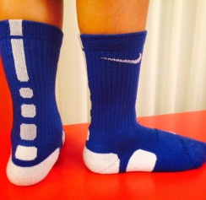 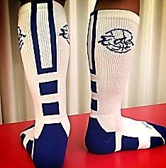

|  |  |  |  |  |
| --- | --- | --- | --- | --- |
| Item Description  *(for sock orders, indicate color preference: white on blue or blue on white )* | for hoodie and Shooting shirts, Please print last name (which will be printed on the back) | Quantity | unit price | Line Total |
|  |  |  |  |  |
|  |  |  |  |  |
|  |  |  |  |  |
|  |  |  |  |  |
|  |  |  |  |  |
|  |  |  |  |  |
|  |  |  |  |  |
|  |  |  |  |  |
|  |  |  |  |  |
|  |  |  | Total |  |

|  |  |
| --- | --- |
| Player’s Name (first, last) |  |
| Parent Name  (first, last) |  |
| Phone No. |  |
| Email |  |

**Please submit order to Roger Lee at** [**Roger.Lee49@sbcglobal.net**](mailto:Roger.Lee49@sbcglobal.net) **by 12/14/14 for delivery in January.** Payment requested upon delivery of merchandise. Please make checks payable to Eden Athletic Club.