Airport - Wait Time Visualisation

Motivation: Planning a trip to various airports, travellers often make wrong decisions in choosing the connecting flight ignoring the wait times at airports due to immigration and security-check. Having the Knowledge of average wait time required during immigration for a airport for a would help the traveller in planning their travel and accordingly.

This Airport-Wait Time Visualization application has different visualizations which provides various aspects of information which would be helpful for international travellers while making their travel plans.

Immigration wait-times at airports are one of the major factors to consider while booking any connecting flights. Wait times here correspond to the time passengers need to wait at the security, passport-control (Immigration) after arriving at an international airport. We are dealing with the data on wait-times at various airports in The United States for international passengers.

We have used data sets from two different data sources:

1. ***awt.cbp.go***

# Different Visualisations include:

1. **US Veronoi Map by Surbhi Arora**
2. **World Map Visualization by Pooja Donekal**
3. **Temporal Radial Clock Visualization by Shreyas Kulkarni**
4. **Line Chart Visualization by Shreyas Kulkarni**
5. **Radial Tree Visualization by Minu Francis.**

# Voronoi diagram of US Map:

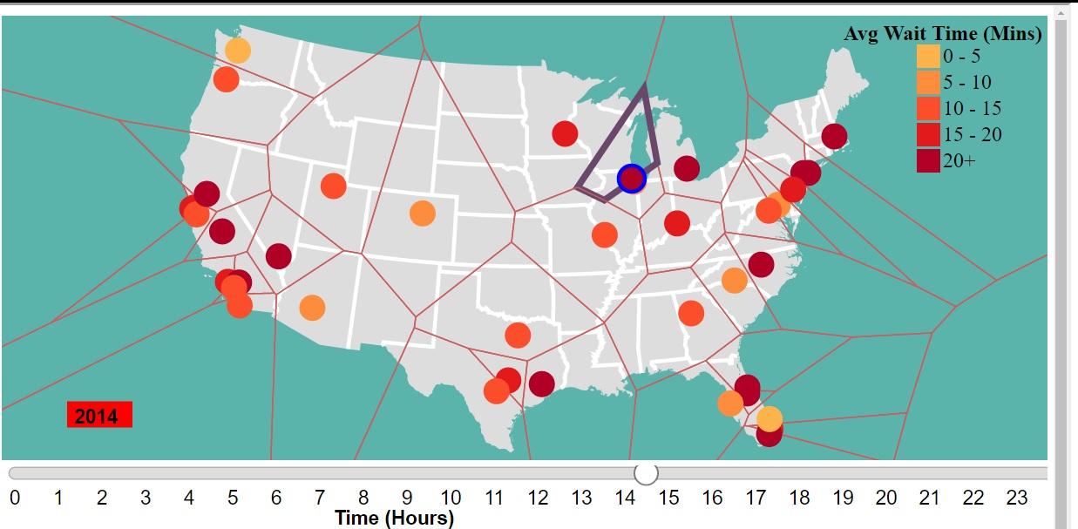

This visualization represents 42 busiest International United States airports across various cities in form of Voronoi. When users hover over a particular airport, the basic details of the airport pops up in a div. The Voronoi technique has been discussed in [1].

Various tasks this visualization supports is as follows:

## Produce – Derive:

As Tamara Munzner described we are doing the derivation task. We have database of average weight time of each date in for every hour. In this visualization we are deriving the average wait time for a particular hour for a complete year. Each airport is represented by coloured circle mark. We have used sequential colour coding as a channel to represent the average wait time of the airport at a particular time. [2]

## Query – Compare:

We have representing all airports at once in a US map with different colour. User can compare the average weight time of different airports based on the different colour. If the airport has a high average weight time the airport colour will be a darker shade and if the weight time is low, then the colour is lighter.

## Animations:

We have used a slider to show average wait time of different hours in a day. When user slides, it will update the airport color according to average wait time of that hour.

When user clicks the airport circle mark three different visualization comes up representing different information corresponding to clicked airport data:

1. Clock –Showing monthly average wait time for that airport for selected year and airport.
2. World Map – Showing inbound and outbound flight for the selected airport.
3. Line Chart – Showing number of passengers and range of time, they waited for each month of a selected year and airport.

# World Map Visualisation

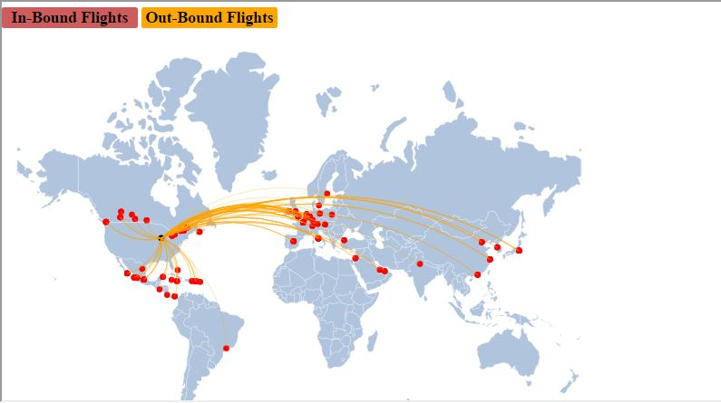

The world map visualisation shows the inbound and outbound flights for the airport selected on the US Voronoi Map, thereby giving an overview of number of international flights to and from the airport chosen.

By default, you have the view of inbound flights. On click of outbound, you can view the outbound flights too. One can zoom in to the map and move it all over the svg to have a concentrated view of the number of flights. On hover, you would be able to see the name of the airport on top-left of the frame.

According to Tamara Munzner, different visualisation tasks in the visualisation can be categorised as:

Query: Query with identity scope: User could look up on a single target(airport) to identify the inbound and outbound flights.

Annotate: The world map visualisation is annotated with the graphics (Zoom & Pan), helping getting a better view.

# Temporal Radial Clock:

When the user selects a particular airport on the USA map the temporal radial visualization is displayed for that airport for the selected year. Also by default when the application is opened for the first time the default year 2015 is selected and the default temporal radial visualization is shown for Chicago’s O’Hare Airport for the year 2015.

The temporal radial visualization shows the total number of flights for each month of the selected year and the average wait time per passenger for that particular month.

**The clock is as follows:**

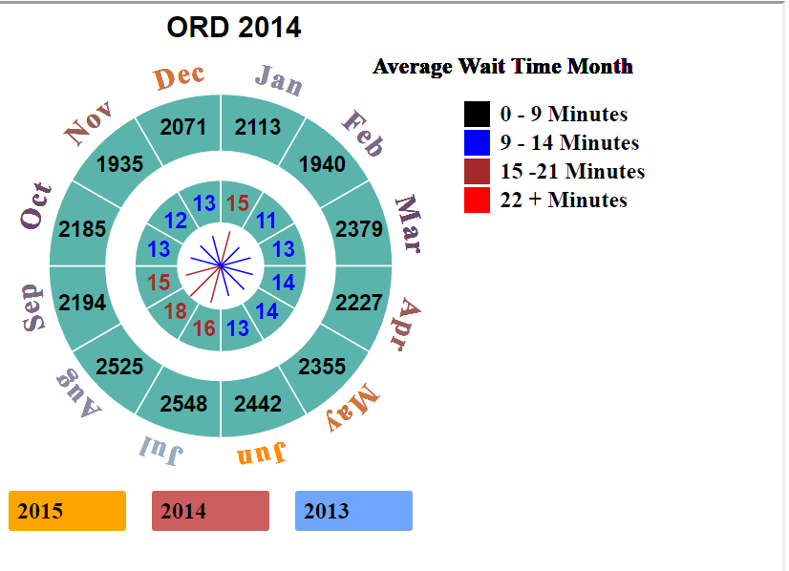

There are two concentric circular paths (outer clock and an inner clock). Above the outer clock the name the airport which was selected in the US map is displayed. The outer clock is divided into 12 arcs, each arc corresponding to a particular month of the year. For each month the outer clock displays the number of inbound flights at that selected airport for the selected year.

Each month is associated with a line originating from the center of the clock. The line represents the average wait time per passenger for that month. The length of the line corresponds to the magnitude of the wait time.

The wait times are divided into 4 ranges which are. 0 to 9 minutes, represented by black line. 10 to 14 minutes represented by blue line, 15 to 21 minutes represented by brown lines and 22 minutes above represented by red line.

The inner clock is also divided into 12 arcs and is concentric with the outer clock. The inner clock represents the values of the average wait time for each month. Each of the 12 arcs of the inner clock will have embedded inside a numeric value which corresponds to the length of the wait time line. Values from 0 to 9 are black in color, values from 10 to 14 are blue in color, values from 15 to 21 are brown in color and values > 22 are red in color. [5]

## Interactions

When the user hovers over an arc on the inner clock a tool tip comes up which displays the wait time for that month which is the value of that arc. Also when the user hovers over an arc on the outer clock a tool tip comes up which displays the total flights for that month of the selected year and airport.

Below the clock there are three buttons which allow the user to select a year from 2015, 2014, 2013. When the user clicks a button clock reanimates to show data for the selected year. Also the line graph which is shown below the temporal radial clock now will shows the data for the selected year. Also the US Map will also show the data for the selected year.

## Visualization Tasks Supported

### Comparison:

The clock does allow the user to compare average wait times per passenger for each month of the year for a particular airport at a glance.

The clock also allows the user to compare total number of flights for each month of the selected year. The users can derive if there is any relation between total number of flights and average wait time per month.

### Identify:

The user can identify any airports which may have a particularly a longer wait time due to number of filghts. It also allows the users to identify months with longer wait time and help them plan their travel accordingly

### Discover:

This visualization allows the user to discover any airports which may have larger number of flights and any airports the average monthly wait time for that year at that airport

Our visualization for temporal radial clocks is a variation of the time clock described in [3].

# Line Chart Visualization:

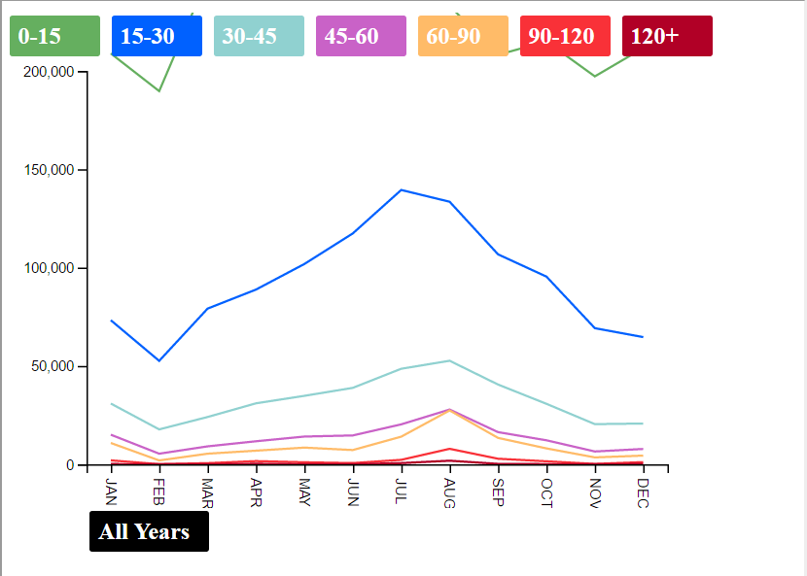

The Line chart visualization shows the number of passengers and the time ranges they waited for each month of the selected year. The wait times are divided into 7 ranges which are as follows.

1. 0 to 15 minutes – Green Color
2. 15 to 30 minutes – Blue Color
3. 30 to 45 minutes—Light Blue
4. 45 to 60 minutes—Purple
5. 60 to 90 minutes—Orange
6. 90 to 120 minutes—Red
7. 120 minutes and above—Maroon

Each of these categories is represented by a separate line of a different color. The Y axis is the number of passengers and the X axis is the months for the selected year. Using the line chart, the user can see the number of passengers and the time they waited in a particular month for the selected year.

## Visualization Tasks:

### Compare:

This visualization allows the users compare the number of passengers and their wait time ranges for each month for a particular selected year and airport.

### Identify:

This visualization allows the user to identify suitable and unsuitable times for travel for the selected year and airport.

### Discover:

This visualization allows the user to discover any months where the number of passengers who waited for a particular time might be more or less

## Interactions

1. When the user clicks on a year in the temporal clock the line graph’s data gets updated for that particular selected year and the airport which is already selected.
2. When the user selects a particular airport on the US map the line graphs data gets updated for the selected airport and the year which is already selected. There is a key on the top of the line graphs which helps the user understand the color encoding for wait time ranges.
3. When the user hovers over a key. Only the line corresponding to that key is displayed and on hover out the default visualization is shown.

All Years Button Animation: Below the line graph there is an All Year’s button. On hover of this button an animation starts, the animation is applied to the line graph visualization and the temporal clock visualization. The animation animates through each year’s data from 2015, 2014, and 2013 every 5 seconds. Once all the years are animated through the animation comesto a stop.

# Radial Tree Visualization

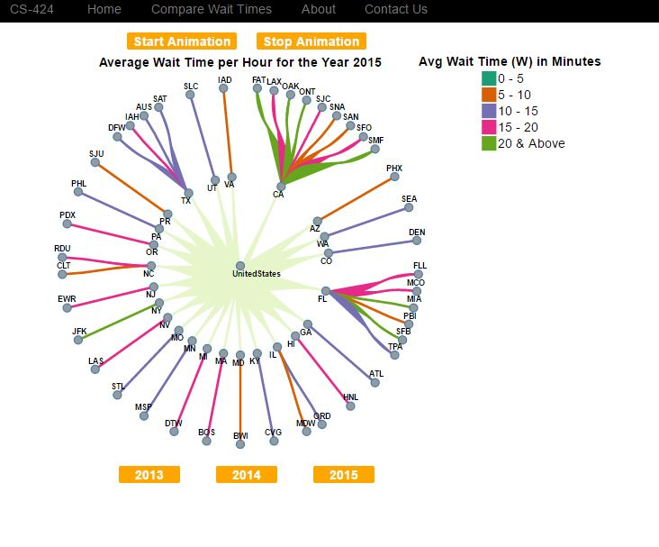

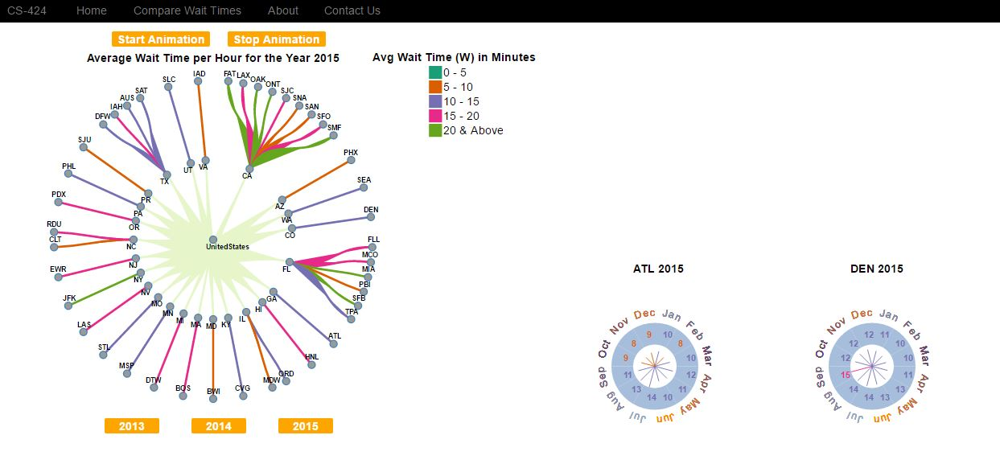

The wait times at passport control are always a concern for passengers during international travel, as, a delay at passport desk can cause them the next flight. Thus, if users are provided with a comparison of how the wait times are, they could make a wiser decision as to which airport is to be chosen while travelling to US without having to deviate from their route as well not getting stuck at the passport control.

In order to provide this information, we have made use of the Radial Tree Visualization. The root of the radial tree is represented as United States and the first level children are the states in United States and the second level children represents the airports corresponding to each state.

The average wait time per hour for each year from 2013 to 2015 has been computed from the initial dataset that was available. The values are divided into various ranges and each range has a specific color associated with it. The path connecting a State and its airports are given a color, based on the range in which the average wait time for the respective airport falls. The technique related to how radial tree visualization has been implemented in the paper described in [4]

## Visualization Tasks

There are various visualization tasks supported by the radial tree visualization. The major ones as described in Tamara Munzner’s textbook, are **Produce, Search and Query**.

### Produce (Derive):

‘Derive’ is a task that comes under Produce. The derive goal is to produce new data elements based on existing data elements. The data represented by the radial tree visualization has been derived from the original dataset that was available from the below website:

***awt.cbp.go***

The original dataset that was available contained the wait time per hour per day for each of the airports corresponding to a year. The data represented by the radial tree is a derivation of the original data. Average wait times for the whole year has been computed from the original dataset and has been represented as a radial tree with paths having colors with respect to each of the wait time range that they fall into.

### Search (Locate, Look up):

The tasks ‘Locate’ and ‘Look Up’ that comes under Search are supported by this visualization.

### Locate:

If a user knows the state that he/she has to look up, they can go to the specific state and compare the wait times of the airports in that state.

### Look up:

If a user knows a specific airport that he/she has to look up, they can choose the airport and once they click on the airport, the average wait time for the chosen airport, for the chosen year would be displayed in another temporal radial visualization.

### Query (Compare, Summarize):

The tasks ‘Compare’ and ‘Summarize’ comes under Query and these are supported by the visualization represented by radial tree.

### Compare:

The path connecting a State in United States with the airports in that respective state is given a color, based on the average wait time at that airport for the chosen year. This would allow the users to compare the wait times of various airports in the same state and will also allow the users to compare each airport with every other airport which has been displayed. Further, on clicking each of the nodes (ie., airport name), a temporal radial visualization comes up which displays the average monthly wait time at the airport for the chosen year. Clicking each airport, brings up a similar visualization which would ultimately allow the users to compare the monthly wait times of different airports at once.

## Summarize:

The radial tree visualization initially represents the data for all the airports that are available in the dataset. The average wait times for the chosen year are summarized and displayed as in the form of a tree.

## Animations:

Initially, the radial tree displays the nodes corresponding to the airports. On clicking ‘Start Animation’, the data for various years are loaded one after the other and the tree changes according to the data for the respective year.

On hovering over each node, the average wait time for the respective airport is shown on a tooltip. On clicking each of the leaf nodes in the tree, which represents the individual airports, a separate temporal radial visualization in the form of a clock is displayed. If ‘Start Animation’ is clicked at this point, the clock also gets updated with the data for the respective year and changes along with the tree for various years.

Clicking the ‘Stop Animation’ button stops the entire animation and the user can now scroll down to compare the wait times of the airports that he/she has chosen.

# Various Domain Tasks Summary:

We have created a website which allows the user to compare average immigration wait times at a particular airport for each hour of all days of a particular year and average monthly wait time for a given airport.

This website also shows the inbound and out bound flights for a particular airport and the total number of inbound flights from various destinations from around the world at an airport for the various years.

The line chart allow the user a view of the total number of people and the time ranges they waited at a particular airport for each month of various years.

The radial tree visualization allows the user to compare the immigration wait times at various airports at once. All this information helps allows the user to conclude the expected wait time for immigration lines at a particular airport when a user’s flight lands and plan their flight travel appropriately.

# Conclusion:

The time radial visualization shows the user average wait time per each month of a given year and the number of flights which landed each month at a particular airport for a given year.

The US map shows all the airports and allows the user to select a particular airport. Each airport is represented by a circle and the color of the circle indicates the wait time for the selected hour. The wait time for each is for each hour is color coded. The user can move the slider and the colours of the airports change accordingly.

The user has information of

1. Average wait time for each month through the temporal clock of a selected year and airport.
2. The number of flights landing at each airport each month of the selected year and airport.
3. Average wait time for each hour for all days of a selected year and airport.
4. The inbound and outbound flights for a particular selected airport through the world map.
5. The number of passengers and the range of time the passengers waited for each month of a selected year.

Air Travel can be a hassle and it has becomes increasing important for passengers to know how much time it takes to pass through immigration once you land at a particular airport so the user can plan their trip accordingly.

So, to conclude, these visualisations helps the passenger in planning of his/her travel based on immigration wait times for a particular airport in United States.

# REFERENCES

[1] Michael Balzer, Oliver Deussen, Vornoi TreeMaps, <http://kops.unikonstanz.de/bitstream/handle/123456789/6212/Voronoi_Treemaps.pdf?sequence=2&isAllowed=y>

[2] [http://colorbrewer2.org/#type=sequential&scheme=YlOrRd&n=5](http://colorbrewer2.org/%23type=sequential&scheme=YlOrRd&n=5)

[3] Natalia Andrienko, Gennady Andrienko, Peter Gatalsky , Exploratory spatio-temporal visualization: an analytical review, <http://geogra.uah.es/patxi/Andrienko03_spatio_temp_visualziation.pdf>

[4] <http://gramaz.io/pdf/li-2015-ehv.pdf>

[5] <https://engineering.purdue.edu/~elm/projects/multilinevis/multilinevis.pdf>