Table of Contents

Make My Figure — Quick Start
MakeMyFigure version: 1.2.1
Documentation generated from commit: d110866
Date: 2026-10-06
This manual describes the application exactly as built at the commit above. Where the packaged installers of an earlier release differ, the text says so.

1. What Make My Figure does
Make My Figure turns a table you already have — a CSV, a TSV, or an Excel workbook — into a manuscript-style scientific figure, and records how the figure was made so it can be rebuilt later.
The path through the application is always the same:
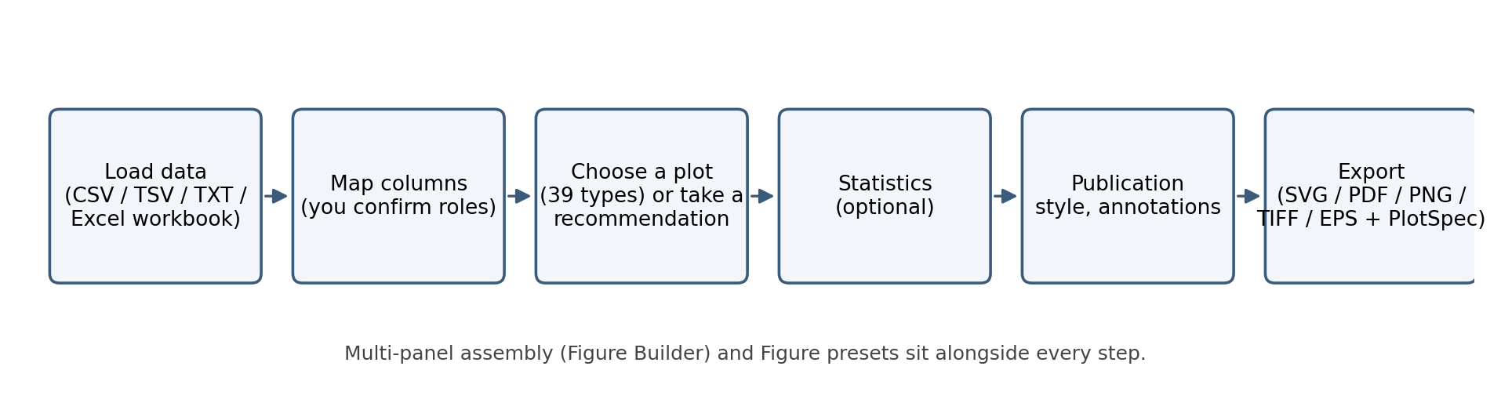
The Make My Figure workflow: load, map columns, choose a plot (or take a recommendation), optional statistics, style and annotate, export with a PlotSpec record.
- Load a table (or one worksheet of a workbook).
- Map columns to roles — you confirm which column is x, y, group, p-value, time, event, and so on. The program never guesses biological meaning silently.
- Choose a plot type from the 38 in the registry, or take one of the advisory recommendations.
- Optionally run statistics — you choose the method; results are stored and every p-value drawn on the figure comes from a stored result.
- Style the figure with the single Publication style (fonts, palette, layout, legend), add annotations.
- Assemble several plots into a multi-panel figure if you need one.
- Export SVG, PDF, PNG (and TIFF/EPS) together with a PlotSpec JSON that records the configuration — or Save Figure Package to get one portable .mmfpackage that also freezes the data.
Two interfaces share one engine: a desktop app (Qt) and a browser app (Streamlit). Both run entirely on your computer; nothing is uploaded anywhere.
Note: Make My Figure is a plotting and reporting tool. It computes the statistics you ask for and recommends plots from the shape of your table, but the choice of method, the interpretation, and journal compliance remain yours. Publication is a general manuscript style, not a journal template.

2. Installation

A. Packaged application (no Python needed)
Download the installer for your system from the project’s GitHub Releases page (release v1.1.1):
System | File | Steps
macOS | MakeMyFigure-1.1.1.dmg | open the DMG, drag Make My Figure to Applications, launch it. The bundle is not notarised: on first launch right-click → Open (or allow it under System Settings → Privacy & Security).
Windows | MakeMyFigure-1.1.1-Setup.exe (or MakeMyFigure-1.1.1-windows.zip) | run the installer (or unzip and start MakeMyFigure\MakeMyFigure.exe). SmartScreen may warn about an unsigned program; choose More info → Run anyway if you trust the source.
Linux | MakeMyFigure-1.1.1.AppImage (or MakeMyFigure-1.1.1-linux.tar.gz) | chmod +x MakeMyFigure-1.1.1.AppImage && ./MakeMyFigure-1.1.1.AppImage, or unpack the tarball and run MakeMyFigure/MakeMyFigure.
WSL2 (Linux under Windows) | not a native package | use the source install below with WSLg (Windows 11) or run the browser app and open it in a Windows browser.
SHA256SUMS.txt on the release page lists the checksum of every file. The status bar (desktop) shows Make My Figure v1.1.1 · <commit> · <platform> · <backend> on launch, and Help → About shows the version.

B. From source (desktop and browser apps)
Requirements: Python 3.10–3.12 (the metadata allows 3.9, but Apple’s bundled 3.9 failed pip’s byte-compile step on a PySide6 file during testing — use a newer interpreter), git, and about 1 GB of disk for the Qt binding.
git clone https://github.com/surPoudel/make-my-figure.git
cd make-my-figure
python3 -m venv .venv
source .venv/bin/activate # Windows PowerShell: .venv\Scripts\Activate.ps1
python -m pip install --upgrade pip
python -m pip install --no-compile -r requirements.txt
python -m pip install --no-compile -e ".[desktop]" # adds PySide6 for the desktop app
--no-compile skips a byte-compile step that fails on one PySide6 template file with some interpreters; Python compiles what it needs on first import.
Verify the build you are running:
python -c "from make_my_figure_core.version import build_banner; print(build_banner())"
The line shows the version, the git commit, the platform and the Matplotlib backend. The same banner appears in the desktop status bar on launch and in the browser sidebar, so you can always confirm the manual matches the app.
Linux / WSL only: the Qt binding needs system libraries that minimal images lack:
sudo apt install -y libxkbcommon0 libxkbcommon-x11-0 libgl1 libegl1 libxcb-cursor0 \
libxcb-xinerama0 libxcb-keysyms1 libxcb-randr0 libxcb-render-util0 libxcb-shape0 \
libxcb-icccm4 libxcb-image0 libxcb-xfixes0 libdbus-1-3
If the desktop app cannot start it prints exactly this list. The browser app needs none of it.

3. Open the app
Desktop:
python -m apps.desktop_app.main
Browser:
streamlit run apps/streamlit_app/streamlit_app.py
and open the address Streamlit prints (normally http://localhost:8501).
The desktop app opens on the Home / Upload page. Drop a file onto it, choose File → Open data file…, or pick a bundled example from File → Open example.
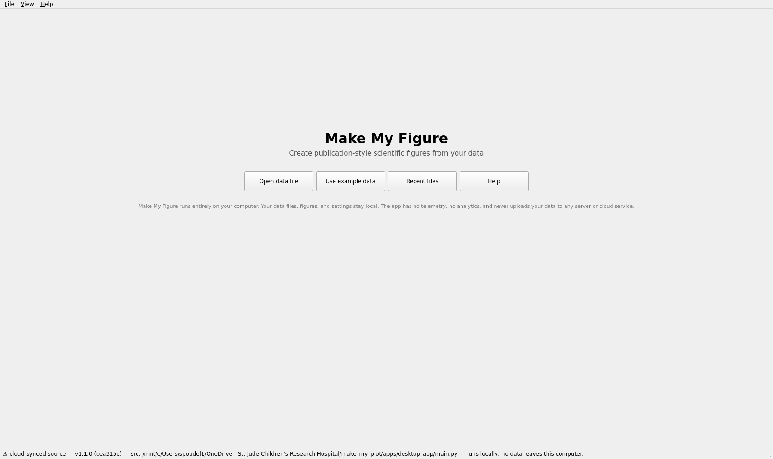
Desktop app on launch: the Home / Upload page. Everything runs locally.
After data loads you are in the plot workspace: controls on the left (plot type, recommendations, column mapping, options, labels, Figure preset, Publication style, Statistics, Export), the data preview and messages at the top right, and the figure below them.
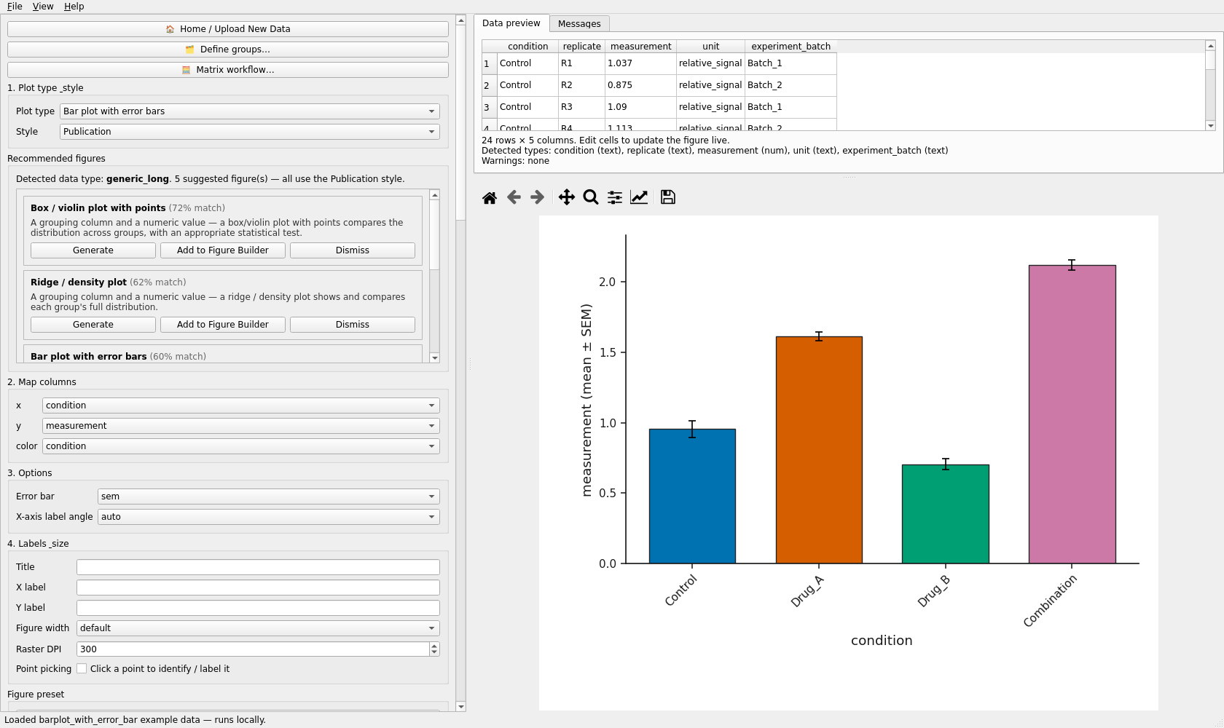
Desktop workspace with the bundled bar-plot example loaded: controls (left), data preview and messages (top right), live figure (bottom right).
The browser app has the same sections in its sidebar, numbered 1–6, with the table, the figure preview, Publication QC and Export in the main column.
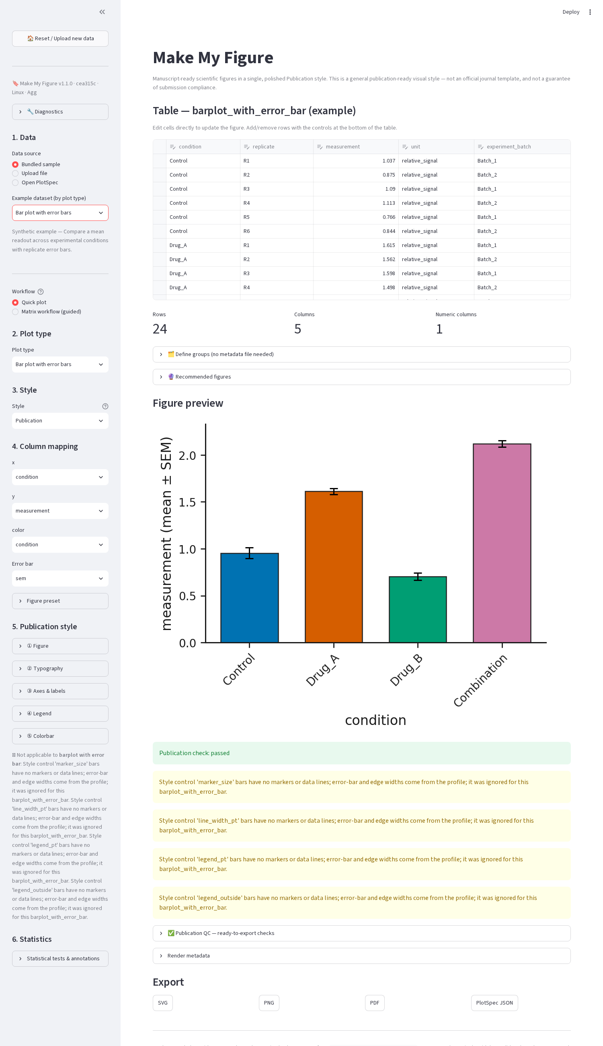
Browser app with the same example: numbered sidebar sections, editable table, figure preview, export buttons.

4. Load data
Supported files: CSV, TSV, TXT/TAB (delimited text) and Excel .xlsx, .xlsm, .xls. Put column names in the first row and one observation per row. Numeric measurements should be numeric columns; identifiers and labels can be text.
- Desktop: drag a file onto the window, or File → Open data file…
- Browser: sidebar 1. Data → Upload file → Upload CSV / TSV / XLSX
Excel workbooks with several sheets. Every worksheet is listed and selectable, including notes and empty sheets. Pick one in the 📑 Worksheet box (desktop) or sidebar (browser). Each sheet is classified — differential results, matrix, metadata, enrichment, documentation, generic, empty — as a hint, not a decision; you can plot from any sheet.
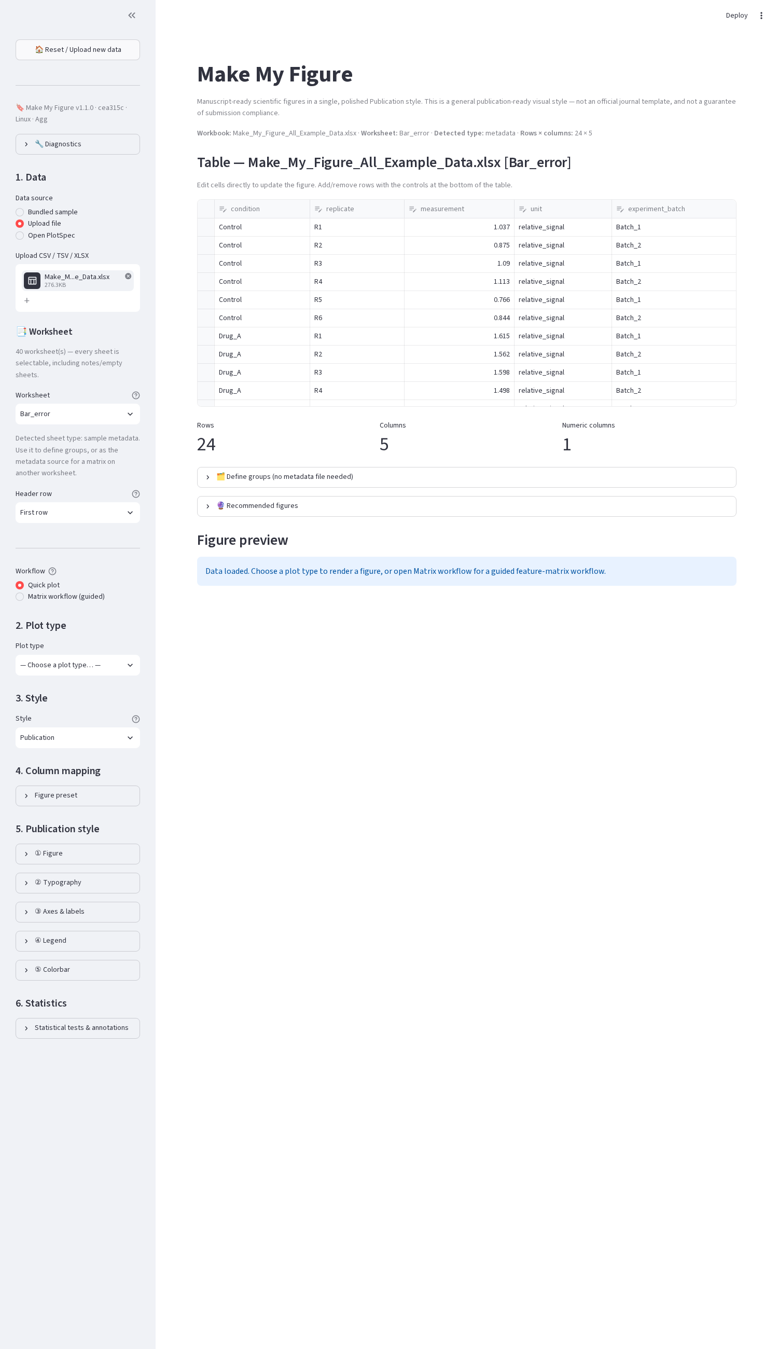
Browser app with the bundled example workbook: 40 worksheets listed, the selected sheet’s detected type, and the header-row selector.
In the browser app you can also choose the Header row (first row, a chosen row, two stacked rows, or no header) and, for spreadsheets whose group label is written once over a block of replicate columns, tick Carry a group label across blank cells. Merged Excel cells are recovered automatically. The desktop app reads the first row as the header.
Matrix tables (features in rows, samples in columns, e.g. an expression or intensity matrix) work in the ordinary editor for heatmaps, clustering and PCA, and have their own guided Matrix workflow (section 8).

5. Make a basic figure
Use the bundled example so the steps match the screenshots exactly: File → Open example → Bar plot with error bars (desktop) or Bundled sample → Bar plot with error bars (browser).
- Plot type is already Bar plot with error bars; the Style is Publication (the only style).
- 2. Map columns: x → condition, y → measurement, color → condition. With your own data, set each role yourself — the defaults only prefill when a matching column exists.
- 3. Options: Error bar → sem, sd, ci95 or none; X-axis label angle.
- The figure re-renders as you change anything (the desktop debounces continuous controls so dragging stays responsive).
- 4. Labels & size: title, axis labels, Figure width preset (default / single / onehalf / double column) and Raster DPI.
- 5. Publication style — tick the box to enable it (desktop) or open the expanders (browser): typography, palette, tick angles, padding, legend location, colorbar, margins.
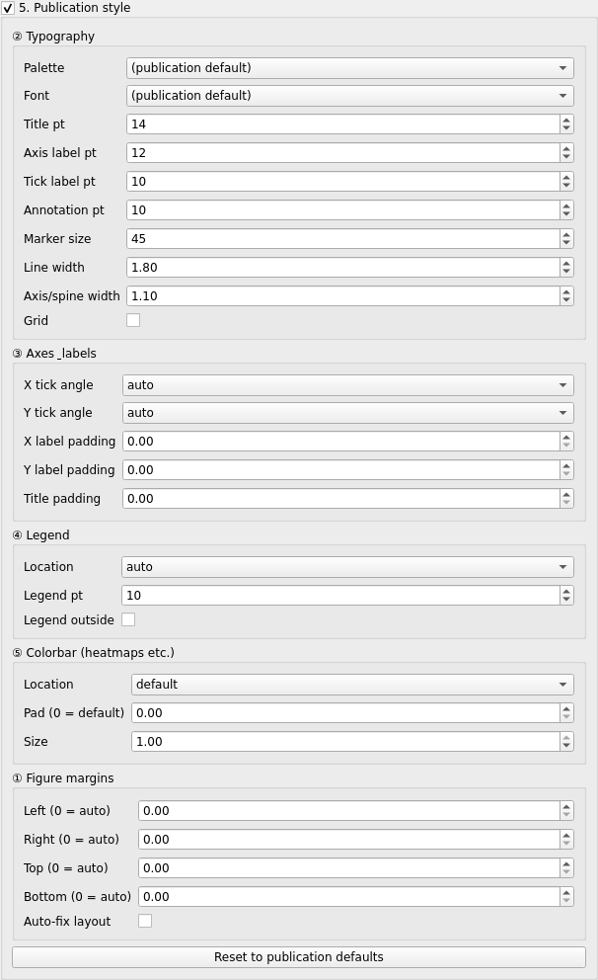
The Publication style group: ② Typography, ③ Axes and labels, ④ Legend, ⑤ Colorbar, ① Figure margins, and Reset to publication defaults.
- Export: desktop 5. Export → Export SVG / PNG / PDF / Export PlotSpec JSON (specification only), Save Figure Package (.mmfpackage) or Export all as ZIP (figures + specs + package); browser Export → SVG / PNG / PDF / PlotSpec JSON / Figure Package download buttons. The PlotSpec JSON records the configuration but not the data — it needs the source table to reopen. The figure package is the file to move or share: it holds the specification and a frozen copy of the data, and reopens anywhere with Open Figure Package.
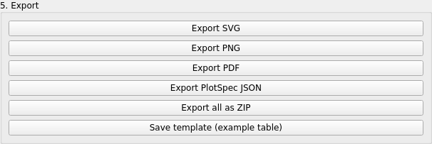
Desktop Export group: SVG, PNG, PDF, PlotSpec JSON, ZIP bundle, template table, and the multi-panel buttons.
Controls that do not apply to the current plot are reported rather than silently ignored — for a bar plot, for example, the marker-size and line-width controls do nothing and the app says so.

6. Use recommendations
When a table loads, Make My Figure profiles it (numeric vs. categorical columns, identifiers, p-value-like columns, matrix shape, edge lists, survival columns…) and suggests plots with a match score and the reason.
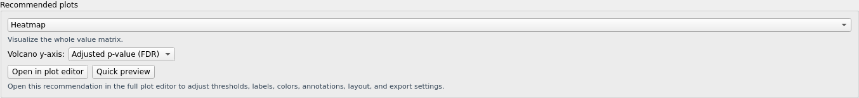
Recommended plots for a grouped-observation table: each card explains the match and offers Generate, Add to Figure Builder, or Dismiss.
- Desktop: the Recommended figures group under the plot type; Generate switches to that plot with the suggested mapping; Add to Figure Builder saves it as a panel.
- Browser: the 🔮 Recommended figures expander above the figure.
Recommendations are advisory. The score is a rule-based heuristic on the table’s shape, not a measure of scientific appropriateness. You remain responsible for choosing what the figure should show.

7. Run statistics
Example: Box / violin plot with points (bundled). In 6. Statistics (desktop: tick the group box, then Enable statistics; browser: Statistical tests & annotations expander):
- Test — e.g. Welch’s t-test. Eighteen methods are available (t-tests, Mann-Whitney, Wilcoxon, ANOVA variants, Kruskal-Wallis, Dunn, chi-square, Fisher, log-rank, Cox, Pearson, Spearman, linear regression, GLM). Auto-suggest proposes one from the mapping; it is a suggestion, not a decision.
- Comparison — all groups pairwise, compare to a control, within each x category, selected pairs, or omnibus only.
- Correction — Benjamini–Hochberg FDR, Bonferroni, Holm, or none.
- Annotation shows / placement — stars, exact p, adjusted p, statistic, effect size…; brackets between compared groups, or one label above each bar when comparing to a control.
- Run statistics. The results table lists each comparison with p, adjusted p, effect size and n, and a method sentence is written for your Methods section. Export the table (CSV) or the method report (Markdown).
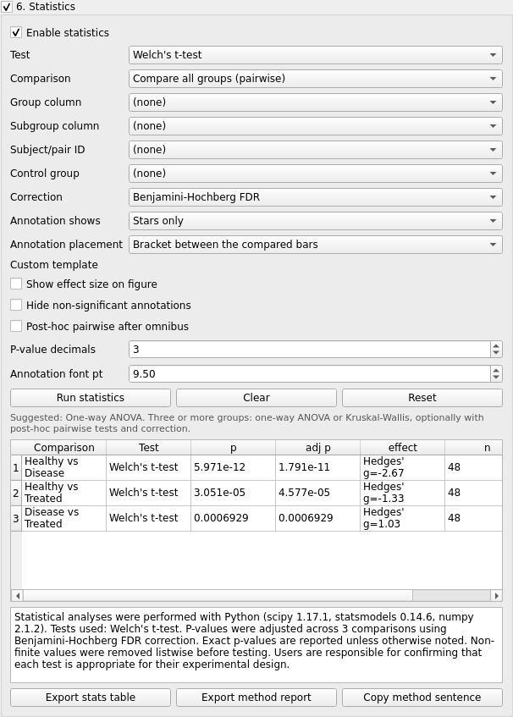
The Statistics panel after Run statistics on the box/violin example: Welch’s t-test, all pairs, BH correction, results table and method sentence.
Warning: the program performs the calculation you request. It does not verify that a test suits your design. Check assumptions (independence, pairing, distribution) before you rely on a result.

8. Matrix workflow
For a feature-by-sample matrix, open 🧮 Matrix workflow… (desktop) or choose Workflow → Matrix workflow (guided) (browser).
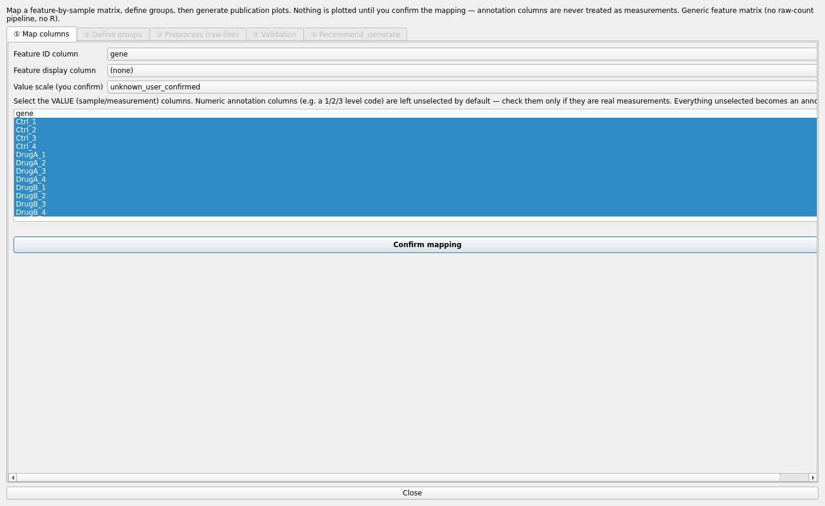
Matrix workflow, step ① Map columns: feature ID column, value columns, and the value scale you confirm before anything is plotted.
- ① Map columns — the feature ID column, optional display column, the value (sample) columns, and the value scale (normalized, log_normalized, raw_numeric, or unknown_user_confirmed). Numeric annotation columns are left unselected until you tick them. Click Confirm mapping.
- ② Define groups — upload a metadata file, take one from another worksheet, or type a group per sample column; then Confirm groups.
- ③ Preprocess (raw-like) — optional, for raw-like data: Run diagnostics (suspected data type, skew, zeros, negatives), preview a QC plot, pick one of the recommended preprocessing recipes (e.g. Total-sum normalize → log2 → z-score; nothing is applied automatically), then Apply preprocessing → use processed matrix. Each step is recorded; the original matrix is never modified; Save before/after QC report… writes the report.
- ④ Validation — a report of the confirmed mapping and groups (features, samples, groups, missing values, duplicate ids) with warnings or ✓ Validation passed.
- ⑤ Recommend & generate — an optional two-group differential summary (test, correction, groups A/B), then recommended plots (heatmap, PCA, box plots, volcano/MA once a summary exists) with Quick preview and Open in plot editor, which hands the derived table to the full editor with its provenance.

9. Save a Figure preset
A Figure preset is your configuration without your data. Configure a figure once, save the preset, and apply it to a new dataset of the same plot type later.
- Figure style only — fonts, palette, line/marker sizes, tick angles, margins, legend and colorbar placement, export size/DPI, and visual plot options (violin vs box, colormap, node colours…). Portable: this is the lab’s Lab_Default_Heatmap.mmfpreset.json.
- Full figure configuration — everything above plus column roles, thresholds, axis labels and the statistics test. On new data it applies what fits and lists the columns it could not find, for you to map — it never guesses.
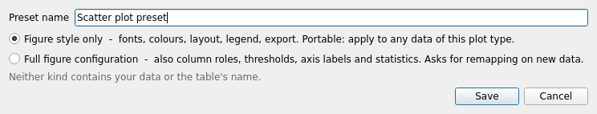
Save Figure Preset: name it and choose style-only or full configuration. Neither kind contains your data.
Desktop: the Figure preset group (above Publication style) — choose a preset, Apply, Save preset…, Delete, Import…, Export…, Reset to Publication defaults; the same actions are in File → Figure preset. Browser: the Figure preset expander in the sidebar.
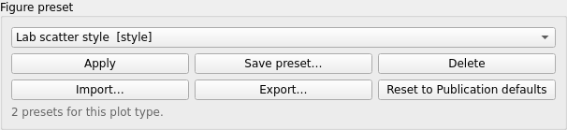
The Figure preset group with saved presets listed for the current plot type.
A PlotSpec is different: it is the exact record of one figure, including the table name and column names — but not the values; the source table is required to reopen it. An existing PlotSpec can be loaded as a full preset.
A Figure package (.mmfpackage) is the third kind of file: the PlotSpec (or FigureSpec) plus a frozen copy of the exact data, the StatsSpec results, the Matrix Workflow records where they apply, imported images, previews and a checksum for every file. It is the one file to send to a collaborator; Open Figure Package reproduces the figure without the original data files. Because it contains data, share it only with people who may see those data.
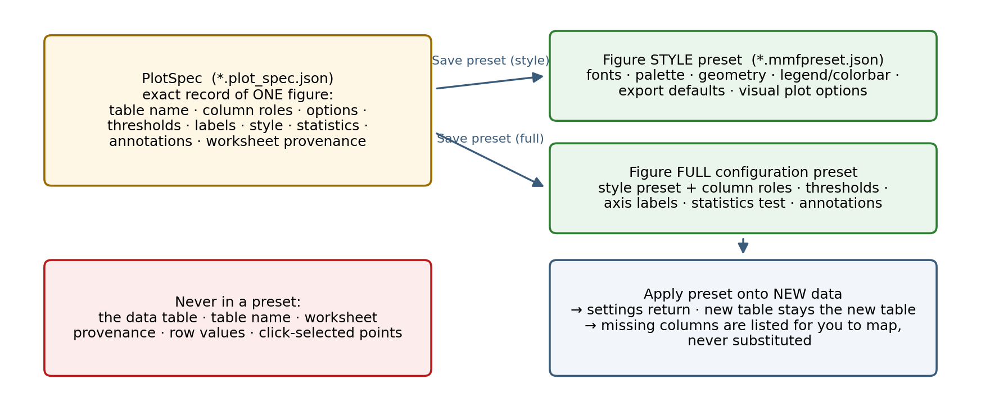
PlotSpec versus Figure preset: what each contains, and what never enters a preset.

10. Figure Builder (multi-panel figures)
In the desktop app, click Save current plot as panel for each plot you want, then Open Figure Builder….
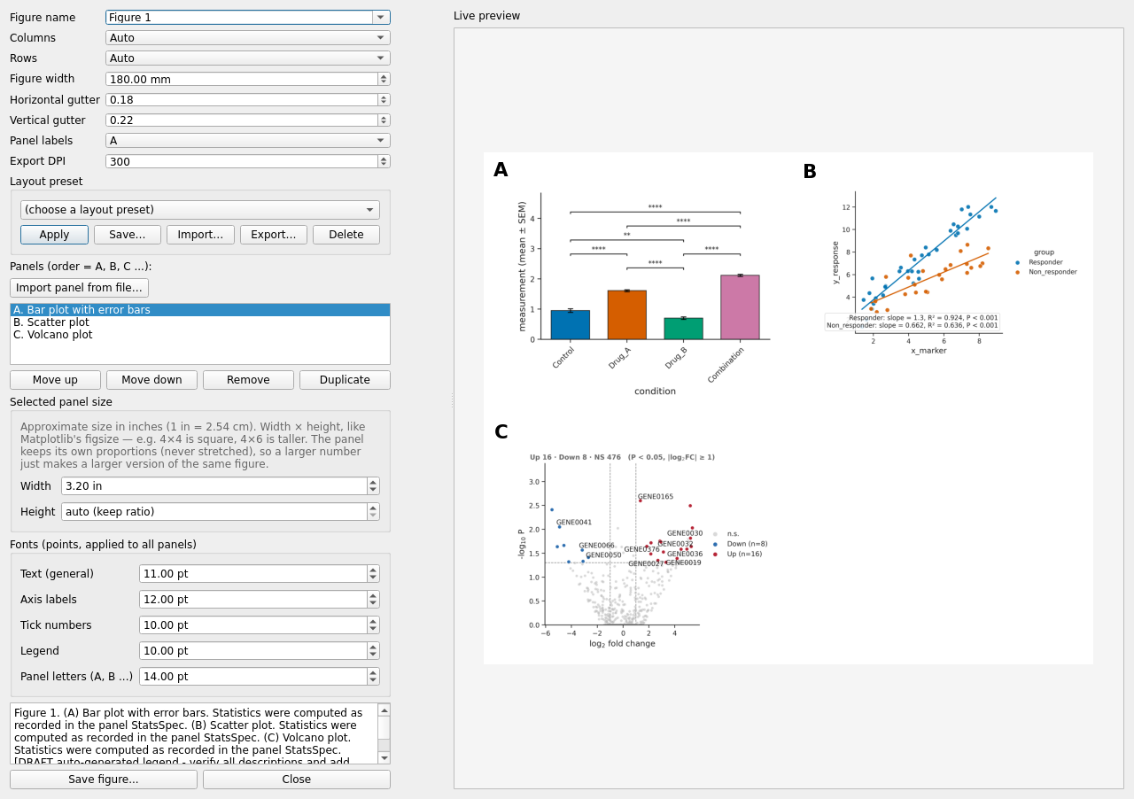
Figure Builder with three saved panels: grid, gutters, panel-letter style, per-panel size in inches, global fonts, layout presets, and a live preview.
- Add generated plots (they re-render from their PlotSpecs) or Import panel from file… (PNG, JPG, TIFF, WEBP, BMP; PDF/SVG/EPS with the optional import-panels extra).
- Set Columns, Rows, Figure width (mm), the two gutters, Panel labels (A / a / 1) and Export DPI.
- Select a panel to set its Width and Height in inches (proportions are preserved, never stretched), reorder, duplicate or remove it.
- Fonts apply to every panel. Layout preset saves the grid/sizes/fonts for reuse without any panel content.
- Save figure… writes PNG/SVG/PDF plus a FigureSpec (.figure_spec.json; panel identities, not the data). Save Figure Package… writes one .mmfpackage with the FigureSpec, every panel’s PlotSpec/StatsSpec, the exact tables and imported images; Open Figure Package rebuilds the composite here.
Note: the composite embeds each panel’s content as a raster image at the export DPI; panel letters and titles stay vector text. For a fully vector single panel, export that plot directly as SVG or PDF. The browser app has a simpler Figure Builder (columns only) inside the guided Matrix workflow.

11. Export
Format | Type | DPI | Text | Typical use
SVG | vector | — | editable | edit further in Illustrator/Inkscape; journals accepting SVG
PDF | vector | — | editable (embedded Type 42 fonts) | manuscript submission, print
EPS | vector | — | editable | legacy journal systems (core/ZIP export)
PNG | raster | 150–600 (set in Raster DPI) | — | slides, previews, journals requiring raster
TIFF | raster (LZW) | as PNG | — | journals requiring TIFF (core/ZIP export)
Export PlotSpec JSON writes name.plot_spec.json (specification only); Export all as ZIP bundles SVG/PNG/PDF, name.plot_spec.json, name.stats_spec.json when statistics ran, and name.mmfpackage. Save Figure Package writes the package alone.

Sharing a reproducible figure
- Finalise the plot. 2. Save Figure Package. 3. Send the one .mmfpackage file. 4. The collaborator opens Make My Figure. 5. Open Figure Package (landing page or File menu). 6. Integrity is verified (every SHA-256). 7. The figure opens with the frozen data and configuration. 8. Inspect, edit and export as usual.
 | PlotSpec | Figure preset | Figure package
purpose | recipe for one plot | reusable configuration | portable reproducibility bundle
contains data | no — source data required | no | yes — frozen copy + specifications
file | .plot_spec.json | .mmfpreset.json | .mmfpackage

12. Where to get help
- Desktop Help menu: Help… (plot types, how to format your data, privacy, the Publication-style disclaimer), About (version), Copy debug info.
- Browser sidebar: the version banner and 🔧 Diagnostics.
- The full User Manual (this folder) documents every control, plot, statistic and file.
- Repository: https://github.com/surPoudel/make-my-figure (issues, if the repository is public for you).
Always quote the banner line (version · commit · platform · backend) when reporting a problem.

