Table of Contents

Make My Figure — User Manual
MakeMyFigure version: 1.2.1
Documentation generated from commit: d110866
Date: 2026-10-06
This manual describes the application exactly as built at the commit above. Where the packaged installers of an earlier release differ, the text says so.

Part I — Introduction

1. About Make My Figure
Make My Figure (package make_my_figure_core, version 1.1.1) turns tabular scientific data — CSV/TSV/TXT files and Excel workbooks — into manuscript-style figures, and records how each figure was made. One engine serves two interfaces: a desktop application built with Qt (PySide6) and a browser application built with Streamlit. Both run entirely on your own computer.

2. Intended users
Bench and computational scientists who have a table of results and need a clean, consistent, reproducible figure: a bar or box plot of replicate measurements, a volcano from a differential-expression table, a heatmap or PCA from a normalised matrix, a Kaplan–Meier curve, a network, a multi-panel composite for a manuscript. No programming is required; the PlotSpec files it writes are plain JSON if you want to look inside.

3. Design principles
- You confirm the mapping. Columns are assigned to roles (x, y, group, p-value, time, event…) by you. Auto-detection only prefills a suggestion — for a differential-expression table it recognises edgeR/limma/DESeq2 headers, for a matrix it proposes value columns — and you accept or change it.
- No silent guessing. A numeric annotation column is not treated as a measurement until you tick it; a value scale (raw, normalised, log) is declared, not inferred; a survival curve that is already computed is refused as a 0/1 event column instead of being drawn wrong.
- Every number drawn is stored. A p-value or effect size on a figure always comes from a stored statistical result that is exported alongside the figure. Renderers never format p-values themselves.
- Controls that do not apply are reported, never ignored quietly.
- One style. The Publication style is a general manuscript-ready visual style — readable fonts, colour-blind-aware palettes, tidy axes. It is not a journal template and the app says so in its exported metadata.
- Original data are never modified. Preprocessing creates a new, derived table with its steps recorded; the source stays as loaded.

4. What Make My Figure does
- Loads delimited text and Excel (including every worksheet of a multi-sheet workbook, stacked and merged headers).
- Profiles a table and recommends plots, with a reason and a match score.
- Renders 38 plot types from a single registry.
- Runs 18 statistical methods with multiple-testing correction and effect sizes, and annotates figures from stored results.
- Guides a Matrix Workflow (feature × sample matrices): mapping, groups/metadata, preprocessing, QC, differential summary, plot generation.
- Offers Publication controls (typography, palette, axes, legend, colorbar, margins) with capability-aware honesty.
- Supports annotations (click-to-label points, duplicate-label policies, a manual annotation layer in the PlotSpec).
- Saves and applies Figure presets (style-only or full configuration) across datasets.
- Assembles multi-panel figures from generated and imported panels.
- Exports SVG, PDF, EPS, PNG, TIFF with a PlotSpec (and StatsSpec / FigureSpec) record, and saves figure packages (.mmfpackage) that carry the specification together with the frozen data.

5. What Make My Figure does not do
- It does not perform differential-expression inference (no DESeq2, edgeR or limma). It plots a DE table you already have and reads its p-values verbatim. (A separate, opt-in count-de extra exists for a Python-only count model; it is not part of the standard install and is not covered by this manual.)
- It does not choose a statistical test for you. Suggestions are advisory.
- It does not guarantee journal acceptance or compliance with any journal’s author guidelines.
- It does not upload data, collect telemetry, or need a network connection to run.
- It does not implement Dunnett’s test; comparisons against a control use the pairwise test you choose with a multiple-testing correction.

6. Reproducibility and provenance model
Export PlotSpec JSON, Export all as ZIP and the browser downloads write a PlotSpec (name.plot_spec.json): the plot type, the table name, the column roles, every option, the style tokens, the layout, statistics settings, manual annotations, worksheet provenance, a content digest of the table, and the render metadata (including the software versions used for statistics). The single-format desktop buttons (SVG/PNG/PDF) write the figure file only. When statistics ran, Export all as ZIP and the browser also write a StatsSpec (name.stats_spec.json) with every result. The Figure Builder writes a FigureSpec referencing each panel’s PlotSpec. A PlotSpec or FigureSpec records the identity of its tables, not their values, so it needs the data to reopen. The Matrix Workflow’s MatrixSpec, SampleMetadataSpec and PreprocessingSpec reach an export only through the figure package.
The figure package (name.mmfpackage) is the portable record: one file with the PlotSpec (or FigureSpec), a frozen lossless copy of the exact table(s) the plot used, the original source file when available, the StatsSpec results, the MatrixSpec / SampleMetadataSpec / PreprocessingSpec where they apply, imported images, PNG/SVG/PDF previews, the software environment and a manifest with a SHA-256 for every file. Open Figure Package verifies every checksum and reopens the figure from the frozen data on any computer (Part XV).
A figure is therefore reconstructable under a recorded software environment: open the figure package (or the PlotSpec with its data) with the same code, and the same figure is rebuilt. Byte-identical output across different machines is not promised — fonts, Matplotlib versions and platform text rendering differ slightly.

7. Local, open-source architecture
Python, pandas, NumPy, SciPy, statsmodels, Matplotlib, openpyxl, networkx. The desktop app adds PySide6; the browser app adds Streamlit. Data flow: loader → PlotSpec (validated against a JSON schema) → renderer → RenderResult → export + sidecar. Source: https://github.com/surPoudel/make-my-figure.

Part II — Installation and startup

8. Which installation is for you
You want to… | Use
Run the desktop app without installing Python | Packaged installer (Windows .exe/.zip, macOS .dmg, Linux .AppImage/.tar.gz)
Run the newest code, the browser app, or develop | Source install with Python 3.10–3.12
Use Make My Figure from your own scripts | pip install the core wheel (make_my_figure_core-*.whl) — no GUI included
The installers attached to release v1.1.1 (MakeMyFigure-1.1.1.dmg, MakeMyFigure-1.1.1-Setup.exe / MakeMyFigure-1.1.1-windows.zip, MakeMyFigure-1.1.1.AppImage / MakeMyFigure-1.1.1-linux.tar.gz) are built from the tagged v1.1.1 source on native macOS, Windows and Linux runners and contain everything this manual documents (Figure presets, the histogram plot, survival-curve and merged-header fixes, the R-validated statistical corrections). Download them from the project’s GitHub Releases page and check the file’s SHA-256 against SHA256SUMS.txt if you want to verify the download.

9. macOS
Packaged: open MakeMyFigure-1.1.1.dmg, drag Make My Figure to Applications. The bundle is not notarised: on first launch right-click → Open, or allow it in System Settings → Privacy & Security.
Source:
git clone https://github.com/surPoudel/make-my-figure.git
cd make-my-figure
# use a modern interpreter (Homebrew python@3.11/3.12 or a conda base python):
python3.11 -m venv .venv_mac
source .venv_mac/bin/activate
python -m pip install --upgrade pip
python -m pip install --no-compile -r requirements.txt
python -m pip install --no-compile -e ".[desktop]"
python -c "from make_my_figure_core.version import build_banner; print(build_banner())"
python -m apps.desktop_app.main
Common macOS startup errors:
Symptom | Cause | Fix
ModuleNotFoundError: No module named 'pandas' while the prompt shows (.venv) | a stale venv label; the folder was moved or the wrong python is first on PATH | deactivate; conda deactivate, then re-create the venv in the project folder and source it again
numpy.dtype size changed … Expected 96 from C header, got 88 | two environments stacked ((base) + a venv) so pandas came from one and NumPy from another | deactivate everything, create one fresh venv, install into it
pip crashes with SyntaxError … {% for module in qt_modules %} while installing PySide6 | Apple’s Python 3.9 byte-compiling a Jinja template inside PySide6 | use Python 3.10+ and pip install --no-compile

10. Windows
Packaged: run MakeMyFigure-1.1.1-Setup.exe (Inno Setup installer) or unzip MakeMyFigure-1.1.1-windows.zip and start MakeMyFigure\MakeMyFigure.exe. Windows Defender may show a SmartScreen prompt for an unsigned binary; choose More info → Run anyway if you trust the source.
Source (PowerShell):
git clone https://github.com/surPoudel/make-my-figure.git
cd make-my-figure
py -3.11 -m venv .venv
.venv\Scripts\Activate.ps1 # if blocked: Set-ExecutionPolicy -Scope Process RemoteSigned
python -m pip install --upgrade pip
python -m pip install --no-compile -r requirements.txt
python -m pip install --no-compile -e ".[desktop]"
python -m apps.desktop_app.main
First launch of the packaged app can take 10–20 s while Windows unpacks and scans the bundle; later launches are faster. Rendering runs in background workers so the window stays responsive.

11. Linux
Packaged: chmod +x MakeMyFigure-1.1.1.AppImage && ./MakeMyFigure-1.1.1.AppImage, or unpack MakeMyFigure-1.1.1-linux.tar.gz and run MakeMyFigure/MakeMyFigure.
Source: as for macOS, using the distribution’s python3 (3.10+). The Qt binding needs system libraries that server and container images usually lack:
sudo apt install -y libxkbcommon0 libxkbcommon-x11-0 libgl1 libegl1 libxcb-cursor0 \
libxcb-xinerama0 libxcb-keysyms1 libxcb-randr0 libxcb-render-util0 libxcb-shape0 \
libxcb-icccm4 libxcb-image0 libxcb-xfixes0 libdbus-1-3
If PySide6 cannot load, the desktop app prints this exact list and exits cleanly; the browser app is unaffected.

12. WSL2 (Linux running under Windows)
WSL2 is Linux running inside Windows; it is not native Windows and the Windows installer does not apply to it. The source install works in WSL 2. The desktop app needs a display: WSLg (Windows 11) provides one automatically; otherwise use the browser app, which needs no display — streamlit run apps/streamlit_app/streamlit_app.py --server.headless true and open the printed URL in a Windows browser. Install the Linux Qt libraries above if you want the desktop app.

13. Launching, verifying the version, updating, uninstalling
- Desktop: python -m apps.desktop_app.main (source) or the installed application. The status bar shows the build banner on launch (Make My Figure v1.1.1 · <commit> · <platform> · <backend>); Help → About shows the version.
- Browser: streamlit run apps/streamlit_app/streamlit_app.py; the banner is in the sidebar, with a 🔧 Diagnostics expander listing the module path and backend. If the commit there does not match your pulled HEAD, an older installed package is shadowing the checkout — run python -m pip install -e ..
- Update a source install: git pull, then re-run the two pip install lines.
- Uninstall: delete the project folder and the venv; packaged apps uninstall like any application. User presets live in a separate folder (Part XIV) and are not removed with the app.

Part III — The application interface

14. Desktop layout
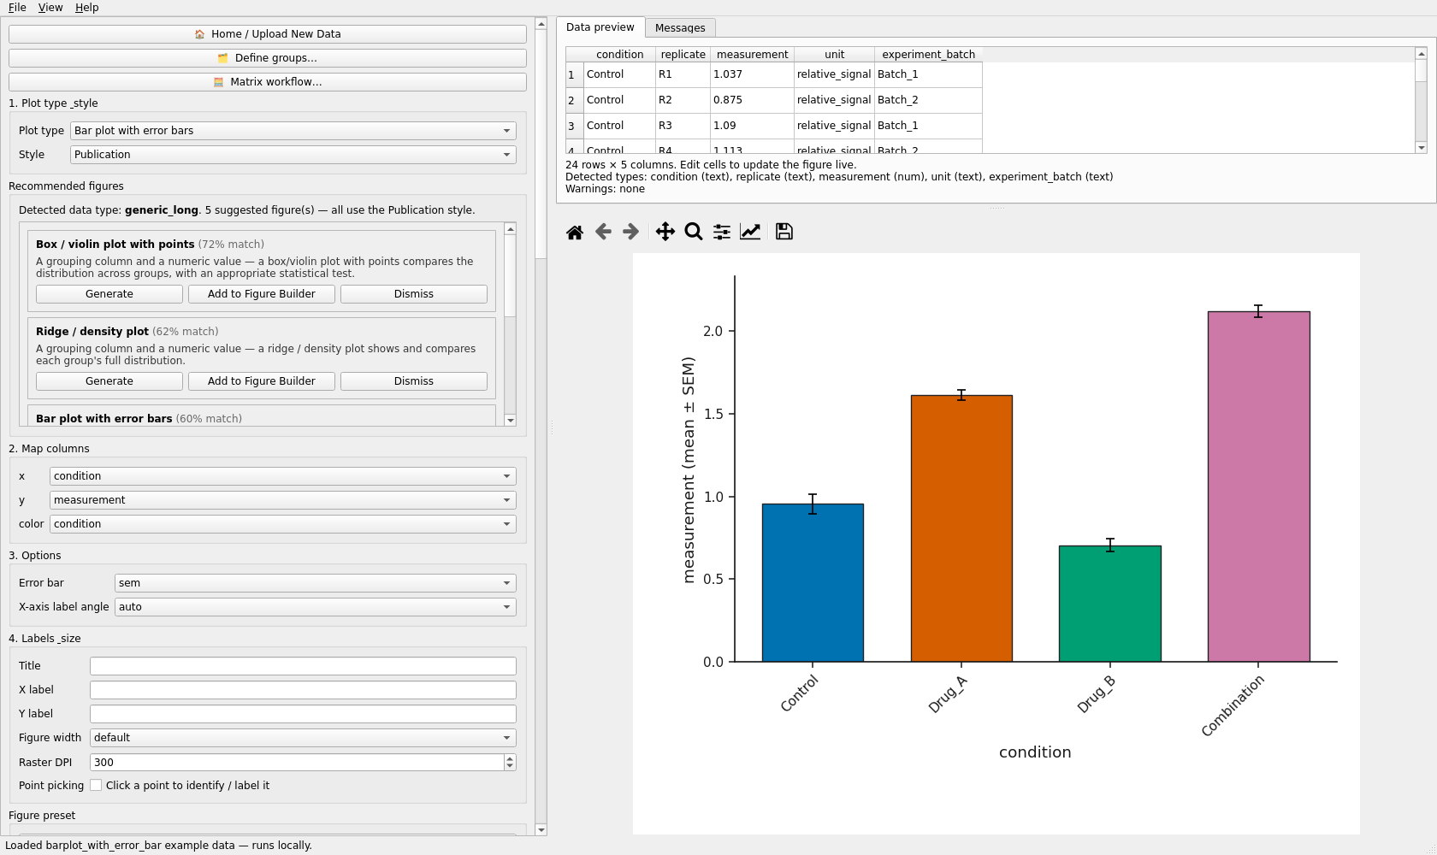
The desktop workspace with numbered regions.
Left column (scrollable, “Plot Controls”): Home / Upload New Data, Define groups…, Matrix workflow…; 1. Plot type & style; Recommended figures; 2. Map columns; 3. Options; 4. Labels & size (title, axis labels, figure width, raster DPI, point picking); Figure preset; 5. Publication style (checkable; ② Typography, ③ Axes & labels, ④ Legend, ⑤ Colorbar, ① Figure margins); 6. Statistics; 5. Export; 6. Multi-panel figure.
Right: Data preview (editable — edits re-render the figure) and Messages tabs above the figure with the Matplotlib toolbar (home/zoom/pan/save). The status bar shows the build banner, loaded-file messages and statistics results.
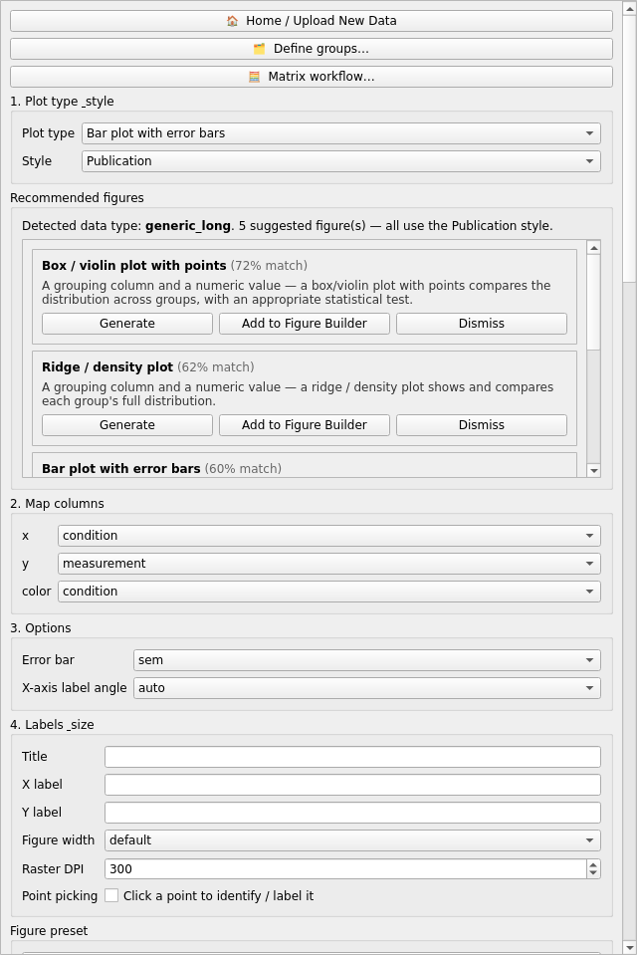
The controls column: plot type, recommended figures, column mapping, options and labels.
Menus. File: Home / Upload New Data, Open data file…, Open Figure Package…, Open PlotSpec… (specification only), Save Reproducible Figure Package…, Open example ▸ (all 38), Recent files (packages marked 📦), Save template…, Figure preset ▸ (Apply, Save, Import, Export, Delete, Reset), Quit. View: Reset Layout, Maximize Figure Panel, Show Data Preview, Dock All Panels. Help: Help…, About, Copy debug info, Diagnose toolbar.
Pop-out panels. Plot Controls, Data & Messages and the Figure can each be popped out into their own window (for a second monitor) and docked back with ⮊ Dock back or View → Dock All Panels; the arrangement persists between sessions.
Home / Upload New Data clears the data, spec, results and statistics and returns to the welcome page without restarting. The Matplotlib toolbar’s own home only resets zoom/pan.
Help. Help → Help… opens a dialog with tabs Plot types (one entry per registered type, from the example manifest), Format your data, Privacy (everything runs locally, no telemetry) and Publication style disclaimer.
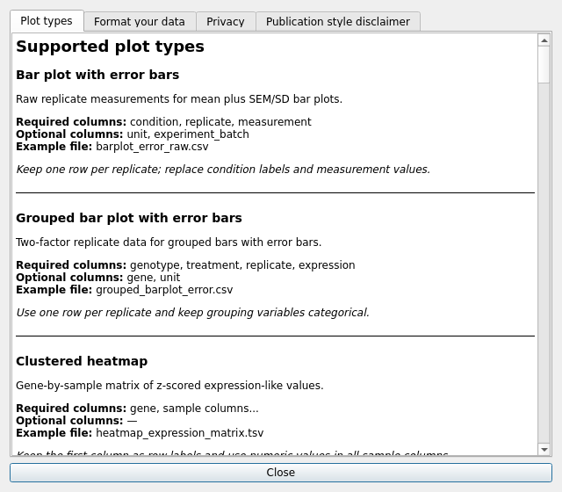
The Help dialog.

15. Browser layout
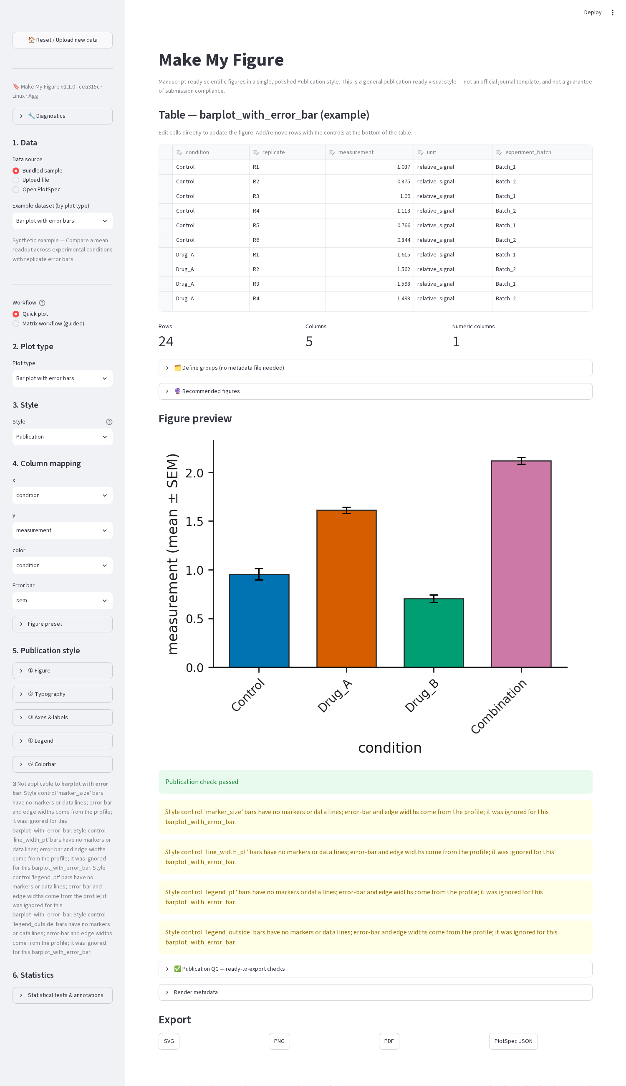
Browser app before data is chosen: data source, workflow, plot type and style in the sidebar.
Sidebar: 1. Data (Bundled sample / Upload file / Open PlotSpec / Open Figure Package; Worksheet + Header row for workbooks; Workflow: Quick plot or Matrix workflow (guided)); 2. Plot type; 3. Style; 4. Column mapping (plus the plot’s own options); Figure preset; 5. Publication style (five expanders); 6. Statistics. Main column: the editable table with row/column counts, 🗂 Define groups, 🔮 Recommended figures, Figure preview with warnings and the publication check, ✅ Publication QC, Render metadata, and Export (SVG / PNG / PDF / PlotSpec JSON / Figure Package downloads). 🏠 Reset / Upload new data clears the session.

16. Functional equivalence and differences
Capability | Desktop | Browser
Header-row choice for uploads | first row only | first / chosen / two stacked / none, plus forward fill
Font family control | yes | no
Click-to-label | click on the canvas | pick from a list + numeric offsets
Figure Builder | full (grid, sizes, imports, layout presets) | columns-only composer inside the Matrix workflow
Export EPS/TIFF | via Export all as ZIP | not offered (SVG/PNG/PDF)
Statistics export | stats table, method report, copy sentence | shown in-page
Preset library | shared folder | shared folder

Part IV — Data input

17. Supported files
Type | Extensions | Notes
Delimited text | .csv, .tsv, .txt, .tab | delimiter is sniffed; an unknown extension is parsed as text with a warning
Excel | .xlsx, .xlsm, .xls | every worksheet is selectable; merged header cells are recovered for .xlsx/.xlsm (.xls has no merge map)
Text encoding should be UTF-8. Column names should be in the first row (desktop) or the row you choose (browser).

18. Headers, missing values, types
- Header row (browser): First row, Choose row… (skips title/report rows above the header), Two rows (stacked) (outer group + inner replicate labels become Group | Replicate column names), No header (positional names column_1, column_2…). Excel merged cells spanning a block of replicate columns are expanded to every column of the block. For labels typed once without merging, tick Carry a group label across blank cells.
- Duplicate column names are disambiguated (event, event.1, event.2) and kept as separate columns — row-level identity is preserved, nothing is collapsed by label.
- Missing values (blank, NA, NaN) are reported per column in Messages; renderers drop them where a statistic or geometry needs a value and say so.
- Numeric detection is by content; a column mixing text and numbers stays text — the preview lists Detected types.
- Empty or documentation worksheets load (you may plot nothing from them) and are labelled as such.
- Hidden worksheets in a workbook are listed and marked hidden.

19. Shapes of data
- Long table — one row per observation with a grouping column (bar, box, violin, strip, beeswarm, raincloud, histogram long form).
- Wide table — one column per group of unequal length (histogram wide form: Input form → wide, tick the columns), or a feature × sample matrix (heatmap, clustering, PCA, Matrix Workflow).
- Precomputed differential results — one row per feature with logFC, p, adjusted p (volcano, MA).
- Survival — one row per subject with time, 0/1 event and group; or a precomputed curve with one S(t) column per group.
- Edge list — source, target, weight (network). Set membership — one 0/1 column per set (UpSet). Coordinates — x, y, colour (embedding scatter).
- Metadata — one row per sample with group/batch columns (PCA colour/shape, Matrix Workflow groups).

20. In-app grouping without a metadata file
🗂 Define groups… (desktop) / 🗂 Define groups (no metadata file needed) (browser):
- Assign sample groups (wide matrix): choose the Feature id column, then type a group for each sample column (leave blank to exclude). Auto-guess groups from names (desktop) or the prefilled table (browser) uses shared name tokens (Ctrl_1, Ctrl_2 → Ctrl). Create grouped table produces a long table feature / sample / group / value that flows into any plot.
- Group by column values: map the values of an existing column to group labels in a new column.
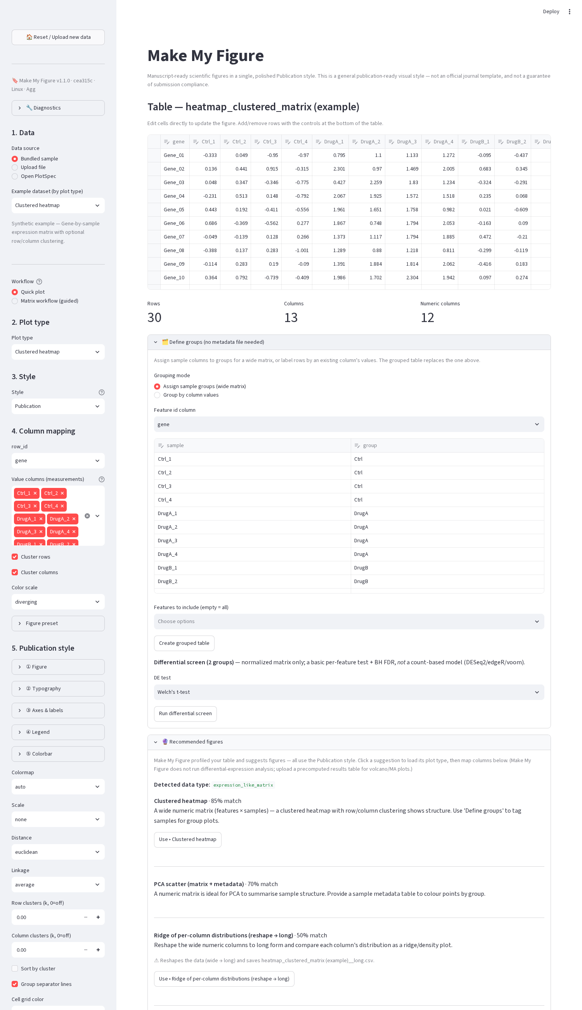
Browser: the Define groups expander for a wide matrix.
The grouped table is a new table; ↩ Revert to original data restores the source.

Part V — Column mapping

21. How mapping works
Every plot type declares its column roles in one registry (ui_hints.py), and both apps build their mapping controls from it — a combo box per single-column role, a multi-select list per multi-column role. When a table loads, a role is prefilled only if a column with the expected name exists (bundled examples), or, for a volcano plot, if a DE-style header is recognised (logFC / log2FoldChange, P.Value / pvalue, adj.P.Val / padj, gene symbol). Everything else you set yourself, and everything prefilled you can change.
Note: Make My Figure does not infer biological meaning. A column called time is not a survival time until you map it to time; a numeric column in a matrix is not a measurement until it is a selected value column.

22. Roles by plot family
Role | Meaning | Plots
x, y | category / value, or numeric axes | bar, grouped bar, box/violin, strip, beeswarm, raincloud, scatter, line, waterfall, lollipop, MA, embedding
group, color, stack, shape | series colour, stacking, marker shape | grouped bar, line, ridge, histogram, dose-response, swimmer, spider, stacked bar, PCA (metadata)
label, id_col | point labels / feature identity (duplicate-safe) | volcano, MA, scatter, lollipop, embedding, Bland-Altman
p, x (effect) | p-value / log fold change | volcano, MA, Manhattan (p), Q-Q (p)
chrom, pos, snp | chromosome, position, variant id | Manhattan
time, event, group; survival_columns | subject-level survival; or precomputed S(t) columns | Kaplan-Meier
subject, condition, value | paired measurements | paired slopegraph
subject, start, end, duration, event | timelines | swimmer
subject, time, value | longitudinal change | spider
label, score, score2 | truth label and one or two scores | ROC, precision-recall
true, predicted | confusion matrix | confusion matrix
label, prob | calibration | calibration
label, estimate, lower, upper | forest plot rows | forest
dose, response, group | dose-response | dose-response
method_a, method_b | two measurements of the same thing | Bland-Altman
source, target, value / weight, interaction_type | flows and edges | Sankey, network
row_id, matrix_row_id, value_columns | matrix feature id and measurement columns | heatmap, clustering, dendrogram, PCA
sample, row, fill | oncoprint long form | oncoprint
sets | 0/1 membership columns | UpSet
y, x, size, color | term, enrichment, count, significance | enrichment dot plot
Multi-column roles (value_columns, survival_columns) are lists: tick every column that belongs — a single choice would silently plot one series.

23. Statistics columns
The Statistics panel has its own Group column, Subgroup column, Subject/pair ID and Control group selectors. When left at (none) they follow the plot mapping (x as the group, y as the value); set them explicitly for paired tests (subject id), two-way designs (subgroup) and comparisons against a control.

Part VI — Data-aware recommendations

24. What the engine does
On load, recommend_for_table profiles the table — column kinds, identifier columns, binary columns, missingness, p-value-like ranges, matrix shape, correlation/adjacency structure — and assigns a schema: precomputed_differential, survival, gwas, classification, dose_response, network_edge_list, mutation_matrix, enrichment, correlation_matrix, expression_like_matrix, numeric_matrix, matrix_plus_metadata, paired, generic_long, or unknown. Rules per schema propose plots with a confidence score, a reason, the suggested mapping, missing mappings, suggested statistics and thresholds.
The desktop Recommended figures group shows cards (Generate, Add to Figure Builder, Dismiss); the browser shows the 🔮 Recommended figures expander. Generate switches the plot type and applies the suggested mapping; you still confirm it in Map columns.
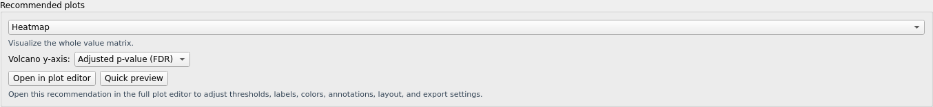
Recommendation cards for a grouped-observation table.
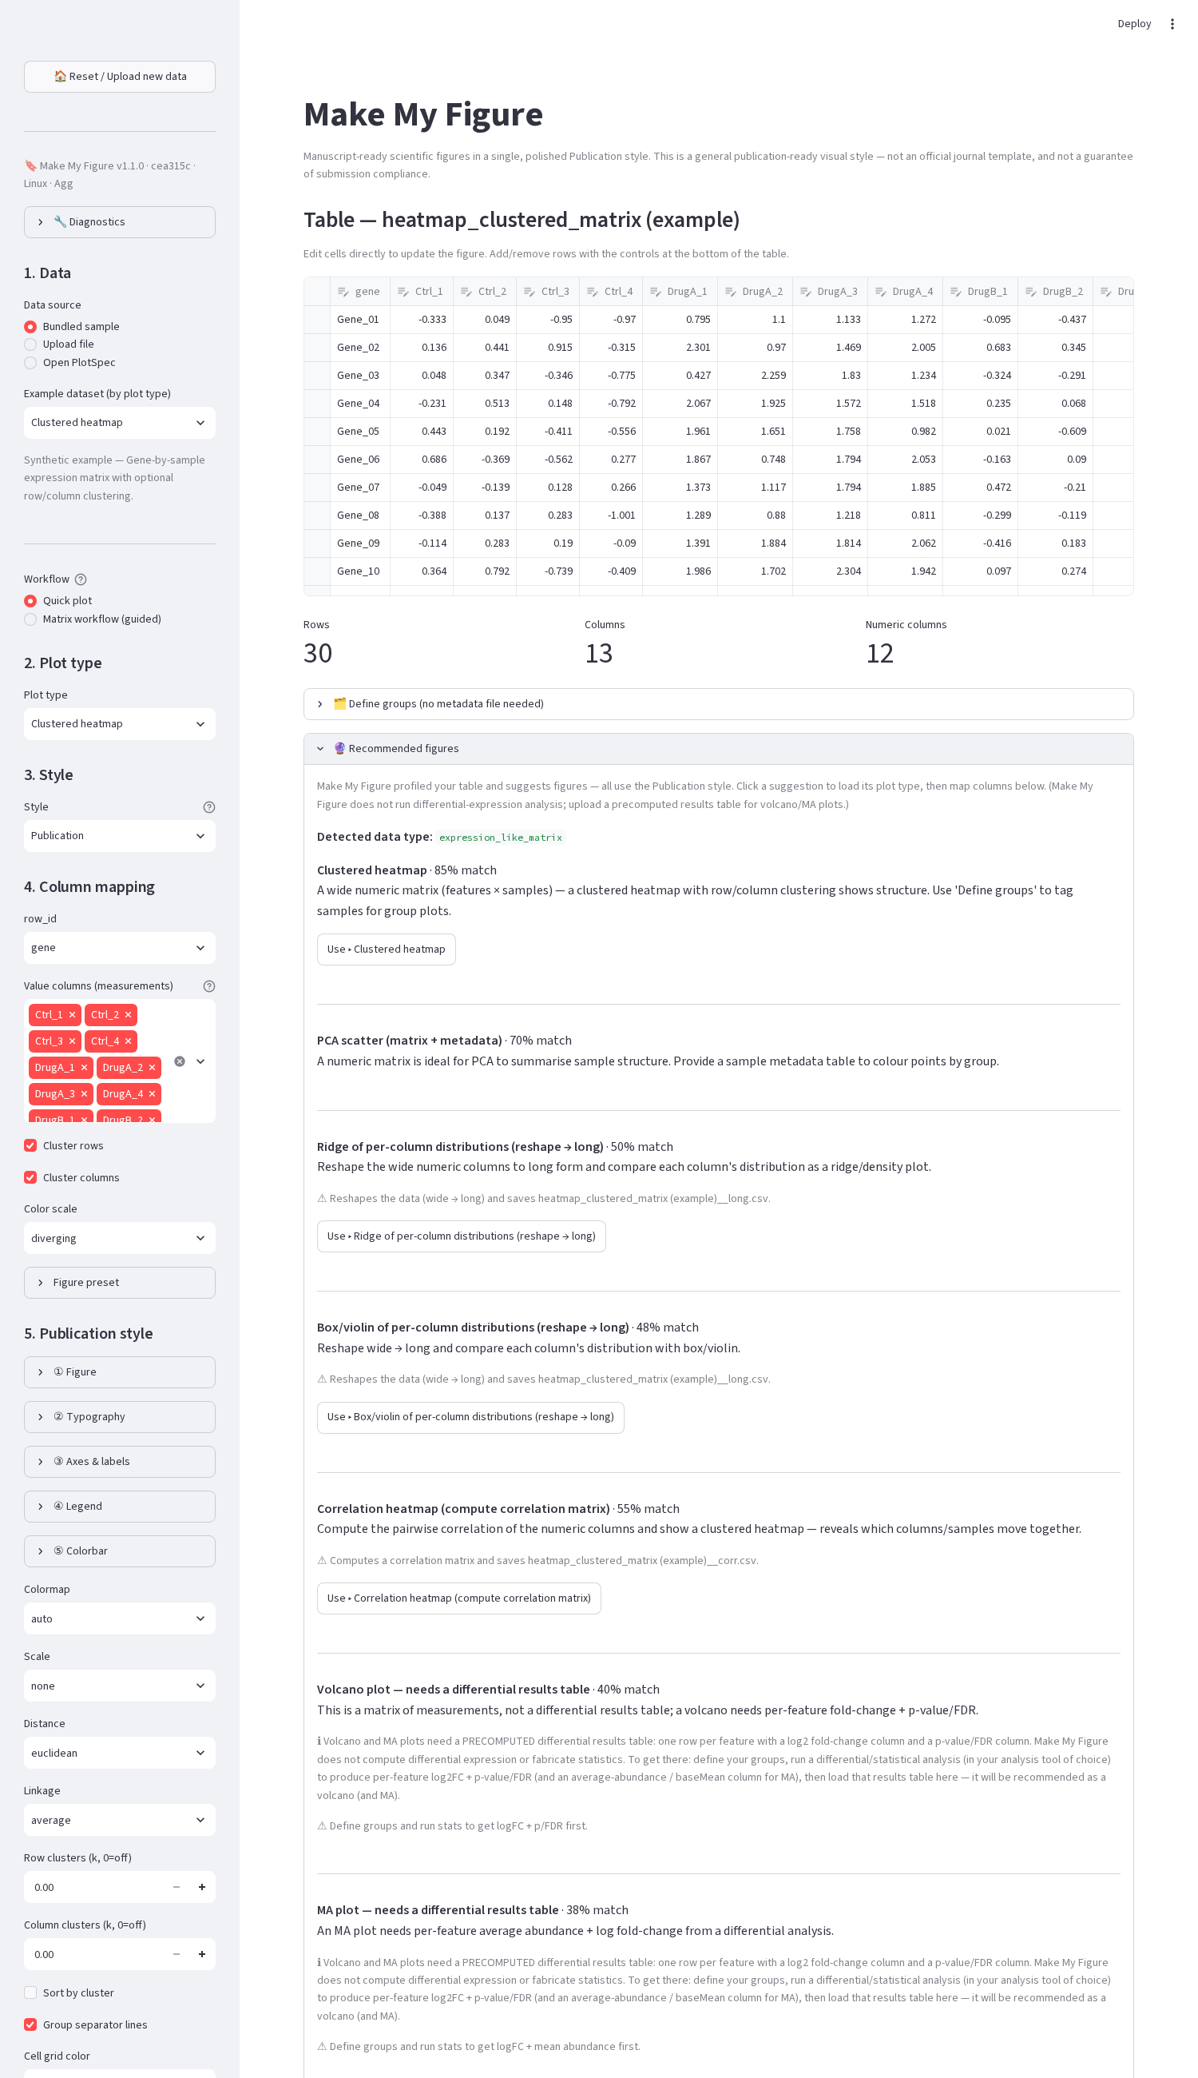
Browser: the Recommended figures expander for a matrix.

25. Typical recommendations (from the bundled examples, this commit)
Table shape (schema) | Suggested plots (score)
grouping column + numeric value (generic_long) | box/violin with points (0.72), ridge/density (0.62), bar with error bars (0.60), grouped bar (0.55)
logFC + p-value (+ FDR) per feature (precomputed_differential) | volcano (0.92); heatmap of the values (0.55)
feature × sample numeric matrix (expression_like_matrix) | clustered heatmap (0.85), PCA (0.70)
time + 0/1 event + group (survival) | Kaplan-Meier (0.88)
source/target(/weight) (network_edge_list) | network graph (0.80)
chromosome + position + p (gwas) | Manhattan (0.82), Q-Q (0.70)
subject × two conditions (paired) | paired slopegraph (0.75), box/violin (0.70)
term + enrichment + count (enrichment) | enrichment dot plot (0.80)
An embedding table (UMAP/t-SNE coordinates) is recognised as a numeric matrix and gets matrix suggestions; choose UMAP / t-SNE embedding scatter yourself.

26. Limitations
Scores are rule-based heuristics about the table’s shape, not probabilities and not a judgement of scientific appropriateness. A wrong column-name convention lowers a score; an unusual but valid design may get no recommendation. Treat every suggestion as a starting point to confirm in Map columns.

Part VII — Matrix Workflow
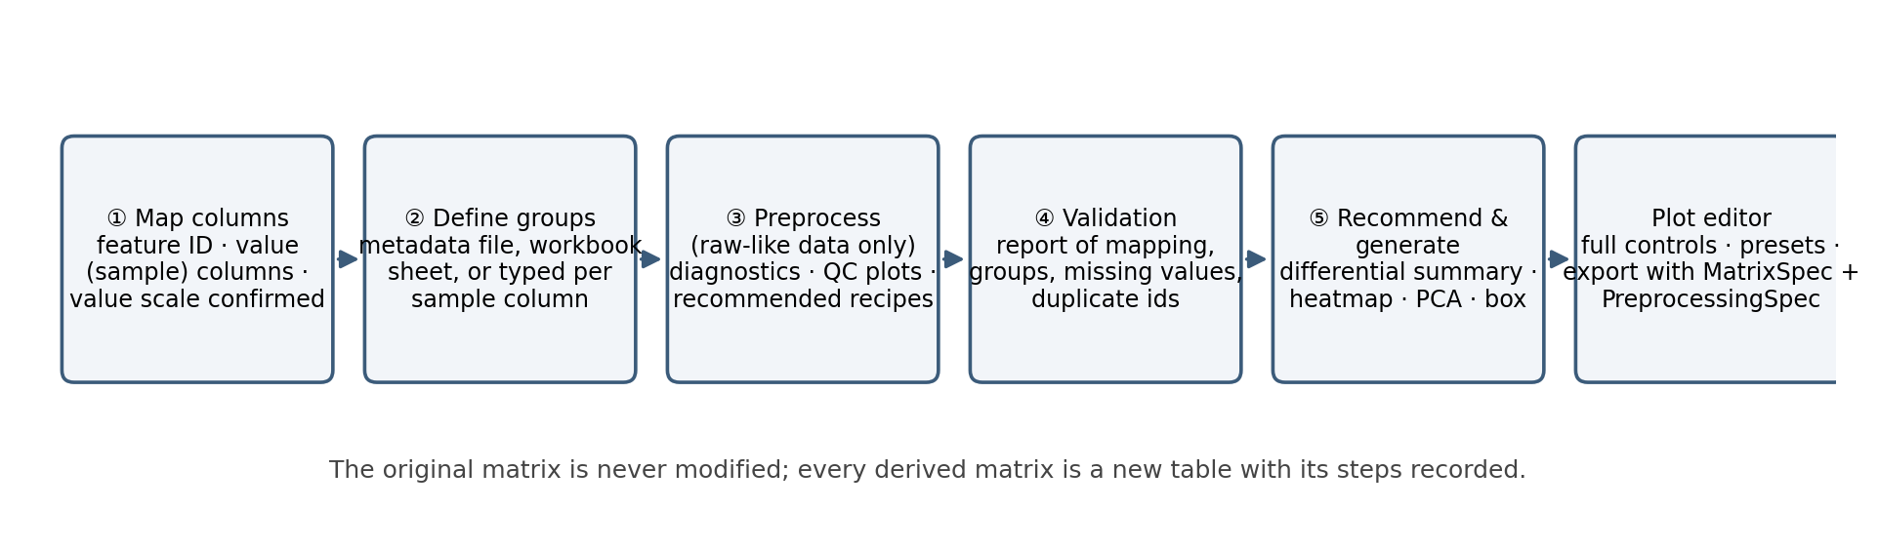
The Matrix Workflow: five confirmed steps from mapping to the plot editor; the original matrix is never modified.

27. Opening it
Load the matrix (any file or worksheet), then 🧮 Matrix workflow… (desktop) or Workflow → Matrix workflow (guided) (browser). The desktop dialog has five tabs; later tabs stay disabled until the earlier step is confirmed. The browser shows the same steps as expanders.
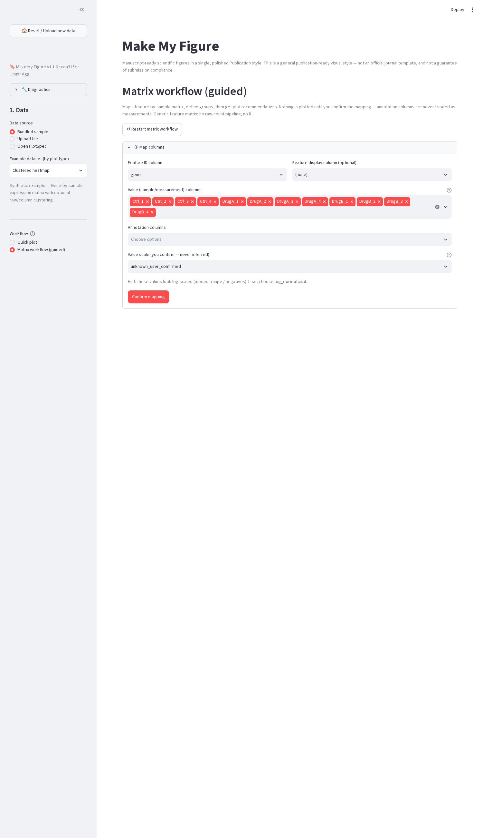
Browser: Matrix workflow (guided), step ① Map columns — feature ID, optional display column, value columns, annotation columns, and the value scale with a hint.

28. ① Map columns
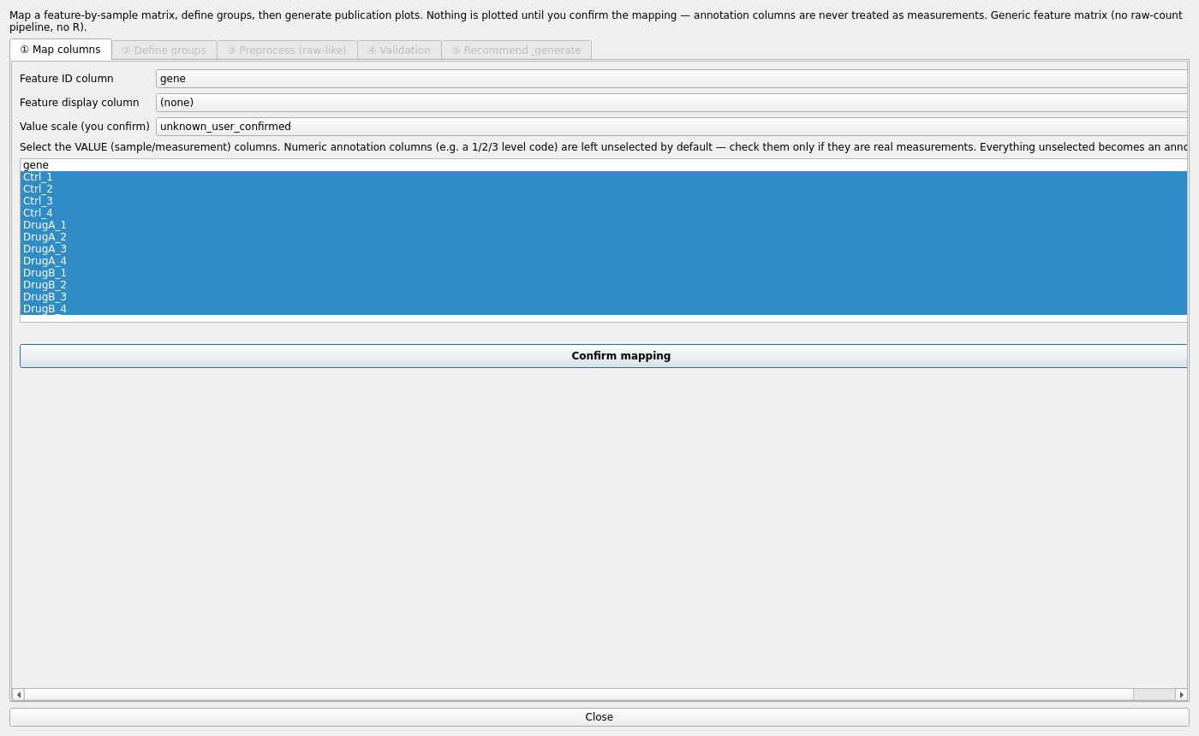
Step ①: feature ID column, feature display column, value scale, and the value-column list.
- Feature ID column — the identifier (gene, protein, feature).
- Feature display column — optional friendlier name for labels.
- Value scale (you confirm) — normalized, log_normalized, raw_numeric, or unknown_user_confirmed. Preprocessing is offered only for raw-like data.
- Value columns — every measurement column; numeric annotation columns (e.g. a 1/2/3 level code) are unselected by default and stay out unless you tick them.
- The browser adds an explicit Annotation columns selector and shows a hint when the values look log-scaled (“If so, choose log_normalized”) — a hint, never a decision.
- Confirm mapping writes the MatrixSpec (source file/sheet, feature column, annotation columns, value columns, excluded columns, value type, missing-value and duplicate-feature policies, confirmation flag).

29. ② Define groups
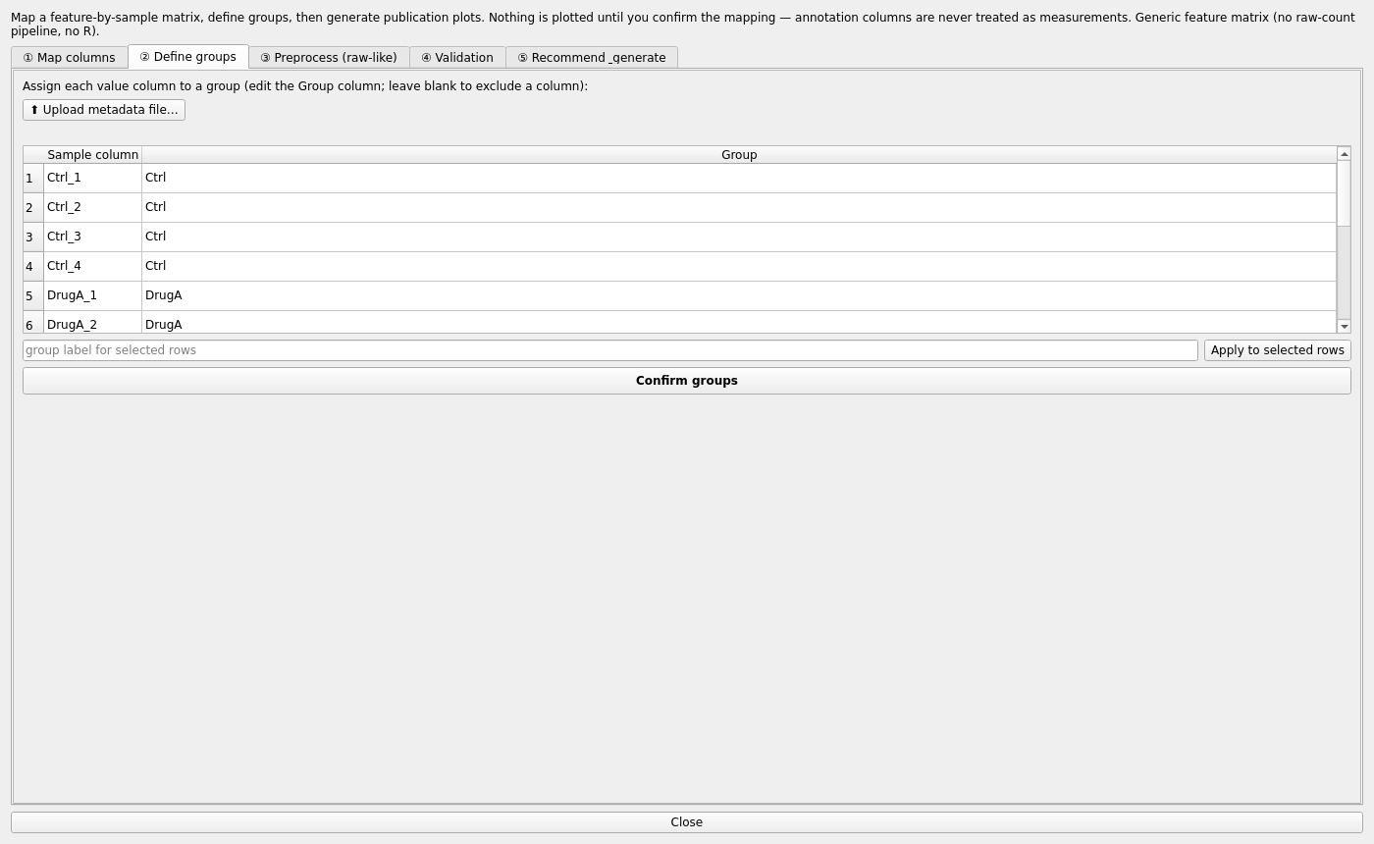
Step ②: one group per sample column, typed or uploaded.
Three sources, in order of preference: ⬆ Upload metadata file… (CSV/TSV/XLSX with a sample column and a group column), a metadata worksheet of the same workbook (browser), or the in-app table — type a group per sample column, or select rows and Apply to selected rows; leave a cell blank to exclude that column. Confirm groups writes the SampleMetadataSpec and reports sample matching (columns in the matrix without metadata and vice versa).

30. ③ Preprocess (raw-like)
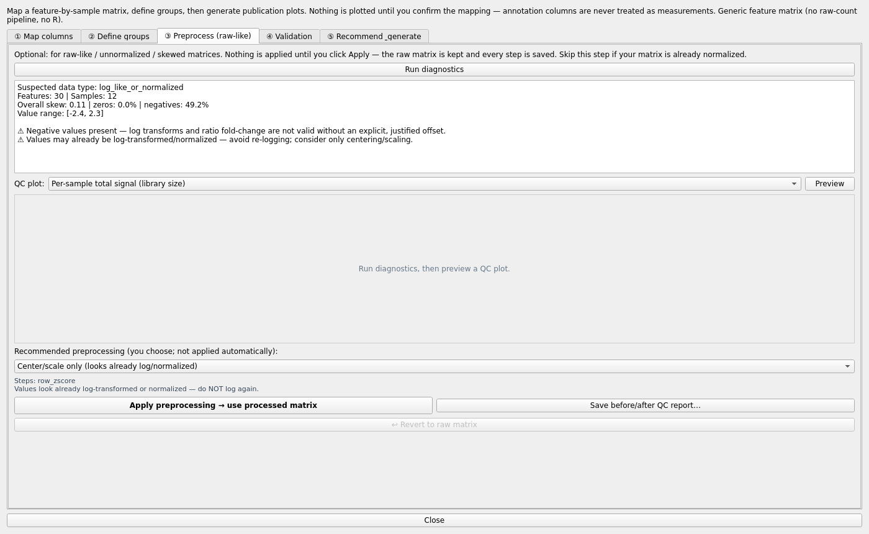
Step ③: Run diagnostics, a QC-plot preview, and the recommended preprocessing recipes (you choose; nothing is applied automatically).
Optional, for raw-like / unnormalised / skewed matrices; skip it if the matrix is already normalised.
- Run diagnostics — reports the suspected data type (e.g. log_like_or_normalized), features × samples, overall skew, zero and negative fractions, the value range, and warnings such as “Negative values present — log transforms and ratio fold-change are not valid without an explicit, justified offset” or “Values may already be log-transformed/normalized — avoid re-logging”.
- QC plot — choose one of the nine QC plots (Part VIII §36) and Preview it for the current matrix.
- Recommended preprocessing (you choose; not applied automatically) — a list of recipes derived from the diagnostics, each a short chain of steps with its reasoning and assumptions:
Recipe | Steps | Offered when
Center/scale only (looks already log/normalized) | row_zscore | values look log-like / normalised — do not log again
Total-sum normalize → log2 → z-score | total_sum (scale 1e6) → log2 (pseudocount 1) → row_zscore | sample totals differ, values non-negative/skewed
Median-scale → log2 | median_scale → log2 (pseudocount 1) | robust alternative when a few features dominate totals
log2(x + 1) → z-score | log2 (pseudocount 1) → row_zscore | strong right skew, non-negative values
arcsinh (intensity-like) → z-score | arcsinh (cofactor 5) → row_zscore | intensity-like skew with zeros
Filter sparse features → log2 | filter (max zero fraction 0.5, drop constant) → log2 | high zero fraction
Z-score for visualization only (negatives present) | row_zscore | negative values — no log, no ratio fold change
Internal-standard normalization | internal_standard_features / _columns | you have internal-standard features or columns
The selected recipe’s steps and note are shown under the list. Apply preprocessing → use processed matrix applies them; the derived matrix becomes the working table and every step is recorded as a PreprocessingStep in the PreprocessingSpec (method, parameters, input/output matrix ids, QC before/after, confirmation). Save before/after QC report… writes a contact sheet (PDF + PNG) and one vector file per QC plot. ↩ Revert to raw matrix returns to the source.

31. ④ Validation
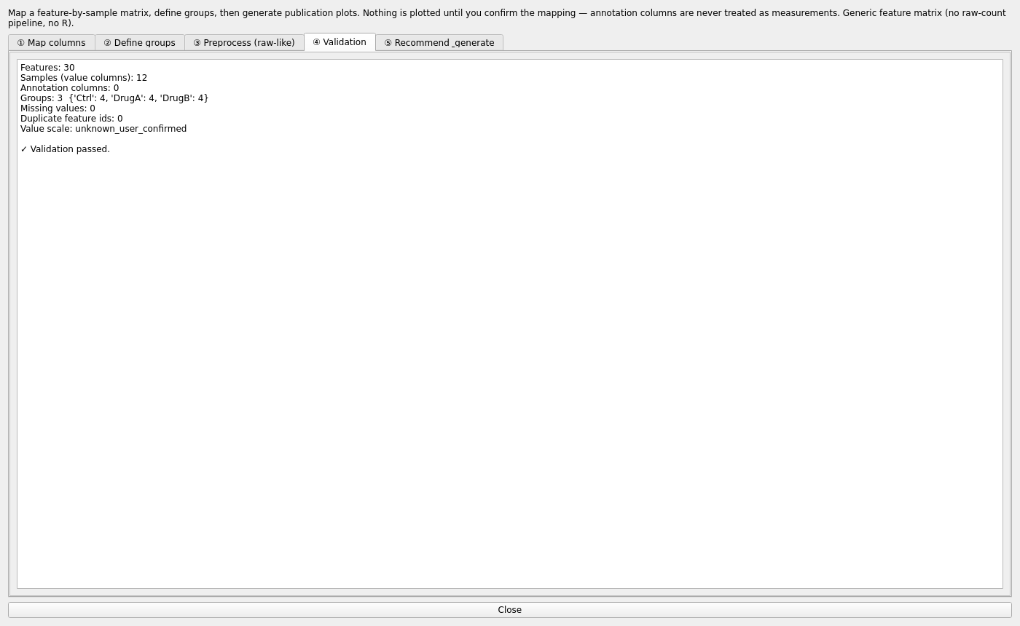
Step ④: the validation report for the confirmed mapping and groups.
A read-only report of the confirmed MatrixSpec and metadata: features, samples (value columns), annotation columns, groups with their sizes, missing values, duplicate feature ids and the declared value scale, followed by ERRORS, Warnings (⚠) — for example sample columns without a group or non-numeric value columns — or ✓ Validation passed.

32. ⑤ Recommend & generate
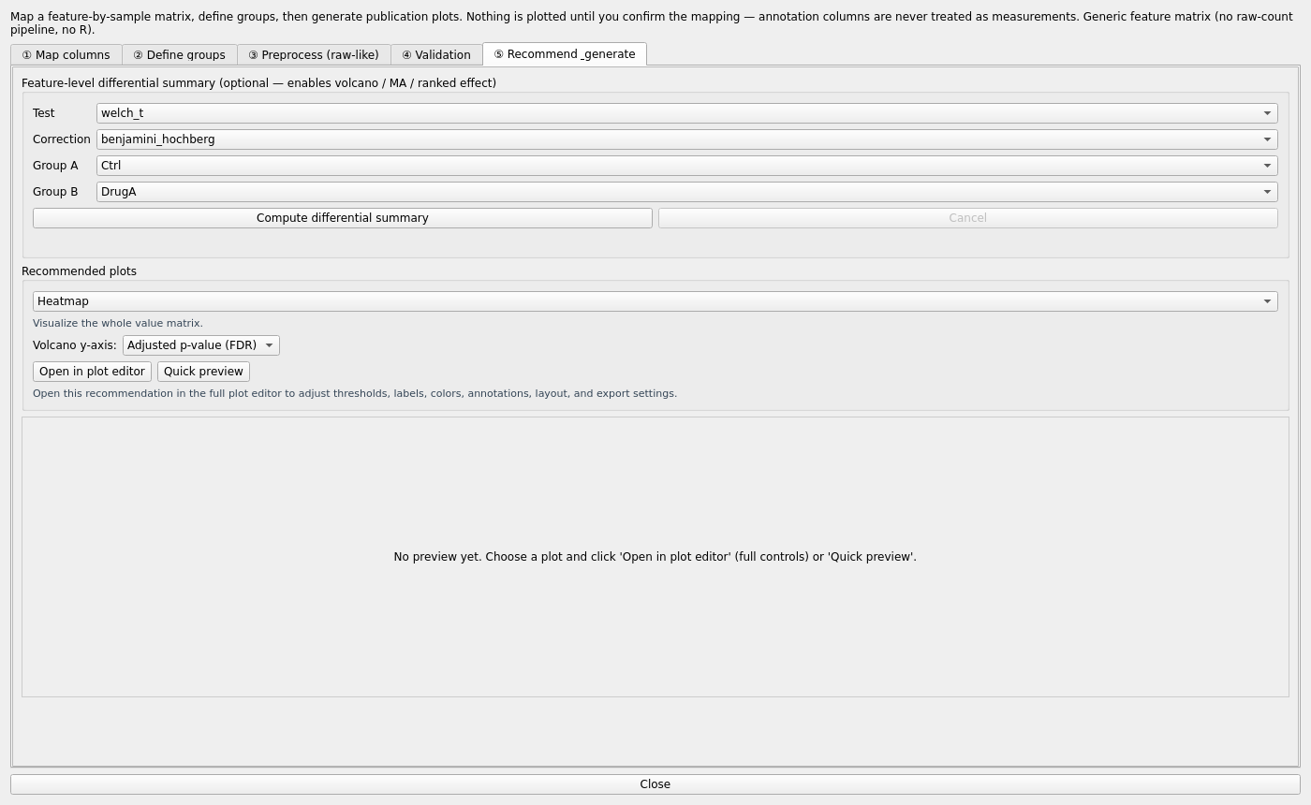
Step ⑤: the optional feature-level differential summary, the recommended plots, and the preview / hand-off buttons.
- Feature-level differential summary (optional — enables volcano / MA / ranked effect): choose Test (Welch’s t, Student’s t, Mann-Whitney, paired t, Wilcoxon; ANOVA or Kruskal-Wallis for more groups), Correction (Benjamini-Hochberg, Bonferroni, Holm), Group A and Group B, then Compute differential summary (runs in the background; Cancel is available). The result is a per-feature table (log2 fold change, p, adjusted p, effect size) that can be saved and that enables volcano and MA recommendations. It is a screen, not DESeq2/edgeR/limma (Part VIII §36).
- Recommended plots: a dropdown (Heatmap, PCA, box/violin of selected features, volcano/MA when a summary exists) with a one-line rationale; Volcano y-axis → Adjusted p-value (FDR) or Raw p-value.
- Open in plot editor hands the (processed) table, mapping, metadata and provenance to the ordinary editor with full controls; Quick preview renders in the dialog.

33. Provenance
The exported PlotSpec of a figure generated from the workflow carries the workbook/sheet, the MatrixSpec, the PreprocessingSpec and the metadata assignment under source, and the statistics block echoes it, so the figure is traceable to the matrix and the steps that produced it.

Part VIII — Preprocessing and QC

34. Principles
No preprocessing is applied silently. A step is applied only when you add it, and the original matrix is preserved; the output is a new matrix with a new id. Each method below is what its name says; parameters (pseudocount, percentile, reference features…) appear as fields on the step when the method takes any. No method is universally correct — the normalisation catalogue lists assumptions and risks for that reason.

35. Implemented methods (available_methods())
Method | What it does | Typical use | Caveats
log2, log10, ln, log | logarithm of the values | compress dynamic range of positive intensities | needs positive values (pseudocount parameter)
sqrt, arcsinh | variance-stabilising transforms | counts with zeros (arcsinh tolerates 0) | changes scale, not just spread
cpm | counts per million per sample; optional log2-CPM with a prior count | count-like data | library-size differences only
total_sum | divide by each sample’s total, rescale | comparable total signal per sample | distorted by dominant features
median_scale | scale samples so medians match | robust size correction | breaks if most features change
upper_quartile | scale by the 75th percentile | data with a few dominant features | sensitive to sparsity
quantile | force identical distributions | technical distribution differences | erases real global shifts
tmm | TMM-CPM: counts per million using TMM-adjusted effective library sizes (optionally log2) | non-negative count-like data | scaling only; not differential inference
voom | limma-style log-CPM transform of the matrix | preparing counts for linear-model-style summaries | transform only; no DE fitting
internal_standard_features, internal_standard_columns, control_features, reference_sample | normalise to spike-ins / stable features / control set / a reference sample | targeted assays | an unstable standard propagates error
row_zscore, column_zscore, zscore, global_zscore, center, standard_scale, robust_scale | centring/scaling by feature, sample or globally | heatmap contrast, PCA input | loses absolute magnitude
filter, winsorize, impute | drop low features, clip extremes, fill missing (missing-value policies: keep, drop features, zero, mean impute) | before scaling | alters n or values — recorded
The normalisation recommendation catalogue (total sum, median scale, upper quartile, quantile, row z-score, internal-standard features) states for each: assumptions, risks, suitable/unsuitable data, output scale. Recommendations are advisory and require confirmation.

36. QC plots and the differential summary
QC plots: per-sample total signal, per-sample median, per-sample distribution (box), value density, zero fraction, missing fraction, sample-correlation heatmap, PCA of samples, mean–variance trend. All are ordinary figures (exportable) and appear in the before/after report.
Differential summary (two groups: Welch’s t, Student’s t, Mann-Whitney, paired t, Wilcoxon; more groups: ANOVA, Kruskal-Wallis; correction: Benjamini-Hochberg, Bonferroni, Holm) yields per-feature log2 fold change, p, adjusted p and effect size for a normalised matrix. It is a screen, not a count model — it is not DESeq2, edgeR or limma, and the app labels it so.

Part IX — Statistics
Note: Make My Figure performs calculations; the researcher remains responsible for choosing a scientifically appropriate method. Every method is pinned against SciPy/statsmodels in the test suite; the method sentence names the versions used.

37. Where statistics live
Desktop 6. Statistics (a checkable group) and browser Statistical tests & annotations: Test (Auto-suggest or one of the 18), Comparison, Group / Subgroup / Subject columns, Control group, Correction, Annotation shows, Annotation placement, Custom template, effect-size toggle, hide non-significant, post-hoc after omnibus, p-value decimals, annotation font. Run statistics fills the results table (comparison, test, p, adjusted p, effect, n) and the method sentence; Export stats table, Export method report, Copy method sentence. Results are written to name.stats_spec.json on export.
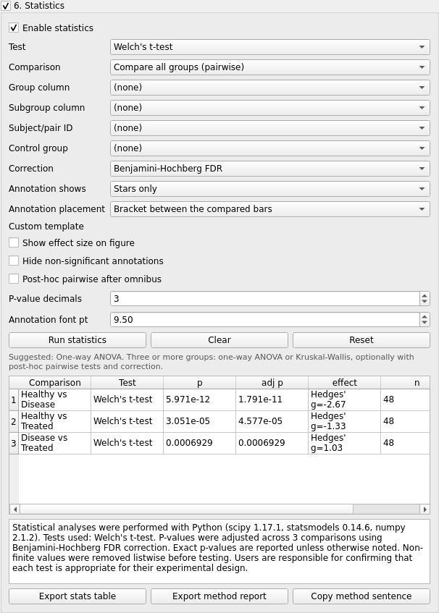
Statistics panel with results for the box/violin example.
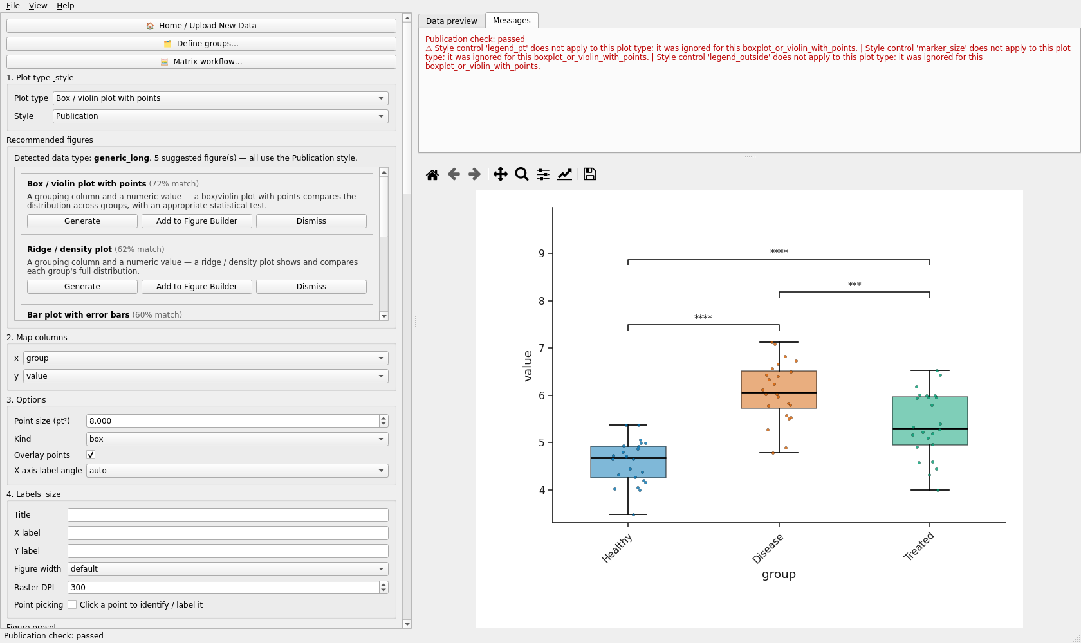
The box/violin figure after Run statistics: brackets with stars from the stored results.
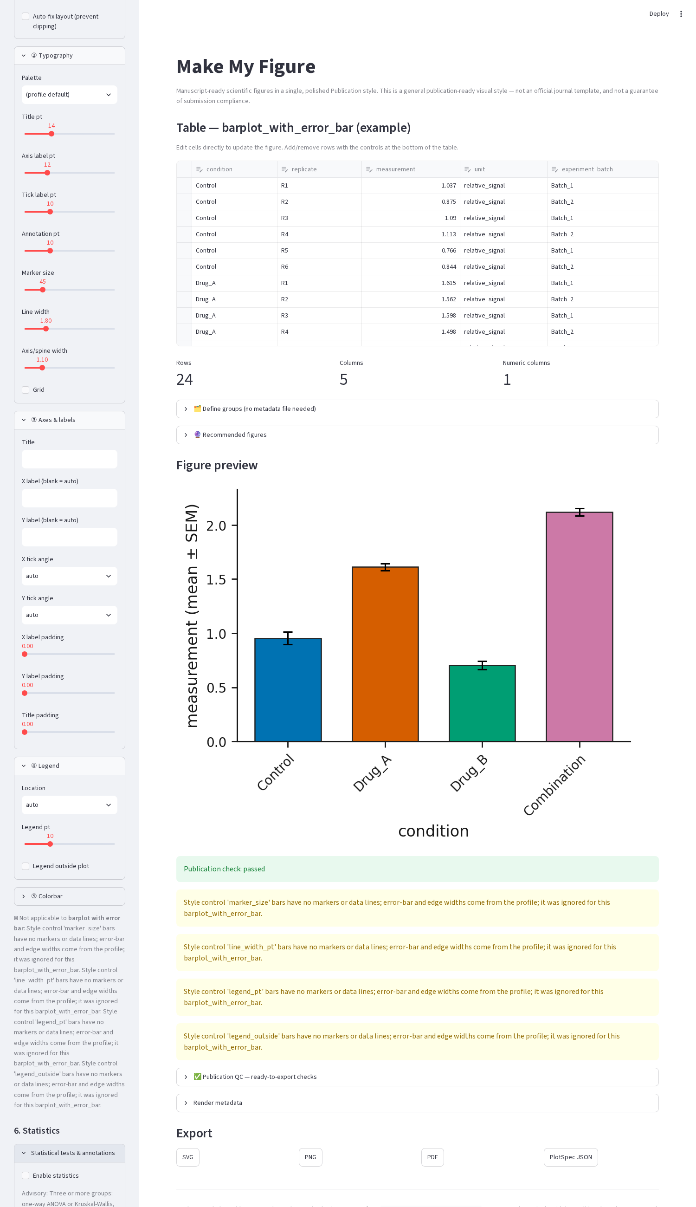
Browser: the Statistical tests & annotations expander.

38. Methods
Two-group (unpaired)
Method | Input | Assumptions | Output | Effect size
Student’s t-test | numeric value, two groups | normality, equal variances | t, df, p, CI of the mean difference | Cohen’s d
Welch’s t-test | as above | normality; variances may differ | t, df (Welch), p, CI | Hedges’ g
Mann-Whitney U | numeric/ordinal, two groups | independent samples | U, p | rank-biserial / Cliff’s delta
Two-group (paired) — require Subject/pair ID
Method | Assumptions | Output | Effect size
Paired t-test | normal paired differences | t, df, p, CI of mean difference | Cohen’s d_z
Wilcoxon signed-rank | symmetric differences | W, p | rank-biserial
Multi-group (omnibus) — three or more groups (two-way / repeated-measures from two)
Method | Design | Output | Effect size
One-way ANOVA | one factor | F, df, p | eta-squared
Two-way ANOVA | group × subgroup | F per term, p | partial eta-squared (approx.)
Repeated-measures ANOVA | subject × condition | F, p | partial eta-squared (approx.)
Kruskal-Wallis | one factor, non-parametric | H, p | epsilon-squared
Dunn’s test (post-hoc) | after Kruskal-Wallis | pairwise z, p (corrected) | —
After an omnibus test, tick Post-hoc pairwise after omnibus to add pairwise comparisons with correction.
Categorical — two categorical columns (stacked composition, oncoprint)
Method | Output | Effect size
Chi-square test | chi², df, p (Yates’ continuity correction on 2 × 2 tables) | Cramér’s V
Fisher’s exact test (2 × 2) | p | odds ratio
Correlation / regression — scatter plot
Method | Output | Effect size
Pearson correlation | r, p, CI (Fisher z) | r / R²
Spearman correlation | rho, p | rho
Linear regression | slope, intercept, R², p | R² (fit statistics box on the plot)
GLM regression (multi-predictor) | coefficients, p per term | —
Survival — Kaplan-Meier (subject-level input only)
Method | Output | Effect size
Log-rank test | chi², p | —
Cox proportional hazards | HR, CI, p | hazard ratio
A log-rank test cannot be computed from a precomputed curve (no numbers at risk); the app refuses with a message rather than inventing one.

39. Multiple testing
Corrections apply across the family of pairwise comparisons in one run: Benjamini-Hochberg FDR, Bonferroni, Holm-Bonferroni, or None. Both raw and adjusted p are stored and either can be shown.

40. Annotation on figures
Supported on: bar plot, grouped bar plot (within-x brackets), box/violin (brackets or above-bar), scatter (fit-statistics box), Kaplan-Meier and stacked composition (corner panel). Not supported on the line/time-course plot and other types. Content modes: stars, p, adjusted p, p + stars, statistic, effect size, p + statistic, full, flags, or a custom template with tokens such as {p}, {p_adj}, {stars} and {stat_symbol} (the Custom template field lists the tokens available for the chosen test). Placement: bracket between compared categories (auto-stacked) or above each bar (comparisons against a control; the control bar stays unmarked). Star thresholds: * p < 0.05, ** p < 0.01, *** p < 0.001, **** p < 0.0001; n.s. optional. Hiding a value on the figure never removes it from the exported StatsSpec.

Part X — Plot catalogue
The 39 plot types below are the complete registry on this commit, enumerated from code (plots/registry.py) — not a historical list. Each figure was rendered from its bundled synthetic example with Publication defaults. Colour and control facts come from the same capability scan that the test suite enforces, so a control listed here is one the renderer actually reads.

Bar plot with error bars
Registry key: barplot_with_error_bar
Purpose: Compare a mean (or median) per category with an error bar.
When to use: few categories, replicate measurements; consider a box or strip plot when you want to show every point
Required / optional input: one table with the roles below; the bundled example has columns condition, replicate, measurement, unit, experiment_batch.
Column mapping: x, y, color; example mapping {"x": "condition", "y": "measurement", "color": "condition"}.
Statistics supported: yes — pairwise brackets or above-bar labels.
Colour controls: Publication palette (publication / colorblind_safe / high_contrast / grayscale).
Annotation controls: manual annotation layer via PlotSpec; statistical annotation (stars / p / effect).
Axis controls: title, x/y labels, tick angles, label/title padding, margins (layout engine).
Legend / colorbar controls: no legend drawn.
Plot-specific controls (visual, carried in a style preset): error — Error bar, x_tick_rotation — X-axis label angle.
Analytical / data-dependent options (full preset only): none.
Recommended export: SVG or PDF for vector; PNG/TIFF at 300–600 dpi for raster.
Figure preset support: style and full presets (verified in the registry-wide preset QC).
Example data: examples/by_plot_type/bar_error/ (synthetic).
Known limitations: none specific beyond the general limitations in Part XXV.
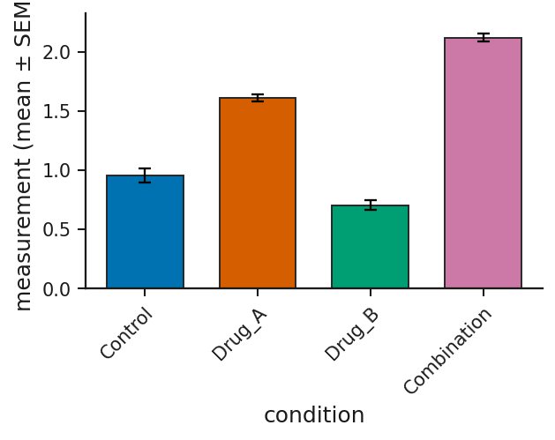
Bar plot with error bars: rendered from the bundled synthetic example with Publication defaults.

Grouped bar plot with error bars
Registry key: grouped_barplot_with_error_bar
Purpose: Compare means across categories split by a second factor.
When to use: two crossed factors with replicates
Required / optional input: one table with the roles below; the bundled example has columns genotype, treatment, replicate, expression, gene, unit.
Column mapping: x, group, y; example mapping {"x": "genotype", "group": "treatment", "y": "expression"}.
Statistics supported: yes — comparisons within each x category.
Colour controls: Publication palette (publication / colorblind_safe / high_contrast / grayscale).
Annotation controls: manual annotation layer via PlotSpec; statistical annotation (stars / p / effect).
Axis controls: title, x/y labels, tick angles, label/title padding, margins (layout engine).
Legend / colorbar controls: legend location (inside/outside), legend size.
Plot-specific controls (visual, carried in a style preset): error — Error bar, x_tick_rotation — X-axis label angle.
Analytical / data-dependent options (full preset only): none.
Recommended export: SVG or PDF for vector; PNG/TIFF at 300–600 dpi for raster.
Figure preset support: style and full presets (verified in the registry-wide preset QC).
Example data: examples/by_plot_type/grouped_bar/ (synthetic).
Known limitations: none specific beyond the general limitations in Part XXV.
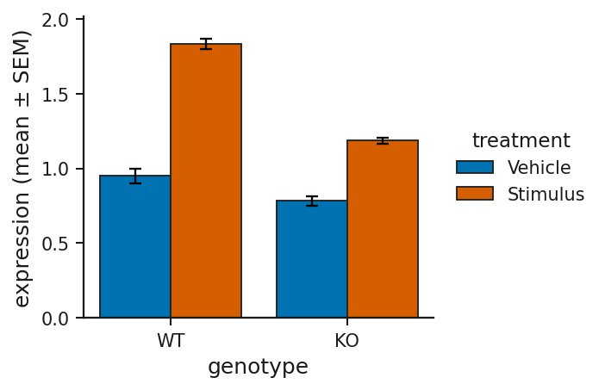
Grouped bar plot with error bars: rendered from the bundled synthetic example with Publication defaults.

Clustered heatmap
Registry key: heatmap_clustered_matrix
Purpose: Show a feature × sample matrix as colour, optionally clustered on both axes.
When to use: expression, intensity, or any normalised matrix; z-score rows for pattern contrast
Required / optional input: one table with the roles below; the bundled example has columns gene, Ctrl_1, Ctrl_2, Ctrl_3, Ctrl_4, DrugA_1, DrugA_2, DrugA_3 ….
Column mapping: row_id; example mapping {"row_id": "gene"}.
Statistics supported: no on-figure statistical annotation (the Statistics panel still runs for the mapped columns where a test applies).
Colour controls: Publication palette (publication / colorblind_safe / high_contrast / grayscale); continuous colormap (sequential/diverging from the palette; colormap option where present); plot options: color_scale, colormap, cell_border_color, group_separator_color, colorbar_location, colorbar_pad, colorbar_shrink.
Annotation controls: manual annotation layer via PlotSpec.
Axis controls: title, x/y labels, tick angles, label/title padding, margins (layout engine).
Legend / colorbar controls: legend location (inside/outside), legend size; colorbar location / pad / size.
Plot-specific controls (visual, carried in a style preset): color_scale — Color scale, colormap — Colormap, y_label_rotation — Y-label angle, group_separators — Group separator lines, cell_border_color — Cell grid color, cell_border_width — Cell grid width (0 = off), group_separator_color — Group separator color, group_separator_width — Group separator width, colorbar_location — Colorbar location, colorbar_pad — Colorbar pad, colorbar_shrink — Colorbar size, row_label_fontsize — Row label font (0=auto), col_label_fontsize — Column label font (0=auto), y_label_pad — Y-axis label padding.
Analytical / data-dependent options (full preset only): cluster_rows — Cluster rows, cluster_columns — Cluster columns, scale — Scale, distance_metric — Distance, linkage_method — Linkage, cluster_k_rows — Row clusters (k, 0=off), cluster_k_columns — Column clusters (k, 0=off), sort_by_cluster — Sort by cluster, max_features — Max features (rows) for clustering.
Recommended export: SVG or PDF for vector; PNG/TIFF at 300–600 dpi for raster. Heat-map cells and dense point clouds are still vector in SVG/PDF but large; PNG is often the practical choice.
Figure preset support: style and full presets (verified in the registry-wide preset QC).
Example data: examples/by_plot_type/heatmap/ (synthetic).
Known limitations: Rows are capped at max_features (default 2 000, selected by variance) for responsiveness..
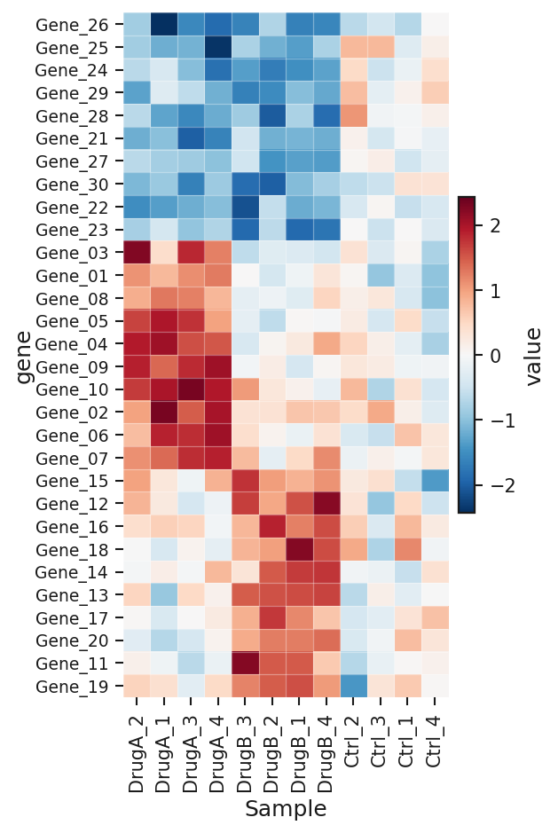
Clustered heatmap: rendered from the bundled synthetic example with Publication defaults.

Volcano plot
Registry key: volcano_plot
Purpose: Effect size against significance for every feature of a differential-expression table.
When to use: any precomputed DE result (edgeR, limma, DESeq2, proteomics)
Required / optional input: one table with the roles below; the bundled example has columns gene, log2_fold_change, p_value, adjusted_p_value, gene_class, label.
Column mapping: x, p, label, id_col; example mapping {"x": "log2_fold_change", "p": "adjusted_p_value", "label": "label"}.
Statistics supported: no on-figure statistical annotation (the Statistics panel still runs for the mapped columns where a test applies).
Colour controls: plot options: color_up, color_down, color_ns.
Annotation controls: point picking, label selection, duplicate-label policy.
Axis controls: title, x/y labels, tick angles, label/title padding, margins (layout engine), marker size.
Legend / colorbar controls: legend location (inside/outside), legend size.
Plot-specific controls (visual, carried in a style preset): show_legend — Show Up / Down / n.s. legend, color_up — Up-regulated colour, color_down — Down-regulated colour, color_ns — Not-significant colour, annotate — Show labels, show_arrows — Arrows to points, label_box — Label background box, duplicate_label_policy — Duplicate labels, duplicate_label_representative_rule — Representative point, duplicate_label_show_count — Append (n=…) count.
Analytical / data-dependent options (full preset only): lfc_cutoff — log2FC cutoff, p_cutoff — p-value / FDR cutoff, use_fdr — P column is FDR/adjusted (y-axis = −log10 FDR), label_mode — Label mode, top_n — Top N labels, top_n_up — Top N up, top_n_down — Top N down, label_by — Label by.
Recommended export: SVG or PDF for vector; PNG/TIFF at 300–600 dpi for raster.
Figure preset support: style and full presets (verified in the registry-wide preset QC).
Example data: examples/by_plot_type/volcano/ (synthetic).
Known limitations: The palette does not apply — points are coloured by significance class (up / down / not significant options). Thresholds travel only in a full preset..
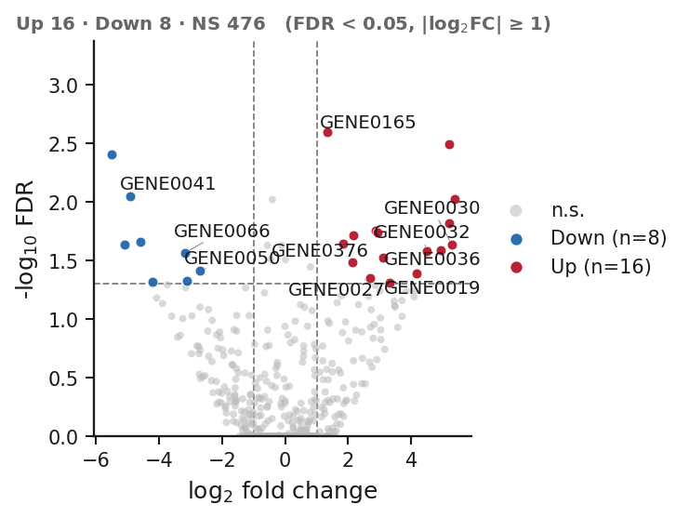
Volcano plot: rendered from the bundled synthetic example with Publication defaults.

Scatter plot
Registry key: scatterplot_with_regression
Purpose: Two numeric variables per observation, optionally coloured by group, with a fitted line and its statistics.
When to use: relationships, method comparison, dose vs response before fitting a model
Required / optional input: one table with the roles below; the bundled example has columns sample_id, x_marker, y_response, group, label.
Column mapping: x, y, color, label; example mapping {"x": "x_marker", "y": "y_response", "color": "group"}.
Statistics supported: yes — correlation / regression statistics box.
Colour controls: Publication palette (publication / colorblind_safe / high_contrast / grayscale).
Annotation controls: point picking, label selection, duplicate-label policy; statistical annotation (stars / p / effect).
Axis controls: title, x/y labels, tick angles, label/title padding, margins (layout engine), marker size, line width.
Legend / colorbar controls: legend location (inside/outside), legend size.
Plot-specific controls (visual, carried in a style preset): show_fit_stats — Show regression stats box, show_slope — • slope, show_r2 — • R², show_p — • p-value, show_r — • Pearson r, show_intercept — • intercept, show_n — • n, show_equation — • full equation (y = a·x + b), fit_stats_loc — Stats box location.
Analytical / data-dependent options (full preset only): fit_line — Fit regression line.
Recommended export: SVG or PDF for vector; PNG/TIFF at 300–600 dpi for raster.
Figure preset support: style and full presets (verified in the registry-wide preset QC).
Example data: examples/by_plot_type/scatter/ (synthetic).
Known limitations: none specific beyond the general limitations in Part XXV.
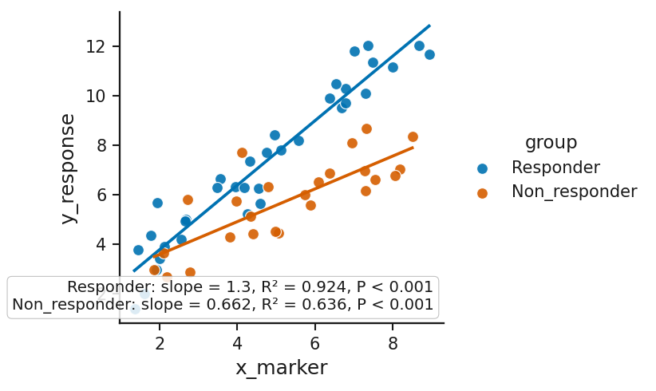
Scatter plot: rendered from the bundled synthetic example with Publication defaults.

Box / violin plot with points
Registry key: boxplot_or_violin_with_points
Purpose: Distribution per category as a box or violin, with the individual points.
When to use: replicate measurements across conditions; the default recommendation for grouped observations
Required / optional input: one table with the roles below; the bundled example has columns sample_id, group, value, batch, sex.
Column mapping: x, y; example mapping {"x": "group", "y": "value"}.
Statistics supported: yes — pairwise brackets or above-bar labels.
Colour controls: Publication palette (publication / colorblind_safe / high_contrast / grayscale).
Annotation controls: manual annotation layer via PlotSpec; statistical annotation (stars / p / effect).
Axis controls: title, x/y labels, tick angles, label/title padding, margins (layout engine), line width.
Legend / colorbar controls: no legend drawn.
Plot-specific controls (visual, carried in a style preset): point_size — Point size (pt²), kind — Kind, points — Overlay points, x_tick_rotation — X-axis label angle.
Analytical / data-dependent options (full preset only): none.
Recommended export: SVG or PDF for vector; PNG/TIFF at 300–600 dpi for raster.
Figure preset support: style and full presets (verified in the registry-wide preset QC).
Example data: examples/by_plot_type/box_violin/ (synthetic).
Known limitations: none specific beyond the general limitations in Part XXV.
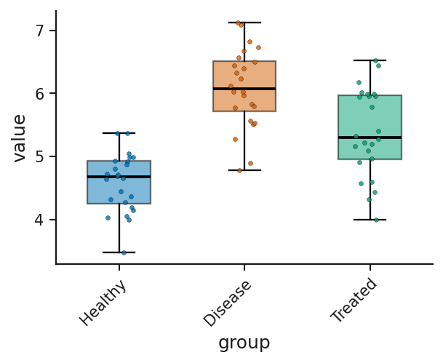
Box / violin plot with points: rendered from the bundled synthetic example with Publication defaults.

Line / time-course with error band
Registry key: lineplot_timecourse_with_error_band
Purpose: Mean over an ordered x (time, dose, contraction number) per series with an SEM/SD/CI band.
When to use: time courses, fatigue protocols, force–frequency curves
Required / optional input: one table with the roles below; the bundled example has columns time_hours, treatment, replicate, signal, unit.
Column mapping: x, y, color, style_by; example mapping {"x": "time_hours", "y": "signal", "color": "treatment"}.
Statistics supported: no on-figure statistical annotation (the Statistics panel still runs for the mapped columns where a test applies).
Colour controls: Publication palette (publication / colorblind_safe / high_contrast / grayscale).
Annotation controls: manual annotation layer via PlotSpec.
Axis controls: title, x/y labels, tick angles, label/title padding, margins (layout engine), line width.
Legend / colorbar controls: legend location (inside/outside), legend size.
Plot-specific controls (visual, carried in a style preset): error — Error band.
Analytical / data-dependent options (full preset only): none.
Recommended export: SVG or PDF for vector; PNG/TIFF at 300–600 dpi for raster.
Figure preset support: style and full presets (verified in the registry-wide preset QC).
Example data: examples/by_plot_type/line_timecourse/ (synthetic).
Known limitations: No statistical annotation on this plot type..
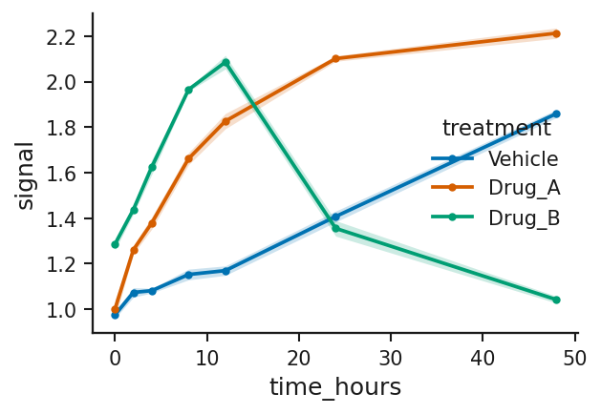
Line / time-course with error band: rendered from the bundled synthetic example with Publication defaults.

Ridge / density plot
Registry key: ridge_or_density_plot
Purpose: Smoothed density per group, stacked (ridgeline) or overlaid.
When to use: comparing distribution shapes across several groups
Required / optional input: one table with the roles below; the bundled example has columns cell_id, sample_id, condition, pseudotime, score.
Column mapping: x, group; example mapping {"x": "pseudotime", "group": "condition"}.
Statistics supported: no on-figure statistical annotation (the Statistics panel still runs for the mapped columns where a test applies).
Colour controls: Publication palette (publication / colorblind_safe / high_contrast / grayscale).
Annotation controls: manual annotation layer via PlotSpec.
Axis controls: title, x/y labels, tick angles, label/title padding, margins (layout engine), line width.
Legend / colorbar controls: legend location (inside/outside), legend size.
Plot-specific controls (visual, carried in a style preset): density_mode — Density mode, overlap — Ridge overlap.
Analytical / data-dependent options (full preset only): none.
Recommended export: SVG or PDF for vector; PNG/TIFF at 300–600 dpi for raster.
Figure preset support: style and full presets (verified in the registry-wide preset QC).
Example data: examples/by_plot_type/ridge/ (synthetic).
Known limitations: A kernel density estimate can merge two modes into one shoulder; use the histogram when shape matters..
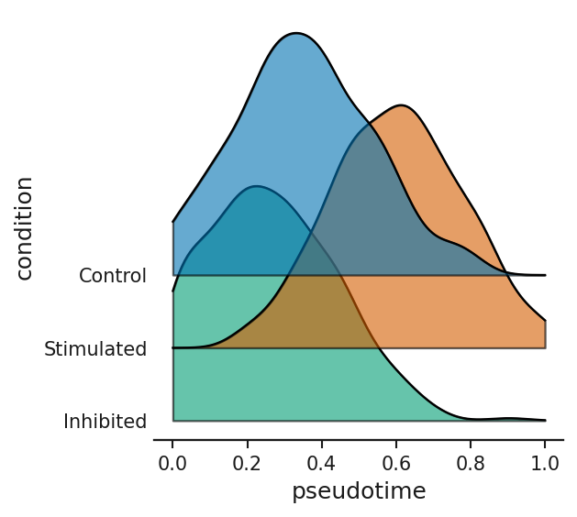
Ridge / density plot: rendered from the bundled synthetic example with Publication defaults.

Histogram (binned distribution)
Registry key: histogram_distribution
Purpose: Binned counts of one measurement, one panel per group or overlaid, bars and/or a frequency polygon.
When to use: distribution shape when modes, gaps and tails matter — bins never smooth
Required / optional input: one table with the roles below; the bundled example has columns cell_id, group, replicate, measurement.
Column mapping: x, group, value_columns (multi-select); example mapping {"x": "measurement", "group": "group"}.
Statistics supported: no on-figure statistical annotation (the Statistics panel still runs for the mapped columns where a test applies).
Colour controls: Publication palette (publication / colorblind_safe / high_contrast / grayscale).
Annotation controls: manual annotation layer via PlotSpec.
Axis controls: title, x/y labels, tick angles, label/title padding, margins (layout engine), marker size, line width.
Legend / colorbar controls: legend location (inside/outside), legend size.
Plot-specific controls (visual, carried in a style preset): panel_mode — Arrangement, draw_style — Draw as, normalize — Y axis shows, cumulative — Cumulative, show_mean — Mark the mean, show_median — Mark the median, bar_alpha — Fill opacity, log_y — Logarithmic Y axis, share_axes — Panels share both axes, x_tick_rotation — X-axis label angle.
Analytical / data-dependent options (full preset only): input_form — Input form, bins — Number of bins, bin_width — Bin width, x_min — X-axis minimum, x_max — X-axis maximum, y_min — Y-axis minimum, y_max — Y-axis maximum.
Recommended export: SVG or PDF for vector; PNG/TIFF at 300–600 dpi for raster.
Figure preset support: style and full presets (verified in the registry-wide preset QC).
Example data: examples/by_plot_type/histogram/ (synthetic).
Known limitations: Bins are shared across groups by design; an overlay of raw counts with unequal group sizes warns you to use percent..
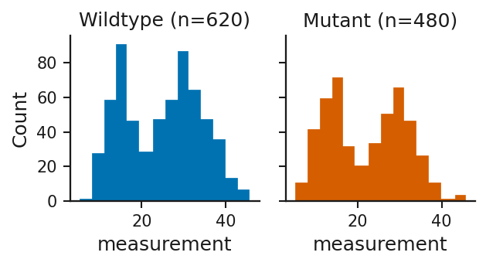
Histogram (binned distribution): rendered from the bundled synthetic example with Publication defaults.

Enrichment dot plot
Registry key: enrichment_dotplot
Purpose: Enriched terms ranked by enrichment, dot size = count, colour = significance.
When to use: GO / pathway enrichment results
Required / optional input: one table with the roles below; the bundled example has columns term, category, gene_ratio, gene_count, fdr, neg_log10_fdr.
Column mapping: y, x, size, color; example mapping {"y": "term", "x": "gene_ratio", "size": "gene_count", "color": "neg_log10_fdr"}.
Statistics supported: no on-figure statistical annotation (the Statistics panel still runs for the mapped columns where a test applies).
Colour controls: Publication palette (publication / colorblind_safe / high_contrast / grayscale); continuous colormap (sequential/diverging from the palette; colormap option where present).
Annotation controls: manual annotation layer via PlotSpec.
Axis controls: title, x/y labels, tick angles, label/title padding, margins (layout engine).
Legend / colorbar controls: legend location (inside/outside), legend size; colorbar location / pad / size.
Plot-specific controls (visual, carried in a style preset): none.
Analytical / data-dependent options (full preset only): top_n — Top N terms.
Recommended export: SVG or PDF for vector; PNG/TIFF at 300–600 dpi for raster.
Figure preset support: style and full presets (verified in the registry-wide preset QC).
Example data: examples/by_plot_type/enrichment/ (synthetic).
Known limitations: none specific beyond the general limitations in Part XXV.
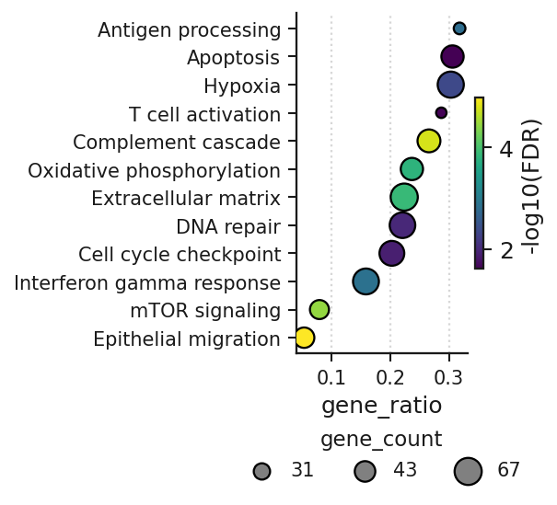
Enrichment dot plot: rendered from the bundled synthetic example with Publication defaults.

Kaplan-Meier survival curve
Registry key: kaplan_meier_survival_curve
Purpose: Survival probability over time per group, from subject-level events or a precomputed curve.
When to use: time-to-event data
Required / optional input: one table with the roles below; the bundled example has columns sample_id, group, time_months, event, censor_reason.
Column mapping: time, event, group, survival_columns (multi-select); example mapping {"time": "time_months", "event": "event", "group": "group"}.
Statistics supported: yes — log-rank / Cox in a corner panel (subject-level input only).
Colour controls: Publication palette (publication / colorblind_safe / high_contrast / grayscale).
Annotation controls: manual annotation layer via PlotSpec; statistical annotation (stars / p / effect).
Axis controls: title, x/y labels, tick angles, label/title padding, margins (layout engine), line width.
Legend / colorbar controls: legend location (inside/outside), legend size.
Plot-specific controls (visual, carried in a style preset): y_scale — Y-axis scale, reference_line — Reference line (y-axis units, blank for none), curve_style — Curve style (line: precomputed curves only), y_ticks — Y ticks.
Analytical / data-dependent options (full preset only): input_form — Input form, x_min — X-axis minimum (blank for auto), x_max — X-axis maximum (blank for auto).
Recommended export: SVG or PDF for vector; PNG/TIFF at 300–600 dpi for raster.
Figure preset support: style and full presets (verified in the registry-wide preset QC).
Example data: examples/by_plot_type/kaplan_meier/ (synthetic).
Known limitations: A precomputed curve cannot yield a log-rank test (no numbers at risk); the app refuses rather than invents one..
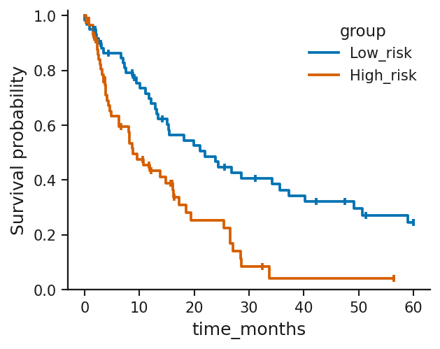
Kaplan-Meier survival curve: rendered from the bundled synthetic example with Publication defaults.

Stacked composition bar plot
Registry key: stacked_bar_composition
Purpose: Composition of categories within each x as stacked bars (counts or proportions).
When to use: cell-type or class composition per sample
Required / optional input: one table with the roles below; the bundled example has columns sample_id, group, cell_type, fraction.
Column mapping: x, stack, y, facet_or_sort_by; example mapping {"x": "sample_id", "stack": "cell_type", "y": "fraction", "facet_or_sort_by": "group"}.
Statistics supported: yes — chi-square / Fisher in a corner panel.
Colour controls: Publication palette (publication / colorblind_safe / high_contrast / grayscale).
Annotation controls: manual annotation layer via PlotSpec; statistical annotation (stars / p / effect).
Axis controls: title, x/y labels, tick angles, label/title padding, margins (layout engine).
Legend / colorbar controls: legend location (inside/outside), legend size.
Plot-specific controls (visual, carried in a style preset): x_tick_rotation — X-axis label angle.
Analytical / data-dependent options (full preset only): none.
Recommended export: SVG or PDF for vector; PNG/TIFF at 300–600 dpi for raster.
Figure preset support: style and full presets (verified in the registry-wide preset QC).
Example data: examples/by_plot_type/stacked/ (synthetic).
Known limitations: none specific beyond the general limitations in Part XXV.
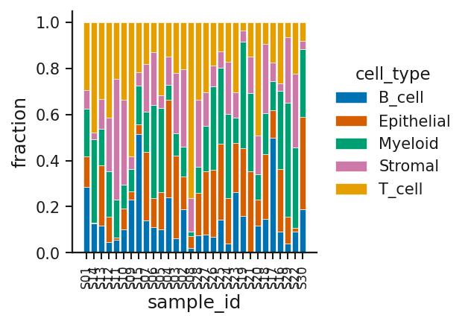
Stacked composition bar plot: rendered from the bundled synthetic example with Publication defaults.

Waterfall plot
Registry key: waterfall_plot
Purpose: Sorted per-subject responses as bars around zero.
When to use: best response per patient, screen hits
Required / optional input: one table with the roles below; the bundled example has columns patient_id, treatment_arm, best_percent_change, response_category, duration_months.
Column mapping: x, y, color; example mapping {"x": "patient_id", "y": "best_percent_change", "color": "response_category"}.
Statistics supported: no on-figure statistical annotation (the Statistics panel still runs for the mapped columns where a test applies).
Colour controls: Publication palette (publication / colorblind_safe / high_contrast / grayscale).
Annotation controls: manual annotation layer via PlotSpec.
Axis controls: title, x/y labels, tick angles, label/title padding, margins (layout engine).
Legend / colorbar controls: legend location (inside/outside), legend size.
Plot-specific controls (visual, carried in a style preset): sort — Sort.
Analytical / data-dependent options (full preset only): none.
Recommended export: SVG or PDF for vector; PNG/TIFF at 300–600 dpi for raster.
Figure preset support: style and full presets (verified in the registry-wide preset QC).
Example data: examples/by_plot_type/waterfall/ (synthetic).
Known limitations: none specific beyond the general limitations in Part XXV.
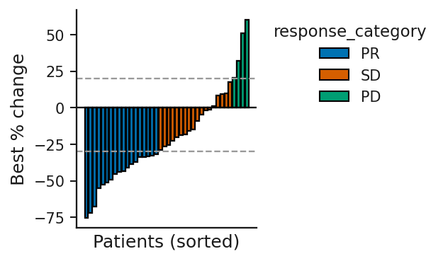
Waterfall plot: rendered from the bundled synthetic example with Publication defaults.

PCA scatter (matrix + metadata)
Registry key: pca_scatter_from_matrix
Purpose: Principal-component scores of samples from a matrix, coloured and shaped from a metadata table.
When to use: sample structure, batch effects, outliers
Required / optional input: one table with the roles below; the bundled example has columns gene, S01, S02, S03, S04, S05, S06, S07 ….
Column mapping: matrix_row_id; example mapping {"matrix_row_id": "gene"} — plus PCA metadata roles color, shape from the metadata table.
Statistics supported: no on-figure statistical annotation (the Statistics panel still runs for the mapped columns where a test applies).
Colour controls: Publication palette (publication / colorblind_safe / high_contrast / grayscale).
Annotation controls: manual annotation layer via PlotSpec.
Axis controls: title, x/y labels, tick angles, label/title padding, margins (layout engine), marker size.
Legend / colorbar controls: legend location (inside/outside), legend size.
Plot-specific controls (visual, carried in a style preset): none.
Analytical / data-dependent options (full preset only): none.
Recommended export: SVG or PDF for vector; PNG/TIFF at 300–600 dpi for raster.
Figure preset support: style and full presets (verified in the registry-wide preset QC).
Example data: examples/by_plot_type/pca/ (synthetic).
Known limitations: none specific beyond the general limitations in Part XXV.
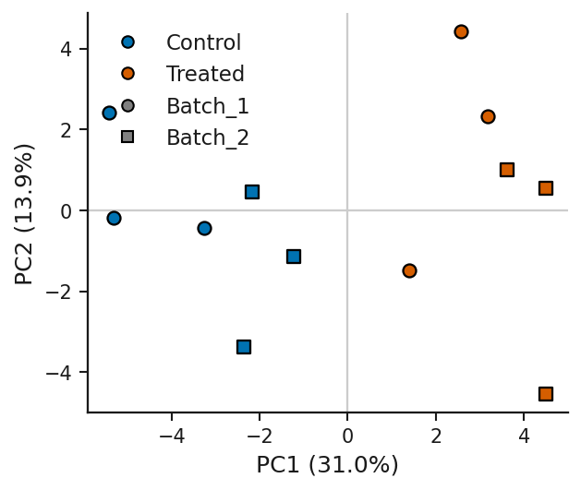
PCA scatter (matrix + metadata): rendered from the bundled synthetic example with Publication defaults.

Oncoprint mutation heatmap
Registry key: oncoprint_mutation_heatmap
Purpose: Samples × genes grid of alteration classes.
When to use: mutation / alteration matrices in long form
Required / optional input: one table with the roles below; the bundled example has columns patient_id, gene, alteration_type, variant_annotation, variant_allele_fraction.
Column mapping: sample, row, fill; example mapping {"sample": "patient_id", "row": "gene", "fill": "alteration_type"}.
Statistics supported: no on-figure statistical annotation (the Statistics panel still runs for the mapped columns where a test applies).
Colour controls: Publication palette (publication / colorblind_safe / high_contrast / grayscale).
Annotation controls: manual annotation layer via PlotSpec.
Axis controls: title, x/y labels, tick angles, label/title padding, margins (layout engine).
Legend / colorbar controls: legend location (inside/outside), legend size.
Plot-specific controls (visual, carried in a style preset): show_sample_labels — Show sample labels (auto: <= 12 samples).
Analytical / data-dependent options (full preset only): order — Row / column order.
Recommended export: SVG or PDF for vector; PNG/TIFF at 300–600 dpi for raster.
Figure preset support: style and full presets (verified in the registry-wide preset QC).
Example data: examples/by_plot_type/oncoprint/ (synthetic).
Known limitations: none specific beyond the general limitations in Part XXV.
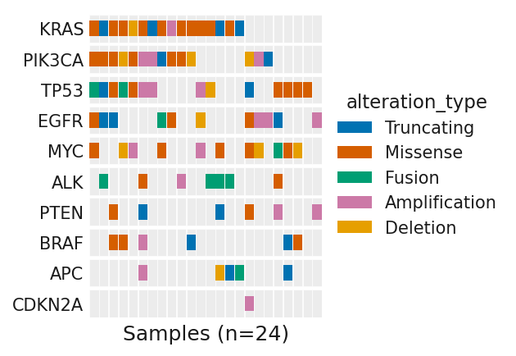
Oncoprint mutation heatmap: rendered from the bundled synthetic example with Publication defaults.

Lollipop mutation plot
Registry key: lollipop_mutation_plot
Purpose: Positions along a protein with lollipops sized by count and coloured by class.
When to use: mutation positions along a sequence
Required / optional input: one table with the roles below; the bundled example has columns gene, protein_position, amino_acid_change, mutation_type, sample_count, domain.
Column mapping: x, y, color, label; example mapping {"x": "protein_position", "y": "sample_count", "color": "mutation_type", "label": "amino_acid_change"}.
Statistics supported: no on-figure statistical annotation (the Statistics panel still runs for the mapped columns where a test applies).
Colour controls: Publication palette (publication / colorblind_safe / high_contrast / grayscale).
Annotation controls: manual annotation layer via PlotSpec.
Axis controls: title, x/y labels, tick angles, label/title padding, margins (layout engine), line width.
Legend / colorbar controls: legend location (inside/outside), legend size.
Plot-specific controls (visual, carried in a style preset): show_labels — Show mutation labels, legend_loc — Legend position, marker_scale — Marker scale, y_margin — Top y-margin, label_font_size — Label font size (0=auto).
Analytical / data-dependent options (full preset only): label_top_n — Label top N mutations.
Recommended export: SVG or PDF for vector; PNG/TIFF at 300–600 dpi for raster.
Figure preset support: style and full presets (verified in the registry-wide preset QC).
Example data: examples/by_plot_type/lollipop/ (synthetic).
Known limitations: none specific beyond the general limitations in Part XXV.
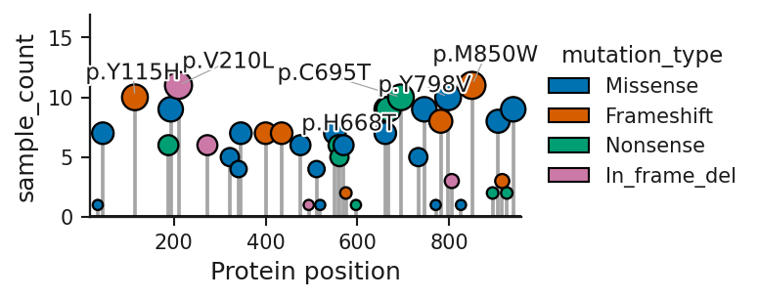
Lollipop mutation plot: rendered from the bundled synthetic example with Publication defaults.

ROC curve
Registry key: roc_curve
Purpose: True- vs false-positive rate for one or two scores with AUC.
When to use: classifier or biomarker evaluation
Required / optional input: one table with the roles below; the bundled example has columns sample_id, true_label, score_model_a, score_model_b, cohort.
Column mapping: label, score, score2; example mapping {"label": "true_label", "score": "score_model_a", "score2": "score_model_b"}.
Statistics supported: no on-figure statistical annotation (the Statistics panel still runs for the mapped columns where a test applies).
Colour controls: Publication palette (publication / colorblind_safe / high_contrast / grayscale).
Annotation controls: manual annotation layer via PlotSpec.
Axis controls: title, x/y labels, tick angles, label/title padding, margins (layout engine), line width.
Legend / colorbar controls: legend location (inside/outside), legend size.
Plot-specific controls (visual, carried in a style preset): none.
Analytical / data-dependent options (full preset only): none.
Recommended export: SVG or PDF for vector; PNG/TIFF at 300–600 dpi for raster.
Figure preset support: style and full presets (verified in the registry-wide preset QC).
Example data: examples/by_plot_type/roc/ (synthetic).
Known limitations: none specific beyond the general limitations in Part XXV.
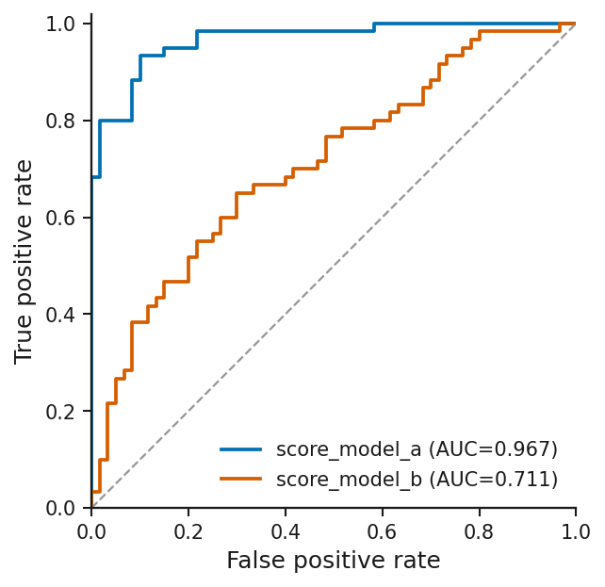
ROC curve: rendered from the bundled synthetic example with Publication defaults.

Forest plot
Registry key: forest_plot
Purpose: Point estimates with confidence intervals per row and a reference line.
When to use: hazard/odds ratios, subgroup effects, meta-analysis
Required / optional input: one table with the roles below; the bundled example has columns study, subgroup, hazard_ratio, ci_low, ci_high, p_value, n.
Column mapping: label, estimate, lower, upper; example mapping {"label": "subgroup", "estimate": "hazard_ratio", "lower": "ci_low", "upper": "ci_high"}.
Statistics supported: no on-figure statistical annotation (the Statistics panel still runs for the mapped columns where a test applies).
Colour controls: Publication palette (publication / colorblind_safe / high_contrast / grayscale).
Annotation controls: manual annotation layer via PlotSpec.
Axis controls: title, x/y labels, tick angles, label/title padding, margins (layout engine), line width.
Legend / colorbar controls: no legend drawn.
Plot-specific controls (visual, carried in a style preset): reference — Reference line, log_scale — Log x-axis.
Analytical / data-dependent options (full preset only): none.
Recommended export: SVG or PDF for vector; PNG/TIFF at 300–600 dpi for raster.
Figure preset support: style and full presets (verified in the registry-wide preset QC).
Example data: examples/by_plot_type/forest/ (synthetic).
Known limitations: none specific beyond the general limitations in Part XXV.
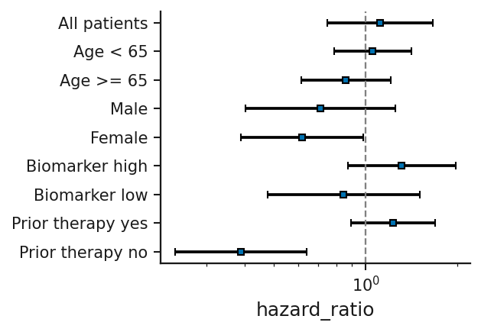
Forest plot: rendered from the bundled synthetic example with Publication defaults.

Dot / strip plot
Registry key: dot_strip_plot
Purpose: Every observation per category with a summary marker.
When to use: small-n replicate data
Required / optional input: one table with the roles below; the bundled example has columns group, value, cohort.
Column mapping: x, y, color; example mapping {"x": "group", "y": "value"}.
Statistics supported: no on-figure statistical annotation (the Statistics panel still runs for the mapped columns where a test applies).
Colour controls: Publication palette (publication / colorblind_safe / high_contrast / grayscale).
Annotation controls: manual annotation layer via PlotSpec.
Axis controls: title, x/y labels, tick angles, label/title padding, margins (layout engine), marker size, line width.
Legend / colorbar controls: legend location (inside/outside), legend size.
Plot-specific controls (visual, carried in a style preset): summary — Summary overlay, jitter — Jitter points, x_tick_rotation — X-axis label angle.
Analytical / data-dependent options (full preset only): none.
Recommended export: SVG or PDF for vector; PNG/TIFF at 300–600 dpi for raster.
Figure preset support: style and full presets (verified in the registry-wide preset QC).
Example data: examples/by_plot_type/dot_strip/ (synthetic).
Known limitations: none specific beyond the general limitations in Part XXV.
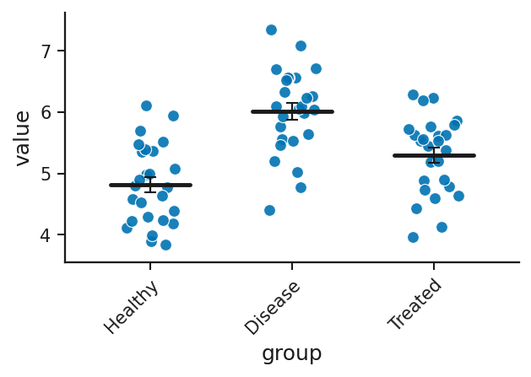
Dot / strip plot: rendered from the bundled synthetic example with Publication defaults.

Beeswarm plot
Registry key: beeswarm_plot
Purpose: Every observation per category, spread to avoid overlap.
When to use: small- to medium-n distributions
Required / optional input: one table with the roles below; the bundled example has columns group, value, sex.
Column mapping: x, y, color; example mapping {"x": "group", "y": "value"}.
Statistics supported: no on-figure statistical annotation (the Statistics panel still runs for the mapped columns where a test applies).
Colour controls: Publication palette (publication / colorblind_safe / high_contrast / grayscale).
Annotation controls: manual annotation layer via PlotSpec.
Axis controls: title, x/y labels, tick angles, label/title padding, margins (layout engine), marker size, line width.
Legend / colorbar controls: legend location (inside/outside), legend size.
Plot-specific controls (visual, carried in a style preset): summary — Summary overlay, x_tick_rotation — X-axis label angle.
Analytical / data-dependent options (full preset only): none.
Recommended export: SVG or PDF for vector; PNG/TIFF at 300–600 dpi for raster.
Figure preset support: style and full presets (verified in the registry-wide preset QC).
Example data: examples/by_plot_type/beeswarm/ (synthetic).
Known limitations: none specific beyond the general limitations in Part XXV.
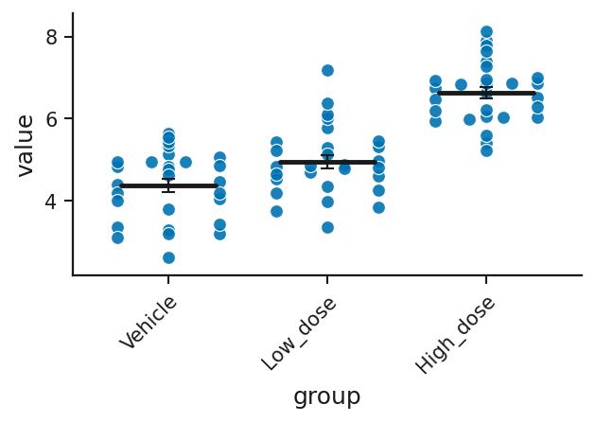
Beeswarm plot: rendered from the bundled synthetic example with Publication defaults.

Paired dot plot / slopegraph
Registry key: paired_slopegraph
Purpose: Each subject’s paired values joined by a line across conditions.
When to use: before/after or matched designs
Required / optional input: one table with the roles below; the bundled example has columns subject, condition, value, arm.
Column mapping: subject, condition, value, color; example mapping {"subject": "subject", "condition": "condition", "value": "value"}.
Statistics supported: no on-figure statistical annotation (the Statistics panel still runs for the mapped columns where a test applies).
Colour controls: Publication palette (publication / colorblind_safe / high_contrast / grayscale); plot options: point_color, line_color.
Annotation controls: manual annotation layer via PlotSpec.
Axis controls: title, x/y labels, tick angles, label/title padding, margins (layout engine), marker size, line width.
Legend / colorbar controls: legend location (inside/outside), legend size.
Plot-specific controls (visual, carried in a style preset): point_color — Point color, line_color — Line color, point_size — Point size, line_width — Line width, line_alpha — Line alpha.
Analytical / data-dependent options (full preset only): none.
Recommended export: SVG or PDF for vector; PNG/TIFF at 300–600 dpi for raster.
Figure preset support: style and full presets (verified in the registry-wide preset QC).
Example data: examples/by_plot_type/paired_slope/ (synthetic).
Known limitations: none specific beyond the general limitations in Part XXV.
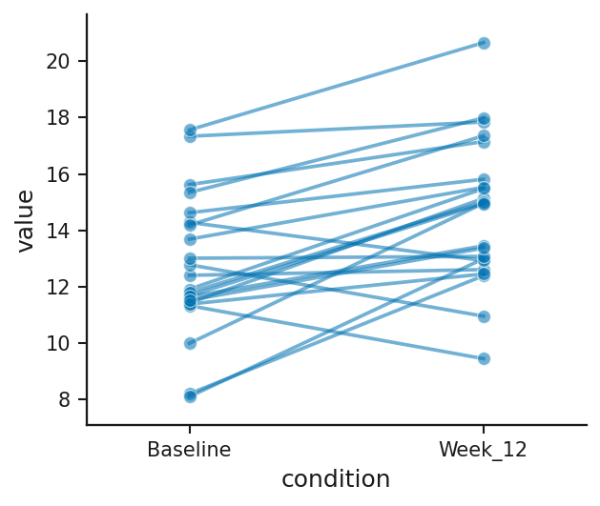
Paired dot plot / slopegraph: rendered from the bundled synthetic example with Publication defaults.

Raincloud plot
Registry key: raincloud_plot
Purpose: Half-violin, box and jittered points per category.
When to use: distribution + summary + raw data in one
Required / optional input: one table with the roles below; the bundled example has columns group, value, batch.
Column mapping: x, y; example mapping {"x": "group", "y": "value"}.
Statistics supported: no on-figure statistical annotation (the Statistics panel still runs for the mapped columns where a test applies).
Colour controls: Publication palette (publication / colorblind_safe / high_contrast / grayscale).
Annotation controls: manual annotation layer via PlotSpec.
Axis controls: title, x/y labels, tick angles, label/title padding, margins (layout engine), marker size, line width.
Legend / colorbar controls: no legend drawn.
Plot-specific controls (visual, carried in a style preset): x_tick_rotation — X-axis label angle.
Analytical / data-dependent options (full preset only): none.
Recommended export: SVG or PDF for vector; PNG/TIFF at 300–600 dpi for raster.
Figure preset support: style and full presets (verified in the registry-wide preset QC).
Example data: examples/by_plot_type/raincloud/ (synthetic).
Known limitations: none specific beyond the general limitations in Part XXV.
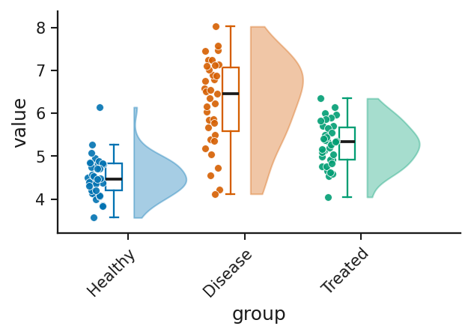
Raincloud plot: rendered from the bundled synthetic example with Publication defaults.

Hierarchical clustering dendrogram
Registry key: hierarchical_dendrogram
Purpose: Tree of hierarchical clustering of the matrix rows or columns.
When to use: similarity structure among samples or features
Required / optional input: one table with the roles below; the bundled example has columns gene, Tumor_1, Tumor_2, Tumor_3, Tumor_4, Tumor_5, Normal_1, Normal_2 ….
Column mapping: row_id; example mapping {"row_id": "gene"}.
Statistics supported: no on-figure statistical annotation (the Statistics panel still runs for the mapped columns where a test applies).
Colour controls: Publication palette (publication / colorblind_safe / high_contrast / grayscale).
Annotation controls: manual annotation layer via PlotSpec.
Axis controls: title, x/y labels, tick angles, label/title padding, margins (layout engine).
Legend / colorbar controls: no legend drawn.
Plot-specific controls (visual, carried in a style preset): orientation — Orientation.
Analytical / data-dependent options (full preset only): method — Linkage method, cluster — Cluster.
Recommended export: SVG or PDF for vector; PNG/TIFF at 300–600 dpi for raster.
Figure preset support: style and full presets (verified in the registry-wide preset QC).
Example data: examples/by_plot_type/dendrogram/ (synthetic).
Known limitations: none specific beyond the general limitations in Part XXV.
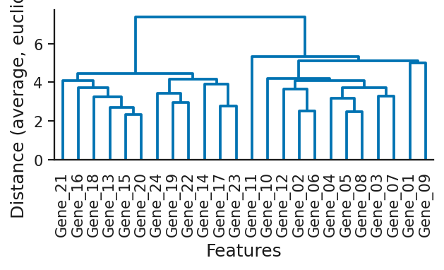
Hierarchical clustering dendrogram: rendered from the bundled synthetic example with Publication defaults.

MA plot (differential expression)
Registry key: ma_plot
Purpose: Log fold change against average abundance per feature.
When to use: DE tables; intensity-dependent bias
Required / optional input: one table with the roles below; the bundled example has columns AveExpr, logFC, adj.P.Val, gene.
Column mapping: x, y, p, label, id_col; example mapping {"x": "AveExpr", "y": "logFC", "p": "adj.P.Val", "label": "gene"}.
Statistics supported: no on-figure statistical annotation (the Statistics panel still runs for the mapped columns where a test applies).
Colour controls: Publication palette (publication / colorblind_safe / high_contrast / grayscale); plot options: color_ns.
Annotation controls: point picking, label selection, duplicate-label policy.
Axis controls: title, x/y labels, tick angles, label/title padding, margins (layout engine), marker size.
Legend / colorbar controls: legend location (inside/outside), legend size.
Plot-specific controls (visual, carried in a style preset): color_ns — Not-significant colour, duplicate_label_policy — Duplicate labels, duplicate_label_representative_rule — Representative point, duplicate_label_show_count — Append (n=…) count.
Analytical / data-dependent options (full preset only): p_cutoff — Significance cutoff, lfc_cutoff — |log2FC| cutoff (0 = none), label_top_n — Label top N hits.
Recommended export: SVG or PDF for vector; PNG/TIFF at 300–600 dpi for raster.
Figure preset support: style and full presets (verified in the registry-wide preset QC).
Example data: examples/by_plot_type/ma_plot/ (synthetic).
Known limitations: none specific beyond the general limitations in Part XXV.
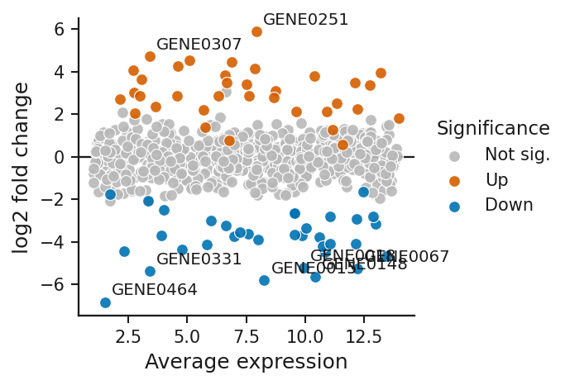
MA plot (differential expression): rendered from the bundled synthetic example with Publication defaults.

Manhattan plot (GWAS)
Registry key: manhattan_plot
Purpose: −log10 p by genomic position, coloured by chromosome, with significance lines.
When to use: GWAS / association results
Required / optional input: one table with the roles below; the bundled example has columns chromosome, position, p_value, snp.
Column mapping: chrom, pos, p, snp; example mapping {"chrom": "chromosome", "pos": "position", "p": "p_value", "snp": "snp"}.
Statistics supported: no on-figure statistical annotation (the Statistics panel still runs for the mapped columns where a test applies).
Colour controls: Publication palette (publication / colorblind_safe / high_contrast / grayscale); plot options: cutoff_line_color.
Annotation controls: manual annotation layer via PlotSpec.
Axis controls: title, x/y labels, tick angles, label/title padding, margins (layout engine), marker size, line width.
Legend / colorbar controls: legend location (inside/outside), legend size.
Plot-specific controls (visual, carried in a style preset): x_tick_rotation — X-axis label angle, show_cutoff_line — Genome-wide cutoff line, cutoff_line_color — Cutoff line color, cutoff_line_style — Cutoff line style, cutoff_line_width — Cutoff line width, show_suggestive_line — Suggestive line.
Analytical / data-dependent options (full preset only): genome_wide_threshold — Cutoff threshold (p).
Recommended export: SVG or PDF for vector; PNG/TIFF at 300–600 dpi for raster. Heat-map cells and dense point clouds are still vector in SVG/PDF but large; PNG is often the practical choice.
Figure preset support: style and full presets (verified in the registry-wide preset QC).
Example data: examples/by_plot_type/manhattan/ (synthetic).
Known limitations: none specific beyond the general limitations in Part XXV.
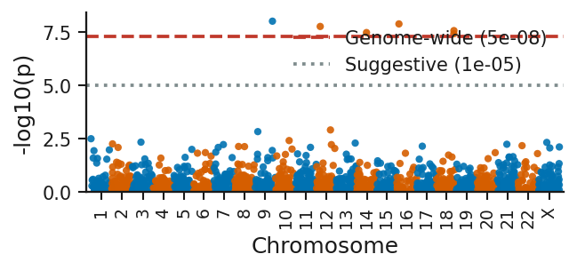
Manhattan plot (GWAS): rendered from the bundled synthetic example with Publication defaults.

Q-Q plot (p-value / quantile)
Registry key: qq_plot
Purpose: Observed vs expected p-value quantiles (or sample quantiles).
When to use: checking p-value inflation or normality
Required / optional input: one table with the roles below; the bundled example has columns p_value.
Column mapping: p; example mapping {"p": "p_value"}.
Statistics supported: no on-figure statistical annotation (the Statistics panel still runs for the mapped columns where a test applies).
Colour controls: Publication palette (publication / colorblind_safe / high_contrast / grayscale).
Annotation controls: manual annotation layer via PlotSpec.
Axis controls: title, x/y labels, tick angles, label/title padding, margins (layout engine), marker size, line width.
Legend / colorbar controls: no legend drawn.
Plot-specific controls (visual, carried in a style preset): none.
Analytical / data-dependent options (full preset only): mode — Mode.
Recommended export: SVG or PDF for vector; PNG/TIFF at 300–600 dpi for raster.
Figure preset support: style and full presets (verified in the registry-wide preset QC).
Example data: examples/by_plot_type/qq/ (synthetic).
Known limitations: none specific beyond the general limitations in Part XXV.
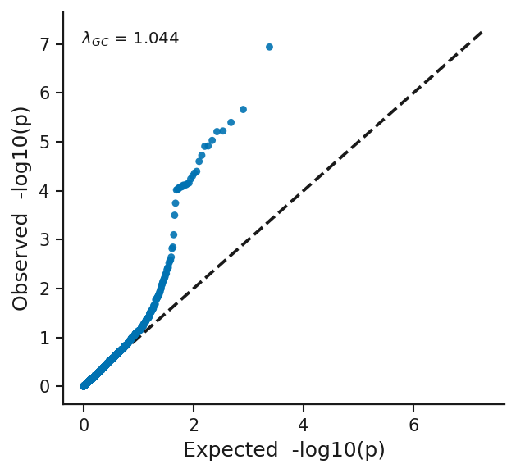
Q-Q plot (p-value / quantile): rendered from the bundled synthetic example with Publication defaults.

Bland-Altman (method agreement)
Registry key: bland_altman_plot
Purpose: Difference vs mean of two measurement methods with bias and limits of agreement.
When to use: method agreement
Required / optional input: one table with the roles below; the bundled example has columns sample_id, device_A, device_B.
Column mapping: method_a, method_b, label; example mapping {"method_a": "device_A", "method_b": "device_B"}.
Statistics supported: no on-figure statistical annotation (the Statistics panel still runs for the mapped columns where a test applies).
Colour controls: Publication palette (publication / colorblind_safe / high_contrast / grayscale).
Annotation controls: manual annotation layer via PlotSpec.
Axis controls: title, x/y labels, tick angles, label/title padding, margins (layout engine), marker size, line width.
Legend / colorbar controls: no legend drawn.
Plot-specific controls (visual, carried in a style preset): show_ci — Shade 95% CI of bias.
Analytical / data-dependent options (full preset only): none.
Recommended export: SVG or PDF for vector; PNG/TIFF at 300–600 dpi for raster.
Figure preset support: style and full presets (verified in the registry-wide preset QC).
Example data: examples/by_plot_type/bland_altman/ (synthetic).
Known limitations: none specific beyond the general limitations in Part XXV.
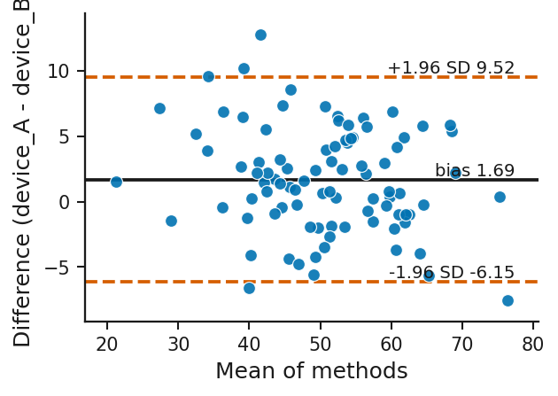
Bland-Altman (method agreement): rendered from the bundled synthetic example with Publication defaults.

Precision-recall curve
Registry key: precision_recall_curve
Purpose: Precision vs recall for one or two scores.
When to use: imbalanced classification
Required / optional input: one table with the roles below; the bundled example has columns sample_id, true_label, score_model_a, score_model_b, cohort.
Column mapping: label, score, score2; example mapping {"label": "true_label", "score": "score_model_a", "score2": "score_model_b"}.
Statistics supported: no on-figure statistical annotation (the Statistics panel still runs for the mapped columns where a test applies).
Colour controls: Publication palette (publication / colorblind_safe / high_contrast / grayscale).
Annotation controls: manual annotation layer via PlotSpec.
Axis controls: title, x/y labels, tick angles, label/title padding, margins (layout engine), line width.
Legend / colorbar controls: legend location (inside/outside), legend size.
Plot-specific controls (visual, carried in a style preset): none.
Analytical / data-dependent options (full preset only): none.
Recommended export: SVG or PDF for vector; PNG/TIFF at 300–600 dpi for raster.
Figure preset support: style and full presets (verified in the registry-wide preset QC).
Example data: examples/by_plot_type/precision_recall/ (synthetic).
Known limitations: none specific beyond the general limitations in Part XXV.
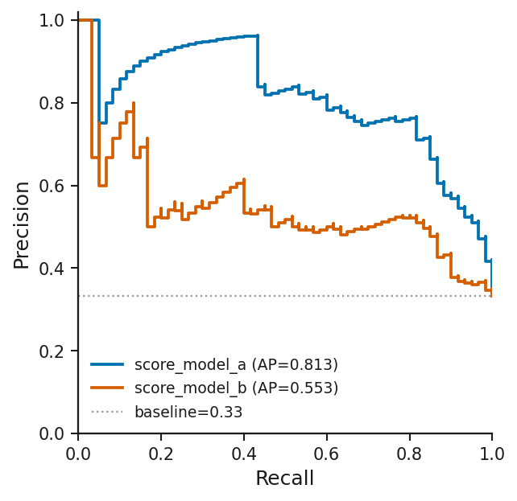
Precision-recall curve: rendered from the bundled synthetic example with Publication defaults.

Confusion matrix
Registry key: confusion_matrix
Purpose: Counts (or normalised rates) of true vs predicted classes.
When to use: classifier evaluation
Required / optional input: one table with the roles below; the bundled example has columns sample_id, true_label, predicted_label.
Column mapping: true, predicted; example mapping {"true": "true_label", "predicted": "predicted_label"}.
Statistics supported: no on-figure statistical annotation (the Statistics panel still runs for the mapped columns where a test applies).
Colour controls: Publication palette (publication / colorblind_safe / high_contrast / grayscale); continuous colormap (sequential/diverging from the palette; colormap option where present).
Annotation controls: manual annotation layer via PlotSpec.
Axis controls: title, x/y labels, tick angles, label/title padding, margins (layout engine).
Legend / colorbar controls: no legend drawn; colorbar location / pad / size.
Plot-specific controls (visual, carried in a style preset): normalize — Normalize.
Analytical / data-dependent options (full preset only): none.
Recommended export: SVG or PDF for vector; PNG/TIFF at 300–600 dpi for raster.
Figure preset support: style and full presets (verified in the registry-wide preset QC).
Example data: examples/by_plot_type/confusion_matrix/ (synthetic).
Known limitations: none specific beyond the general limitations in Part XXV.
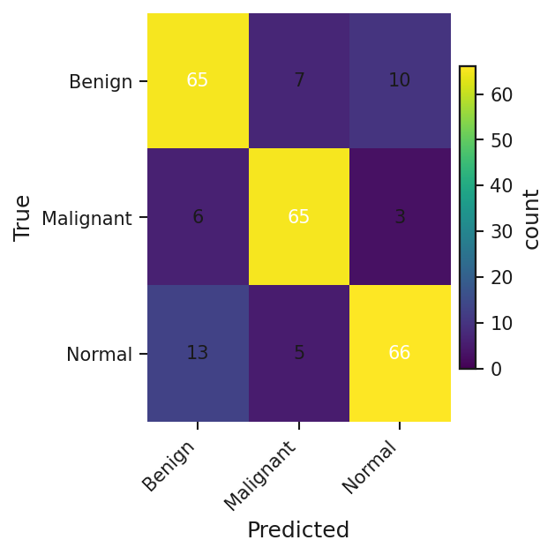
Confusion matrix: rendered from the bundled synthetic example with Publication defaults.

Calibration plot
Registry key: calibration_plot
Purpose: Predicted probability vs observed frequency in bins.
When to use: probability calibration
Required / optional input: one table with the roles below; the bundled example has columns sample_id, true_label, predicted_prob.
Column mapping: label, prob; example mapping {"label": "true_label", "prob": "predicted_prob"}.
Statistics supported: no on-figure statistical annotation (the Statistics panel still runs for the mapped columns where a test applies).
Colour controls: Publication palette (publication / colorblind_safe / high_contrast / grayscale).
Annotation controls: manual annotation layer via PlotSpec.
Axis controls: title, x/y labels, tick angles, label/title padding, margins (layout engine), marker size, line width.
Legend / colorbar controls: legend location (inside/outside), legend size.
Plot-specific controls (visual, carried in a style preset): none.
Analytical / data-dependent options (full preset only): n_bins — Number of bins.
Recommended export: SVG or PDF for vector; PNG/TIFF at 300–600 dpi for raster.
Figure preset support: style and full presets (verified in the registry-wide preset QC).
Example data: examples/by_plot_type/calibration/ (synthetic).
Known limitations: none specific beyond the general limitations in Part XXV.
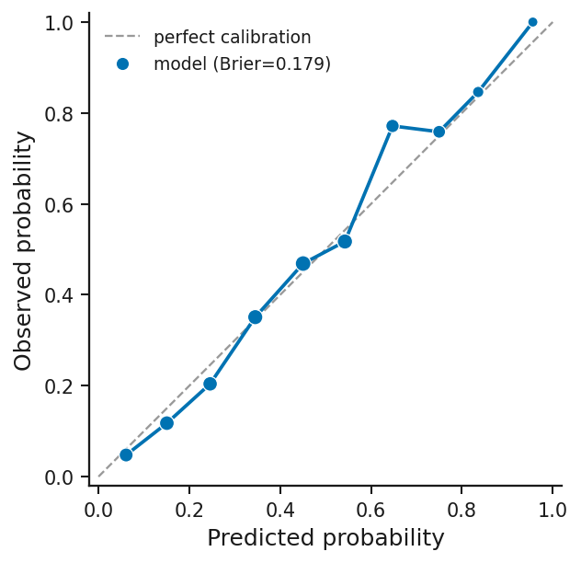
Calibration plot: rendered from the bundled synthetic example with Publication defaults.

Dose-response curve
Registry key: dose_response_curve
Purpose: Response vs dose per group with an optional four-parameter logistic fit.
When to use: IC50/EC50-style experiments
Required / optional input: one table with the roles below; the bundled example has columns drug, concentration_uM, viability_pct.
Column mapping: dose, response, group; example mapping {"dose": "concentration_uM", "response": "viability_pct", "group": "drug"}.
Statistics supported: no on-figure statistical annotation (the Statistics panel still runs for the mapped columns where a test applies).
Colour controls: Publication palette (publication / colorblind_safe / high_contrast / grayscale).
Annotation controls: manual annotation layer via PlotSpec.
Axis controls: title, x/y labels, tick angles, label/title padding, margins (layout engine), marker size, line width.
Legend / colorbar controls: legend location (inside/outside), legend size.
Plot-specific controls (visual, carried in a style preset): none.
Analytical / data-dependent options (full preset only): fit — Fit 4PL curve.
Recommended export: SVG or PDF for vector; PNG/TIFF at 300–600 dpi for raster.
Figure preset support: style and full presets (verified in the registry-wide preset QC).
Example data: examples/by_plot_type/dose_response/ (synthetic).
Known limitations: The 4PL fit is a display fit; report parameters from a dedicated tool for inference..
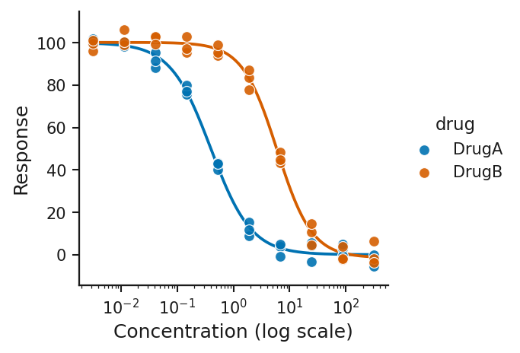
Dose-response curve: rendered from the bundled synthetic example with Publication defaults.

UpSet plot (set intersections)
Registry key: upset_plot
Purpose: Set intersections as a matrix with intersection-size bars.
When to use: overlaps among several sets
Required / optional input: one table with the roles below; the bundled example has columns gene, DEG_up, DEG_down, Promoter_peak, Conserved.
Column mapping: — set columns are given as the sets list.
Statistics supported: no on-figure statistical annotation (the Statistics panel still runs for the mapped columns where a test applies).
Colour controls: Publication palette (publication / colorblind_safe / high_contrast / grayscale).
Annotation controls: manual annotation layer via PlotSpec.
Axis controls: title, x/y labels, tick angles, label/title padding, margins (layout engine), marker size, line width.
Legend / colorbar controls: no legend drawn.
Plot-specific controls (visual, carried in a style preset): none.
Analytical / data-dependent options (full preset only): none.
Recommended export: SVG or PDF for vector; PNG/TIFF at 300–600 dpi for raster.
Figure preset support: style and full presets (verified in the registry-wide preset QC).
Example data: examples/by_plot_type/upset/ (synthetic).
Known limitations: none specific beyond the general limitations in Part XXV.
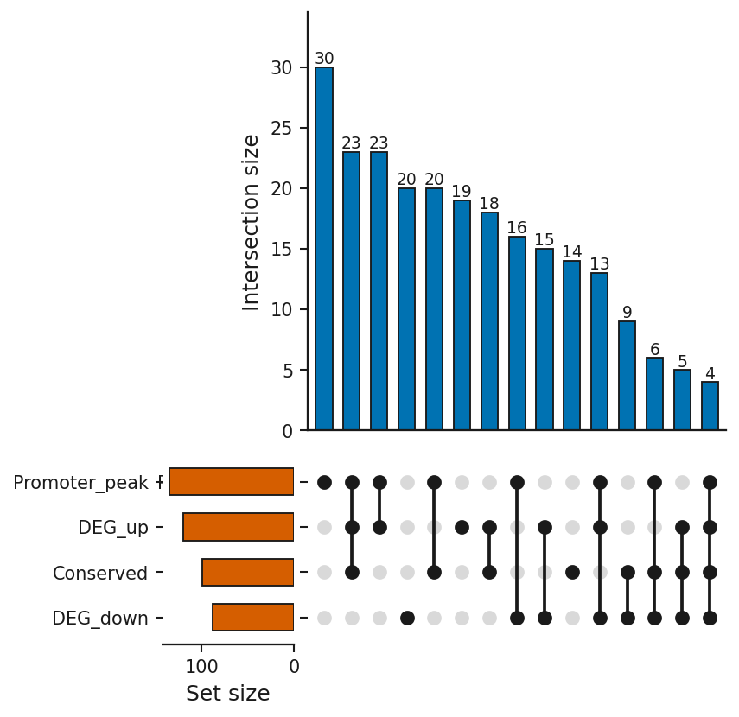
UpSet plot (set intersections): rendered from the bundled synthetic example with Publication defaults.

Swimmer plot
Registry key: swimmer_plot
Purpose: One horizontal bar per subject with events marked along time.
When to use: treatment timelines
Required / optional input: one table with the roles below; the bundled example has columns patient_id, start_month, end_month, duration_month, response, event_type.
Column mapping: subject, start, end, duration, event, group; example mapping {"subject": "patient_id", "start": "start_month", "end": "end_month", "event": "event_type", "group": "response"}.
Statistics supported: no on-figure statistical annotation (the Statistics panel still runs for the mapped columns where a test applies).
Colour controls: Publication palette (publication / colorblind_safe / high_contrast / grayscale).
Annotation controls: manual annotation layer via PlotSpec.
Axis controls: title, x/y labels, tick angles, label/title padding, margins (layout engine), marker size.
Legend / colorbar controls: legend location (inside/outside), legend size.
Plot-specific controls (visual, carried in a style preset): right_pad_frac — Right-side headroom.
Analytical / data-dependent options (full preset only): none.
Recommended export: SVG or PDF for vector; PNG/TIFF at 300–600 dpi for raster.
Figure preset support: style and full presets (verified in the registry-wide preset QC).
Example data: examples/by_plot_type/swimmer/ (synthetic).
Known limitations: none specific beyond the general limitations in Part XXV.
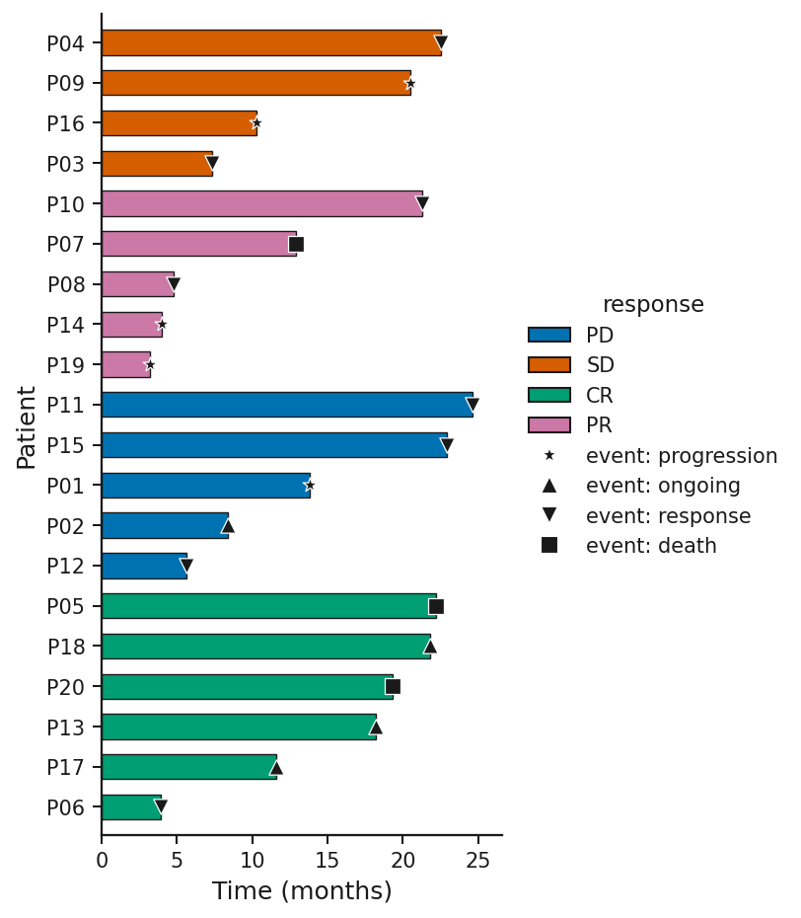
Swimmer plot: rendered from the bundled synthetic example with Publication defaults.

Spider plot (longitudinal change)
Registry key: spider_plot
Purpose: Change from baseline per subject over time.
When to use: longitudinal response
Required / optional input: one table with the roles below; the bundled example has columns patient_id, week, pct_change, arm.
Column mapping: subject, time, value, group; example mapping {"subject": "patient_id", "time": "week", "value": "pct_change", "group": "arm"}.
Statistics supported: no on-figure statistical annotation (the Statistics panel still runs for the mapped columns where a test applies).
Colour controls: Publication palette (publication / colorblind_safe / high_contrast / grayscale).
Annotation controls: manual annotation layer via PlotSpec.
Axis controls: title, x/y labels, tick angles, label/title padding, margins (layout engine), marker size, line width.
Legend / colorbar controls: legend location (inside/outside), legend size.
Plot-specific controls (visual, carried in a style preset): reference — Reference line (y).
Analytical / data-dependent options (full preset only): none.
Recommended export: SVG or PDF for vector; PNG/TIFF at 300–600 dpi for raster.
Figure preset support: style and full presets (verified in the registry-wide preset QC).
Example data: examples/by_plot_type/spider/ (synthetic).
Known limitations: none specific beyond the general limitations in Part XXV.
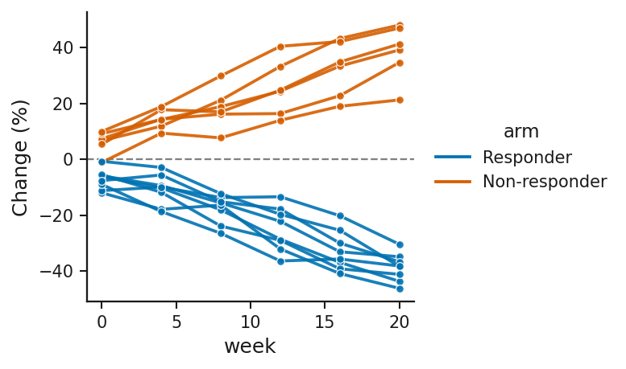
Spider plot (longitudinal change): rendered from the bundled synthetic example with Publication defaults.

Sankey / alluvial flow (two-stage)
Registry key: sankey_plot
Purpose: Flows between two stages as proportional bands.
When to use: transitions, allocations
Required / optional input: one table with the roles below; the bundled example has columns baseline_response, outcome, n_patients.
Column mapping: source, target, value; example mapping {"source": "baseline_response", "target": "outcome", "value": "n_patients"}.
Statistics supported: no on-figure statistical annotation (the Statistics panel still runs for the mapped columns where a test applies).
Colour controls: Publication palette (publication / colorblind_safe / high_contrast / grayscale).
Annotation controls: manual annotation layer via PlotSpec.
Axis controls: title, x/y labels, tick angles, label/title padding, margins (layout engine).
Legend / colorbar controls: no legend drawn.
Plot-specific controls (visual, carried in a style preset): none.
Analytical / data-dependent options (full preset only): none.
Recommended export: SVG or PDF for vector; PNG/TIFF at 300–600 dpi for raster.
Figure preset support: style and full presets (verified in the registry-wide preset QC).
Example data: examples/by_plot_type/sankey/ (synthetic).
Known limitations: none specific beyond the general limitations in Part XXV.
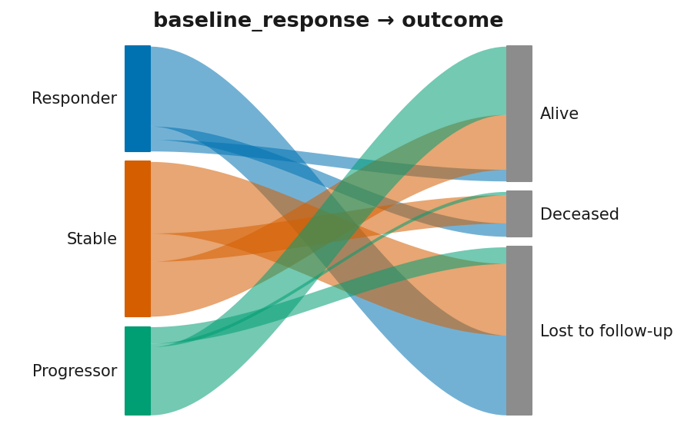
Sankey / alluvial flow (two-stage): rendered from the bundled synthetic example with Publication defaults.

UMAP / t-SNE embedding scatter
Registry key: embedding_scatter
Purpose: Precomputed 2-D embedding coordinates coloured by a label or a continuous value.
When to use: UMAP / t-SNE results computed elsewhere
Required / optional input: one table with the roles below; the bundled example has columns UMAP_1, UMAP_2, cell_type, batch, n_genes.
Column mapping: x, y, color, shape, label; example mapping {"x": "UMAP_1", "y": "UMAP_2", "color": "cell_type"}.
Statistics supported: no on-figure statistical annotation (the Statistics panel still runs for the mapped columns where a test applies).
Colour controls: Publication palette (publication / colorblind_safe / high_contrast / grayscale); continuous colormap (sequential/diverging from the palette; colormap option where present).
Annotation controls: point picking, label selection, duplicate-label policy.
Axis controls: title, x/y labels, tick angles, label/title padding, margins (layout engine), marker size.
Legend / colorbar controls: legend location (inside/outside), legend size; colorbar location / pad / size.
Plot-specific controls (visual, carried in a style preset): none.
Analytical / data-dependent options (full preset only): none.
Recommended export: SVG or PDF for vector; PNG/TIFF at 300–600 dpi for raster. Heat-map cells and dense point clouds are still vector in SVG/PDF but large; PNG is often the practical choice.
Figure preset support: style and full presets (verified in the registry-wide preset QC).
Example data: examples/by_plot_type/embedding/ (synthetic).
Known limitations: Coordinates must be precomputed; the app does not run UMAP or t-SNE..
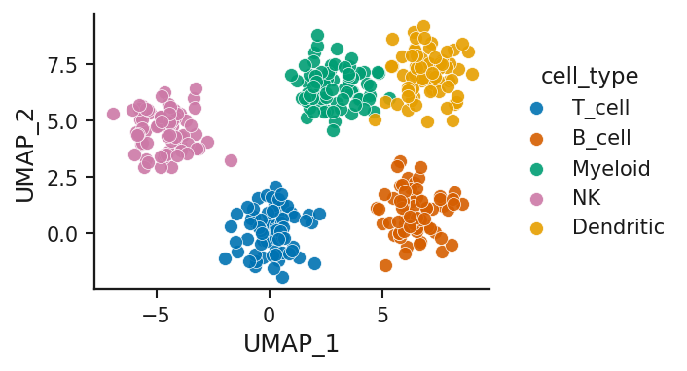
UMAP / t-SNE embedding scatter: rendered from the bundled synthetic example with Publication defaults.

Hierarchical clustering (heatmap + clusters)
Registry key: hierarchical_clustering
Purpose: Clustered heatmap with k clusters marked and a dendrogram.
When to use: grouping features/samples into k clusters
Required / optional input: one table with the roles below; the bundled example has columns gene, Ctrl_1, Ctrl_2, Ctrl_3, Ctrl_4, TreatA_1, TreatA_2, TreatA_3 ….
Column mapping: row_id; example mapping {"row_id": "gene"}.
Statistics supported: no on-figure statistical annotation (the Statistics panel still runs for the mapped columns where a test applies).
Colour controls: Publication palette (publication / colorblind_safe / high_contrast / grayscale); continuous colormap (sequential/diverging from the palette; colormap option where present); plot options: colormap, colorbar_location, colorbar_pad, colorbar_shrink.
Annotation controls: manual annotation layer via PlotSpec.
Axis controls: title, x/y labels, tick angles, label/title padding, margins (layout engine).
Legend / colorbar controls: legend location (inside/outside), legend size; colorbar location / pad / size.
Plot-specific controls (visual, carried in a style preset): colormap — Colormap, y_label_rotation — Y-label angle, cluster_legend_title — Show cluster legend title, show_dendrogram — Show dendrogram tree, colorbar_location — Colorbar location, colorbar_pad — Colorbar pad, colorbar_shrink — Colorbar size, row_label_fontsize — Row label font (0=auto), col_label_fontsize — Column label font (0=auto), y_label_pad — Y-axis label padding.
Analytical / data-dependent options (full preset only): cluster — Cluster, k — Number of clusters k, scale — Scale, distance_metric — Distance, linkage_method — Linkage, max_features — Max features (rows) for clustering.
Recommended export: SVG or PDF for vector; PNG/TIFF at 300–600 dpi for raster. Heat-map cells and dense point clouds are still vector in SVG/PDF but large; PNG is often the practical choice.
Figure preset support: style and full presets (verified in the registry-wide preset QC).
Example data: examples/by_plot_type/hier_clustering/ (synthetic).
Known limitations: Rows are capped at max_features (default 2 000)..
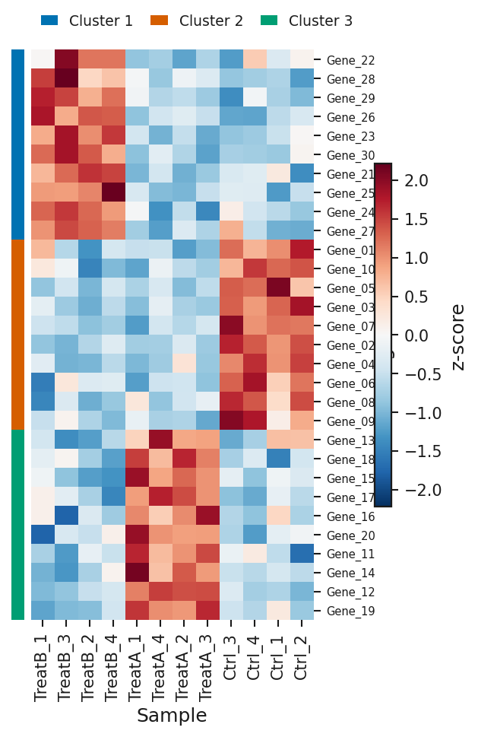
Hierarchical clustering (heatmap + clusters): rendered from the bundled synthetic example with Publication defaults.

Network graph
Registry key: network_graph
Purpose: Nodes and edges from an edge list with layout, community detection and colour/size mappings.
When to use: interaction or correlation networks
Required / optional input: one table with the roles below; the bundled example has columns source, target, weight, interaction_type.
Column mapping: source, target, weight, interaction_type; example mapping {"source": "source", "target": "target", "weight": "weight"}.
Statistics supported: no on-figure statistical annotation (the Statistics panel still runs for the mapped columns where a test applies).
Colour controls: Publication palette (publication / colorblind_safe / high_contrast / grayscale); continuous colormap (sequential/diverging from the palette; colormap option where present); plot options: color_by, node_color, node_cmap, edge_color_by, edge_color, edge_color_positive, edge_color_negative, label_color.
Annotation controls: manual annotation layer via PlotSpec.
Axis controls: title, x/y labels, tick angles, label/title padding, margins (layout engine).
Legend / colorbar controls: legend location (inside/outside), legend size; colorbar location / pad / size.
Plot-specific controls (visual, carried in a style preset): layout — Layout, node_color — Node color (when ‘none’), node_cmap — Node colormap (when ‘value’), node_size — Fixed node size (when ‘fixed’), edge_color — Edge color (single), edge_color_positive — Edge color +corr, edge_color_negative — Edge color -corr, edge_width — Fixed edge width (when ‘fixed’), node_labels — Show node labels, label_color — Label color, label_font_size — Label font size (0=auto), show_legend — Show legend (grouped).
Analytical / data-dependent options (full preset only): seed — Layout seed, color_by — Color nodes by, size_by — Size nodes by, edge_color_by — Color edges by category, edge_width_by — Edge width by, min_weight — Min edge weight, corr_cutoff — |correlation| cutoff, top_n_edges — Top N edges (0=all), min_degree — Min node degree, remove_isolates — Remove isolated nodes, detect_communities — Detect communities (heuristic).
Recommended export: SVG or PDF for vector; PNG/TIFF at 300–600 dpi for raster.
Figure preset support: style and full presets (verified in the registry-wide preset QC).
Example data: examples/by_plot_type/network/ (synthetic).
Known limitations: Layouts with a random component are reproducible only with the seed option; large networks are slow..
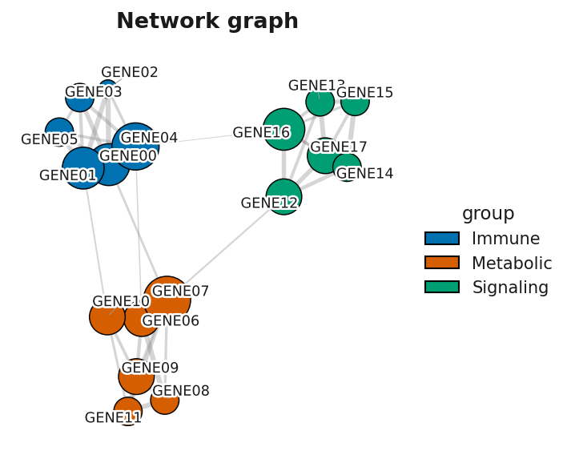
Network graph: rendered from the bundled synthetic example with Publication defaults.

Circos-style chord diagram
Registry key: chord_diagram
Purpose: Flows between categories that share one set, as ribbons around a ring of segments sized by total flow (Circos-style).
When to use: cell-cell interaction counts, transitions or migrations between states, co-occurrence, any many-to-many edge list with up to ~20 categories
Required / optional input: one table with the roles below; the bundled example has columns source_cell, target_cell, interactions, compartment.
Column mapping: source, target, value, group; example mapping {"source": "source_cell", "target": "target_cell", "value": "interactions", "group": "compartment"}.
Statistics supported: no — a chord diagram summarises flows; no inferential comparison is standard for it.
Colour controls: Publication palette (publication / colorblind_safe / high_contrast / grayscale); plot options: ribbon_color_by.
Annotation controls: manual annotation layer via PlotSpec; statistical annotation (stars / p / effect).
Axis controls: title, x/y labels, tick angles, label/title padding, margins (layout engine).
Legend / colorbar controls: legend location (inside/outside), legend size.
Plot-specific controls (visual, carried in a style preset): segment_order — Segment order, gap_degrees — Gap between segments (degrees), start_angle — Start angle (degrees, 90 = top), ribbon_color_by — Colour ribbons by, ribbon_alpha — Ribbon transparency (alpha), show_labels — Show segment labels, label_placement — Label placement, show_ticks — Show segment totals as tick marks, show_legend — Show group legend.
Analytical / data-dependent options (full preset only): min_value — Minimum link value shown, directed — Directed (ribbons narrow toward the target), draw_self_links — Draw self-links.
Recommended export: SVG or PDF for vector; PNG/TIFF at 300–600 dpi for raster.
Figure preset support: style and full presets (verified in the registry-wide preset QC).
Example data: examples/by_plot_type/chord_diagram/ (synthetic).
Known limitations: Single ring only: genomic ideogram coordinates and heatmap/histogram tracks are not drawn in this version. No statistics. Labels wrap beyond 14 characters; above ~24 segments the plot warns that labels may overlap..
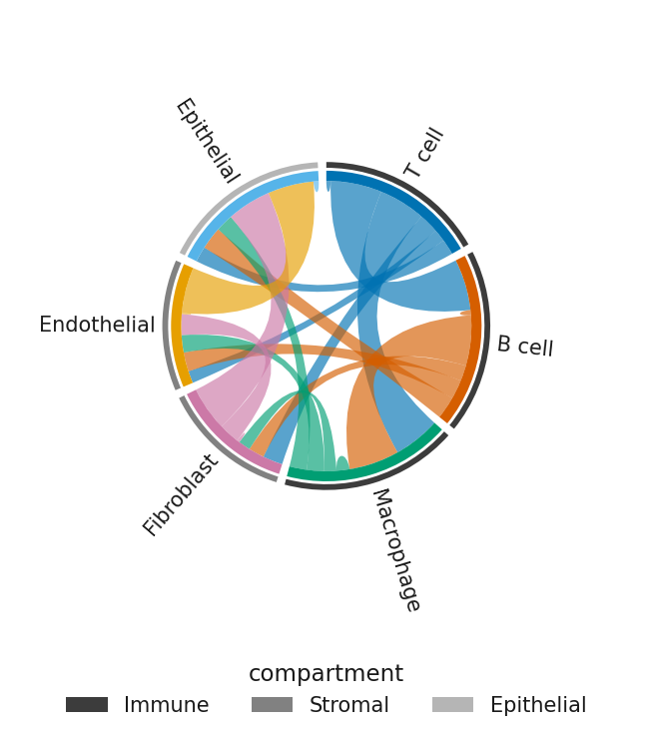
Circos-style chord diagram: rendered from the bundled synthetic example with Publication defaults.

Part XI — Publication controls

41. The Publication style
There is one style, Publication: a general manuscript-ready visual style with readable sizes (title 14 pt, axis labels 12 pt, ticks 10 pt, annotations 10 pt), thin spines, no grid, a colour-blind-aware default palette, and editable text in vector exports. It is not an official journal template; the exported metadata carries a disclaimer to that effect. Older PlotSpecs that named one of the removed, journal-named style profiles are migrated to Publication when loaded, with a notice.

42. Shared controls
Desktop: tick 5. Publication style to enable the group (unticked, the defaults apply). Browser: the five expanders under 5. Publication style.
Group | Controls | Where the value goes
① Figure | width preset (default / single / onehalf / double column), raster DPI (150–600), left/right/top/bottom margins (0 = auto), auto-fix layout | layout / output
② Typography | palette, font (desktop only), title pt, axis label pt, tick label pt, annotation pt, marker size, line width, axis/spine width, grid | style tokens
③ Axes & labels | title, x label, y label (in 4. Labels & size on desktop), x/y tick angle (auto / 0 / 45 / 90), x/y label padding, title padding | layout
④ Legend | location (auto, inside upper/lower left/right, outside right/left/top/bottom), legend pt, legend outside | layout / style
⑤ Colorbar | location (default/right/left/top/bottom), pad, size | mapping (read by colorbar-capable plots)
Reset to publication defaults returns every control to the defaults.
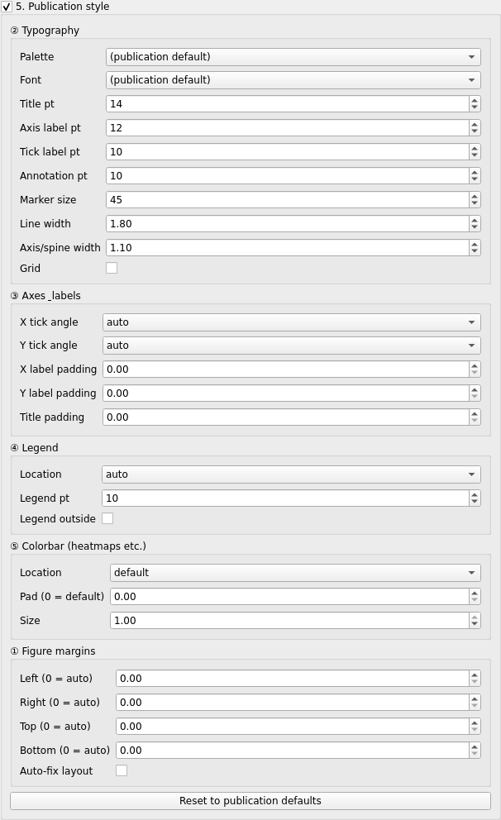
Publication style controls (desktop).
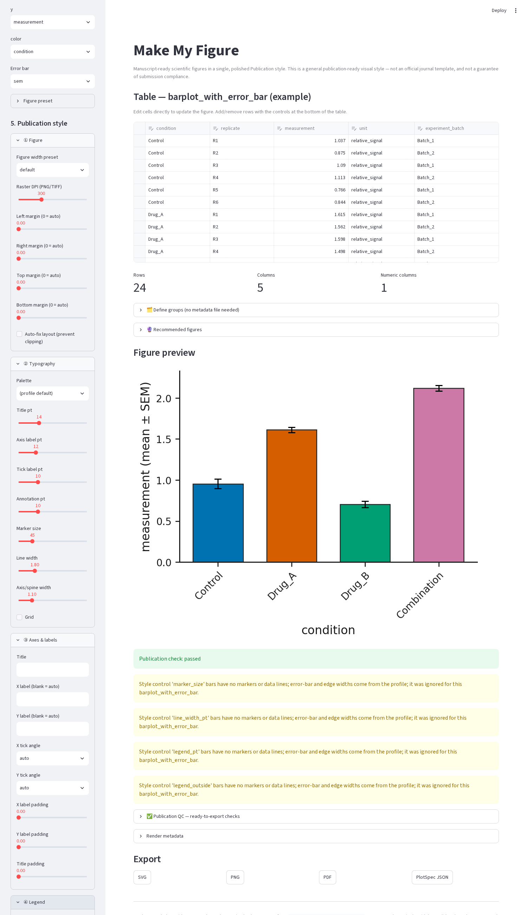
Publication style expanders (browser).

43. Capability-aware honesty
Not every control applies to every plot: bars have no markers, a heatmap has no categorical palette, a network has no axes. Which controls a renderer honours is declared per plot type in styles/capabilities.py, and that table is generated from the renderer source and checked by a test, so a control shown for a plot is one the code reads. When a control does not apply the app says so — a caption under the controls (desktop) or yellow notices under the figure (browser). Because the browser app always sends every style token, a bar plot shows notices for marker size, line width and legend controls even at their defaults; they are informational.

44. Axis ranges and ticks
Some plot types expose x_min / x_max / y_min / y_max and y ticks options (histogram, Kaplan-Meier, forest plot); line plots also take a layout x/y axis scale (linear, log, symlog — a log axis is skipped when the data include non-positive values). A range that would hide plotted data is refused with a message, never silently clipped — a truncated axis overstates differences. Leave the field on (auto) to let the figure choose.

Part XII — Colour customisation

45. Where colours come from
Colour model | Plots | Control
Categorical palette (one colour per category/series) | bar, grouped bar, box/violin, strip, beeswarm, raincloud, line, ridge, histogram, KM, ROC, PR, calibration, dose-response, forest, waterfall, stacked, swimmer, spider, Sankey, UpSet, lollipop, oncoprint, dendrogram, paired slopegraph, MA, Manhattan, PCA, embedding, network | Palette (publication, colorblind_safe, high_contrast, grayscale)
Continuous colormap (+ colorbar) | clustered heatmap, hierarchical clustering, confusion matrix, enrichment dot plot, embedding (continuous colour), network (node colour by value) | colormap option (heatmaps: auto, RdBu_r, coolwarm, seismic, RdYlBu_r, PuOr, BrBG, viridis, magma, cividis, Blues, YlOrRd, Greys); the palette also switches the sequential/diverging maps (grayscale → Greys/gray)
Significance classes | volcano (color_up, color_down, color_ns), MA (color_ns) | options with a curated colour list; the palette does not apply to the volcano and the app says so
Threshold-line colour | Manhattan (cutoff_line_color, style, width) | options
Node / edge mapping | network (node_color, node_cmap, edge_color, edge_color_positive, edge_color_negative, label_color, custom node-colour JSON in the browser) | options
Point / line colour | paired slopegraph (point_color, line_color) | options
Cell borders / separators | heatmap (cell_border_color, group_separator_color) | options
Colours in option lists are hex values and named Matplotlib colours from curated lists; there is no free colour picker in either app. A colour that is not in a list can be set by editing the PlotSpec JSON (any Matplotlib colour name or hex) and reopening it.

46. Volcano example
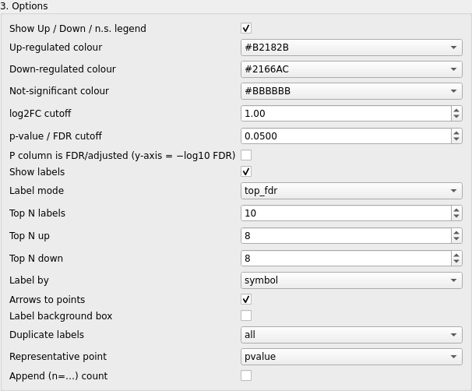
Volcano options: up/down/not-significant colours, cutoffs, labelling and duplicate-label policy.
Set Up-regulated colour, Down-regulated colour and Not-significant colour in 3. Options; the points recolour immediately. Save a style preset to reuse the three colours on every volcano.

47. Category mapping example
A categorical palette assigns colours in category order. To fix which category gets which colour, order the categories in your table (or in the grouping step) — the first category takes the first palette colour. Per-category manual colour maps exist only for the network graph (custom node-colour JSON, browser) and oncoprint alteration classes (fixed).

Part XIII — Annotations

48. Click to label (desktop)
Tick Point picking — Click a point to identify / label it (4. Labels & size). On volcano, MA, scatter and embedding plots, clicking near a point shows its name in the status bar and toggles a label on it; clicking again removes it. Volcano and MA toggle by point identity (row), so two rows sharing a gene symbol are independent; other plots toggle by label text. Selections are stored in the PlotSpec (selected_points / selected_labels) and survive export and reload.
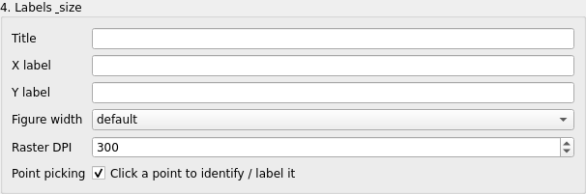
Labels & size with Point picking enabled.
Manual offsets: the desktop app does not currently support dragging a label; offsets stored in a PlotSpec (label_offsets, point_offsets) are honoured when rendering.

49. Label points (browser)
The Label points (annotate) expander (volcano, MA): choose Points to label from the list, then Move which label with x offset / y offset (pt) and Reset this label position. The same AnnotationState round-trips into the PlotSpec as the desktop picks.
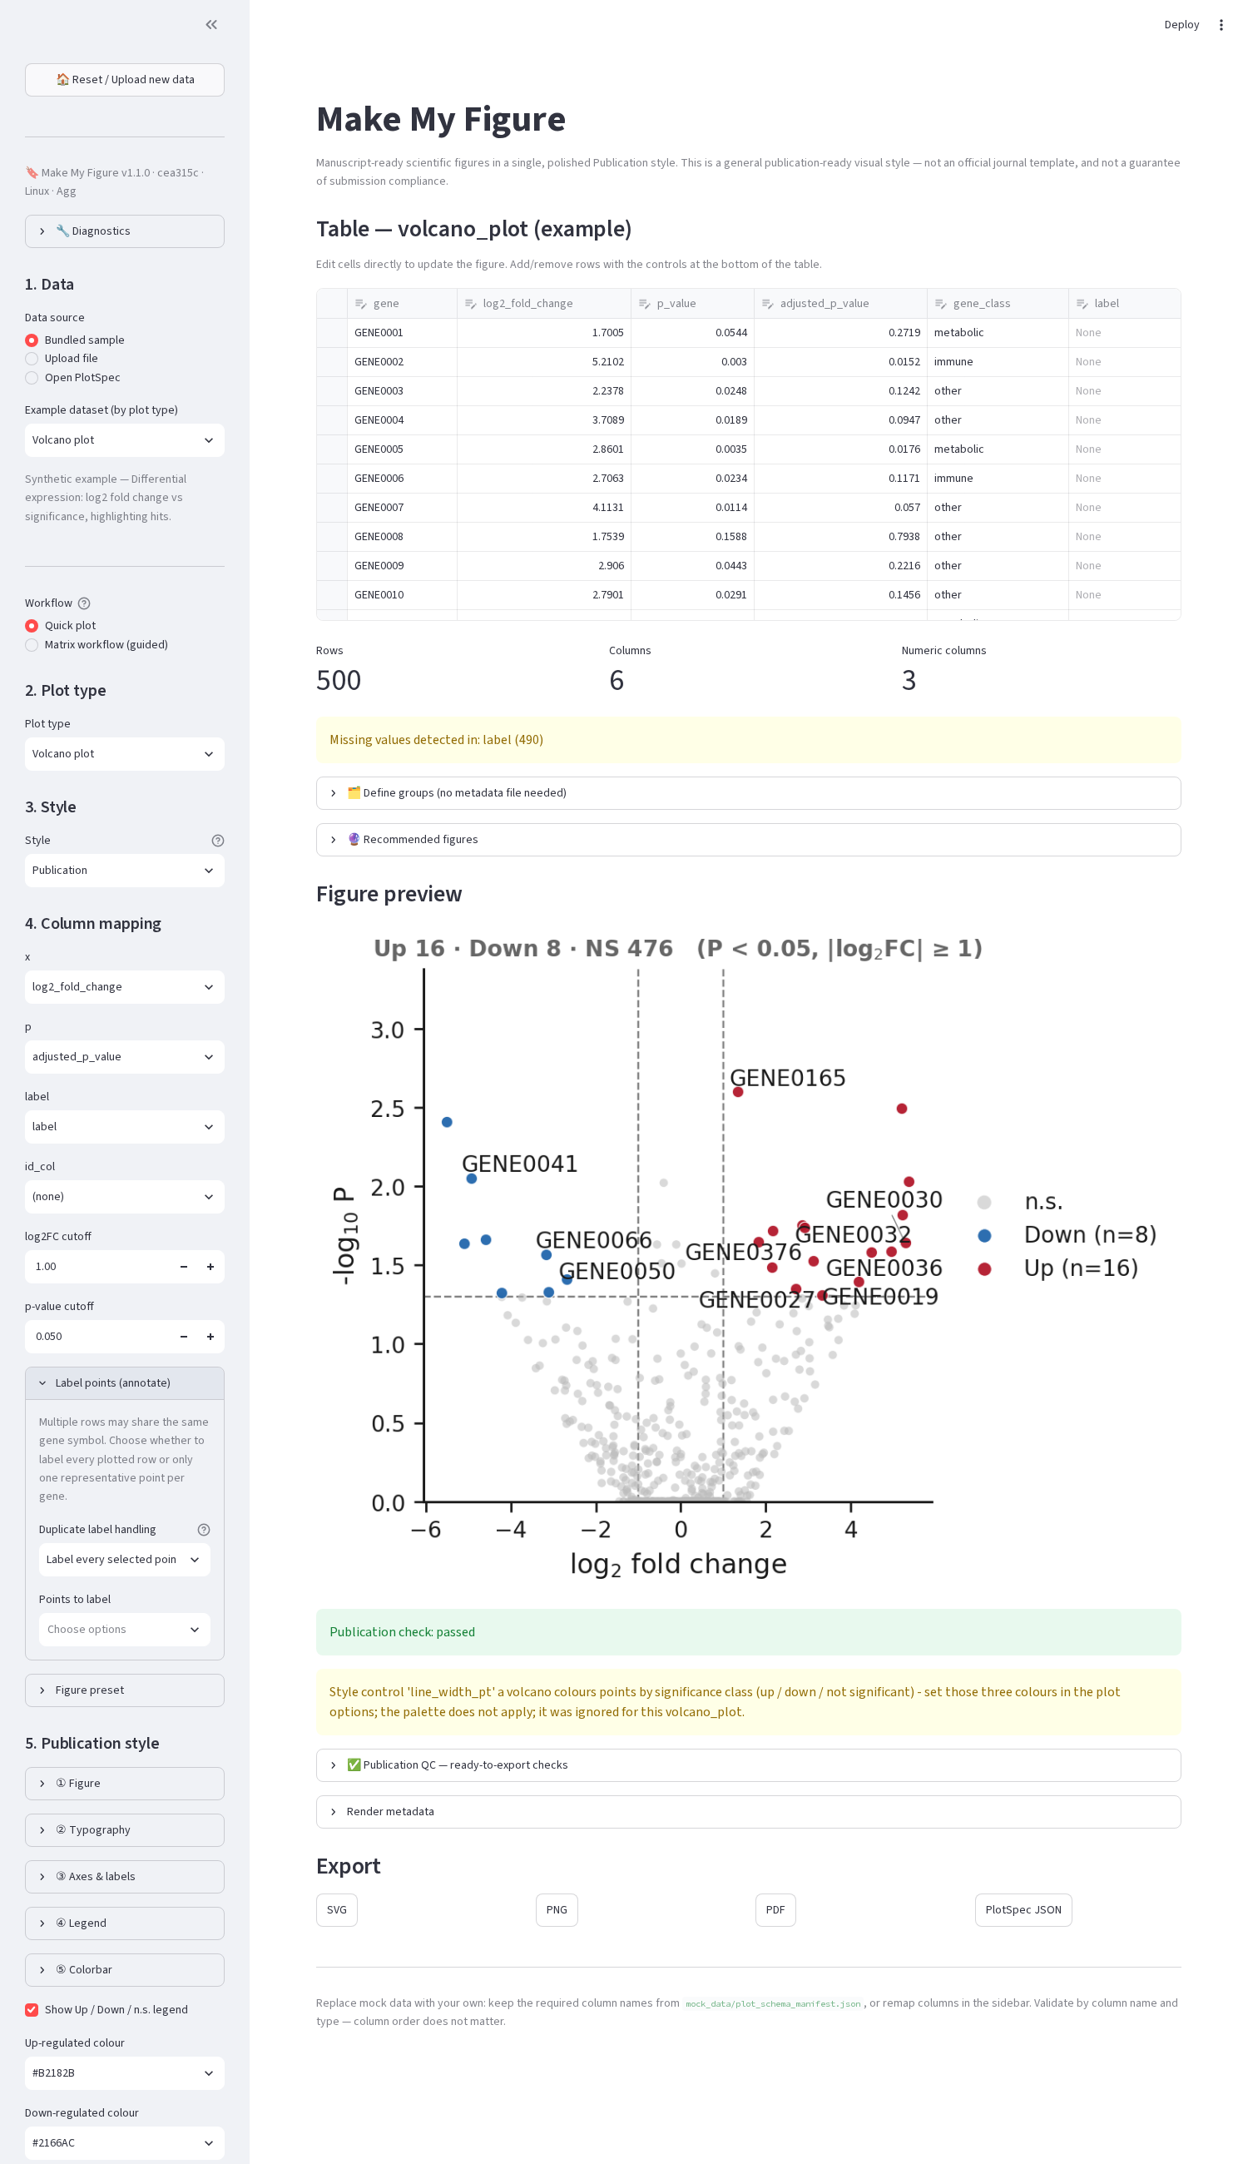
Browser volcano with the Label points expander.

50. Duplicate feature labels (volcano and MA)
Several rows may share one symbol (peptides of a protein, probes of a gene). Duplicate label handling: Label every selected point (all), one representative per label (unique), or representative + count (count). The representative is chosen by rule: smallest p-value, smallest adjusted p, largest absolute effect, highest absolute statistic, or first row. Row identity is never collapsed in the data — only in what is labelled.

51. Other label controls (volcano/MA)
In 3. Options: Show labels (master switch); Label mode (e.g. top_fdr); Top N labels, Top N up, Top N down (how many extreme features get labels); Label by (which column supplies the text, e.g. symbol); Arrows to points (leader lines); Label background box; Duplicate labels / Representative point / Append (n=…) count (§50). Label collisions are resolved automatically with adjustText.

52. Manual annotation layer
A PlotSpec may carry an annotations list — text, arrow, callout, box, region, bracket, hline, vline — with coordinates in data, axes or figure space, colour, font size, line width, alpha and z-order. They are applied to every plot type on render and exported with the figure. There is no in-app drawing editor for generated plots; imported Figure Builder panels accept annotations through the builder. Positions are data-specific and travel only in a full preset (with a warning that they may need moving).

Part XIV — Figure presets
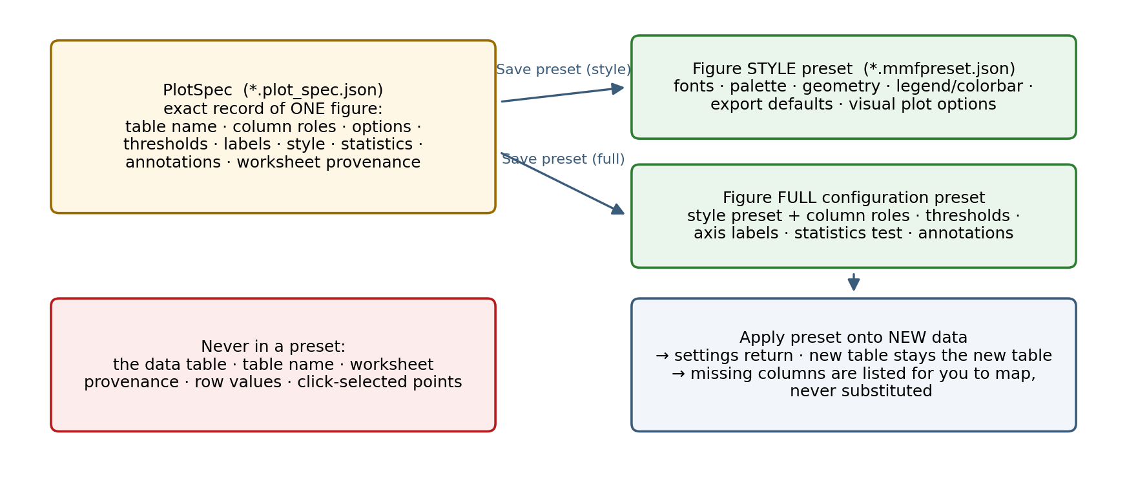
PlotSpec versus Figure preset.

53. What a preset is
A Figure preset is the reusable part of a figure’s configuration, saved without the data. A PlotSpec is the exact record of one figure including the table name and its columns. Presets are files (*.mmfpreset.json, format make_my_figure.figure_preset, version 1) kept in a per-user library that both apps share.
Two kinds:
- Figure style only — typography tokens, palette, layout geometry (width preset, tick angles, paddings, margins, legend location, colorbar geometry), export defaults (formats, size, DPI), statistical display settings (annotation content/placement), and the plot’s visual options. Portable to any dataset of the same plot type; universal parts (fonts, palette, layout) also apply to other plot types.
- Full figure configuration — all of the above plus column roles, analytical options (thresholds, bins, clustering method…), axis labels, the statistics test block, and manual annotations. Applies only to the same plot type.
Never in a preset: the table name, worksheet provenance, row values, click-selected points and their offsets.

54. Which options are visual
Every plot option declares a scope in the registry. Visual (style) examples: box vs violin, histogram bars/line, panel arrangement, colormap, node colours, error-bar type, tick angle, show/hide fit statistics. Analytical (full only) examples: volcano/MA/Manhattan thresholds, bin width and count, clustering distance/linkage, k, axis limits, input form, top_n, correlation cutoffs. The default for a new option is analytical, so a threshold cannot leak into a lab style by omission. The plot catalogue (Part X) lists both sets for each plot.

55. Saving
Desktop: Figure preset group → Save preset… → name → Figure style only or Full figure configuration → Save. Browser: Figure preset expander → Save preset form → name → Save radio → Save; a Download the saved preset button appears. The preset is written to the library and listed for its plot type.
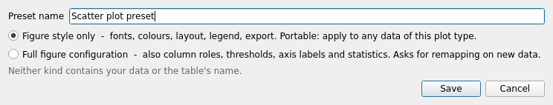
Save Figure Preset (desktop).

56. Applying
Choose a preset for the current plot type (universal presets are listed for every type) → Apply. The controls move to the preset’s values — including tick angles, legend location, margins, colorbar geometry, options and (full presets) column roles — and the figure re-renders. The status line reports how many settings applied and how many did not apply to this plot type.
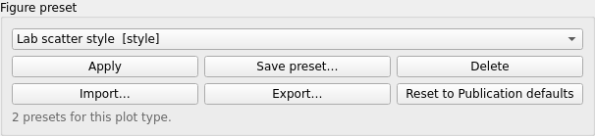
Figure preset group with saved presets (desktop).
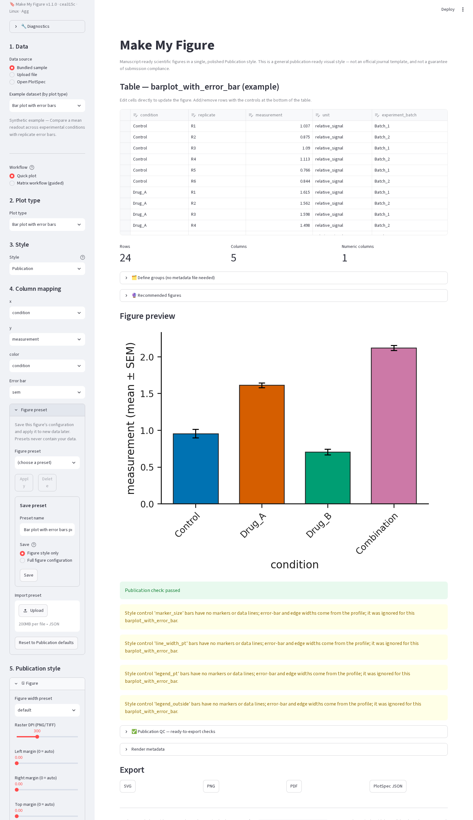
Figure preset expander (browser).

57. Compatibility, remapping, warnings
- A full preset saved for another plot type is refused (its roles and thresholds mean nothing elsewhere).
- A style preset saved for another plot type applies its universal parts and lists the plot-specific options it dropped.
- A full preset whose columns the new table lacks reports each missing role — “wanted ‘x_marker’ … nothing was substituted” — and leaves that role for you to set in Map columns. Statistics columns the table lacks are cleared and reported the same way.
- Manual annotations from a full preset are restored at their saved positions with a warning.

58. Import, export, delete, reset, sharing
Import… adds a .mmfpreset.json (or an old PlotSpec / sidecar, converted to a full preset) to the library. Export… writes the selected preset to a file for a colleague. Delete removes it from the library. Reset to Publication defaults returns every style control to the defaults without touching the library. To share a lab style, export Lab_Default_Heatmap.mmfpreset.json and have colleagues import it.

59. Storage location and versioning
OS | Library folder
Windows | %APPDATA%\MakeMyFigure\presets
macOS | ~/Library/Application Support/MakeMyFigure/presets
Linux | $XDG_DATA_HOME/make_my_figure/presets (default ~/.local/share/make_my_figure/presets)
The environment variable MAKE_MY_FIGURE_PRESETS overrides the folder (portable installs, shared network folders, tests). Files carry format_version; a preset from a newer version is refused with a clear message rather than misread. Foreign JSON files in the folder are ignored.

60. Lab workflow
- Finalise a heatmap (colormap, fonts, colorbar placement, cell borders, double-column width).
- Save preset… → Lab Heatmap → Figure style only.
- Months later, load a new matrix, choose Clustered heatmap, Apply Lab Heatmap.
- Adjust only what is data-specific: feature/value columns, clustering method, title.
- Export; the PlotSpec of the new figure records everything, including that the preset’s values are in effect.
Worked example with bundled data (dataset A → preset → dataset B). You can repeat this with the two apps’ bundled examples; it is also executed by the release validation script (scripts/validate_documented_workflows.py, results in docs/manuals/audit/v1.1.0_documentation_validation.csv).
- Dataset A: File → Open example → Box / violin with points (desktop) or Bundled sample → Box / violin with points (browser). Set Palette to colorblind_safe, Marker size to 30 and, in 3. Options, Point size to 20.
- Save preset… → Lab box style → Figure style only. The file Lab_box_style.mmfpreset.json appears in the preset library (Section 59); it contains the palette, the marker size and the point size but no column names and no data rows.
- Dataset B: open your own CSV with a different group column and value column (any two-column long table), choose Box / violin with points, map x and y yourself.
- Apply Lab box style. The palette, marker size and point size move to the saved values; your x/y mapping is untouched because a style preset never carries roles. The status line reports how many settings applied.
- Export. The new PlotSpec records the applied values, so the figure is reproducible without the preset file.
If you had saved a full configuration in step 2 instead, step 4 would also try to restore the roles x = group and y = value; when dataset B has no columns with those names the status line lists each unresolved role (“wanted ‘x’ … nothing was substituted”) and you map them in Map columns.
Categorical colours after applying a preset. A preset stores the palette, not a table of category → colour pairs. Categories of dataset B receive the palette colours in the order in which they appear in dataset B (Section 47), so the first category in B gets the first palette colour even if a category of the same name was second in A. To pin a category to a colour, order the categories in the table (or in the grouping step) identically in both datasets. The exceptions are plots whose colours are options rather than palette entries — volcano and MA class colours (color_up, color_down, color_ns), Manhattan threshold-line colour, network node/edge colours, paired-slopegraph point/line colours: these are style options and are carried by the preset exactly.

Part XV — PlotSpec, figure packages and reproducibility

61. What a PlotSpec records
plot_type, input_table, mapping (roles + options + click selections), journal_style, output (formats, width/height mm, DPI), layout (labels, geometry, legend, margins), style (token overrides), statistics (test, comparison, correction, annotation, columns), annotations, column_annotations (heatmap group strips), source (workbook name and hash, worksheet name/index/type, header row, Matrix Workflow provenance, and since v1.1.1 source_table_sha256, a content digest of the table). The sidecar adds render_metadata: rows and columns used, plot-specific facts (bins, n per group, clusters…), the publication check, layout QC, software versions for statistics, and the Publication disclaimer.

62. Reload
Desktop: File → Open PlotSpec… (specification only; needs the data file) — pick the JSON; the app looks for the data table by name next to it (or the only data file in that folder) and otherwise asks; when the PlotSpec carries a content digest and the table differs, a warning says so. Every control is restored through the same path a preset uses. Browser: Data source → Open PlotSpec — upload the JSON and the data table. The figure is reconstructable under a recorded software environment: same code, same data, same figure. Different machines may differ in fonts and text metrics; that is expected and not a reproducibility failure.
A PlotSpec is not portable on its own: it names the table, it does not contain it. To move a figure to another folder, computer or laboratory use a figure package (§63a).

63. Related records
name.stats_spec.json (every statistical result), name.figure_spec.json (a composite: panels with their PlotSpecs, layout, draft legend), MatrixSpec / SampleMetadataSpec / PreprocessingSpec (as JSON inside a figure package; as identifiers and a method sentence in the PlotSpec source block).

63a. Figure packages (.mmfpackage)
What it is. One portable file containing everything needed to reopen the figure: the PlotSpec (or, for a composite, the FigureSpec and every panel’s PlotSpec), a frozen lossless copy of the exact table(s) the plot used (data/*.mmftable.json; doubles, missing values, strings, category order and row/column order are reproduced bit for bit), the original CSV/TSV/XLSX when it was available, the StatsSpec with its results, the MatrixSpec / SampleMetadataSpec / PreprocessingSpec when the plot came from the Matrix Workflow (with both the original and the derived matrix), imported panel images, PNG/SVG/PDF previews, the software environment, and manifest.json listing every file with its SHA-256.
Save. 5. Export → Save Figure Package (.mmfpackage) or File → Save Reproducible Figure Package… (Ctrl+Shift+S). A dialog states that figure packages include the data required to reproduce the figure, lists the tables and records that will be included and the estimated size, then asks where to save. In the Figure Builder, Save Figure Package… packages the composite. Export all as ZIP contains the figure files, the PlotSpec/StatsSpec JSON and the package.
Open. Landing page Open Figure Package, File → Open Figure Package… (Ctrl+Shift+P), drag-and-drop, or Recent files (📦). The application validates the container, checks the manifest against its schema, verifies every checksum, loads the frozen tables and specifications and renders the figure in the normal editor — you never locate the original data. The status bar reports integrity verified. Statistics are recomputed from the frozen data and compared with the stored StatsSpec; a preprocessing chain is replayed on the frozen source and compared with the frozen derived matrix; differences are reported, the frozen values are never replaced. Composite packages open in the Figure Builder with the recorded layout and every panel’s data.
If something is wrong. A package whose files were edited fails with Package integrity check failed: data differ from the values recorded when the package was created and is not rendered. Missing files, an invalid manifest, a corrupt container or a newer format version give a plain message, never a traceback. Packages are treated as untrusted input (no path traversal, links, oversized or over-compressed entries; nothing is executed).
Privacy. A package contains data. Share it only with people who may see those data.
Three artifacts. PlotSpec = recipe for one plot, source data required. Figure preset = reusable configuration, no data. Figure package = portable reproducibility bundle, frozen data + specifications.

Part XVI — Figure Builder
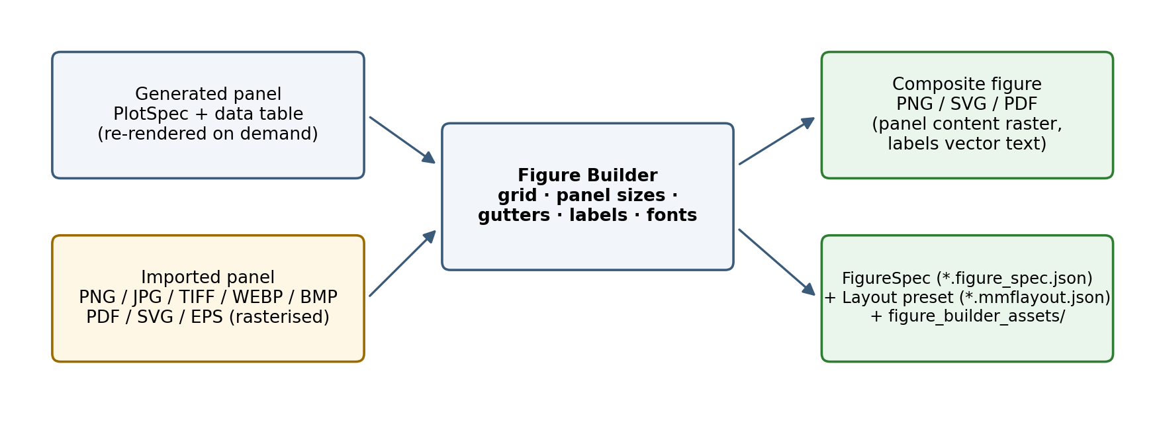
Figure Builder provenance: generated and imported panels, the composite, the FigureSpec and layout preset.

64. Opening it and adding panels
Render a plot, then Save current plot as panel (5. Export / 6. Multi-panel figure group); the counter shows N panels saved. Add to Figure Builder on a recommendation card does the same for that recommended plot. Then Open Figure Builder….
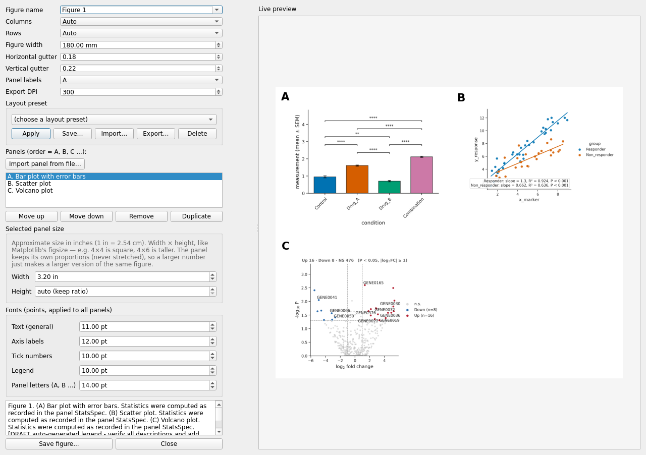
Figure Builder (desktop).

65. Importing external panels
Import panel from file…: PNG, JPG/JPEG, TIF/TIFF, WEBP, BMP directly; PDF, SVG and EPS when the optional import-panels extra is installed (pip install -e ".[import-panels]": PyMuPDF and cairosvg) — those are rasterised at 300 dpi on import. The file is copied into a managed assets folder and recorded (original name, dimensions, DPI, checksum, page). Imported panels have their own controls: fit mode (contain / fill / crop / stretch), crop fractions, rotate (0/90/180/270), flip, auto-trim, background, border, and annotations in normalised coordinates. Publication-readiness warnings flag low resolution or stretching.

66. Layout controls
Control | Effect
Figure name | title used in the draft legend and file names
Columns / Rows | grid (Auto derives one from the panel count)
Figure width (mm) | overall width; 89 mm ≈ single column, 180 mm ≈ double
Horizontal / Vertical gutter | spacing between cells (fractions)
Panel labels | A B C / a b c / 1 2 3, bold, top-left of each panel
Export DPI | raster DPI for the embedded panel content
Selected panel size — Width / Height (inches) | the panel’s cell size; proportions are preserved (never stretched); Height auto follows the panel’s own ratio
Move up / Move down / Remove / Duplicate | order = label order
Fonts (points, applied to all panels) | text, axis labels, tick numbers, legend, panel letters
There is no free x/y positioning, z-order or snap grid: the builder is a grid with per-cell sizes and width/height ratios derived from the widest/tallest panel per column/row.
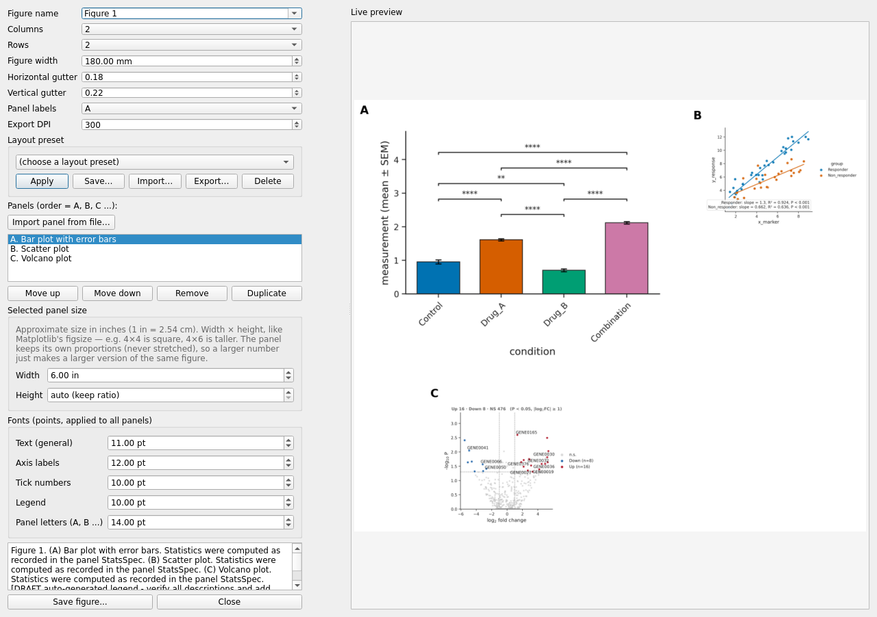
Figure Builder after widening panel A and setting a 2 × 2 grid.

67. Layout presets
Layout preset group: Save… (grid, gutters, width, label style, fonts, per-panel sizes — no panel content), Apply to the current panels (sizes are applied positionally; a count mismatch is reported), Import… (a .mmflayout.json, or a .figure_spec.json whose geometry is taken and panels left behind), Export…, Delete. Files use format make_my_figure.figure_layout_preset in the same library folder as figure presets.

68. Export and FigureSpec
Save figure… writes PNG (and SVG and PDF alongside) at the export DPI, plus name.figure_spec.json (panels with PlotSpecs, stats specs, sizes, imported-asset records, layout, auto-drafted legend text — verify the draft before use). Imported assets are copied to figure_builder_assets/ next to the figure. The FigureSpec records the panels’ table identities, not their values. Save Figure Package… writes one .mmfpackage with the FigureSpec, every panel’s PlotSpec/StatsSpec, the exact tables and the imported images; Open Figure Package (landing page or File menu) rebuilds the composite in the Figure Builder with its layout (§63a).
Warning: the composite embeds each panel as a raster image at the export DPI; only panel letters and titles are vector text, even in the SVG/PDF. For fully vector output export single plots directly.

69. Browser Figure Builder
Inside the guided Matrix workflow, step ⑤ Figure Builder lists the panels generated in that session, takes a Columns value and Compose multi-panel figure offers PNG/SVG/PDF downloads; Clear Figure Builder empties it. Per-panel sizing, imports and layout presets are desktop-only.

Part XVII — Exporting

70. Formats
Format | Raster/vector | DPI | Text | Transparency | Size | Recommended use
SVG | vector | — | editable (svg.fonttype: none) | background is part of the figure | small for line/point plots; large for dense heatmaps | further editing in Illustrator/Inkscape; journals accepting SVG
PDF | vector | — | editable, fonts embedded as Type 42 | as SVG | as SVG | manuscript submission, print proofs
EPS | vector | — | Type 42 | no | as PDF | legacy submission systems
PNG | raster | 150–600 (Raster DPI) | rasterised | white background | grows with DPI² | slides, quick sharing, journals requiring raster
TIFF | raster, LZW-compressed | as PNG | rasterised | white | larger than PNG | journals requiring TIFF
All exports use a tight bounding box that also includes the axis labels and title, so a long axis label is never clipped. Desktop buttons: Export SVG / PNG / PDF (figure file only), Export PlotSpec JSON (specification only), Save Figure Package (.mmfpackage), Export all as ZIP (SVG, PNG, PDF, name.plot_spec.json, name.stats_spec.json when statistics ran, and name.mmfpackage; TIFF/EPS are available through the core API). Browser: SVG / PNG / PDF / PlotSpec JSON / Figure Package downloads (plus StatsSpec JSON when statistics ran). The Figure Builder exports PNG + SVG + PDF + name.figure_spec.json with panel content embedded as raster at the export DPI, and Save Figure Package… for the portable composite.
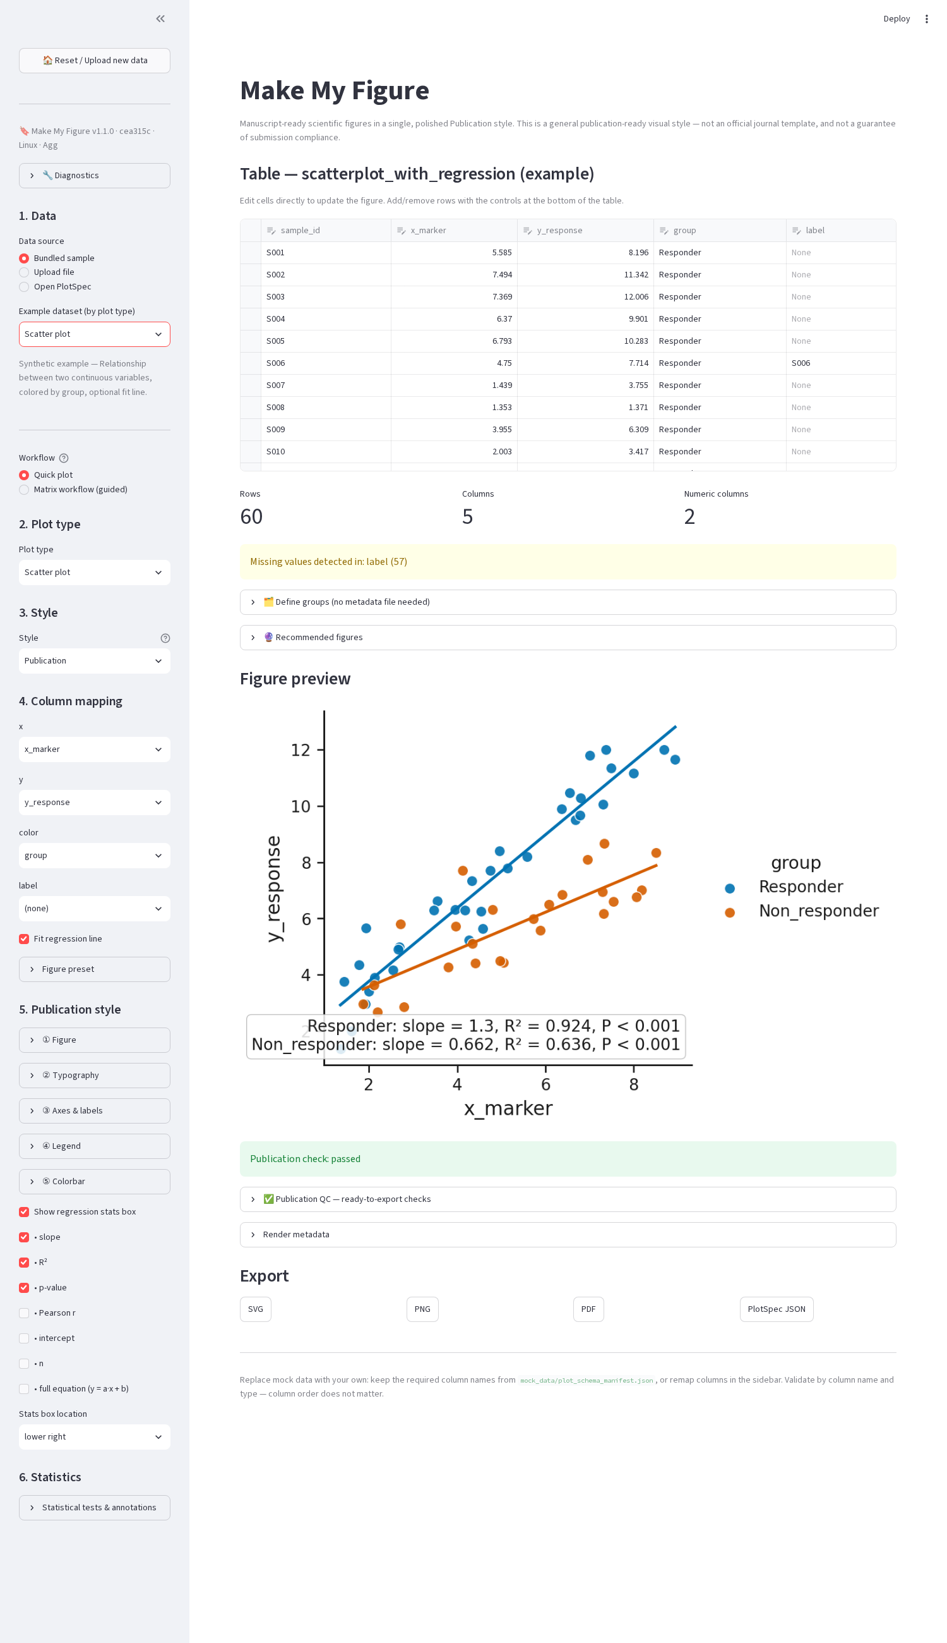
Browser: figure preview with the Export downloads (SVG, PNG, PDF, PlotSpec JSON).

71. Practical notes
- Exporting the same figure twice from the same PlotSpec and code gives the same content; file bytes may differ by timestamps.
- Choose the Figure width preset to match the journal column before exporting; fonts are then at their true point sizes.
- Very large PNGs (600 dpi, double column) can exceed 20 MB; 300 dpi is the usual requirement.

Part XVIII — Multi-sheet Excel workbooks

72. Workflow
- Upload a .xlsx/.xlsm/.xls (desktop: Open data file… or drag-and-drop; browser: Upload file).
- The 📑 Worksheet box lists every sheet in workbook order, including empty and notes sheets, and marks hidden ones. The active sheet loads first.
- Inspect: each sheet shows a detected type and reason — differential_results (fold-change + p/FDR columns), matrix, metadata, enrichment, documentation (mostly text or blank), generic, empty, unknown. This is advisory: any sheet can be plotted.
- Switch sheets in the box; mapping controls rebuild for the new columns, and the header-row choice (browser) applies per sheet.
- Provenance: the PlotSpec source block records the workbook name, file hash, sheet name/index/type and header row; export file names start with the worksheet name (<Sheet>_<plot_type>.png).
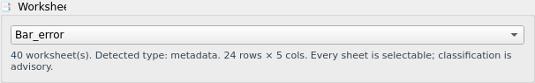
Desktop: the Worksheet chooser for the bundled example workbook.
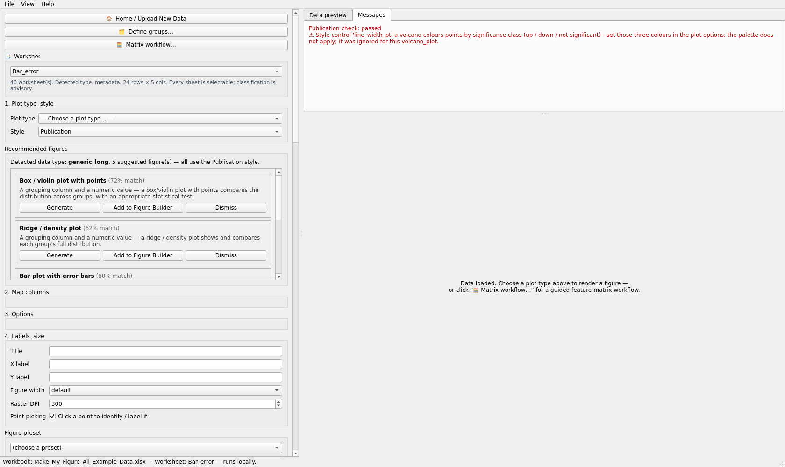
Desktop with the workbook loaded: worksheet box, preview and figure.
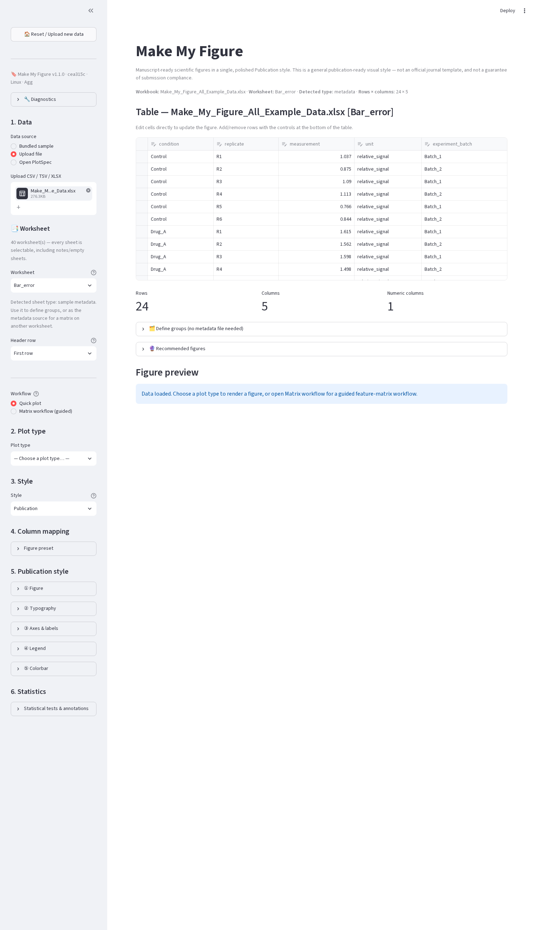
Browser workbook browser with the bundled example workbook (40 sheets).
Several DE comparison sheets in one workbook: plot each as a volcano from its own sheet; the exported PlotSpecs differ only in the sheet name and can be opened side by side in the Figure Builder.

Part XIX — Differential results

73. Input
One row per feature with a feature ID (gene, protein, peptide), a log fold change (logFC, log2FoldChange), a p-value (P.Value, pvalue), optionally an adjusted p / FDR (adj.P.Val, padj) and an average abundance (AveExpr, baseMean, logCPM). These headers are recognised (edgeR, limma, DESeq2 conventions) and prefilled; you confirm them in Map columns.

74. Plots
- Volcano — x = log fold change, y = −log10 p (or FDR when P column is FDR/adjusted is ticked). log2FC cutoff and p-value / FDR cutoff draw the threshold lines and colour classes (up / down / not significant). Labels: top-N by extremity, a pasted list, or click-picked points; duplicate-label policy as in Part XIII.
- MA — x = average abundance, y = log fold change, coloured by significance at the p_cutoff.
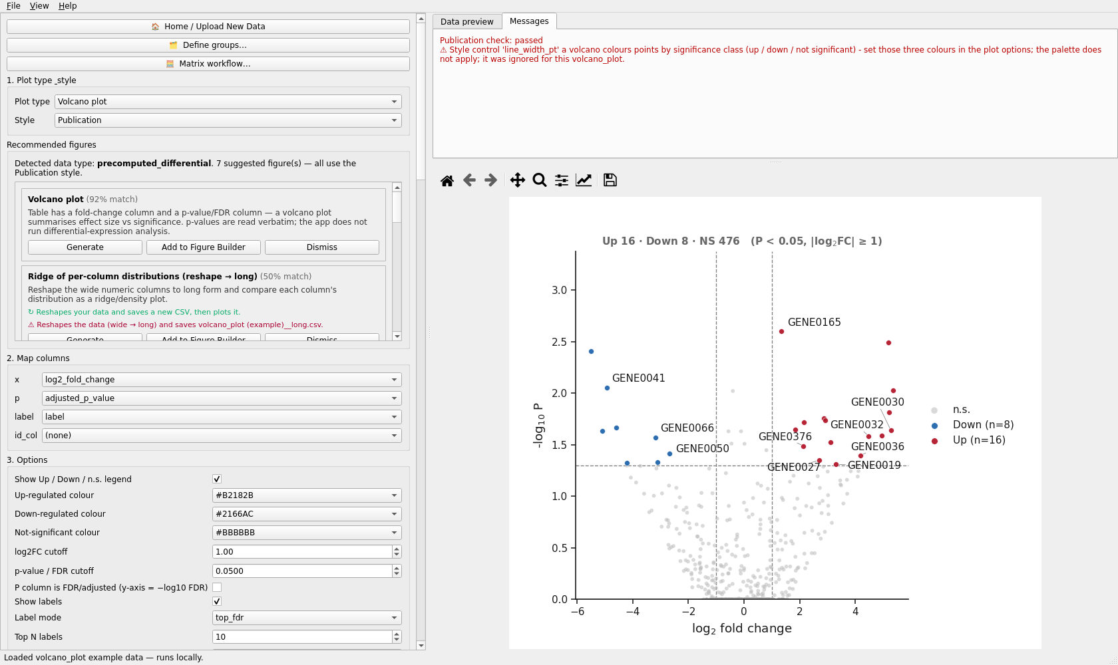
Desktop volcano editor.

75. Raw p versus FDR
The y axis plots whatever column you mapped to p. Tick P column is FDR/adjusted so the axis label says FDR and the cutoff is interpreted on the adjusted scale. Nothing is recomputed: Make My Figure does not replace specialist differential-expression inference (DESeq2, edgeR, limma). It reads the values you provide. The Matrix Workflow’s differential summary is a per-feature t/Mann-Whitney/ANOVA screen on a normalised matrix, labelled as such.

Part XX — Performance and large datasets
- Rendering runs in background workers on the desktop; continuous controls are debounced so dragging a slider triggers one render.
- Heatmap / clustering: rows are capped at max_features = 2 000 by default (adjustable 50–50 000), chosen by variance; highlighted rows survive the cap. Integer annotation columns are dropped from the value matrix and reported.
- Volcano / MA with ~50 000 rows: rendering is fast; labelling is the cost — keep top-N labels modest (tens), use the duplicate-label policy unique, and prefer PNG for previews.
- Networks: filter with min_weight / corr_cutoff / top_n_edges / min_degree before layout; use seed for reproducible layouts.
- Browser app: each control change re-runs the script; large tables make every interaction slower — pre-filter, or use the desktop app.
- Windows first launch of the packaged app is slow while the bundle is unpacked and scanned; later launches are quicker. See docs/WINDOWS_PERFORMANCE.md.
No timing figures are quoted here because none were benchmarked for this manual.

Part XXI — Cross-platform notes
 | macOS | Windows | Linux | WSL
Native desktop | packaged .dmg or source | .exe installer / zip or source | AppImage / tar.gz or source (needs Qt libs) | source; needs WSLg or an X server
Browser app | source | source | source | source (open the URL from Windows)
Fonts | Arial/Helvetica present | Arial present | DejaVu Sans fallback | DejaVu Sans
Paths | ~/Library/Application Support/MakeMyFigure/presets | %APPDATA%\MakeMyFigure\presets | ~/.local/share/make_my_figure/presets | as Linux
Known | unsigned bundle needs right-click → Open | SmartScreen prompt; slower first launch | missing libxkbcommon etc. on minimal images | no display → use the browser app
Figures rendered on different platforms differ slightly in font metrics and spacing; the style is the same, the pixels are not guaranteed identical. Emoji in button labels depend on an installed emoji font.

Part XXII — Troubleshooting
Each entry: Problem · Likely cause · Diagnose · Fix.
- App does not start (desktop). Qt binding missing or unloadable. Run python -c "import PySide6.QtWidgets"; the app prints the exact apt install list on Linux. Fix: pip install -e ".[desktop]"; install the Qt system libraries; or use the browser app.
- Python not found / py not recognised (Windows). Python not on PATH. Reinstall Python ticking Add to PATH, or use the full path to python.exe.
- libxkbcommon.so.0: cannot open shared object file. Minimal Linux/WSL image. Install the listed Qt libraries.
- PowerShell refuses to activate the venv. Execution policy. Set-ExecutionPolicy -Scope Process RemoteSigned, then activate.
- WSL: no window appears. No display. Use WSLg (Windows 11) or the browser app.
- Banner shows an old commit / features missing. An installed package shadows the checkout. python -m pip install -e . in the checkout; confirm with the banner.
- ModuleNotFoundError: pandas although a venv seems active. Stale venv label or wrong interpreter first on PATH. Deactivate everything; create and activate a fresh venv in the project folder.
- numpy.dtype size changed on macOS. Two environments stacked. One fresh venv.
- pip fails compiling a PySide6 template. Old interpreter. Use Python 3.10+ and pip install --no-compile.
- Wrong worksheet plotted. Active sheet loaded by default. Choose the sheet in 📑 Worksheet; check the source block of the PlotSpec.
- Plot selector blank / “Choose a plot type…”. By design after upload: pick a plot type or a recommendation.
- Figure does not change when I move a control. The control does not apply to this plot (a notice says so), or the Publication style group is unticked (desktop). Tick the group; check Messages.
- Statistics slow. Many groups × many comparisons with post-hoc; reduce comparisons (vs control) or groups.
- Stale figure after an error. The app clears the figure on error and shows the message; fix the mapping and re-render.
- Preset “cannot be applied”. A full preset for another plot type. Save a style preset for cross-type reuse, or open the matching plot type.
- Preset applied but a column role is empty. The new table lacks that column; the app listed it — choose one in Map columns.
- Missing font. The requested family is not installed; Matplotlib falls back to DejaVu Sans. Install the font or choose one installed.
- PDF looks different from the screen. Font substitution or DPI; the vector export is authoritative. Check fonts and the width preset.
- Labels overlap. Reduce top-N, enable unique duplicate policy, enlarge the figure width, or reposition (browser offsets / PlotSpec).
- Large heatmap slow. Rows above max_features are trimmed by variance; lower max_features or pre-filter.
- Figure Builder panel clipped or blurry. Panel too small for its content or raster DPI too low; increase its width or the Export DPI; import vector files with the import-panels extra.
- Excel header wrong. Title rows above the header, or merged/stacked headers. Browser: choose the header row / two stacked rows, tick forward fill; desktop: remove the title rows first.
- “Survival probabilities as event column” error. You mapped an already-computed curve as a 0/1 event column. Set Input form → precomputed and pick the S(t) columns.

Part XXIII — Reproducible lab workflows
1. Same scatter style across experiments. Finalise one scatter (fonts, palette, fit statistics shown, legend outside right). Save preset Lab scatter (style). For every later experiment: load, choose Scatter plot, map x/y/colour, Apply Lab scatter, export. Only the mapping and title are ever set by hand.
2. Reusable heatmap preset. As §60: Lab Heatmap (style) carries colormap, cell borders, colorbar position and fonts; the clustering method and value columns remain per dataset.
3. DE result → volcano → preset → Figure Builder. Load the DE table (or the DE sheet of a workbook), confirm the detected columns, set thresholds and class colours, label top genes, save Lab volcano (full, to keep thresholds). Save current plot as panel for each comparison, then compose in the Figure Builder with a 1 × 3 grid; save the layout preset Three volcanoes.
4. Matrix → QC → transformation → PCA/heatmap. Matrix Workflow: map, confirm raw scale, groups from metadata, log2 → median_scale → row_zscore steps, Run diagnostics, save the before/after report, Open in plot editor for the heatmap and PCA; the PlotSpecs carry the preprocessing identifiers and method sentence, and Save Figure Package stores the MatrixSpec, SampleMetadataSpec, PreprocessingSpec, the original and the derived matrix with the plot.
6. Sharing a reproducible figure with another laboratory. Finalise the plot → Save Figure Package → send the one .mmfpackage file → the collaborator opens Make My Figure → Open Figure Package → integrity is verified → the figure opens with the frozen data and configuration → they inspect, edit and re-export. No original data file, worksheet or sidecar folder is needed.
5. Multi-sheet workbook → several comparisons → separate exports. Upload once; for each DE sheet choose it, apply Lab volcano, export — file names start with the sheet name and each PlotSpec’s source names the sheet.

Part XXIV — Files generated by Make My Figure
<Sheet>_<plot_type>.png / .svg / .pdf / .tiff / .eps the figure(s); the stem is the worksheet
name (or the file stem) plus the plot type
<stem>.plot_spec.json PlotSpec + render metadata (Export PlotSpec JSON, ZIP, browser)
<stem>.stats_spec.json every statistical result (ZIP and browser, when statistics ran)
<stem>.mmfpackage figure package: specification + frozen data + records + previews
+ manifest with SHA-256 per file (Save Figure Package; also in the ZIP)
Figure_1.png / .svg / .pdf Figure Builder composite
Figure_1.figure_spec.json FigureSpec (panels, PlotSpecs, layout, draft legend; table identities only)
Figure_1.mmfpackage composite figure package (FigureSpec + panel specs + tables + images)
figure_builder_assets/ copies of imported panel files
<table> (grouped) / <table>__diff.csv grouped table / differential screen (Define groups)
<report folder>/before_after_contact_sheet.pdf, .png Matrix Workflow before/after QC report
+ one vector file per QC plot
<name>.csv, <name>.md statistics table and method report (you name them)
<preset library>/*.mmfpreset.json Figure presets (per-user folder, Part XIV)
<preset library>/*.mmflayout.json Figure Builder layout presets

Part XXV — Limitations
- Publication is a general style, not an official journal template; it does not guarantee acceptance.
- Statistical design and method choice remain the researcher’s responsibility; suggestions are advisory; Dunnett’s test is not implemented.
- No DE inference; DE values are read verbatim. The Matrix Workflow differential summary is a screen.
- Very large matrices are trimmed by variance (max_features); very large networks need filtering.
- Figure Builder composites rasterise panel content; no free positioning or z-order; the browser builder is columns-only.
- Desktop: no header-row selector, no drag-to-move for labels; browser: no font-family control, no EPS/TIFF buttons.
- Colour choices are from curated lists (no colour picker); per-category manual colour maps only for network nodes.
- The recommendation engine is rule-based.
- No transformation is ever applied silently; conversely nothing is auto-normalised for you.
- Cross-platform font differences; no byte-identical guarantee.
- Packaged v1.1.1 installers are built from the same tagged source as this manual; the two cosmetic Qt defects below are present in them as well.
- Statistics annotation is not available on the line/time-course plot.

Part XXVI — Glossary
- PlotSpec — the JSON record of one figure: plot type, table, roles, options, style, layout, statistics, annotations, provenance.
- StatsSpec — the JSON record of the statistical results drawn on / computed for a figure.
- MatrixSpec — the confirmed structure of a feature × sample matrix (feature id, value columns, value scale, policies).
- PreprocessingSpec / PreprocessingStep — the ordered, confirmed transformation steps applied to a matrix, with QC before/after.
- SampleMetadataSpec — the sample → group (and other attribute) assignment used by the Matrix Workflow.
- FigureSpec — the JSON record of a multi-panel composite (panels, PlotSpecs, layout, legend draft).
- Figure preset — reusable configuration without data: style-only or full configuration.
- Figure package — one portable .mmfpackage file: PlotSpec/FigureSpec + frozen data + StatsSpec/Matrix/Preprocessing records + assets + previews + checksums; reopens without the original files.
- Layout preset — reusable Figure Builder geometry without panel content.
- Derived matrix — a new table produced by preprocessing or grouping; the source table is unchanged.
- Publication style — the single visual style profile (tokens for fonts, widths, palette).
- Mapping — the assignment of table columns to plot roles (and the plot’s options).
- Recommendation — an advisory plot suggestion with score and reason from the table’s shape.
- Annotation identity — a picked point is remembered by row identity (volcano/MA) or label text (other plots) so labels survive re-rendering.

Part XXVII — Quick reference
Input format → workflow
Format | Workflow
CSV/TSV/TXT long table | Quick plot: map x/y/group
Excel single sheet | as CSV; merged headers recovered
Excel multi-sheet | choose the worksheet; each has its own header row and provenance
Feature × sample matrix | Quick plot (heatmap/PCA) or Matrix Workflow (QC, preprocessing, groups)
Wide columns of unequal length | Histogram (Input form → wide) or Define groups → grouped table
Precomputed DE table | Volcano / MA
Subject-level survival | Kaplan-Meier (subject_level) · Precomputed S(t)
Data type → recommended plots — see Part VI §25.
Plot → required columns — see Part X (each section’s Column mapping).
Statistics → required data
Method | Data
t-tests, Mann-Whitney | numeric value + group column with two levels (paired: + subject id)
ANOVA / Kruskal / Dunn | numeric value + group (≥ 3 levels); two-way: + subgroup; RM: + subject
Chi-square / Fisher | two categorical columns
Pearson / Spearman / regression / GLM | two numeric columns (GLM: several predictors)
Log-rank / Cox | time, 0/1 event, group (subject-level)
Export format → use — see Part XVII §70.
Specification → purpose
File | Purpose
.plot_spec.json | the recipe of one figure (needs the source data)
.stats_spec.json | every statistic behind it
.figure_spec.json | the recipe of a composite (needs the panel tables)
.mmfpackage | reopen a figure or composite anywhere: recipe + frozen data
.mmfpreset.json | reuse a configuration on new data
.mmflayout.json | reuse a composite layout
Preset type → purpose
Preset | Carries | Use when
Figure style only | fonts, palette, geometry, legend/colorbar, export, visual options | “make all our figures of this kind look like this”
Full figure configuration | + roles, thresholds, labels, statistics, annotations | repeat the same analysis on the next dataset
Layout preset | grid, sizes, gutters, labels, fonts | reuse a multi-panel arrangement

