**NFT-Metaverse-Demo**

**About Project:-**

The project **NFT-Metaverse** is - a digital marketplace.

When a user puts an item for sale, the ownership of the item will be transferred from the creator to the marketplace.

When a user purchases an item, the purchase price will be transferred from the buyer to the seller and the item will be transferred from the marketplace to the buyer.

The marketplace owner will be able to set a listing fee. This fee will be taken from the seller and transferred to the contract owner upon completion of any sale, enabling the owner of the marketplace to earn recurring revenue from any sale transacted in the marketplace.

The marketplace logic will consist of two smart contracts:

**NFT Contract** - This contract allows users to mint unique digital assets.

**NFTMarket Contract** - This contract allows users to put their digital assets for sale on an open market.

**What is a Non-Fungible Token?**

A Non-Fungible Token (NFT) is used to identify something or someone in a unique way. This type of Token is perfect to be used on platforms that offer collectible items, access keys, lottery tickets, numbered seats for concerts and sports matches, etc.

**What is ERC-721?**

The ERC-721 introduces a standard for NFT, in other words, this type of Token is unique and can have different value than another Token from the same Smart Contract.

All NFTs have a uint256 variable called tokenId, so for any ERC-721 Contract, the pair contract address, uint256 tokenId must be globally unique.

**NPX install credential**

**--------------------------------**

npx create-react-app react-dapp

npm install ethers hardhat @nomiclabs/hardhat-waffle ethereum-waffle chai @nomiclabs/hardhat-ethers

npx hardhat

npx hardhat compile

npm i react-router-dom

npm i web3modal

npm i ipfs-http-client

npx hardhat run scripts/deploy.js --network goerli

npm start

npm install @openzeppelin/contracts

npx hardhat node

npm i bootstrap

**Project Demo**

**Home Page Screenshot**

**NFT Contract Address** : 0x9a4e65D00ab3C7A103058217F173a467C5056d8e

**NFT Market Contract Address** : 0x37239103587f90fa0C2763e45911036979bB6a52

**Test net** : Goerli

**Wallet** : Mata mask

**Development Tool**: Hardhat

**Front End** :React js

**Token Name** :DABLU PRASAD

**Symbol** : DP

**For Interaction between frontend and smart contract :** Ether js

1. **Sell Digital Asset**

Sell Digital Asset tab is used to create NFT on Marketplace for sell.

**Step1:-** Click on Sell Digital Asset Tab.

**Steps 2:** then, new component is open ,where you feed name,description,price and choose file for make NFT,then click on Sell_Digital_Asset.

**Step3:** then, click on two confirm button of metamask, one for create NFT confirmation and second for createMarketitem confirmation.

**Finally:-**you create two hash of both transections, given below:-

**1)Transaction Hash:**

0xf0b7eb816c15d06b16adb9d98b843324a51fef4a4c51af22aaadad12dd5f1d38

**2)Transaction Hash:**

0x0651a3207e6f5b5c9625647efd309bd1e9be70c47b0108afd47fa385a0042f47

1. **Home Page**

When click on home button where you see all created marketplace item for sell, if other person interested to purchases item click on buy button of item.

**Steps1:** click on Home Tab button

**Steps 2:** then, new component is open where see created marketplace item

**Steps 3:** then , if someone interested to purchases item click on buy button.

**Step4:** click on confirm button of matamask.

**Finally:** We get transection hash, given below.

**Transaction Hash:**

0x3fd3e67b218f166a74ddbd1bb98fccba801b2d434ee59d62ce23eb6817923743

**3)My Digital Asset**

All purchases item is showing in My Digital Asset tab

**Step1:** click on My Digital Asset tab

**Step2:** then, see all purchases Digital asset.

1. **Create DashBoard**

When you see all created and sold marketplace NFT, click on Create DashBoard.

**Step1:** click on Create DashBoard

Step2: then, See all Item Created and Sold items on DashBoard

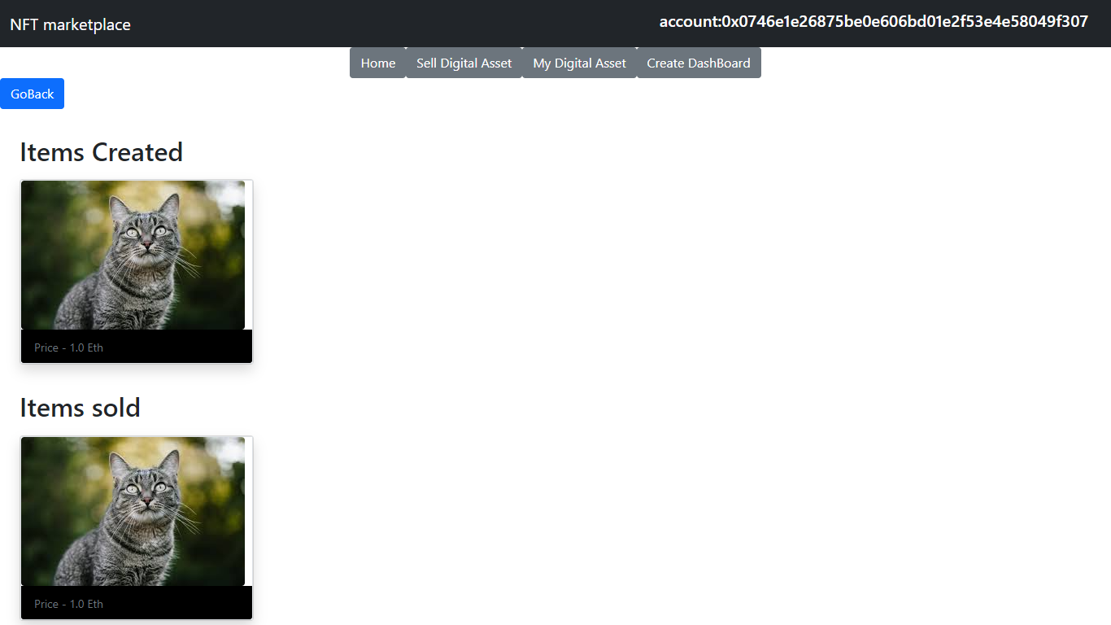

**Thank you**