**MALIGNANT URL DETECTION USING MACHINE LEARNING**

**TECHNIQUES**

*Report submitted to the SASTRA Deemed to be University as the requirement for the course*

**MINI PROJECT**

*Submitted by*

**AJAY N (Reg. No.: 124003018, CSE)**

**PA. SURAAJ VIKAS RAJU (Reg. No.: 124003209, CSE)**

**S SATHYA PRAKASH (Reg. No.: 124003396, CSE)**

**May 2023**

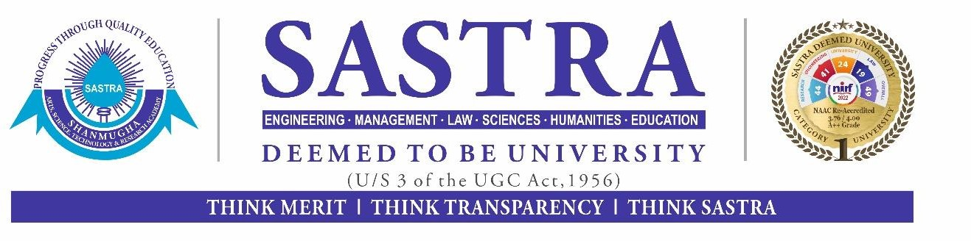

**SCHOOL OF COMPUTING**

**THANJAVUR, TAMIL NADU, INDIA – 613 401**



**SCHOOL OF COMPUTING THANJAVUR – 613 401**

**Bonafide Certificate**

This is to certify that the report titled “**Malignant URL Detection using Machine Learning techniques**” submitted as a requirement for the course, **MINI PROJECT** for B.Tech. is a Bonafide record of the work done by **AJAY N (124003018, CSE), PA. SURAAJ VIKAS RAJU (124003209, CSE), S SATHYA PRAKASH (124003396, CSE)** during the academic year 2022-23, in School of Computing, SASTRA Deemed University.

Project Based Work *Viva voce* held on ___________________________

# Examiner 1 Examiner 2