VISVESVARAYA TECHNOLOGICAL UNIVERSITY

JNANA SANGAMA, BELAGAVI-590018

#### 

*A Mini Project Report on*

“ORGAN DONATION AND PROCUREMENT MANAGEMENT”

Submitted in the partial fulfillment for the requirements for the conferment of degree of

BACHELOR OF ENGINEERING

In

#### **COMPUTER SCIENCE AND ENGINEERING**

#### Submitted By

**Ms. Surabhi Raghavan** USN: 1BY20CS198

**Ms. Thanushree** USN: 1BY20CS207

Under the guidance of

**Mrs. Ambika G.N**

Assistant Professor

Department of CSE, BMSIT&M.



DEPARTMENT OF COMPUTER SCIENCE AND ENGINEERING

# BMS INSTITUTE OF TECHNOLOGY AND MANAGEMENT

**(An Autonomous Institute, Affiliated to VTU, Belagavi**

**Avalahalli, Yelahanka, Bengaluru-560064)**

**2022-2023**

**BMS INSTITUTE OF TECHNOLOGY AND MANAGEMENT**

**(An Autonomous Institute, Affiliated to VTU, Belagavi**

**Avalahalli, Yelahanka, Bengaluru-560064)**

**DEPARTMENT OF COMPUTER SCIENCE AND ENGINEERING**



**CERTIFICATE**

This is to certify that the Mini Project work entitled **“**ORGAN DONATION AND PROCUREMENT MANAGEMENT**”** is a bonafide work has been carried out by **Ms. SURABHI RAGHAVAN (1BY20CS198) and Ms. THANUSHREE (1BY20CS207), bonafide students of BMS Institute of Technology and Management, Autonomous Institute Affiliated to VTU,** in partial fulfillment for the award of **Bachelor of Engineering Degree in Department of Computer Science and Engineering** during the year 2022-23. It is certified that all corrections/suggestions indicated for Internal Assessment have been incorporated in this report. The Mini project report has been approved as it satisfies the academic requirements in respect of Mini project work for the B.EDegree.

**_________________ ______________ __________________**

**Signature of the Guide1 Signature of the Guide2 Signature of the HOD**

**Mrs. Ambika G.N** **Mr. Rajesh N.V** **Dr. Thippeswamy .G**

Assistant Professor Assistant Professor Professor & HOD

Dept. Of CSE Dept. Of CSE Dept. Of CSE

BMSIT&M BMSIT&M BMSIT&M

**Name of the Examiners Signature with Date**

**1.**

**2.**

**ABSTRACT**

The need for organs for donation is far greater than organ availability. In the last decade this has led to restructuring and investment in the organ donation program with political and public support. The majority of transplanted organs are retrieved from patients dying on an intensive care unit, and the wish to consider organ donation as a normal part of end-of-life care has led to considerable pressure on clinicians to adhere to the large amount of practical and ethical guidance being published to achieve this.

**ACKNOWLEDGEMENT**

We are happy to present this Mini project after completing it successfully. This project would not have been possible without the guidance, assistance and suggestions of many individuals. I would like to express my deep sense of gratitude and indebtedness to each and every one who has helped me to make this project a success.

We heartily thank our **Principal, Dr. MOHAN BABU G N,** **BMS Institute of Technology & Management, Autonomous Institute Affiliated to VTU** for his constant encouragement and inspiration in taking up this Mini project.

We heartily thank our **Head of the Department, DR. THIPPESWAMY. G, Dept. of Computer Science** **and** **Engineering, BMS Institute of Technology & Management, Autonomous Institute Affiliated to VTU** for his constant encouragement and inspiration in taking up this Mini project.

We gracefully thank our Project guide**, MRS. AMBIKA G.N, Assistant Professor, Dept. of** **Computer Science and Engineering,** for her encouragement and advice throughout the course of the Mini Project work.

Special thanks to all the staff members of Computer Science Department for their help and kind co-operation.

By,

**Surabhi Raghavan (1BY20CS198)**

**Thanushree (1BY20CS207)**

**CONTENTS**

**Chapters Page no**

Chapter 1: **Introduction** 01

1.1 Background 01

Chapter 2: **Literature Survey** 02

Chapter 3: **Software Requirements Specification** 03

3.1 Hardware requirements 03

3.2 Software requirements 03

Chapter 4: **Design 04**

4.1 ER Analysis: Entity sets and relationship set 04

4.2 Schema Diagram 05

4.3 Entity-Relationship Diagram 06

Chapter 5: **Implementation 07**

5.1 Implementation with Screen shot 07

Chapter 6: **Conclusion & Future Enhancement 09**

6.1 Conclusion 09

6.2 Future Enhancement 09

Chapter 7: **References** 10

**CHAPTER 1: INTRODUCTION**

Organ transplantation is a medical procedure in which an organ is removed from one body and placed in the body of a recipient, to replace a damaged or missing organ. The donor and recipient may be at the same location, or organs may be transported from a donor site to another location.

The Organ Donation and Procurement Network Management System is a database management system that uses database technology to construct, maintain and manipulate various kinds of data about a person’s donation or procurement of a particular organ. It maintains a comprehensive medical history and other critical information like blood group, age, etc of every person in the database design.

Organ Donation and Procurement Organizations play a pivotal role in today’s medical institutions. Such organizations are responsible for the evaluation and procurement of organs for organ transplantation. These organizations represent the front-line of organ procurement, having direct contact with the hospital and the family of a recently deceased donor.

**Organ donation** is the process when a person allows an organ of their own to be removed and transplanted to another person, legally, either by consent while the donor is alive or dead with the assent of the next of kind.

In India, the Transplantation of organs is done according to the Transplantation of Human Organs (THO) Act,1994. Many new rules had been added to the act, later on, to cater to current needs. According to this Act, every transplantation operation should be approved by the Government Organization. Hence, the records of transplantation are there with the organization. Also, these operations can only be done in Government-authorized Hospitals.

Organ Wastage is a major issue that can only be solved by having a proper database of all Patient and Donors in a well-formed way, that can be processed easily. Our aim is to create a solution that effectively deals with the problems of finding donors and also providing statistical data of the transplants that can help the government to form better rules and regulations.

**1.1 BACKGROUND**

The idea of organ donation is not new but unlike today, it was considered to be a myth back in the ancient times. It was only in the middle of the eighteenth century that the possibility was realized.

One of the major challenges that the early transplant surgeons faced was the resistance from the immune system. The immune system is built into our body to fight ‘alien' components that the body thinks to be harmful. The same happened when an attempt at transplantation was made. Now the question faced by the doctors was that how to deal with this issue. A few years later, it was discovered that some drugs could lower the body's guard-thus the immune system. It did put the patients at risk of certain infections but it also made transplant possible.

In 1960, Dr. Peter Medawar introduced a way of typing tissue (similar to the blood typing of the 1900s) and soon tissue typing along with immune system suppression was used to carry out an organ transplant. The invention of an immunosuppressant drug named ‘cyclosporine' made a major breakthrough in the 1980s. In 1986, 9000 kidney transplants were performed in the United States that a good survival rate of 85% in the first year.

The overall success and public acceptance of organ donation and transplant today is thanks to multidisciplinary teams of basic scientists, immunologists, surgeons, and public advocates. Today, research is propelling the field forward with advancements like face transplants, experiments of lab-grown organs, and much more. In the United States alone, over 800,000 patients have had their lives saved or significantly improved thanks to transplant since national recording began by the Organ Procurement and Transplant Network in 1988.

Records of donor and patients are created when a person donates or procures an organ from a Medical Institution. Records may include the following information:

1. Personal Information

2. Medical History

3. Medical insurance, if any

4. Allergies to any medicine, if any

5. The need for an organ presently

6. Medical Insurance provided by any private or government insurers.

7. Address

This record serves a variety of purposes and is critical to the proper functioning of Organ Donation and Procurement Network, especially in today’s complicated health care environment. These records provide statistical information regarding the number of organs needed and available at a particular point of time. It is essential for planning, evaluating and coordinating organ donation and procurement.

**CHAPTER 2: LITERATURE SURVEY**

This study systematically located and appraised peer-reviewed evidence for the efficacy of strategies to increase organ donation decision communication among adults including an assessment of study quality to guide future research in this field. There is little room to move in strengthening unanimously positive public attitudes toward organ donation. Consequently, researchers have called for a focus on organ donation decision communication to understand modifiable factors to increase organ donation rates.

Multiple databases were searched during September 2015, and 44 studies were selected for inclusion. Data concerning participants, design, and outcomes were extracted. Studies were rated for quality and levels of evidence. Although not amenable to meta-analysis, the literature indicates that approximately 50% of adults who are willing to become an organ donor have discussed this decision with family. The majority of research was conducted in a Western context with an overrepresentation of students. Strategies to increase communication include education, motivation, input from lived experience, efforts to address salient audience beliefs, and scheduled reminders or prompts. Intentions and willingness to discuss organ donation were consistently positively related to discussion behavior; however, formative research and experimental studies testing theoretically driven interventions were scarce.

There is mixed evidence for the role of demographic and attitudinal characteristics in the success of organ donation communication interventions. Additional theoretically based research is recommended to establish boundary conditions and validate strategies to increase organ donation decision communication among adults.

The 2019 National Survey was completed by 10,000 U.S. adults online or by phone. Key findings include:

1)Current support for organ donation

2)Number of registered donors and mean of registration

3)Discussion with family members about organ donation and their wish

4)Beliefs about organ donation and transplantation

5)Allocation of organs by medical urgency or geographic location

6)Sources of information on organ donation in the past year

**HARDWARE AND SOFTWARE REQUIREMENTS**

**HARDWARE REQUIREMENTS**

The following are the minimum hardware requirements for the task management software:

* Dual Core 2nd generation
* RAM -4GB
* HDD- 80GB
* Windows 7/8/8.1/10

**SOFTWARE REQUIREMENTS**

The following are the minimum software requirements for the task management system:

* Platform- VS Code or any other platform that supports localhost launching
* Front end –
  + HTML
  + CSS
* Back end-
  + Flask
  + Python
* Server database-
  + MySQL
* Strong server connection

**DESIGN**

Every user has an account with can only be registered by a government certified hospital, which will keep all the information as defined in Problem Statement. Only Hospitals are eligible to request for a donation or procurement transaction. Government organizations will keep a watch on the pairing of donors and Patients and can approve a transplantation operation if all the rules are satisfied. Collecting Statistical Data through the history of Transplantation Transaction.

**ER Analysis: Identifying Entity Sets and Relationship Sets:**

**Entity Sets:**

**A) User:**

1. User ID

2. Name

3. Date of birth

4. Phone Number (multi-valued)

5. Medical Insurance

6. Medical History

7. Address

**B) Patient:**

1. Patient_ID

2. Organ Required

3. Reason of procurement

4. User_ID ( foreign key)

**C) Donor:**

1. Donor_ID

2. Organ Donated

3. Reason of donation

4. User_ID (foreign key)

**D) Organ Available:**

1. Organ_ID

2. Organ Name

3. Donor_ID (foreign key)

**E) Organization:**

1. Organization ID

2. Organization Name

3. Location

4. Government approved organization or not

5. Phone Number (multi-valued)

**F) Doctor:**

1. Doctor ID

2. Doctor Name

3. Phone Number (multi-valued)

**G) Organization Head:**

1. Head Name

2. Date of Joining

3. Term Length

**Relationship Sets:**

1. **Donates –** The act of donation of an organ from a donor

a) Date – Date of donation

2. **Procures -** The act of procuring an organ by the patient

3. **Transaction**

a) Date of transaction

b) Status – whether the surgery was successful or not

4. **Organ Donated -** The organ donated by a donor, which is then stored in Organ available table.

5. **Attended By** -The transplantation performed by doctor – procuring an organ from a donor and transplanting it to the patient by surgery.

6**. Registers** - Donor is registered in which organization

7. **Works in –** The organization where the doctor works.

8. **Headed By –** The organization is headed by which person

**SCHEMA DIAGRAM:**

**User**

|  |  |  |  |  |  |  |
| --- | --- | --- | --- | --- | --- | --- |
| **User_ID** | **Name** | **DOB** | **Phn_No** | **Med_ins** | **Med_His** | **Address** |

**Patient**

|  |  |  |  |
| --- | --- | --- | --- |
| **Patient_ID** | **Organ_Requires** | **Reason** | **User_ID** |

**Donor**

|  |  |  |  |
| --- | --- | --- | --- |
| **Donor_ID** | **Organ_Donated** | **Reason_Of_Don** | **User_ID** |

**Organ Available**

|  |  |  |
| --- | --- | --- |
| **Organ_ID** | **Organ_Name** | **Donor_ID** |

**Organization**

|  |  |  |  |  |
| --- | --- | --- | --- | --- |
| **Org_ID** | **Org_Name** | **Location** | **Govt_Approved** | **Phn_No** |

**Doctor**

|  |  |  |
| --- | --- | --- |
| **Doctor_ID** | **Doctor_Name** | **Phn_No** |

**Organization Head**

|  |  |  |
| --- | --- | --- |
| **Head_Name** | **Date_Of_Joining** | **Term_Length** |

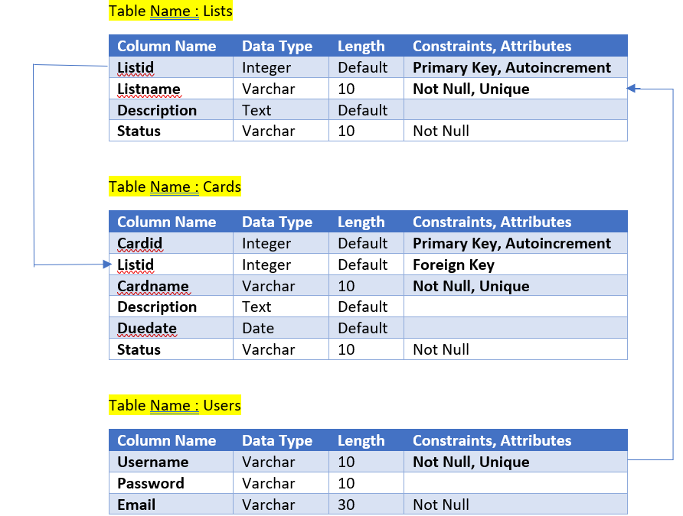

**ER DIAGRAM**

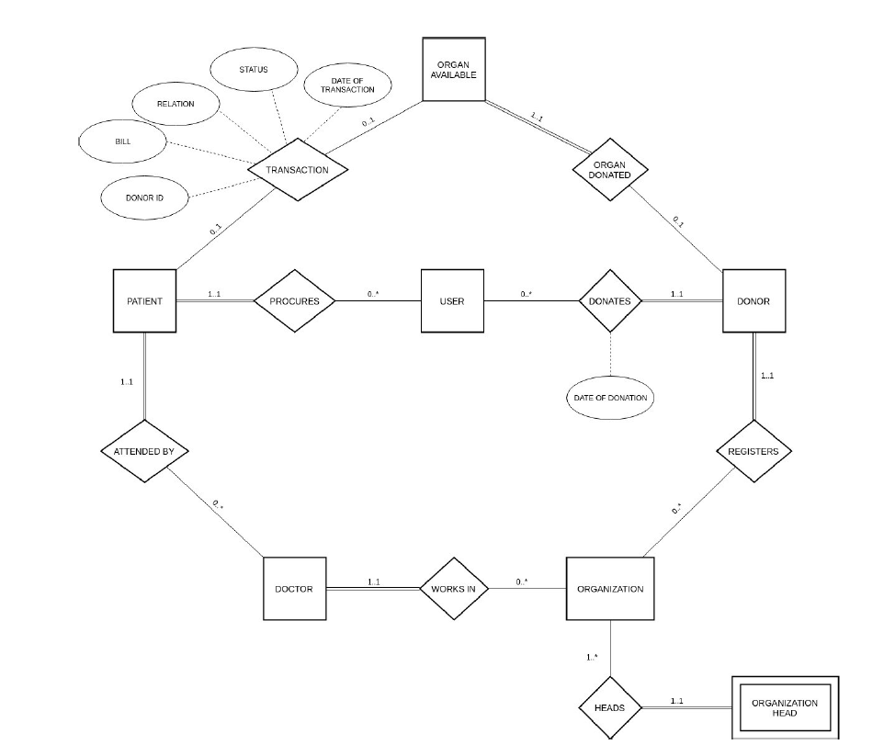

**IMPLEMENTATION**

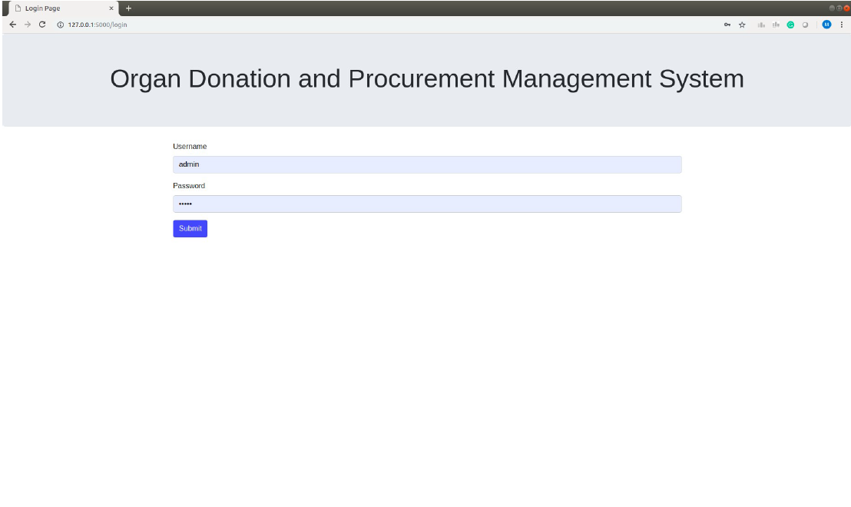

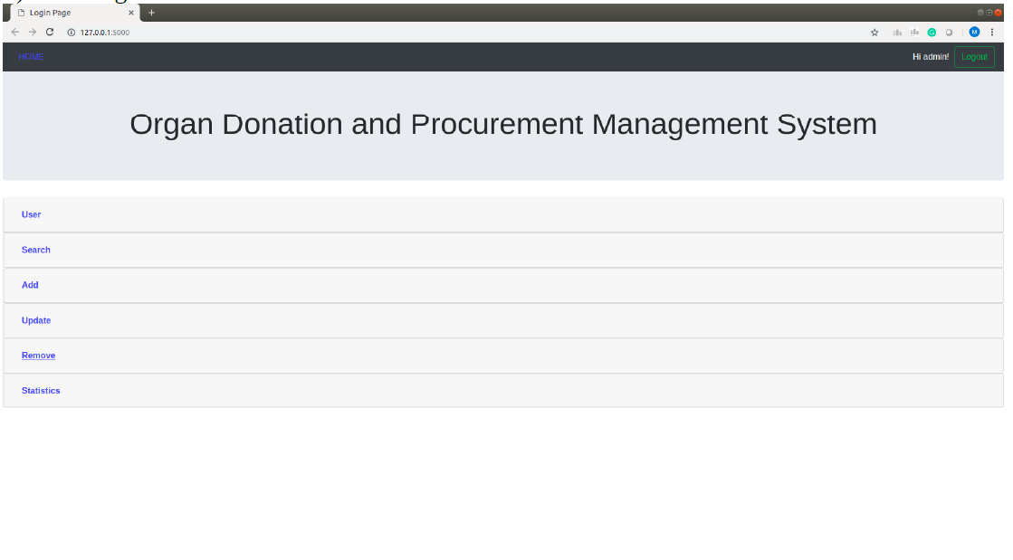

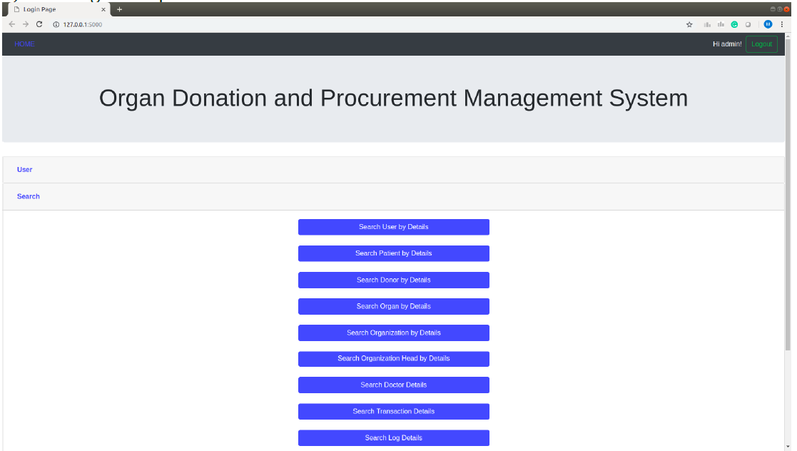

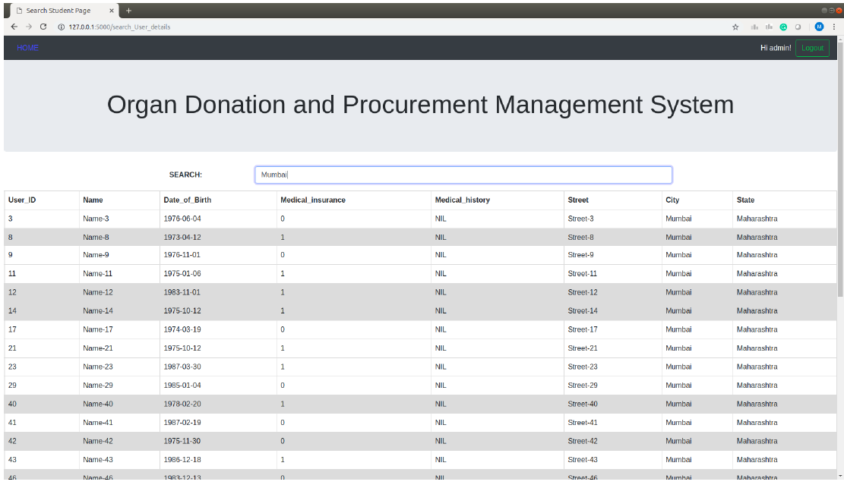

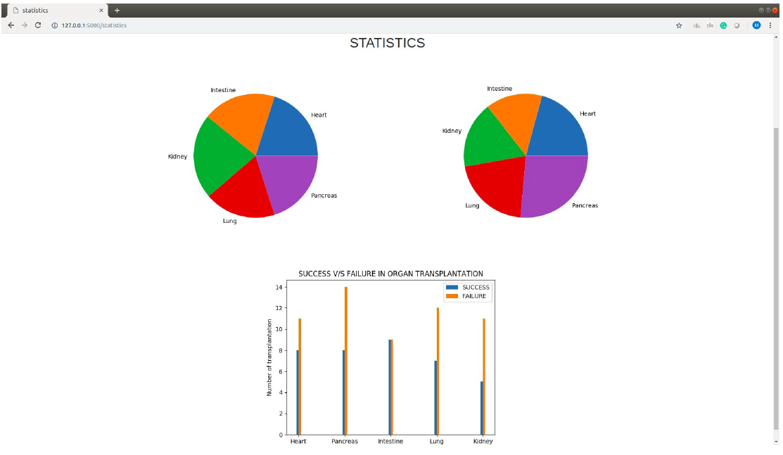

**CONCLUSION**

Organ donation is significantly beneficial for medical science research. Donated organs offer an excellent tool for conducting scientific researches and experiments. Furthermore, many medical students can greatly benefit from these organs. Most noteworthy, beneficial medical discoveries could result due to organ donation. Organ donation would also contribute to the field of Biotechnology. To sum it up, organ donation is a noble deed. Furthermore, it shows the contribution of an individual even after death. Most noteworthy, organ donation can save plenty of lives. Extensive awareness regarding organ donation must certainly be spread among the people. Organ Wastage is a major issue that can only be solved by having a proper database of all Patient and Donors in a well-formed way, that can be processed easily. Our aim to create a solution that effectively deals with the problems of finding donors and also providing Statistical data of the transplants that can help the government to form better rules and regulations. Registering for organ donation is a hard decision to make, but at the same time is one of the bravest decisions you will ever make in your life. Is sad how each day more people are added to the national transplant waiting list and even sadder how many die waiting for an organ. Be socially responsible and register to be a donor because life is the most valuable gift anybody can give.

**FUTURE ENHANCEMENTS**

* Improved GUI
* Add more Data Visualization options – graphs, scatter plots, pie-charts etc.
* Provide more query options
* Accomodate more transactions
* Use data scored in the database to suggest suitable donor and patient pairs using various biological and geographical factors.

**REFERENCES**

* [**https://www.organdonor.gov/**](https://www.organdonor.gov/)
* [**https://pubmed.ncbi.nlm.nih.gov/1621733/**](https://pubmed.ncbi.nlm.nih.gov/1621733/)
* [**https://my.clevelandclinic.org/health/articles/11750-organ-donation-and-transplantation**](https://my.clevelandclinic.org/health/articles/11750-organ-donation-and-transplantation)