MID TERM MILESTONE

Sowmya Gumpina – 020813624
Basic Queries:
- Which products are losing money?
Query:
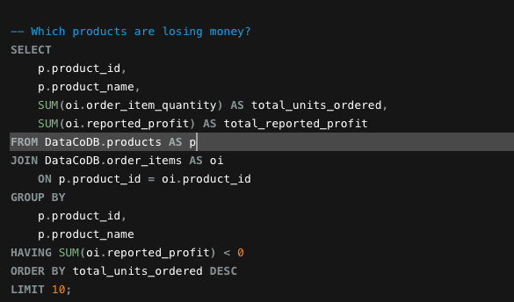
Output:
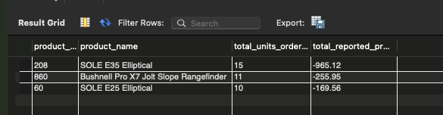

Explanation:
I combined products and order items table to calculate each products total quantity ordered and reported profit. I selected products with negative total profit to show loss. I observed that only 3 products are at loss, and only 10-15 units sold for each.

- How many orders were delivered late, and what was their average delay?
Query:
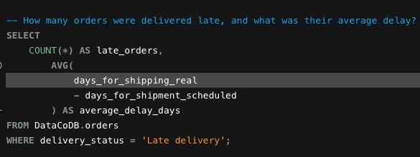
Output:
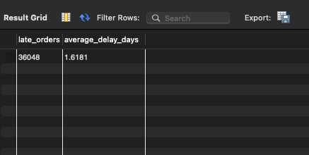

Interpretation:
I selected orders marked as late deliveries and counted them. For each order, I calculated the delay by subtracting the scheduled shipping dates from actual days. On average the delay is between 1-2 days.

Advanced Queries:
- Which departments generate the most reported profit? But also what is their profit on average per unit?
Query:
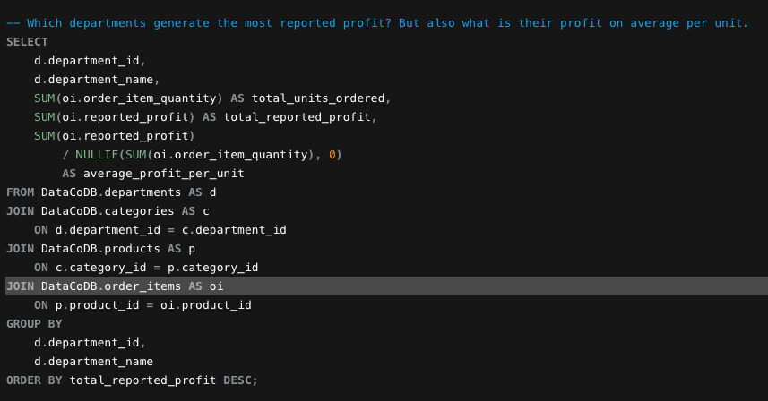
Output:
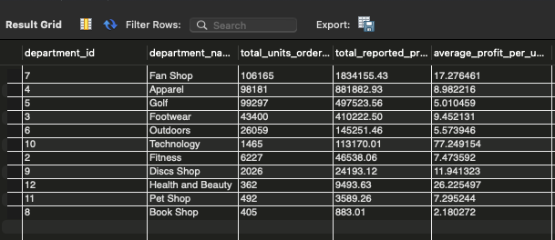
Interpretation:
I connected departments, categories, products and order items to calculate profitability at the department level. I calculated each departments total reported profit and divided by its total units ordered to find the average profit per unit. This helps compare both the overall profit contribution and the profit earned per unit.
Fan shop sold more units and made more total profit but per unit profit was less. In contrast, technology had more average profit per unit.

- Which region has the highest number of distinct orders for each product category, including ties?

Query:

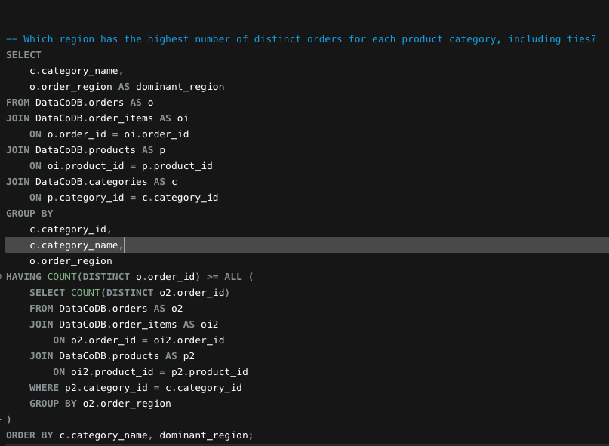

Output:
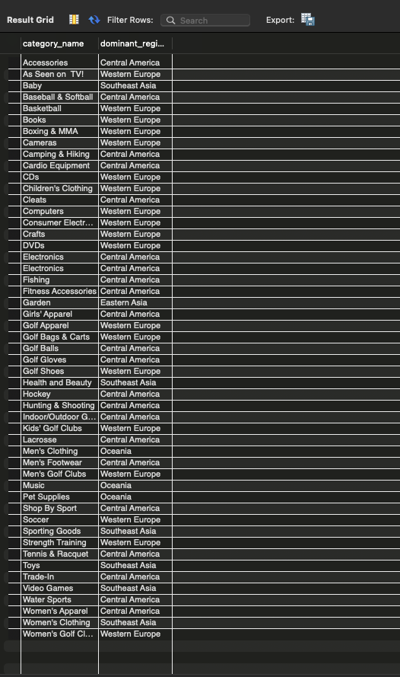

Interpretation:
I counted the distinct orders for each category in each region. Then I compared the regional counts within the same category and selected the region with the highest count.
Western Europe and central America are dominating market share for most categories followed by Southeast Asia, eastern Asia and Oceania

