DataCo Supply Chain SQL Queries
Solutions, result screenshots, and interpretations
Purpose. This document presents four SQL analyses using the normalized DataCo Supply Chain database. Each section includes the business question, SQL solution, result screenshot, and interpretation.

Query 1
Question: Which payment type is used most often?
SQL solution
SELECT
payment_type,
COUNT(*) AS payment_count
FROM orders
GROUP BY payment_type
ORDER BY payment_count DESC
LIMIT 1;
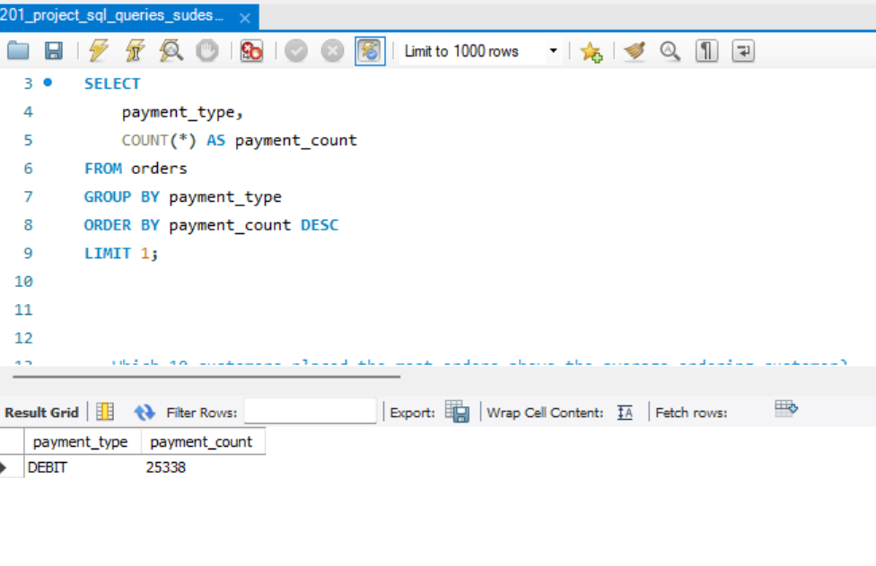
Result screenshot for Query 1
Interpretation. The query counts orders for each payment type and returns the most frequently used option. The result shows DEBIT with 25,338 orders, indicating that debit is the most common payment type in the displayed results.
SQL techniques. COUNT, GROUP BY, ORDER BY, and LIMIT.

Query 2
Question: Which order region generated the highest total sales revenue?
SQL solution
SELECT
o.order_region,
ROUND(
SUM(p.product_price * oi.order_item_quantity),
2
) AS total_revenue
FROM orders AS o
JOIN order_items AS oi
ON o.order_id = oi.order_id
JOIN products AS p
ON oi.product_card_id = p.product_card_id
GROUP BY o.order_region
ORDER BY total_revenue DESC
LIMIT 1;
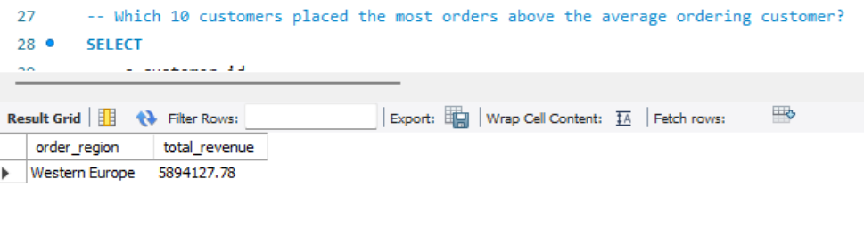
Result screenshot for Query 2
Interpretation. The query calculates revenue for each order region using product price multiplied by order-item quantity. Western Europe generated the highest displayed revenue, with total revenue of $5,894,127.78. This identifies the strongest region in terms of sales value rather than order count.
SQL techniques. JOIN, SUM, ROUND, GROUP BY, ORDER BY, and LIMIT.

Query 3
Question: Which 10 customers placed the most orders above the average ordering customer?
SQL solution
SELECT
c.customer_id,
c.customer_name,
(
SELECT COUNT(*)
FROM orders AS o2
WHERE o2.customer_id = c.customer_id
) AS order_count
FROM customers AS c
WHERE EXISTS (
SELECT 1
FROM orders AS o
WHERE o.customer_id = c.customer_id
GROUP BY o.customer_id
HAVING COUNT(*) >
(
SELECT AVG(order_count)
FROM
(
SELECT
customer_id,
COUNT(*) AS order_count
FROM orders
GROUP BY customer_id
) AS customer_order_counts
)
)
ORDER BY order_count DESC
LIMIT 10;
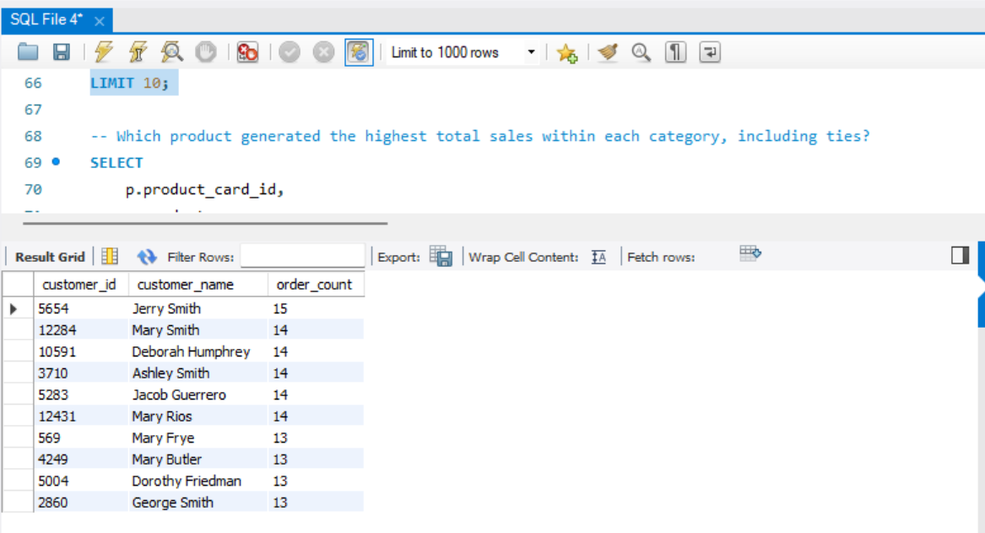
Result screenshot for Query 3
Interpretation. The query identifies customers whose order counts are above the average ordering customer and returns the ten highest counts. Jerry Smith placed the most orders in the displayed results, with 15 orders. Several other customers placed 14 orders, while the remaining displayed customers placed 13 orders. These customers may be useful targets for loyalty and retention strategies.
SQL techniques. WHERE EXISTS, nested subqueries, COUNT, AVG, GROUP BY, ORDER BY, and LIMIT.

Query 4
Question: Which product generated the highest total sales within each category, including ties?
SQL solution
SELECT
p.product_card_id,
p.product_name,
p.category_id,
ROUND(
SUM(p.product_price * oi.order_item_quantity),
2
) AS total_sales
FROM products AS p
JOIN order_items AS oi
ON p.product_card_id = oi.product_card_id
GROUP BY
p.product_card_id,
p.product_name,
p.category_id
HAVING SUM(p.product_price * oi.order_item_quantity) >= ALL
(
SELECT
SUM(p2.product_price * oi2.order_item_quantity)
FROM products AS p2
JOIN order_items AS oi2
ON p2.product_card_id = oi2.product_card_id
WHERE p2.category_id = p.category_id
GROUP BY p2.product_card_id
)
ORDER BY total_sales DESC;
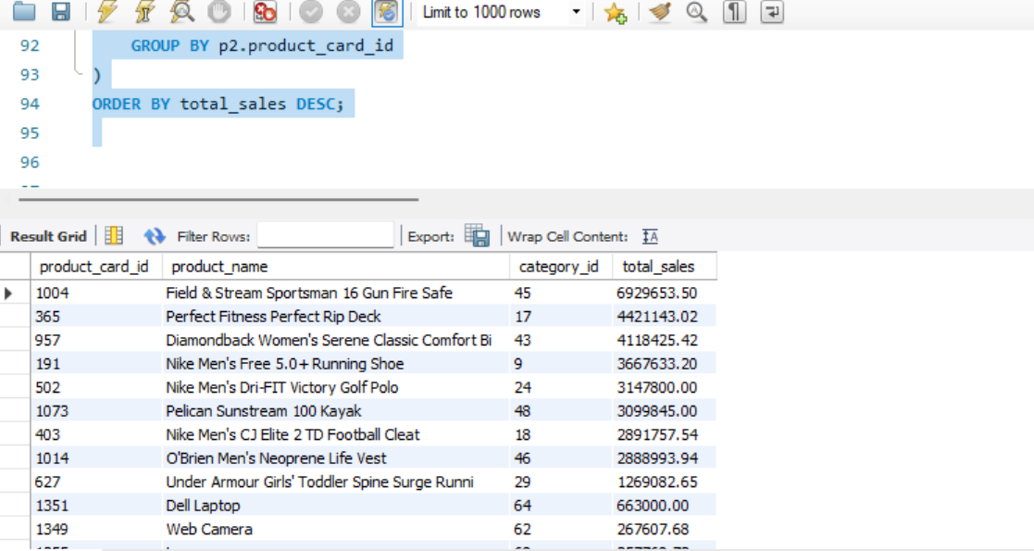
Result screenshot for Query 4
Interpretation. The query compares products within each category and returns the product or products with the highest calculated sales. Sales are calculated as product price multiplied by order-item quantity. The highest displayed result is Field & Stream Sportsman 16 Gun Fire Safe at $6,926,953.50. The >= ALL condition preserves ties.
SQL techniques. Multi-row subquery, ALL, JOIN, SUM, ROUND, GROUP BY, and ORDER BY.

Overall findings
- DEBIT is the most frequently used payment type in the displayed result.
- Western Europe generated the highest displayed total revenue.
- A small group of customers places more orders than the average ordering customer.
- The highest-sales product varies by category, so category-level comparisons are useful.

