Basic: Which shipping mode has the highest average actual shipping time?

USE supplychain_project;

SELECT ShippingMode, COUNT(*) ,AVG(ActualShippingDays) AS avg_actual_days
FROM Orders
GROUP BY ShippingMode
ORDER BY avg_actual_days
LIMIT 5;
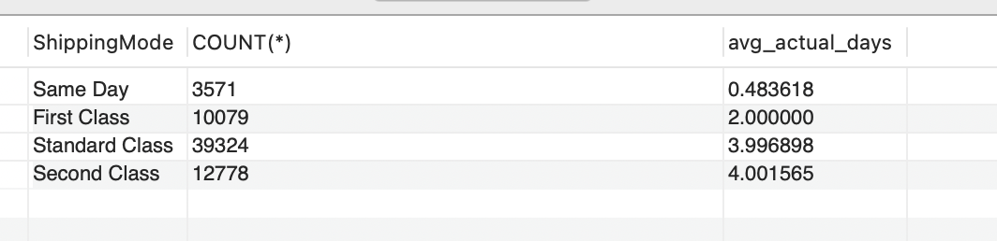

Interpretation: The query reads data from the Orders table and groups the orders by ShippingMode.The COUNT counts the orders in each shipping mode and the average calculates the average shipping days for each mode.ORDER BY sorts the results in ascending order and the result is displayed of first five shipping orders using LIMIT.

-- Basic: How many orders were delayed in each market?
USE supplychain_project;

SELECT Market, COUNT(*) AS delayed_orders
FROM Orders
WHERE ActualShippingDays > ScheduledShippingDays
GROUP BY Market
ORDER BY avg_actual_days DESC
LIMIT 5;
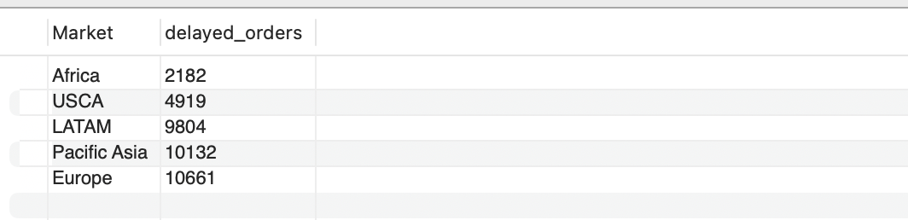

Interpretation:
The query first reads the Orders table and filters the data to keep only orders that took longer than scheduled. It then groups these delayed orders by market and counts the number of delayed orders in each market. The results are sorted in ascending order and only the first five markets are displayed.
-- Advanced: Which shipping modes have an average actual shipping time higher than the overall average?
USE supplychain_project;
SELECT
ShippingMode,
AVG(ActualShippingDays) AS AverageActualShippingDays
FROM Orders
GROUP BY ShippingMode
HAVING AVG(ActualShippingDays) >
(
SELECT AVG(ActualShippingDays)
FROM Orders
)
ORDER BY AverageActualShippingDays DESC;

This query calculates the average actual shipping time for each shipping mode. The subquery calculates the overall average actual shipping time for all orders and displays it as OverallAverageDays. The HAVING clause keeps only the shipping modes whose average shipping time is higher than the overall average. Finally, the results are sorted from the highest shipping-mode average to the lowest.
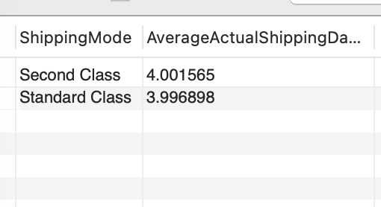
-- Advanced: How many delayed and on-time or early orders are there in each market?
USE supplychain_project;
SELECT
Market,
'Delayed' AS ShippingStatus,
COUNT(*) AS OrderCount
FROM Orders
WHERE ActualShippingDays > ScheduledShippingDays
GROUP BY Market

UNION ALL

SELECT
Market,
'On Time or Early' AS ShippingStatus,
COUNT(*) AS OrderCount
FROM Orders
WHERE ActualShippingDays <= ScheduledShippingDays
GROUP BY Market

ORDER BY Market, ShippingStatus;
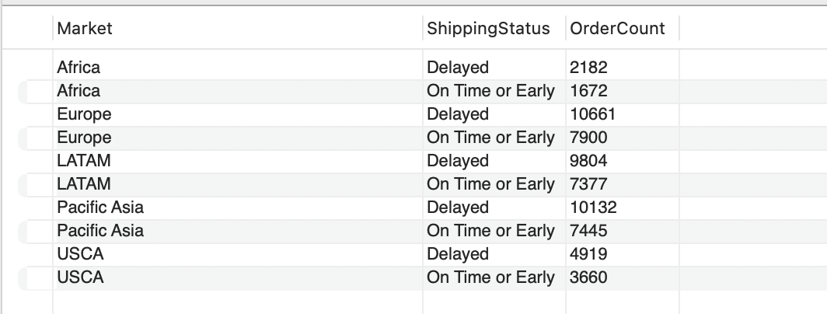

Interpretation:
The first query filters and counts delayed orders for each market. The second query filters and counts orders that were on time or early for each market. UNION ALL combines the results from both queries. The final combined result is sorted by market and shipping status.

