DataCo Supply Chain SQL Queries
Purpose. This document contains four additional SQL queries selected for the DBMS 201 project. The queries use the table and column names from the logical model. Execute each query in MySQL Workbench and paste the result-grid screenshot into the labeled section.

Schema Reference
The following logical model is included as a reference for the table relationships and column names.
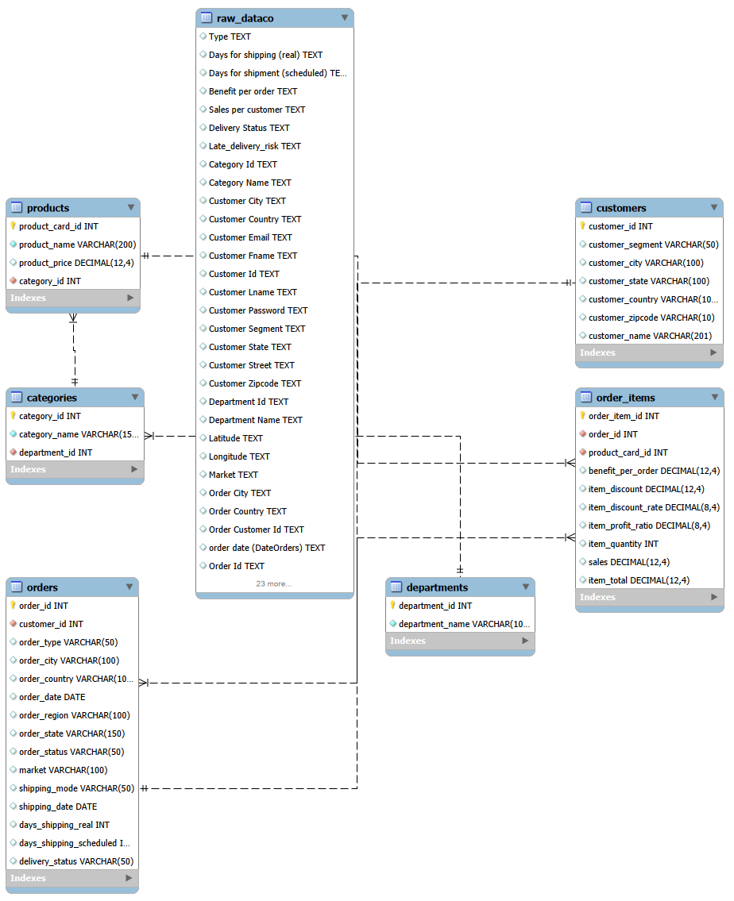
Basic Query 1. Top 10 Customers by Revenue
SQL code
SELECT
c.customer_id,
c.customer_name,
(
SELECT COUNT(DISTINCT o.order_id)
FROM orders o
WHERE o.customer_id = c.customer_id
) AS total_orders,
(
SELECT SUM(oi.item_total)
FROM orders o
JOIN order_items oi
ON o.order_id = oi.order_id
WHERE o.customer_id = c.customer_id
) AS total_revenue
FROM customers c
ORDER BY total_revenue DESC
LIMIT 10;

Interpretation: The outer query reads customer details. The two correlated subqueries calculate the number of orders and total revenue for each customer. The result is sorted from the highest-revenue customer to the lowest.
Expected result: The output should list ten customers with their customer ID, name, order count, and total revenue.
Result screenshot
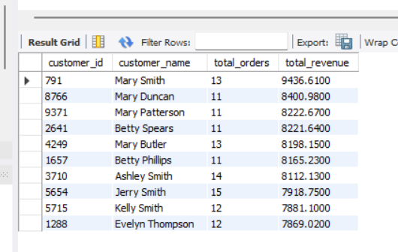

Basic Query 2. Revenue by Product Category
SQL code
SELECT
c.category_id,
c.category_name,
category_data.total_units_sold,
category_data.total_revenue,
category_data.average_profit
FROM categories c
JOIN (
SELECT
p.category_id,
SUM(oi.item_quantity) AS total_units_sold,
SUM(oi.item_total) AS total_revenue,
ROUND(AVG(oi.benefit_per_order), 2) AS average_profit
FROM products p
JOIN order_items oi
ON p.product_card_id = oi.product_card_id
GROUP BY p.category_id
) AS category_data
ON c.category_id = category_data.category_id
ORDER BY category_data.total_revenue DESC;

Interpretation: The subquery aggregates units sold, revenue, and average benefit for each category ID. The outer query joins those results to categories so that the category name is displayed.
Expected result: The output should show each category, units sold, total revenue, and average profit, ordered by revenue.
Result screenshot
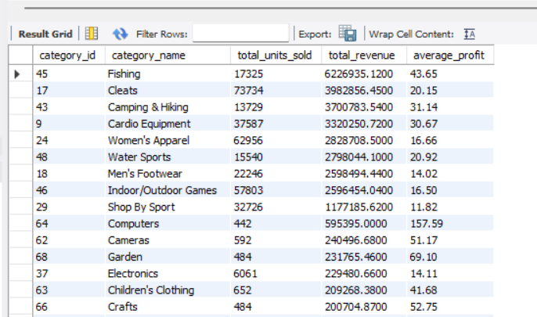

Advanced -Level Query 3. Average Order Value by Customer Segment
SQL code
SELECT
c.customer_segment,
COUNT(order_summary.order_id) AS total_orders,
ROUND(AVG(order_summary.order_total), 2) AS average_order_value
FROM customers c
JOIN (
SELECT
o.order_id,
o.customer_id,
SUM(oi.item_total) AS order_total
FROM orders o
JOIN order_items oi
ON o.order_id = oi.order_id
GROUP BY o.order_id, o.customer_id
) AS order_summary
ON c.customer_id = order_summary.customer_id
GROUP BY c.customer_segment
ORDER BY average_order_value DESC;

Interpretation: The subquery first calculates the total value of every order. The outer query groups those order totals by customer segment and calculates the average order value for each segment.
Expected result: The output should compare customer segments by total orders and average order value.
Result screenshot
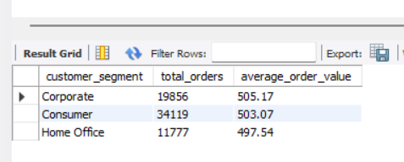

Advanced Query 4. Month-over-Month Revenue Growth W
SQL code
SELECT
current_month.order_month,
current_month.monthly_revenue,
previous_month.monthly_revenue AS previous_month_revenue,
ROUND(
(current_month.monthly_revenue
- previous_month.monthly_revenue) * 100.0
/ NULLIF(previous_month.monthly_revenue, 0),
2
) AS growth_percentage
FROM (
SELECT
DATE_FORMAT(o.order_date, '%Y-%m') AS order_month,
SUM(oi.item_total) AS monthly_revenue
FROM orders o
JOIN order_items oi
ON o.order_id = oi.order_id
GROUP BY DATE_FORMAT(o.order_date, '%Y-%m')
) AS current_month
LEFT JOIN (
SELECT
DATE_FORMAT(o.order_date, '%Y-%m') AS order_month,
SUM(oi.item_total) AS monthly_revenue
FROM orders o
JOIN order_items oi
ON o.order_id = oi.order_id
GROUP BY DATE_FORMAT(o.order_date, '%Y-%m')
) AS previous_month
ON previous_month.order_month = DATE_FORMAT(
DATE_SUB(
STR_TO_DATE(CONCAT(current_month.order_month, '-01'), '%Y-%m-%d'),
INTERVAL 1 MONTH
),
'%Y-%m'
)
ORDER BY current_month.order_month;

Interpretation: The first derived table calculates revenue for each month. The second derived table provides the same monthly totals for matching. The LEFT JOIN connects each month to the previous month, and the outer query calculates the percentage growth or decline.
Expected result: The output should show current revenue, previous-month revenue, and the percentage change for each month. The first month may have a blank previous-month value.

Result screenshot
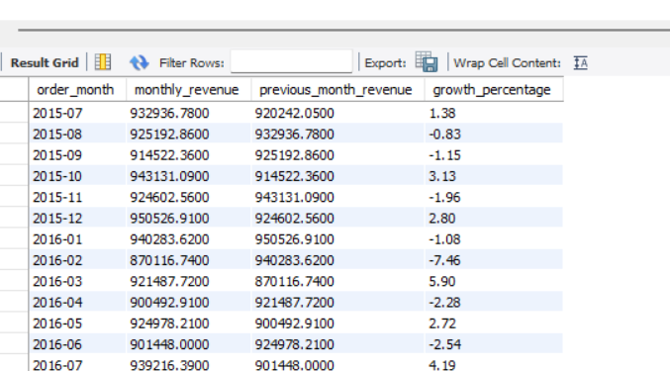

Database Import Evidence
An existing MySQL result screenshot is included below as supporting evidence that the normalized tables were imported and joined successfully.
SELECT
o.order_id,
c.customer_name,
p.product_name,
cat.category_name,
d.department_name,
oi.item_quantity,
oi.item_total,
o.delivery_status
FROM orders o
JOIN customers c
ON o.customer_id = c.customer_id
JOIN order_items oi
ON o.order_id = oi.order_id
JOIN products p
ON oi.product_card_id = p.product_card_id
JOIN categories cat
ON p.category_id = cat.category_id
JOIN departments d
ON cat.department_id = d.department_id
LIMIT 10;

Result screenshot
